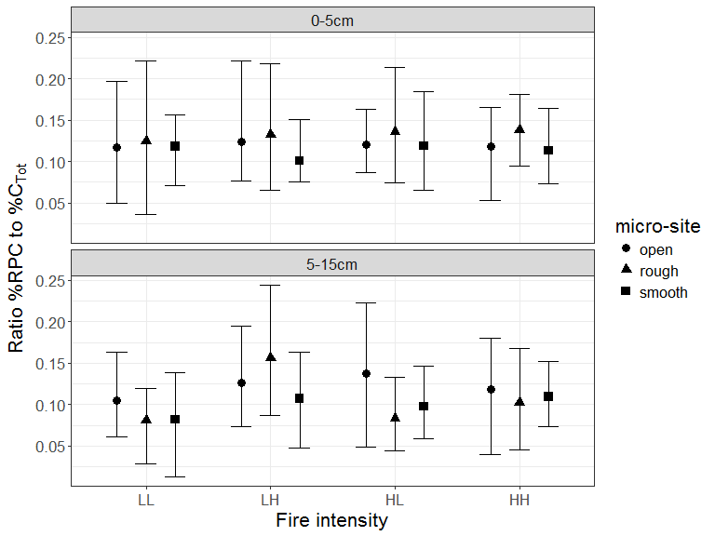

Figure B.2. Ratio of %RPC to %CTot in relation to fire intensity and site characteristics shown as mean values (points) with 95% credible intervals. Within each combination, mean %RPC was calculated for each field sample using a Bayesian procedure in which a heavy-tailed distribution (t-distribution with flexible shape parameter) was fitted to five replicate analytical values. This approach ensured that any outlying analytical values for a field sample would be down-weighted in a data-driven manner. Markov Chain Monte Carlo estimation resulted in a set of credible mean %RPC values for each field sample and a corresponding set of ratio values to %CTot from which the means and intervals shown here were derived. Fire intensity was rated low (L), tree crowns unaffected, or high (H), tree crowns affected. Sites selected from two successive fires separated by 8 years, soil collected 10 years post fire, yielding four intensity combinations (LL, LH, HL, HH). Soil depth was characterized by two layers (0-5cm; 5-15cm). Micro sites sampled were: adjacent to base of rough barked trees (Rough); adjacent to base of smooth barked trees (Smooth); open patches largely between tree crowns (Open).