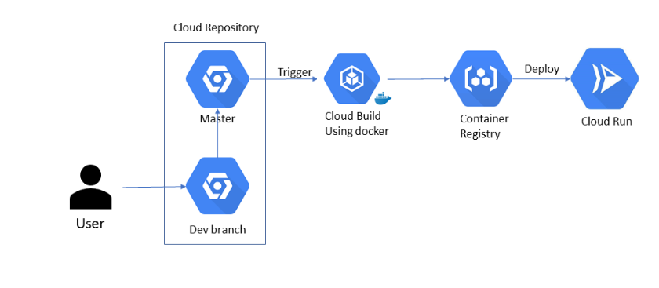

**Directory**: /home/mangeshsoni82/clock/

SELECT * FROM `ind-coe.mangesh.clock`

* Read Hour (INT64) and Minute (INT64) from BQ Table (which is having Angle as Null)
  + then run a python program /home/mangeshsoni82/clock/Cal_Angle_Store_in_BQ.py
  + that will update the Angle (Numeric) column
  + logs available in /home/mangeshsoni82/clock/StrAnleInBQ2020_05_17_02_41_38.log

main.py

* Python program that will take user inputs (hour:minute) and displays the Angle
* Logs available in /home/mangeshsoni82/clock/GetAngleFromClock2020_05_16_23_50_07.log

test.py

* Testing of sample records and passing it to main.py and compare the results (hard coded).

Function_angle.py

* Take Inputs like Hour and Minute and Displays Output. Can also store in Bigquery.

**Directory**: /home/mangeshsoni82/clock/docker

* Dockerfile, cloudbuild.yaml, app.py (Flask Program) 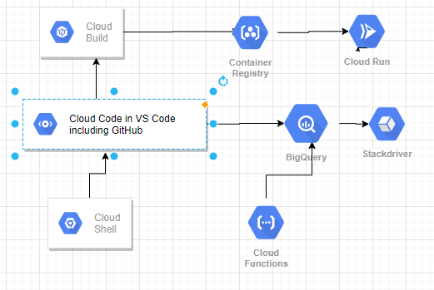

**Bigquery Output (Update in Angle)**

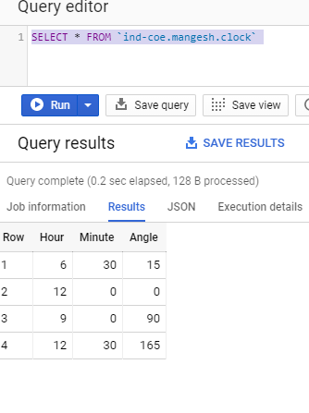

**Cloud Function**

