ROI Curator
  - Assigning atlas plates and placing region landmarks on salmon brain sections
26 August 2026
Table of Contents

What this tool is for
Every section in this study has to be matched to an atlas plate, and the atlas’s region seeds have to be placed onto the tissue so that pERK and PCNA signal can be counted per region.
The ROI curator is where that is done by hand. It shows one section beside one atlas plate, you tell it which plate the section is and where a handful of matching points are, and it warps the atlas regions onto the section from those points.
The matching is deliberately not automatic. Automatic level assignment was measured twice on this data and failed both times — silhouette IoU correlated with serial order at −0.05 to 0.17, and registered-intensity cross-correlation at −0.18 to +0.09. The published tool for this task (SHARCQ) also has the operator pick the plate by eye, so this does too. What is automated is the registration, the warping, and the export.

The window at a glance
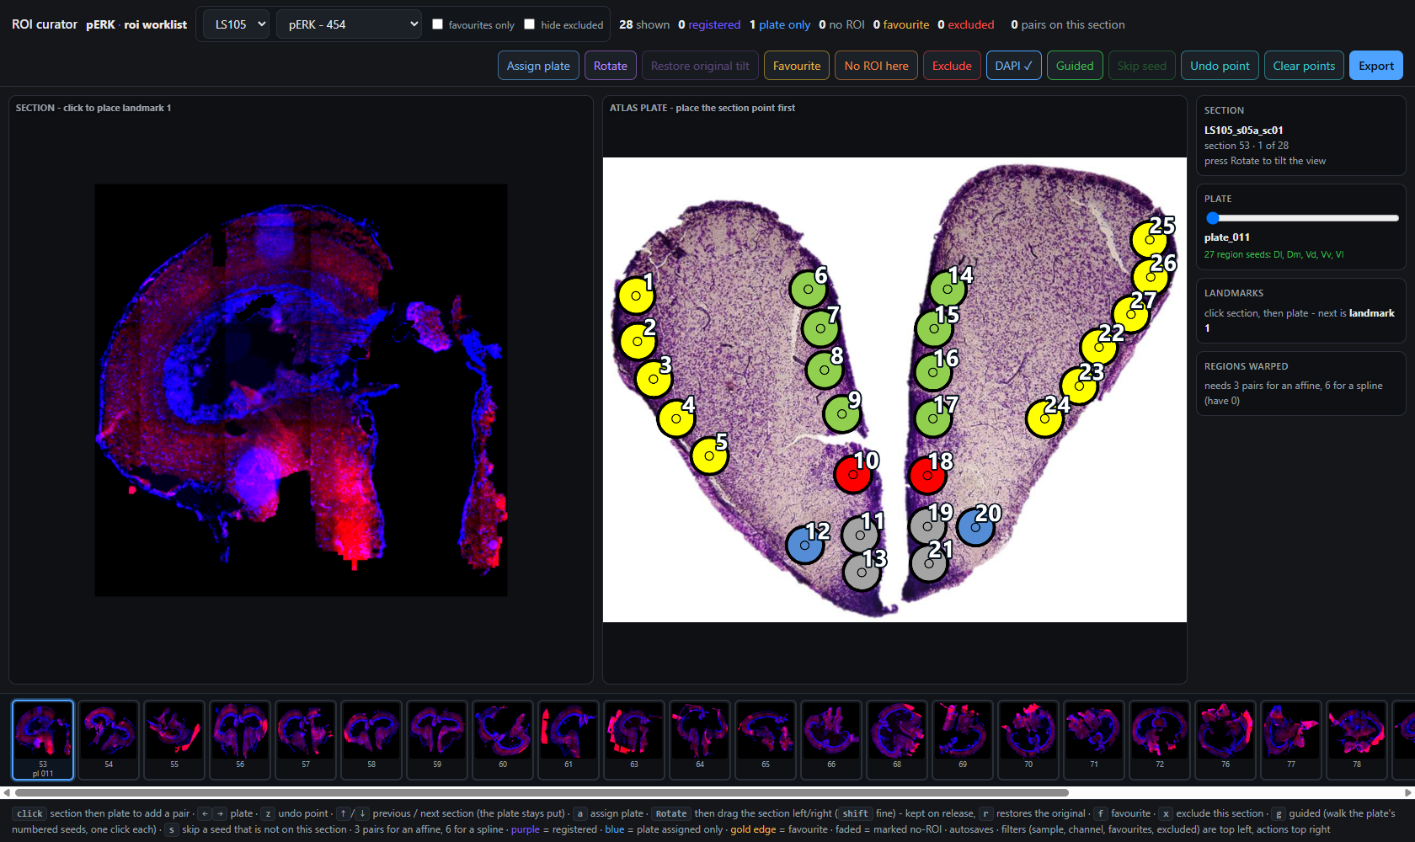
The curator with a section loaded, its atlas plate beside it, and the section strip along the bottom
Four regions, and each does one job:
Region | What it is
Toolbar (top) | Filters on the left, actions on the right
Section pane (left) | The section you are working on. You click here
Atlas plate pane (middle) | The plate you are matching to. Numbered seeds
Sidebar (right) | Which section, which plate, landmarks, fit quality
Strip (bottom) | Every section in the current view, colour-coded by state

The toolbar
Filters left, actions right
The header is split so that what narrows the view sits by the sample selector and what acts on a section sits by Export.

Filters (left)
Control | Effect
Animal | Which fish. Twelve of them
Channel | pERK (454 worklist sections), PCNA (788), or both channels (1242)
favourites only | Show only the sections you flagged for quantification
hide excluded | Hide rejected sections from the strip
pERK and PCNA are independent. They are separate physical sections cut at different times. The tool is shared; no judgement crosses between them. Nothing you decide about a pERK section reaches its PCNA partner, and every export row records the channel it was made on.
hide excluded is a view, not a deletion. Hidden sections keep their flag, still appear in the excluded count, and are still written to roi_plates.csv with excluded=1.

Counters
shown · registered · plate only · no ROI · favourite · excluded · pairs on this section, then the autosave clock (saved 14:31:26).

The workflow

1. Find the plate
Scrub the PLATE slider in the sidebar, or press ← / →, until the plate matches the section. Only some plates carry region seeds; the sidebar tells you which regions a plate has.
Press Assign plate (a) to record the plate as a deliberate decision. This matters: a plate assignment is a judgement in its own right, and is exported even if you place no landmarks at all.

2. Turn on Guided
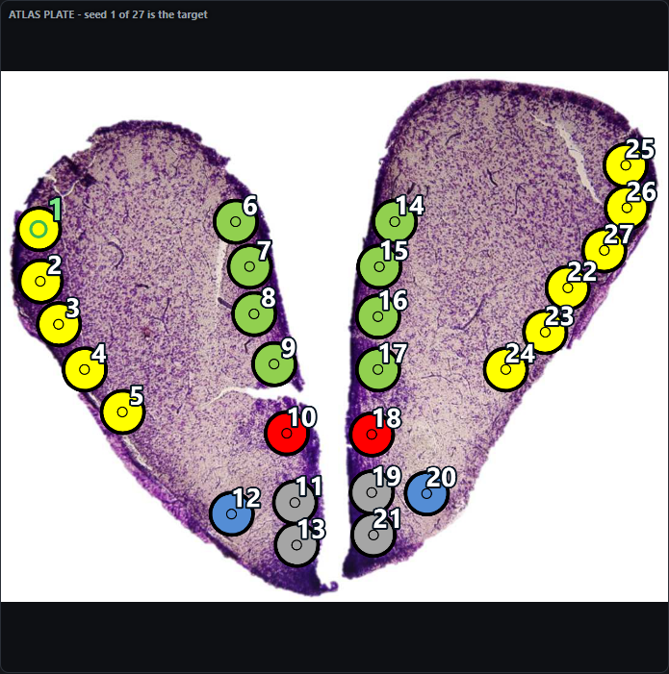
Guided mode: seed 1 is the target, ringed in green. Every seed carries its number
Press Guided (g). The plate’s seeds are numbered in a fixed order — down each column, columns left to right — so seed 4 is always the same seed, in the tool, in every export, and on a re-run.
The order follows the anatomy: the left lateral arc first, then the medial strip on the left of the midline, then the medial strip on the right, then the right lateral arc. Consecutive numbers stay within one structure instead of jumping across the brain.
The current target is ringed in green. Seeds you have already placed go hollow, so progress down the plate is visible without reading anything.

3. Place each seed with one click
Click on the section where that seed belongs. One click makes the whole pair — the plate half comes from the seed itself, so it is exact rather than eyeballed. The cursor then advances to the next seed.
Situation | What to do
The seed is not on this section | Skip seed (s)
You want to go back, or jump ahead | Click that seed on the plate to re-aim
You misplaced one | Undo point (z) — the cursor follows back
Leaving a section and returning resumes where you left off. The cursor is worked out from the pairs already placed, so it always points at the first gap.

4. Size the landmark as you place it
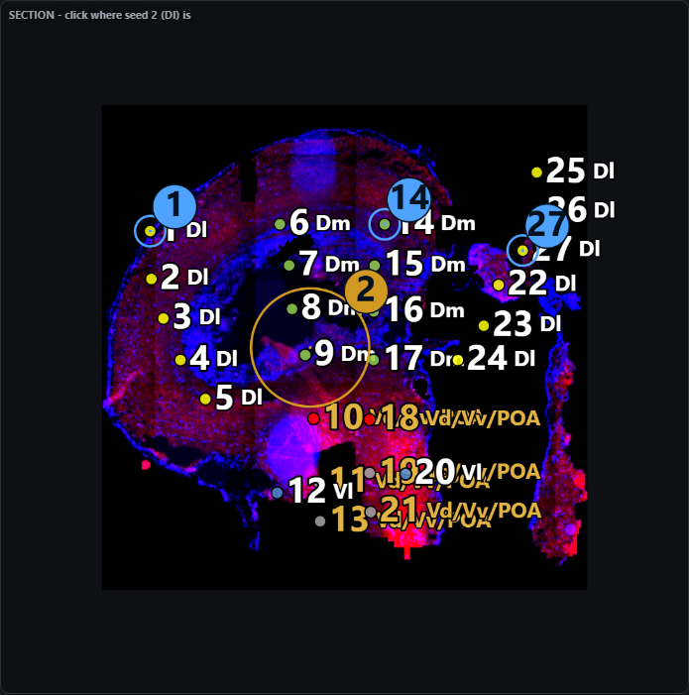
Press, drag out to set the radius, release to place
A landmark is a position and a radius. Press where the point is, drag out to the size you want, and release. The readout shows the radius live. A plain click without dragging keeps the default, so nothing is slower than it was.
The size is asked for at the moment of placing because that is when it is known — sizing afterwards would mean finding the landmark again and remembering which one it was.

5. Check the overlay, not the number
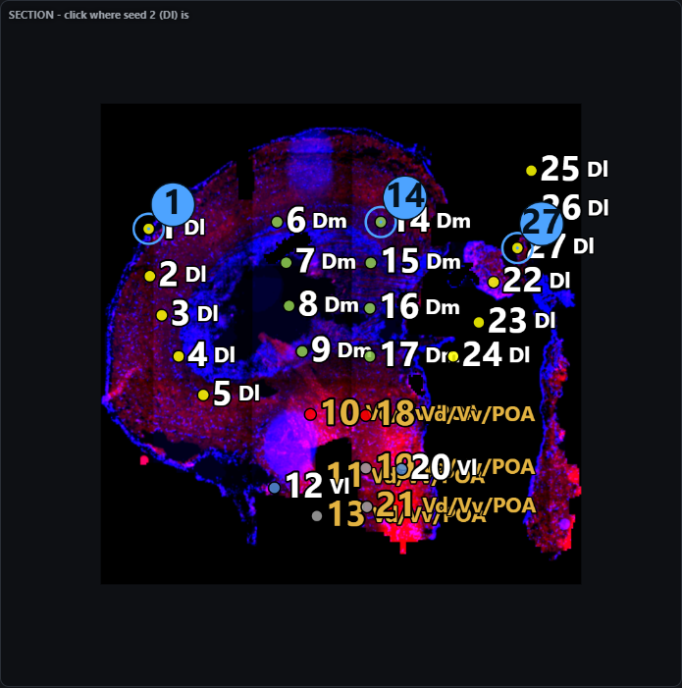
Three landmarks placed; all 27 atlas seeds warped onto the tissue and numbered
From three pairs the atlas regions are warped live onto the section in their atlas colours. This overlay is the check that matters, not the residual.
The seeds on the section carry the same numbers as the plate, so you can say “seed 17 landed in the wrong place” and both panes agree on what that means.
Landmarks | Transform
3–5 | Affine. The residual per landmark is meaningful
6 or more | Thin-plate spline. Residual is 0 by construction

Rotating the view
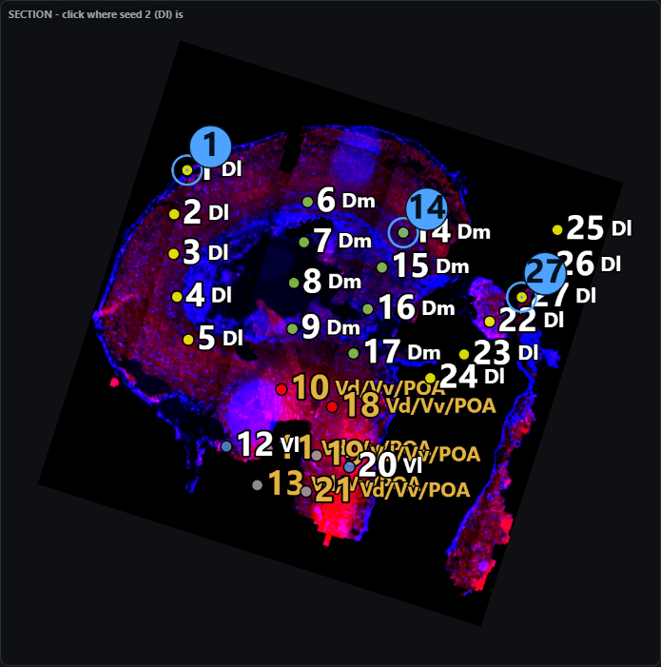
The rotate tool mid-drag, showing the tilt in degrees
Press Rotate, then drag left or right on the section. Hold shift for fine control. The tilt is saved the moment you release and stays with that section. Restore original tilt (r) puts it back.
Rotation is a viewing aid and nothing else. Every stored coordinate stays in the unrotated frame, so all three exports are identical whether you turned the section or not. The angle rides along in roi_plates.csv as view_rotation_deg for provenance.

Per-section decisions
Button | Key | Meaning
Favourite | f | This section is in the subset you will quantify. Orthogonal to everything else — a section can be worth quantifying before anyone has landmarked it
No ROI here | — | This section carries no region of interest
Exclude | x | Reject the section. A judgement in its own right, and exported as one
DAPI | — | Show or hide the blue counterstain, leaving the marker channel alone

Reading the strip
Section thumbnails, colour-coded by what has been decided about them
Appearance | State
Purple border | Registered — 3 or more landmarks
Blue border | Plate assigned only
Gold inner edge | Favourite
Red border, greyed | Excluded
Faded | Marked “no ROI”
↑ / ↓ move between sections; the plate stays put, which is what makes working through a run of neighbouring sections quick.

The sidebar
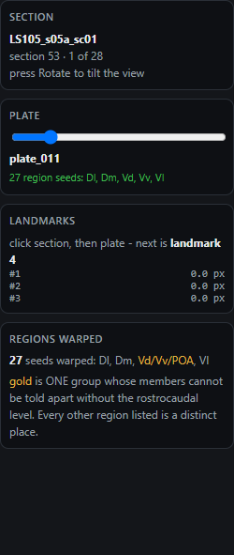
Section identity, plate slider, landmark residuals and the warped-region summary
The LANDMARKS card lists each pair with its residual, so a mis-clicked pair shows up as a large error instead of quietly dragging the whole fit. The REGIONS WARPED card names the regions the current plate will contribute.

Keyboard shortcuts
Key | Action |  | Key | Action
← → | Previous / next plate |  | a | Assign plate
↑ ↓ | Previous / next section |  | f | Favourite
g | Guided mode on/off |  | x | Exclude section
s | Skip the current seed |  | z | Undo point
r | Restore original tilt |  | shift | Fine rotation while dragging

Saving
Your work is written to browser storage on every change — there is no save button and nothing is waiting on a timer.
On top of that, once a minute the tool writes a rolling snapshot under a second key, and shows saved HH:MM:SS in the header. That snapshot is a recovery point: if the live state goes wrong, roiRestoreBackup() in the browser console rolls back to it, confirming the timestamp and section count first. It is deliberately not a button, because it replaces everything currently in the tool.
Two things to know:
- Storage is per browser and per machine. Clearing site data takes both copies.
- The snapshot is at most a minute old. Export is what commits your work to disk; autosave is a safety net under it, not a replacement.

What Export writes
Three files, because there are three different decisions and collapsing them loses one.

roi_plates.csv — one row per decided section
scene_uid, animal, marker, subset, section_order, plate_set, plate_id, plate_index, plate_has_seeds, n_landmarks, transform, status, favorite, view_rotation_deg, excluded
A section appears here if anything was decided about it — assigned, favourited or excluded — even with no landmarks.

roi_landmarks.csv — one row per pair
scene_uid, animal, marker, section_order, plate_set, plate_id, pair, sec_x, sec_y, sec_r, plate_x, plate_y, residual_px, seed_n, seed_region
seed_n and seed_region say whether the landmark was placed against a numbered atlas seed, and which one. Blank means it was free-clicked.

roi_regions.csv — one row per warped seed
scene_uid, animal, marker, plate_set, plate_id, region, region_ambiguous, ambiguity_group, region_uncertain_in_atlas, sec_x, sec_y, n_landmarks, transform, mean_residual_px
All coordinates are in canonical reformatted-frame pixels (the 256 grid), the same frame the masks and every other reformatted product live in — regardless of what resolution was on screen.

Things worth knowing

A guided landmark is an assertion, not a measurement
When you place a landmark against a seed, you are stating where that region is. The warp then reproduces your statement at that point exactly — a thin-plate spline interpolates its landmarks with zero residual by construction — so the residual is not an independent check on a guided pair.
Seeds you did not click are still atlas-derived, interpolated from the ones you did, and those are the rows the atlas is actually doing work for. This is why every landmark records the seed it came from: which method produced a number stays recoverable instead of being lost in the mean.

Two different kinds of uncertainty
All 356 atlas seeds carry a region name; none are blank. The overwhelming majority name a distinct place and are not qualified by anything — Dl and Dm in particular are separate regions in separate locations, and nothing in the tool treats them as interchangeable.
Two groups are qualified, for two different reasons:
 | Seeds | Why
region_ambiguous | 42 | Vd / Vv / POA cannot be told apart without knowing the section’s rostrocaudal level, so the group is shown rather than a name the data cannot support. Drawn in gold
region_uncertain_in_atlas | 8 | The atlas itself labels these "Rm (Raphe) ??". Shown with a trailing ?
A seed can carry either, both, or neither, and they are exported in separate columns. The specific region name is always kept alongside.
Everything outside those two groups — Dl, Dm, Vl, Vs, Vc, the tuberal regions — is reported as itself, with region_ambiguous = 0. In the sidebar only the ambiguous entry is drawn in gold, so the caveat applies to the one entry it names and not to the list around it.

Free correspondence is still available
With Guided off, the original two-click flow works as before: click a point on the section, then the matching point on the plate. Those landmarks carry no seed number and no region — they are arbitrary correspondence points, which is exactly what you want when the useful matching feature is not a region centre.

Generated from the live tool. Screenshots are of animal LS105, section 53, matched to plate_011.

