**Design**

**Introduction:**

The web of things, or IoT, is an arrangement of interrelated figuring gadgets, mechanical and computerized machines, items, creatures or individuals that are furnished with remarkable identifiers (UIDs) and the capacity to move information over a system without expecting human-to-human or human-to-PC interaction. The web of things, or IoT, is an arrangement of interrelated processing gadgets, mechanical and advanced machines, articles, creatures or individuals that are given one of a kind identifiers (UIDs) and the capacity to move information over a system without expecting human-to-human or human-to-PC interaction. The web of things, or IoT, is an arrangement of interrelated registering gadgets, mechanical and computerized machines, articles, creatures or individuals that are given one of a kind identifiers (UIDs) and the capacity to move information over a system without expecting human-to-human or human-to-PC connection.

IOT has seen many applications in practical problems. For instance, the major breakthrough is in healthcare sector as the patient at home can be monitored continually for blood pressure and sugar levels and the values can be monitored by medical professionals in hospital and in case the values exceed to emergency levels the doctors can arrange for ambulance and admitted. Similar applications are found in different industries and in the current paper we will observe the manufacturing industry where the pressure, temperature and humidity must be monitored and sensor values are transformed through IOT to client system and visualisations of the parameter values are kept under check.

**Design:**

We will design for the application of IOT in manufacturing industry where pressure, temperature and humidity must be monitored every now and then. So we use three sensors that outputs values at different times and visualizations are analysed in design centre. So the sensors in shop floor of the factory can be kept under check by observing the values at the design centre. The hardware in this application is on sensors and values are transformed via MQTT server. The sensor position, values at different times for three sensors are observed without requiring going to shop floor. So person in one department can observe the values of sensors situated in other place. This is the essence of using IOT here. We have used mqtt to publish the sensor values and then subscribe the values at the receiving end. We then visualize using different plots to understand danger levels.

**Architecture:**

A product running on a PC (running on-premises or in the cloud), could act naturally assembled or facilitated by a third get-together. Accessible as open source and exclusive with additional highlights included. The merchant goes about as a mail station, MQTT doesn't utilize the location of the planned beneficiary however utilizes the title called "Point", and any individual who needs a duplicate of that message will buy in to that subject. Different customers can get the message from a solitary intermediary (one to numerous capacity). Correspondingly, different distributers can distribute themes to a solitary endorser (numerous to one). Every customer can both deliver and get information by both distributing and buying in, for example the gadgets can distribute sensor information and still have the option to get the design data or control orders (MQTT is a bi-directional correspondence convention). This aide in both sharing information, overseeing and controlling gadgets. With MQTT agent engineering, the gadgets and application becomes decoupled and progressively secure. MQTT utilizes Transport Layer Security (TLS) encryption with client name, secret key ensured associations, and discretionary affirmations that expect customers to furnish an authentication document that matches with the server's. The customers are ignorant of every others' IP address. If there should be an occurrence of a solitary wellspring of disappointment, representative programming and customers have a programmed handover to Redundant/programmed reinforcement agent. The reinforcement representative can likewise be arrangement to share the heap of customers over various servers on location, cloud, or the mix of both. The specialist can bolster both standard MQTT and MQTT for consistent determinations, for example, Sparkplug, should be possible with same server, same time and with same degrees of security. The agent can store the information as held messages (need to buy in with database customer) so new supporters of the point can get the last worth straight away. The merchant additionally monitors all the meeting's data as the gadgets goes on and off called "steady meetings".

The mqtt architecture is as shown below:

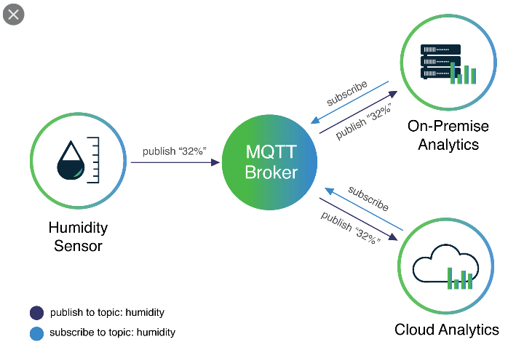

**Code Outputs:**

The sensor data transferred through mqtt is as below

sensors: {"id": "Sensor 2", "value": 45, "lat": 90, "lng": 90, "unit": "C", "type": "temperature", "description": "Temperature"} subcriber received message

------------------------------------------------------------% (0, 1) sensors: {"id": "Sensor 2", "value": 23, "lat": 90, "lng": 90, "unit": "C", "type": "temperature", "description": "Temperature"} subcriber received message------------------------------------------------------------% (0, 1) sensors: {"id": "Sensor 3", "value": 28, "lat": 90, "lng": 10, "unit": "grams per cubic meter of moisture", "type": "Humidity", "description": "Humidity"} subscriber

received message------------------------------------------------------------% (0, 1) sensors: {"id": "Sensor 2", "value": 21, "lat": 90, "lng": 90, "unit": "C", "type": "temperature", "description": "Temperature"} subcriber

received message------------------------------------------------------------%

**Visualizations**

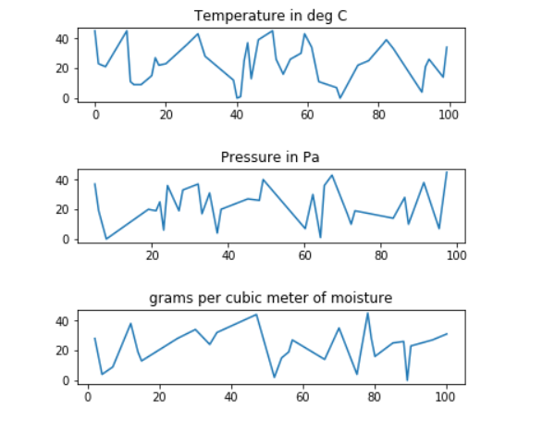

**Advice:** We can observe the fluctuations in temperature and in case for example the client has the lower limit of 16 deg C, then we can rise the alarm looking at the visualisations

**Conclusion**: So, using the mqtt IOT technology, a professional sitting in design department can observe the values of critical parameters (Temperature, humidity, Pressure) values transferred from sensors through IOT. We have implemented this using mqtt.