**EDL Migration Form**

1. Summary

* + 1. **High Level Information [To be filled by the Customer]**

|  |  |
| --- | --- |
| Application Name/Appcode | OTIF |
| ISM-IRIS Ticket No. (REQ#/CR#/INC#) |  |
| Requested By | Anindita Rath |
| Requestor J&J WWID | 643014909 |
| Requestor Contact Phone | +91 9658554855 |
| Requestor Contact Email | [arath3@its.jnj.com](mailto:arath3@its.jnj.com) |
| Package reviewed by | Hiresh Roy |
| Jira reference | PD- |
| Short Description | Prod Cluster Migration Configuration changes |
| Source Environment (Dev/QA/Prod) | QA |
| Source Objects (Folder/Scripts/Database/Table/View  /UDF/HBase/SOLR etc.) | Config.properties and other configuration files ,HQL Scripts, workflows |
| Target Environment (Dev/QA/Prod) ) | PROD |
| Target Objects  (Folder/Scripts/Database/Table/View  /UDF/HBase/SOLR etc.) | Config.properties and other configuration files ,HQL Scripts, workflows |
| Migration Date | 16-11-2018 |
| Purpose | Migration of HQL Scripts and related workflow changes with configuration files for OTIF from QA to PROD |

1. Functionalities deployed as part of the package

|  |  |  |
| --- | --- | --- |
| JIRA# | Description | Type (Defect or Story) |
| ABFY-12130 | Changes in OTIF jobs for QA Cluster migration - Including Post migration checks | Story |
| 1. ABFY-12180 | SOTIF - SOTIF report based on J&J calendar | Story |
| ABFY-12181 | SOTIF - Supplier driven OTIF not calculated correctly | Story |

1. Prerequisites & Assumptions
2. Ensure Kerberos authentication is done before executing the scripts
3. Ensure permission are set to a+x for all sh scripts before executing
4. Login using service account
5. Evidence of successful execution in lower environment

* **Package execution evidence from lower environment**

**package_00010_2018-10-11_18-38-55**

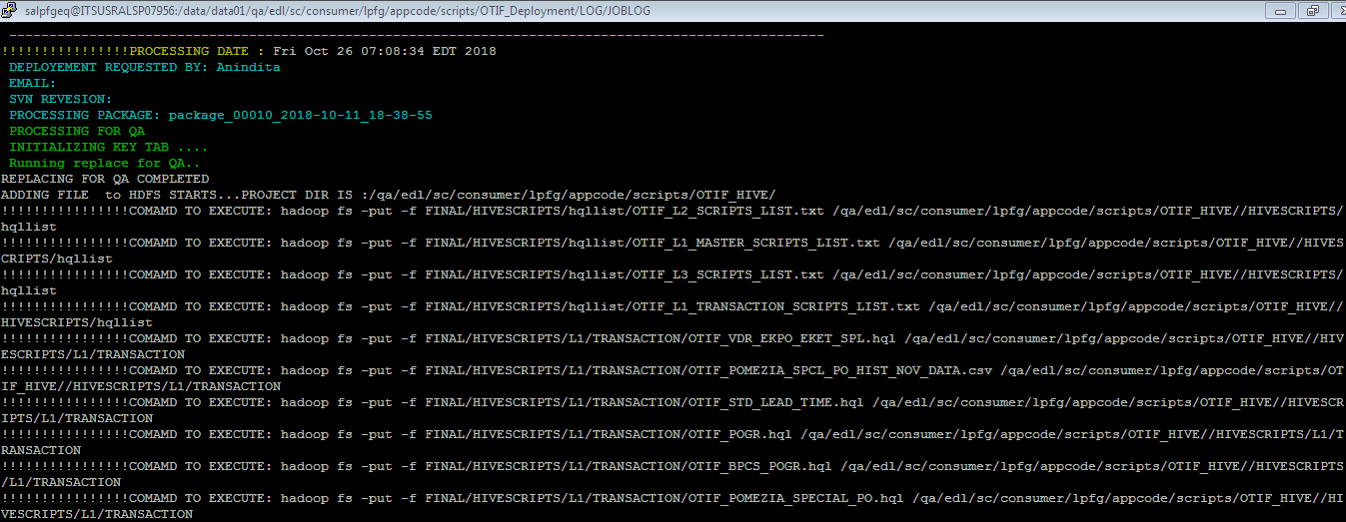

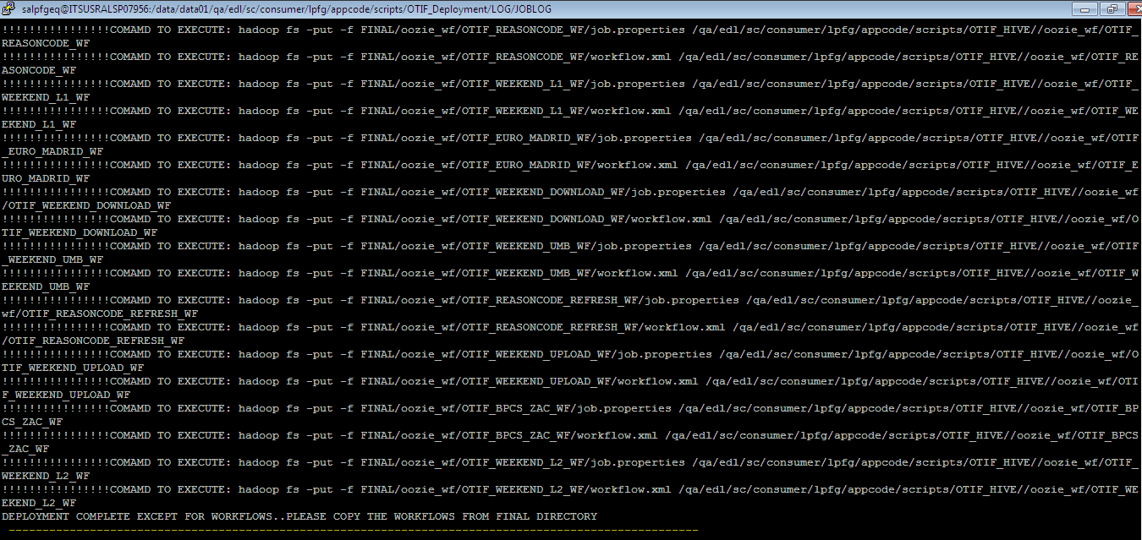

**package_00011_2018-10-29_15-23-58**

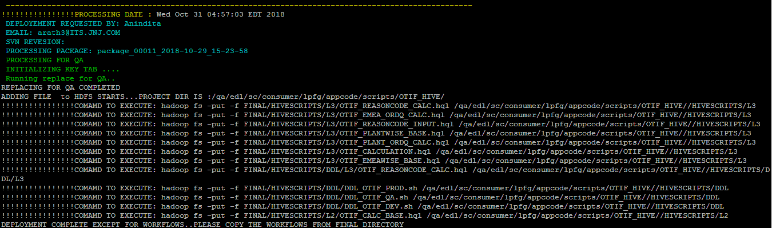

**Umbrella workflow execution**

OTIF_WEEKEND_UMB_WF

<https://edlhueqa.jnj.com:8888/oozie/list_oozie_workflow/0012009-181108232202130-oozie-oozi-W/>

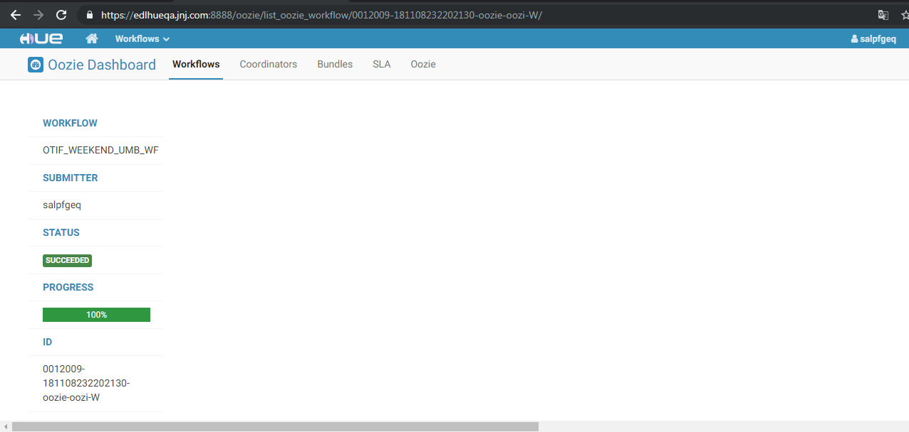

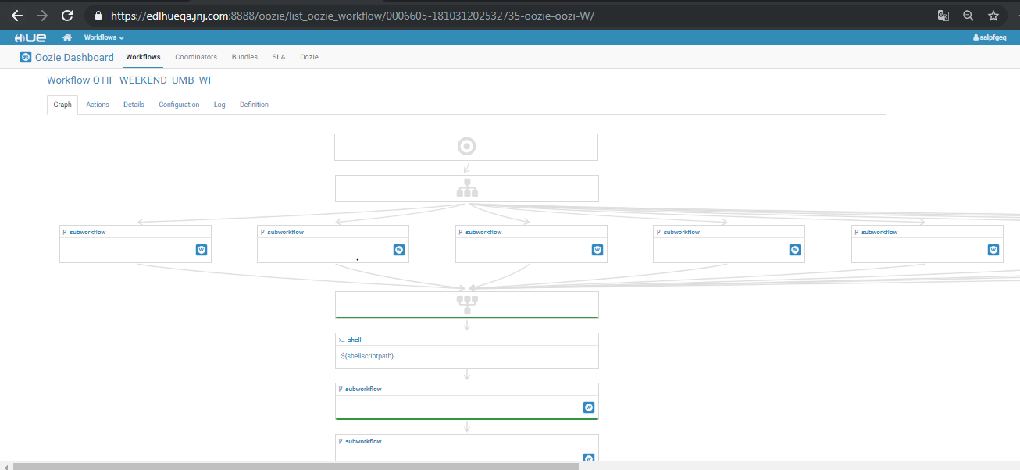

Start Time - Mon, 12 Nov 2018 02:18:42

End Time - Mon, 12 Nov 2018 02:56:56

<https://edlhueqa.jnj.com:8888/oozie/list_oozie_workflow/0006605-181031202532735-oozie-oozi-W/>





Start Time - Wed, 07 Nov 2018 23:27:02

End Time - Wed, 07 Nov 2018 23:49:15

<https://edlhueqa.jnj.com:8888/oozie/list_oozie_workflow/0000875-180904132611760-oozie-oozi-W/>





Start Time -Sun, 09 Sep 2018 06:00:00

End Time - Sun, 09 Sep 2018 06:32:04

**Rollback Strategy**

• hadoop fs -mkdir /prod/edl/sc/consumer/lpfg/appcode/scripts/OTIF_HIVE/OTIF_BACKUP/OTIF_BACKUP_16NOV18_Script_WF_Coord_Backup

• hadoop fs -cp /prod/edl/sc/consumer/lpfg/appcode/scripts/OTIF_HIVE/ /prod/edl/sc/consumer/lpfg/appcode/scripts/OTIF_HIVE/OTIF_BACKUP/OTIF_BACKUP_16NOV18_Script_WF_Coord_Backup

## Package deployment steps

## Source packages folder

1. Source : QA
2. Base Package folder :

## /data/data01/qa/edl/sc/consumer/lpfg/appcode/scripts/OTIF_Deployment/OTIF/ Target packages folder

1. Target : PROD
2. Target Package Folder:

## /data/data01/prod/edl/sc/consumer/lpfg/appcode/scripts/OTIF_Deployment/OTIF/ Overwrite packages

Copy following package from source to target

* **package_00010_2018-10-11_18-38-55**
* **package_00011_2018-10-29_15-23-58**

## Execute packages

* **Execute the steps for package_00010_2018-10-11_18-38-55 in the mentioned order -**

cd /data/data01/prod/edl/sc/consumer/lpfg/appcode/scripts/OTIF_Deployment/OTIF/

1. chmod -R 771 **package_00010_2018-10-11_18-38-55**
2. chown -R salpfgep **package_00010_2018-10-11_18-38-55**
3. cd **package_00010_2018-10-11_18-38-55**
4. chmod 755 deploy.sh
5. sh deploy.sh

* **Execute the steps for package_00011_2018-10-29_15-23-58 in the mentioned order -**

cd /data/data01/prod/edl/sc/consumer/lpfg/appcode/scripts/OTIF_Deployment/OTIF/

1. chmod -R 771 **package_00011_2018-10-29_15-23-58**
2. chown -R salpfgep **package_00011_2018-10-29_15-23-58**
3. cd **package_00011_2018-10-29_15-23-58**
4. chmod 755 deploy.sh
5. sh deploy.sh

## Workflow Execution:

**Please execute the command**

oozie job -oozie https://edloozieprod.jnj.com:11443/oozie -config /data/data01/prod/edl/sc/consumer/lpfg/appcode/scripts/OTIF_Deployment/OTIF/package_00010_2018-10-11_18-38-55/FINAL/oozie_wf/OTIF_WEEKEND_UMB_WF/job.properties -run

* + 1. **Resolution Information [To be filled by ITS]**

|  |  |
| --- | --- |
| Implemented Date |  |
| Change Control No. |  |

* + 1. **Migration Task Screenshots [To be filled by ITS]**

|  |
| --- |
|  |

1. Frequently Asked Questions:
2. How to submit a Service request to the EDL team?

Please duly fill the above section and attach the migration form to a service request (SR) in IRIS. Please follow the below mentioned “how-to” document to raise a SR in IRIS.

<http://wise.jnj.com/SharedServicesNonERP/BI/ClouderaEDL/Shared%20Documents/How%20to%20documents/How%20to%20Submit%20a%20Service%20Request%20to%20EDL%20Team.pdf>

1. How to contact the EDL team?

Mail to [DL-NCSUS-ITS-DATS-EDL-SUPPORT@ITS.JNJ.com](mailto:DL-NCSUS-ITS-DATS-EDL-SUPPORT@ITS.JNJ.com)