EDL Migration Form

1. Summary

* + 1. **High Level Information [To be filled by the Customer]**

|  |  |
| --- | --- |
| Application Name/Appcode | Leapfrog |
| ISM-IRIS Ticket No. (REQ#/CR#/INC#) |  |
| Requested By | Anindita Rath |
| Requestor J&J WWID | 643014909 |
| Requestor Contact Phone | +91 9658554855 |
| Requestor Contact Email | [arath3@its.jnj.com](mailto:arath3@its.jnj.com) |
| Package reviewed by | Hiresh Roy |
| Jira reference | PD- |
| Short Description | Prod Cluster Migration Configuration changes |
| Source Environment (Dev/QA/Prod) | QA |
| Source Objects (Folder/Scripts/Database/Table/View  /UDF/HBase/SOLR etc.) | Config.properties and other configuration files ,HQL Scripts, workflows |
| Target Environment (Dev/QA/Prod) ) | PROD |
| Target Objects  (Folder/Scripts/Database/Table/View  /UDF/HBase/SOLR etc.) | Config.properties and other configuration files ,HQL Scripts, workflows |
| Migration Date | 16-11-2018 |
| Purpose | Migration of HQL Scripts and related workflow changes with configuration files for Leapfrog from QA to PROD |

1. Functionalities deployed as part of the package

|  |  |  |
| --- | --- | --- |
| JIRA# | Description | Type (Defect or Story) |
| ABFY-12129 | Changes in Leapfrog/PSI for EDL QA cluster migration - Including Post migration checks | Story |
| ABFY-12363 | Modify append logic inv_psi_bydate | Story |

# Prerequisites & Assumptions

1. Ensure Kerberos authentication is done before executing the scripts
2. Ensure permission are set to a+x for all sh scripts before executing
3. Login using service account

# Evidence of successful execution in lower environment

## Package execution evidence from lower environment

**package_00070_2018-10-19_14-09-08**

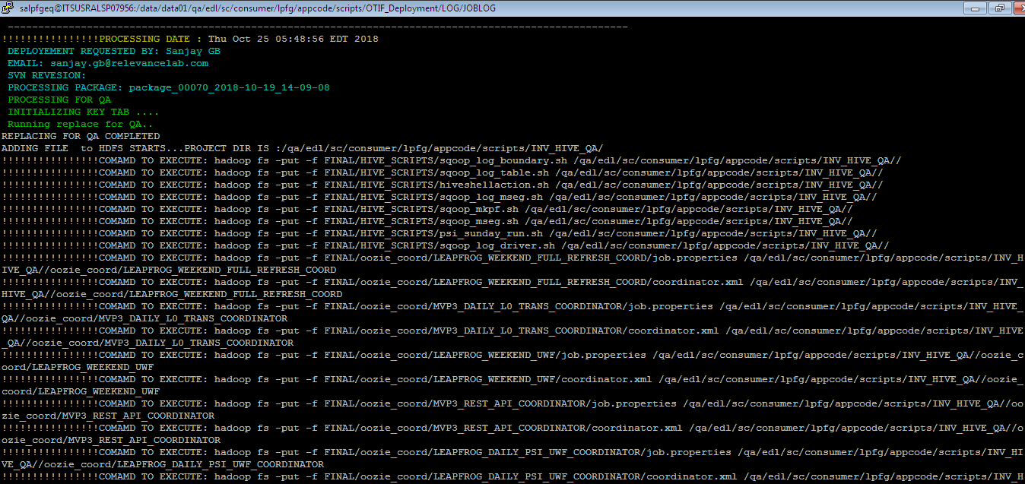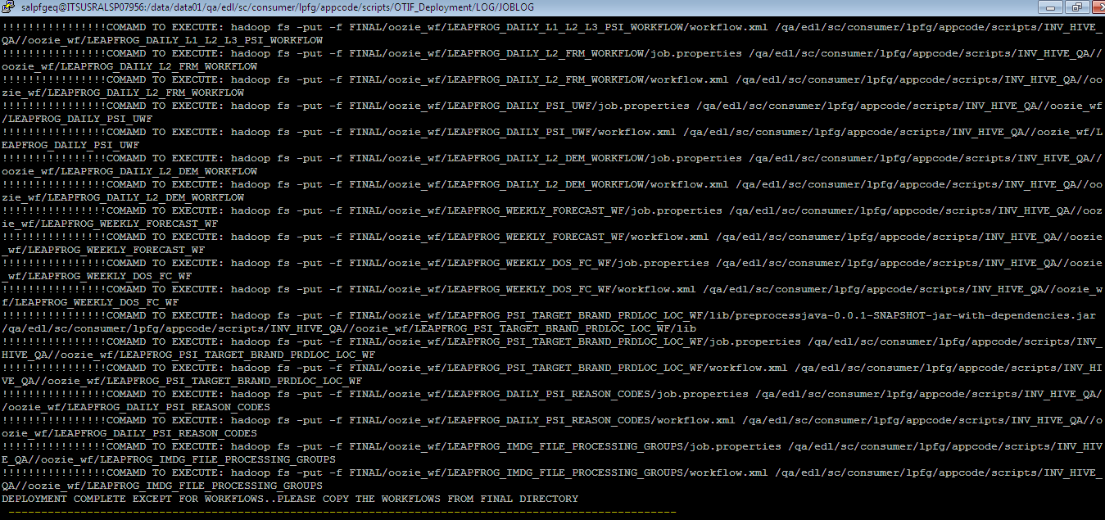

**package_00071_2018-10-29_18-09-25**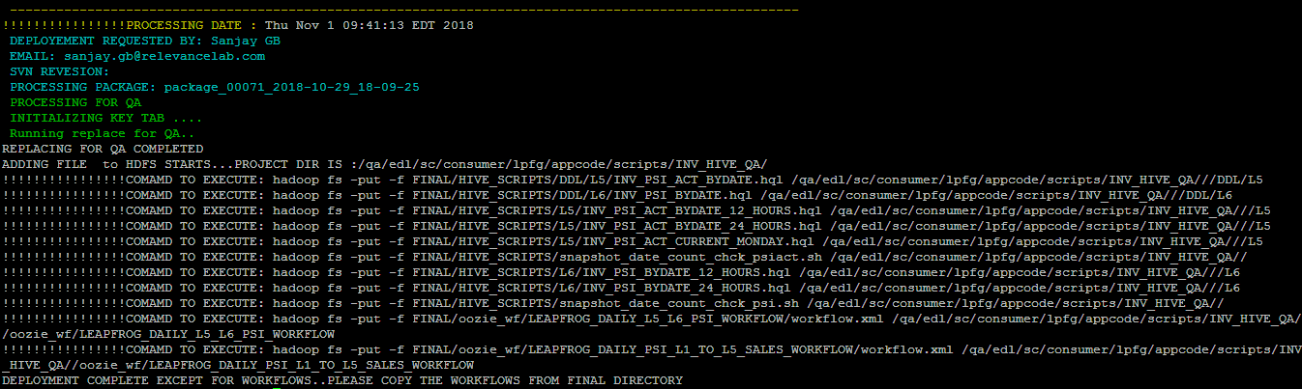

Full log path-

/data/data01/qa/edl/sc/consumer/lpfg/appcode/scripts/Leapfrog_Deployment/LOG/JOBLOG/execute.log

## Affected objects workflow execution

None

## Umbrella workflow execution

<https://edlhueqa.jnj.com:8888/oozie/list_oozie_workflow/0012007-181108232202130-oozie-oozi-W/>

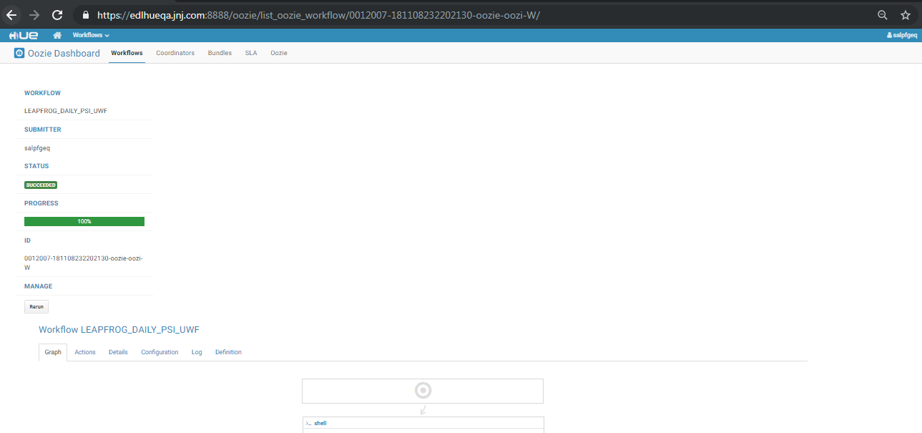

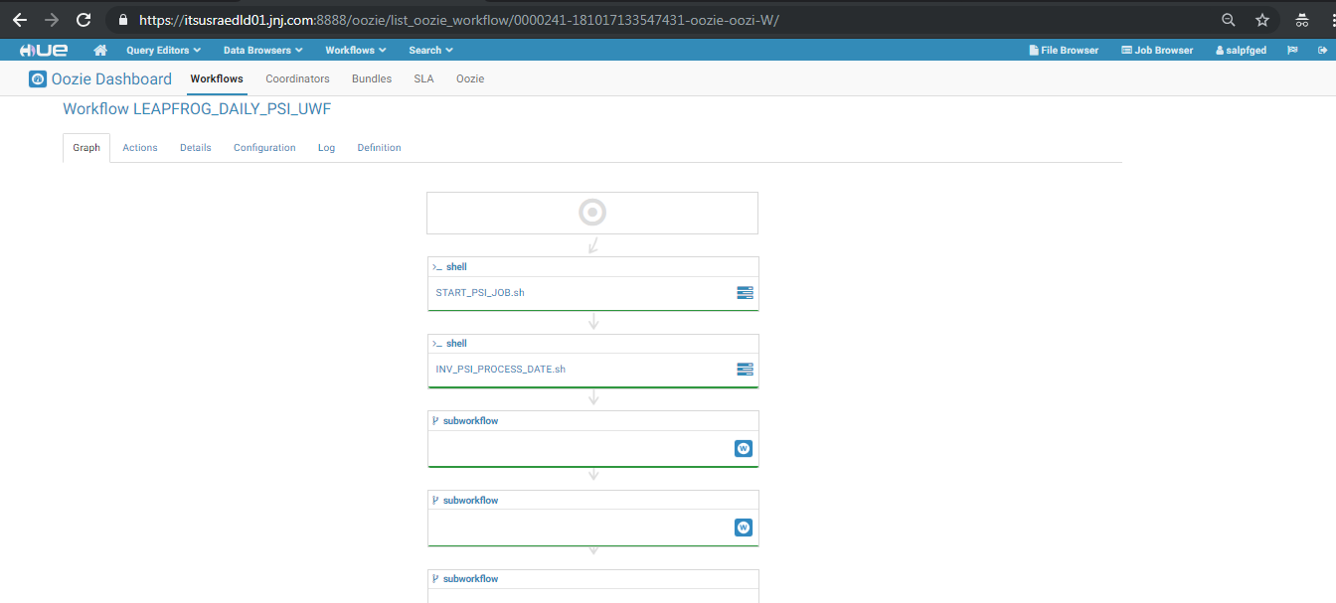

Start Time -Mon, 12 Nov 2018 02:18:01

End Time - Mon, 12 Nov 2018 03:28:52

<https://edlhueqa.jnj.com:8888/oozie/list_oozie_workflow/0003015-181029213245027-oozie-oozi-W/>





Start Time- Tue, 06 Nov 2018 01:21:25

End Time - Tue, 06 Nov 2018 02:27:49

## Evidence from UI or user perspective

None

# Package deployment steps

## Bck up Startegy

Please take the backup of the folder in QA. And once the migration is successful, please delete the backup folder.

Commands

For taking backup

hadoop fs -cp /prod/edl/sc/consumer/lpfg/appcode/scripts/INV_HIVE_PROD/ /prod/edl/sc/consumer/lpfg/appcode/scripts/INV_HIVE_PROD_2018_11_12

and once the migratoin is successful delete the folder

hadoop fs -rmr /prod/edl/sc/consumer/lpfg/appcode/scripts/INV_HIVE_PROD_2018_11_12

## Source packages folder

1. **QA**
2. Base packages folder

/data/data01/qa/edl/sc/consumer/lpfg/appcode/scripts/Leapfrog_Deployment/Leapfrog/

## Target packages folder

1. **PROD**
2. Target packages folder

/data/data01/prod/edl/sc/consumer/lpfg/appcode/scripts/Leapfrog_Deployment/Leapfrog/

**Overwrite** **following packages from source to target**

1. **package_00070_2018-10-19_14-09-08**
2. **package_00071_2018-10-29_18-09-25**

## Execute packages

Each package has to be executed by using following steps

* **Execute the steps for package package_00070_2018-10-19_14-09-08 in the below mentioned order-**

1. chmod -R 771 package_00070_2018-10-19_14-09-08
2. chown -R salpfgep package_00070_2018-10-19_14-09-08
3. cd package_00070_2018-10-19_14-09-08
4. chmod 755 deploy.sh
5. sh deploy.sh

* **Execute the steps for package package_00071_2018-10-29_18-09-25 in the below mentioned order-**

1. chmod -R 771 package_00071_2018-10-29_18-09-25
2. chown -R salpfgep package_00071_2018-10-29_18-09-25
3. cd package_00071_2018-10-29_18-09-25
4. chmod 755 deploy.sh
5. sh deploy.sh

## Import workflows

None

## Import coordinators

None

## Other additional instructions

None

### Resolution Information [To be filled by ITS]

|  |  |
| --- | --- |
| Implemented Date |  |
| Change Control No. |  |

### Migration Task Screenshots [To be filled by ITS]

|  |
| --- |
|  |

# Frequently Asked Questions:

1. How to submit a Service request to the EDL team?

Please duly fill the above section and attach the migration form to a service request (SR) in IRIS. Please follow the below mentioned “how-to” document to raise a SR in IRIS.

<http://wise.jnj.com/SharedServicesNonERP/BI/ClouderaEDL/Shared%20Documents/How%20to%20documents/How%20to%20Submit%20a%20Service%20Request%20to%20EDL%20Team.pdf>

1. How to contact the EDL team?

Mail to [DL-NCSUS-ITS-DATS-EDL-SUPPORT@ITS.JNJ.com](mailto:DL-NCSUS-ITS-DATS-EDL-SUPPORT@ITS.JNJ.com)