**EDL Migration Form**

1. Summary

* + 1. **High Level Information [To be filled by the Customer]**

|  |  |
| --- | --- |
| Application Name/Appcode | GLOVIS |
| ISM-IRIS Ticket No. (REQ#/CR#/INC#) |  |
| Requested By | Anuradha |
| Requestor J&J WWID | 643015100 |
| Requestor Contact Phone | 9900128508 |
| Requestor Contact Email | [ameldodd@its.jnj.com](mailto:ameldodd@its.jnj.com) |
| Package reviewed by | Hiresh Roy |
| Jira reference |  |
| Short Description | Cluster Migration Changes |
| Source Environment (Dev/QA/Prod) | QA |
| Source Objects (Folder/Scripts/Database/Table/View  /UDF/HBase/SOLR etc.) | Workflows and coordinators |
| Target Environment (Dev/QA/Prod) ) | PROD |
| Target Objects  (Folder/Scripts/Database/Table/View  /UDF/HBase/SOLR etc.) | Workflows and shell script |
| Migration Date | 11-14-2018 |
| Purpose | Shell Scripts, Workflows and coordinators |

1. Functionalities deployed as part of the package

|  |  |  |
| --- | --- | --- |
| JIRA# | Description | Type (Defect or Story) |
|  | Cluster Migration | Task |

1. Prerequisites & Assumptions
2. Ensure Kerberos authentication is done before executing the scripts
3. Ensure permission are set to a+x for all sh scripts before executing
4. Login using service account
5. Evidence of successful execution in lower environment

* **Package execution evidence from lower environment**

Refer to Log /data/data01/qa/edl/sc/consumer/lpfg/appcode/scripts/Glovis_deployment/LOG/JOBLOG/execute.log

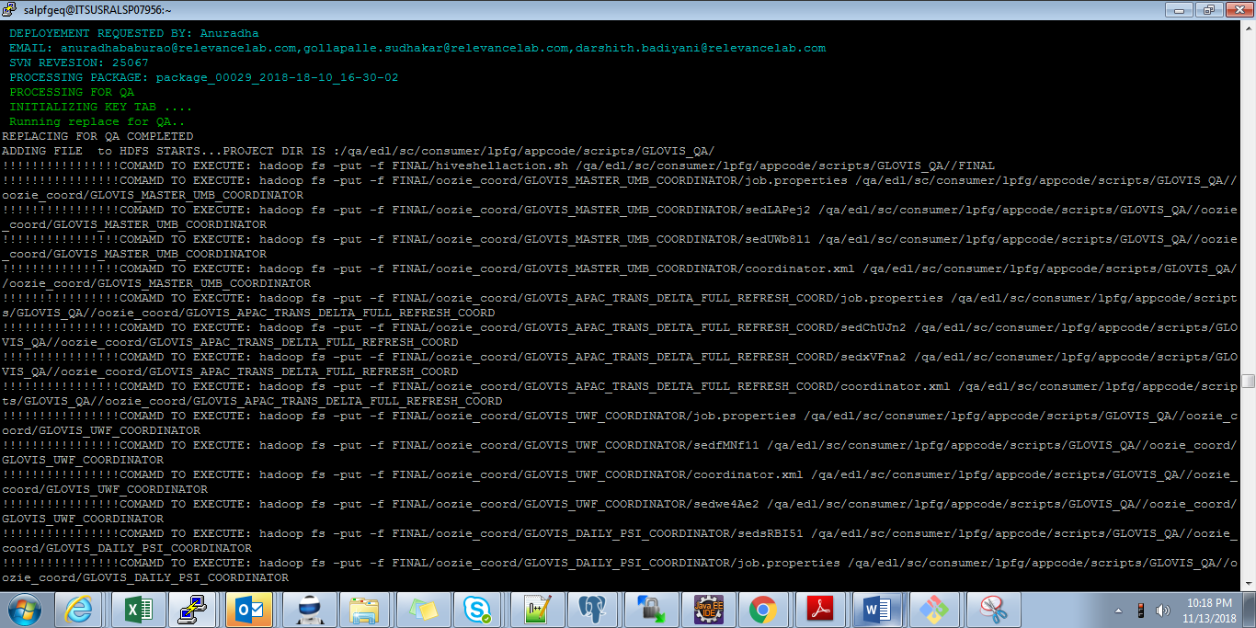

**CO-Ordinator Execution :**

**GLOVIS MASTER UMB COORDINATOR :**

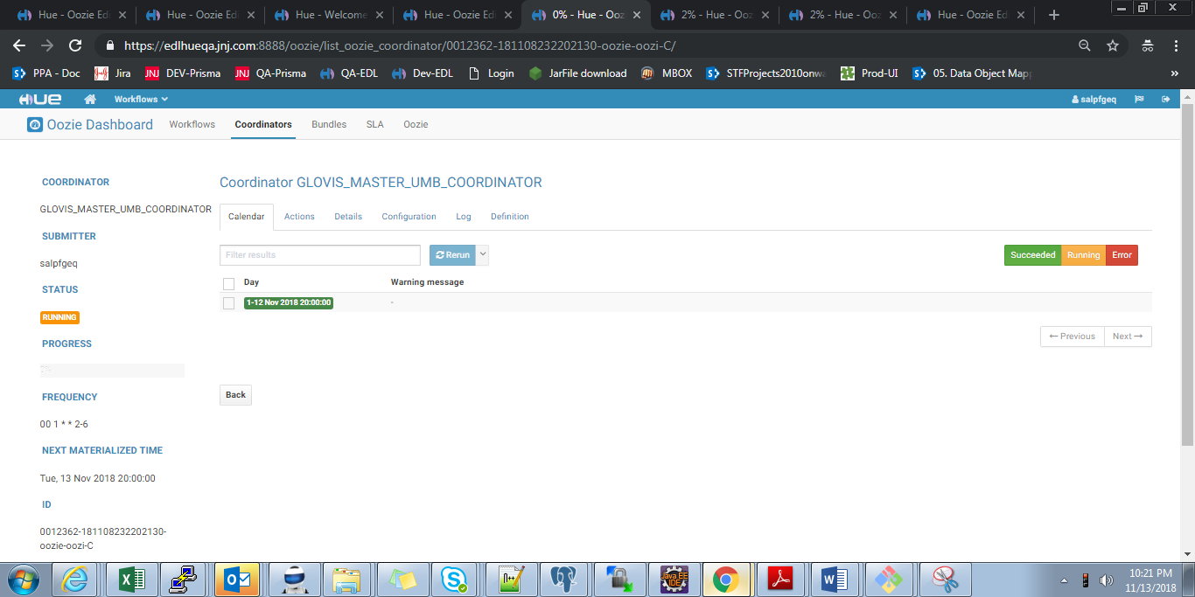

**GLOVIS_UWF_COORDINATOR**

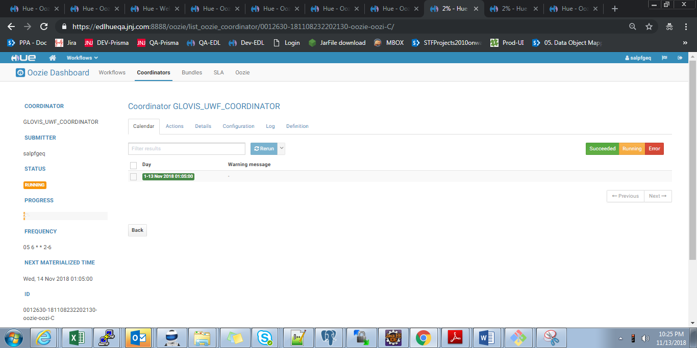

**GLOVIS_REFERENCE_COORDINATOR :**

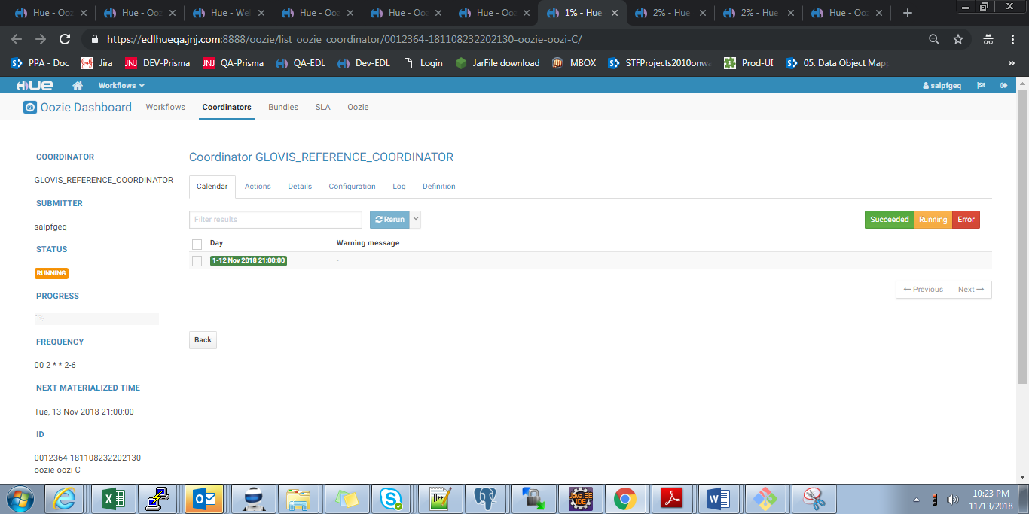

**Evidence From User Perspective :**

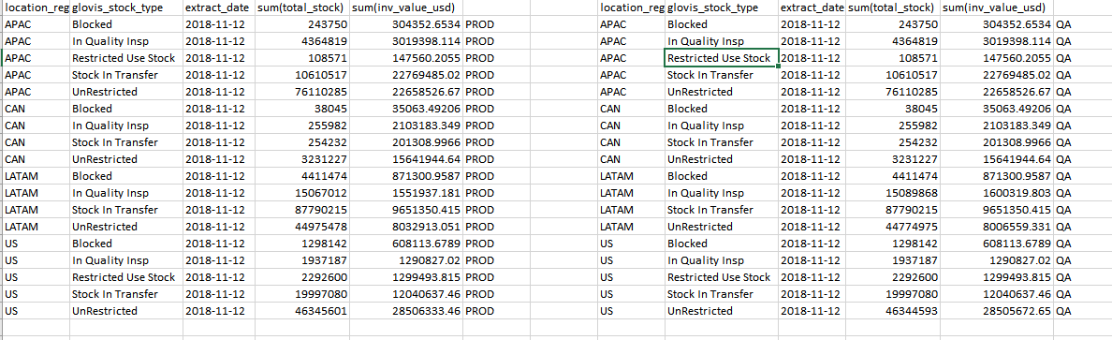

**Rollback Strategy**

• hadoop fs -mkdir -p /prod/edl/sc/consumer/lpfg/appcode/scripts/GLOVIS_PROD/Glovis_BKP/GLV_PKG29_Cluster_change

• hadoop fs -cp /prod/edl/sc/consumer/lpfg/appcode/scripts/GLOVIS_PROD/oozie_wf /prod/edl/sc/consumer/lpfg/appcode/scripts/GLOVIS_PROD/Glovis_BKP/GLV_PKG29_Cluster_change/

• hadoop fs -cp /prod/edl/sc/consumer/lpfg/appcode/scripts/GLOVIS_PROD/oozie_coord /prod/edl/sc/consumer/lpfg/appcode/scripts/GLOVIS_PROD/Glovis_BKP/GLV_PKG29_Cluster_change/

**Package deployment steps**

Copy Package from source to Destination:

**Source Path:** /data/data01/qa/edl/sc/consumer/lpfg/appcode/scripts/Glovis_deployment/Glovis/package_00029_2018-18-10_16-30-02

**Destination Path:** /data/data01/prod/edl/sc/consumer/lpfg/appcode/scripts/Glovis_deployment/Glovis/

1. chmod -R 771 **package_00029_2018-18-10_16-30-02**
2. chown -R salpfgep **package_00029_2018-18-10_16-30-02**
3. cd **/data/data01/prod/edl/sc/consumer/lpfg/appcode/scripts/Glovis_deployment/Glovis/package_00029_2018-18-10_16-30-02**
4. chmod 755 deploy.sh
5. sh deploy.sh

**Run below Commands :**

1. hadoop fs -put -f FINAL/ hiveshellaction.sh /prod/edl/sc/consumer/lpfg/appcode/scripts/INV_HIVE_PROD/hiveshellaction.sh
2. hadoop fs -rmr /prod/edl/sc/consumer/lpfg/str/lpfg_wrk/INV_MATMASTER
3. hadoop fs -rmr /prod/edl/sc/consumer/lpfg/str/lpfg_wrk/inv_details
4. oozie job -oozie https://edloozieprod.jnj.com:11443/oozie -config /data/data01/prod/edl/sc/consumer/lpfg/appcode/scripts/Glovis_deployment/Glovis/package_00029_2018-18-10_16-30-02/FINAL/oozie_coord/GLOVIS_REFERENCE_COORDINATOR/job.properties -submit -Dfrequency="00 4 * * 1" -Dstart_date=`date -u "+%Y-%m-%dT%H:00Z"` -Demail='DL-JJCUS-EMEA-CONS-LF-SUPP@ITS.JNJ.com,sgb@its.jnj.com,mkumar57@ITS.JNJ.com,sanjay.gb@relevancelab.com,sagar.mahanty@relevancelab.com,manu.janardanan@relevancelab.com,nishant.sinha@relevancelab.com,anuradha.meldoddi@relevancelab.com'
5. oozie job -oozie https://edloozieprod.jnj.com:11443/oozie -config /data/data01/prod/edl/sc/consumer/lpfg/appcode/scripts/Glovis_deployment/Glovis/package_00029_2018-18-10_16-30-02/FINAL/oozie_coord/GLOVIS_MASTER_UMB_COORDINATOR/job.properties -submit -Dfrequency="00 3 * * 1" -Dstart_date=`date -u "+%Y-%m-%dT%H:00Z"` -Demail='DL-JJCUS-EMEA-CONS-LF-SUPP@ITS.JNJ.com,sgb@its.jnj.com,mkumar57@ITS.JNJ.com,sanjay.gb@relevancelab.com,sagar.mahanty@relevancelab.com,manu.janardanan@relevancelab.com,nishant.sinha@relevancelab.com,anuradha.meldoddi@relevancelab.com'
6. oozie job -oozie https://edloozieprod.jnj.com:11443/oozie -config /data/data01/prod/edl/sc/consumer/lpfg/appcode/scripts/Glovis_deployment/Glovis/package_00029_2018-18-10_16-30-02/FINAL/oozie_coord/GLOVIS_UWF_COORDINATOR/job.properties -submit -Dfrequency="00 07 * * 2-7" -Dstart_date=`date -u "+%Y-%m-%dT%H:00Z"` -Demail='DL-JJCUS-EMEA-CONS-LF-SUPP@ITS.JNJ.com,sgb@its.jnj.com,mkumar57@ITS.JNJ.com,sanjay.gb@relevancelab.com,sagar.mahanty@relevancelab.com,manu.janardanan@relevancelab.com,nishant.sinha@relevancelab.com,anuradha.meldoddi@relevancelab.com'
7. oozie job -oozie https://edloozieprod.jnj.com:11443/oozie -config /data/data01/prod/edl/sc/consumer/lpfg/appcode/scripts/Glovis_deployment/Glovis/package_00029_2018-18-10_16-30-02/FINAL/oozie_coord/GLOVIS_APAC_TRANS_DELTA_FULL_REFRESH_COORD/job.properties -submit -Dfrequency="30 11 * * 1" -Dstart_date=`date -u "+%Y-%m-%dT%H:00Z"` -Demail='DL-JJCUS-EMEA-CONS-LF-SUPP@ITS.JNJ.com,sgb@its.jnj.com,mkumar57@ITS.JNJ.com,sanjay.gb@relevancelab.com,sagar.mahanty@relevancelab.com,manu.janardanan@relevancelab.com,nishant.sinha@relevancelab.com,anuradha.meldoddi@relevancelab.com'

**Run Below workflows in parallel :**

**Note :** Below steps are optional Please inform us before triggering these commands .It depends upon the deployment time

1. oozie job -oozie https://edloozieprod.jnj.com:11443/oozie -config /data/data01/prod/edl/sc/consumer/lpfg/appcode/scripts/Glovis_deployment/Glovis/package_00029_2018-18-10_16-30-02/FINAL/oozie_wf/GLOVIS_MASTER_UMB_WORKFLOW/job.properties -run
2. oozie job -oozie https://edloozieprod.jnj.com:11443/oozie -config /data/data01/prod/edl/sc/consumer/lpfg/appcode/scripts/Glovis_deployment/Glovis/package_00029_2018-18-10_16-30-02/FINAL/oozie_wf/GLOVIS_REFERENCE_UMB_WF/job.properties -run

After completion of above workflows trigger below workflow :

1. impala-shell --ssl --ca_cert=/opt/cloudera/security/CAcerts/combinedtrust.pem -k -i edlimpalaprod.jnj.com:21000 --query "insert overwrite table lpfg_stg.inv_process values('2014-11-12')"
2. oozie job -oozie https://edloozieprod.jnj.com:11443/oozie -config /data/data01/prod/edl/sc/consumer/lpfg/appcode/scripts/Glovis_deployment/Glovis/package_00029_2018-18-10_16-30-02/FINAL/oozie_wf/GLOVIS_UWF/job.properties -run

**Updated Design_and_Release_Review_Checklist can be found in below mentioned location**

<https://jnj.sharepoint.com/:x:/r/teams/CON-TEAM-SHARED_2/STFProjects2010onwards/2015%20Projects/_layouts/15/Doc.aspx?sourcedoc=%7B707908FA-6A9A-4F99-832E-64410F3A06F9%7D&file=Design_and_Release_Review_Checklist.xlsx&action=default&mobileredirect=true>”

* + 1. **Resolution Information [To be filled by ITS]**

|  |  |
| --- | --- |
| Implemented Date |  |
| Change Control No. |  |

* + 1. **Migration Task Screenshots [To be filled by ITS]**

|  |
| --- |
|  |

1. Frequently Asked Questions:
2. How to submit a Service request to the EDL team?

Please duly fill the above section and attach the migration form to a service request (SR) in IRIS. Please follow the below mentioned “how-to” document to raise a SR in IRIS.

<http://wise.jnj.com/SharedServicesNonERP/BI/ClouderaEDL/Shared%20Documents/How%20to%20documents/How%20to%20Submit%20a%20Service%20Request%20to%20EDL%20Team.pdf>

1. How to contact the EDL team?

Mail to [DL-NCSUS-ITS-DATS-EDL-SUPPORT@ITS.JNJ.com](mailto:DL-NCSUS-ITS-DATS-EDL-SUPPORT@ITS.JNJ.com)