EDL Migration Form

# Summary

### High Level Information [To be filled by the Customer]

|  |  |
| --- | --- |
| Application Name/Appcode | Hurricane |
| ISM-IRIS Ticket No. (REQ#/CR#/INC#) |  |
| Requested By | Badal Panda |
| Requestor J&J WWID | 643022820 |
| Requestor Contact Phone | +91 8884126404 |
| Requestor Contact Email | Bpanda2@its.jnj.com |
| Package reviewed by | Hiresh |
| Jira reference |  |
| Short Description | package_0009_2019-03-13_21-40-12 functional changes, wf and hql changes for Hurricane |
| Source Environment (Dev/QA/PROD) | QA |
| Source Objects (Folder/Scripts/Database/Table/View  /UDF/HBase/SOLR etc.) | Scripts, HDFS Folder |
| Target Environment (Dev/QA/PROD) | PROD |
| Target Objects  (Folder/Scripts/Database/Table/View  /UDF/HBase/SOLR etc.) | Scripts, HDFS Folder |
| Migration Date | 25/03/2019 |
| QA Reference Number |  |
| Purpose | functional changes, wf and hql changes for hurricane |
| Migration Timing | Please migrate the things to PROD after 8 PM IST |

# Functionalities deployed as part of the package

|  |  |  |  |  |  |  |  |  |  |  |  |  |  |  |  |  |  |  |  |  |
| --- | --- | --- | --- | --- | --- | --- | --- | --- | --- | --- | --- | --- | --- | --- | --- | --- | --- | --- | --- | --- |
| |  |  |  | | --- | --- | --- | | JIRA# | Description | Type (Defect or Story) | | AELN-901 | Connected Metric - Demand from last 7 days | **task** | | AELN-908 | SO script in MARS needs to consider LIKP/LIPS quantity to determine delivery complete or not | task | | AELN-902 | Simplify hrc_dos_so | task | | AELN-915 | Exclude Short Term BOs toggle button functionality to be changed | task | |  |  |  | |  |  |

# Prerequisites & Assumptions

1. Ensure Kerberos authentication is done before executing the scripts
2. Ensure permission are set to a+x for all sh scripts before executing
3. Login using service account

# Evidence of successful execution in lower environment

## Package execution evidence from lower environment

Beginning

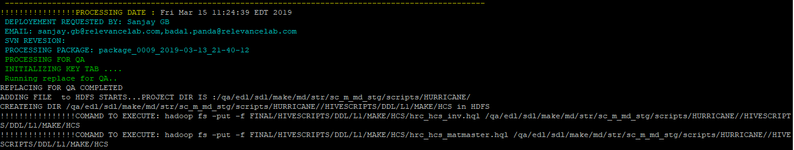

Ending

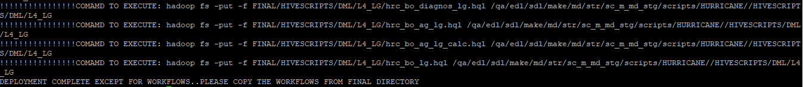

Full log path-

/data/data02/qa/edl/sdl/md/appcode/scripts/Hurricane_Deployment/LOG/JOBLOG

## Affected objects workflow execution

None

## Umbrella workflow execution

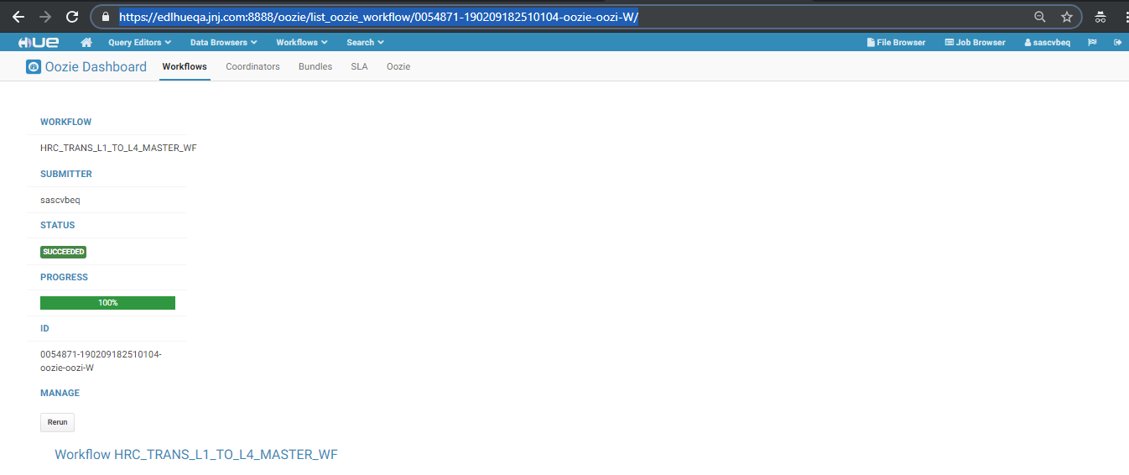

<https://edlhueqa.jnj.com:8888/oozie/list_oozie_workflow/0054871-190209182510104-oozie-oozi-W/>

## Evidence from UI or user perspective

None

# Package deployment steps

## Bck up Startegy

Please take the backup of the folder in PROD. And once the migration is successful, please delete the backup folder.

Command for taking backup

hadoop fs -cp /prod/edl/sdl/make/md/str/sc_m_md_stg/scripts/HURRICANE/HIVESCRIPTS/DML

/prod/edl/sdl/make/md/str/sc_m_md_stg/scripts/HURRICANE/HIVESCRIPTS/DML_2019_03_25

## Source packages folder

1. QA
2. Base packages folder
   1. /data/data02/qa/edl/sdl/md/appcode/scripts/Hurricane_Deployment/HURRICANE

## Target packages folder

1. PROD
2. Target packages folder
   1. /data/data02/prod/edl/sdl/md/appcode/scripts/Hurricane_Deployment/HURRICANE

## Copy packages

Copy following packages from source to target

1. package_0009_2019-03-13_21-40-12

## Execute packages

Execute the packages in the order mentioned above. Each package has to be executed using following steps

1. chmod -R 771 package_0009_2019-03-13_21-40-12
2. chown -R sascvbep package_0009_2019-03-13_21-40-12
3. cd package_0009_2019-03-13_21-40-12
4. chmod 755 deploy.sh
5. sh deploy.sh

## Import workflows

1. None

## Import coordinators

NONE

## Other additional instructions

**Step 1**

Copy the below files from QA to PROD [ delete folder in PROD and copy it from QA]

Source-- /qa/edl/sdl/make/md/str/sc_m_md_stg/master/hrc_plant_type_mapping

Dest-- /prod/edl/sdl/make/md/str/sc_m_md_stg/master/hrc_plant_type_mapping

Source— /qa/edl/sdl/source/md/str/sc_s_md_stg/master/hrc_mars_ZEM01T023

Dest— /prod/edl/sdl/source/md/str/sc_s_md_stg/master/hrc_mars_ZEM01T023

Source— /qa/edl/sdl/deliver/md/str/sc_d_md_stg/master/hrc_mars_ZEM01T027

Dest— /prod/edl/sdl/deliver/md/str/sc_d_md_stg/master/hrc_mars_ZEM01T027

Source— /qa/edl/sdl/deliver/md/str/sc_d_md_stg/master/hrc_mars_ZEM02T029

Dest— /prod/edl/sdl/deliver/md/str/sc_d_md_stg/master/hrc_mars_ZEM02T029

Source - /qa/edl/sdl/make/md/str/sc_m_md_stg/master/hrc_franchise_filter_mapping

Dest - /prod/edl/sdl/make/md/str/sc_m_md_stg/master/hrc_franchise_filter_mapping

Source - /qa/edl/sdl/make/md/str/sc_m_md_stg/master/hrc_inv_sloc_mapping

Dest - /prod/edl/sdl/make/md/str/sc_m_md_stg/master/hrc_inv_sloc_mapping

Source - /qa/edl/sdl/deliver/md/str/sc_d_md_stg/hrc_partner_mapping

Dest - /prod/edl/sdl/deliver/md/str/sc_d_md_stg/hrc_partner_mapping

Source - /qa/edl/sdl/make/md/str/sc_m_md_stg/master/hrc_plan_nodes

Dest - /prod/edl/sdl/make/md/str/sc_m_md_stg/master/hrc_plan_nodes

**Step 2**

Run the DDL commands by following the below steps

sh /data/data02/prod/edl/sdl/md/appcode/scripts/Hurricane_Deployment/HURRICANE/ package_0009_2019-03-13_21-40-12/hql_runner.sh

It will prompt for 3 inputs

1st input-- edlimpalaprod.jnj.com

2nd input— prod

3rd input— (Please make sure there is no spaces in the path)

/data/data02/prod/edl/sdl/md/appcode/scripts/Hurricane_Deployment/HURRICANE/package_0009_2019-03-13_21-40-12/FINAL/HIVESCRIPTS/DDL

Step 3

sh /data/data02/prod/edl/sdl/md/appcode/scripts/Hurricane_Deployment/HURRICANE/ package_0009_2019-03-13_21-40-12/hql_hive_prod_runner.sh

It will prompt for 3 inputs

1st input-- edlhiveprod.jnj.com

2nd input— prod

3rd input— (Please make sure there is no spaces in the path)

/data/data02/prod/edl/sdl/md/appcode/scripts/Hurricane_Deployment/HURRICANE/package_0009_2019-03-13_21-40-12/FINAL/HIVESCRIPTS/DML/L0_REC

### Resolution Information [To be filled by ITS]

|  |  |
| --- | --- |
| Implemented Date |  |
| Change Control No. |  |

### Migration Task Screenshots [To be filled by ITS]

|  |
| --- |
|  |

# Frequently Asked Questions:

1. How to submit a Service request to the EDL team?

Please duly fill the above section and attach the migration form to a service request (SR) in IRIS. Please follow the below mentioned “how-to” document to raise a SR in IRIS.

<http://wise.jnj.com/SharedServicesNonERP/BI/ClouderaEDL/Shared%20Documents/How%20to%20documents/How%20to%20Submit%20a%20Service%20Request%20to%20EDL%20Team.pdf>

1. How to contact the EDL team?

Mail to [DL-NCSUS-ITS-DATS-EDL-SUPPORT@ITS.JNJ.com](mailto:DL-NCSUS-ITS-DATS-EDL-SUPPORT@ITS.JNJ.com)