Exercise Sheet 2

LogP Model – bus topology

Unique messages to all processors
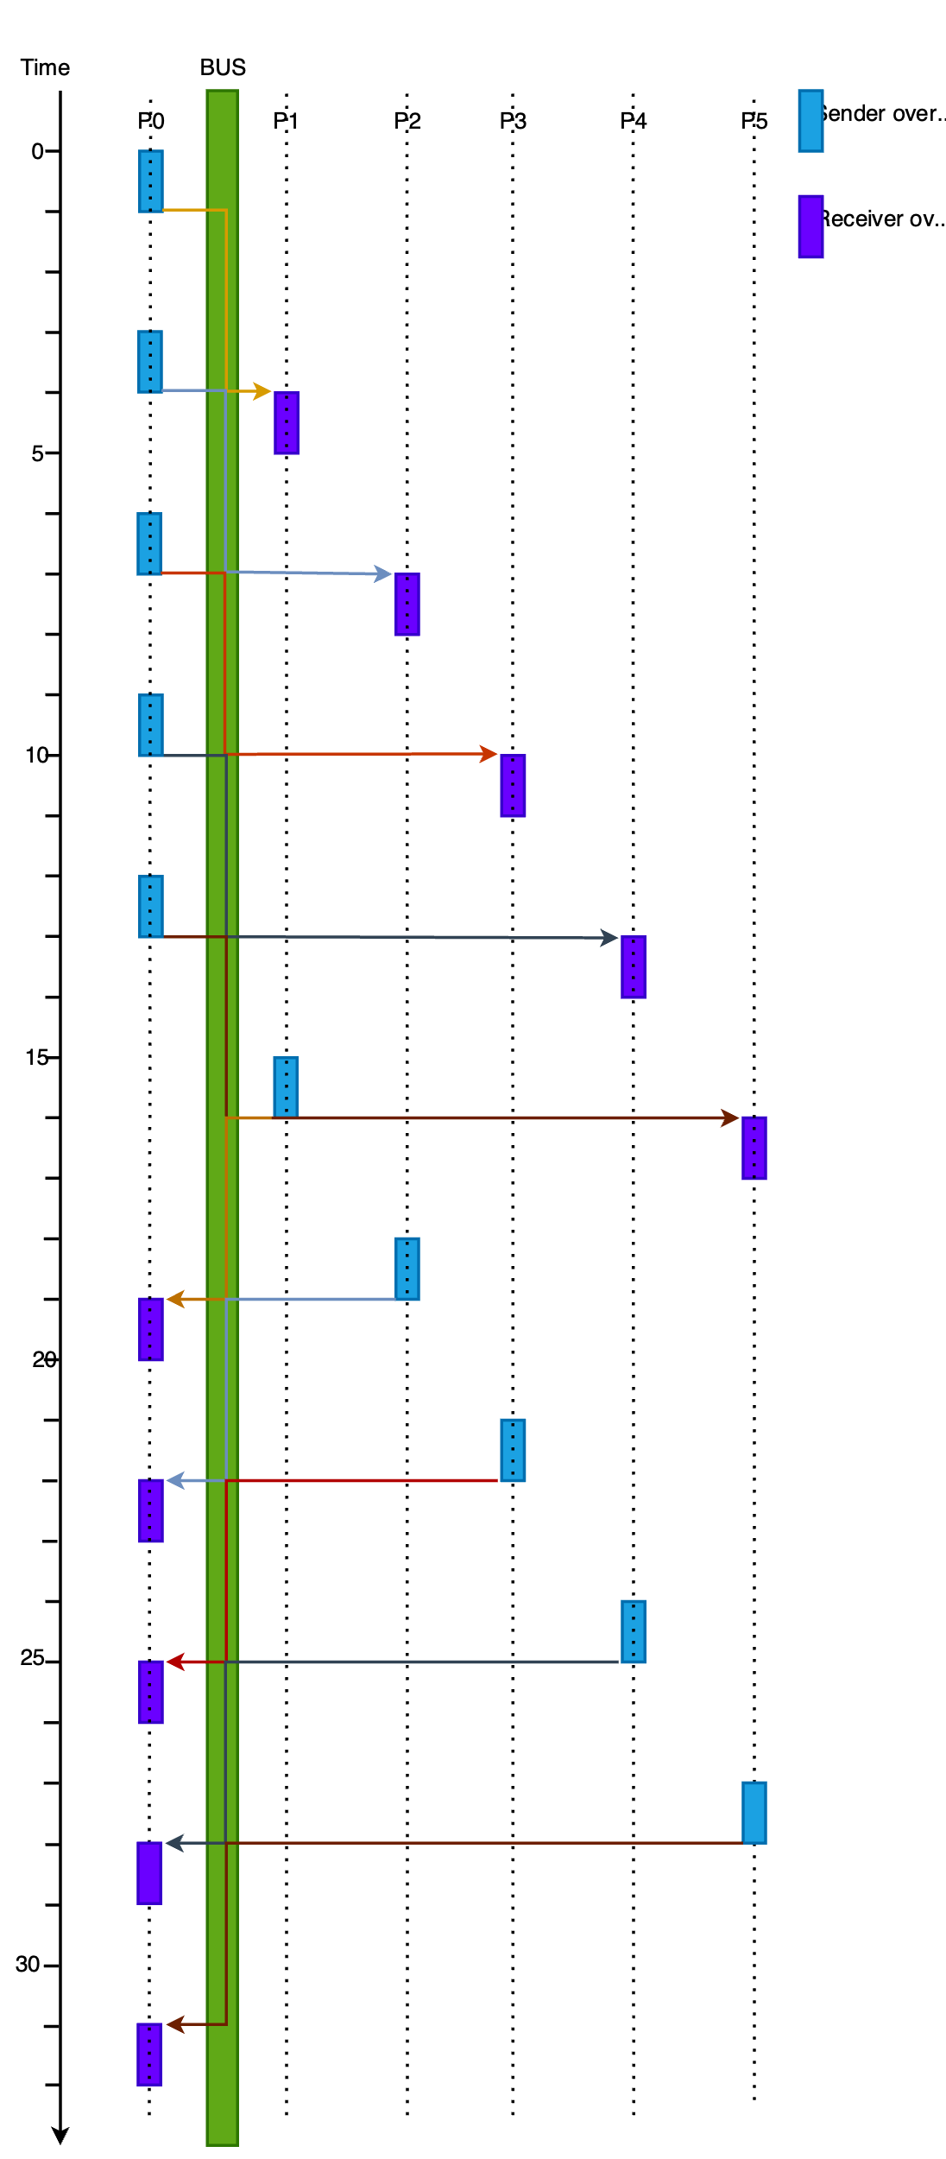
The first message flow illustrates the case where the P1 sends distinct messages to each of the units. The messages enter the bus after the sender overhead and travels in the bus for 3 clock cycles before being delivered to the first processor (P1). While the message is in the bus, no other message can be sent or received by P1 because only one message can occupy the bus at the same time. But during this time, P1 is already preparing to send the next message and as soon as the bus is free (message delivered), the next message enters the bus. The sender overhead of the sender is spent while the message is in the bus, so that the processor can send another message immediately the bus is free. This continues until all processors have received their messages. As soon as the processors receive their messages, they start preparing to send the reply. However, they cannot send yet until the bus is free. Once the bus is free, the first processor send the response to P0. Messages are serially sent both ways (not at the same time). Therefore, the overall runtime for this setup is the sum of the latencies of all the messages plus the sender overhead for the first message sent by P0 and the sender overhead of the last message sent to P0.
The total runtime is 1 + 10 messages * 3 + 1 = 32 clock cycles

A single message broadcasted to all processors
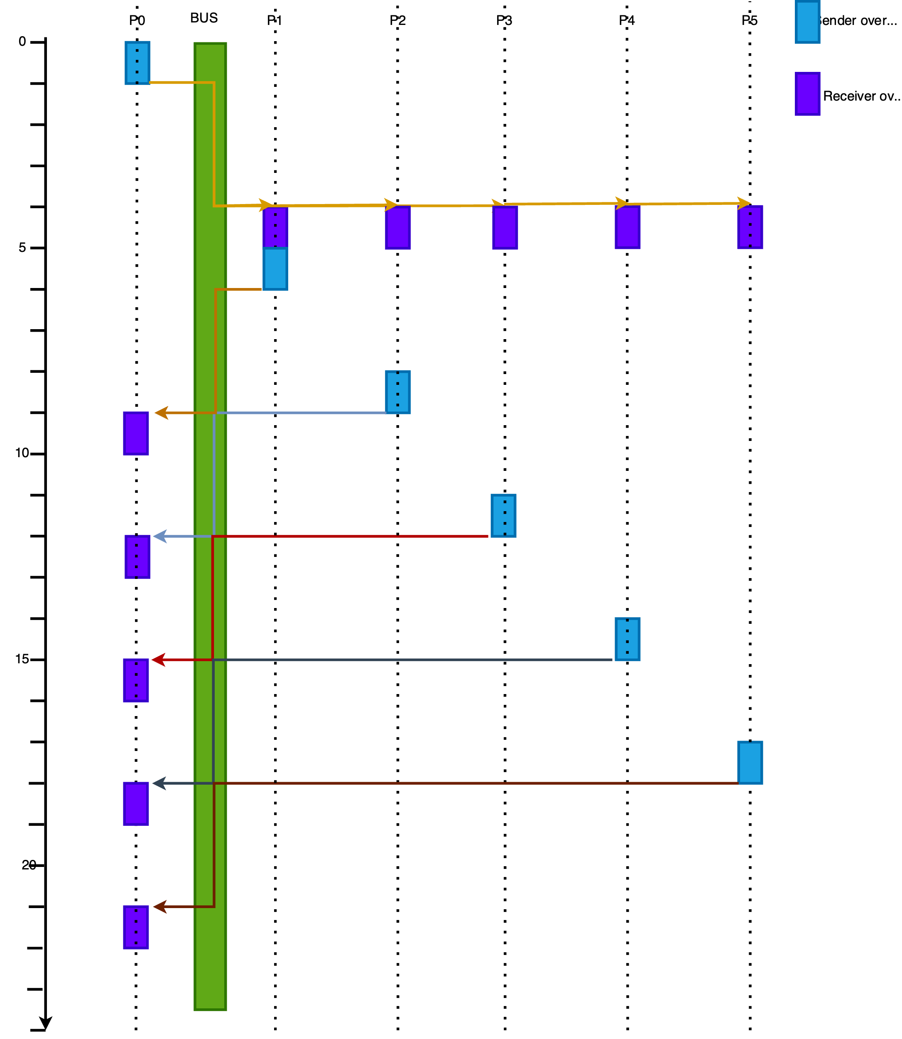
In an alternative scenario, P₀ only sends one message and is broadcasted to all processors. Again, they prepare to send the message as soon as possible. The total runtime for this scenario is the total time for P₀ to send 1 message plus the messages it received. That is O_{s} + L + O_{r} + 5L + O_{s} + O_{r} = 1 + 3 + 1 + 5 * 3 + 1 + 1 = 22 clock cycles
T_{run} = 22 clock cycles

LogP Model - Star Topology

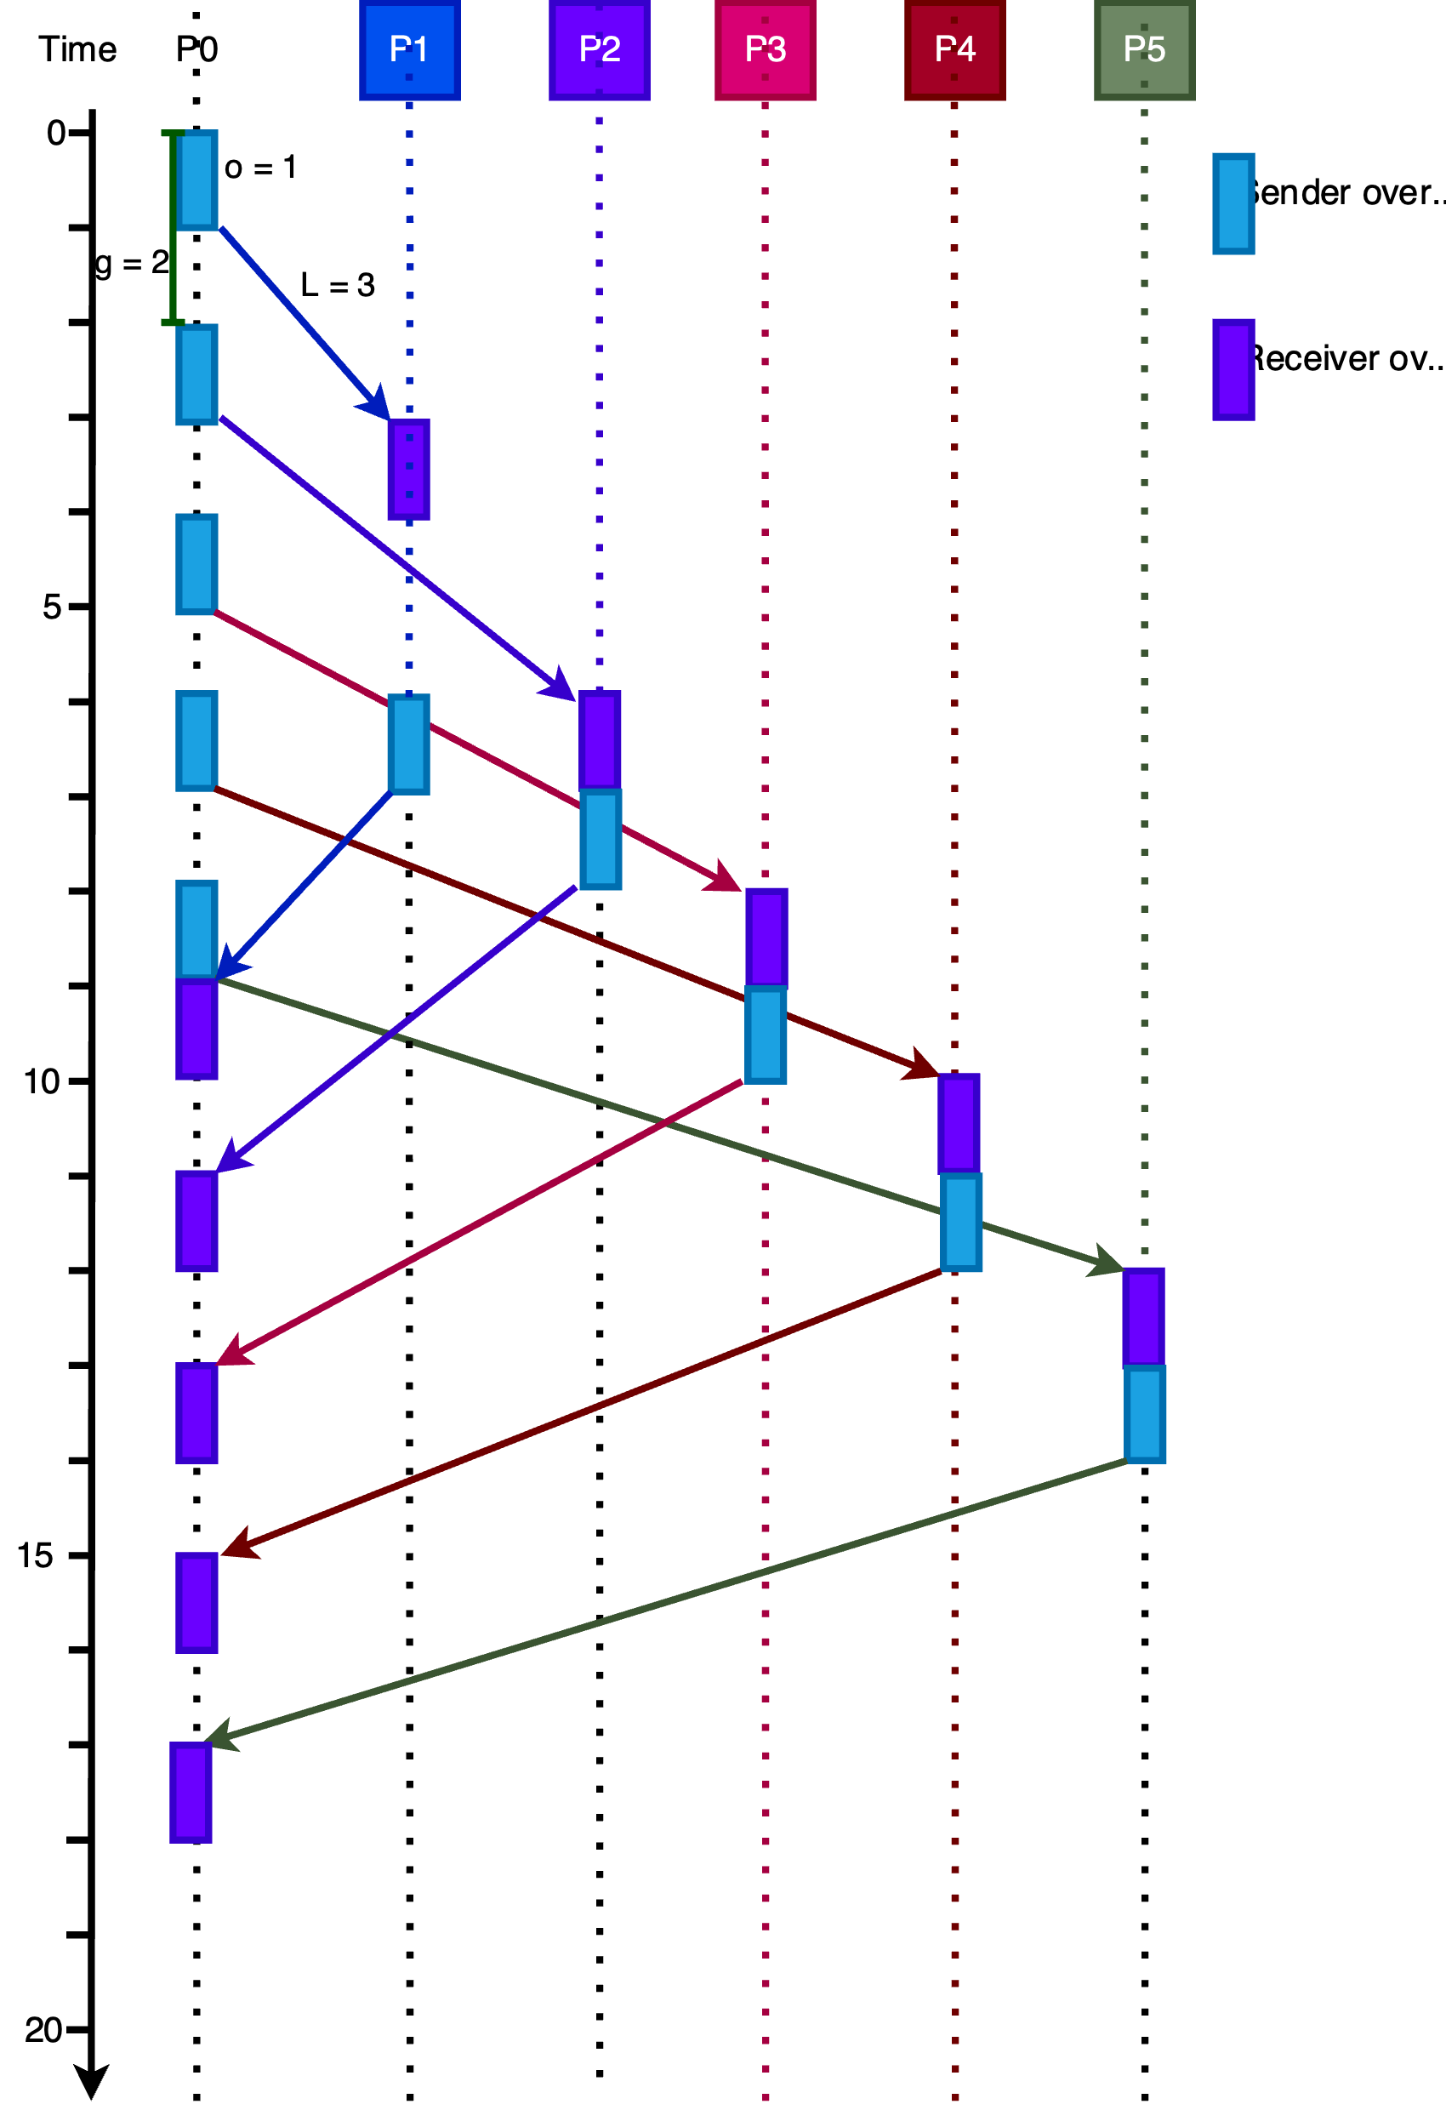

P0 sends messages serially to each processor at intervals g = 2. The messages take time L = 3 to reach each processor. Once processor P1 receives the messages it processes it with time o_{r} = 1 cycle and prepares with time os = 1 cycle to send the response to P0. However, since the messages will arrive at t=8, P0 cannot receive it because it in the sender overhead preparing to send the message to P5. Therefore, P1’s message must be postponed. The other processors immediately start the sender overhead after the receiver overhead since the messages will arrive P0 when it is not currently receiving or sending any messages.
Therefore T_{run} = time for P0 to send messages to all 5 processors ((n-1) * g) + Time for the last message to arrive P5 + Time for P0 to receive the last message (from p5)
T_{run}​=(n−1) * g+2 * (o_{s} ​+ L + o_{r}​)
T_{run} = (5 * 2) + 2 * (1 + 3 + 1) = 18 cycles.

BSP
The figure shows the sequence graph for BSP. The lines marked in red are local data transfer within a processor which do not contribute to the communication cost of that processor.

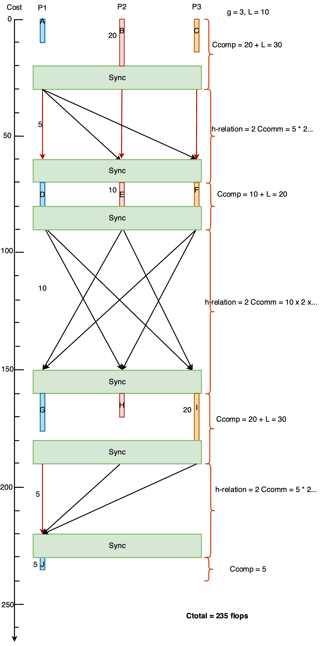

Multi-BSP

Hierarchy tree of Processor
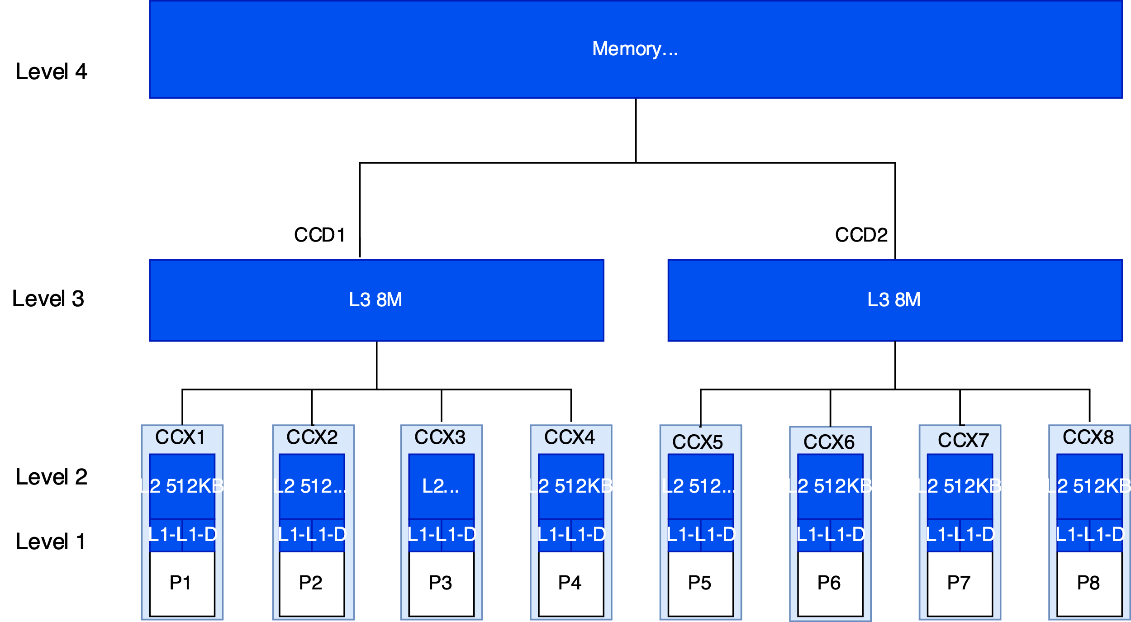

Processing Flow when All tasks are executed on 1 CCD
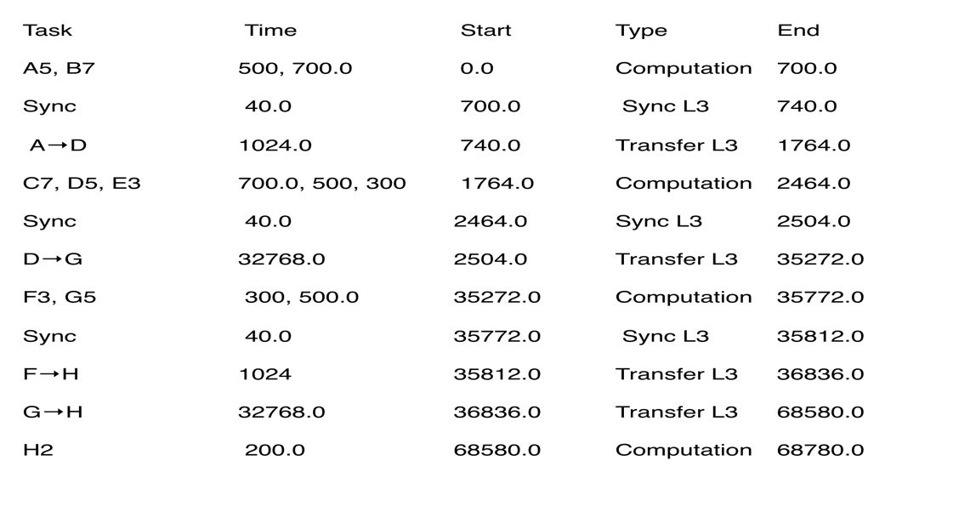
The large range for the time forces the time axis to be broken for better visualization
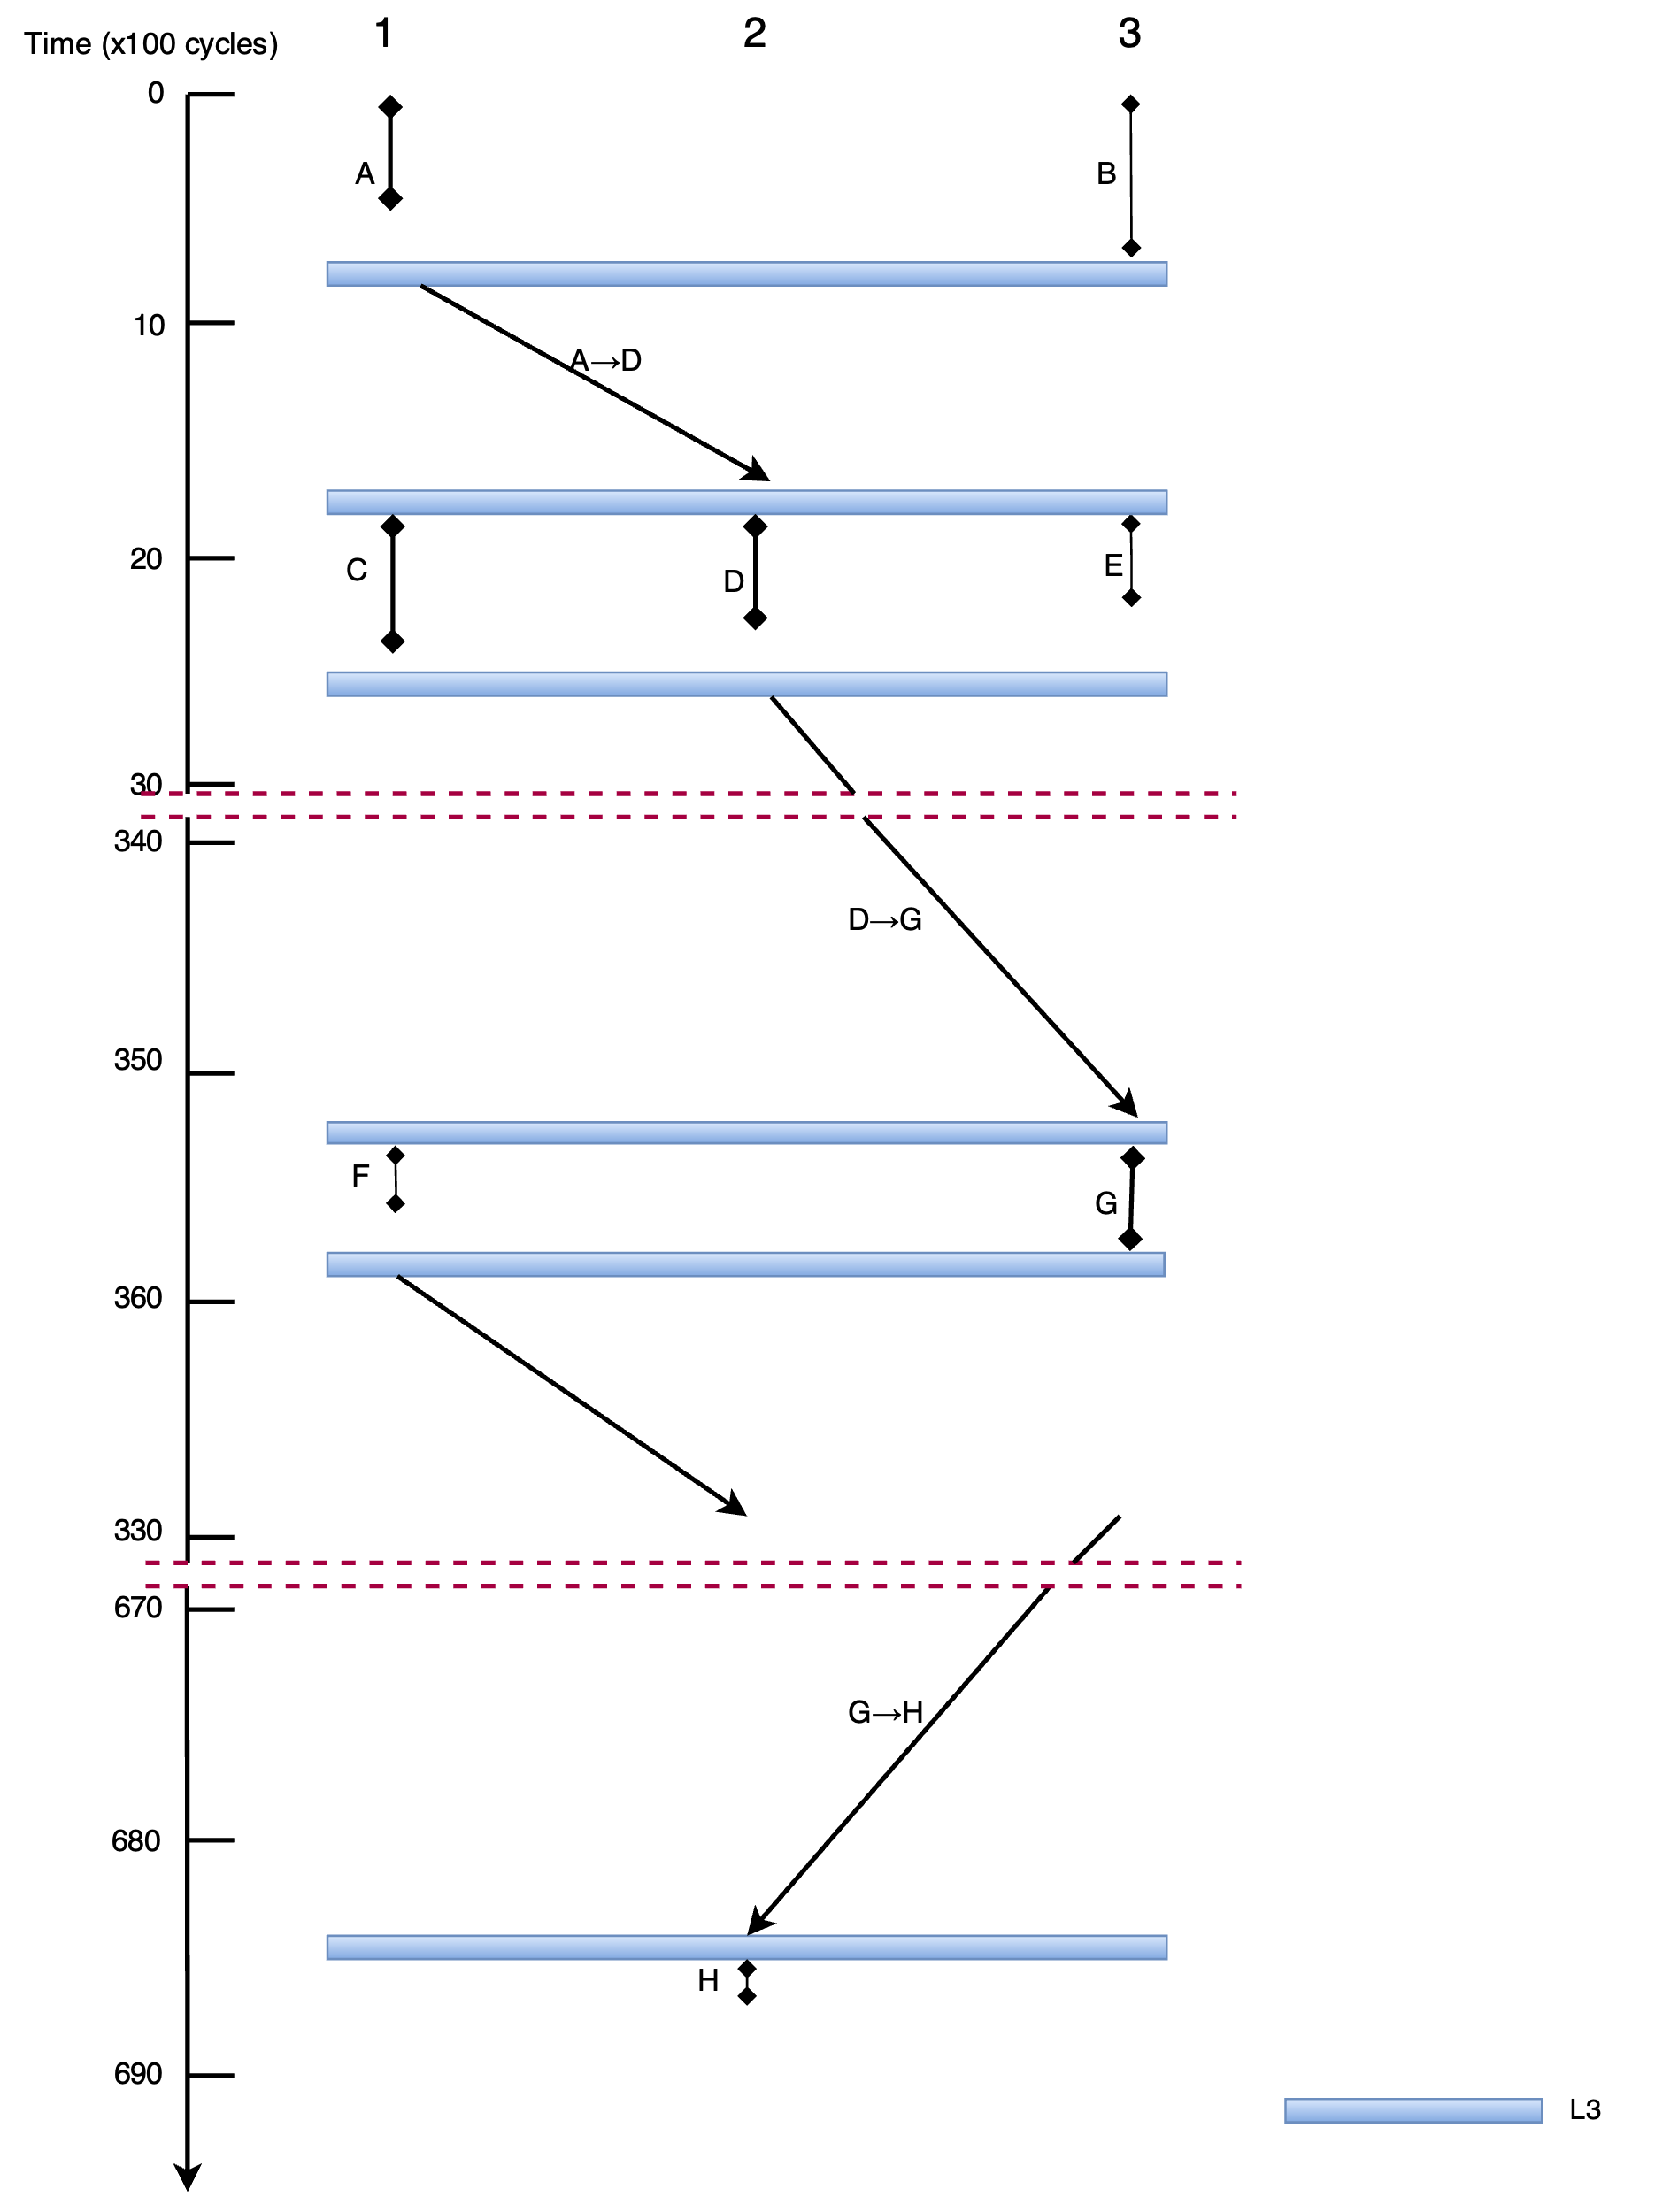

When tasks are executed on both CCDs
