Sentiment Analysis on Twitter: Effects in a Social Network

Mohamed Ben Hamdoune and Yannis Tannier

Our purpose is to build a powerful platform for real-time data analysis of tweets on twitter trends. We also want to analyse all the tweets of 2017 based on a downloaded sample of data (average of 6To). All this data analysis will be accessible via a web interface that will be developed. We want to build a powerful system of sentiments analysis by making a database structure of tweets which is relevant about impacts and effects. The system should provide a faster way to execute Machine Learning methodologies behind data extracted from Twitter. Analysis news actuality by getting an analysis on actual trends with real stream data by building an efficient web interface to get results easily and build a system without false accounts and keep a control on data continuously.

[Cloud Computing] [Social Media Analytics]

Jason Scott Sadofsky acknowledges a Jason Scott, is an American archivist, historian of technology, and filmmaker. Archive Team is a group dedicated to preserving digital history that was founded by Jason Scott in 2009. Data was collected from the website of The Archive Team.

# Introduction

The main subject is Sentiment Analysis on Twitter, a microblogging platform where people can easily share their thought on anything and their habits too. We have a lot of publications on sentiment analysis but not so much research about impacts and their effect on society. The maximum characters are 140 which can be a good thing for the process of analysis because it will make it faster in a way to perform on small messages but in the other hand we should pay attention on accuracy of results. Even it’s an enormously continuous stream of data, Twitter is a good extra sentiment though an online community. Therefore, how to optimize all this streaming data and build a web interface for users who want to get data. We will use in our project will use many methodologies from Machine Learning like unsupervised methods to make a classification of sentiments, and supervised method to predicate psychological profile. Finally, one big step will be and efficient system about control of massive data incoming, a check on false account and spam messages that will destroy our results for example.

Jeffrey Zeldman “The best way to engage honestly with the marketplace via Twitter is to never use the words “engage,” “honesty,” or “marketplace.”

In this study, we introduce to the readers, a problem of Data Processing and Cloud Computation, which have been rapidly a trend over the last decade.

# Related Work

To begin, ye can refer to this article because [cite palpatine] we can relate that it is a point of start, it gives us a theoretical review on the development of Sentiment Analysis. The interested reader can also refer to previous surveys in the area, like [cite] for … because …. We also base on a previous work of [cite], that helped us on machine learning techniques and the work of [cite] because of their work with Python language. As an active research field that has emerged for a long time now, sentiment analysis is now been greatly implement but it is also with a cost (for example, IBM Watson Tone Analyzer). Sentiment analysis is a discipline that extracts people’s feelings, opinions, thoughts and behaviors from user’s text data using Natural Language Processing (NLP) methods. For methodologies on preprocessing, and feature generation, we based our work on process. Then we can also cite for a reason, they removed numbers from theirs tweet thinking that in general, numbers are of no use when measuring sentiment and are removed from tweets to refine the tweet content but we wanted to keep them thinking the contrary. We had over 800 million tweets in English and all that data to analyze where possible just because of the MapReduce Model in majority but there also a weakness for this model in our case.

# Cloud Computing

Cloud computing was used for the project with Amazon Web Service (AWS) for helping developer making machine learning built systems quickly.

Amazon Elastic MapReduce is a cloud-based Hadoop solution that Amazon has been offering since 2009. It is hosted on Amazon EC2's scalable cloud infrastructure and leverages the Amazon S3 storage service. The main interest of such a service in cloud mode is its elasticity. There is no need to plan in advance the necessary processing and storage capacity, this can be increased on the fly and the pricing is based on the resources actually consumed.

Some of the potential disadvantages to be aware of are the high latency times for I / O on S3, which is inevitably greater than on a Hadoop home installation. Some of the scripts (see repositories) were launched on desktop, the config used at was:

I7 6700K @4.20Ghz

16GO DDR4 @2400Mhz

NVIDIA GTX 1060

128Go SSD / 3TO HDD

Debian 9.4 (Stretch) kernel version: 4.9.0-6-amd64

For the read operations, the SSD was used to load the JSON files by hundreds or thousands, later calculations, the recording will be done on the HDD.

## MapReduce Model and Spark Framework

In 2015, Spark was used in more than one thousand Airbus companies at Toyota, Netflix or EBay. Spark is a distributed computing framework. MapReduce greatly simplified Big Data analysis on large clusters of machines that could fail. But MapReduce has become a victim of its success users are always asking more with applications, such as iterative operations (ML for example) or interactive operations (several requests is not suitable) for these types of operations. The only way for MapReduce (for example, two steps of the same algorithm) is through stable storage, physically writing to HDFS for example. But writing on a large volume of data data on HDFS is already taking a long time since it is necessary to replicate this data to be able to cope with any failures and to reload several times the same data from HDFS in the following jobs will be very slow. An algorithm that repeats the same operation in a loop will therefore quickly have a prohibitive calculation cost in MapReduce. Some Hadoop MapReduce applications thus pass the priority of their execution times on read and write operations.

# Methodology

First, we will talk about scripts using Spark with Scikit-learn and TextBlop. Scikit-learn provides us with efficient tools for data mining and data analysis, it’s usable in various contexts and can be downloaded on their website as an open-source program. TextBlob is a library for processing textual data with natural language processing (NLP) tasks such as sentiment analysis, classification, translation, and more. TextBlop use Google translate for sentences that are not in English, so in free and anonymous usage are limited 1000 words/day which is why we could not have analyzed every tweet on the database. The Spark Python API (PySpark) exposes the Spark programming model to Python. We used it because it simpler and we have a gain of productivity against language such as Scala (In some cases like counting the number of languages or doings some basic statistics we used Scala, source is available in the Github repository of the project) or Java. Python is dynamically type, so RDDs can hold objects of multiple types. To run all those libraries, we used Amazon EMR, an Amazon EMR. For the real-stream part, we created a module for Data Stream with Kinesis and MQTT. We used a StreamListener that will permanently get data from Twitter and with TextBlop we run an analysis on each tweet and sum all of them.

MQTT is a publish-subscribe messaging protocol based on the TCP / IP protocol, it was originally developed by Andy Stanford-Clark (IBM) and Arlan Nipper (EurtoTech), then offered to the Open Source community (For information, MQTT v3.1.1 is now an OASIS standard). We developed the website using React.js, we could design simple views for each state in our application, and React efficiently update and render just the right components when your data changes. Text from tweets are inherently noisy. They contain twitter specific words along with hashtags and username mentions. Cleaning the text before further processing helps to generate better features and semantics.

Machine learning approach relies on statistical algorithms in one hand to solve the Sentiment Analysis as a regular text classification problem that makes use of syntactic and/or linguistic features. Text Classification Problem Definition: We have a set of training records D where each record is Sentiment analysis algorithms and applications: A survey labeled to a class. The classification model was written in Python and we used TextBlop for sentiment analysis. Then for a given instance which mean an input of tweet coming via a StreamListener with Kinesis or in the Archive of unknown class, the model is used to predict in what label it should be. The hard classification problem about tweets is that we can’t really be sure about results only if tweet were confirmed by a human being or every user of Tweeter will have to add information like sentiment and emotion for his tweet before sending it but, how can we be sure it is true?

## Pre-processing

In this paper we introduce two new resources for pre-processing twitter data, as you can see in the repository, an emoticon dictionary is available in Python and we can remove them from any tweets. It is powerful because even it is relevant, we can’t take them for computing them after due to a problem of time. Positive, Negative, and Neutral are the three labels for Sentiment Analysis and Joy, Fear, Anger, Surprise and Sadness are the fifth labels for Emotion Analysis. We pre-process all the tweets as follows:

1) We remove all the emoticons

2) We remove all URLs with a regular expression

3) Replace targets (e.g. “@John”) by also removing them

4) Removing “RT” for most of the tweet, because it doesn’t mean something for the application.

Tweets in a general way contain a lot of opinions but they are expressed in different ways by users. It deals with the preparation that removes the repeated words and punctuations and improves the efficiency the data. Forward other process is doing like converting upper case to lower case. User names and URLs are not important from the perspective of future processing; hence their presence is futile. All usernames and URLs are removed to improve increase the real result.

// Ajouter histogramme des 10 premiers langues de l’archive.

## Feature Generation

Take the example of a two-step algorithm, MapReduce will have to perform two jobs:

At the first job:

1. Read the initial data.
2. Execute step 1 in a first job.
3. Save the intermediate result in a distributed way

In the second job:

1. Read this result
2. Execute step 2
3. Save the result in a distributed way.

Spark shares the RDD with the initial data and, by applying step 1, will provide in step 2 a "virtual" intermediate RDD representing the result of step 1 without necessarily immediately rotating the calculation. When the result of step 2 is requested, Spark will combine the calculations required in steps 1 and 2 into one Spark job that will:

1. Read the initial data
2. Perform steps 1 and 2, the intermediate result remaining in memory.
3. Save the result in a distributed way.

Spark thus avoids expensive distributed writing and replay and then only requires the execution of one job (each job having an incompressible structure cost).

When the algorithm has several steps, the time saving becomes considerable!

Two types of operations (In technical terms, Spark calculates a direct acyclic graph of the operations to be performed, like Apache Storm or Apache Tez) can be performed on RDDs: transformations and actions. Transformations return a new "virtual" RDD: nothing is then evaluated or persisted, while the actions evaluate and return a value. After an action, all the previous transformations are then computed (see the repository in the compute folder).

# Implementation

We have used the following technologies for many reasons. Hadoop assumes that conventional approaches (consisting of developing ever more powerful centralized systems) have technical and financial limitations. The development of distributed systems consisting of machines or nodes, relatively affordable (commodity hardware) and scaling out is an alternative from a technical and financial point of view because a distributed system comprising tens, hundreds or thousands of nodes will regularly be confronted with hardware and/or software failures. Google has developed the Google File System (GFS), ancestor of the Hadoop Disrelated File System (HDFS) and The MapReduce Approach. A Hadoop program usually implements both map tasks and reduce tasks. Hadoop is particularly effective for dealing with problems that have one or more of the following characteristics: Volume of data to store or process very important. Need to perform processing on all data (batch rather than transactional, therefore). Heterogeneous data in terms of origin, structure, and format (JSON for example, Tweets collected via any Tweeter API are send in JSON because of the flexibility of this type of object. Several examples are in the repository for interested readers). Execute the tasks of a Hadoop job in parallel, without a pre-established order. A Hadoop cluster is made up of tens, hundreds, or thousands of nodes. It is the addition of the storage and processing capacities of each of these nodes which makes it possible to offer a storage space and a computing power yet to handle data volumes of several To or Po. To improve the performance of a read / write cluster, Hadoop’s file management system, HDFS, writes and reads files in blocks of 64 MB or 128 MB. Working on such large blocks maximizes data transfer rates by limiting search time on hard drives (seek time). MapReduce is a programming model designed specifically to read, process and write very large volumes of data. A Hadoop program usually implements both map tasks and reduce tasks those programs are usually divided into three parts: The driver, which runs on a client machine, is responsible for configuring the job and submitting it for execution. The map is responsible for reading and processing data stored on disk. The reducer is responsible for consolidating the results from the map and write them on disk. Naturally, the implementation core use Hadoop for these reasons.

# Results

## English tweets monthly analyzed

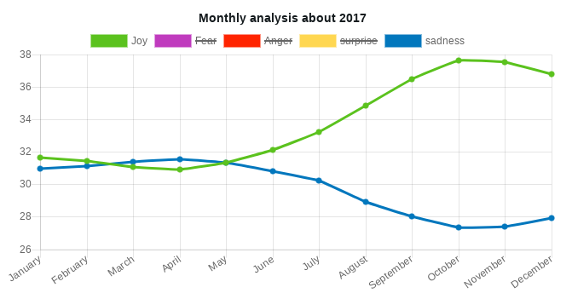

## Psychological profile for any users

## Results predicted by our models with Donald John Trump (born June 14, 1946), the 45th and current President of the United States.

## Impacts of tweets

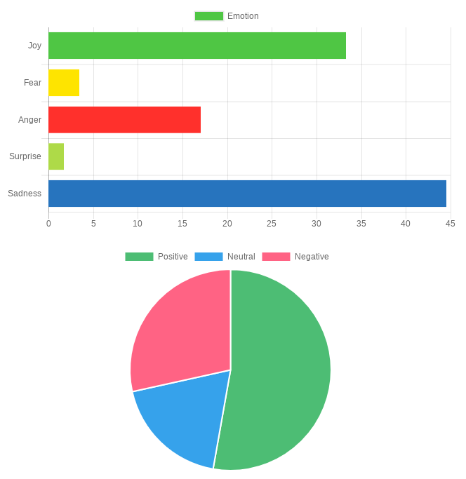

# Discussion

We now turn our attention to the following interesting question: whether the subjective data that exist on the web carry useful information. Information can be thought of as data that reduce our uncertainty about some subject. According to this view, the diversity and pluralism of information on different topics can have a rather negative role. It is well understood, that true knowledge is being described by facts, rather than subjective opinions. However, this diversity in opinions, when analyzed, may deliver new information and contribute to the overall knowledge of a subject matter. This is especially true when the object of our study is the attitude of people. In this case, opinion native data can be useful to uncover the distribution of sentiments across time, or different groups of people. However, data mining differs from machine learning and statistics in that it deals with large volumes of data, stored primarily on disk. Some types of knowledge discovered from a database can be represented by a set of rules. The following is an example of a rule, stated informally: “Donald Trump and his totals of retweets incomes are greater than the average with the most sadly effects on users”. Of course, such riles are not universally true, and have degrees of “support” and “confidence”. Other types of knowledge are represented by equations relating different variables to each other, or by other mechanisms for predicting outcomes when the values of some variables are known. There are a variety of possible types of patterns that may be useful, and different techniques are used to find different types of patterns. Usually there is a manual component to data mining, consisting of preprocessing data to a form acceptable to the algorithms and post-processing of discovered patterns. For this reason, data mining is really a semiautomatic process in real life. The mode widely used applications are those that requires some sort of prediction. In our case, we want to predict emotions and sentiments, then a psychological profile. We outline what is classification, study techniques for building one type of classifiers, called decision-tree classifiers, and then study other predication techniques. Abstractly, the classification problem is this: Given that user in the archive, and given his tweet. We use a given instances of items along with the classes to which they belong, the problem is to predict the class. Since we associate several classes together, then we come to conflicting analyzes. This is an example with a sample of 383 623 424 tweets in English.

[tab:cross_tab]

//Ajout du schema Contradiction analysis

# Conclusion and Future Work

In this report we have presented a sentiment analysis tool on a Web interface, in one hand we used data from an archive end in the other we used real time stream analysis. Due to the absence of labelled data we couldn’t argue on reliability of data.

# References

We are grateful to the following people for resources, discussions and suggestions: Jason Scott (Archivist) and Diana Yuan (Co-Founder & Vice President, Talent & Operations from Indico).