POWERACT
CONSULTING

ADMINISTRATION GUIDE
CortexSkills
Configure, govern and operate the platform
Version 1.10.0 · 2026-10-08
Prepared by POWERACT Consulting

Table of Contents
1. About this guide 3
2. Organizations, users and access 4
3. Configuration 7
4. Process design 9
5. Organization (OBS) and RACSI 11
6. Project templates and blueprints 13
7. Artificial intelligence 14
8. Documented information 16
9. Audits 18
10. Data protection and operations 19
Traceability 20
11. Production deployment 21

1. About this guide
This guide is for the people who configure and run CortexSkills: the platform administrator, who manages every organization, and the organization administrator, who manages one organization. Every procedure is written as a step followed directly by what to type.
Account | Scope | Sign in
Platform administrator | All groups and organizations, licences, reference process design | admin@cortexskills.app · Admin#2026
Organization administrator | One organization: users, configuration, design copy, OBS, AI, documents | admin@maghrebhospitalsgr.ma · CortexSkills#2026
Head of L&D | Runs, templates, documents; approves with the HR Director | headld@maghrebhospitalsgr.ma · CortexSkills#2026
HR Director | Second approver: releases, documents, gates | hrd@maghrebhospitalsgr.ma · CortexSkills#2026

Two-person rule
A process-design release, a document and a gate decision are published by a person other than the one who submitted them. Plan two administrators per organization.

2. Organizations, users and access
The demonstration holds 61 organizations: one large company and one SME for each of the 29 verticals, the multi-sector Horizon Services Group used for the sample documents, and two healthcare showcases (Santé Ora private clinic group and the Centre Hospitalier Régional). Each has a licence, a pack and its add-ons.
Create an organization (production: server console)
- On the server, open a terminal in the server folder.
Type: cd /opt/cortexskills/server
- Create the organization, its licence and its first administrator in one command.
Type: npm run -s admin -- org-create --name "Atlas Cold Chain" --domain atlascoldchain.ma --segment SME --sector LOGI --pack SME-CMP --seats 25 --days 365 --lang fr --admin-email dsi@atlascoldchain.ma --admin-name "Youssef Amrani" --admin-password "Atlas#Cold2026x"
- Note the Organization ID printed by the console. In OnPrem mode, send it to the vendor to receive the signed licence (licence-request, then licence-install). The Installation Guides describe each mode.
Create an organization (platform administrator, through the API)
- Sign in with the API as the platform administrator.
Type: POST /api/auth/login {"email":"admin@cortexskills.app","password":"Admin#2026"}
- Create the organization with the token received.
Type: POST /api/organizations {"name":{"en":"Atlas Cold Chain","fr":"Atlas Cold Chain","ar":"أطلس للتبريد"},"sector":"LOGI","segment":"SME","employees":40,"city":"Agadir","email_domain":"atlascoldchain.ma","pack_id":"SME-CMP","seats":25,"starter_team":true,"default_language":"fr"}
- The organization receives its functions, governance catalog, AI use cases and checklists; the starter team receives one account per role with the password Welcome#2026, to change at first sign-in.
- Open Groups & organizations to see it in the tree.
Add a user and give a role
- Open Administration › Users and click New user.
- Type the identity.
Type: Name — Salma Tazi; E-mail — salma.tazi@maghrebhospitalsgr.ma; Language — French; Title — Training coordinator
- Type a first password, tick the role L&D Planner and click Save. Give the password to the user, who changes it in the profile menu › Change password.
Type: Welcome#2026
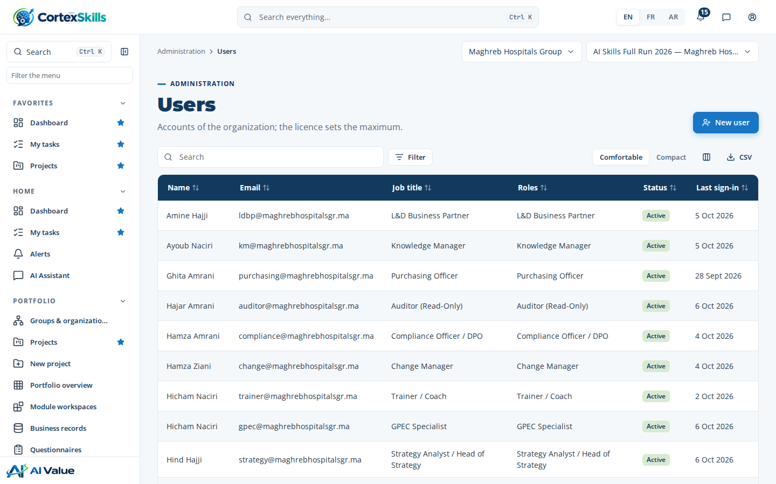
Figure 1 — Users of the organization
Change your own password
- Click the profile icon at the top right, then Change password.
- Type the current password, then the new one twice and click Save.
Type: At least 12 characters with upper and lower case letters, a digit and a symbol — for example Rabat#Skills2026
- The change is written in the audit log (User · password.change). A user who forgot the password receives a temporary one from the organization administrator (Administration › Users).
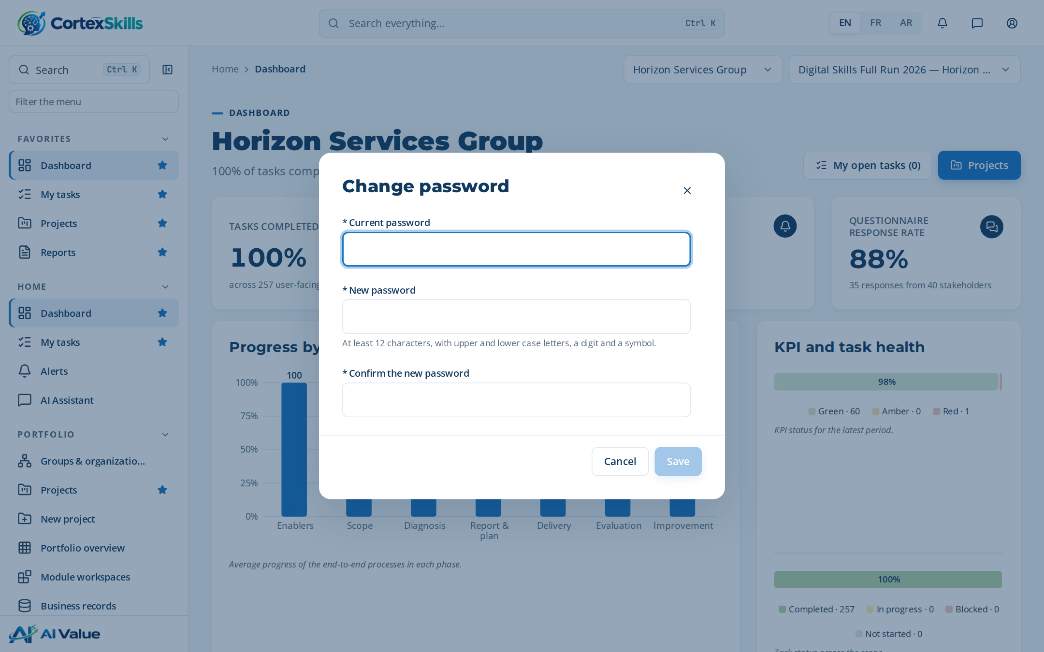
Figure 2 — Change password (profile menu)
Adjust a permission
- Open Administration › Permissions. Rows are permissions, columns are roles.
- Tick documents.approve for the role Quality Manager.
- Type the justification and confirm. The change is in the audit log.
Type: Quality Manager approves procedures from 2026.
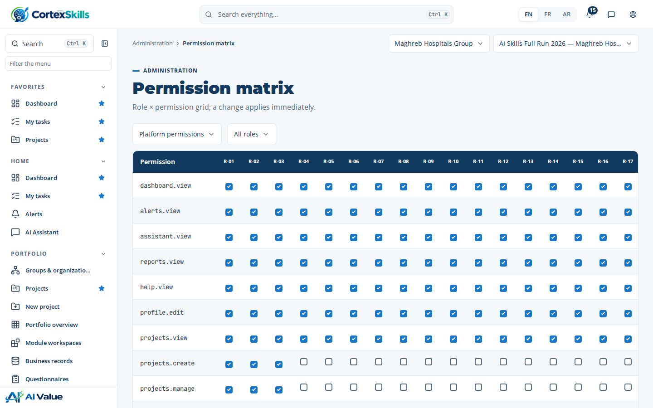
Figure 3 — Permission matrix

3. Configuration
Configuration sets the pack, add-ons, compliance standards, quotas and the justification rule. A field marked as governed asks for a justification when it changes.
Activate a compliance standard
- Open Administration › Configuration, section Compliance standards.
- Tick ISO 21001 and click Save.
Type: Justification — Certification audit planned in March 2027.
- Open Reports › Master list › Required by standards: ISO 21001 now lists its documented information.
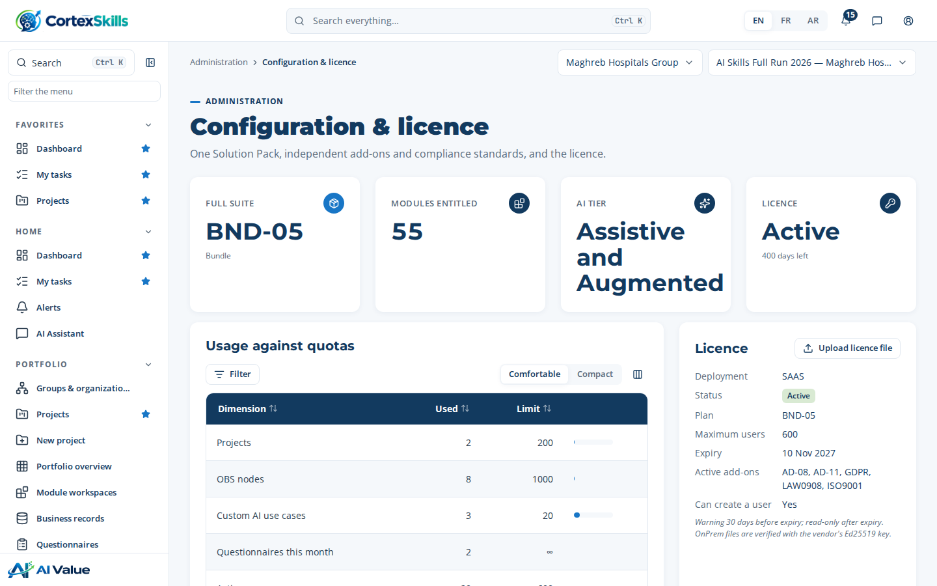
Figure 4 — Configuration of the organization
Change the pack, add an add-on, renew the licence
- Open Administration › Configuration & licence. The tiles show the pack, the modules, the AI tier and the licence state.
- Pack: in Solution Packs, click Switch on the new pack, read the proration and type the justification.
Type: Justification — Purchase order PO-2026-118: move to the Enterprise Suite.
- Add-on: tick its box in Add-ons. Data of a deactivated add-on is kept.
- Licence: click Upload licence file in the Licence card and choose the .lic file received from the vendor. The server checks the vendor signature and the Organization ID before accepting it.
Connect the e-mail and WhatsApp channels
- Open Administration › Channels.
- In E-mail, fill the SMTP account.
Type: Host — smtp.maghrebhospitalsgr.ma; Port — 587; User — formation@maghrebhospitalsgr.ma; Sender — CortexSkills Formation
- In WhatsApp, paste the phone-number ID and the access token of the WhatsApp Business account.
- Click Send a test. Without credentials, messages stay in sandbox and are listed as simulated.
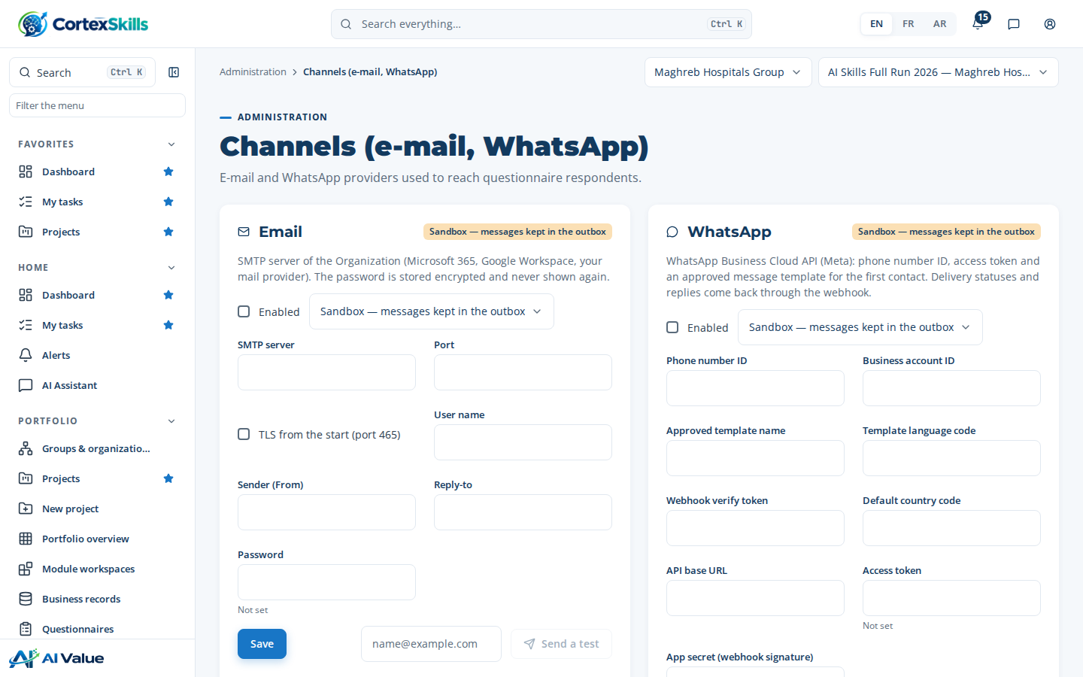
Figure 5 — Channels

4. Process design
The reference design (33 end-to-end processes, 54 macro processes, their tasks and steps) is read-only. Your organization edits its own copy: the first change to an element copies it. Every change creates a version; a release freezes the design for projects.
Rename a step
- Open Process design. In the tree, choose By macro process, open MP-01 and its first task, then click step MP-01.1.
- In Details, change the name in each language.
Type: EN — Record the corporate strategic objectives; FR — Enregistrer les objectifs stratégiques de l’entreprise; AR — تسجيل الأهداف الاستراتيجية للمؤسسة
- Leave the name field. The naming rules are checked: verb first, no generic word, no unexplained abbreviation, no duplicate.
- Type the change note and click Save.
Type: Clearer object for the strategy team.
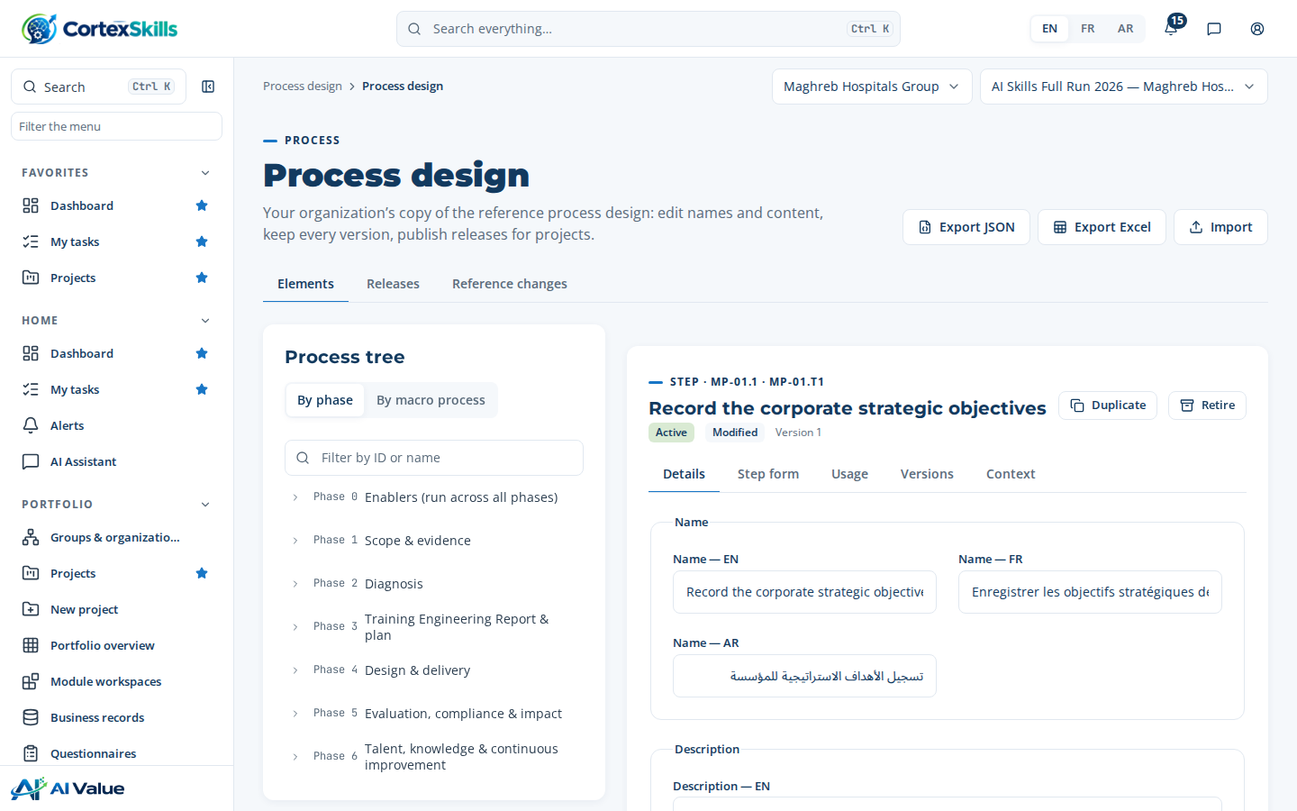
Figure 6 — Process design: tree and element form
Compare and restore a version
- Open the tab Versions of the element. Tick v0 (reference) and the latest version, then click Compare.
- Click Restore on the version to bring back, and type why.
Type: Back to the reference wording after the steering committee.
Publish a release (two people)
- Open the tab Releases and click New release.
Type: Name — 2027 design; Note — After the internal audit.
- Click Submit.
- Sign in as the HR Director, open the same release and click Publish.
Type: Reviewed with the process owners.
- New projects run on the published release. To move a running project, open the project and use Migrate release: the preview lists affected open records.
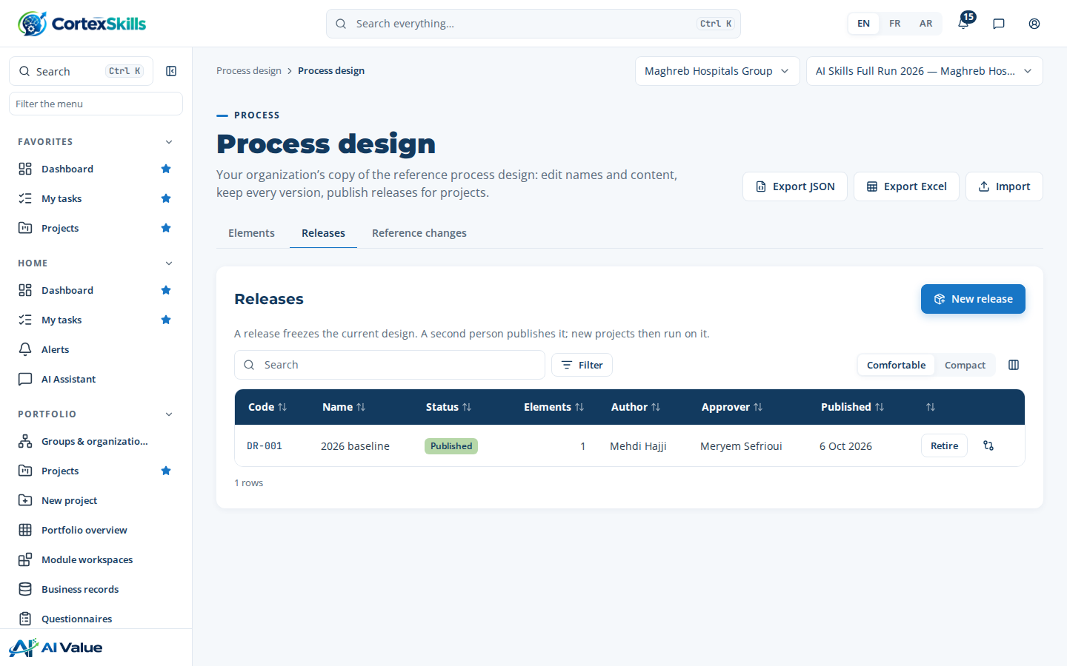
Figure 7 — Releases
Export JSON produces a file that another installation imports with Import; Export Excel gives one sheet per level. The tab Reference changes lists copied elements whose reference changed since the copy.

5. Organization (OBS) and RACSI
Functions group roles; a role has a mission and is held by people with dates and an allocation. Holding an OBS role gives no access right. When an assignment ends, open work assigned through the role moves to the remaining holder.
Create a role and assign it
- Open Governance › Organization (OBS), tab Roles, and click New role.
Type: Code — OR-31; Role EN — Training coordinator; FR — Coordinateur formation; AR — منسق التكوين; Function — Human Resources; Reports to — OR-02
- Click Assign on the new role.
Type: Person — Salma Tazi; Type — Holder; Allocation — 60; Start — 2026-11-01
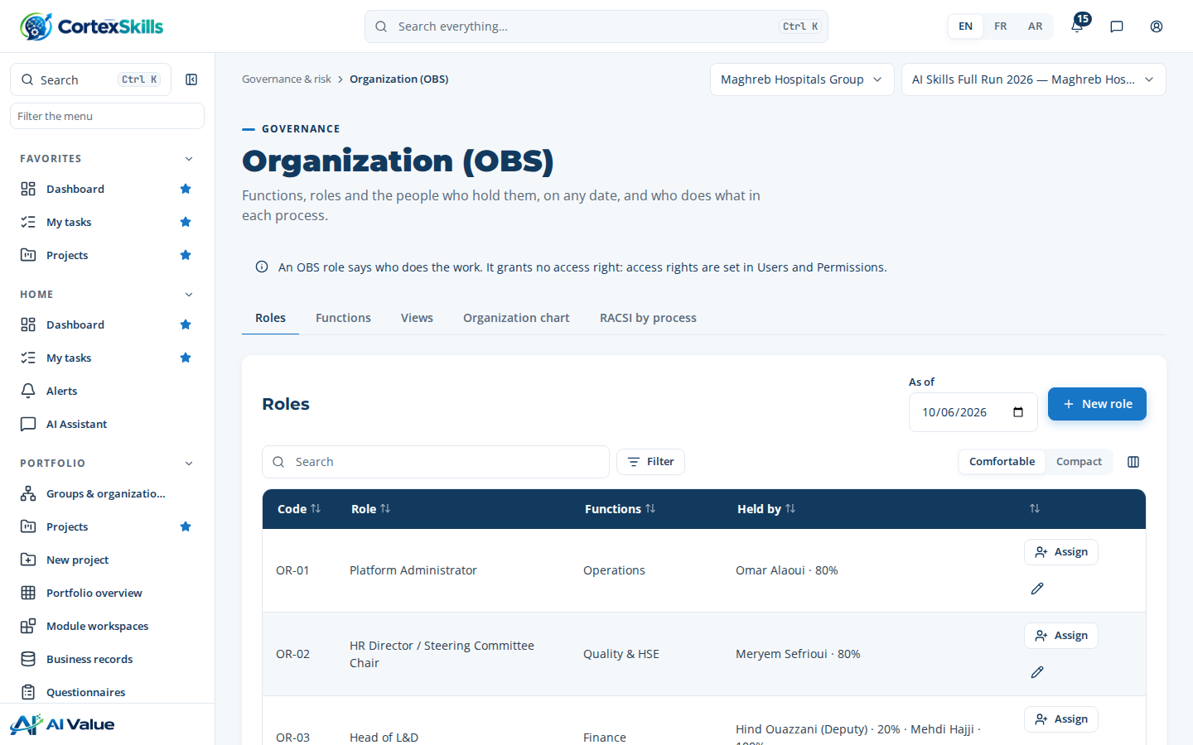
Figure 8 — Roles and holders
Set the RACSI of a macro process
- Open the tab RACSI by process and choose MP-01.
- Click the pencil of a step and pick roles rather than names.
Type: R — L&D Analyst; A — Head of L&D (exactly one); C — HR Director; I — Finance Manager
- Click Save. The matrix shows Complete when every step has one Accountable.
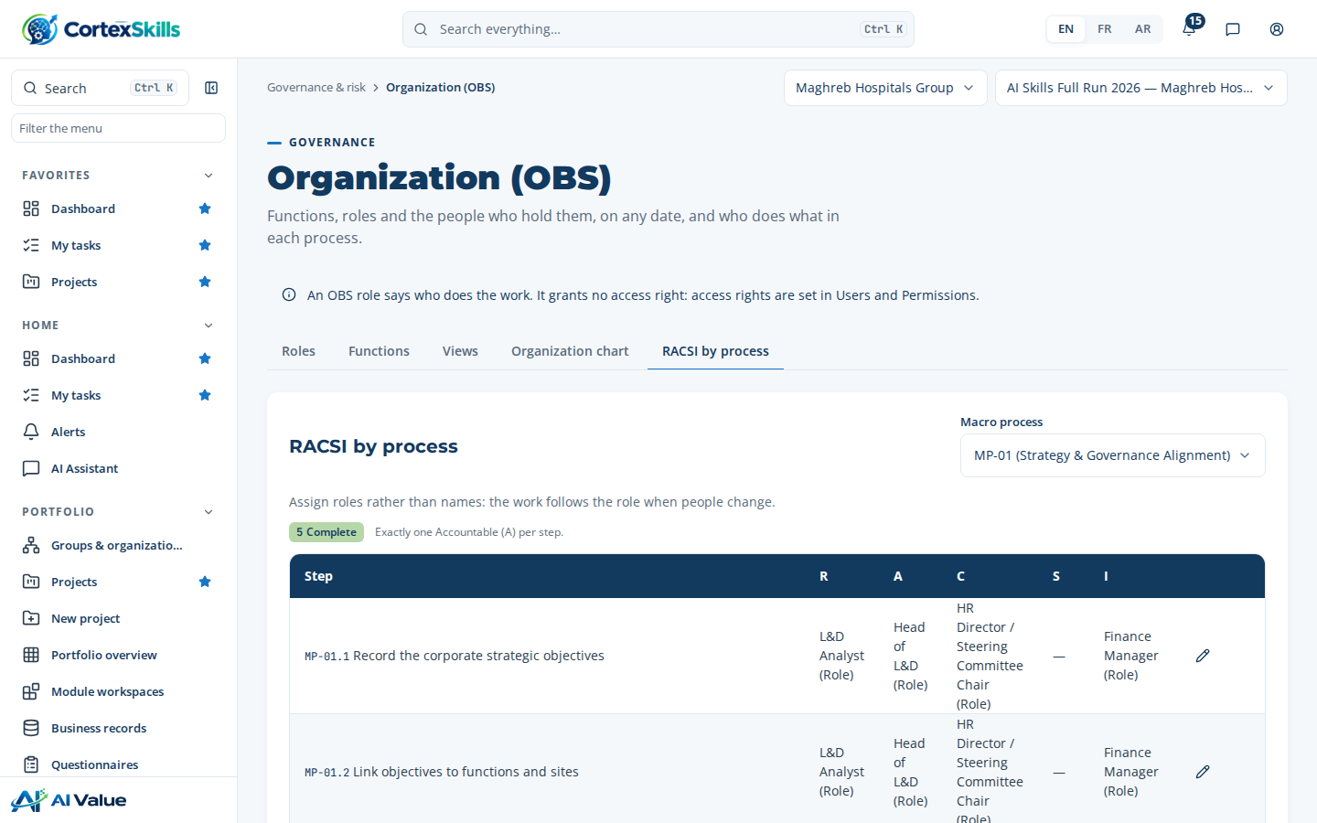
Figure 9 — RACSI by macro process

6. Project templates and blueprints
A template’s blueprint says what a project receives. Library templates are read-only; Customize copies one into the organization. Published organization templates are offered first at project creation; the project keeps the template code and version it was created from.
Customize a template
- Open Process design › Project templates and open Healthcare Providers — full run — AI. Click Customize (copy).
- In Processes and steps, untick a task the organization does not run; click the pencil of a task to rename it in projects.
Type: Name in projects — Validate the plan with the executive committee
- Click + on a task to add a custom step.
Type: Level — Step; Name — Record the board minutes
- In Reporting plan, click Add manually.
Type: Report — Monthly steering pack; Audience — Executive committee; Frequency — Monthly; Format — PDF; Owner — Head of L&D
- Click Publish. A template with no included step cannot be published. Export it in Word, PDF or Excel from the header.
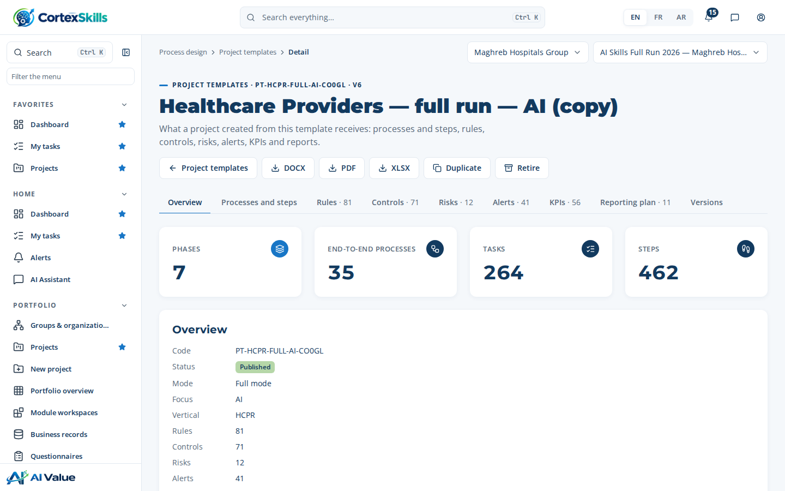
Figure 10 — Blueprint of an organization template

7. Artificial intelligence
Without a model, CortexSkills answers with its built-in engine. With an organization model, each AI use case sends its assembled prompt; nothing proposed by the AI is saved before a person validates it.
Connect the organization model
- Open AI & knowledge › AI settings.
- Choose the provider and the model.
Type: Provider — Anthropic; Model — claude-sonnet-5-5
- Paste the API key. It is stored encrypted and never shown again.
- Set the maximum answer length, tick Use this model for the organization and click Save.
Type: 1500
- Click Test connection. The result names the cause of any failure: key refused, model not found, parameter rejected, rate limit, unreachable.
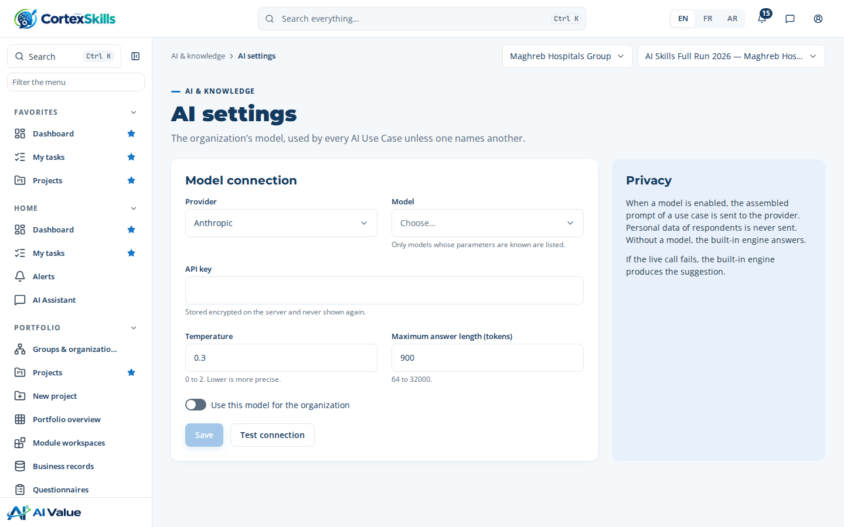
Figure 11 — AI settings
Complete a prompt specification and activate the use case
- Open AI use cases and click Specification on AIUC-01.
- Fill each required field in each language; each field is saved when you leave it.
Type: Constraints — Never assign a level without evidence; cite the evidence for each level.
- Click Assembled prompt to check the variables, then Test on this project. The test writes nothing.
- Back in AI use cases, tick the use case in the column Organization. Activation is refused while a required field is empty.
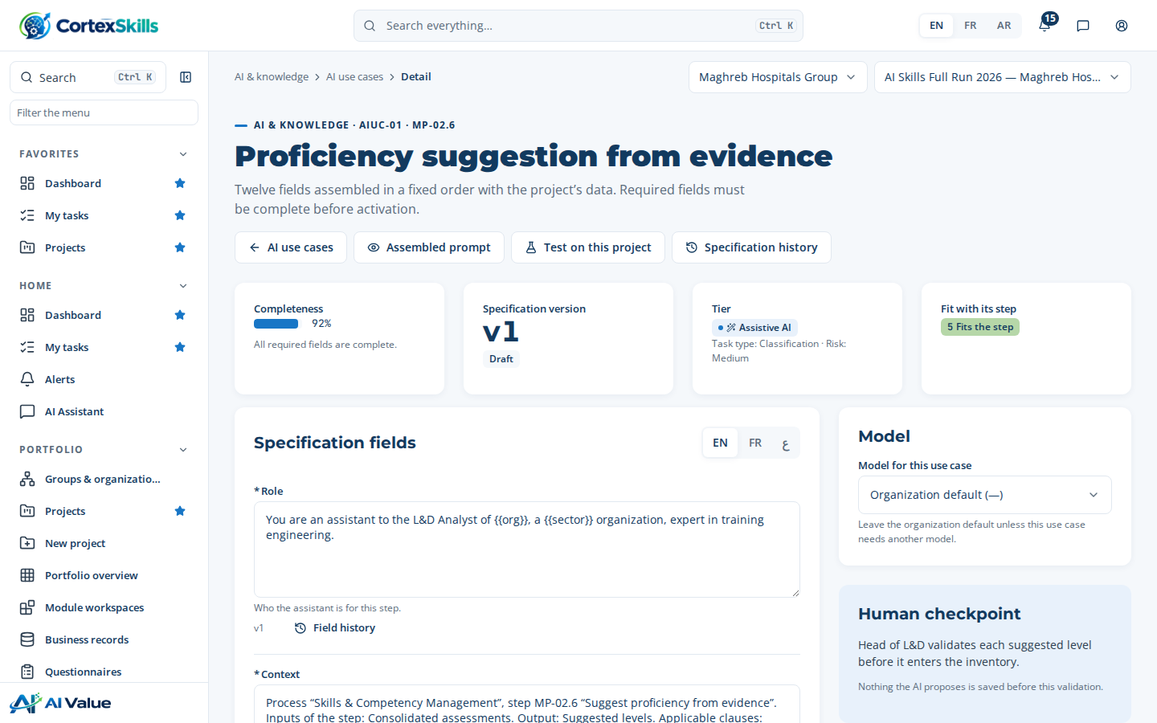
Figure 12 — Prompt specification

8. Documented information
The library holds 37 templates: one per end-to-end deliverable, the Training Engineering Report, the training plan, the audit report and the master list. An organization copy replaces the library template with the same code. The layout applies to every generated document.
Adapt a template
- Open Reports › Document templates and click DT-E2E-01.
- Click Copy to my organization. Drafts that use an older version are listed.
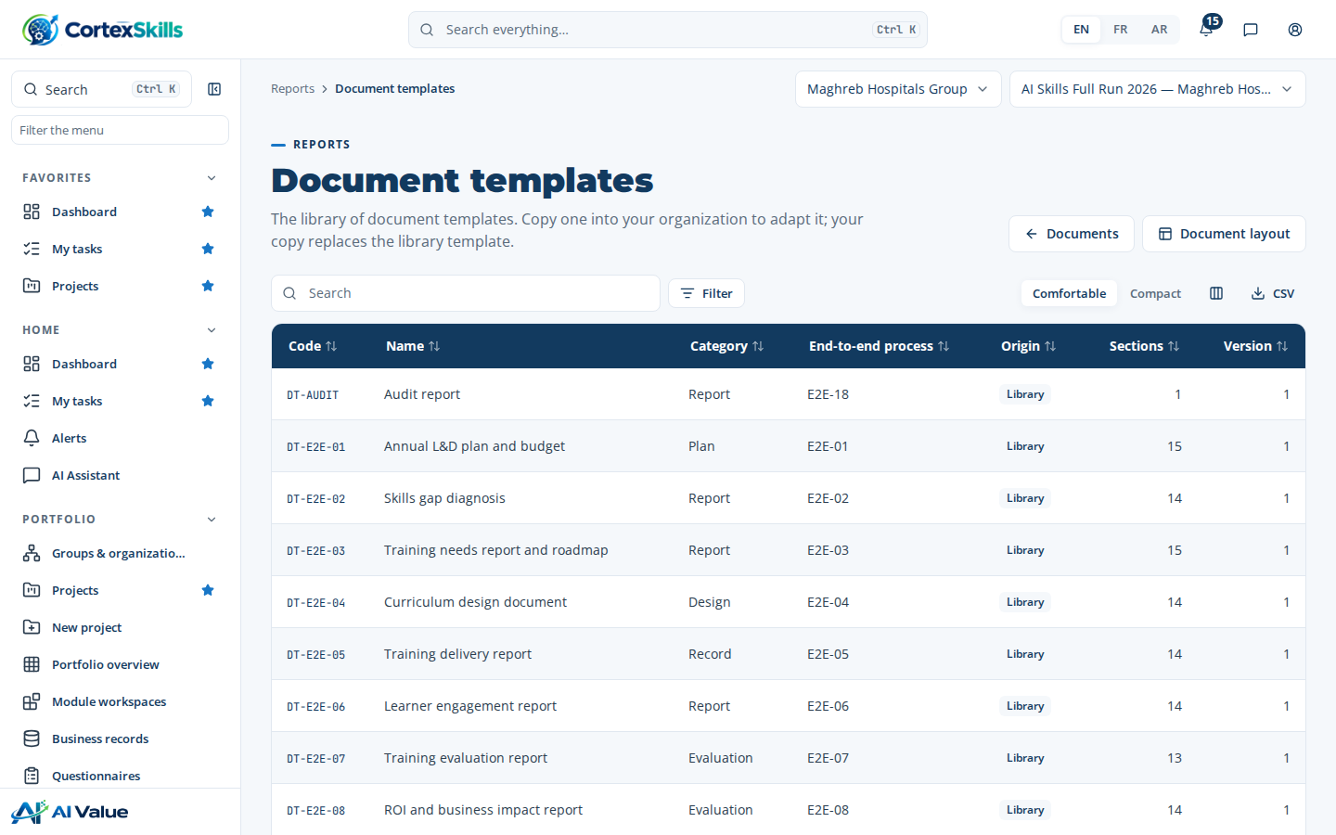
Figure 13 — Document template library
Set the organization layout
- Open Reports › Document layout.
- Choose fonts, sizes, alignment and colors from the allowed lists.
Type: Body font — Open Sans 11 pt; Heading font — Montserrat 16 pt; Alignment — Left; Table header color — 123A5F (Navy); Paper — A4; Margins — 20 mm
- Type the header and footer texts, choose Uploaded image as logo and upload a PNG of 5 MB or less.
Type: Header — Maghreb Hospitals Group · Training; Footer — Internal use
- Click Preview as PDF, then Save. Each save is a version.
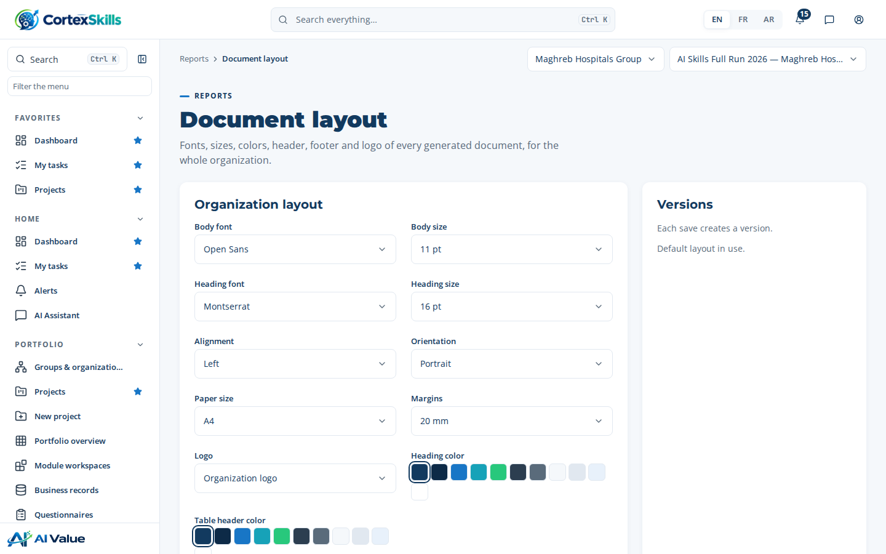
Figure 14 — Document layout
Reports › Master list lists every document of the project with version, status, owner and review dates; the tab Required by standards shows, clause by clause, the template and the document that answer each standard.
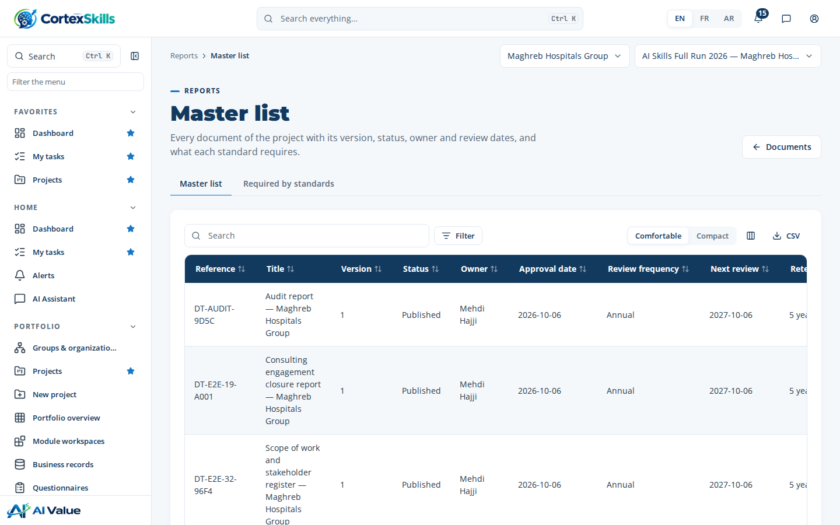
Figure 15 — Master list

9. Audits
Plan an audit and treat a nonconformity
- Open Governance › Audits and click New.
Type: Code — AUD-2027-01; Name — Internal audit of the training process; Standard — ISO 9001; Frequency — Annual; Planned date — 2027-03-15
- Save. The next date is computed from the frequency.
- Open the audit and add a finding.
Type: Grade — Minor; Requirement — ISO 9001 §7.2; Statement — Two trainers have no evidence of competence on file.
- Click Raise the action. The corrective action enters the action process; the finding moves to Action planned.
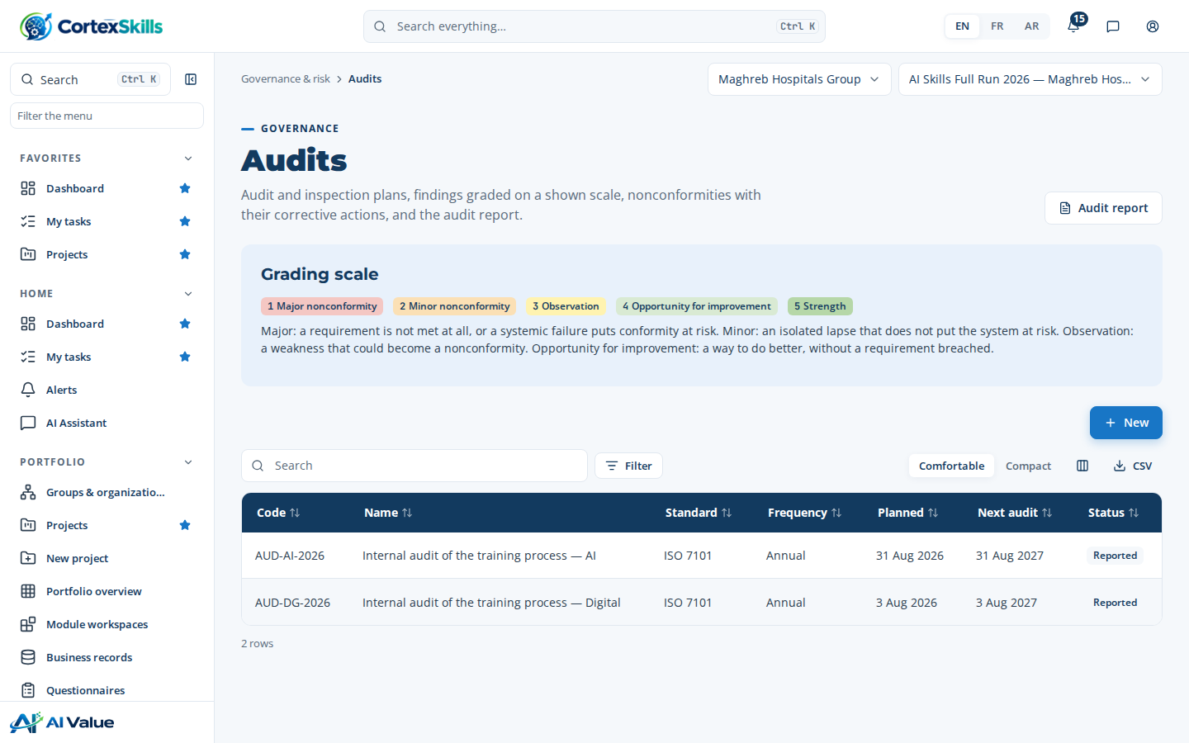
Figure 16 — Audit programmes and grading scale

10. Data protection and operations
Topic | Rule in CortexSkills
Retention of responses | Questionnaire responses older than the retention period (5 years by default, record Retention policy) are anonymized every day: identity and free text removed, scores kept.
Anonymized questionnaires | Tick Anonymized on the questionnaire: identity is stripped before storage and no link to the respondent is kept.
Audit log | Append-only: every change with user, time, before and after values and justification.
Backups | Daily copy of the database while the service runs; retention set in the server configuration; Backup now on demand (platform administrator).
Keys and secrets | Model keys and channel tokens are sealed on the server; only the last characters are shown.

Purge expired responses now
- Set the period: open Portfolio › Business records › RetentionPolicy and create the record.
Type: Questionnaire years — 5; Mode — anonymize
- The purge runs every day. To run it now, call the API as organization administrator.
Type: POST /api/retention/purge {"mode":"anonymize"}
- Check the count in the audit log entry RetentionPolicy · purge.
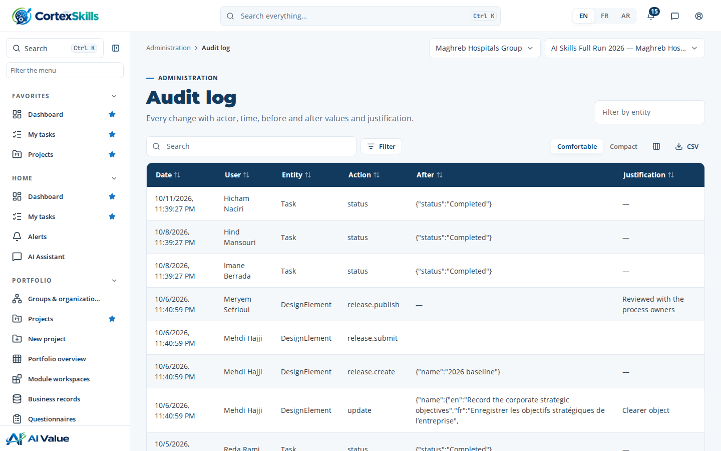
Figure 17 — Audit log

Traceability
Administration › Traceability lists the 580 requirements of the Dynamic Apps Standard SRS v1.10 with their status and evidence: 558 met, 10 partial and 12 left to the production hosting (sizing, uptime, encryption at rest, residency).
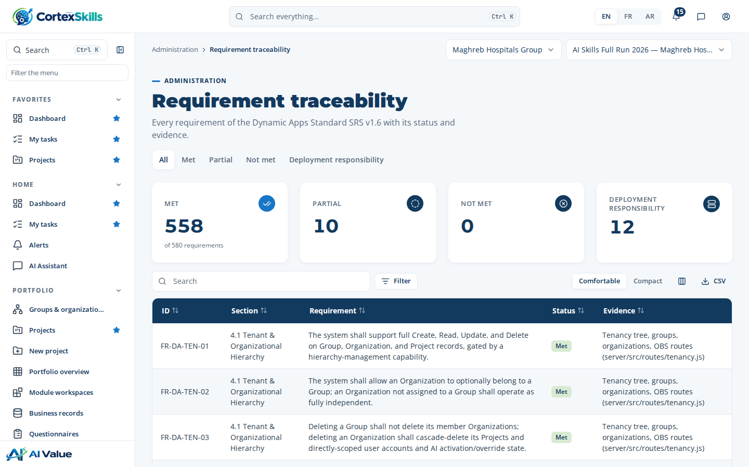
Figure 18 — Requirement traceability

11. Production deployment
The demonstration runs in development mode with shared passwords. A production installation is created empty with npm run init and is administered from the server console (npm run admin). Two Installation Guides give every step: CortexSkills — SaaS Mode, and CortexSkills — Dedicated Cloud & On-Premises.
Mode | Where | Licence | Pack activation
SaaS (DEPLOYMENT_MODE=saas) | One installation at the provider, many organizations | Issued by the provider: npm run admin -- licence | Console (licence, addon) or Configuration & licence screen
Dedicated cloud / On-Prem (DEPLOYMENT_MODE=onprem) | One installation per customer: public cloud, private cloud or own datacenter | Vendor-signed file: licence-request → vendor signs → licence-install | Signed licence (pack, users, date); add-ons and standards on screen

Console command | Purpose
npm run secrets | New random secrets for server/.env
npm run init | Empty production database and platform administrator
npm run admin -- org-create / org-list | Create and list customer organizations
npm run admin -- licence / addon | SaaS: issue, renew, resize a licence; add-ons
npm run admin -- licence-request / licence-install | OnPrem: request and install the signed licence
npm run admin -- user-create / password / platform-admin | Users, password reset, platform administrators
npm run backup | Back up the database now

Safety at start-up
With NODE_ENV=production the server refuses to start while a secret is missing or weak, the public address is not HTTPS, CORS is open, the database holds the demonstration data, or (OnPrem) the vendor public key is missing or the vendor private key is present. It lists each problem with its fix.

