POWERACT
C O N S U L T I N G
USER GUIDE
CortexPLM
Run innovation projects from idea to launch, relaunch or retirement
Version 1.0 · September 2026

Table of Contents
1. About This Guide 5
1.1 Conventions 5
2. Getting Started 6
2.1 Sign in 6
2.2 The dashboard 6
2.3 The navigation bar: pin, slide and position 7
2.4 Language 8
2.5 Organizations and groups 9
2.6 Alerts, notifications and the assistant 9
3. How a Project Moves Through CortexPLM 11
3.1 Who does what in the runs 11
3.2 Create a project 11
3.3 Complete a task 12
3.4 Complete the gate checklist 13
3.5 Submit the gate and record the decision 14
4. Common Values Used in the Runs 17
5. Run 1: Fast Track in the Public Sector 18
Step 1. Create the project 18
Step 2. E2E-01 Idea-to-Business Plan 18
Step 3. E2E-02 Idea-to-Business Proposal 19
Step 4. E2E-05 Development-to-Launch 20
Result of the run 21
6. Run 2: Fast Track in Transportation, with a skipped task and a Recycle decision 22
Step 1. Create the project 22
Step 2. E2E-01 Idea-to-Business Plan 22
Step 3. E2E-02 Idea-to-Business Proposal 23
Step 4. E2E-02 Idea-to-Business Proposal 24
Step 5. E2E-05 Development-to-Launch 25
Result of the run 26
7. Run 3: Light Track in Agro-Business (Dairy), from idea to relaunch 27
Step 1. Prepare the Light Track observation period 27
Step 2. Create the project 27
Step 3. E2E-01 Idea-to-Business Plan 28
Step 4. E2E-02 Idea-to-Business Proposal 29
Step 5. E2E-03 Business Proposal-to-Design 30
Step 6. E2E-04 Design-to-Development 30
Step 7. E2E-05 Development-to-Launch 31
Step 8. E2E-07 After-Sales-to-Performance 32
Step 9. E2E-09 Market Strategy-to-Campaign 33
Step 10. E2E-08 Assessment-to-Relaunch or Retirement · Branch A 34
Step 11. E2E-05 Development-to-Launch (run 2) 34
Result of the run 35
8. Run 4: Full Track in Healthcare, from idea to retirement 36
Step 1. Create the project 36
Step 2. E2E-01 Idea-to-Business Plan 36
Step 3. E2E-02 Idea-to-Business Proposal 37
Step 4. E2E-03 Business Proposal-to-Design 39
Step 5. E2E-04 Design-to-Development 40
Step 6. E2E-05 Development-to-Launch 41
Step 7. E2E-06 Launch-to-After-Sales 42
Step 8. E2E-09 Market Strategy-to-Campaign 42
Step 9. E2E-07 After-Sales-to-Performance 43
Step 10. E2E-08 Assessment-to-Relaunch or Retirement · Branch B 44
Result of the run 45
9. Run 5: Full Track in Oil, Gas & Energy, relaunching a live product 46
Step 1. Open the project 46
Step 2. E2E-09 Market Strategy-to-Campaign 46
Step 3. E2E-07 After-Sales-to-Performance 46
Step 4. E2E-08 Assessment-to-Relaunch or Retirement · Branch A 47
Step 5. E2E-04 Design-to-Development (run 2) 48
Step 6. E2E-05 Development-to-Launch (run 2) 49
Result of the run 50
10. Run 6: Benchmarking in Construction, within the organization and across the group 51
Step 1. Compare project types 51
Step 2. Compare tracks and filter 52
Step 3. Compare with the organizations of the group 53
Step 4. Stop or resume sharing with the group 54
Step 5. An independent organization 54
11. Everyday Scenarios by Module 56
11.1 Record a business rule 56
11.2 Add a control, change it and compare versions 56
11.3 Log a risk and read the heat map 56
11.4 See the governance of one process 56
11.5 Build a RACSI activity 57
11.6 Track a custom KPI 57
11.7 Edit and exchange a BPMN diagram 57
11.8 Ask for an AI suggestion on a task 57
11.9 Search the knowledge base in your language 57
11.10 Create a project template and use it 58
11.11 Plan with a WBS and a Gantt chart 58
11.12 Record a lesson learned 58
11.13 Export a report 58
11.14 Choose how you are notified 58
11.15 Add a user within the licence limit 59
11.16 Give a project its own team tree (OBS) 59
11.17 Back up the database 59
11.18 Check the audit trail 59
12. Messages You May Meet 60

1. About This Guide
This guide shows how to use CortexPLM through complete, worked examples. Five runs take real projects through their whole lifecycle, in five industries and all three tracks. Every value you type is given in bold, exactly as you enter it. The runs were replayed on a freshly installed demonstration database, so the codes and results match what you will see.
Run | Industry | Track | From | To | Gate decisions
1 | Public Sector | Fast | New idea | Launched | T-1, T0, T3
2 | Transportation | Fast | New idea | Launched | T-1, T0 (Recycle, then Go), T3
3 | Agro-Business – Dairy | Light | New idea | Relaunched | T-1, T0, T1, T2, T3, T5, T3
4 | Healthcare | Full | New idea | Retired | T-1, T0, T1, T2, T3, T4, T5, T6
5 | Oil, Gas & Energy | Full | Live product | Relaunched | T5, T2, T3
6 | Construction | All | Portfolio | Benchmarked | Within the organization and across its group

Chapter 11 adds short scenarios for every other module: governance registers, RACSI, KPIs, BPMN, AI, knowledge, templates, WBS, lessons learned, reports, notifications and administration.
Before you start Start from a fresh demonstration database (Installation Guide, "Reset the demonstration data") so the project codes match: PUB-022, TRN-022, DAI-022 and HLT-022. If you already created projects, your codes will simply have a higher number.

1.1 Conventions
You see | Meaning
Bold text | A value to type, or a button, tab or menu item to select.
Menu > Item | Open the menu group, then the item, in the navigation bar.
UFT-01-02 | The identifier of a user-facing task from the process reference.
T-1 … T6 | The eight decision gates of the phase-gate process.

2. Getting Started

2.1 Sign in
1. Open http://localhost:5173 in your browser.
2. Type your e-mail and password (demonstration users: password Demo#2026).
3. Select Sign in.
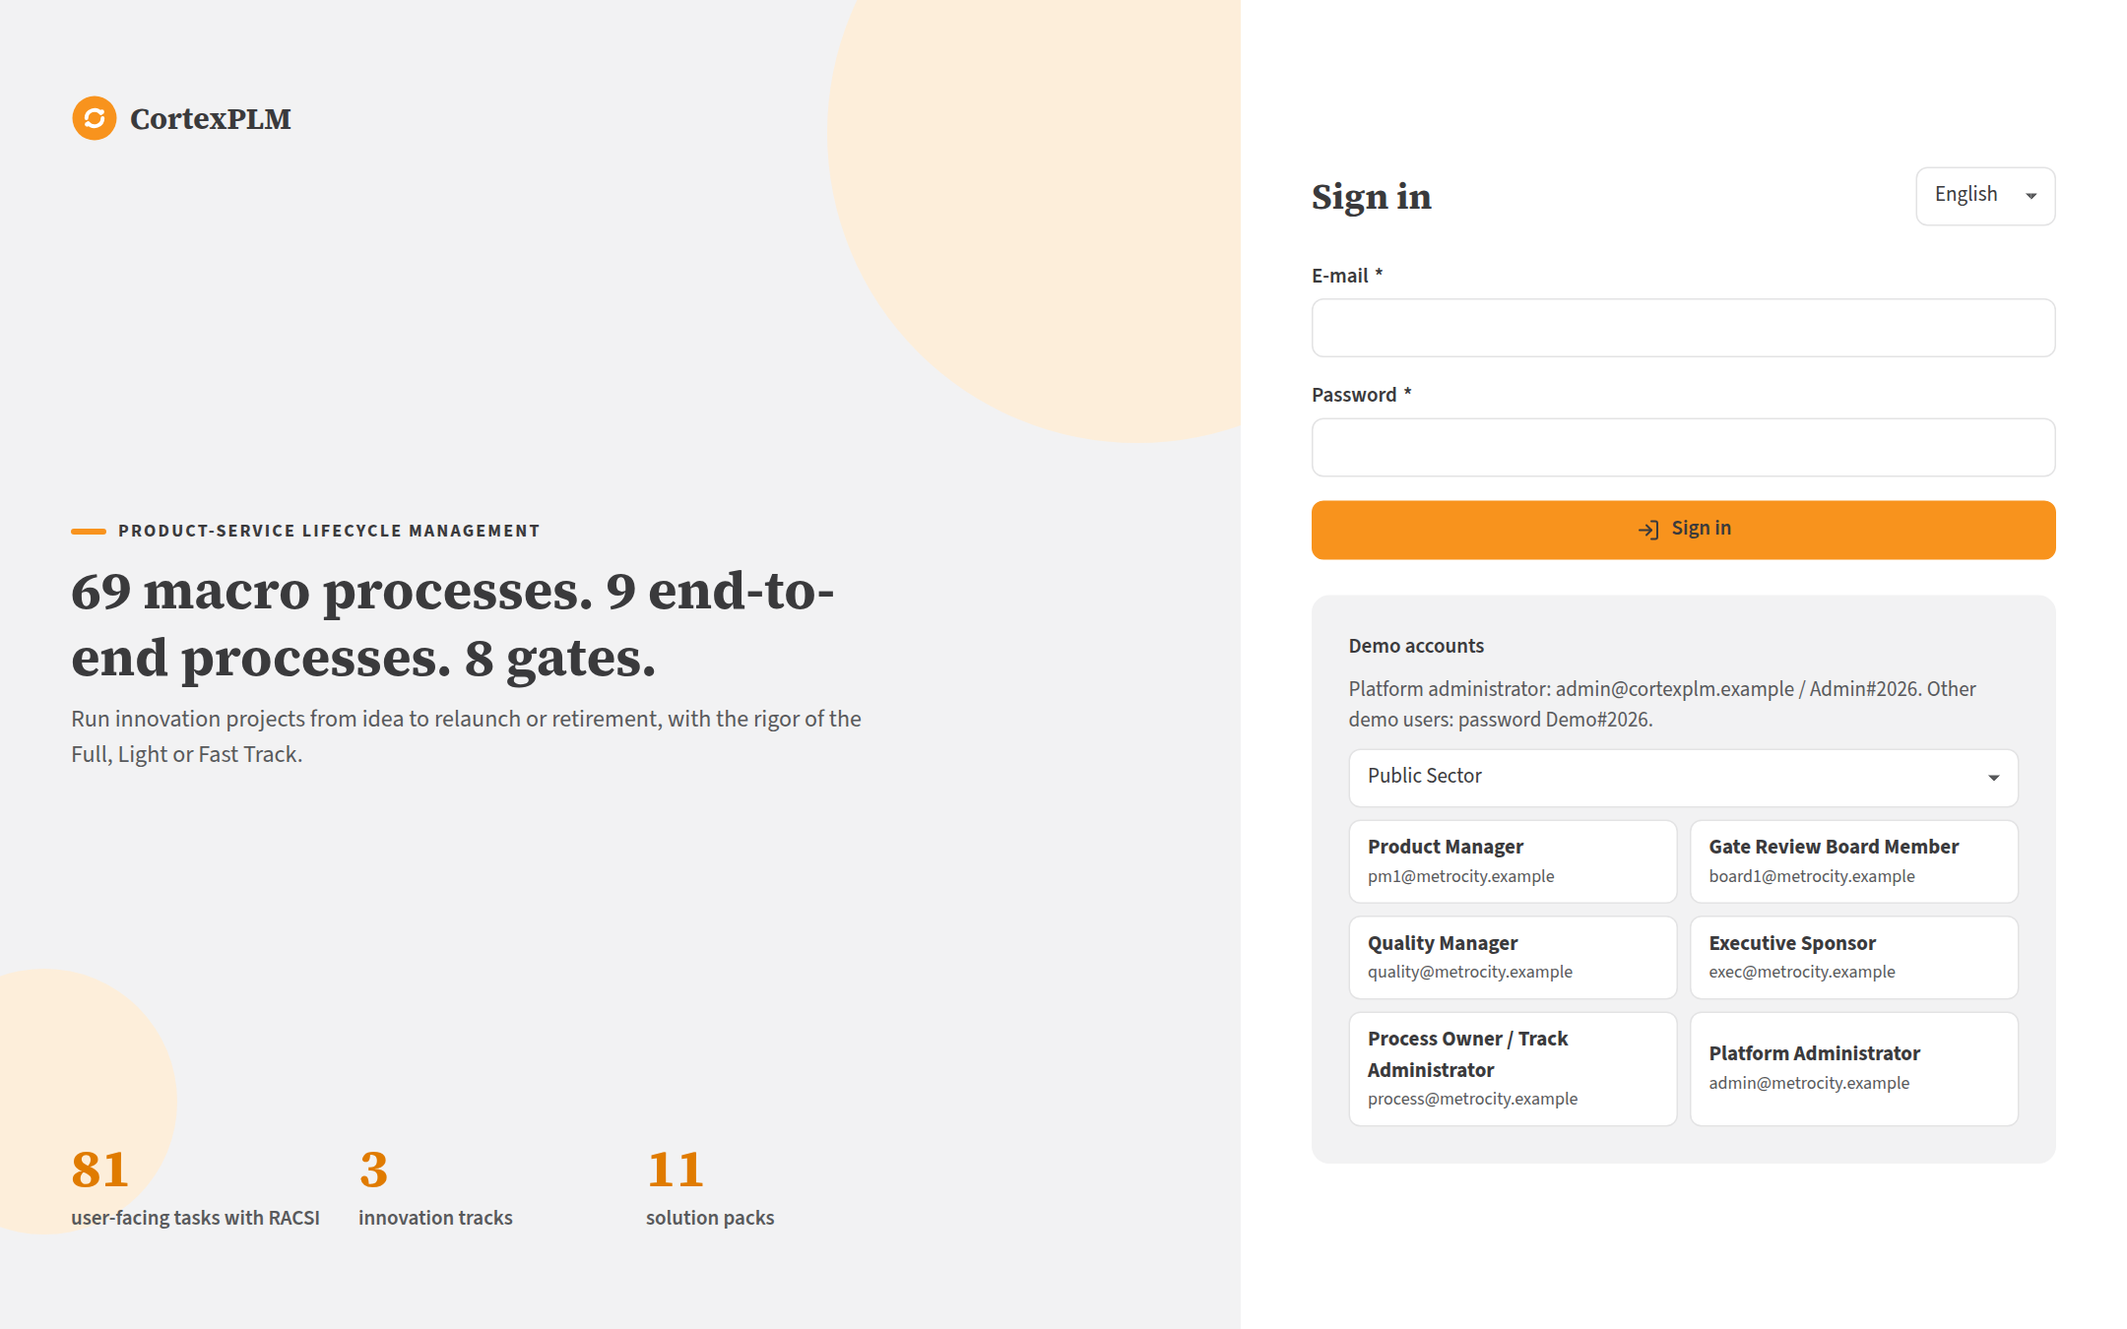
The sign-in page lists the demonstration accounts.

2.2 The dashboard
The dashboard leads with four figures: active projects, gates waiting for a decision, overdue tasks and checklist compliance. Charts below show E2E instances and gate decisions.
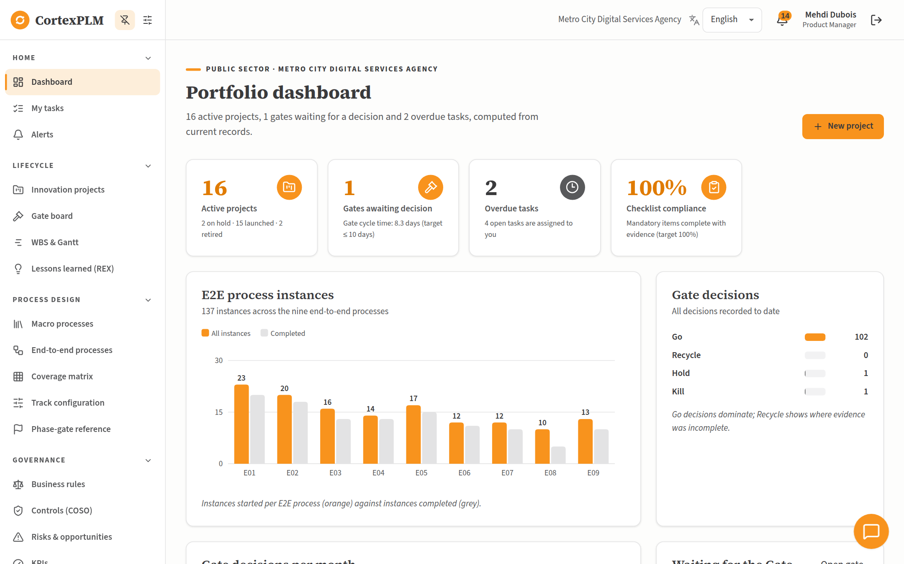
Dashboard of Metro City Digital Services Agency for a Product Manager.

2.3 The navigation bar: pin, slide and position
1. Select the sliders icon at the top of the navigation bar to open Menu position.
2. Choose Left, Right, Top or Bottom. The menu moves at once and the choice is saved for your account.
3. Clear Keep the menu pinned open to let the menu slide away. It slides back when you point at the edge of the screen. The pin icon next to the sliders does the same.
4. Select the star next to any item to add it to Pinned favourites at the top of the menu. Select a group title to fold or unfold it.
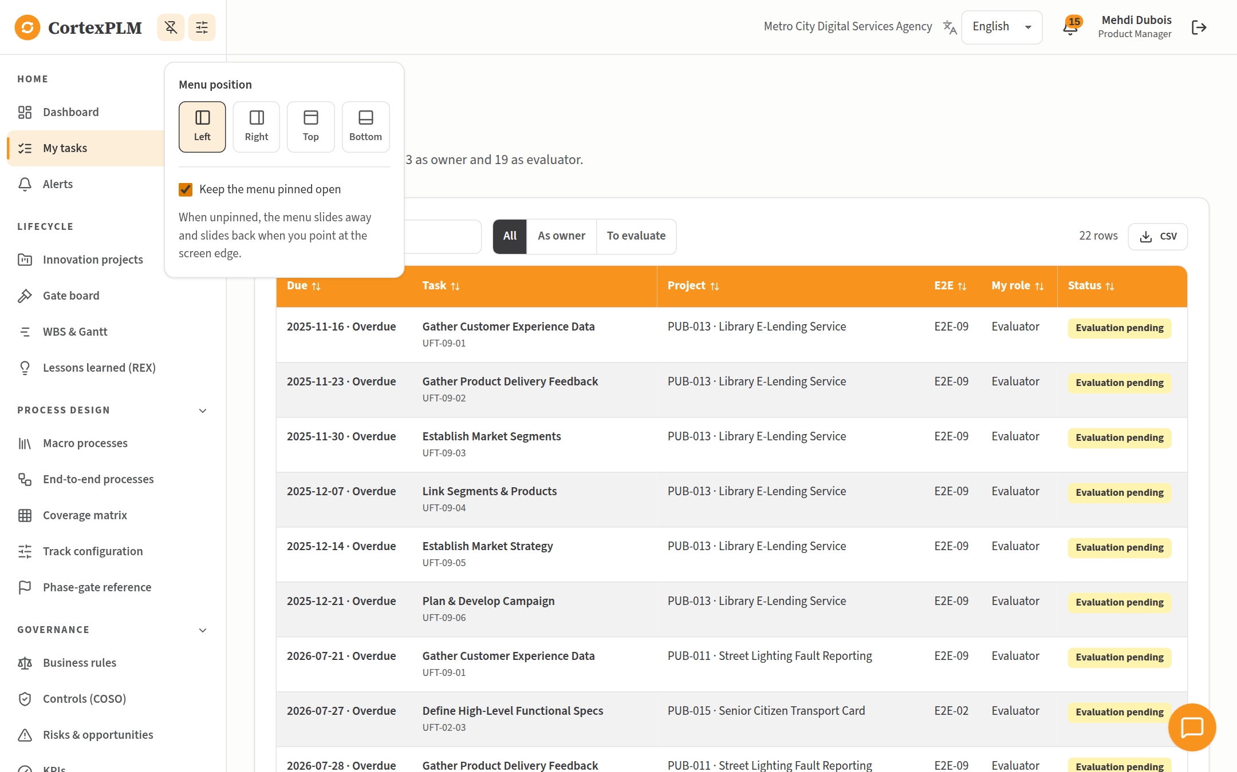
Menu position settings: four positions and the pin option.

2.4 Language
Choose English, Français or العربية in the language list of the top bar. Arabic switches the whole layout to right-to-left, and the navigation bar moves to the right. Your choice is saved; the organization default applies otherwise.
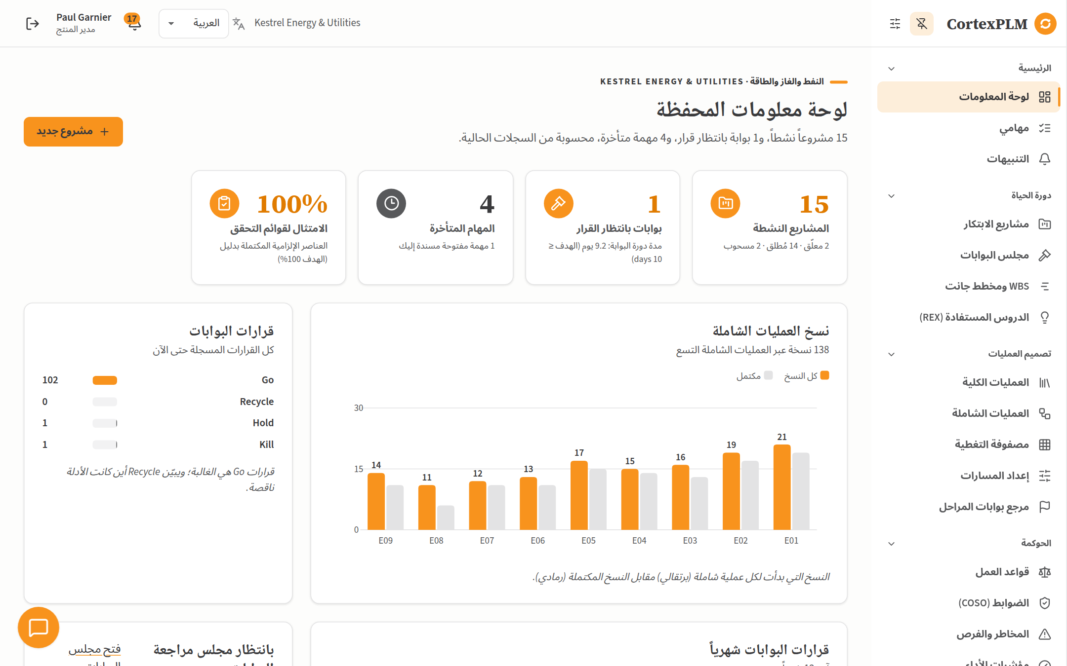
The dashboard in Arabic, laid out right to left.

2.5 Organizations and groups
The demonstration has seven organizations, one per sector. An organization may belong to a group; its members can compare themselves with each other (Run 6). The others are independent.
Organization | Sector | Domain | Group
Metro City Digital Services Agency | Public Sector | metrocity.example | No (independent)
Cedarline Precast Systems | Manufacturing in Construction | cedarline.example | Atlas Infrastructure Holding
Meridale Health Network | Healthcare | meridale.example | No (independent)
Valdora Dairy Cooperative | Agro-Business – Dairy Products | valdora.example | Crescent Agro-Energy Group
Orvane Transit Group | Transportation | orvane.example | Atlas Infrastructure Holding
Kestrel Energy & Utilities | Oil, Gas & Energy | kestrel.example | Crescent Agro-Energy Group
Ridgeway Construction Contractors | Construction | ridgeway.example | Atlas Infrastructure Holding

2.6 Alerts, notifications and the assistant
- The bell in the top bar shows unread alerts, such as overdue tasks or a gate waiting too long. Open Alerts for the full list.
- Notifications holds your inbox and lets you choose, per category, the channels you want (in-app, e-mail, webhook, SMS, push).
- The round assistant button at the bottom of the screen answers questions about your data within your permissions, for example How many active projects?, and explains how to use each screen.
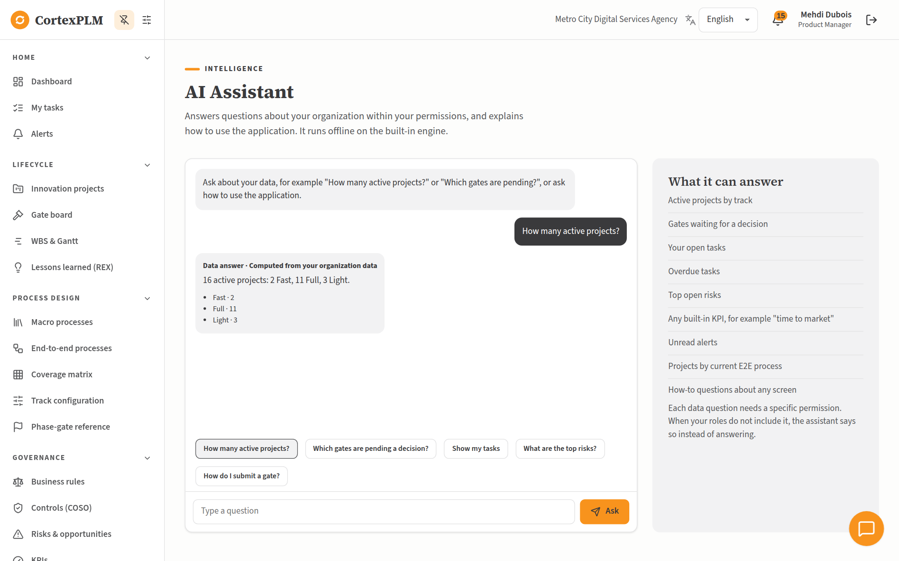
The assistant answers from live organization data and says which permission it used.

3. How a Project Moves Through CortexPLM
Every project follows the end-to-end (E2E) processes of its track. Each E2E process is a list of tasks and ends with a gate. At the gate, the Executive Sponsor records one of four decisions.
Track | Total score | E2E processes | Gates | Checklist items per gate
Fast | 7 to 14 | E2E-01, E2E-02, E2E-05 | T-1, T0, T3 | 6
Light | 15 to 24 | E2E-01 to E2E-05, E2E-07, E2E-08 (relaunch only), E2E-09 | T-1, T0, T1, T2, T3, T5 | 15
Full | 25 to 35, or any safety-critical product | All nine | All eight | 30

Decision | What happens
Go | The gate is passed and the next E2E process starts automatically.
Kill | The project stops. You are invited to record a lesson learned.
Hold | The project pauses until a re-review date. Resume project reopens the gate.
Recycle | Named tasks go back to To do; the gate is reviewed again afterwards.

3.1 Who does what in the runs
- The Product Manager creates the project, completes the tasks, completes the gate checklist and submits the gate. Each task shows its own owner (for example Finance or Marketing). In daily use each owner completes their task; in these runs the Product Manager completes them on the owners' behalf, which the role allows.
- The Executive Sponsor records the gate decision. The project owner can never decide their own gate (control CTL-01).
- The evaluator of a task (Accountable in the RACSI matrix) rates it Effective or Not effective after completion. Evaluations do not block the process.

3.2 Create a project
Open Innovation projects > New project. Step 1 describes the project, Step 2 scores seven complexity criteria from 1 to 5, Step 3 confirms the recommended track, and Step 4 adds optional macro processes. Select Create project; E2E-01 starts.
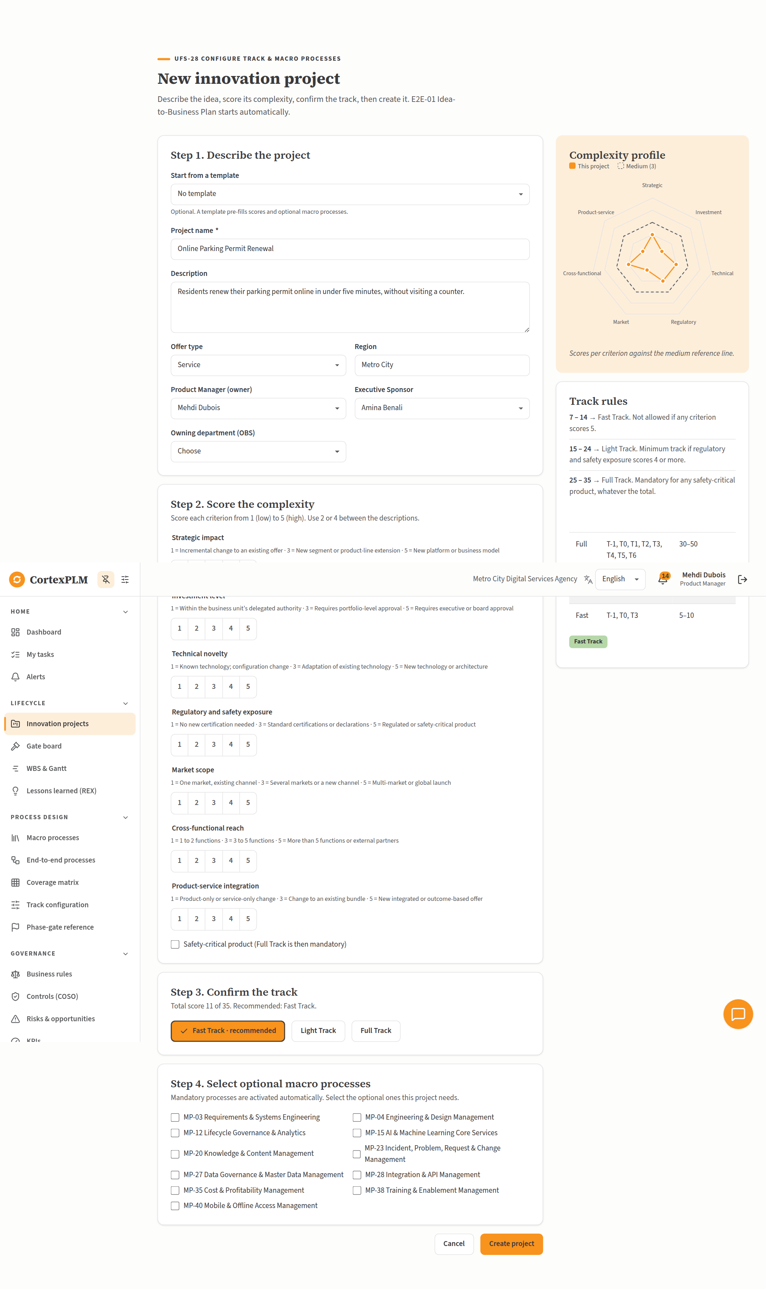
The New project wizard with the scores of Run 1 and the Fast Track selected.

3.3 Complete a task
Open the task from the project page or from My tasks. Fill in the fields, type the Result / output and select Complete task. A window proposes to record a lesson learned: fill it in, or select Skip. You may select Start task first to show that work has begun; it is optional.
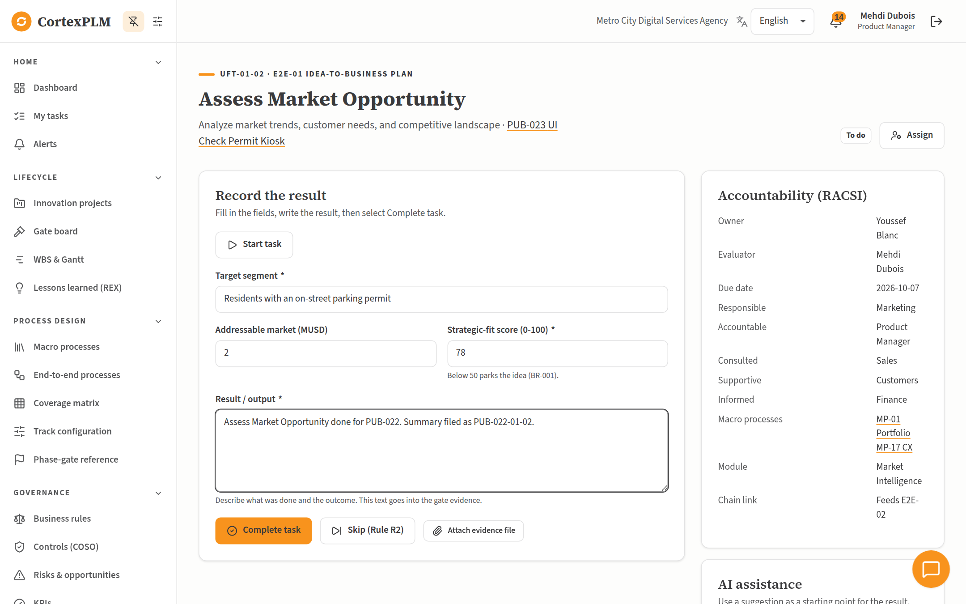
Task UFT-01-02 Assess Market Opportunity with its fields filled in.

3.4 Complete the gate checklist
The last task before each gate is Complete Gate Checklist. Every Mandatory item needs an evidence reference (or an attached file) before Mark complete works (BR-005). When all mandatory items are complete or waived, select Complete checklist task (BR-004).
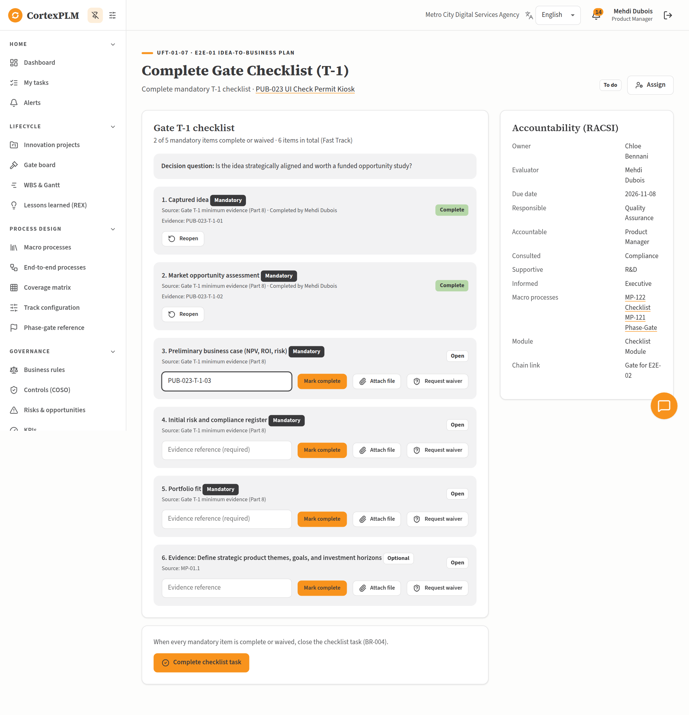
The T-1 checklist: mandatory items need an evidence reference.

3.5 Submit the gate and record the decision
When all tasks are done, the project page shows Submit gate for decision on the gate card. The Executive Sponsor then opens Gate board, opens the gate, chooses the decision, types a rationale and selects Record decision.
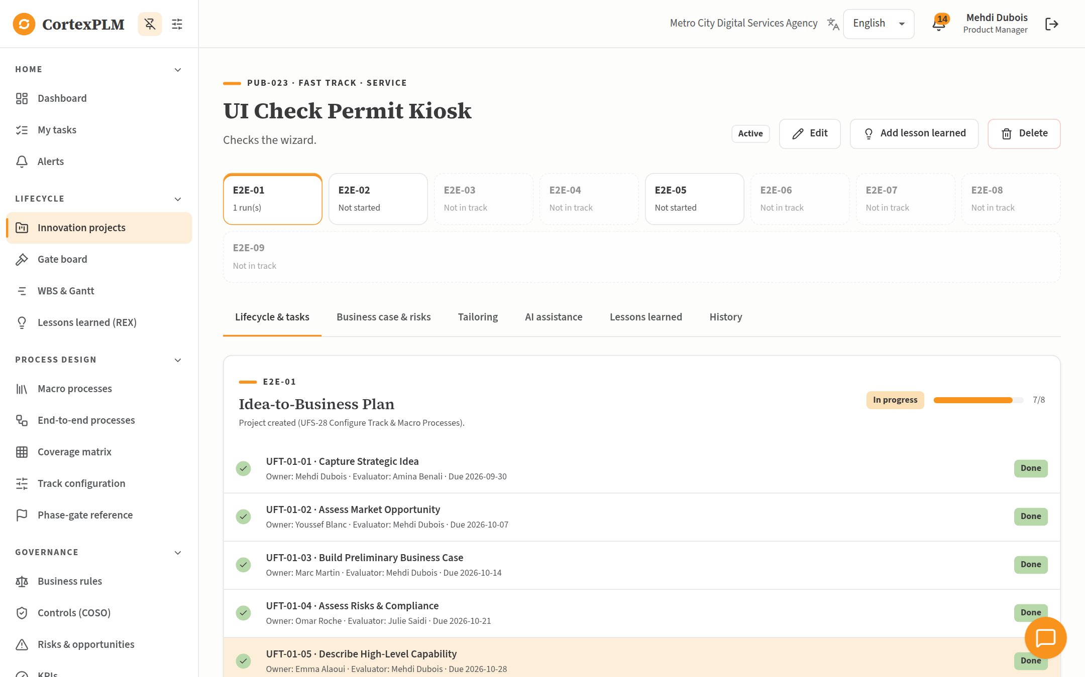
Project page: E2E-01 tasks done and the gate ready to submit.
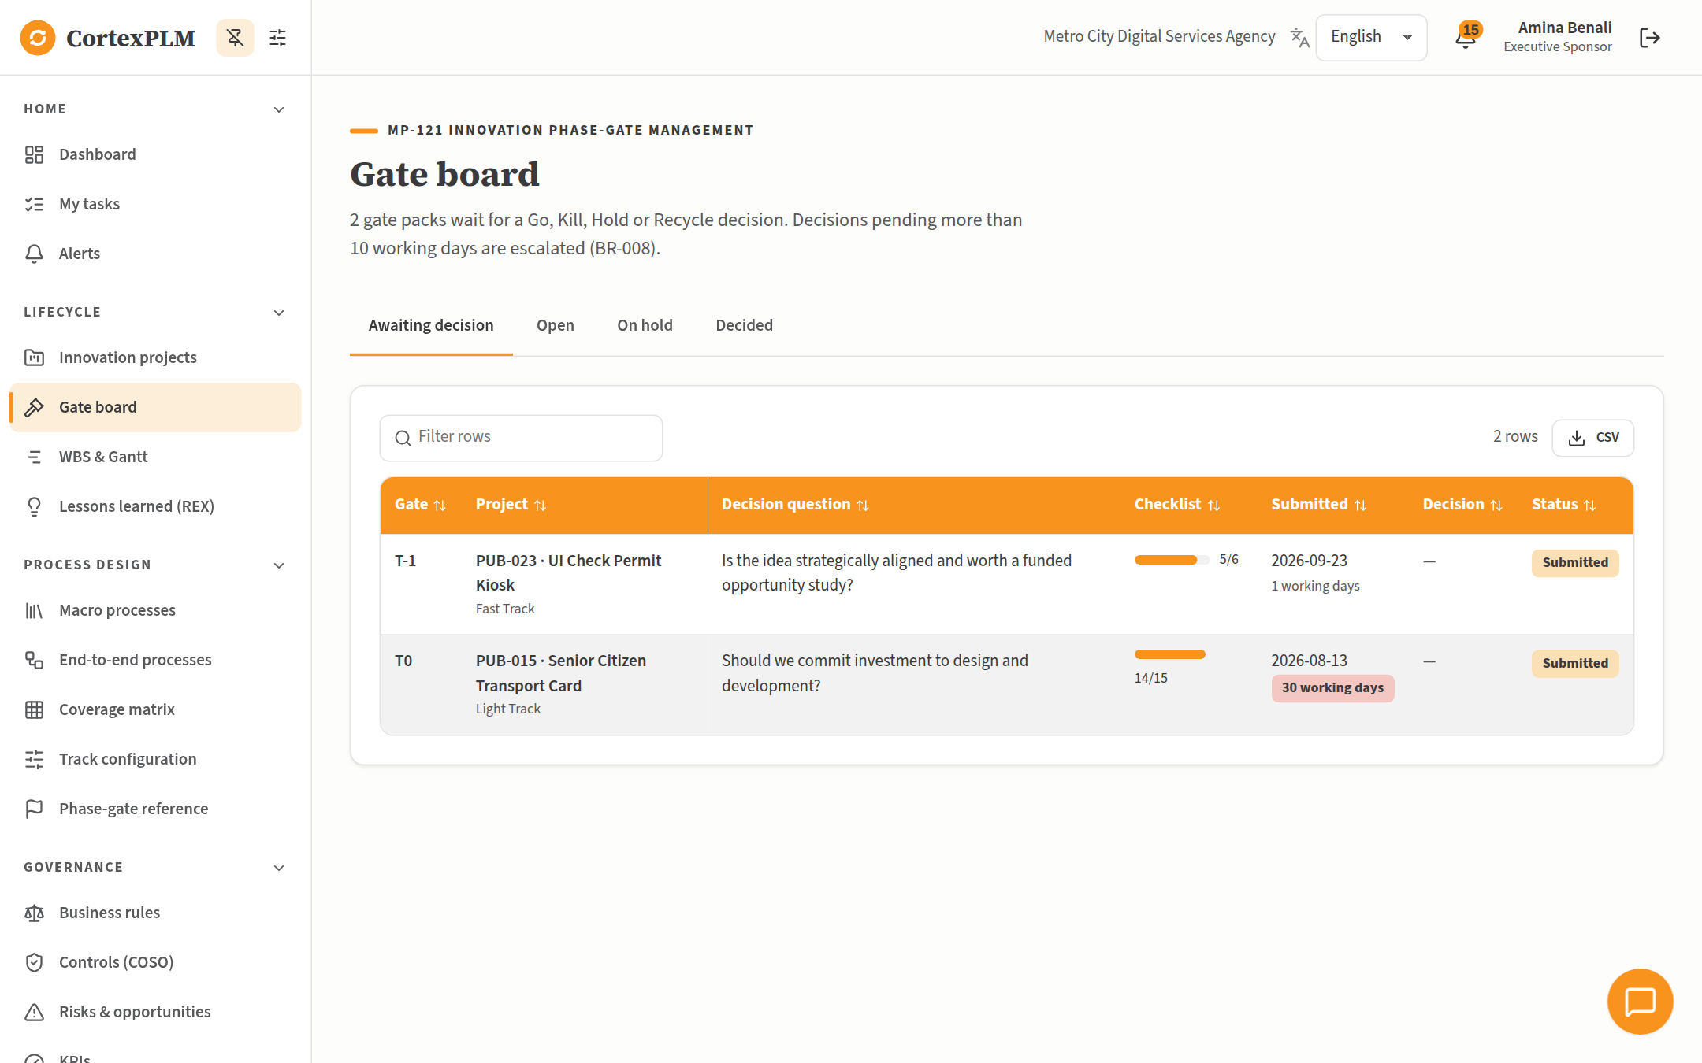
Gate board: gates waiting for a decision, with the working days elapsed.
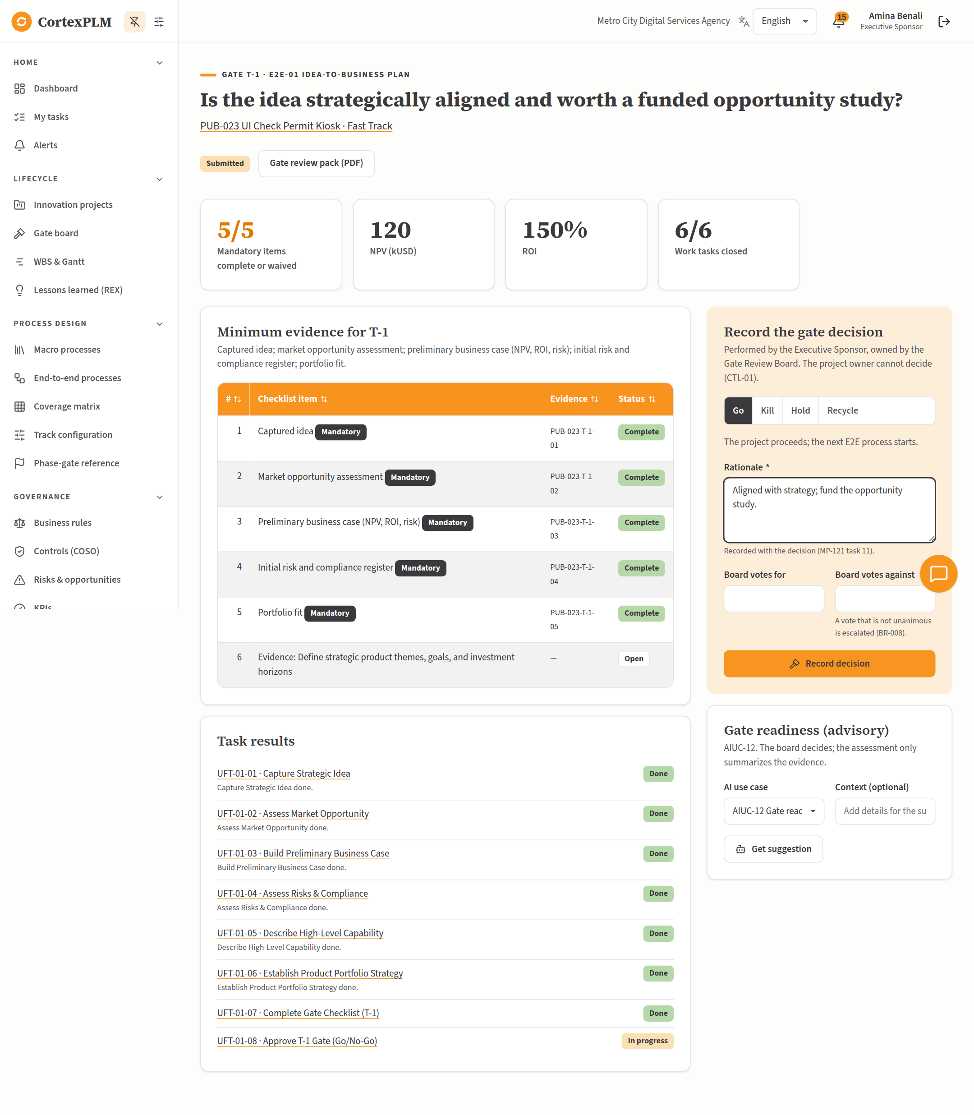
Gate decision page: evidence summary on the left, decision form on the right.

4. Common Values Used in the Runs
The runs use the same patterns so you can type quickly:
- Result / output of a task: "<task name> done for <project code>. Summary filed as <project code>-<task number>." The exact text is given in every table.
- Evidence reference of a checklist item: <project code>-<gate>-<item number>, for example PUB-022-T-1-01.
- Dates: any future date works; the tables show the dates used in the example runs.
- Fields not listed in a table can stay empty.

5. Run 1: Fast Track in the Public Sector
A low-complexity citizen service goes from idea to launch in the Fast Track: E2E-01, E2E-02 and E2E-05 with gates T-1, T0 and T3.
Item | Value
Organization | Metro City Digital Services Agency (Public Sector)
Product Manager | Mehdi Dubois · pm1@metrocity.example
Executive Sponsor | Amina Benali · exec@metrocity.example
Project | PUB-022 Online Parking Permit Renewal
Track | Fast (total score 11 of 35)
End state | Launched · NPV 120 kUSD, ROI 132.1%

Step 1. Create the project
Sign in as pm1@metrocity.example (password Demo#2026), the Product Manager.
Open Innovation projects and select New project. Fill in the wizard:
Field | What to type or select
Project name | Online Parking Permit Renewal
Description | Residents renew their parking permit online in under five minutes, without visiting a counter.
Offer type | Service
Region | Metro City
Product Manager (owner) | keep Mehdi Dubois
Executive Sponsor | Amina Benali
Strategic impact | select 2
Investment level | select 1
Technical novelty | select 2
Regulatory and safety exposure | select 2
Market scope | select 1
Cross-functional reach | select 2
Product-service integration | select 1
Step 3. Confirm the track | Total score 11 of 35: select Fast Track · recommended
Step 4. Optional macro processes | leave all unticked

Select Create project. The message reads "Project PUB-022 created. E2E-01 has started." and the project page opens.

Step 2. E2E-01 Idea-to-Business Plan
Open the project, tab Lifecycle & tasks, card E2E-01. Open each task in turn, fill in the fields shown, type the Result / output, then select Complete task. In the Record a lesson learned window that follows, select Skip.
# | Task | Fields to fill | Result / output to type
1 | UFT-01-01 Capture Strategic Idea | Idea source: Customer request  One-sentence idea statement: Let residents renew parking permits online. | Capture Strategic Idea done for PUB-022. Summary filed as PUB-022-01-01.
2 | UFT-01-02 Assess Market Opportunity | Target segment: Residents with an on-street parking permit  Addressable market (MUSD): 2  Strategic-fit score (0-100): 78 | Assess Market Opportunity done for PUB-022. Summary filed as PUB-022-01-02.
3 | UFT-01-03 Build Preliminary Business Case | Investment (kUSD): 120  Expected net cash flow per year (kUSD): 60  Evaluation horizon (years): 5  Discount rate (%): 8 | Build Preliminary Business Case done for PUB-022. Summary filed as PUB-022-01-03.
4 | UFT-01-04 Assess Risks & Compliance | Main risk identified: Payment data exposure  Likelihood (1-5): 2  Impact (1-5): 3  Regulated product?: No | Assess Risks & Compliance done for PUB-022. Summary filed as PUB-022-01-04.
5 | UFT-01-05 Describe High-Level Capability | Key capabilities and skills needed: Online forms, payment gateway, permit database link | Describe High-Level Capability done for PUB-022. Summary filed as PUB-022-01-05.
6 | UFT-01-06 Establish Product Portfolio Strategy | Portfolio position: Core  Roadmap slot (e.g. 2027-Q2): 2027-Q1 | Establish Product Portfolio Strategy done for PUB-022. Summary filed as PUB-022-01-06.

What you will see NPV 120 kUSD, ROI 150%, payback 2 years. Risk added to the risk register.

Evaluation example: Amina Benali is the evaluator of Capture Strategic Idea. Sign in as exec@metrocity.example, open My tasks, filter To evaluate, open the task, choose Verdict Effective, type Notes Clear and complete. and select Record evaluation. Then sign in again as pm1@metrocity.example.
Open the task Complete Gate Checklist (T-1). The gate T-1 checklist has 6 items; 5 are Mandatory. For each mandatory item, type the evidence reference below in its field and select Mark complete. Optional items can stay open. Then select Complete checklist task (and Skip in the lesson window).
Item | Checklist item (mandatory) | Evidence reference to type
1 | Captured idea | PUB-022-T-1-01
2 | Market opportunity assessment | PUB-022-T-1-02
3 | Preliminary business case (NPV, ROI, risk) | PUB-022-T-1-03
4 | Initial risk and compliance register | PUB-022-T-1-04
5 | Portfolio fit | PUB-022-T-1-05

Submit the gate: on the project page, card Gate T-1, select Submit gate for decision. Sign out.
1. Sign in as exec@metrocity.example (Amina Benali, Executive Sponsor) and open Gate board.
2. Open the T-1 line of PUB-022.
3. Under Decision, keep Go.
4. In Rationale, type Aligned with strategy; fund the opportunity study., then select Record decision.
5. Result: E2E-02 starts automatically. Sign in again as pm1@metrocity.example to continue.

Step 3. E2E-02 Idea-to-Business Proposal
Open the project, tab Lifecycle & tasks, card E2E-02. Open each task in turn, fill in the fields shown, type the Result / output, then select Complete task. In the Record a lesson learned window that follows, select Skip.
# | Task | Fields to fill | Result / output to type
1 | UFT-02-01 Conduct Opportunity Study | — | Conduct Opportunity Study done for PUB-022. Summary filed as PUB-022-02-01.
2 | UFT-02-02 Develop Detailed Business Case | Investment (kUSD): 140  Expected net cash flow per year (kUSD): 65  Evaluation horizon (years): 5  Discount rate (%): 8 | Develop Detailed Business Case done for PUB-022. Summary filed as PUB-022-02-02.
3 | UFT-02-03 Define High-Level Functional Specs | — | Define High-Level Functional Specs done for PUB-022. Summary filed as PUB-022-02-03.
4 | UFT-02-04 Map Preliminary Customer Journey | — | Map Preliminary Customer Journey done for PUB-022. Summary filed as PUB-022-02-04.
5 | UFT-02-05 Conduct Detailed Profitability Analysis | Expected gross margin (%): 35 | Conduct Detailed Profitability Analysis done for PUB-022. Summary filed as PUB-022-02-05.
6 | UFT-02-06 Validate Regulatory Aspects | Applicable regulations and standards: GDPR, PCI DSS for card payments | Validate Regulatory Aspects done for PUB-022. Summary filed as PUB-022-02-06.
7 | UFT-02-07 Assess Technical Feasibility | Technical feasibility: High | Assess Technical Feasibility done for PUB-022. Summary filed as PUB-022-02-07.
8 | UFT-02-08 Develop Development Plan | — | Develop Development Plan done for PUB-022. Summary filed as PUB-022-02-08.
9 | UFT-02-09 Validate Opportunity | — | Validate Opportunity done for PUB-022. Summary filed as PUB-022-02-09.

What you will see NPV 120 kUSD, ROI 132.1%, payback 2.2 years.

Open the task Complete Gate Checklist (T0). The gate T0 checklist has 6 items; 6 are Mandatory. For each mandatory item, type the evidence reference below in its field and select Mark complete. Optional items can stay open. Then select Complete checklist task (and Skip in the lesson window).
Item | Checklist item (mandatory) | Evidence reference to type
1 | Opportunity study | PUB-022-T0-01
2 | Detailed business case and profitability analysis | PUB-022-T0-02
3 | High-level functional specifications | PUB-022-T0-03
4 | Preliminary customer journey | PUB-022-T0-04
5 | Regulatory validation | PUB-022-T0-05
6 | Technical feasibility | PUB-022-T0-06

Submit the gate: on the project page, card Gate T0, select Submit gate for decision. Sign out.
1. Sign in as exec@metrocity.example (Amina Benali, Executive Sponsor) and open Gate board.
2. Open the T0 line of PUB-022.
3. Under Decision, keep Go.
4. In Rationale, type Business case and feasibility are convincing; commit design investment., then select Record decision.
5. Result: E2E-05 starts automatically. Sign in again as pm1@metrocity.example to continue.

Step 4. E2E-05 Development-to-Launch
Open the project, tab Lifecycle & tasks, card E2E-05. Open each task in turn, fill in the fields shown, type the Result / output, then select Complete task. In the Record a lesson learned window that follows, select Skip.
# | Task | Fields to fill | Result / output to type
1 | UFT-05-01 Approve for Launch/Rollout | — | Approve for Launch/Rollout done for PUB-022. Summary filed as PUB-022-05-01.
2 | UFT-05-02 Develop Detailed Launch Plan | Planned launch date: 2026-11-22 (any future date) | Develop Detailed Launch Plan done for PUB-022. Summary filed as PUB-022-05-02.
3 | UFT-05-03 Develop Communication Plan | — | Develop Communication Plan done for PUB-022. Summary filed as PUB-022-05-03.
4 | UFT-05-04 Develop Marketing & Sales Materials | — | Develop Marketing & Sales Materials done for PUB-022. Summary filed as PUB-022-05-04.
5 | UFT-05-05 Execute Communication Campaign | — | Execute Communication Campaign done for PUB-022. Summary filed as PUB-022-05-05.
6 | UFT-05-06 Train Teams | People trained: 14 | Train Teams done for PUB-022. Summary filed as PUB-022-05-06.
7 | UFT-05-07 Validate Customer Journey | — | Validate Customer Journey done for PUB-022. Summary filed as PUB-022-05-07.
8 | UFT-05-08 Final Regulatory Validation | All regulatory approvals obtained?: Yes | Final Regulatory Validation done for PUB-022. Summary filed as PUB-022-05-08.

Open the task Complete Gate Checklist (T3). The gate T3 checklist has 6 items; 5 are Mandatory. For each mandatory item, type the evidence reference below in its field and select Mark complete. Optional items can stay open. Then select Complete checklist task (and Skip in the lesson window).
Item | Checklist item (mandatory) | Evidence reference to type
1 | Detailed launch and communication plans | PUB-022-T3-01
2 | Marketing and sales materials | PUB-022-T3-02
3 | Trained teams | PUB-022-T3-03
4 | Validated customer journey | PUB-022-T3-04
5 | Final regulatory validation | PUB-022-T3-05

Submit the gate: on the project page, card Gate T3, select Submit gate for decision. Sign out.
1. Sign in as exec@metrocity.example (Amina Benali, Executive Sponsor) and open Gate board.
2. Open the T3 line of PUB-022.
3. Under Decision, keep Go.
4. In Rationale, type Approvals in place and teams trained; go live., then select Record decision.
5. Result: no further process starts; see the result of the run below. Sign in again as pm1@metrocity.example to continue.

Result of the run
The project status is Launched. The Fast Track ends at T3; performance and retirement follow the parent product (Rule R3).
- Open the tab Business case & risks to see NPV, ROI and payback calculated from your entries (BR-002), and the risk created by "Assess Risks & Compliance".
- Open the tab History to read every change with its author and time.
- Open Reports & cockpits to see the project counted in the portfolio figures.

6. Run 2: Fast Track in Transportation, with a skipped task and a Recycle decision
A Fast Track feature for bus passengers. One task is skipped under Rule R2, and the board sends the T0 gate back once (Recycle) before approving it.
Item | Value
Organization | Orvane Transit Group (Transportation)
Product Manager | Rachid Nguyen · pm1@orvane.example
Executive Sponsor | Laura Mansouri · exec@orvane.example
Project | TRN-022 Real-time Bus Crowding Indicator
Track | Fast (total score 13 of 35)
End state | Launched · NPV 140 kUSD, ROI 106.5%

Step 1. Create the project
Sign in as pm1@orvane.example (password Demo#2026), the Product Manager.
Open Innovation projects and select New project. Fill in the wizard:
Field | What to type or select
Project name | Real-time Bus Crowding Indicator
Description | Shows how full the next bus is in the passenger app, using existing automatic passenger counters.
Offer type | Product-Service
Region | Orvane network
Product Manager (owner) | keep Rachid Nguyen
Executive Sponsor | Laura Mansouri
Strategic impact | select 2
Investment level | select 2
Technical novelty | select 2
Regulatory and safety exposure | select 1
Market scope | select 2
Cross-functional reach | select 2
Product-service integration | select 2
Step 3. Confirm the track | Total score 13 of 35: select Fast Track · recommended
Step 4. Optional macro processes | leave all unticked

Select Create project. The message reads "Project TRN-022 created. E2E-01 has started." and the project page opens.

Step 2. E2E-01 Idea-to-Business Plan
Open the project, tab Lifecycle & tasks, card E2E-01. Open each task in turn, fill in the fields shown, type the Result / output, then select Complete task. In the Record a lesson learned window that follows, select Skip.
# | Task | Fields to fill | Result / output to type
1 | UFT-01-01 Capture Strategic Idea | Idea source: Market trend  One-sentence idea statement: Show bus occupancy in real time in the passenger app. | Capture Strategic Idea done for TRN-022. Summary filed as TRN-022-01-01.
2 | UFT-01-02 Assess Market Opportunity | Target segment: Daily commuters on the ten busiest lines  Addressable market (MUSD): 5  Strategic-fit score (0-100): 71 | Assess Market Opportunity done for TRN-022. Summary filed as TRN-022-01-02.
3 | UFT-01-03 Build Preliminary Business Case | Investment (kUSD): 210  Expected net cash flow per year (kUSD): 90  Evaluation horizon (years): 5  Discount rate (%): 9 | Build Preliminary Business Case done for TRN-022. Summary filed as TRN-022-01-03.
4 | UFT-01-04 Assess Risks & Compliance | Main risk identified: Counter data latency above 2 minutes  Likelihood (1-5): 3  Impact (1-5): 2  Regulated product?: No | Assess Risks & Compliance done for TRN-022. Summary filed as TRN-022-01-04.
5 | UFT-01-05 Describe High-Level Capability | Key capabilities and skills needed: Passenger counter feed, mobile app update, data pipeline | Describe High-Level Capability done for TRN-022. Summary filed as TRN-022-01-05.
6 | UFT-01-06 Establish Product Portfolio Strategy | Portfolio position: Adjacent  Roadmap slot (e.g. 2027-Q2): 2027-Q2 | Establish Product Portfolio Strategy done for TRN-022. Summary filed as TRN-022-01-06.

What you will see NPV 140 kUSD, ROI 114.3%, payback 2.3 years. Risk added to the risk register.

Open the task Complete Gate Checklist (T-1). The gate T-1 checklist has 6 items; 5 are Mandatory. For each mandatory item, type the evidence reference below in its field and select Mark complete. Optional items can stay open. Then select Complete checklist task (and Skip in the lesson window).
Item | Checklist item (mandatory) | Evidence reference to type
1 | Captured idea | TRN-022-T-1-01
2 | Market opportunity assessment | TRN-022-T-1-02
3 | Preliminary business case (NPV, ROI, risk) | TRN-022-T-1-03
4 | Initial risk and compliance register | TRN-022-T-1-04
5 | Portfolio fit | TRN-022-T-1-05

Submit the gate: on the project page, card Gate T-1, select Submit gate for decision. Sign out.
1. Sign in as exec@orvane.example (Laura Mansouri, Executive Sponsor) and open Gate board.
2. Open the T-1 line of TRN-022.
3. Under Decision, keep Go.
4. In Rationale, type Aligned with strategy; fund the opportunity study., then select Record decision.
5. Result: E2E-02 starts automatically. Sign in again as pm1@orvane.example to continue.

Step 3. E2E-02 Idea-to-Business Proposal
Open the project, tab Lifecycle & tasks, card E2E-02. Open each task in turn, fill in the fields shown, type the Result / output, then select Complete task. In the Record a lesson learned window that follows, select Skip.
# | Task | Fields to fill | Result / output to type
1 | UFT-02-01 Conduct Opportunity Study | — | Conduct Opportunity Study done for TRN-022. Summary filed as TRN-022-02-01.
2 | UFT-02-02 Develop Detailed Business Case | Investment (kUSD): 230  Expected net cash flow per year (kUSD): 95  Evaluation horizon (years): 5  Discount rate (%): 9 | Develop Detailed Business Case done for TRN-022. Summary filed as TRN-022-02-02.
3 | UFT-02-03 Define High-Level Functional Specs | — | Define High-Level Functional Specs done for TRN-022. Summary filed as TRN-022-02-03.
4 | UFT-02-04 Map Preliminary Customer Journey | Select Skip (Rule R2). Reason: The dependent macro process is not activated in the Fast Track. | Select Skip task.
5 | UFT-02-05 Conduct Detailed Profitability Analysis | Expected gross margin (%): 28 | Conduct Detailed Profitability Analysis done for TRN-022. Summary filed as TRN-022-02-05.
6 | UFT-02-06 Validate Regulatory Aspects | Applicable regulations and standards: GDPR (location data), accessibility of the app | Validate Regulatory Aspects done for TRN-022. Summary filed as TRN-022-02-06.
7 | UFT-02-07 Assess Technical Feasibility | Technical feasibility: Medium | Assess Technical Feasibility done for TRN-022. Summary filed as TRN-022-02-07.
8 | UFT-02-08 Develop Development Plan | — | Develop Development Plan done for TRN-022. Summary filed as TRN-022-02-08.
9 | UFT-02-09 Validate Opportunity | — | Validate Opportunity done for TRN-022. Summary filed as TRN-022-02-09.

What you will see NPV 140 kUSD, ROI 106.5%, payback 2.4 years.

Open the task Complete Gate Checklist (T0). The gate T0 checklist has 6 items; 6 are Mandatory. For each mandatory item, type the evidence reference below in its field and select Mark complete. Optional items can stay open. Then select Complete checklist task (and Skip in the lesson window).
Item | Checklist item (mandatory) | Evidence reference to type
1 | Opportunity study | TRN-022-T0-01
2 | Detailed business case and profitability analysis | TRN-022-T0-02
3 | High-level functional specifications | TRN-022-T0-03
4 | Preliminary customer journey | TRN-022-T0-04
5 | Regulatory validation | TRN-022-T0-05
6 | Technical feasibility | TRN-022-T0-06

Submit the gate: on the project page, card Gate T0, select Submit gate for decision. Sign out.
1. Sign in as exec@orvane.example (Laura Mansouri, Executive Sponsor) and open Gate board.
2. Open the T0 line of TRN-022.
3. Under Decision, select Recycle. Under Tasks to rework, tick UFT-02-02 Develop Detailed Business Case.
4. In Rationale, type The business case needs a sensitivity analysis before we commit., then select Record decision.
5. Sign in again as pm1@orvane.example. The reworked task is back to To do, and so are the checklist and gate tasks. Complete the task again with the same values, complete the checklist task again (items already complete stay complete), then submit the gate again.

Step 4. E2E-02 Idea-to-Business Proposal
Open the project, tab Lifecycle & tasks, card E2E-02. Open each task in turn, fill in the fields shown, type the Result / output, then select Complete task. In the Record a lesson learned window that follows, select Skip.
# | Task | Fields to fill | Result / output to type
1 | UFT-02-02 Develop Detailed Business Case | Investment (kUSD): 230  Expected net cash flow per year (kUSD): 95  Evaluation horizon (years): 5  Discount rate (%): 9 | Develop Detailed Business Case done for TRN-022. Summary filed as TRN-022-02-02.

What you will see NPV 140 kUSD, ROI 106.5%, payback 2.4 years.

Open the task Complete Gate Checklist (T0). The gate T0 checklist has 6 items; 6 are Mandatory. For each mandatory item, type the evidence reference below in its field and select Mark complete. Optional items can stay open. Then select Complete checklist task (and Skip in the lesson window).
Item | Checklist item (mandatory) | Evidence reference to type
1 | Opportunity study | TRN-022-T0-01
2 | Detailed business case and profitability analysis | TRN-022-T0-02
3 | High-level functional specifications | TRN-022-T0-03
4 | Preliminary customer journey | TRN-022-T0-04
5 | Regulatory validation | TRN-022-T0-05
6 | Technical feasibility | TRN-022-T0-06

Submit the gate: on the project page, card Gate T0, select Submit gate for decision. Sign out.
1. Sign in as exec@orvane.example (Laura Mansouri, Executive Sponsor) and open Gate board.
2. Open the T0 line of TRN-022.
3. Under Decision, keep Go.
4. In Rationale, type Business case and feasibility are convincing; commit design investment., then select Record decision.
5. Result: E2E-05 starts automatically. Sign in again as pm1@orvane.example to continue.

Step 5. E2E-05 Development-to-Launch
Open the project, tab Lifecycle & tasks, card E2E-05. Open each task in turn, fill in the fields shown, type the Result / output, then select Complete task. In the Record a lesson learned window that follows, select Skip.
# | Task | Fields to fill | Result / output to type
1 | UFT-05-01 Approve for Launch/Rollout | — | Approve for Launch/Rollout done for TRN-022. Summary filed as TRN-022-05-01.
2 | UFT-05-02 Develop Detailed Launch Plan | Planned launch date: 2026-12-07 (any future date) | Develop Detailed Launch Plan done for TRN-022. Summary filed as TRN-022-05-02.
3 | UFT-05-03 Develop Communication Plan | — | Develop Communication Plan done for TRN-022. Summary filed as TRN-022-05-03.
4 | UFT-05-04 Develop Marketing & Sales Materials | — | Develop Marketing & Sales Materials done for TRN-022. Summary filed as TRN-022-05-04.
5 | UFT-05-05 Execute Communication Campaign | — | Execute Communication Campaign done for TRN-022. Summary filed as TRN-022-05-05.
6 | UFT-05-06 Train Teams | People trained: 40 | Train Teams done for TRN-022. Summary filed as TRN-022-05-06.
7 | UFT-05-07 Validate Customer Journey | — | Validate Customer Journey done for TRN-022. Summary filed as TRN-022-05-07.
8 | UFT-05-08 Final Regulatory Validation | All regulatory approvals obtained?: Yes | Final Regulatory Validation done for TRN-022. Summary filed as TRN-022-05-08.

Open the task Complete Gate Checklist (T3). The gate T3 checklist has 6 items; 5 are Mandatory. For each mandatory item, type the evidence reference below in its field and select Mark complete. Optional items can stay open. Then select Complete checklist task (and Skip in the lesson window).
Item | Checklist item (mandatory) | Evidence reference to type
1 | Detailed launch and communication plans | TRN-022-T3-01
2 | Marketing and sales materials | TRN-022-T3-02
3 | Trained teams | TRN-022-T3-03
4 | Validated customer journey | TRN-022-T3-04
5 | Final regulatory validation | TRN-022-T3-05

Submit the gate: on the project page, card Gate T3, select Submit gate for decision. Sign out.
1. Sign in as exec@orvane.example (Laura Mansouri, Executive Sponsor) and open Gate board.
2. Open the T3 line of TRN-022.
3. Under Decision, keep Go.
4. In Rationale, type Approvals in place and teams trained; go live., then select Record decision.
5. Result: no further process starts; see the result of the run below. Sign in again as pm1@orvane.example to continue.

Result of the run
The project status is Launched. The Fast Track ends at T3; performance and retirement follow the parent product (Rule R3).
- Open the tab Business case & risks to see NPV, ROI and payback calculated from your entries (BR-002), and the risk created by "Assess Risks & Compliance".
- Open the tab History to read every change with its author and time.
- Open Reports & cockpits to see the project counted in the portfolio figures.

7. Run 3: Light Track in Agro-Business (Dairy), from idea to relaunch
A new dairy product runs the whole Light Track: six gate decisions, the E2E-09 market campaign, the performance review (E2E-07) with Rule R1, and a relaunch through E2E-08 Branch A that loops back to launch (E2E-05).
Item | Value
Organization | Valdora Dairy Cooperative (Agro-Business - Dairy Products)
Product Manager | Leila Mansouri · pm1@valdora.example
Executive Sponsor | Daniel Roche · exec@valdora.example
Project | DAI-022 Lactose-free Greek Yogurt 500 g
Track | Light (total score 19 of 35)
End state | Active · NPV 389 kUSD, ROI 114.3%

Step 1. Prepare the Light Track observation period
1. Sign in as process@valdora.example (Mehdi Carpentier, Process Owner / Track Administrator).
2. Open Process design > Track configuration.
3. In the card Light Track observation period (Rule R1), type 0 in Observation period (days) and select Save.
4. Sign out. With 0 days, the performance review (E2E-07) starts right after the T3 Go-Live decision, so you can finish the whole run today. The default is 182 days.

Step 2. Create the project
Sign in as pm1@valdora.example (password Demo#2026), the Product Manager.
Open Innovation projects and select New project. Fill in the wizard:
Field | What to type or select
Project name | Lactose-free Greek Yogurt 500 g
Description | A lactose-free strained yogurt for the national retail chains, made on the existing cup line.
Offer type | Product
Region | National retail
Product Manager (owner) | keep Leila Mansouri
Executive Sponsor | Daniel Roche
Strategic impact | select 3
Investment level | select 3
Technical novelty | select 2
Regulatory and safety exposure | select 3
Market scope | select 3
Cross-functional reach | select 3
Product-service integration | select 2
Step 3. Confirm the track | Total score 19 of 35: select Light Track · recommended
Step 4. Optional macro processes | leave all unticked

Select Create project. The message reads "Project DAI-022 created. E2E-01 has started." and the project page opens.

Step 3. E2E-01 Idea-to-Business Plan
Open the project, tab Lifecycle & tasks, card E2E-01. Open each task in turn, fill in the fields shown, type the Result / output, then select Complete task. In the Record a lesson learned window that follows, select Skip.
# | Task | Fields to fill | Result / output to type
1 | UFT-01-01 Capture Strategic Idea | Idea source: Market trend  One-sentence idea statement: Launch a lactose-free Greek yogurt in 500 g cups. | Capture Strategic Idea done for DAI-022. Summary filed as DAI-022-01-01.
2 | UFT-01-02 Assess Market Opportunity | Target segment: Lactose-intolerant households  Addressable market (MUSD): 18  Strategic-fit score (0-100): 74 | Assess Market Opportunity done for DAI-022. Summary filed as DAI-022-01-02.
3 | UFT-01-03 Build Preliminary Business Case | Investment (kUSD): 650  Expected net cash flow per year (kUSD): 240  Evaluation horizon (years): 6  Discount rate (%): 10 | Build Preliminary Business Case done for DAI-022. Summary filed as DAI-022-01-03.
4 | UFT-01-04 Assess Risks & Compliance | Main risk identified: Lactase enzyme supply shortage  Likelihood (1-5): 3  Impact (1-5): 3  Regulated product?: Yes | Assess Risks & Compliance done for DAI-022. Summary filed as DAI-022-01-04.
5 | UFT-01-05 Describe High-Level Capability | Key capabilities and skills needed: Lactase treatment, straining, cup filling | Describe High-Level Capability done for DAI-022. Summary filed as DAI-022-01-05.
6 | UFT-01-06 Establish Product Portfolio Strategy | Portfolio position: Adjacent  Roadmap slot (e.g. 2027-Q2): 2027-Q3 | Establish Product Portfolio Strategy done for DAI-022. Summary filed as DAI-022-01-06.

What you will see NPV 395 kUSD, ROI 121.5%, payback 2.7 years. Risk added to the risk register.

Open the task Complete Gate Checklist (T-1). The gate T-1 checklist has 15 items; 8 are Mandatory. For each mandatory item, type the evidence reference below in its field and select Mark complete. Optional items can stay open. Then select Complete checklist task (and Skip in the lesson window).
Item | Checklist item (mandatory) | Evidence reference to type
1 | Captured idea | DAI-022-T-1-01
2 | Market opportunity assessment | DAI-022-T-1-02
3 | Preliminary business case (NPV, ROI, risk) | DAI-022-T-1-03
4 | Initial risk and compliance register | DAI-022-T-1-04
5 | Portfolio fit | DAI-022-T-1-05
7 | Evidence: Elicit and capture requirements from all sources | DAI-022-T-1-07
10 | Evidence: Monitor regulatory intelligence | DAI-022-T-1-10
13 | Evidence: Define and manage lifecycle workflows | DAI-022-T-1-13

Submit the gate: on the project page, card Gate T-1, select Submit gate for decision. Sign out.
1. Sign in as exec@valdora.example (Daniel Roche, Executive Sponsor) and open Gate board.
2. Open the T-1 line of DAI-022.
3. Under Decision, keep Go.
4. In Rationale, type Aligned with strategy; fund the opportunity study., then select Record decision.
5. Result: E2E-02 starts automatically. Sign in again as pm1@valdora.example to continue.

Step 4. E2E-02 Idea-to-Business Proposal
Open the project, tab Lifecycle & tasks, card E2E-02. Open each task in turn, fill in the fields shown, type the Result / output, then select Complete task. In the Record a lesson learned window that follows, select Skip.
# | Task | Fields to fill | Result / output to type
1 | UFT-02-01 Conduct Opportunity Study | — | Conduct Opportunity Study done for DAI-022. Summary filed as DAI-022-02-01.
2 | UFT-02-02 Develop Detailed Business Case | Investment (kUSD): 700  Expected net cash flow per year (kUSD): 250  Evaluation horizon (years): 6  Discount rate (%): 10 | Develop Detailed Business Case done for DAI-022. Summary filed as DAI-022-02-02.
3 | UFT-02-03 Define High-Level Functional Specs | — | Define High-Level Functional Specs done for DAI-022. Summary filed as DAI-022-02-03.
4 | UFT-02-04 Map Preliminary Customer Journey | — | Map Preliminary Customer Journey done for DAI-022. Summary filed as DAI-022-02-04.
5 | UFT-02-05 Conduct Detailed Profitability Analysis | Expected gross margin (%): 32 | Conduct Detailed Profitability Analysis done for DAI-022. Summary filed as DAI-022-02-05.
6 | UFT-02-06 Validate Regulatory Aspects | Applicable regulations and standards: Food labelling rules, lactose-free claim threshold | Validate Regulatory Aspects done for DAI-022. Summary filed as DAI-022-02-06.
7 | UFT-02-07 Assess Technical Feasibility | Technical feasibility: High | Assess Technical Feasibility done for DAI-022. Summary filed as DAI-022-02-07.
8 | UFT-02-08 Develop Development Plan | — | Develop Development Plan done for DAI-022. Summary filed as DAI-022-02-08.
9 | UFT-02-09 Validate Opportunity | — | Validate Opportunity done for DAI-022. Summary filed as DAI-022-02-09.

What you will see NPV 389 kUSD, ROI 114.3%, payback 2.8 years.

Open the task Complete Gate Checklist (T0). The gate T0 checklist has 15 items; 9 are Mandatory. For each mandatory item, type the evidence reference below in its field and select Mark complete. Optional items can stay open. Then select Complete checklist task (and Skip in the lesson window).
Item | Checklist item (mandatory) | Evidence reference to type
1 | Opportunity study | DAI-022-T0-01
2 | Detailed business case and profitability analysis | DAI-022-T0-02
3 | High-level functional specifications | DAI-022-T0-03
4 | Preliminary customer journey | DAI-022-T0-04
5 | Regulatory validation | DAI-022-T0-05
6 | Technical feasibility | DAI-022-T0-06
7 | Development plan | DAI-022-T0-07
10 | Evidence: Perform should-cost and target costing | DAI-022-T0-10
13 | Evidence: Monitor regulatory intelligence | DAI-022-T0-13

Submit the gate: on the project page, card Gate T0, select Submit gate for decision. Sign out.
1. Sign in as exec@valdora.example (Daniel Roche, Executive Sponsor) and open Gate board.
2. Open the T0 line of DAI-022.
3. Under Decision, keep Go.
4. In Rationale, type Business case and feasibility are convincing; commit design investment., then select Record decision.
5. Result: E2E-03 starts automatically. Sign in again as pm1@valdora.example to continue.

Step 5. E2E-03 Business Proposal-to-Design
Open the project, tab Lifecycle & tasks, card E2E-03. Open each task in turn, fill in the fields shown, type the Result / output, then select Complete task. In the Record a lesson learned window that follows, select Skip.
# | Task | Fields to fill | Result / output to type
1 | UFT-03-01 Develop Detailed Specifications | — | Develop Detailed Specifications done for DAI-022. Summary filed as DAI-022-03-01.
2 | UFT-03-02 Validate Marketing Specifications | — | Validate Marketing Specifications done for DAI-022. Summary filed as DAI-022-03-02.
3 | UFT-03-03 Validate Customer Journey | — | Validate Customer Journey done for DAI-022. Summary filed as DAI-022-03-03.
4 | UFT-03-04 Model Detailed Processes | — | Model Detailed Processes done for DAI-022. Summary filed as DAI-022-03-04.
5 | UFT-03-05 Develop Detailed Design | — | Develop Detailed Design done for DAI-022. Summary filed as DAI-022-03-05.
6 | UFT-03-06 Build Functional Prototype | — | Build Functional Prototype done for DAI-022. Summary filed as DAI-022-03-06.
7 | UFT-03-07 Validate Architectures | — | Validate Architectures done for DAI-022. Summary filed as DAI-022-03-07.
8 | UFT-03-08 Develop Development Plan | — | Develop Development Plan done for DAI-022. Summary filed as DAI-022-03-08.

Open the task Complete Gate Checklist (T1). The gate T1 checklist has 15 items; 9 are Mandatory. For each mandatory item, type the evidence reference below in its field and select Mark complete. Optional items can stay open. Then select Complete checklist task (and Skip in the lesson window).
Item | Checklist item (mandatory) | Evidence reference to type
1 | Detailed specifications | DAI-022-T1-01
2 | Validated marketing specifications and customer journey | DAI-022-T1-02
3 | Process models | DAI-022-T1-03
4 | Detailed design | DAI-022-T1-04
5 | Functional prototype | DAI-022-T1-05
6 | Architecture validation | DAI-022-T1-06
7 | Detailed development plan | DAI-022-T1-07
10 | Evidence: Define personas and segments | DAI-022-T1-10
13 | Evidence: Train generative AI models | DAI-022-T1-13

Submit the gate: on the project page, card Gate T1, select Submit gate for decision. Sign out.
1. Sign in as exec@valdora.example (Daniel Roche, Executive Sponsor) and open Gate board.
2. Open the T1 line of DAI-022.
3. Under Decision, keep Go.
4. In Rationale, type Design validated; start development., then select Record decision.
5. Result: E2E-04 starts automatically. Sign in again as pm1@valdora.example to continue.

Step 6. E2E-04 Design-to-Development
Open the project, tab Lifecycle & tasks, card E2E-04. Open each task in turn, fill in the fields shown, type the Result / output, then select Complete task. In the Record a lesson learned window that follows, select Skip.
# | Task | Fields to fill | Result / output to type
1 | UFT-04-01 Support Operational Introduction | — | Support Operational Introduction done for DAI-022. Summary filed as DAI-022-04-01.
2 | UFT-04-02 Conduct Operational Readiness Testing | — | Conduct Operational Readiness Testing done for DAI-022. Summary filed as DAI-022-04-02.
3 | UFT-04-03 Manage Product Configuration | — | Manage Product Configuration done for DAI-022. Summary filed as DAI-022-04-03.
4 | UFT-04-04 Develop Product Offering Procedures | — | Develop Product Offering Procedures done for DAI-022. Summary filed as DAI-022-04-04.
5 | UFT-04-05 Manage Acceptance Testing | Acceptance tests passed (%): 97 | Manage Acceptance Testing done for DAI-022. Summary filed as DAI-022-04-05.
6 | UFT-04-06 Develop Preliminary Launch Plan | — | Develop Preliminary Launch Plan done for DAI-022. Summary filed as DAI-022-04-06.
7 | UFT-04-07 Complete Functionalities | — | Complete Functionalities done for DAI-022. Summary filed as DAI-022-04-07.

Open the task Complete Gate Checklist (T2). The gate T2 checklist has 15 items; 8 are Mandatory. For each mandatory item, type the evidence reference below in its field and select Mark complete. Optional items can stay open. Then select Complete checklist task (and Skip in the lesson window).
Item | Checklist item (mandatory) | Evidence reference to type
1 | Completed functionalities | DAI-022-T2-01
2 | Operational readiness and acceptance test results | DAI-022-T2-02
3 | Configuration baseline | DAI-022-T2-03
4 | Offering procedures | DAI-022-T2-04
5 | Preliminary launch plan | DAI-022-T2-05
7 | Evidence: Define manufacturing process plans and routings | DAI-022-T2-07
10 | Evidence: Initiate and submit change requests (ECR) | DAI-022-T2-10
13 | Evidence: Develop go-to-market plans | DAI-022-T2-13

Submit the gate: on the project page, card Gate T2, select Submit gate for decision. Sign out.
1. Sign in as exec@valdora.example (Daniel Roche, Executive Sponsor) and open Gate board.
2. Open the T2 line of DAI-022.
3. Under Decision, keep Go.
4. In Rationale, type Product complete and tested; prepare launch., then select Record decision.
5. Result: E2E-05 starts automatically. Sign in again as pm1@valdora.example to continue.

Step 7. E2E-05 Development-to-Launch
Open the project, tab Lifecycle & tasks, card E2E-05. Open each task in turn, fill in the fields shown, type the Result / output, then select Complete task. In the Record a lesson learned window that follows, select Skip.
# | Task | Fields to fill | Result / output to type
1 | UFT-05-01 Approve for Launch/Rollout | — | Approve for Launch/Rollout done for DAI-022. Summary filed as DAI-022-05-01.
2 | UFT-05-02 Develop Detailed Launch Plan | Planned launch date: 2026-12-22 (any future date) | Develop Detailed Launch Plan done for DAI-022. Summary filed as DAI-022-05-02.
3 | UFT-05-03 Develop Communication Plan | — | Develop Communication Plan done for DAI-022. Summary filed as DAI-022-05-03.
4 | UFT-05-04 Develop Marketing & Sales Materials | — | Develop Marketing & Sales Materials done for DAI-022. Summary filed as DAI-022-05-04.
5 | UFT-05-05 Execute Communication Campaign | — | Execute Communication Campaign done for DAI-022. Summary filed as DAI-022-05-05.
6 | UFT-05-06 Train Teams | People trained: 60 | Train Teams done for DAI-022. Summary filed as DAI-022-05-06.
7 | UFT-05-07 Validate Customer Journey | — | Validate Customer Journey done for DAI-022. Summary filed as DAI-022-05-07.
8 | UFT-05-08 Final Regulatory Validation | All regulatory approvals obtained?: Yes | Final Regulatory Validation done for DAI-022. Summary filed as DAI-022-05-08.

Open the task Complete Gate Checklist (T3). The gate T3 checklist has 15 items; 8 are Mandatory. For each mandatory item, type the evidence reference below in its field and select Mark complete. Optional items can stay open. Then select Complete checklist task (and Skip in the lesson window).
Item | Checklist item (mandatory) | Evidence reference to type
1 | Detailed launch and communication plans | DAI-022-T3-01
2 | Marketing and sales materials | DAI-022-T3-02
3 | Trained teams | DAI-022-T3-03
4 | Validated customer journey | DAI-022-T3-04
5 | Final regulatory validation | DAI-022-T3-05
7 | Evidence: Define personas and segments | DAI-022-T3-07
10 | Evidence: Define and manage quality plans (APQP, PPAP) | DAI-022-T3-10
13 | Evidence: Onboard and certify partners | DAI-022-T3-13

Submit the gate: on the project page, card Gate T3, select Submit gate for decision. Sign out.
1. Sign in as exec@valdora.example (Daniel Roche, Executive Sponsor) and open Gate board.
2. Open the T3 line of DAI-022.
3. Under Decision, keep Go.
4. In Rationale, type Approvals in place and teams trained; go live., then select Record decision.
5. Result: E2E-07, E2E-09 start automatically. Sign in again as pm1@valdora.example to continue.

Step 8. E2E-07 After-Sales-to-Performance
Open the project, tab Lifecycle & tasks, card E2E-07. Open each task in turn, fill in the fields shown, type the Result / output, then select Complete task. In the Record a lesson learned window that follows, select Skip.
# | Task | Fields to fill | Result / output to type
1 | UFT-06-04 Track Customer Satisfaction (light form, Rule R1) | CSAT (1-5): 4.3  Net Promoter Score (-100 to 100): 38 | Track Customer Satisfaction done for DAI-022. Summary filed as DAI-022-06-04.
2 | UFT-06-05 Track Product Performance (light form, Rule R1) | — | Track Product Performance done for DAI-022. Summary filed as DAI-022-06-05.
3 | UFT-07-01 Evaluate Overall Performance | — | Evaluate Overall Performance done for DAI-022. Summary filed as DAI-022-07-01.
4 | UFT-07-02 Analyze Profitability | Revenue to date (kUSD): 1450  Cost of goods sold (kUSD): 960 | Analyze Profitability done for DAI-022. Summary filed as DAI-022-07-02.
5 | UFT-07-03 Gather Customer Experience Feedback | CSAT (1-5): 4.2  Net Promoter Score (-100 to 100): 35 | Gather Customer Experience Feedback done for DAI-022. Summary filed as DAI-022-07-03.
6 | UFT-07-04 Develop Improvement Recommendations | Recommendation to the T5 gate: Relaunch | Develop Improvement Recommendations done for DAI-022. Summary filed as DAI-022-07-04.

Open the task Complete Gate Checklist (T5). The gate T5 checklist has 15 items; 7 are Mandatory. For each mandatory item, type the evidence reference below in its field and select Mark complete. Optional items can stay open. Then select Complete checklist task (and Skip in the lesson window).
Item | Checklist item (mandatory) | Evidence reference to type
1 | Overall performance evaluation | DAI-022-T5-01
2 | Profitability analysis | DAI-022-T5-02
3 | Customer experience feedback | DAI-022-T5-03
4 | Improvement recommendations | DAI-022-T5-04
7 | Evidence: Define personas and segments | DAI-022-T5-07
10 | Evidence: Provide generative design | DAI-022-T5-10
13 | Evidence: Manage lifecycle costing | DAI-022-T5-13

Step 9. E2E-09 Market Strategy-to-Campaign
Open the project, tab Lifecycle & tasks, card E2E-09. Open each task in turn, fill in the fields shown, type the Result / output, then select Complete task. In the Record a lesson learned window that follows, select Skip.
# | Task | Fields to fill | Result / output to type
1 | UFT-09-01 Gather Customer Experience Data | — | Gather Customer Experience Data done for DAI-022. Summary filed as DAI-022-09-01.
2 | UFT-09-02 Gather Product Delivery Feedback | — | Gather Product Delivery Feedback done for DAI-022. Summary filed as DAI-022-09-02.
3 | UFT-09-03 Establish Market Segments | — | Establish Market Segments done for DAI-022. Summary filed as DAI-022-09-03.
4 | UFT-09-04 Link Segments & Products | — | Link Segments & Products done for DAI-022. Summary filed as DAI-022-09-04.
5 | UFT-09-05 Establish Market Strategy | — | Establish Market Strategy done for DAI-022. Summary filed as DAI-022-09-05.
6 | UFT-09-06 Plan & Develop Campaign | — | Plan & Develop Campaign done for DAI-022. Summary filed as DAI-022-09-06.
7 | UFT-09-07 Launch & Monitor Campaign | — | Launch & Monitor Campaign done for DAI-022. Summary filed as DAI-022-09-07.
8 | UFT-09-08 Complete Campaign & Report | Qualified leads generated: 420  Conversion rate (%): 12 | Complete Campaign & Report done for DAI-022. Summary filed as DAI-022-09-08.

Submit the gate: on the project page, card Gate T5, select Submit gate for decision. Sign out.
1. Sign in as exec@valdora.example (Daniel Roche, Executive Sponsor) and open Gate board.
2. Open the T5 line of DAI-022.
3. Under Decision, keep Go.
4. Under Next path (E2E-08), select Relaunch (Branch A).
5. In Rationale, type Performance is below target but fixable; relaunch., then select Record decision.
6. Result: E2E-08 starts automatically. Sign in again as pm1@valdora.example to continue.

Step 10. E2E-08 Assessment-to-Relaunch or Retirement · Branch A
Open the project, tab Lifecycle & tasks, card E2E-08. Open each task in turn, fill in the fields shown, type the Result / output, then select Complete task. In the Record a lesson learned window that follows, select Skip.
# | Task | Fields to fill | Result / output to type
1 | UFT-08-01 Update Product Specifications | — | Update Product Specifications done for DAI-022. Summary filed as DAI-022-08-01.
2 | UFT-08-02 Support Operational Re-introduction | — | Support Operational Re-introduction done for DAI-022. Summary filed as DAI-022-08-02.
3 | UFT-08-03 Manage Product Improvements | — | Manage Product Improvements done for DAI-022. Summary filed as DAI-022-08-03.
4 | UFT-08-04 Approve for Relaunch | Relaunch re-entry point: E2E-05 | Approve for Relaunch done for DAI-022. Summary filed as DAI-022-08-04.

Step 11. E2E-05 Development-to-Launch (run 2)
Open the project, tab Lifecycle & tasks, card E2E-05. Open each task in turn, fill in the fields shown, type the Result / output, then select Complete task. In the Record a lesson learned window that follows, select Skip.
# | Task | Fields to fill | Result / output to type
1 | UFT-05-01 Approve for Launch/Rollout | — | Approve for Launch/Rollout done for DAI-022. Summary filed as DAI-022-05-01.
2 | UFT-05-02 Develop Detailed Launch Plan | Planned launch date: 2026-12-22 (any future date) | Develop Detailed Launch Plan done for DAI-022. Summary filed as DAI-022-05-02.
3 | UFT-05-03 Develop Communication Plan | — | Develop Communication Plan done for DAI-022. Summary filed as DAI-022-05-03.
4 | UFT-05-04 Develop Marketing & Sales Materials | — | Develop Marketing & Sales Materials done for DAI-022. Summary filed as DAI-022-05-04.
5 | UFT-05-05 Execute Communication Campaign | — | Execute Communication Campaign done for DAI-022. Summary filed as DAI-022-05-05.
6 | UFT-05-06 Train Teams | People trained: 60 | Train Teams done for DAI-022. Summary filed as DAI-022-05-06.
7 | UFT-05-07 Validate Customer Journey | — | Validate Customer Journey done for DAI-022. Summary filed as DAI-022-05-07.
8 | UFT-05-08 Final Regulatory Validation | All regulatory approvals obtained?: Yes | Final Regulatory Validation done for DAI-022. Summary filed as DAI-022-05-08.

Open the task Complete Gate Checklist (T3). The gate T3 checklist has 15 items; 8 are Mandatory. For each mandatory item, type the evidence reference below in its field and select Mark complete. Optional items can stay open. Then select Complete checklist task (and Skip in the lesson window).
Item | Checklist item (mandatory) | Evidence reference to type
1 | Detailed launch and communication plans | DAI-022-T3-01
2 | Marketing and sales materials | DAI-022-T3-02
3 | Trained teams | DAI-022-T3-03
4 | Validated customer journey | DAI-022-T3-04
5 | Final regulatory validation | DAI-022-T3-05
7 | Evidence: Define personas and segments | DAI-022-T3-07
10 | Evidence: Define and manage quality plans (APQP, PPAP) | DAI-022-T3-10
13 | Evidence: Onboard and certify partners | DAI-022-T3-13

Submit the gate: on the project page, card Gate T3, select Submit gate for decision. Sign out.
1. Sign in as exec@valdora.example (Daniel Roche, Executive Sponsor) and open Gate board.
2. Open the T3 line of DAI-022.
3. Under Decision, keep Go.
4. In Rationale, type Approvals in place and teams trained; go live., then select Record decision.
5. Result: E2E-07, E2E-09 start automatically. Sign in again as pm1@valdora.example to continue.

Result of the run
The project stays Active, now in E2E-07 after gate T3. Active · open runs: E2E-07, E2E-09
- Open the tab Business case & risks to see NPV, ROI and payback calculated from your entries (BR-002), and the risk created by "Assess Risks & Compliance".
- Open the tab History to read every change with its author and time.
- Open Reports & cockpits to see the project counted in the portfolio figures.

8. Run 4: Full Track in Healthcare, from idea to retirement
A safety-critical medical device runs the complete Full Track: all nine E2E processes and all eight gates, ending with retirement through E2E-08 Branch B.
Item | Value
Organization | Meridale Health Network (Healthcare)
Product Manager | Youssef Roche · pm1@meridale.example
Executive Sponsor | Julie Alaoui · exec@meridale.example
Project | HLT-022 Remote Cardiac Monitoring Patch
Track | Full (total score 29 of 35)
End state | Retired · NPV 1527 kUSD, ROI 120.8%

Step 1. Create the project
Sign in as pm1@meridale.example (password Demo#2026), the Product Manager.
Open Innovation projects and select New project. Fill in the wizard:
Field | What to type or select
Project name | Remote Cardiac Monitoring Patch
Description | A wearable ECG patch that sends arrhythmia alerts to the cardiology team.
Offer type | Product-Service
Region | Meridale hospitals
Product Manager (owner) | keep Youssef Roche
Executive Sponsor | Julie Alaoui
Strategic impact | select 5
Investment level | select 4
Technical novelty | select 4
Regulatory and safety exposure | select 5
Market scope | select 3
Cross-functional reach | select 4
Product-service integration | select 4
Safety-critical product | tick the box
Step 3. Confirm the track | Total score 29 of 35: select Full Track · recommended
Step 4. Optional macro processes | leave all unticked

Select Create project. The message reads "Project HLT-022 created. E2E-01 has started." and the project page opens.

Step 2. E2E-01 Idea-to-Business Plan
Open the project, tab Lifecycle & tasks, card E2E-01. Open each task in turn, fill in the fields shown, type the Result / output, then select Complete task. In the Record a lesson learned window that follows, select Skip.
# | Task | Fields to fill | Result / output to type
1 | UFT-01-01 Capture Strategic Idea | Idea source: Internal - strategy  One-sentence idea statement: Monitor cardiac patients at home with a wearable ECG patch. | Capture Strategic Idea done for HLT-022. Summary filed as HLT-022-01-01.
2 | UFT-01-02 Assess Market Opportunity | Target segment: Post-discharge cardiac patients  Addressable market (MUSD): 40  Strategic-fit score (0-100): 86 | Assess Market Opportunity done for HLT-022. Summary filed as HLT-022-01-02.
3 | UFT-01-03 Build Preliminary Business Case | Investment (kUSD): 2400  Expected net cash flow per year (kUSD): 780  Evaluation horizon (years): 7  Discount rate (%): 9 | Build Preliminary Business Case done for HLT-022. Summary filed as HLT-022-01-03.
4 | UFT-01-04 Assess Risks & Compliance | Main risk identified: Missed arrhythmia alert  Likelihood (1-5): 2  Impact (1-5): 5  Regulated product?: Yes | Assess Risks & Compliance done for HLT-022. Summary filed as HLT-022-01-04.
5 | UFT-01-05 Describe High-Level Capability | Key capabilities and skills needed: Biosensor design, secure telemetry, clinical dashboard | Describe High-Level Capability done for HLT-022. Summary filed as HLT-022-01-05.
6 | UFT-01-06 Establish Product Portfolio Strategy | Portfolio position: Transformational  Roadmap slot (e.g. 2027-Q2): 2028-Q1 | Establish Product Portfolio Strategy done for HLT-022. Summary filed as HLT-022-01-06.

What you will see NPV 1526 kUSD, ROI 127.5%, payback 3.1 years. Risk added to the risk register.

Open the task Complete Gate Checklist (T-1). The gate T-1 checklist has 30 items; 17 are Mandatory. For each mandatory item, type the evidence reference below in its field and select Mark complete. Optional items can stay open. Then select Complete checklist task (and Skip in the lesson window).
Item | Checklist item (mandatory) | Evidence reference to type
1 | Captured idea | HLT-022-T-1-01
2 | Market opportunity assessment | HLT-022-T-1-02
3 | Preliminary business case (NPV, ROI, risk) | HLT-022-T-1-03
4 | Initial risk and compliance register | HLT-022-T-1-04
5 | Portfolio fit | HLT-022-T-1-05
7 | Evidence: Elicit and capture requirements from all sources | HLT-022-T-1-07
9 | Evidence: Perform should-cost and target costing | HLT-022-T-1-09
11 | Evidence: Manage invention disclosures and patent filings | HLT-022-T-1-11
13 | Evidence: Define and manage lifecycle workflows | HLT-022-T-1-13
15 | Evidence: Provide generative design | HLT-022-T-1-15
17 | Evidence: Structure and categorize requirements | HLT-022-T-1-17
19 | Evidence: Manage lifecycle costing | HLT-022-T-1-19
21 | Evidence: Manage trademark and copyright registrations | HLT-022-T-1-21
23 | Evidence: Enforce GRC policies | HLT-022-T-1-23
25 | Evidence: Automate data classification | HLT-022-T-1-25
27 | Evidence: Analyze and validate requirements | HLT-022-T-1-27
29 | Evidence: Analyze profitability | HLT-022-T-1-29

Submit the gate: on the project page, card Gate T-1, select Submit gate for decision. Sign out.
1. Sign in as exec@meridale.example (Julie Alaoui, Executive Sponsor) and open Gate board.
2. Open the T-1 line of HLT-022.
3. Under Decision, keep Go.
4. In Rationale, type Aligned with strategy; fund the opportunity study., then select Record decision.
5. Result: E2E-02 starts automatically. Sign in again as pm1@meridale.example to continue.

Step 3. E2E-02 Idea-to-Business Proposal
Open the project, tab Lifecycle & tasks, card E2E-02. Open each task in turn, fill in the fields shown, type the Result / output, then select Complete task. In the Record a lesson learned window that follows, select Skip.
# | Task | Fields to fill | Result / output to type
1 | UFT-02-01 Conduct Opportunity Study | — | Conduct Opportunity Study done for HLT-022. Summary filed as HLT-022-02-01.
2 | UFT-02-02 Develop Detailed Business Case | Investment (kUSD): 2600  Expected net cash flow per year (kUSD): 820  Evaluation horizon (years): 7  Discount rate (%): 9 | Develop Detailed Business Case done for HLT-022. Summary filed as HLT-022-02-02.
3 | UFT-02-03 Define High-Level Functional Specs | — | Define High-Level Functional Specs done for HLT-022. Summary filed as HLT-022-02-03.
4 | UFT-02-04 Map Preliminary Customer Journey | — | Map Preliminary Customer Journey done for HLT-022. Summary filed as HLT-022-02-04.
5 | UFT-02-05 Conduct Detailed Profitability Analysis | Expected gross margin (%): 41 | Conduct Detailed Profitability Analysis done for HLT-022. Summary filed as HLT-022-02-05.
6 | UFT-02-06 Validate Regulatory Aspects | Applicable regulations and standards: EU MDR class IIa, IEC 60601, ISO 13485, GDPR | Validate Regulatory Aspects done for HLT-022. Summary filed as HLT-022-02-06.
7 | UFT-02-07 Assess Technical Feasibility | Technical feasibility: Medium | Assess Technical Feasibility done for HLT-022. Summary filed as HLT-022-02-07.
8 | UFT-02-08 Develop Development Plan | — | Develop Development Plan done for HLT-022. Summary filed as HLT-022-02-08.
9 | UFT-02-09 Validate Opportunity | — | Validate Opportunity done for HLT-022. Summary filed as HLT-022-02-09.

What you will see NPV 1527 kUSD, ROI 120.8%, payback 3.2 years.

Open the task Complete Gate Checklist (T0). The gate T0 checklist has 30 items; 18 are Mandatory. For each mandatory item, type the evidence reference below in its field and select Mark complete. Optional items can stay open. Then select Complete checklist task (and Skip in the lesson window).
Item | Checklist item (mandatory) | Evidence reference to type
1 | Opportunity study | HLT-022-T0-01
2 | Detailed business case and profitability analysis | HLT-022-T0-02
3 | High-level functional specifications | HLT-022-T0-03
4 | Preliminary customer journey | HLT-022-T0-04
5 | Regulatory validation | HLT-022-T0-05
6 | Technical feasibility | HLT-022-T0-06
7 | Development plan | HLT-022-T0-07
9 | Evidence: Elicit and capture requirements from all sources | HLT-022-T0-09
11 | Evidence: Manage design process (conceptual, detailed, validation) | HLT-022-T0-11
13 | Evidence: Monitor regulatory intelligence | HLT-022-T0-13
15 | Evidence: Define and manage lifecycle workflows | HLT-022-T0-15
17 | Evidence: Manage invention disclosures and patent filings | HLT-022-T0-17
19 | Evidence: Structure and categorize requirements | HLT-022-T0-19
21 | Evidence: Integrate with CAD/CAM/CAE tools (Creo, NX, CATIA, SolidWorks, AutoCAD) | HLT-022-T0-21
23 | Evidence: Prepare and submit filings | HLT-022-T0-23
25 | Evidence: Enforce GRC policies | HLT-022-T0-25
27 | Evidence: Manage trademark and copyright registrations | HLT-022-T0-27
29 | Evidence: Analyze and validate requirements | HLT-022-T0-29

Submit the gate: on the project page, card Gate T0, select Submit gate for decision. Sign out.
1. Sign in as exec@meridale.example (Julie Alaoui, Executive Sponsor) and open Gate board.
2. Open the T0 line of HLT-022.
3. Under Decision, keep Go.
4. In Rationale, type Business case and feasibility are convincing; commit design investment., then select Record decision.
5. Result: E2E-03 starts automatically. Sign in again as pm1@meridale.example to continue.

Step 4. E2E-03 Business Proposal-to-Design
Open the project, tab Lifecycle & tasks, card E2E-03. Open each task in turn, fill in the fields shown, type the Result / output, then select Complete task. In the Record a lesson learned window that follows, select Skip.
# | Task | Fields to fill | Result / output to type
1 | UFT-03-01 Develop Detailed Specifications | — | Develop Detailed Specifications done for HLT-022. Summary filed as HLT-022-03-01.
2 | UFT-03-02 Validate Marketing Specifications | — | Validate Marketing Specifications done for HLT-022. Summary filed as HLT-022-03-02.
3 | UFT-03-03 Validate Customer Journey | — | Validate Customer Journey done for HLT-022. Summary filed as HLT-022-03-03.
4 | UFT-03-04 Model Detailed Processes | — | Model Detailed Processes done for HLT-022. Summary filed as HLT-022-03-04.
5 | UFT-03-05 Develop Detailed Design | — | Develop Detailed Design done for HLT-022. Summary filed as HLT-022-03-05.
6 | UFT-03-06 Build Functional Prototype | — | Build Functional Prototype done for HLT-022. Summary filed as HLT-022-03-06.
7 | UFT-03-07 Validate Architectures | — | Validate Architectures done for HLT-022. Summary filed as HLT-022-03-07.
8 | UFT-03-08 Develop Development Plan | — | Develop Development Plan done for HLT-022. Summary filed as HLT-022-03-08.

Open the task Complete Gate Checklist (T1). The gate T1 checklist has 30 items; 18 are Mandatory. For each mandatory item, type the evidence reference below in its field and select Mark complete. Optional items can stay open. Then select Complete checklist task (and Skip in the lesson window).
Item | Checklist item (mandatory) | Evidence reference to type
1 | Detailed specifications | HLT-022-T1-01
2 | Validated marketing specifications and customer journey | HLT-022-T1-02
3 | Process models | HLT-022-T1-03
4 | Detailed design | HLT-022-T1-04
5 | Functional prototype | HLT-022-T1-05
6 | Architecture validation | HLT-022-T1-06
7 | Detailed development plan | HLT-022-T1-07
9 | Evidence: Manage design process (conceptual, detailed, validation) | HLT-022-T1-09
11 | Evidence: Develop go-to-market plans | HLT-022-T1-11
13 | Evidence: Train generative AI models | HLT-022-T1-13
15 | Evidence: Initiate and submit change requests (ECR) | HLT-022-T1-15
17 | Evidence: Define and manage lifecycle workflows | HLT-022-T1-17
19 | Evidence: Monitor regulatory intelligence | HLT-022-T1-19
21 | Evidence: Perform should-cost and target costing | HLT-022-T1-21
23 | Evidence: Integrate with CAD/CAM/CAE tools (Creo, NX, CATIA, SolidWorks, AutoCAD) | HLT-022-T1-23
25 | Evidence: Prepare collateral | HLT-022-T1-25
27 | Evidence: Generate design alternatives | HLT-022-T1-27
29 | Evidence: Assess change impact (cost, schedule, quality, compliance) | HLT-022-T1-29

Submit the gate: on the project page, card Gate T1, select Submit gate for decision. Sign out.
1. Sign in as exec@meridale.example (Julie Alaoui, Executive Sponsor) and open Gate board.
2. Open the T1 line of HLT-022.
3. Under Decision, keep Go.
4. In Rationale, type Design validated; start development., then select Record decision.
5. Result: E2E-04 starts automatically. Sign in again as pm1@meridale.example to continue.

Step 5. E2E-04 Design-to-Development
Open the project, tab Lifecycle & tasks, card E2E-04. Open each task in turn, fill in the fields shown, type the Result / output, then select Complete task. In the Record a lesson learned window that follows, select Skip.
# | Task | Fields to fill | Result / output to type
1 | UFT-04-01 Support Operational Introduction | — | Support Operational Introduction done for HLT-022. Summary filed as HLT-022-04-01.
2 | UFT-04-02 Conduct Operational Readiness Testing | — | Conduct Operational Readiness Testing done for HLT-022. Summary filed as HLT-022-04-02.
3 | UFT-04-03 Manage Product Configuration | — | Manage Product Configuration done for HLT-022. Summary filed as HLT-022-04-03.
4 | UFT-04-04 Develop Product Offering Procedures | — | Develop Product Offering Procedures done for HLT-022. Summary filed as HLT-022-04-04.
5 | UFT-04-05 Manage Acceptance Testing | Acceptance tests passed (%): 99 | Manage Acceptance Testing done for HLT-022. Summary filed as HLT-022-04-05.
6 | UFT-04-06 Develop Preliminary Launch Plan | — | Develop Preliminary Launch Plan done for HLT-022. Summary filed as HLT-022-04-06.
7 | UFT-04-07 Complete Functionalities | — | Complete Functionalities done for HLT-022. Summary filed as HLT-022-04-07.

Open the task Complete Gate Checklist (T2). The gate T2 checklist has 30 items; 17 are Mandatory. For each mandatory item, type the evidence reference below in its field and select Mark complete. Optional items can stay open. Then select Complete checklist task (and Skip in the lesson window).
Item | Checklist item (mandatory) | Evidence reference to type
1 | Completed functionalities | HLT-022-T2-01
2 | Operational readiness and acceptance test results | HLT-022-T2-02
3 | Configuration baseline | HLT-022-T2-03
4 | Offering procedures | HLT-022-T2-04
5 | Preliminary launch plan | HLT-022-T2-05
7 | Evidence: Define manufacturing process plans and routings | HLT-022-T2-07
9 | Evidence: Create and manage Engineering BOM (eBOM) | HLT-022-T2-09
11 | Evidence: Design and model processes (BPMN) | HLT-022-T2-11
13 | Evidence: Develop go-to-market plans | HLT-022-T2-13
15 | Evidence: Provide generative design | HLT-022-T2-15
17 | Evidence: Monitor regulatory intelligence | HLT-022-T2-17
19 | Evidence: Integrate with CAD/CAM/CAE tools (Creo, NX, CATIA, SolidWorks, AutoCAD) | HLT-022-T2-19
21 | Evidence: Manage non-conformance reports (NCR) | HLT-022-T2-21
23 | Evidence: Assess change impact (cost, schedule, quality, compliance) | HLT-022-T2-23
25 | Evidence: Review and approve | HLT-022-T2-25
27 | Evidence: Enforce GRC policies | HLT-022-T2-27
29 | Evidence: Map journeys and touchpoints | HLT-022-T2-29

Submit the gate: on the project page, card Gate T2, select Submit gate for decision. Sign out.
1. Sign in as exec@meridale.example (Julie Alaoui, Executive Sponsor) and open Gate board.
2. Open the T2 line of HLT-022.
3. Under Decision, keep Go.
4. In Rationale, type Product complete and tested; prepare launch., then select Record decision.
5. Result: E2E-05 starts automatically. Sign in again as pm1@meridale.example to continue.

Step 6. E2E-05 Development-to-Launch
Open the project, tab Lifecycle & tasks, card E2E-05. Open each task in turn, fill in the fields shown, type the Result / output, then select Complete task. In the Record a lesson learned window that follows, select Skip.
# | Task | Fields to fill | Result / output to type
1 | UFT-05-01 Approve for Launch/Rollout | — | Approve for Launch/Rollout done for HLT-022. Summary filed as HLT-022-05-01.
2 | UFT-05-02 Develop Detailed Launch Plan | Planned launch date: 2027-01-21 (any future date) | Develop Detailed Launch Plan done for HLT-022. Summary filed as HLT-022-05-02.
3 | UFT-05-03 Develop Communication Plan | — | Develop Communication Plan done for HLT-022. Summary filed as HLT-022-05-03.
4 | UFT-05-04 Develop Marketing & Sales Materials | — | Develop Marketing & Sales Materials done for HLT-022. Summary filed as HLT-022-05-04.
5 | UFT-05-05 Execute Communication Campaign | — | Execute Communication Campaign done for HLT-022. Summary filed as HLT-022-05-05.
6 | UFT-05-06 Train Teams | People trained: 85 | Train Teams done for HLT-022. Summary filed as HLT-022-05-06.
7 | UFT-05-07 Validate Customer Journey | — | Validate Customer Journey done for HLT-022. Summary filed as HLT-022-05-07.
8 | UFT-05-08 Final Regulatory Validation | All regulatory approvals obtained?: Yes | Final Regulatory Validation done for HLT-022. Summary filed as HLT-022-05-08.

Open the task Complete Gate Checklist (T3). The gate T3 checklist has 30 items; 17 are Mandatory. For each mandatory item, type the evidence reference below in its field and select Mark complete. Optional items can stay open. Then select Complete checklist task (and Skip in the lesson window).
Item | Checklist item (mandatory) | Evidence reference to type
1 | Detailed launch and communication plans | HLT-022-T3-01
2 | Marketing and sales materials | HLT-022-T3-02
3 | Trained teams | HLT-022-T3-03
4 | Validated customer journey | HLT-022-T3-04
5 | Final regulatory validation | HLT-022-T3-05
7 | Evidence: Define personas and segments | HLT-022-T3-07
9 | Evidence: Monitor regulatory intelligence | HLT-022-T3-09
11 | Evidence: Define and manage lifecycle workflows | HLT-022-T3-11
13 | Evidence: Onboard and certify partners | HLT-022-T3-13
15 | Evidence: Manage invention disclosures and patent filings | HLT-022-T3-15
17 | Evidence: Develop and manage mobile apps | HLT-022-T3-17
19 | Evidence: Map journeys and touchpoints | HLT-022-T3-19
21 | Evidence: Prepare and submit filings | HLT-022-T3-21
23 | Evidence: Enforce GRC policies | HLT-022-T3-23
25 | Evidence: Manage partner agreements and contracts | HLT-022-T3-25
27 | Evidence: Manage trademark and copyright registrations | HLT-022-T3-27
29 | Evidence: Enable offline access and synchronization | HLT-022-T3-29

Submit the gate: on the project page, card Gate T3, select Submit gate for decision. Sign out.
1. Sign in as exec@meridale.example (Julie Alaoui, Executive Sponsor) and open Gate board.
2. Open the T3 line of HLT-022.
3. Under Decision, keep Go.
4. In Rationale, type Approvals in place and teams trained; go live., then select Record decision.
5. Result: E2E-06, E2E-09 start automatically. Sign in again as pm1@meridale.example to continue.

Step 7. E2E-06 Launch-to-After-Sales
Open the project, tab Lifecycle & tasks, card E2E-06. Open each task in turn, fill in the fields shown, type the Result / output, then select Complete task. In the Record a lesson learned window that follows, select Skip.
# | Task | Fields to fill | Result / output to type
1 | UFT-06-01 Identify Product Issues | Open product issues: 3 | Identify Product Issues done for HLT-022. Summary filed as HLT-022-06-01.
2 | UFT-06-02 Assess Product Performance | — | Assess Product Performance done for HLT-022. Summary filed as HLT-022-06-02.
3 | UFT-06-03 Analyze Campaign Results | — | Analyze Campaign Results done for HLT-022. Summary filed as HLT-022-06-03.
4 | UFT-06-04 Track Customer Satisfaction | CSAT (1-5): 4.4  Net Promoter Score (-100 to 100): 41 | Track Customer Satisfaction done for HLT-022. Summary filed as HLT-022-06-04.
5 | UFT-06-05 Track Product Performance | Field MTBF (hours): 5200 | Track Product Performance done for HLT-022. Summary filed as HLT-022-06-05.

Open the task Complete Gate Checklist (T4). The gate T4 checklist has 30 items; 17 are Mandatory. For each mandatory item, type the evidence reference below in its field and select Mark complete. Optional items can stay open. Then select Complete checklist task (and Skip in the lesson window).
Item | Checklist item (mandatory) | Evidence reference to type
1 | Issue log | HLT-022-T4-01
2 | Performance assessment | HLT-022-T4-02
3 | Campaign results | HLT-022-T4-03
4 | CSAT and NPS | HLT-022-T4-04
5 | Field performance data | HLT-022-T4-05
7 | Evidence: Log and categorize incidents and requests | HLT-022-T4-07
9 | Evidence: Collect field failure data | HLT-022-T4-09
11 | Evidence: Define personas and segments | HLT-022-T4-11
13 | Evidence: Manage service parts and inventory | HLT-022-T4-13
15 | Evidence: Perform should-cost and target costing | HLT-022-T4-15
17 | Evidence: Prioritize and escalate | HLT-022-T4-17
19 | Evidence: Analyze failure modes | HLT-022-T4-19
21 | Evidence: Map journeys and touchpoints | HLT-022-T4-21
23 | Evidence: Create and manage maintenance plans (preventive, predictive) | HLT-022-T4-23
25 | Evidence: Manage lifecycle costing | HLT-022-T4-25
27 | Evidence: Diagnose and resolve | HLT-022-T4-27
29 | Evidence: Model reliability (Weibull, MTBF) | HLT-022-T4-29

Step 8. E2E-09 Market Strategy-to-Campaign
Open the project, tab Lifecycle & tasks, card E2E-09. Open each task in turn, fill in the fields shown, type the Result / output, then select Complete task. In the Record a lesson learned window that follows, select Skip.
# | Task | Fields to fill | Result / output to type
1 | UFT-09-01 Gather Customer Experience Data | — | Gather Customer Experience Data done for HLT-022. Summary filed as HLT-022-09-01.
2 | UFT-09-02 Gather Product Delivery Feedback | — | Gather Product Delivery Feedback done for HLT-022. Summary filed as HLT-022-09-02.
3 | UFT-09-03 Establish Market Segments | — | Establish Market Segments done for HLT-022. Summary filed as HLT-022-09-03.
4 | UFT-09-04 Link Segments & Products | — | Link Segments & Products done for HLT-022. Summary filed as HLT-022-09-04.
5 | UFT-09-05 Establish Market Strategy | — | Establish Market Strategy done for HLT-022. Summary filed as HLT-022-09-05.
6 | UFT-09-06 Plan & Develop Campaign | — | Plan & Develop Campaign done for HLT-022. Summary filed as HLT-022-09-06.
7 | UFT-09-07 Launch & Monitor Campaign | — | Launch & Monitor Campaign done for HLT-022. Summary filed as HLT-022-09-07.
8 | UFT-09-08 Complete Campaign & Report | Qualified leads generated: 260  Conversion rate (%): 18 | Complete Campaign & Report done for HLT-022. Summary filed as HLT-022-09-08.

Submit the gate: on the project page, card Gate T4, select Submit gate for decision. Sign out.
1. Sign in as exec@meridale.example (Julie Alaoui, Executive Sponsor) and open Gate board.
2. Open the T4 line of HLT-022.
3. Under Decision, keep Go.
4. In Rationale, type Post-launch performance is stable; move to steady-state review., then select Record decision.
5. Result: E2E-07 starts automatically. Sign in again as pm1@meridale.example to continue.

Step 9. E2E-07 After-Sales-to-Performance
Open the project, tab Lifecycle & tasks, card E2E-07. Open each task in turn, fill in the fields shown, type the Result / output, then select Complete task. In the Record a lesson learned window that follows, select Skip.
# | Task | Fields to fill | Result / output to type
1 | UFT-07-01 Evaluate Overall Performance | — | Evaluate Overall Performance done for HLT-022. Summary filed as HLT-022-07-01.
2 | UFT-07-02 Analyze Profitability | Revenue to date (kUSD): 3100  Cost of goods sold (kUSD): 1850 | Analyze Profitability done for HLT-022. Summary filed as HLT-022-07-02.
3 | UFT-07-03 Gather Customer Experience Feedback | CSAT (1-5): 3.6  Net Promoter Score (-100 to 100): 12 | Gather Customer Experience Feedback done for HLT-022. Summary filed as HLT-022-07-03.
4 | UFT-07-04 Develop Improvement Recommendations | Recommendation to the T5 gate: Retire | Develop Improvement Recommendations done for HLT-022. Summary filed as HLT-022-07-04.

Open the task Complete Gate Checklist (T5). The gate T5 checklist has 30 items; 17 are Mandatory. For each mandatory item, type the evidence reference below in its field and select Mark complete. Optional items can stay open. Then select Complete checklist task (and Skip in the lesson window).
Item | Checklist item (mandatory) | Evidence reference to type
1 | Overall performance evaluation | HLT-022-T5-01
2 | Profitability analysis | HLT-022-T5-02
3 | Customer experience feedback | HLT-022-T5-03
4 | Improvement recommendations | HLT-022-T5-04
5 | Evidence: Define and manage lifecycle workflows | HLT-022-T5-05
7 | Evidence: Define personas and segments | HLT-022-T5-07
9 | Evidence: Define strategic product themes, goals, and investment horizons | HLT-022-T5-09
11 | Evidence: Collect field failure data | HLT-022-T5-11
13 | Evidence: Manage lifecycle costing | HLT-022-T5-13
15 | Evidence: Collect and analyze feedback | HLT-022-T5-15
17 | Evidence: Automate data classification | HLT-022-T5-17
19 | Evidence: Define and track KPIs | HLT-022-T5-19
21 | Evidence: Identify pain points and moments of truth | HLT-022-T5-21
23 | Evidence: Evaluate and score product ideas against strategic fit | HLT-022-T5-23
25 | Evidence: Model reliability (Weibull, MTBF) | HLT-022-T5-25
27 | Evidence: Optimize cost structures | HLT-022-T5-27
29 | Evidence: Conduct quality audits | HLT-022-T5-29

Submit the gate: on the project page, card Gate T5, select Submit gate for decision. Sign out.
1. Sign in as exec@meridale.example (Julie Alaoui, Executive Sponsor) and open Gate board.
2. Open the T5 line of HLT-022.
3. Under Decision, keep Go.
4. Under Next path (E2E-08), select Retire (Branch B).
5. In Rationale, type Demand has fallen and a successor exists; retire the product., then select Record decision.
6. Result: E2E-08 starts automatically. Sign in again as pm1@meridale.example to continue.

Step 10. E2E-08 Assessment-to-Relaunch or Retirement · Branch B
Open the project, tab Lifecycle & tasks, card E2E-08. Open each task in turn, fill in the fields shown, type the Result / output, then select Complete task. In the Record a lesson learned window that follows, select Skip.
# | Task | Fields to fill | Result / output to type
1 | UFT-08-05 Assess Exit Impact | — | Assess Exit Impact done for HLT-022. Summary filed as HLT-022-08-05.
2 | UFT-08-06 Develop Exit Strategy | — | Develop Exit Strategy done for HLT-022. Summary filed as HLT-022-08-06.
3 | UFT-08-07 Execute Product Exit | — | Execute Product Exit done for HLT-022. Summary filed as HLT-022-08-07.
4 | UFT-08-08 Communicate End-of-Life | — | Communicate End-of-Life done for HLT-022. Summary filed as HLT-022-08-08.
5 | UFT-08-09 Support Customer Migration | Customers affected: 1200  Customers migrated: 1200 | Support Customer Migration done for HLT-022. Summary filed as HLT-022-08-09.
6 | UFT-08-10 Financial Closure | Closure cost (kUSD): 180 | Financial Closure done for HLT-022. Summary filed as HLT-022-08-10.

Open the task Complete Gate Checklist (T6). The gate T6 checklist has 30 items; 18 are Mandatory. For each mandatory item, type the evidence reference below in its field and select Mark complete. Optional items can stay open. Then select Complete checklist task (and Skip in the lesson window).
Item | Checklist item (mandatory) | Evidence reference to type
1 | Exit impact assessment | HLT-022-T6-01
2 | Exit strategy | HLT-022-T6-02
3 | Executed market exit | HLT-022-T6-03
4 | End-of-life communication | HLT-022-T6-04
5 | Customer migration | HLT-022-T6-05
6 | Financial closure | HLT-022-T6-06
7 | Evidence: Elicit and capture requirements from all sources | HLT-022-T6-07
9 | Evidence: Manage design process (conceptual, detailed, validation) | HLT-022-T6-09
11 | Evidence: Define and manage quality plans (APQP, PPAP) | HLT-022-T6-11
13 | Evidence: Define and manage lifecycle workflows | HLT-022-T6-13
15 | Evidence: Monitor obsolescence | HLT-022-T6-15
17 | Evidence: Define personas and segments | HLT-022-T6-17
19 | Evidence: Perform should-cost and target costing | HLT-022-T6-19
21 | Evidence: Create and manage Engineering BOM (eBOM) | HLT-022-T6-21
23 | Evidence: Provide generative design | HLT-022-T6-23
25 | Evidence: Manage invention disclosures and patent filings | HLT-022-T6-25
27 | Evidence: Structure and categorize requirements | HLT-022-T6-27
29 | Evidence: Integrate with CAD/CAM/CAE tools (Creo, NX, CATIA, SolidWorks, AutoCAD) | HLT-022-T6-29

Submit the gate: on the project page, card Gate T6, select Submit gate for decision. Sign out.
1. Sign in as exec@meridale.example (Julie Alaoui, Executive Sponsor) and open Gate board.
2. Open the T6 line of HLT-022.
3. Under Decision, keep Go.
4. In Rationale, type Customers migrated and costs closed; end of life confirmed., then select Record decision.
5. Result: no further process starts; see the result of the run below. Sign in again as pm1@meridale.example to continue.

Result of the run
The project status is Retired. The whole Full Track, from idea to end of life, is recorded in the tab History.
- Open the tab Business case & risks to see NPV, ROI and payback calculated from your entries (BR-002), and the risk created by "Assess Risks & Compliance".
- Open the tab History to read every change with its author and time.
- Open Reports & cockpits to see the project counted in the portfolio figures.

9. Run 5: Full Track in Oil, Gas & Energy, relaunching a live product
The seeded project ENR-012 is live and waiting in its performance review. You finish its open market campaign (E2E-09) and review (E2E-07); the T5 board chooses a relaunch; E2E-08 Branch A loops back to development (E2E-04), and the improved product goes live again at T3.
Item | Value
Organization | Kestrel Energy & Utilities (Oil, Gas & Energy)
Product Manager | Salma Amrani · pm1@kestrel.example
Executive Sponsor | Adam Nguyen · exec@kestrel.example
Project | ENR-012 Green Hydrogen Electrolyser Pilot
End state | Active · NPV 3743 kUSD, ROI 160.9%

Step 1. Open the project
Sign in as pm1@kestrel.example (password Demo#2026), the Product Manager.
Open Innovation projects, type ENR-012 in Filter rows and open the project. It belongs to another product manager; as Product Manager you can complete its tasks on the owners' behalf.

Step 2. E2E-09 Market Strategy-to-Campaign
Open the project, tab Lifecycle & tasks, card E2E-09. Open each task in turn, fill in the fields shown, type the Result / output, then select Complete task. In the Record a lesson learned window that follows, select Skip.
# | Task | Fields to fill | Result / output to type
1 | UFT-09-07 Launch & Monitor Campaign | — | Launch & Monitor Campaign done for ENR-012. Summary filed as ENR-012-09-07.
2 | UFT-09-08 Complete Campaign & Report | — | Complete Campaign & Report done for ENR-012. Summary filed as ENR-012-09-08.

Step 3. E2E-07 After-Sales-to-Performance
Open the project, tab Lifecycle & tasks, card E2E-07. Open each task in turn, fill in the fields shown, type the Result / output, then select Complete task. In the Record a lesson learned window that follows, select Skip.
# | Task | Fields to fill | Result / output to type
1 | UFT-07-01 Evaluate Overall Performance | — | Evaluate Overall Performance done for ENR-012. Summary filed as ENR-012-07-01.
2 | UFT-07-02 Analyze Profitability | Revenue to date (kUSD): 5200  Cost of goods sold (kUSD): 4300 | Analyze Profitability done for ENR-012. Summary filed as ENR-012-07-02.
3 | UFT-07-03 Gather Customer Experience Feedback | CSAT (1-5): 3.9  Net Promoter Score (-100 to 100): 22 | Gather Customer Experience Feedback done for ENR-012. Summary filed as ENR-012-07-03.
4 | UFT-07-04 Develop Improvement Recommendations | Recommendation to the T5 gate: Relaunch | Develop Improvement Recommendations done for ENR-012. Summary filed as ENR-012-07-04.

Open the task Complete Gate Checklist (T5). The gate T5 checklist has 30 items; 17 are Mandatory. For each mandatory item, type the evidence reference below in its field and select Mark complete. Optional items can stay open. Then select Complete checklist task (and Skip in the lesson window).
Item | Checklist item (mandatory) | Evidence reference to type
1 | Overall performance evaluation | ENR-012-T5-01
2 | Profitability analysis | ENR-012-T5-02
3 | Customer experience feedback | ENR-012-T5-03
4 | Improvement recommendations | ENR-012-T5-04
5 | Evidence: Define and manage lifecycle workflows | ENR-012-T5-05
7 | Evidence: Define personas and segments | ENR-012-T5-07
9 | Evidence: Define strategic product themes, goals, and investment horizons | ENR-012-T5-09
11 | Evidence: Collect field failure data | ENR-012-T5-11
13 | Evidence: Manage lifecycle costing | ENR-012-T5-13
15 | Evidence: Collect and analyze feedback | ENR-012-T5-15
17 | Evidence: Automate data classification | ENR-012-T5-17
19 | Evidence: Define and track KPIs | ENR-012-T5-19
21 | Evidence: Identify pain points and moments of truth | ENR-012-T5-21
23 | Evidence: Evaluate and score product ideas against strategic fit | ENR-012-T5-23
25 | Evidence: Model reliability (Weibull, MTBF) | ENR-012-T5-25
27 | Evidence: Optimize cost structures | ENR-012-T5-27
29 | Evidence: Conduct quality audits | ENR-012-T5-29

Submit the gate: on the project page, card Gate T5, select Submit gate for decision. Sign out.
1. Sign in as exec@kestrel.example (Adam Nguyen, Executive Sponsor) and open Gate board.
2. Open the T5 line of ENR-012.
3. Under Decision, keep Go.
4. Under Next path (E2E-08), select Relaunch (Branch A).
5. In Rationale, type Performance is below target but fixable; relaunch., then select Record decision.
6. Result: E2E-08 starts automatically. Sign in again as pm1@kestrel.example to continue.

Step 4. E2E-08 Assessment-to-Relaunch or Retirement · Branch A
Open the project, tab Lifecycle & tasks, card E2E-08. Open each task in turn, fill in the fields shown, type the Result / output, then select Complete task. In the Record a lesson learned window that follows, select Skip.
# | Task | Fields to fill | Result / output to type
1 | UFT-08-01 Update Product Specifications | — | Update Product Specifications done for ENR-012. Summary filed as ENR-012-08-01.
2 | UFT-08-02 Support Operational Re-introduction | — | Support Operational Re-introduction done for ENR-012. Summary filed as ENR-012-08-02.
3 | UFT-08-03 Manage Product Improvements | — | Manage Product Improvements done for ENR-012. Summary filed as ENR-012-08-03.
4 | UFT-08-04 Approve for Relaunch | Relaunch re-entry point: E2E-04 | Approve for Relaunch done for ENR-012. Summary filed as ENR-012-08-04.

Step 5. E2E-04 Design-to-Development (run 2)
Open the project, tab Lifecycle & tasks, card E2E-04. Open each task in turn, fill in the fields shown, type the Result / output, then select Complete task. In the Record a lesson learned window that follows, select Skip.
# | Task | Fields to fill | Result / output to type
1 | UFT-04-01 Support Operational Introduction | — | Support Operational Introduction done for ENR-012. Summary filed as ENR-012-04-01.
2 | UFT-04-02 Conduct Operational Readiness Testing | — | Conduct Operational Readiness Testing done for ENR-012. Summary filed as ENR-012-04-02.
3 | UFT-04-03 Manage Product Configuration | — | Manage Product Configuration done for ENR-012. Summary filed as ENR-012-04-03.
4 | UFT-04-04 Develop Product Offering Procedures | — | Develop Product Offering Procedures done for ENR-012. Summary filed as ENR-012-04-04.
5 | UFT-04-05 Manage Acceptance Testing | Acceptance tests passed (%): 98 | Manage Acceptance Testing done for ENR-012. Summary filed as ENR-012-04-05.
6 | UFT-04-06 Develop Preliminary Launch Plan | — | Develop Preliminary Launch Plan done for ENR-012. Summary filed as ENR-012-04-06.
7 | UFT-04-07 Complete Functionalities | — | Complete Functionalities done for ENR-012. Summary filed as ENR-012-04-07.

Open the task Complete Gate Checklist (T2). The gate T2 checklist has 30 items; 17 are Mandatory. For each mandatory item, type the evidence reference below in its field and select Mark complete. Optional items can stay open. Then select Complete checklist task (and Skip in the lesson window).
Item | Checklist item (mandatory) | Evidence reference to type
1 | Completed functionalities | ENR-012-T2-01
2 | Operational readiness and acceptance test results | ENR-012-T2-02
3 | Configuration baseline | ENR-012-T2-03
4 | Offering procedures | ENR-012-T2-04
5 | Preliminary launch plan | ENR-012-T2-05
7 | Evidence: Define manufacturing process plans and routings | ENR-012-T2-07
9 | Evidence: Create and manage Engineering BOM (eBOM) | ENR-012-T2-09
11 | Evidence: Design and model processes (BPMN) | ENR-012-T2-11
13 | Evidence: Develop go-to-market plans | ENR-012-T2-13
15 | Evidence: Provide generative design | ENR-012-T2-15
17 | Evidence: Monitor regulatory intelligence | ENR-012-T2-17
19 | Evidence: Integrate with CAD/CAM/CAE tools (Creo, NX, CATIA, SolidWorks, AutoCAD) | ENR-012-T2-19
21 | Evidence: Manage non-conformance reports (NCR) | ENR-012-T2-21
23 | Evidence: Assess change impact (cost, schedule, quality, compliance) | ENR-012-T2-23
25 | Evidence: Review and approve | ENR-012-T2-25
27 | Evidence: Enforce GRC policies | ENR-012-T2-27
29 | Evidence: Map journeys and touchpoints | ENR-012-T2-29

Submit the gate: on the project page, card Gate T2, select Submit gate for decision. Sign out.
1. Sign in as exec@kestrel.example (Adam Nguyen, Executive Sponsor) and open Gate board.
2. Open the T2 line of ENR-012.
3. Under Decision, keep Go.
4. In Rationale, type Product complete and tested; prepare launch., then select Record decision.
5. Result: E2E-05 starts automatically. Sign in again as pm1@kestrel.example to continue.

Step 6. E2E-05 Development-to-Launch (run 2)
Open the project, tab Lifecycle & tasks, card E2E-05. Open each task in turn, fill in the fields shown, type the Result / output, then select Complete task. In the Record a lesson learned window that follows, select Skip.
# | Task | Fields to fill | Result / output to type
1 | UFT-05-01 Approve for Launch/Rollout | — | Approve for Launch/Rollout done for ENR-012. Summary filed as ENR-012-05-01.
2 | UFT-05-02 Develop Detailed Launch Plan | Planned launch date: 2026-11-07 (any future date) | Develop Detailed Launch Plan done for ENR-012. Summary filed as ENR-012-05-02.
3 | UFT-05-03 Develop Communication Plan | — | Develop Communication Plan done for ENR-012. Summary filed as ENR-012-05-03.
4 | UFT-05-04 Develop Marketing & Sales Materials | — | Develop Marketing & Sales Materials done for ENR-012. Summary filed as ENR-012-05-04.
5 | UFT-05-05 Execute Communication Campaign | — | Execute Communication Campaign done for ENR-012. Summary filed as ENR-012-05-05.
6 | UFT-05-06 Train Teams | People trained: 25 | Train Teams done for ENR-012. Summary filed as ENR-012-05-06.
7 | UFT-05-07 Validate Customer Journey | — | Validate Customer Journey done for ENR-012. Summary filed as ENR-012-05-07.
8 | UFT-05-08 Final Regulatory Validation | All regulatory approvals obtained?: Yes | Final Regulatory Validation done for ENR-012. Summary filed as ENR-012-05-08.

Open the task Complete Gate Checklist (T3). The gate T3 checklist has 30 items; 17 are Mandatory. For each mandatory item, type the evidence reference below in its field and select Mark complete. Optional items can stay open. Then select Complete checklist task (and Skip in the lesson window).
Item | Checklist item (mandatory) | Evidence reference to type
1 | Detailed launch and communication plans | ENR-012-T3-01
2 | Marketing and sales materials | ENR-012-T3-02
3 | Trained teams | ENR-012-T3-03
4 | Validated customer journey | ENR-012-T3-04
5 | Final regulatory validation | ENR-012-T3-05
7 | Evidence: Define personas and segments | ENR-012-T3-07
9 | Evidence: Monitor regulatory intelligence | ENR-012-T3-09
11 | Evidence: Define and manage lifecycle workflows | ENR-012-T3-11
13 | Evidence: Onboard and certify partners | ENR-012-T3-13
15 | Evidence: Manage invention disclosures and patent filings | ENR-012-T3-15
17 | Evidence: Develop and manage mobile apps | ENR-012-T3-17
19 | Evidence: Map journeys and touchpoints | ENR-012-T3-19
21 | Evidence: Prepare and submit filings | ENR-012-T3-21
23 | Evidence: Enforce GRC policies | ENR-012-T3-23
25 | Evidence: Manage partner agreements and contracts | ENR-012-T3-25
27 | Evidence: Manage trademark and copyright registrations | ENR-012-T3-27
29 | Evidence: Enable offline access and synchronization | ENR-012-T3-29

Submit the gate: on the project page, card Gate T3, select Submit gate for decision. Sign out.
1. Sign in as exec@kestrel.example (Adam Nguyen, Executive Sponsor) and open Gate board.
2. Open the T3 line of ENR-012.
3. Under Decision, keep Go.
4. In Rationale, type Approvals in place and teams trained; go live., then select Record decision.
5. Result: E2E-06, E2E-09 start automatically. Sign in again as pm1@kestrel.example to continue.

Result of the run
The project stays Active, now in E2E-06 after gate T3. Active · open runs: E2E-06, E2E-09
- Open the tab Business case & risks to see NPV, ROI and payback calculated from your entries (BR-002), and the risk created by "Assess Risks & Compliance".
- Open the tab History to read every change with its author and time.
- Open Reports & cockpits to see the project counted in the portfolio figures.

10. Run 6: Benchmarking in Construction, within the organization and across the group
Ridgeway Construction Contractors (Construction) belongs to Atlas Infrastructure Holding with Cedarline Precast Systems and Orvane Transit Group. Its Executive Sponsor compares the organization's own project types and tracks, then compares the organization with its two sister companies. Comparisons outside the group are not possible: external benchmarking is out of scope.
Item | Value
Organization | Ridgeway Construction Contractors (Construction), group Atlas Infrastructure Holding
Sign in | exec@ridgeway.example / Demo#2026 (Executive Sponsor)
Screen | Reports > Benchmarking

Step 1. Compare project types
1. Sign in as exec@ridgeway.example and open Reports > Benchmarking. The tab Within the organization opens, with Compare by set to Project type.
2. Read the four figures at the top: projects compared, first-time Go rate, time to market and checklist compliance for the whole organization.
3. In the chart, open the Indicator list and choose Time to market, then Average NPV. The bars compare Product, Product-Service and Service projects.
4. Read the Scorecard by project type. Green marks the best segment and red the weakest for each indicator.
Project type | Projects | First-time Go | Time to market | Average NPV
Product | 7 | 90.3% | 246 days | 89 kUSD
Product-Service | 4 | 77.8% | 245 days | 186 kUSD
Service | 10 | 86.5% | 237 days | 433 kUSD

What it tells you: Service projects reach the market fastest and carry the best business cases, while Product-Service projects are sent back most often (lowest first-time Go rate).
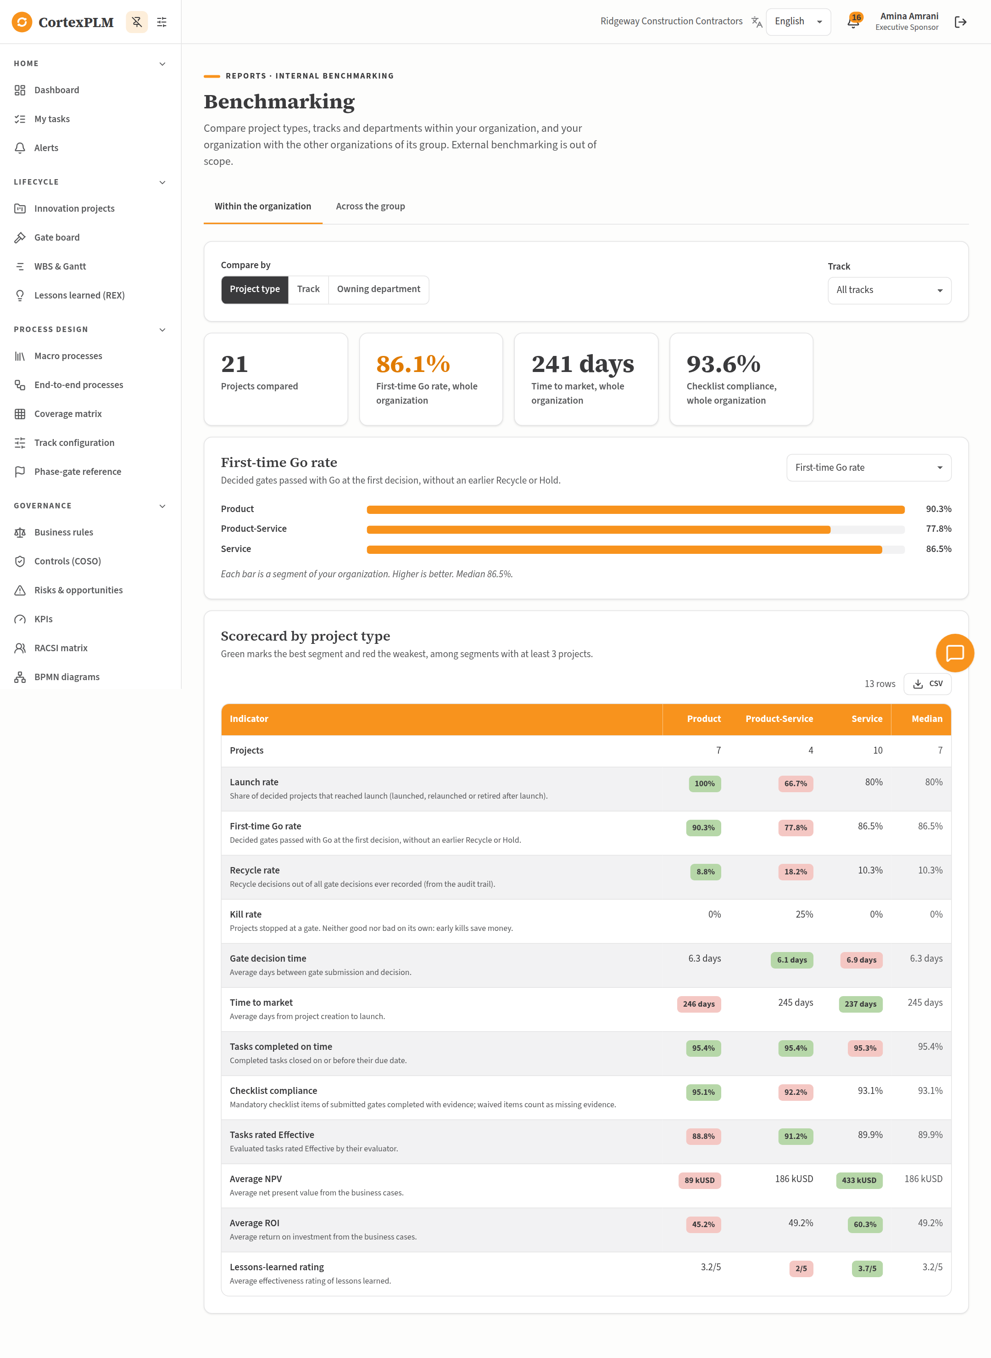
Benchmarking within the organization, compared by project type.

Step 2. Compare tracks and filter
1. Under Compare by, select Track. The scorecard now compares the Full, Light and Fast tracks.
2. In Project type, choose Service to compare tracks for Service projects only. Choose All project types to reset.
3. Select CSV above the scorecard to download the figures.
Track | Projects | First-time Go | Time to market | Average NPV
Fast | 3 | 100% | 121 days | 957 kUSD
Full | 15 | 86.4% | 250 days | 190 kUSD
Light | 3 | 75% | 254 days | 201 kUSD

Step 3. Compare with the organizations of the group
1. Select the tab Across the group. The card shows Atlas Infrastructure Holding and its three organizations.
2. Read the note: only aggregated indicators are exchanged. No project, person or document of Cedarline or Orvane is visible.
3. In the chart, choose First-time Go rate, then Gate decision time. Your organization is marked (you).
4. Read the Scorecard by organization and the Median column.
Organization | First-time Go | Recycle | Decision time | Time to market
Cedarline Precast Systems | 95% | 2.9% | 4.2 days | 174 days
Orvane Transit Group | 86.5% | 11.1% | 7.7 days | 212 days
Ridgeway Construction Contractors (you) | 86.1% | 11.4% | 6.6 days | 241 days

What it tells you: Cedarline passes gates first time most often and decides fastest; Ridgeway can learn from its gate preparation.
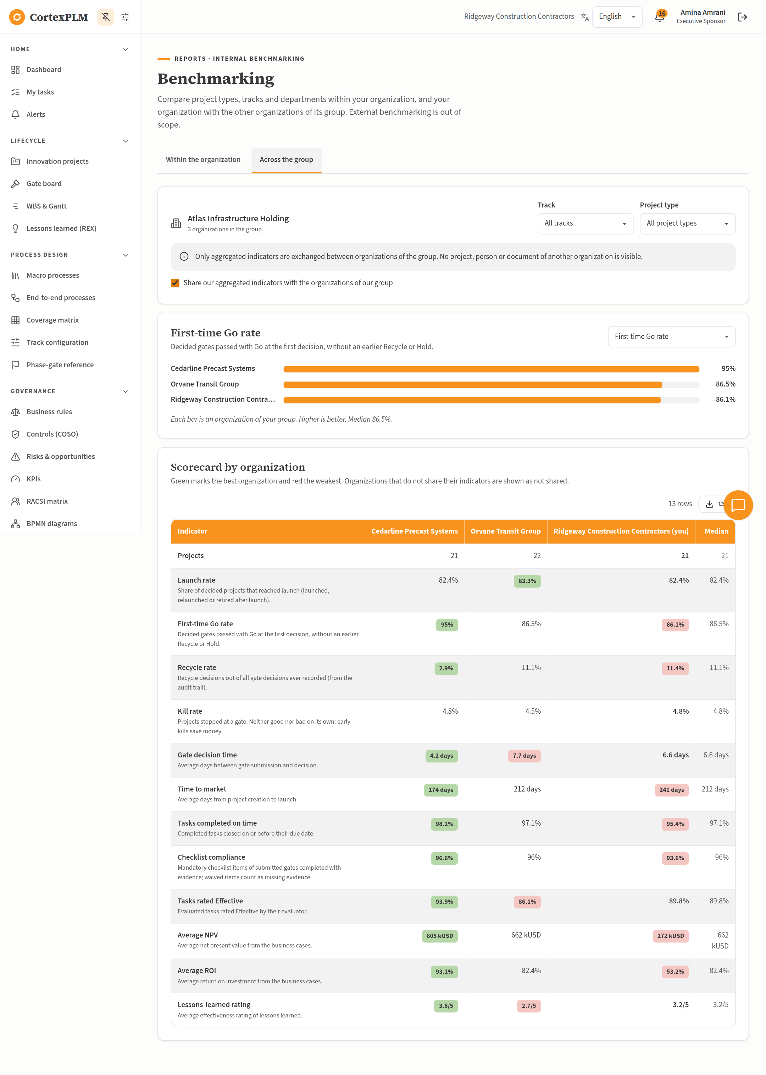
Benchmarking across Atlas Infrastructure Holding, as seen by Ridgeway.

Step 4. Stop or resume sharing with the group
1. Still on Across the group, clear Share our aggregated indicators with the organizations of our group. A message confirms Saved.
2. Sign in as exec@cedarline.example, open Benchmarking > Across the group: Ridgeway now shows Not shared in every row.
3. Sign in again as exec@ridgeway.example and tick the box again to resume sharing.

Step 5. An independent organization
1. Sign in as exec@meridale.example (Meridale Health Network, no group) and open Reports > Benchmarking.
2. The tab Within the organization works as in Step 1. The tab Across the group explains that the organization belongs to no group, so there is no comparison.
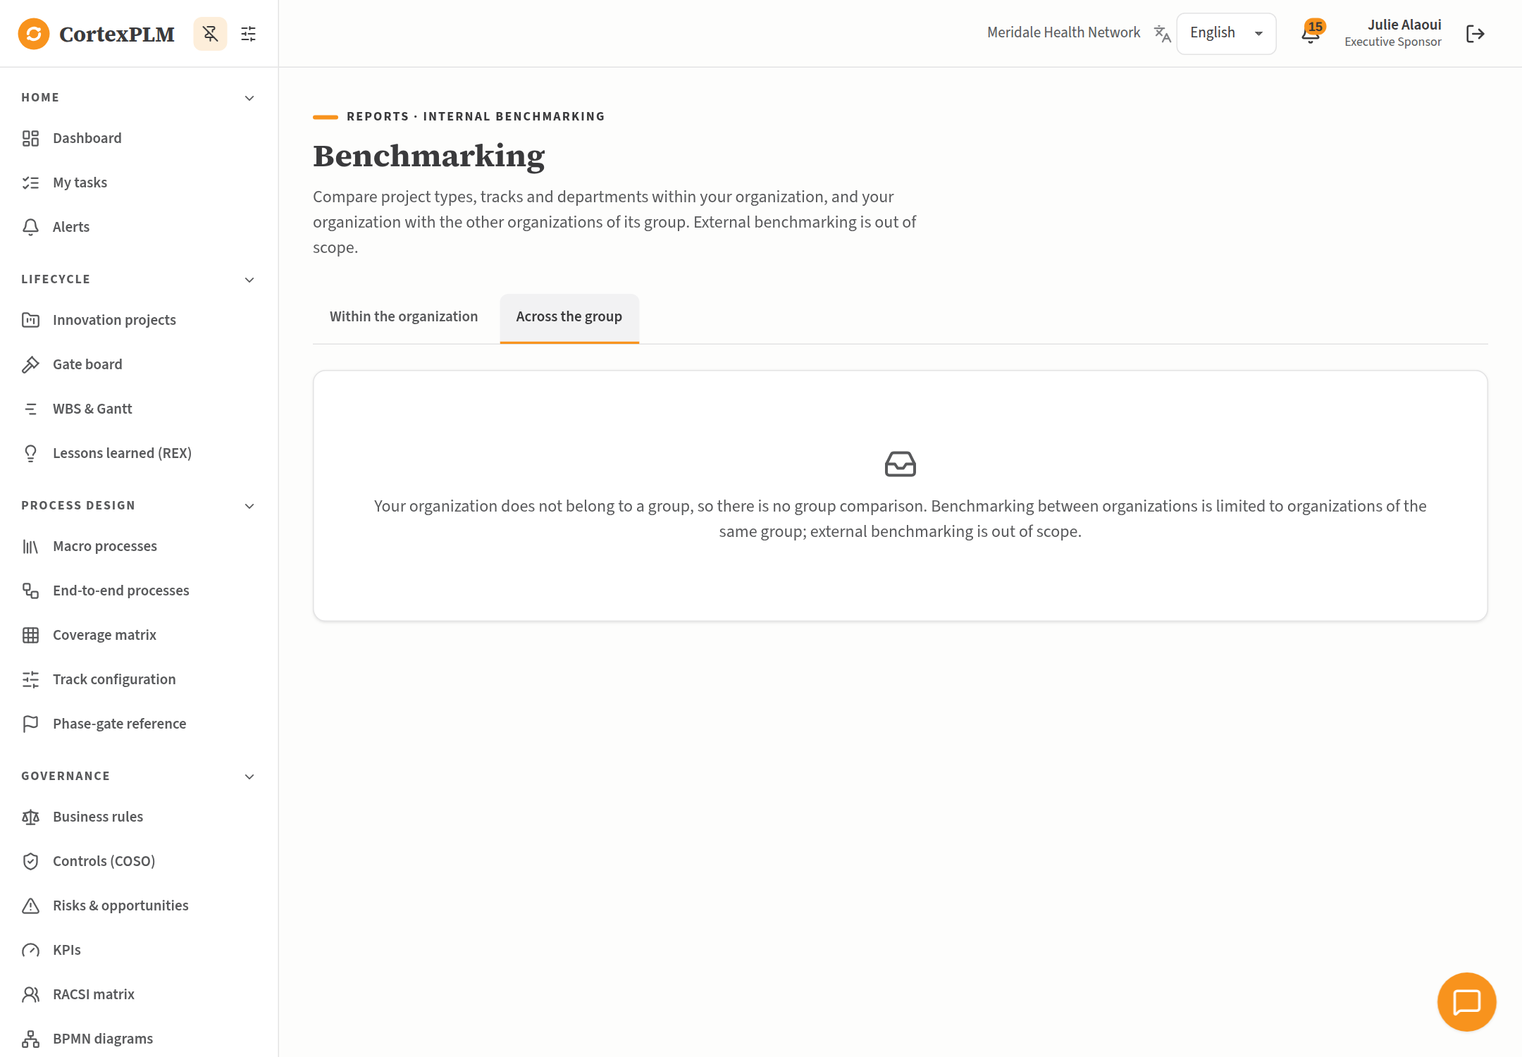
An independent organization has no group comparison.

11. Everyday Scenarios by Module
Short scenarios for the modules not used in the runs. All take place in Metro City Digital Services Agency unless stated; the password is Demo#2026. Where a justification is requested, type the text given or your own reason.

11.1 Record a business rule
Sign in as process@metrocity.example.
1. Open Governance > Business rules and select Add rule.
2. Type Rule ID BR-PUB-101, Triggering step MP-33.2, Condition A service goes live without an accessibility audit, Action Block the T3 submission and notify the Quality Manager.
3. Choose Rule type Validation, Severity High, type Owner Quality Manager and Process tag MP-121.
4. Select Save. In the justification window type New accessibility policy 2026 and select Save change.

11.2 Add a control, change it and compare versions
Sign in as process@metrocity.example.
1. Open Governance > Controls (COSO) and select Add control.
2. Type Name Accessibility audit before go-live; choose COSO component Control Activities, Control type Preventive, Testing frequency Per change; type Owner Quality Manager; choose Effectiveness Not tested; type Process tag MP-121. Select Save, justification New control for the accessibility policy.
3. Open the new control, change Effectiveness to Effective, select Save, justification Tested on PUB-022.
4. Open it again, select the tab Version history. Under Compare two versions choose From Version 1 and To Version 2: the row effectiveness is marked Changed.

11.3 Log a risk and read the heat map
Sign in as process@metrocity.example.
1. Open Governance > Risks & opportunities and select Add.
2. Choose Type Risk; type Name Payment provider outage, Category Operational, Likelihood 3, Impact 4, Owner Finance Controller; choose Status Open; type Process tag MP-121. Save with the justification Identified during PUB-022 launch.
3. In the heat map, select the cell likelihood 3 × impact 4: the list shows the risks scored 12.

11.4 See the governance of one process
Sign in as process@metrocity.example.
1. Open Process design > Macro processes and open MP-121.
2. Scroll to Governance tagged to this process: the rule BR-PUB-101, the new control and the new risk appear with the organization's other MP-121 records.

11.5 Build a RACSI activity
Sign in as process@metrocity.example.
1. Open Governance > RACSI matrix and select Add activity. Type Activity Accessibility audit, Process tag MP-121, then Save.
2. In the row, select + under R and type Quality Manager; select + under A and type Product Manager.
3. Select + under A again and type Executive Sponsor: the application refuses a second Accountable.

11.6 Track a custom KPI
Sign in as process@metrocity.example.
1. Open Governance > KPIs, tab Custom KPIs, and select Add custom KPI.
2. Type Name Online completion rate, Formula (plain language) Requests completed online divided by all requests, Target 85, Unit %, Current value 81, Owner Product Manager, Process tag MP-12. Save.
3. Open the tab Built-in KPIs and select KPI-07 Design review first-pass yield. Select Record measurement, type Period (YYYY-MM) 2026-09 and Value 88, then Save. The trend line shows the measurement against the dashed target.

11.7 Edit and exchange a BPMN diagram
Sign in as process@metrocity.example.
1. Open Governance > BPMN diagrams and open the E2E-01 diagram.
2. Drag a task from the palette on the left onto the canvas and name it Accessibility audit. Select Save diagram.
3. Select Export .bpmn to download the file; Import .bpmn loads a file from any BPMN 2.0 tool.

11.8 Ask for an AI suggestion on a task
Sign in as pm1@metrocity.example.
1. Open My tasks and open a task in progress.
2. In the card AI assistance, keep the proposed use case, type Focus on accessibility in Add details for the suggestion, then select Get suggestion.
3. The suggestion is labelled AI-generated with its tier, source and references. Select Accept, Edit or Reject; the decision goes to the usage log (Intelligence > AI use cases > Usage log).

11.9 Search the knowledge base in your language
Sign in as pm2@metrocity.example (French interface).
1. Open Intelligence > Base de connaissances (tab Rechercher).
2. In the search box type preuves checklist jalon: the French reference articles are ranked first, followed by matching records of your organization.
3. Open the tab Articles: the list shows French articles by default; use the language filter to show English or العربية articles.

11.10 Create a project template and use it
Sign in as process@metrocity.example.
1. Open Intelligence > Templates and select Add template. Type Name Citizen e-service (Fast), Kind Project.
2. In Default values (JSON) type {"offer_type":"Service","scores":{"strategic":2,"investment":1,"novelty":2,"regulatory":2,"market":1,"reach":2,"integration":1}}. Save.
3. Sign in as pm1@metrocity.example, open New project and choose the template in Start from a template: type and scores are pre-filled and remain editable.

11.11 Plan with a WBS and a Gantt chart
Sign in as pm1@metrocity.example.
1. Open Lifecycle > WBS & Gantt and select New WBS. Type Name PUB-022 launch plan, choose Project PUB-022, tick Fill it with all tasks of this project, grouped by E2E run, then Create.
2. Open the Gantt: bars show planned, in-progress, completed and overdue tasks with dependency lines.
3. Select Export PDF to download the chart.

11.12 Record a lesson learned
Sign in as pm1@metrocity.example.
1. Open Lifecycle > Lessons learned (REX) and select Add lesson.
2. Type Title Accessibility audit booked too late, What went well The audit found no blocking issue, What did not go well The audit slot was booked two weeks before go-live, Root cause No audit step in the launch plan, Recommendation Add the audit to UFT-05-02 Develop Detailed Launch Plan; choose Category Governance; type Effectiveness rating 3. Save.
3. The register view groups lessons by category and shows the average rating by month.

11.13 Export a report
Sign in as exec@metrocity.example.
1. Open Reports & cockpits and open RPT-01.
2. Select PDF, Excel or Word: the file is named with the report key and today's date.

11.14 Choose how you are notified
Sign in as pm1@metrocity.example.
1. Open Notifications, tab Preferences, and tick E-mail for Gate submissions and decisions.
2. Open the tab Delivery log to see each delivery with its status and attempts.

11.15 Add a user within the licence limit
Sign in as admin@metrocity.example.
1. Open Administration > Users & roles and select Add user.
2. Type Name Nora Idrissi, E-mail nora.idrissi@metrocity.example, choose Roles Quality Manager, Language Français, and type Password Welcome#2026. Save.
3. The seat counter increases by one. When all seats are used, the application refuses new users.

11.16 Give a project its own team tree (OBS)
Sign in as admin@metrocity.example.
1. Open Administration > Organizations & OBS, tab OBS of Metro City Digital Services Agency.
2. In Tree, choose PUB-022 Online Parking Permit Renewal, then Add node. Type Name Permit delivery team, Type Team, and Save.
3. Choose Organization tree in Tree to return to the organization's own structure.

11.17 Back up the database
Sign in as admin@cortexplm.example / Admin#2026 (platform administrator).
1. Open Administration > Configuration and scroll to Backups.
2. Select Back up now. The new file appears in the list; one automatic backup is also made every day.

11.18 Check the audit trail
Sign in as auditor@metrocity.example.
1. Open Administration > Audit trail, type accessibility in the search box and select Search.
2. Each line shows who changed what, when, the old and new values and the justification. The trail is read-only.

12. Messages You May Meet
Message | Why | What to do
Evidence is required before this item can be marked complete (BR-005). | A mandatory checklist item has no evidence. | Type an evidence reference or attach a file, then select Mark complete.
Gate submission blocked: … mandatory checklist item(s) are open (BR-004). | The checklist is not finished. | Complete or waive the mandatory items, then complete the checklist task.
The person accountable for the project cannot record its gate decision (CTL-01). | You own the project. | Ask the Executive Sponsor or a Gate Review Board member to decide.
Go-live is blocked: final regulatory validation reports incomplete approvals (BR-030). | UFT-05-08 answered No. | Once the approvals are obtained, open Final Regulatory Validation, select Reopen task, type the reason, answer Yes, complete the task and submit the gate again.
Strategic-fit score below 50: the idea is parked (BR-001). | UFT-01-02 scored below 50. | The project goes On Hold for 90 days. Select Resume project after re-review.
Only the task owner or a process manager can update this task. | You are not the owner and lack project edit rights. | Ask the owner, or sign in as the Product Manager.
This E2E run has not started yet (observation period, Rule R1). | Light Track performance review is scheduled after launch. | Wait for the start date, or ask the Track Administrator to shorten the observation period.

