POWERACT
CONSULTING


INSTALLATION GUIDE · PRODUCTION
CortexSkills — Dedicated Cloud & On-Premises
Install CortexSkills for one customer in its public cloud, its private cloud or its own datacenter, activate the licence and the packs
Version 1.10.0 · 2026-10-07
Prepared by POWERACT Consulting

Table of Contents
1. About this guide 4
Licence: a vendor-signed file 4
Who does what 4
2. Before you start (server side) 5
Server and network 5
Sizing 5
Cloud-specific preparation 5
What you receive from the vendor 6
3. Install on Linux (server side) 7
Step 1 — Install Node.js 22 LTS 7
Step 2 — Create the service account and the folders 7
Step 3 — Copy and unzip the application 7
Step 4 — Install the components 7
Step 5 — Write the configuration file (.env) 7
Step 6 — Place the vendor public key 8
Step 7 — Create the production database 8
Step 8 — Run CortexSkills as a service 9
Step 9 — Publish it in HTTPS 9
Option A — Nginx with Let’s Encrypt 9
Option B — Caddy (automatic certificate) 9
Option C — Company certificate 9
Step 10 — Check the installation 9
Installing without Internet access 10
4. Install on Windows Server (server side) 11
5. Create the organization and activate the licence 12
Step 1 — Create the organization 12
Step 2 — Request the licence 12
Step 3 — The vendor signs the licence 13
Step 4 — Install the licence 13
6. Activate and change the packs 14
The catalogue 14
How the activation works in a dedicated installation 15
Upgrade, add users or renew 15
Licence states 16
7. Customer side: get started 17
First sign-in and password 17
Check the licence 18
Create the users 18
Finish the set-up 18
Activate add-ons, standards and upload a licence 19
The Configuration & licence screen 19
Activate an add-on 19
Activate a compliance standard 20
Upload a new licence file 21
8. Operate the installation (server side) 22
Backups 22
Restore a backup 22
Updating to a new version 22
Monitoring and logs 22
Security checklist 23
Troubleshooting 23
Appendix — Console commands 24

1. About this guide
In a dedicated installation, CortexSkills runs for one customer only, in an environment chosen by the customer. The same guide covers the three cases below, because the installation is the same: only the place of the server, the network and the source of the HTTPS certificate change.
 | Dedicated public cloud | Dedicated private cloud | On-premises
Where | A virtual machine in the customer’s Azure, AWS, Google Cloud or OVHcloud subscription | A virtual machine in the customer’s VMware, Nutanix, OpenStack or Hyper-V platform | A server (physical or virtual) in the customer’s premises
Address | https://skills.customer.com | https://skills.customer.local (internal DNS) or public | Internal address, often no Internet
Certificate | Let’s Encrypt or company | Company certificate authority | Company certificate authority
Backups | Disk snapshots + storage account | VM backup + network share | Backup tool + network share
Install steps | Same (chapters 3 to 6) | Same (chapters 3 to 6) | Same; without Internet see chapter 3

Licence: a vendor-signed file
A dedicated installation runs in onprem mode (DEPLOYMENT_MODE=onprem). The licence is a file signed by the vendor with its private key; the server checks the signature with the vendor public key. Nobody can change the pack, the number of users or the date in the file without breaking the signature. The vendor private key never leaves the vendor.
Dedicated cloud operated by the provider
If the provider operates a dedicated instance in its own cloud subscription for one customer, it can also use the SaaS mode with a single organization (see the SaaS guide). Use this guide when the customer or its IT partner operates the server.

Who does what
Task | Vendor | Customer IT (server side) | Customer administrator
Deliver the application and the public key | ●
Prepare the server, network, DNS, certificate |  | ●
Install, configure, initialize (chapters 3–4) | support | ●
Create the organization, request the licence (chapter 5) |  | ●
Sign the licence file (chapter 5) | ●
Install the licence (chapter 5) |  | ●
Users, channels, add-ons, standards (chapters 6–7) |  |  | ●
Backups, updates, monitoring (chapter 8) | new versions | ●

2. Before you start (server side)

Server and network
Item | Recommended | Notes
Operating system | Ubuntu Server 22.04 / 24.04 LTS | Also works on Debian 12, RHEL 9 and Windows Server 2019/2022 (see the Windows chapter).
Node.js | 22 LTS (22.13 or newer) | The only runtime needed. The database is built into Node.js (SQLite): no database server to install.
Reverse proxy | Nginx or Caddy (Linux), IIS (Windows) | Terminates HTTPS and forwards to CortexSkills on 127.0.0.1:4000.
Domain name | skills.customer.com | A DNS record pointing to the server (or to the load balancer).
TLS certificate | Let’s Encrypt (automatic) or your company certificate | HTTPS is mandatory in production: the server refuses to start without an https:// public address.
Open ports | 443 (HTTPS), 80 (redirect only) | Port 4000 stays closed to the outside; only the reverse proxy reaches it.
Outbound access | SMTP server; WhatsApp Cloud API (optional); AI provider (optional) | Only needed for the channels and AI features you use.

Sizing
CortexSkills runs as one Node.js process with an embedded database. It scales up (a larger server), not out. The sizes below are recommendations for active users at the same time of day; monitor the server and adjust.
Users (total) | vCPU | Memory | SSD disk | Example
up to 500 | 2 | 4 GB | 40 GB | Azure B2ms · AWS t3.medium · GCP e2-medium
500 – 3 000 | 4 | 8 GB | 100 GB | Azure D4s v5 · AWS m6i.xlarge · GCP e2-standard-4
3 000 – 10 000 | 8 | 16 GB | 250 GB | Azure D8s v5 · AWS m6i.2xlarge · GCP e2-standard-8

Disk space
Plan the disk for the data folder (database + attached files + 30 days of daily backups). A database of 1 GB with 30 backups needs about 31 GB. Put the data folder on a disk that is snapshotted or backed up.

Cloud-specific preparation
Platform | What to prepare
Microsoft Azure | A Linux VM (Ubuntu 24.04), a Premium SSD data disk mounted on /var/lib/cortexskills, a Network Security Group allowing 443 (and 80 for Let’s Encrypt), Azure Backup on the VM, an Azure Files share mounted for BACKUP_COPY_DIR.
AWS | An EC2 instance (Ubuntu 24.04), an EBS gp3 volume for /var/lib/cortexskills, a security group allowing 443/80, EBS snapshots with Data Lifecycle Manager, an S3 bucket mounted (Mountpoint for S3) or EFS for BACKUP_COPY_DIR.
Google Cloud | A Compute Engine VM, a persistent SSD disk, a firewall rule for 443/80, snapshot schedules, a Filestore share or a Cloud Storage bucket (gcsfuse) for BACKUP_COPY_DIR.
Private cloud (VMware, Nutanix, OpenStack, Hyper-V) | A VM from the Ubuntu or RHEL template, an internal DNS record, a certificate from the company authority, the VM in the backup policy, an NFS/SMB share for BACKUP_COPY_DIR.
On-premises | The same as private cloud. On Windows Server, follow chapter 4 instead of chapter 3.

What you receive from the vendor
File | Content
CortexSkills-app.zip | The application: server, web/dist (built screens), deploy (configuration examples)
vendor-public.pem | The vendor public key (checks the licence signature)
<company>.lic (later) | The signed licence file, after you send the Organization ID (chapter 5)

3. Install on Linux (server side)
The commands below are for Ubuntu Server; on RHEL use dnf instead of apt-get. Type them one at a time.

Step 1 — Install Node.js 22 LTS
Connect to the server with SSH as a user with sudo rights, then type:
curl -fsSL https://deb.nodesource.com/setup_22.x | sudo -E bash -
sudo apt-get install -y nodejs unzip
node -v
The last command must print v22.13 or higher.

Step 2 — Create the service account and the folders
sudo useradd --system --home /opt/cortexskills --shell /usr/sbin/nologin cortexskills
sudo mkdir -p /opt/cortexskills /var/lib/cortexskills /var/log/cortexskills

Step 3 — Copy and unzip the application
Copy CortexSkills-app.zip to the server (for example with scp or WinSCP), then:
cd /tmp && unzip -q CortexSkills-app.zip
sudo cp -r /tmp/CortexSkills/. /opt/cortexskills/
The folder now holds server (the application and its tools), web/dist (the screens, already built) and deploy (the configuration files used in this guide).

Step 4 — Install the components
cd /opt/cortexskills/server && sudo npm ci --omit=dev
This downloads the components listed in package-lock.json (1 to 3 minutes). The server needs Internet access to the npm registry for this step only; for a server without Internet access, see “Installing without Internet access”.

Step 5 — Write the configuration file (.env)
sudo cp /opt/cortexskills/deploy/env.production.example /opt/cortexskills/server/.env
cd /opt/cortexskills/server && npm run -s secrets
The second command prints three new random secrets. Open the .env file (sudo nano .env) and fill it as below:
Setting | Value to type
NODE_ENV | production
DEPLOYMENT_MODE | onprem
PUBLIC_URL / CORS_ORIGIN | https://skills.customer.com
TRUST_PROXY | loopback (the reverse proxy is on the same server)
JWT_SECRET, CHANNEL_SECRET_KEY | the values printed by npm run secrets
LICENSE_HMAC_SECRET | leave empty (not used: the licence is a vendor-signed file)
DATA_DIR | /var/lib/cortexskills
BACKUP_RETENTION_DAYS / BACKUP_COPY_DIR | 30 / a mounted folder on another machine or cloud storage
ADMIN_EMAIL, ADMIN_NAME, ADMIN_PASSWORD | the first platform administrator (used once by npm run init)
SMTP_HOST, SMTP_PORT, SMTP_USER, SMTP_PASS, SMTP_FROM | the platform e-mail server (invitations, reminders)
WHATSAPP_* | optional: WhatsApp Business Cloud API

Keep the secrets safe
Store a copy of the .env file in your password vault. Changing JWT_SECRET signs every user out; changing CHANNEL_SECRET_KEY makes the stored channel passwords unreadable.

Step 6 — Place the vendor public key
The vendor sends vendor-public.pem with the licence. It lets the server check that the licence file was signed by the vendor and not modified.
sudo mkdir -p /opt/cortexskills/server/tools/keys
sudo cp vendor-public.pem /opt/cortexskills/server/tools/keys/
Never the private key
Only the public key goes on the customer server. If a file named vendor-private.pem is found in tools/keys, the server refuses to start.

Step 7 — Create the production database
sudo chown -R cortexskills:cortexskills /opt/cortexskills /var/lib/cortexskills /var/log/cortexskills
cd /opt/cortexskills/server && sudo -u cortexskills npm run init
npm run init builds the reference catalog (process design, packs, sectors, document templates), creates the platform administrator from ADMIN_EMAIL / ADMIN_PASSWORD and takes a first backup. It holds no demonstration data and no customer organization. It takes a few seconds and prints:
Production database ready in 1 s: reference catalog, 261 library records, no organization.
- The password must have at least 12 characters, with upper and lower case letters, a digit and a symbol; otherwise init stops and says why.
- Then remove the ADMIN_PASSWORD line from .env.
- npm run init refuses to run on a database that already holds organizations. npm run seed (demonstration data) is disabled in production.

Step 8 — Run CortexSkills as a service
sudo cp /opt/cortexskills/deploy/cortexskills.service /etc/systemd/system/
sudo systemctl daemon-reload && sudo systemctl enable --now cortexskills
sudo systemctl status cortexskills
The service starts with the server, restarts automatically after a failure and writes its log to /var/log/cortexskills. The first lines of the log show:
CortexSkills API is running on http://localhost:4000 (mode: onprem, production)
Open the application at https://skills.customer.com.
Safety check at start-up
In production the server refuses to start while a setting is unsafe and lists each problem with the fix: a missing or development secret, the same value for two secrets, a public address that is not https://, CORS_ORIGIN=*, demonstration data, a missing vendor public key or a vendor private key on the server.
Read the reason with: sudo tail -n 20 /var/log/cortexskills/cortexskills-error.log

Step 9 — Publish it in HTTPS

Option A — Nginx with Let’s Encrypt
sudo apt-get install -y nginx certbot python3-certbot-nginx
sudo certbot certonly --nginx -d skills.customer.com
sudo cp /opt/cortexskills/deploy/nginx-cortexskills.conf /etc/nginx/sites-available/cortexskills
Replace skills.example.com with skills.customer.com in the file, then:
sudo ln -s /etc/nginx/sites-available/cortexskills /etc/nginx/sites-enabled/ && sudo nginx -t && sudo systemctl reload nginx

Option B — Caddy (automatic certificate)
Install Caddy (caddyserver.com), copy deploy/Caddyfile to /etc/caddy/Caddyfile, replace the address with skills.customer.com and run sudo systemctl reload caddy. Caddy obtains and renews the certificate by itself.

Option C — Company certificate
With a certificate from your own certificate authority (common in private clouds and on-premises), keep the Nginx file and point ssl_certificate and ssl_certificate_key to your certificate (full chain) and private key.

Step 10 — Check the installation
curl https://skills.customer.com/api/health
The answer must be:
{"status":"ok","initialized":true,"mode":"onprem","version":"1.10.0"}
Then open https://skills.customer.com in a browser and sign in with the platform administrator account (ADMIN_EMAIL).

Installing without Internet access
Step 4 (npm ci) needs the npm registry. For a server without Internet (common on-premises):
- On a connected machine with the same operating system, the same processor type (x64 or arm64) and Node.js 22, unzip CortexSkills-app.zip and run npm ci --omit=dev in the server folder.
- Zip the whole CortexSkills folder (now with server/node_modules) and copy it to the server, with the Node.js 22 installer (nodejs.org, “Linux binaries” or the .msi for Windows).
- Continue at step 5. The operating system must match because one component (the image renderer used for document charts) ships a compiled file per system.
Without Internet, the e-mail and WhatsApp channels need an internal SMTP relay and an outbound route to the WhatsApp API; the AI assistant needs a route to the AI provider (or stays off).

4. Install on Windows Server (server side)
Use PowerShell opened as administrator.
- Install Node.js 22 LTS (the .msi from nodejs.org) with the default options; check with node -v (v22.13 or higher).
- Unzip CortexSkills-app.zip to C:\CortexSkills (the folder holds server, web and deploy). Create the data folder D:\CortexSkillsData (on a backed-up disk).
- In C:\CortexSkills\server run: npm ci --omit=dev
- Copy deploy\env.production.example to server\.env, run npm run -s secrets and fill .env as in chapter 3 step 5, with DEPLOYMENT_MODE=onprem and DATA_DIR=D:\CortexSkillsData.
- Create server\tools\keys and copy vendor-public.pem into it.
- Run npm run init (it uses ADMIN_EMAIL, ADMIN_NAME and ADMIN_PASSWORD from .env), then remove ADMIN_PASSWORD from .env.
- Install NSSM (nssm.cc), add it to the PATH, then run the script deploy\install-windows-service.ps1 (adapt $App if the folder is not C:\CortexSkills). Check: nssm status CortexSkills shows SERVICE_RUNNING.
- In IIS, install the URL Rewrite and Application Request Routing modules; in ARR “Server Proxy Settings” tick Enable proxy. Create a site bound to https://skills.customer.com with your certificate, and copy deploy\web.config into its folder. It forwards every request to http://127.0.0.1:4000 and allows uploads up to 30 MB.
- Open https://skills.customer.com/api/health: the answer is {"status":"ok", … "mode":"onprem"}. The logs are in C:\CortexSkills\logs.
Windows notes
On Windows, run the console commands of this guide in C:\CortexSkills\server without sudo -u cortexskills, for example: npm run -s admin -- org-list. Exclude the data folder from antivirus real-time scanning and from OneDrive synchronization. Restore and update work as in chapter 8 with the service stopped (nssm stop CortexSkills).

5. Create the organization and activate the licence
The licence is tied to the Organization ID created on your server. The activation takes four steps; the customer’s users cannot sign in before step 4.
Step | Who | Action
1 | Customer IT | Create the organization and its administrator (org-create)
2 | Customer IT | Send the licence request to the vendor (licence-request)
3 | Vendor | Sign the licence file and send it
4 | Customer IT | Install the file (licence-install); the users can sign in

Step 1 — Create the organization
cd /opt/cortexskills/server
sudo -u cortexskills npm run -s admin -- org-create --name "Office Régional Nord" --domain orn.ma --segment LARGE --sector HCPR --pack BND-02 --seats 150 --days 365 --lang en --country Morocco --city Casablanca --admin-email dsi@orn.ma --admin-name "Nadia Benali" --admin-password "Choose#AStrong1"
The console prints the Organization ID and the administrator account:
Organization created: Office Régional Nord
Organization ID: 5c2f2728-9f25-4059-af3e-931b36b51b20
Pack: BND-02 · seats: 150 · licence valid 365 days (OnPrem: upload the vendor-signed licence to activate it)
Administrator: dsi@orn.ma (role R-01, full rights in this organization)
Option | Meaning
--name / --domain | Company name; e-mail domain of its users (unique per organization)
--segment | LARGE (default) or SME
--sector | Sector code (for example HCPR private healthcare); the console lists the valid codes if you type a wrong one
--pack / --seats / --days | Contracted pack, number of users and licence duration
--lang / --country / --city | Default language (en, fr, ar) and location
--admin-email / --admin-name / --admin-password | The customer’s first administrator (role R-01). A strong password is required.

Step 2 — Request the licence
sudo -u cortexskills npm run -s admin -- licence-request --org orn.ma
Company: Office Régional Nord
Organization ID: 6ec2a117-eb31-4af4-ad03-5696108ecd13
Requested pack: BND-02
Requested users: 150
Add-ons: none
Send these lines to the vendor with the expected end date of the contract.

Step 3 — The vendor signs the licence
On the vendor signing computer only (never on a customer server), in the server folder of the source code:
npm run sign-licence -- --company "Office Régional Nord" --companyId 6ec2a117-eb31-4af4-ad03-5696108ecd13 --expiry 2027-12-31 --maxUsers 150 --plan BND-02 --features analytics,export,api --output ./ORN.lic
The first run creates the vendor key pair in server/tools/keys: vendor-private.pem (secret: keep it offline and back it up) and vendor-public.pem (the same for every customer). The vendor sends ORN.lic and vendor-public.pem to the customer.

Step 4 — Install the licence
sudo -u cortexskills npm run -s admin -- licence-install --file /tmp/ORN.lic
Licence installed for Office Régional Nord: pack BND-02, 150 users, valid until 2027-12-31.
The console checks the vendor signature and the Organization ID, writes the file to the data folder (license.lic, or LICENSE_PATH) and sets the organization’s pack and number of users. No restart is needed: the administrator can sign in at once. A modified file is refused with “The licence signature is not valid”.
Several organizations on one dedicated server
A group with several companies can create one organization per company on the same server. Each organization needs its own signed licence; the licence file keeps one entry per Organization ID.

6. Activate and change the packs

The catalogue
A customer organization always has exactly one Solution Pack (a pack, a bundle or an SME pack). Add-ons and compliance standards are independent and can be added to any pack. Changing a pack keeps all the data: modules outside the new pack become read-only, never deleted.
ID | Name | Type | Contains | AI tier | Price
PK-01 | Core Training Engineering Pack | Pack | PK-01 | Assistive | $99 USD/month (up to 100 users); $0.75/user/month beyond 100 users
PK-02 | Learning Delivery & Experience Pack | Pack | PK-02 | Assistive | $149 USD/month (up to 250 users); $0.60/user/month beyond 250 users
PK-03 | Assessment, Analytics & ROI Pack | Pack | PK-03 | Assistive and augmented | $129 USD/month (up to 500 users); $0.50/user/month beyond 500 users
PK-04 | Compliance & Certification Pack | Pack | PK-04 | Assistive | $99 USD/month (up to 300 users); $0.55/user/month beyond 300 users
PK-05 | Talent & Mobility Pack | Pack | PK-05 | Assistive | $119 USD/month (up to 300 users); $0.65/user/month beyond 300 users
PK-06 | Extended Enterprise Pack | Pack | PK-06 | Assistive | $109 USD/month (up to 200 external users); $0.80/external user/month beyond 200 users
PK-07 | Consulting & Diagnostic Pack | Pack | PK-07 | Assistive and augmented | $249 USD/month (up to 50 concurrent engagements); $5/engagement/month beyond 50
PK-08 | Strategic Workforce & Governance Pack | Pack | PK-08 | Assistive and augmented | $199 USD/month (up to 500 users); $0.45/user/month beyond 500 users
BND-01 | Starter Bundle | Bundle | PK-01, PK-02 | Assistive | 10% off the sum of base prices (248 USD)
BND-02 | Growth Bundle | Bundle | PK-01, PK-02, PK-03 | Assistive and augmented | 15% off the sum of base prices (377 USD)
BND-03 | Enterprise Bundle | Bundle | PK-01, PK-02, PK-03, PK-04, PK-05 | Assistive and augmented | 20% off the sum of base prices (595 USD)
BND-04 | Strategic Bundle | Bundle | PK-01, PK-02, PK-03, PK-04, PK-05, PK-06, PK-08 | Assistive and augmented | 25% off the sum of base prices (903 USD)
BND-05 | Full Suite | Bundle | PK-01, PK-02, PK-03, PK-04, PK-05, PK-06, PK-07, PK-08 | Assistive and augmented | 30% off the sum of base prices (1152 USD)
SME-ESS | SME Essentials Pack | SME pack | PK-01 + AD-11 | Assistive | Minimum 25 users; 1.2 USD per extra user per month
SME-GRO | SME Growth Pack | SME pack | PK-01, PK-02, PK-03 | Assistive and augmented | Minimum 50 users; 1 USD per extra user per month
SME-CMP | SME Complete Pack | SME pack | PK-01, PK-02, PK-03, PK-04, PK-05, PK-06, PK-07, PK-08 | Assistive and augmented | Minimum 100 users; 0.9 USD per extra user per month
Packs, bundles and SME packs (list prices of the catalogue; your contract prevails).
ID | Add-on | Price
AD-01 | Immersive Learning (VR/AR/Simulation) | $49 / month
AD-02 | AI Personalization Engine | $59 / month
AD-03 | Predictive Analytics | $69 / month
AD-04 | Social & Collaborative Learning | $40 / month
AD-05 | Gamification Engine | $40 / month
AD-06 | Content Curation & Aggregation Engine | $49 / month
AD-07 | Expert Knowledge Capture & Transfer | $45 / month
AD-08 | Multi-Site / Multi-Entity Deployment | $55 / month
AD-09 | External Training Plan Validation (Regulatory) | $45 / month
AD-10 | Leadership Maturity Assessment & Development | $69 / month
AD-11 | Questionnaire Library & Multi-Channel Distribution | $49 / month
Add-ons.
ID | Compliance & security standard
GDPR | GDPR
ISO27001 | ISO/IEC 27001
SOC2 | SOC 2
ISO27701 | ISO/IEC 27701
ISO9001 | ISO 9001
LAW0908 | Law 09-08 (CNDP, Morocco)
Compliance standards. CortexSkills organizes the evidence; it does not certify compliance.
On the server, the console prints the same catalogue: npm run -s admin -- packs

How the activation works in a dedicated installation
Element | Decided by | How
Pack, number of users, end date | The signed licence file | Installed with licence-install (server) or uploaded in Configuration & licence (customer administrator)
Add-ons | Customer administrator, per contract | Tick boxes in Configuration & licence, or addon --on (server); listed in licence-request for the true-up
Compliance standards | Customer administrator | Tick boxes in Configuration & licence

Upgrade, add users or renew
- The customer orders the change from the vendor (new pack, more users or a new end date).
- The vendor signs a new file for the same Organization ID (step 3 of chapter 5) and sends it.
- The customer administrator opens Administration › Configuration & licence, clicks Upload licence file and chooses the file — or the IT team runs licence-install again. The new file replaces the previous one for this organization; the pack and the number of users are updated at once.
Upload before the end date
After the end date the licence is read-only but administrators can still sign in and upload a new file. If the licence was never installed (status inactive), use licence-install on the server.

Licence states
State | When | What users see
Active | More than 30 days before the expiry date | Normal use.
Warning | 30 days or less before expiry | A banner reminds the administrator to renew.
Expired | After the expiry date | Read-only: users can sign in and read, not change.
Inactive | No licence for the organization | Sign-in is refused with “The licence of this Organization is not active”.

The number of users is enforced: when the active users reach the licence maximum, creating a new user is refused until a user is deactivated or the licence is extended.

7. Customer side: get started
This chapter is for the customer administrator, once the licence is installed. Everything is done in the browser.

First sign-in and password
- Open https://skills.customer.com and sign in with the administrator e-mail and the temporary password received from your IT team or the vendor.
- Click the profile icon (top right), then Change password.
- Type the current password, then the new one twice (12 characters or more, upper and lower case, a digit and a symbol) and click Save.
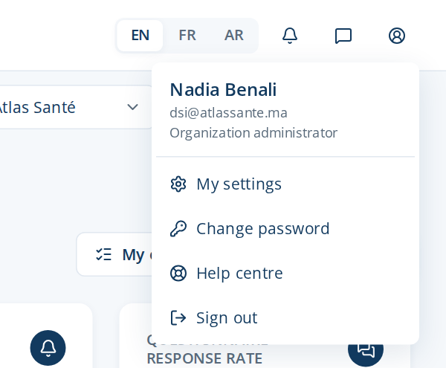
Figure 1 — The profile menu
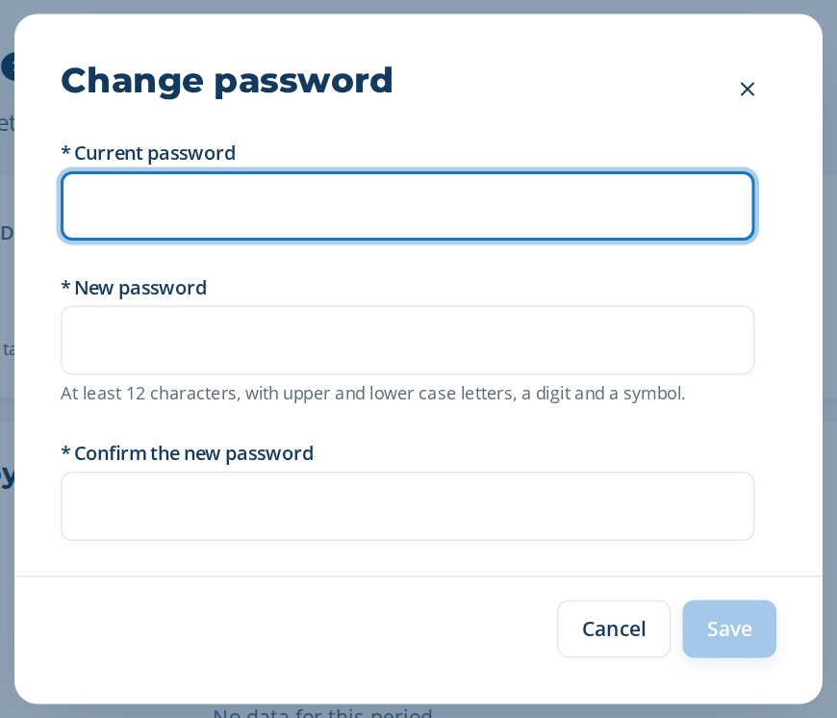
Figure 2 — Change password

Check the licence
Open Administration › Configuration & licence and check the Licence card: status Active, the plan and the number of users of your contract, the expiry date. If something is wrong, contact the vendor before inviting users.

Create the users
- Open Administration › Users and click New user.
- Type the name, the e-mail, the job title, the language and a temporary password; choose the role (for example Head of Learning & Development, Training Manager, Process Owner, Employee).
- Send each user the address of the application and the temporary password, and ask them to change it at first sign-in (profile › Change password).
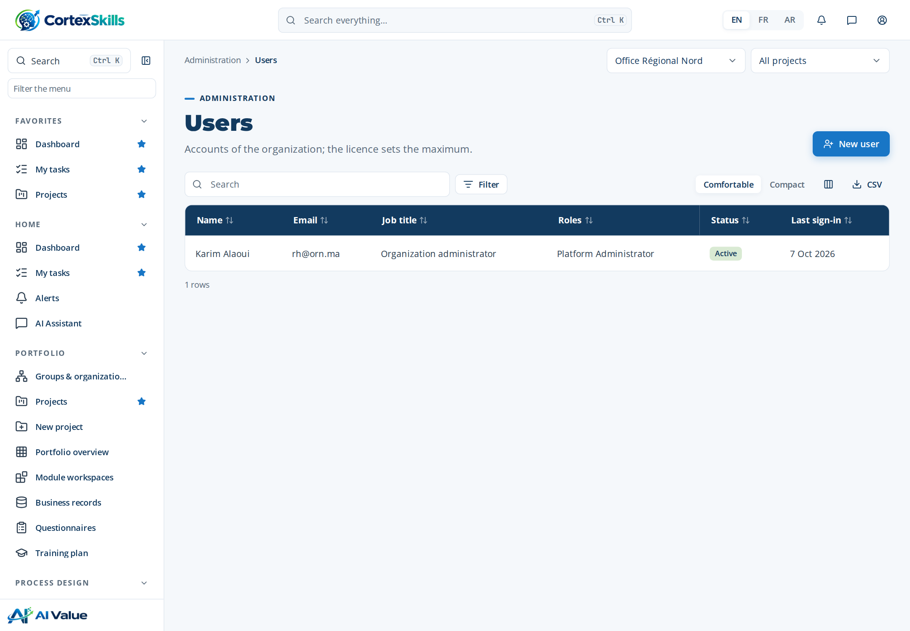
Figure 3 — Administration › Users

Finish the set-up
Menu | What to do
Administration › Channels (e-mail, WhatsApp) | Enter your own e-mail server (optional: otherwise the platform e-mail is used) and, if you use it, your WhatsApp Business account. Send a test message.
Administration › AI settings | Choose the AI provider and model, or keep the assistant off.
Administration › Permission matrix | Review what each role can see and do; adapt it to your organization.
Portfolio › Groups & organizations | Build the organization structure (directorates, departments, units) and assign the people.
Administration › SME onboarding | SME packs only: answer the short onboarding questions; the guided track is prepared for you.
Administration › Backups & health | See the last backups and the health of the service.

Then create the first project (Portfolio › New project): the users find their tasks in My tasks. The User Guide and the Administrator Guide describe each screen in detail.

Activate add-ons, standards and upload a licence

The Configuration & licence screen
Menu: Administration › Configuration & licence. The four tiles show the current pack, the number of modules included, the AI tier and the licence state. The Licence card shows the deployment mode, the plan, the maximum number of users, the expiry date and the active add-ons.
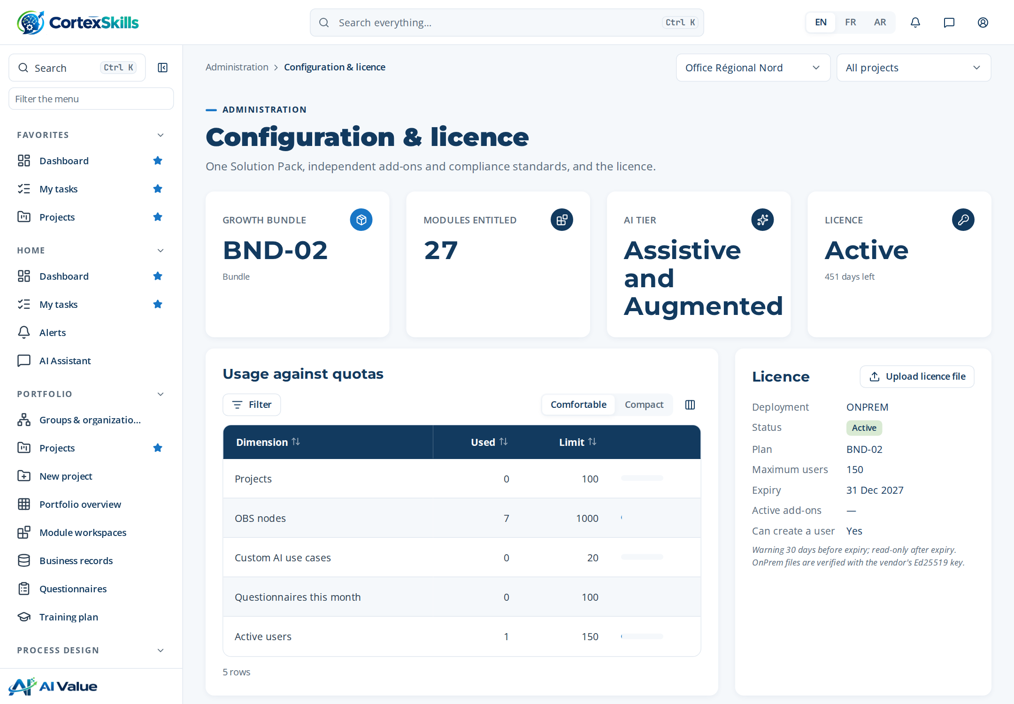
Figure 4 — Administration › Configuration & licence

Activate an add-on
In the Add-ons section, tick the box of the add-on. It becomes Active and its screens appear for the users who have the permission. Untick to deactivate it (its data is kept).
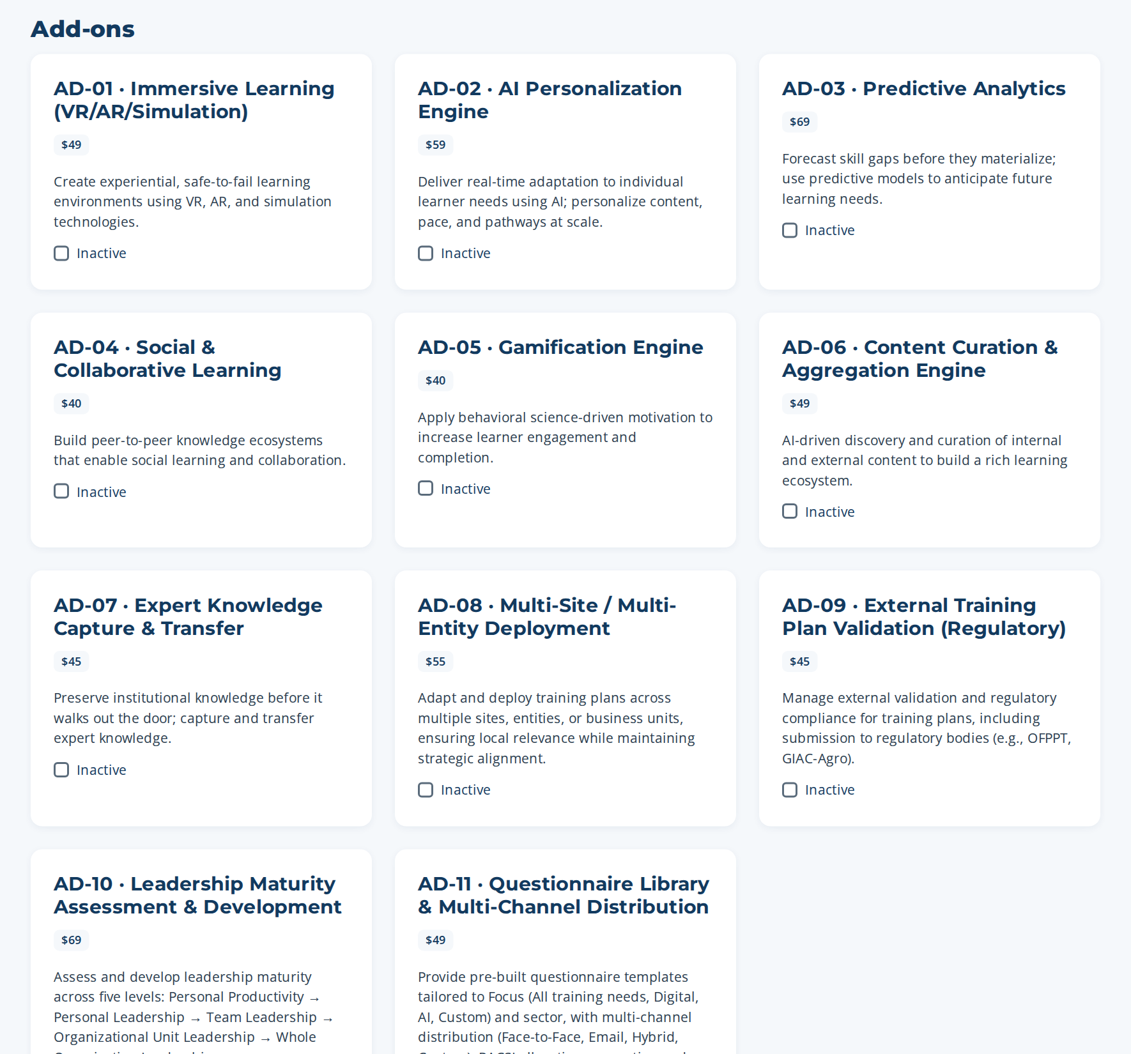
Figure 5 — Add-ons: one tick box per add-on

Activate a compliance standard
In Compliance & security standards, tick the standard. The first activation creates its controls once (for example 4 controls for ISO/IEC 27001) in the controls register. Deactivating keeps the controls. Read the notice: the application organizes the evidence; only an accredited body can certify.
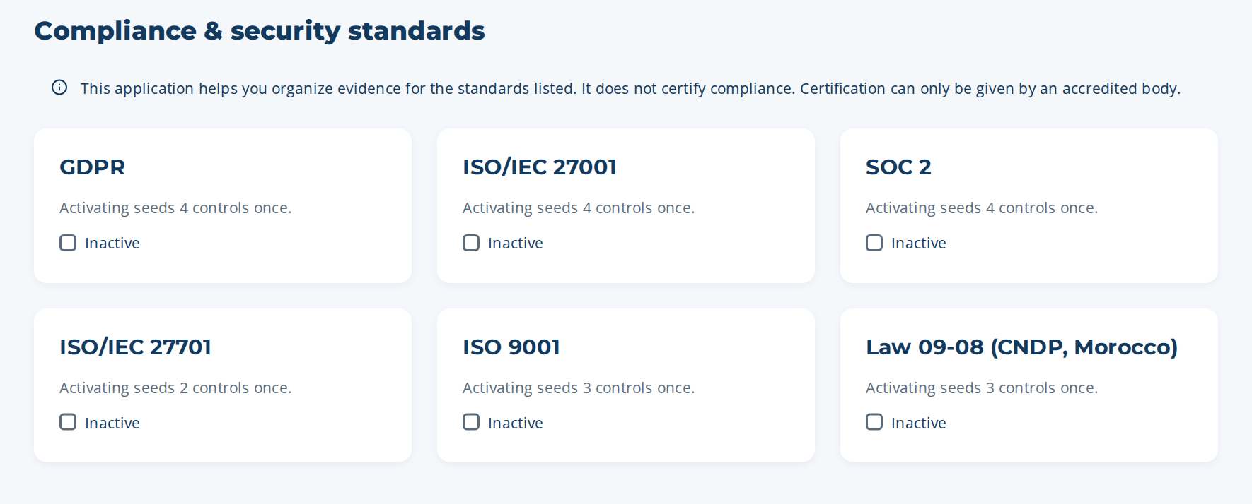
Figure 6 — Compliance & security standards

Upload a new licence file
- Save the .lic file received from the vendor on your computer.
- In Administration › Configuration & licence, click Upload licence file (Licence card) and choose the file.
- The Licence card shows the new plan, users and date. A message explains any refusal (signature not valid, file for another organization).

8. Operate the installation (server side)
Paths are for Linux. On Windows: C:\CortexSkills for the application, your DATA_DIR for the data, nssm stop / nssm start CortexSkills for the service.

Backups
- The server takes a backup of the database every day (data folder › backups) and keeps it BACKUP_RETENTION_DAYS days. Each backup is also copied to BACKUP_COPY_DIR when it is set: mount there a folder of another machine or of cloud storage.
- Take a backup at any time, for example before an update:
cd /opt/cortexskills/server && sudo -u cortexskills npm run backup
- The attached files (data folder › attachments) are not inside the database backup: include the whole data folder in your file backup or disk snapshots.

Restore a backup
- Stop the service: sudo systemctl stop cortexskills
- In /var/lib/cortexskills, move cortexskills.db (and the files cortexskills.db-wal and cortexskills.db-shm if present) to a safe folder.
- Copy the chosen file from backups (or from BACKUP_COPY_DIR) to /var/lib/cortexskills/cortexskills.db and give it to the cortexskills user (chown).
- Start the service: sudo systemctl start cortexskills. A backup from an earlier version is upgraded automatically at start-up.

Updating to a new version
- Take a backup (npm run backup) and stop the service.
- Keep server/.env and server/tools/keys/vendor-public.pem. The data folder (/var/lib/cortexskills) is outside the application folder and is not touched.
- Unzip the new CortexSkills-app.zip over /opt/cortexskills, put back the kept file(s), then run: cd /opt/cortexskills/server && sudo npm ci --omit=dev
- Give the folder back to the service account (chown -R cortexskills:cortexskills /opt/cortexskills) and start the service. Database changes are applied automatically at start-up.

Monitoring and logs
- Health check for your monitoring tool: GET https://skills.customer.com/api/health (status ok).
- Each API request is written as one JSON line (time, method, path, status, duration, client address, user) in /var/log/cortexskills/cortexskills.log; errors go to cortexskills-error.log. Rotate them with logrotate.
- Every administrative change (pack, add-on, licence, users, password change) is in the audit trail of the organization.

Security checklist
✓ | Check
☐ | HTTPS only; port 4000 not reachable from outside (firewall).
☐ | .env readable only by root and cortexskills (chmod 600); a copy in the password vault.
☐ | ADMIN_PASSWORD removed from .env after npm run init.
☐ | Backups copied off the server (BACKUP_COPY_DIR) and a restore tested once.
☐ | Operating system updates applied every month; Node.js kept on the 22 LTS line.
☐ | Only vendor-public.pem in server/tools/keys (never vendor-private.pem).
☐ | Every administrator changed the temporary password at first sign-in.

Troubleshooting
Message or symptom | What to do
“CortexSkills will not start in production mode” followed by a list | Fix each line in server/.env (or in server/tools/keys), then start again. npm run secrets generates the secrets.
“The database holds the demonstration data” | The database was created with npm run seed. Initialize a production database: npm run init -- --wipe-all-data (erases everything).
“The database already holds N organization(s)” (npm run init) | Normal protection: the database is already in use. Do not re-initialize it.
“The licence of this Organization is not active” at sign-in | Install the signed licence: npm run admin -- licence-install --file <file.lic>
“The licence signature is not valid” | The file was modified or not signed with the vendor key. Ask the vendor for a new file; do not edit it.
“This licence file belongs to another Organization” | The Organization ID in the file is not this organization. Compare with npm run admin -- org-list.
502 Bad Gateway in the browser | The service is stopped: sudo systemctl status cortexskills, then read the error log.
Uploads larger than 30 MB refused | Limit set in the reverse proxy (client_max_body_size in Nginx, max_size in Caddy, maxAllowedContentLength in IIS).
A user forgot the password | The organization administrator sets a temporary one in Administration › Users; on the server: npm run admin -- password --email <e-mail> --password <new>

Appendix — Console commands
Command (in /opt/cortexskills/server) | Purpose
npm run secrets | Print three new random secrets for .env
npm run init | Create the empty production database and the platform administrator
npm run backup | Back up the database now
npm run admin -- org-create … | Create a customer organization, its licence and its administrator
npm run admin -- org-list | List organizations with pack, users, add-ons and licence end date
npm run admin -- packs | List packs, bundles, SME packs, add-ons and standards
npm run admin -- licence-request --org <domain> | Print what to send to the vendor (company, Organization ID, pack, users, add-ons)
npm run admin -- licence-install --file <file.lic> | Check the vendor signature and install the licence
npm run admin -- addon --org <domain> --id AD-08 --on|--off | Activate or deactivate an add-on
npm run admin -- user-create --org <domain> --email … --name … --password … [--role R-03] | Create a user (role R-01 by default)
npm run admin -- password --email … --password … | Reset a password
npm run admin -- platform-admin --email … --name … --password … | Add a platform administrator

