POWERACT
CONSULTING


INSTALLATION GUIDE · PRODUCTION
CortexSkills — SaaS Mode
Host one CortexSkills platform for many customer organizations, onboard each customer and activate its packs
Version 1.10.0 · 2026-10-07
Prepared by POWERACT Consulting

Table of Contents
1. About this guide 4
How it works 4
2. Before you start (server side) 5
Server and network 5
Sizing 5
What you receive 5
3. Install the platform (server side) 7
Step 1 — Install Node.js 22 LTS 7
Step 2 — Create the service account and the folders 7
Step 3 — Copy and unzip the application 7
Step 4 — Install the components 7
Step 5 — Write the configuration file (.env) 7
Step 6 — Create the production database 8
Step 7 — Run CortexSkills as a service 8
Step 8 — Publish it in HTTPS 9
Option A — Nginx with Let’s Encrypt 9
Option B — Caddy (automatic certificate) 9
Option C — Company certificate 9
Step 9 — Check the installation 9
4. Onboard a customer (server side) 10
Collect the information 10
Create the organization 10
Send the welcome message 11
Check the customers 11
5. Activate and change the packs 12
The catalogue 12
Server side: the provider 13
Customer side: self-service 14
Licence file (optional) 14
Licence states 14
6. Customer side: get started 15
First sign-in and password 15
Check the licence 16
Create the users 16
Finish the set-up 16
Activate add-ons, standards and change the pack 17
The Configuration & licence screen 17
Change the pack 17
Activate an add-on 18
Activate a compliance standard 19
Renewal 20
7. Operate the platform (server side) 21
Backups 21
Restore a backup 21
Updating to a new version 21
Monitoring and logs 21
Security checklist 21
Troubleshooting 22
Appendix — Console commands 23

1. About this guide
In SaaS mode, the provider runs one CortexSkills installation on its own servers and serves many customers from it. Each customer is an Organization: its users, projects and documents are separated from the other customers. The provider issues each customer’s licence from the server console; the customer administrator manages users, pack options and add-ons from the web screens.
Who | Does what | Chapters
Provider operations team (server side) | Installs and runs the platform, onboards each customer, issues and renews licences, backs up and updates. | 2, 3, 4, 5, 7
Customer administrator (customer side) | Signs in, checks the licence, creates the users, configures channels and AI, activates add-ons and standards, changes the pack. | 5, 6
Customer users | Sign in with the address and the account received and work in My tasks. | 6

How it works
Element | SaaS mode
Installations | One, at the provider
Customers | Many organizations, data separated by organization
Address | One address for all customers, for example https://skills.example.com
Licence | A record per organization in the database, signed by the server (LICENSE_HMAC_SECRET); issued by the provider with the console
Pack activation | Provider: console (licence, add-on). Customer: Configuration & licence screen (self-service, logged)
DEPLOYMENT_MODE | saas

Time needed
About 1 hour for the platform (chapter 3), then 5 minutes per new customer (chapter 4) and 20 minutes for the customer administrator (chapter 6).

2. Before you start (server side)

Server and network
Item | Recommended | Notes
Operating system | Ubuntu Server 22.04 / 24.04 LTS | Also works on Debian 12, RHEL 9 and Windows Server 2019/2022 (see the Windows chapter of the Dedicated Cloud & On-Prem guide).
Node.js | 22 LTS (22.13 or newer) | The only runtime needed. The database is built into Node.js (SQLite): no database server to install.
Reverse proxy | Nginx or Caddy (Linux), IIS (Windows) | Terminates HTTPS and forwards to CortexSkills on 127.0.0.1:4000.
Domain name | skills.example.com | A DNS record pointing to the server (or to the load balancer).
TLS certificate | Let’s Encrypt (automatic) or your company certificate | HTTPS is mandatory in production: the server refuses to start without an https:// public address.
Open ports | 443 (HTTPS), 80 (redirect only) | Port 4000 stays closed to the outside; only the reverse proxy reaches it.
Outbound access | SMTP server; WhatsApp Cloud API (optional); AI provider (optional) | Only needed for the channels and AI features you use.

Sizing
CortexSkills runs as one Node.js process with an embedded database. It scales up (a larger server), not out. The sizes below are recommendations for active users at the same time of day; monitor the server and adjust.
Users (total) | vCPU | Memory | SSD disk | Example
up to 500 | 2 | 4 GB | 40 GB | Azure B2ms · AWS t3.medium · GCP e2-medium
500 – 3 000 | 4 | 8 GB | 100 GB | Azure D4s v5 · AWS m6i.xlarge · GCP e2-standard-4
3 000 – 10 000 | 8 | 16 GB | 250 GB | Azure D8s v5 · AWS m6i.2xlarge · GCP e2-standard-8

Disk space
Plan the disk for the data folder (database + attached files + 30 days of daily backups). A database of 1 GB with 30 backups needs about 31 GB. Put the data folder on a disk that is snapshotted or backed up.

What you receive
File | Content
CortexSkills-app.zip | The application: server, web/dist (built screens), deploy (configuration examples)
deploy/env.production.example | The settings file to copy to server/.env
deploy/cortexskills.service | The Linux service (systemd)
deploy/nginx-cortexskills.conf · deploy/Caddyfile | The HTTPS reverse proxy (choose one)

3. Install the platform (server side)
The commands below are for Ubuntu Server. Type them one at a time and wait for each to finish.

Step 1 — Install Node.js 22 LTS
Connect to the server with SSH as a user with sudo rights, then type:
curl -fsSL https://deb.nodesource.com/setup_22.x | sudo -E bash -
sudo apt-get install -y nodejs unzip
node -v
The last command must print v22.13 or higher.

Step 2 — Create the service account and the folders
sudo useradd --system --home /opt/cortexskills --shell /usr/sbin/nologin cortexskills
sudo mkdir -p /opt/cortexskills /var/lib/cortexskills /var/log/cortexskills

Step 3 — Copy and unzip the application
Copy CortexSkills-app.zip to the server (for example with scp or WinSCP), then:
cd /tmp && unzip -q CortexSkills-app.zip
sudo cp -r /tmp/CortexSkills/. /opt/cortexskills/
The folder now holds server (the application and its tools), web/dist (the screens, already built) and deploy (the configuration files used in this guide).

Step 4 — Install the components
cd /opt/cortexskills/server && sudo npm ci --omit=dev
This downloads the components listed in package-lock.json (1 to 3 minutes). The server needs Internet access to the npm registry for this step only; for a server without Internet access, see “Installing without Internet access”.

Step 5 — Write the configuration file (.env)
sudo cp /opt/cortexskills/deploy/env.production.example /opt/cortexskills/server/.env
cd /opt/cortexskills/server && npm run -s secrets
The second command prints three new random secrets. Open the .env file (sudo nano .env) and fill it as below:
Setting | Value to type
NODE_ENV | production
DEPLOYMENT_MODE | saas
PUBLIC_URL / CORS_ORIGIN | https://skills.example.com
TRUST_PROXY | loopback (the reverse proxy is on the same server)
JWT_SECRET, CHANNEL_SECRET_KEY | the values printed by npm run secrets
LICENSE_HMAC_SECRET | the value printed by npm run secrets (signs the customer licences)
DATA_DIR | /var/lib/cortexskills
BACKUP_RETENTION_DAYS / BACKUP_COPY_DIR | 30 / a mounted folder on another machine or cloud storage
ADMIN_EMAIL, ADMIN_NAME, ADMIN_PASSWORD | the first platform administrator (used once by npm run init)
SMTP_HOST, SMTP_PORT, SMTP_USER, SMTP_PASS, SMTP_FROM | the platform e-mail server (invitations, reminders)
WHATSAPP_* | optional: WhatsApp Business Cloud API

Keep the secrets safe
Store a copy of the .env file in your password vault. Changing JWT_SECRET signs every user out; changing CHANNEL_SECRET_KEY makes the stored channel passwords unreadable; changing LICENSE_HMAC_SECRET invalidates every customer licence (re-issue them with npm run admin -- licence).

Step 6 — Create the production database
sudo chown -R cortexskills:cortexskills /opt/cortexskills /var/lib/cortexskills /var/log/cortexskills
cd /opt/cortexskills/server && sudo -u cortexskills npm run init
npm run init builds the reference catalog (process design, packs, sectors, document templates), creates the platform administrator from ADMIN_EMAIL / ADMIN_PASSWORD and takes a first backup. It holds no demonstration data and no customer organization. It takes a few seconds and prints:
Production database ready in 1 s: reference catalog, 261 library records, no organization.
- The password must have at least 12 characters, with upper and lower case letters, a digit and a symbol; otherwise init stops and says why.
- Then remove the ADMIN_PASSWORD line from .env.
- npm run init refuses to run on a database that already holds organizations. npm run seed (demonstration data) is disabled in production.

Step 7 — Run CortexSkills as a service
sudo cp /opt/cortexskills/deploy/cortexskills.service /etc/systemd/system/
sudo systemctl daemon-reload && sudo systemctl enable --now cortexskills
sudo systemctl status cortexskills
The service starts with the server, restarts automatically after a failure and writes its log to /var/log/cortexskills. The first lines of the log show:
CortexSkills API is running on http://localhost:4000 (mode: saas, production)
Open the application at https://skills.example.com.
Safety check at start-up
In production the server refuses to start while a setting is unsafe and lists each problem with the fix: a missing or development secret, the same value for two secrets, a public address that is not https://, CORS_ORIGIN=*, demonstration data.
Read the reason with: sudo tail -n 20 /var/log/cortexskills/cortexskills-error.log

Step 8 — Publish it in HTTPS

Option A — Nginx with Let’s Encrypt
sudo apt-get install -y nginx certbot python3-certbot-nginx
sudo certbot certonly --nginx -d skills.example.com
sudo cp /opt/cortexskills/deploy/nginx-cortexskills.conf /etc/nginx/sites-available/cortexskills
Replace skills.example.com with skills.example.com in the file, then:
sudo ln -s /etc/nginx/sites-available/cortexskills /etc/nginx/sites-enabled/ && sudo nginx -t && sudo systemctl reload nginx

Option B — Caddy (automatic certificate)
Install Caddy (caddyserver.com), copy deploy/Caddyfile to /etc/caddy/Caddyfile, replace the address with skills.example.com and run sudo systemctl reload caddy. Caddy obtains and renews the certificate by itself.

Option C — Company certificate
With a certificate from your own certificate authority (common in private clouds and on-premises), keep the Nginx file and point ssl_certificate and ssl_certificate_key to your certificate (full chain) and private key.

Step 9 — Check the installation
curl https://skills.example.com/api/health
The answer must be:
{"status":"ok","initialized":true,"mode":"saas","version":"1.10.0"}
Then open https://skills.example.com in a browser and sign in with the platform administrator account (ADMIN_EMAIL).

4. Onboard a customer (server side)

Collect the information
Information | Example
Company name and e-mail domain | Clinique Atlas Santé · atlassante.ma
Segment and sector | Large organization · HCPR (private healthcare)
Contracted pack, users, duration | BND-03 · 250 users · 12 months
Add-ons in the contract | AD-11
Customer administrator | Nadia Benali · dsi@atlassante.ma
Default language | French

Create the organization
cd /opt/cortexskills/server
sudo -u cortexskills npm run -s admin -- org-create --name "Clinique Atlas Santé" --domain atlassante.ma --segment LARGE --sector HCPR --pack BND-03 --seats 250 --days 365 --lang en --country Morocco --city Casablanca --admin-email dsi@atlassante.ma --admin-name "Nadia Benali" --admin-password "Choose#AStrong1"
The console prints the Organization ID and the administrator account:
Organization created: Clinique Atlas Santé
Organization ID: 5c2f2728-9f25-4059-af3e-931b36b51b20
Pack: BND-03 · seats: 250 · licence valid 365 days
Administrator: dsi@atlassante.ma (role R-01, full rights in this organization)
Option | Meaning
--name / --domain | Company name; e-mail domain of its users (unique per organization)
--segment | LARGE (default) or SME
--sector | Sector code (for example HCPR private healthcare); the console lists the valid codes if you type a wrong one
--pack / --seats / --days | Contracted pack, number of users and licence duration
--lang / --country / --city | Default language (en, fr, ar) and location
--admin-email / --admin-name / --admin-password | The customer’s first administrator (role R-01). A strong password is required.

The licence is issued at once (status Active). Add the add-ons of the contract:
sudo -u cortexskills npm run -s admin -- addon --org atlassante.ma --id AD-11 --on

Send the welcome message
Send the customer administrator, by two separate channels: the address (https://skills.example.com) and the e-mail of the account in a first message; the temporary password in a second message (SMS or phone). Ask them to change it at first sign-in and to follow chapter 6 of this guide.

Check the customers
sudo -u cortexskills npm run -s admin -- org-list
One line per organization: ID, name, domain, segment, pack, seats, active users, add-ons and licence end date.

5. Activate and change the packs

The catalogue
A customer organization always has exactly one Solution Pack (a pack, a bundle or an SME pack). Add-ons and compliance standards are independent and can be added to any pack. Changing a pack keeps all the data: modules outside the new pack become read-only, never deleted.
ID | Name | Type | Contains | AI tier | Price
PK-01 | Core Training Engineering Pack | Pack | PK-01 | Assistive | $99 USD/month (up to 100 users); $0.75/user/month beyond 100 users
PK-02 | Learning Delivery & Experience Pack | Pack | PK-02 | Assistive | $149 USD/month (up to 250 users); $0.60/user/month beyond 250 users
PK-03 | Assessment, Analytics & ROI Pack | Pack | PK-03 | Assistive and augmented | $129 USD/month (up to 500 users); $0.50/user/month beyond 500 users
PK-04 | Compliance & Certification Pack | Pack | PK-04 | Assistive | $99 USD/month (up to 300 users); $0.55/user/month beyond 300 users
PK-05 | Talent & Mobility Pack | Pack | PK-05 | Assistive | $119 USD/month (up to 300 users); $0.65/user/month beyond 300 users
PK-06 | Extended Enterprise Pack | Pack | PK-06 | Assistive | $109 USD/month (up to 200 external users); $0.80/external user/month beyond 200 users
PK-07 | Consulting & Diagnostic Pack | Pack | PK-07 | Assistive and augmented | $249 USD/month (up to 50 concurrent engagements); $5/engagement/month beyond 50
PK-08 | Strategic Workforce & Governance Pack | Pack | PK-08 | Assistive and augmented | $199 USD/month (up to 500 users); $0.45/user/month beyond 500 users
BND-01 | Starter Bundle | Bundle | PK-01, PK-02 | Assistive | 10% off the sum of base prices (248 USD)
BND-02 | Growth Bundle | Bundle | PK-01, PK-02, PK-03 | Assistive and augmented | 15% off the sum of base prices (377 USD)
BND-03 | Enterprise Bundle | Bundle | PK-01, PK-02, PK-03, PK-04, PK-05 | Assistive and augmented | 20% off the sum of base prices (595 USD)
BND-04 | Strategic Bundle | Bundle | PK-01, PK-02, PK-03, PK-04, PK-05, PK-06, PK-08 | Assistive and augmented | 25% off the sum of base prices (903 USD)
BND-05 | Full Suite | Bundle | PK-01, PK-02, PK-03, PK-04, PK-05, PK-06, PK-07, PK-08 | Assistive and augmented | 30% off the sum of base prices (1152 USD)
SME-ESS | SME Essentials Pack | SME pack | PK-01 + AD-11 | Assistive | Minimum 25 users; 1.2 USD per extra user per month
SME-GRO | SME Growth Pack | SME pack | PK-01, PK-02, PK-03 | Assistive and augmented | Minimum 50 users; 1 USD per extra user per month
SME-CMP | SME Complete Pack | SME pack | PK-01, PK-02, PK-03, PK-04, PK-05, PK-06, PK-07, PK-08 | Assistive and augmented | Minimum 100 users; 0.9 USD per extra user per month
Packs, bundles and SME packs (list prices of the catalogue; your contract prevails).
ID | Add-on | Price
AD-01 | Immersive Learning (VR/AR/Simulation) | $49 / month
AD-02 | AI Personalization Engine | $59 / month
AD-03 | Predictive Analytics | $69 / month
AD-04 | Social & Collaborative Learning | $40 / month
AD-05 | Gamification Engine | $40 / month
AD-06 | Content Curation & Aggregation Engine | $49 / month
AD-07 | Expert Knowledge Capture & Transfer | $45 / month
AD-08 | Multi-Site / Multi-Entity Deployment | $55 / month
AD-09 | External Training Plan Validation (Regulatory) | $45 / month
AD-10 | Leadership Maturity Assessment & Development | $69 / month
AD-11 | Questionnaire Library & Multi-Channel Distribution | $49 / month
Add-ons.
ID | Compliance & security standard
GDPR | GDPR
ISO27001 | ISO/IEC 27001
SOC2 | SOC 2
ISO27701 | ISO/IEC 27701
ISO9001 | ISO 9001
LAW0908 | Law 09-08 (CNDP, Morocco)
Compliance standards. CortexSkills organizes the evidence; it does not certify compliance.
On the server, the console prints the same catalogue: npm run -s admin -- packs

Server side: the provider
Need | Command
Activate the contracted pack (new customer) | org-create … --pack BND-03 --seats 250 --days 365
Renew for one more year | licence --org atlassante.ma --days 365
Upgrade the pack and the users | licence --org atlassante.ma --pack BND-05 --seats 400 --days 365
Add or remove an add-on | addon --org atlassante.ma --id AD-08 --on (--off)
Each command starts with: sudo -u cortexskills npm run -s admin -- (in /opt/cortexskills/server).
The licence command issues a new licence that starts today for the number of days given; it prints the new end date. Every change is written in the customer’s audit trail with the author “server console”.

Customer side: self-service
The customer administrator can change the pack, the add-ons and the compliance standards in the web application (chapter 6, “Activate add-ons, standards and change the pack”). The provider bills from the audit trail (each switch records the proration). If your contract does not allow self-service changes, remove the config.manage permission from the customer roles in Administration › Permission matrix and make the changes with the console.

Licence file (optional)
A customer can also receive a vendor-signed licence file (same format as in the Dedicated Cloud & On-Prem guide) and upload it in Configuration & licence › Upload licence file. In SaaS mode the server accepts it only if the vendor signature is valid (vendor-public.pem in server/tools/keys) and the Organization ID in the file is the customer’s.

Licence states
State | When | What users see
Active | More than 30 days before the expiry date | Normal use.
Warning | 30 days or less before expiry | A banner reminds the administrator to renew.
Expired | After the expiry date | Read-only: users can sign in and read, not change.
Inactive | No licence for the organization | Sign-in is refused with “The licence of this Organization is not active”.

The number of users is enforced: when the active users reach the licence maximum, creating a new user is refused until a user is deactivated or the licence is extended.

6. Customer side: get started
This chapter is for the customer administrator. Everything is done in the browser; nothing is installed on the customer side.

First sign-in and password
- Open https://skills.example.com and sign in with the administrator e-mail and the temporary password received from the provider.
- Click the profile icon (top right), then Change password.
- Type the current password, then the new one twice (12 characters or more, upper and lower case, a digit and a symbol) and click Save.
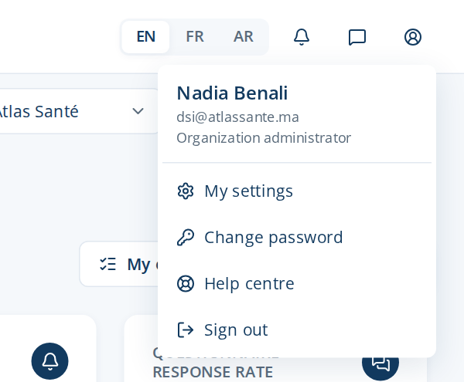
Figure 1 — The profile menu
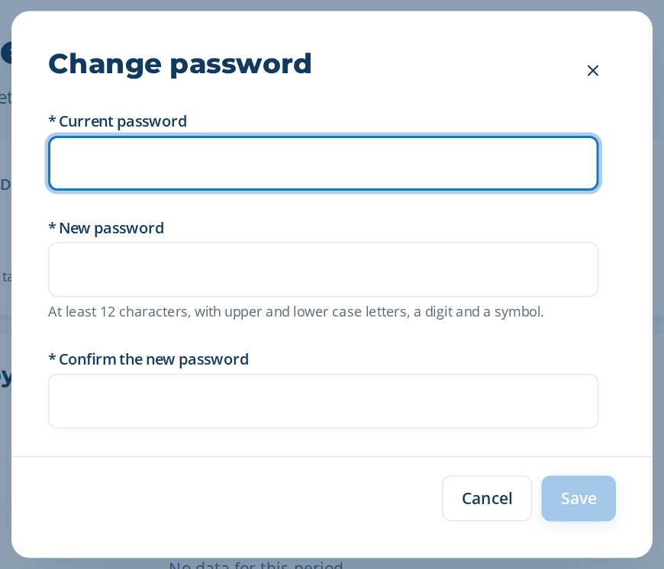
Figure 2 — Change password

Check the licence
Open Administration › Configuration & licence and check the Licence card: status Active, the plan and the number of users of your contract, the expiry date. If something is wrong, contact the provider before inviting users.

Create the users
- Open Administration › Users and click New user.
- Type the name, the e-mail, the job title, the language and a temporary password; choose the role (for example Head of Learning & Development, Training Manager, Process Owner, Employee).
- Send each user the address of the application and the temporary password, and ask them to change it at first sign-in (profile › Change password).
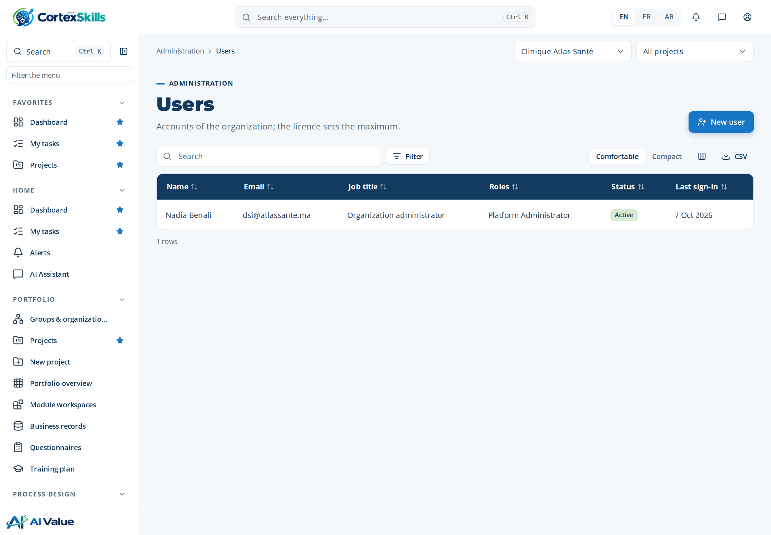
Figure 3 — Administration › Users

Finish the set-up
Menu | What to do
Administration › Channels (e-mail, WhatsApp) | Enter your own e-mail server (optional: otherwise the platform e-mail is used) and, if you use it, your WhatsApp Business account. Send a test message.
Administration › AI settings | Choose the AI provider and model, or keep the assistant off.
Administration › Permission matrix | Review what each role can see and do; adapt it to your organization.
Portfolio › Groups & organizations | Build the organization structure (directorates, departments, units) and assign the people.
Administration › SME onboarding | SME packs only: answer the short onboarding questions; the guided track is prepared for you.
Administration › Backups & health | See the last backups and the health of the service (operated by the provider).

Then create the first project (Portfolio › New project): the users find their tasks in My tasks. The User Guide and the Administrator Guide describe each screen in detail.

Activate add-ons, standards and change the pack

The Configuration & licence screen
Menu: Administration › Configuration & licence. The four tiles show the current pack, the number of modules included, the AI tier and the licence state. The Licence card shows the deployment mode, the plan, the maximum number of users, the expiry date and the active add-ons.
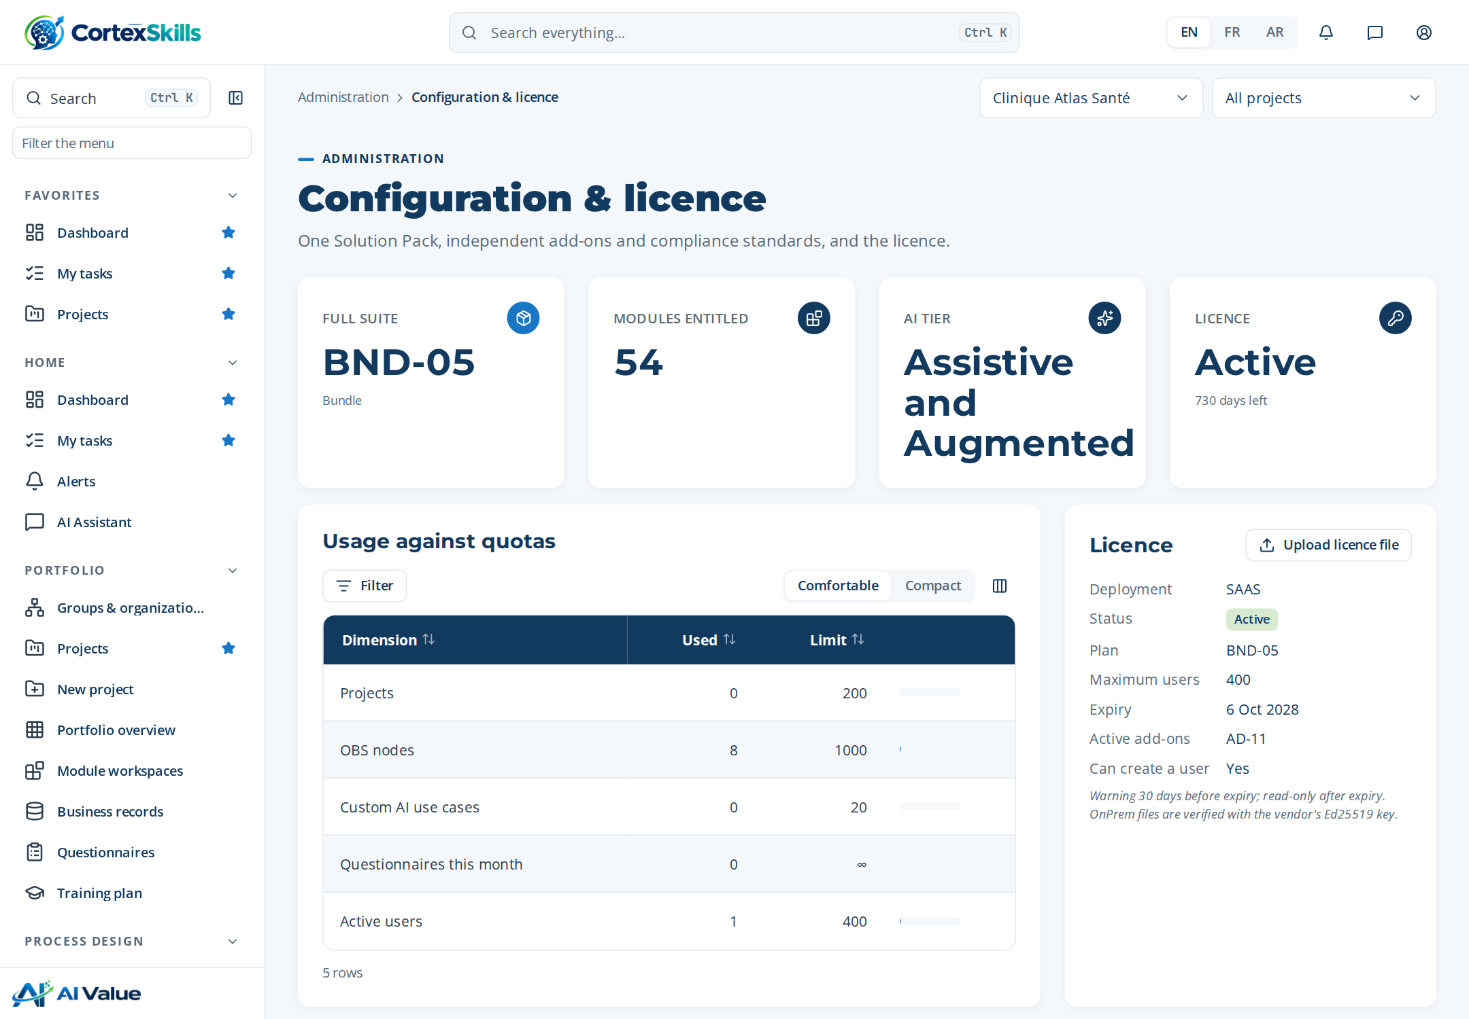
Figure 4 — Administration › Configuration & licence

Change the pack
- In the Solution Packs table, find the pack you want and click Switch.
- Read the proration (credit for the days left on the current pack, charge for the new one) and type the justification (for example the purchase order number).
- Confirm. The new modules appear in the menu at once; the change, its justification and the proration are kept in the audit trail.
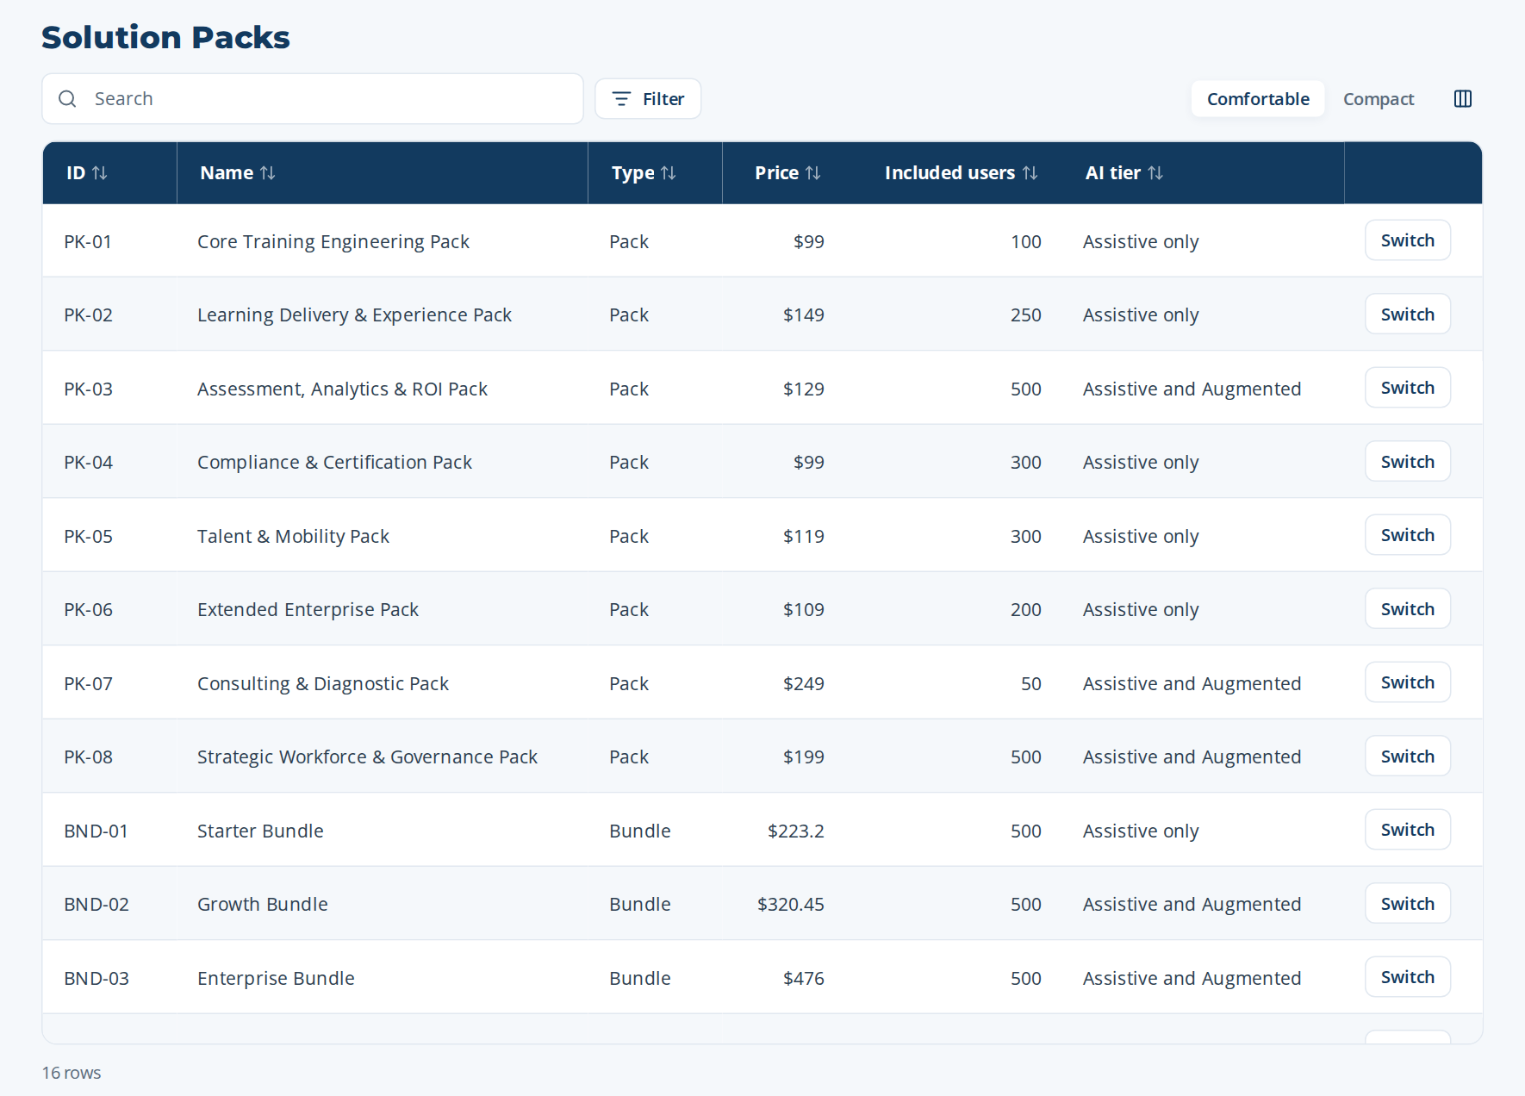
Figure 5 — The Solution Packs table: the current pack is marked “Current”

Activate an add-on
In the Add-ons section, tick the box of the add-on. It becomes Active and its screens appear for the users who have the permission. Untick to deactivate it (its data is kept).
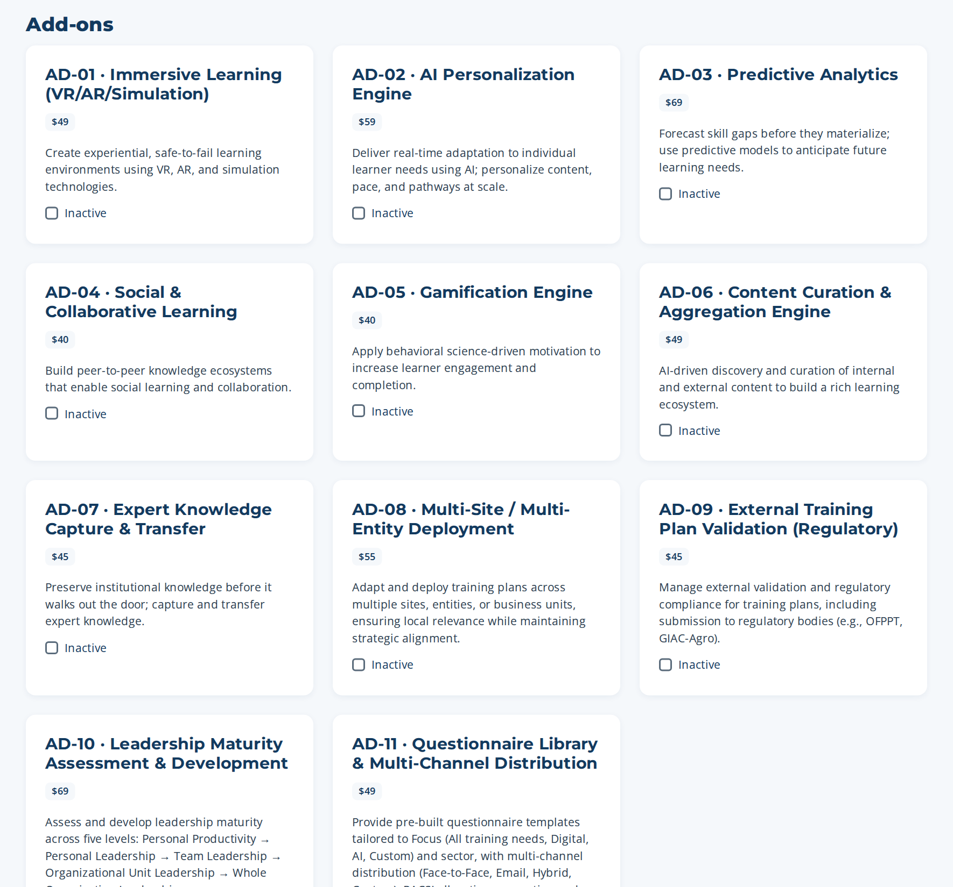
Figure 6 — Add-ons: one tick box per add-on

Activate a compliance standard
In Compliance & security standards, tick the standard. The first activation creates its controls once (for example 4 controls for ISO/IEC 27001) in the controls register. Deactivating keeps the controls. Read the notice: the application organizes the evidence; only an accredited body can certify.
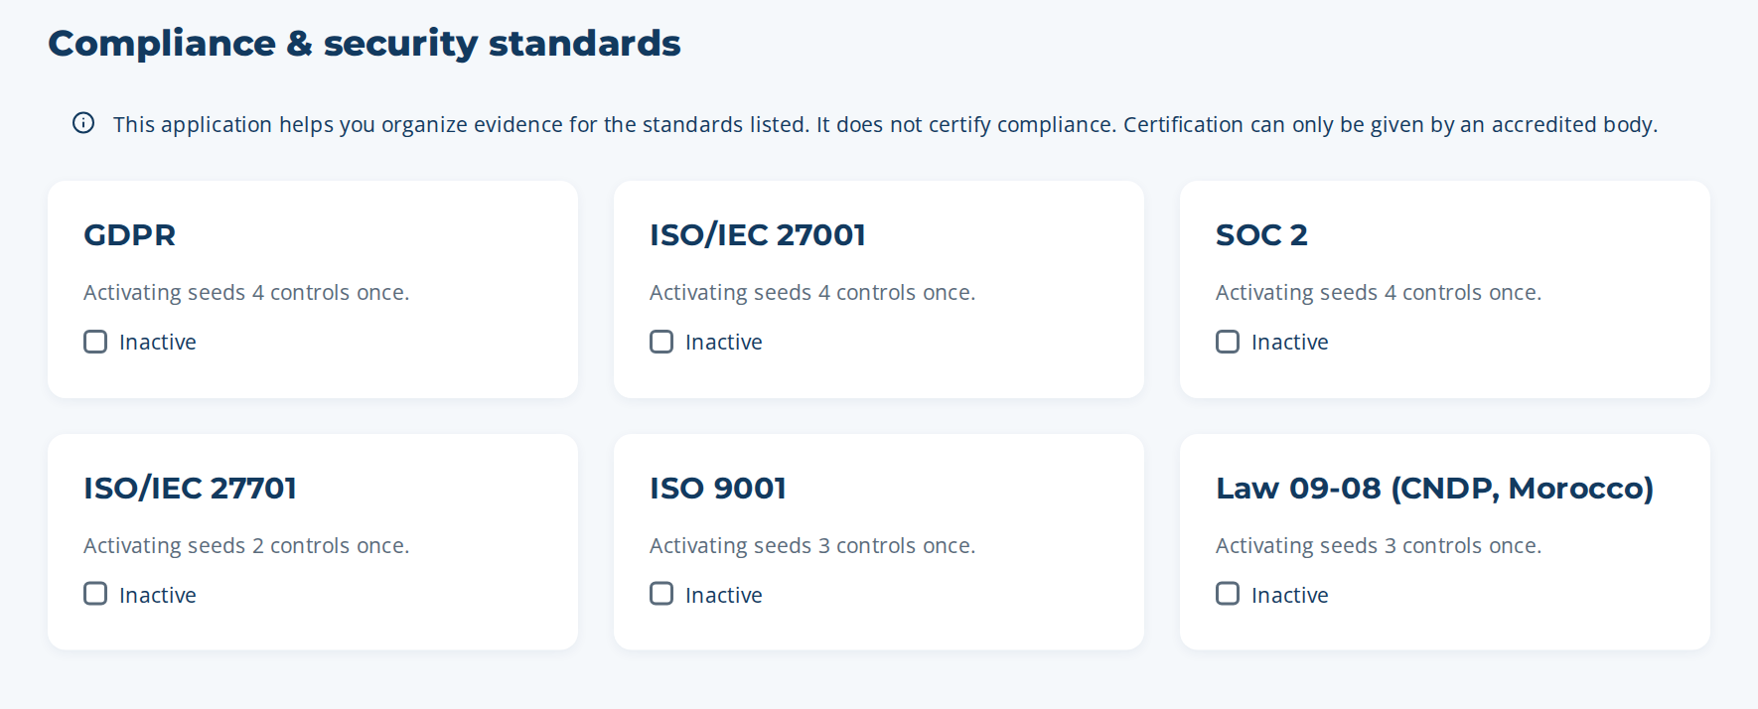
Figure 7 — Compliance & security standards

Renewal
Thirty days before the end of the licence, a banner reminds the administrators. Contact the provider: they renew it from the console and the new date appears at once in the Licence card. No action is needed on the customer side.

7. Operate the platform (server side)

Backups
- The server takes a backup of the database every day (data folder › backups) and keeps it BACKUP_RETENTION_DAYS days. Each backup is also copied to BACKUP_COPY_DIR when it is set: mount there a folder of another machine or of cloud storage.
- Take a backup at any time, for example before an update:
cd /opt/cortexskills/server && sudo -u cortexskills npm run backup
- The attached files (data folder › attachments) are not inside the database backup: include the whole data folder in your file backup or disk snapshots.

Restore a backup
- Stop the service: sudo systemctl stop cortexskills
- In /var/lib/cortexskills, move cortexskills.db (and the files cortexskills.db-wal and cortexskills.db-shm if present) to a safe folder.
- Copy the chosen file from backups (or from BACKUP_COPY_DIR) to /var/lib/cortexskills/cortexskills.db and give it to the cortexskills user (chown).
- Start the service: sudo systemctl start cortexskills. A backup from an earlier version is upgraded automatically at start-up.

Updating to a new version
- Take a backup (npm run backup) and stop the service.
- Keep server/.env. The data folder (/var/lib/cortexskills) is outside the application folder and is not touched.
- Unzip the new CortexSkills-app.zip over /opt/cortexskills, put back the kept file(s), then run: cd /opt/cortexskills/server && sudo npm ci --omit=dev
- Give the folder back to the service account (chown -R cortexskills:cortexskills /opt/cortexskills) and start the service. Database changes are applied automatically at start-up.

Monitoring and logs
- Health check for your monitoring tool: GET https://skills.example.com/api/health (status ok).
- Each API request is written as one JSON line (time, method, path, status, duration, client address, user) in /var/log/cortexskills/cortexskills.log; errors go to cortexskills-error.log. Rotate them with logrotate.
- Every administrative change (pack, add-on, licence, users, password change) is in the audit trail of the organization.

Security checklist
✓ | Check
☐ | HTTPS only; port 4000 not reachable from outside (firewall).
☐ | .env readable only by root and cortexskills (chmod 600); a copy in the password vault.
☐ | ADMIN_PASSWORD removed from .env after npm run init.
☐ | Backups copied off the server (BACKUP_COPY_DIR) and a restore tested once.
☐ | Operating system updates applied every month; Node.js kept on the 22 LTS line.
☐ | Every administrator changed the temporary password at first sign-in.

Troubleshooting
Message or symptom | What to do
“CortexSkills will not start in production mode” followed by a list | Fix each line in server/.env (or in server/tools/keys), then start again. npm run secrets generates the secrets.
“The database holds the demonstration data” | The database was created with npm run seed. Initialize a production database: npm run init -- --wipe-all-data (erases everything).
“The database already holds N organization(s)” (npm run init) | Normal protection: the database is already in use. Do not re-initialize it.
“The licence of this Organization is not active” at sign-in | Issue the licence: npm run admin -- licence --org <domain> --days 365
“The licence signature is not valid” | The file was modified or not signed with the vendor key. Ask the vendor for a new file; do not edit it.
“This licence file belongs to another Organization” | The Organization ID in the file is not this organization. Compare with npm run admin -- org-list.
502 Bad Gateway in the browser | The service is stopped: sudo systemctl status cortexskills, then read the error log.
Uploads larger than 30 MB refused | Limit set in the reverse proxy (client_max_body_size in Nginx, max_size in Caddy, maxAllowedContentLength in IIS).
A user forgot the password | The organization administrator sets a temporary one in Administration › Users; on the server: npm run admin -- password --email <e-mail> --password <new>

Appendix — Console commands
Command (in /opt/cortexskills/server) | Purpose
npm run secrets | Print three new random secrets for .env
npm run init | Create the empty production database and the platform administrator
npm run backup | Back up the database now
npm run admin -- org-create … | Create a customer organization, its licence and its administrator
npm run admin -- org-list | List organizations with pack, users, add-ons and licence end date
npm run admin -- packs | List packs, bundles, SME packs, add-ons and standards
npm run admin -- licence --org <domain> [--pack] [--seats] [--days] | Issue, renew, resize or change the pack of a licence
npm run admin -- addon --org <domain> --id AD-08 --on|--off | Activate or deactivate an add-on
npm run admin -- user-create --org <domain> --email … --name … --password … [--role R-03] | Create a user (role R-01 by default)
npm run admin -- password --email … --password … | Reset a password
npm run admin -- platform-admin --email … --name … --password … | Add a platform administrator

