POWERACT
CONSULTING


INSTALLATION GUIDE
CortexSkills
Install, start and run the training engineering platform on your computer
Version 1.10.0 · 2026-10-07
Prepared by POWERACT Consulting

Table of Contents
1. What you need to know first 3
2. Install Node.js (once) 4
2.1 Windows and macOS 4
2.2 Linux 4
2.3 Check the installation 4
3. Unzip the application 5
4. Start the server 6
5. Start the web application 7
6. Sign in 8
7. Everyday use 9
8. Backups, licence and AI model 10
8.1 Backups 10
8.2 Licence 10
8.3 AI features 10
9. Production mode (optional) 11
9.1 Questionnaire channels: e-mail and WhatsApp 11
10. If something goes wrong 13

1. What you need to know first
CortexSkills runs on your own computer as two small programs that work together: the server (it keeps the data) and the web application (the screens you use in your browser). You start each one in its own window with three short commands. No database, no internet account and no technical tool other than Node.js is needed.
Item | What it is
Node.js 22.13 or newer | The free engine that runs CortexSkills. You install it once.
server folder | Keeps the data (a file named cortexskills.db in server/data), the backups and the attached files.
web folder | The screens. You open them at http://localhost:5173 in Chrome, Edge, Firefox or Safari.
Demonstration data | 59 organizations: a large company and an SME in each of 29 sectors, plus a multi-sector services group; each has two full runs (Digital skills and AI skills) with every process, task and step, in English, French and Arabic.

Time needed
About 15 minutes the first time: 5 minutes to install Node.js, 5 minutes for the two installs, 2 minutes for the demonstration data. Keep 2 GB of free disk space: the demonstration database takes about 450 MB.

2. Install Node.js (once)

2.1 Windows and macOS
- Open https://nodejs.org in your browser.
- Click the button marked LTS (the recommended version, 22 or newer) and download the installer.
- Run the installer and accept the default options until it finishes.
- Restart your computer if the installer asks you to.

2.2 Linux
Install Node.js 22 LTS with your distribution’s package manager or from nodejs.org. Then continue with section 2.3.

2.3 Check the installation
Open a terminal window. On Windows: press the Windows key, type PowerShell, press Enter. On macOS: press Cmd + Space, type Terminal, press Enter. Then type:
node -v
The answer must start with v22.13 or higher (for example v22.14.0). If it shows an older number, install the LTS version again.

3. Unzip the application
- Copy the file CortexSkills-app.zip to a folder of your choice, for example Documents.
- Right-click the file and choose Extract All (Windows) or double-click it (macOS).
- Open the new CortexSkills folder. You see two folders: server and web, and a README file.
Tip
Keep the folder path short and without special characters, for example C:\CortexSkills or Documents/CortexSkills.

4. Start the server
The server must run the whole time you use CortexSkills. Keep its window open.
- Open a terminal window (see 2.3).
- Go to the server folder. Type cd followed by a space, drag the server folder onto the window, and press Enter.
- Type the three commands below, one at a time, pressing Enter after each and waiting for it to finish.
npm install
npm run seed
npm run dev
Command | What it does | How long
npm install | Downloads the components the server needs. You do this only once. | 1–3 minutes
npm run seed | Creates the demonstration data. It erases any existing data, so run it only the first time or when you want a fresh start. | About 2 minutes
npm run dev | Starts the server. You do this every time you want to use CortexSkills. | A few seconds

When the server is ready, the window shows:
CortexSkills API is running on http://localhost:4000 (mode: saas)
Now start the web application: open the "web" folder and run "npm run dev".

5. Start the web application
- Open a second terminal window. Leave the server window open.
- Go to the web folder in the same way (cd, then drag the web folder, then Enter).
- Type the two commands below, one at a time.
npm install
npm run dev
The window shows a line with Local: http://localhost:5173. Open that address in your browser.
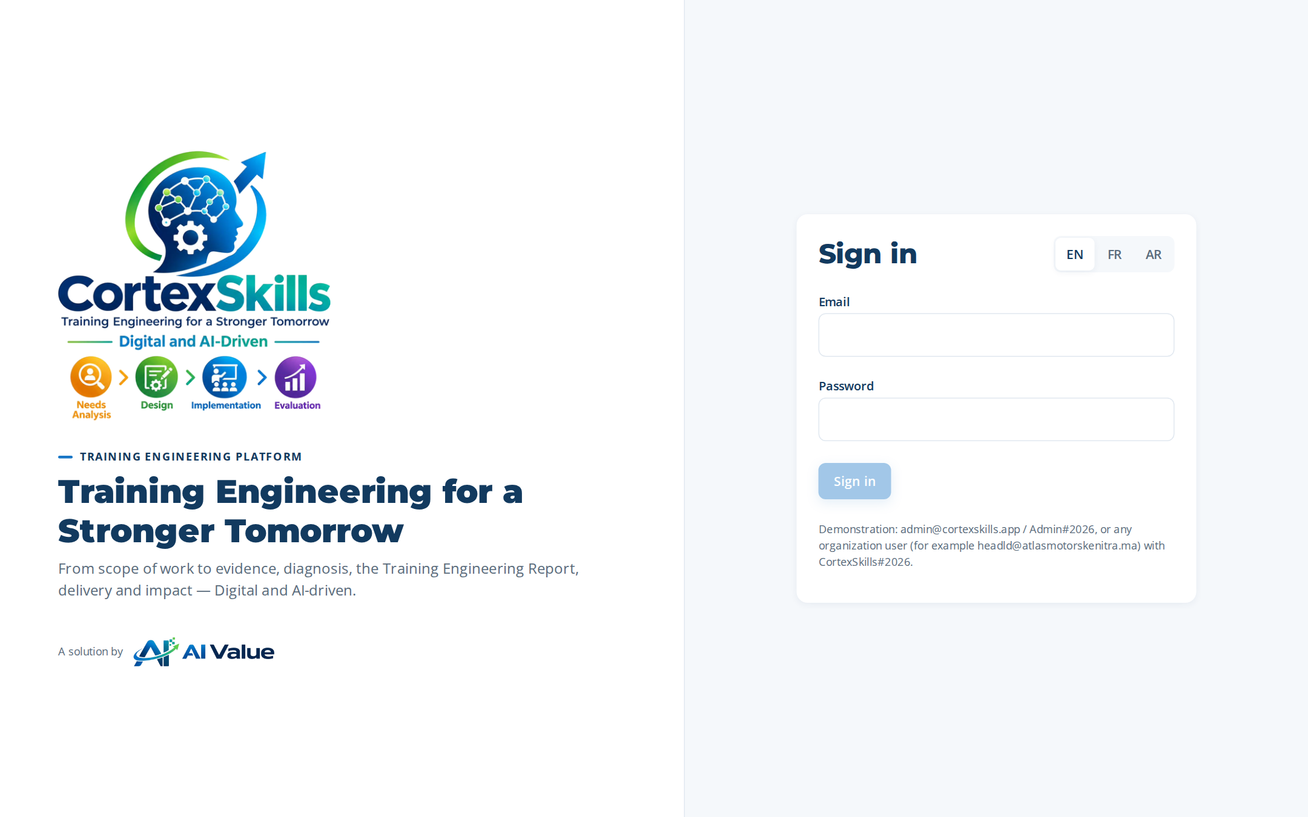
Figure 1 — The sign-in screen at http://localhost:5173

6. Sign in
All demonstration accounts use the same password, except the platform administrator.
Who | E-mail | Password
Platform administrator (all organizations) | admin@cortexskills.app | Admin#2026
Head of L&D, Large company — Automotive | headld@atlasmotorskenitra.ma | CortexSkills#2026
Head of L&D, SME — Automotive | headld@tangerautoparts.ma | CortexSkills#2026
Head of L&D, SME — AEC construction | headld@soussbtpsolutions.ma | CortexSkills#2026
Head of L&D, SME — Healthcare | headld@cliniquealamal.ma | CortexSkills#2026

Every organization has one account per role. The address is the role name followed by @ and the organization’s domain, for example hrd@atlasmotorskenitra.ma (HR Director), analyst@… (L&D Analyst), trainer@…, manager@…, finance@…, compliance@…, auditor@… (read-only). The full list is in Administration › Users when you are signed in as an administrator.
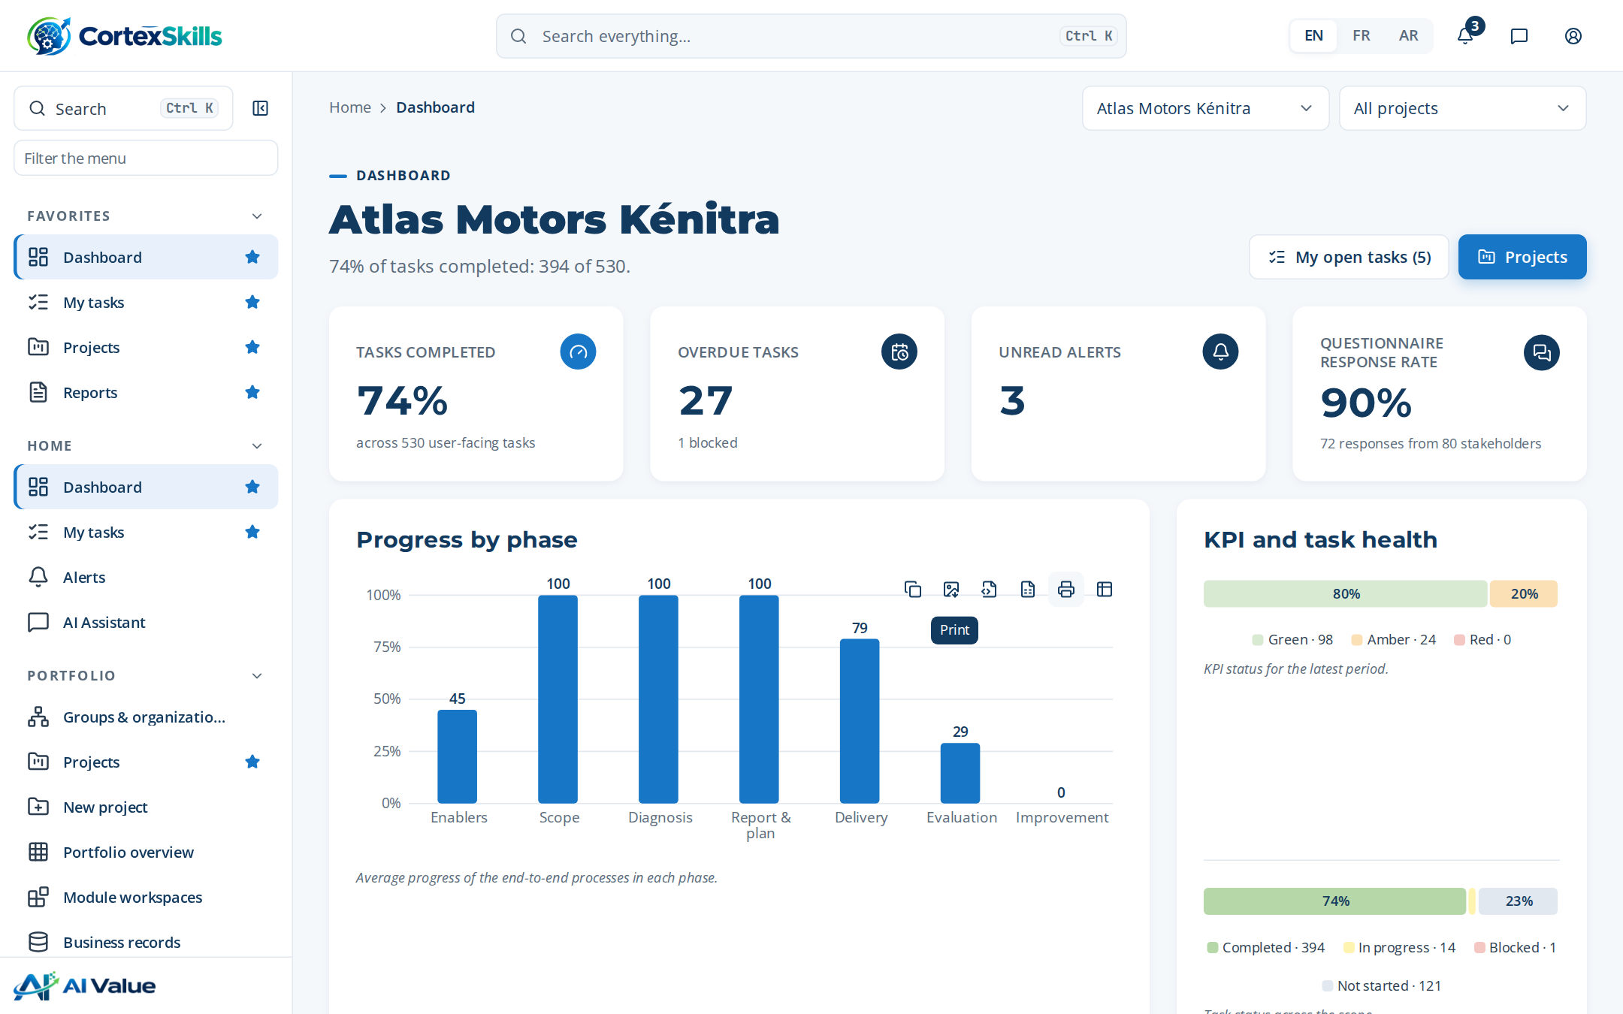
Figure 2 — The dashboard after sign-in
Choose your language at the top of the screen (EN, FR, AR). Arabic switches the whole application to right-to-left.

7. Everyday use
I want to… | Do this
Stop CortexSkills | In each of the two windows, press Ctrl + C. Your data is kept.
Start again tomorrow | Server window: cd to the server folder, then npm run dev. Web window: cd to the web folder, then npm run dev. Do not run npm run seed again.
Go back to the original demonstration data | Stop the server, run npm run seed in the server folder, then npm run dev. All your changes are erased.
Make a backup now | In the server folder: npm run backup. Or sign in as administrator and open Administration › Backups.
Use it from another computer on the same network | Use the address http://<this computer’s name or IP>:5173 in that computer’s browser.

8. Backups, licence and AI model

8.1 Backups
The server takes a backup automatically once a day and keeps backups for 14 days. Backups are stored in server/data/backups. To restore one: stop the server, copy the backup file over server/data/cortexskills.db, and start the server again. A backup from an earlier version starts without any extra step.

8.2 Licence
In the default SaaS mode, each organization has a signed licence record created by the demonstration data. For an on-premises installation, set DEPLOYMENT_MODE=onprem in a file named .env in the server folder; the licence is then read from server/data/license.lic. A new licence file is produced with:
npm run sign-licence
The administrator can upload a licence file in Administration › Licence. The application warns 30 days before expiry and becomes read-only when the licence has expired.

8.3 AI features
All AI features work without internet and without any key: a built-in engine produces the suggestions from the organization’s own records. A user may optionally connect a live language model in Settings › AI model. The key stays in that user’s browser and is sent only with that user’s own requests.

9. Production mode (optional)
To run everything from one address, build the screens once and start the server in production mode:
cd web
npm run build
cd ../server
npm start
Open http://localhost:4000. The server now also serves the screens. Before a real deployment, set a private JWT_SECRET and LICENSE_HMAC_SECRET in server/.env.
Setting (server/.env) | Default | Purpose
PORT | 4000 | Port of the server
DEPLOYMENT_MODE | saas | saas or onprem (licence provider)
DATA_DIR | server/data | Where the data, backups and attachments are kept
JWT_SECRET | development value | Signs the sign-in tokens — change it in production
BACKUP_RETENTION_DAYS | 14 | How long backups are kept
CORS_ORIGIN | * | Allowed web addresses

9.1 Questionnaire channels: e-mail and WhatsApp
Questionnaire invitations and reminders go out by e-mail (SMTP) and WhatsApp (WhatsApp Business Cloud API). Each organization can enter its own providers in Administration › Channels; the settings below give a platform default used by organizations that have none. Without any provider, messages are kept in the outbox (sandbox) and nothing is sent.
Setting (server/.env) | Default | Purpose
PUBLIC_URL | address of the request | Public address of the application, used in the personal links sent to respondents (for example https://skills.example.com)
CHANNEL_SECRET_KEY | JWT_SECRET | Key that encrypts the channel passwords and tokens (AES-256-GCM) — set a long private value and keep it
SMTP_HOST, SMTP_PORT | —, 587 | Mail server and port
SMTP_SECURE | false | true for TLS from the start (port 465)
SMTP_USER, SMTP_PASS | — | Mail account
SMTP_FROM | — | Sender address shown to respondents
WHATSAPP_TOKEN | — | Access token of the WhatsApp Business app
WHATSAPP_PHONE_NUMBER_ID | — | Phone number ID from Meta › WhatsApp › API setup
WHATSAPP_TEMPLATE, WHATSAPP_TEMPLATE_LANG | — | Approved message template used for the first contact, and its language code
WHATSAPP_VERIFY_TOKEN | — | Token you choose and type in Meta when declaring the webhook
WHATSAPP_APP_SECRET | — | App secret used to check the signature of webhook calls
WHATSAPP_API_BASE | https://graph.facebook.com/v21.0 | Cloud API address
Declare the webhook <PUBLIC_URL>/api/public/whatsapp/webhook in Meta so delivery statuses (sent, delivered, read, failed) and replies come back. The server retries failed messages every minute and plays due reminders every 10 minutes.

10. If something goes wrong
Message or symptom | What to do
“CortexSkills needs Node.js 22.13 or newer” | Install the LTS version from nodejs.org (section 2), close the window, open a new one and try again.
“Port 4000 is already in use” | CortexSkills is probably already running in another window. Close it, or start on another port (set PORT=4001 on Windows, export PORT=4001 on macOS/Linux).
“The database is empty” | Run npm run seed in the server folder, then npm run dev.
“npm is not recognized” / “command not found” | Node.js is not installed or the window was opened before the installation. Install Node.js, then open a new window.
The browser shows “This site can’t be reached” | Check that both windows are still open and show no error. The address is http://localhost:5173.
Sign-in says “Email or password is incorrect” | Check the password (it is case-sensitive). If you changed the data, run npm run seed to restore the demonstration accounts.
“Too many attempts” | Wait 15 minutes; sign-in is limited to protect accounts.

