POWERACT
C O N S U L T I N G
CORTEXSKILLS · COMMERCIAL ARCHITECTURE & PRICING STRATEGY
Packs, Integrations & Add-Ons
For CortexSkills, the #1 Market-Leading Training Engineering Application
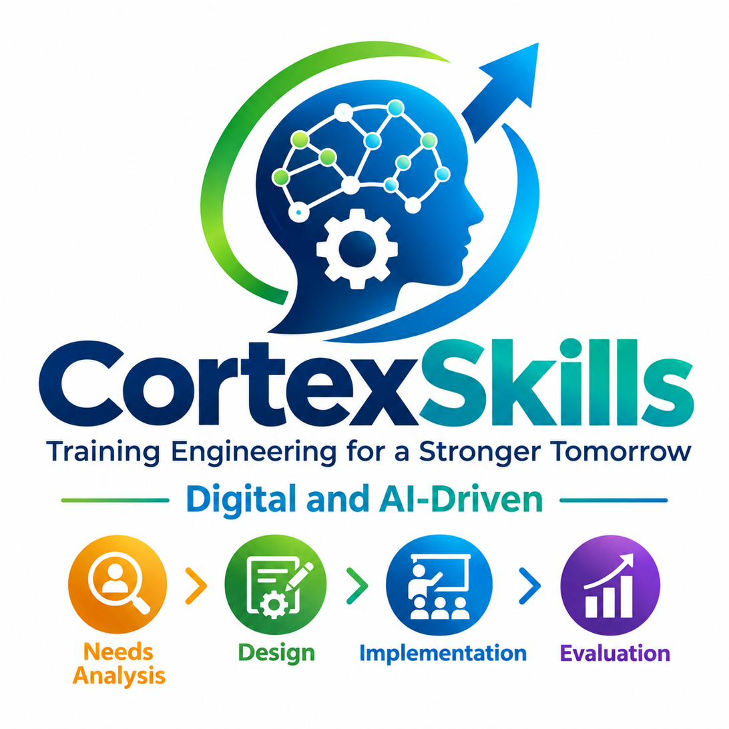
8  packs | 18  integrations | 11  add-ons | $40  minimum monthly price
Prepared by POWERACT Consulting · Version 3.0 · 16 October 2026
Confidential

CONTENTS
Table of Contents
1. Executive Summary 5
1.1 How to Read This Document 5
2. Pack Architecture Overview 7
2.1 Pack Summary 7
2.2 Pack Positioning Map 7
2.3 Price Comparison 8
3. Detailed Pack Specifications 9
PK-01: Core Training Engineering Pack 10
PK-02: Learning Delivery & Experience Pack 12
PK-03: Assessment, Analytics & ROI Pack 14
PK-04: Compliance & Certification Pack 15
PK-05: Talent & Mobility Pack 16
PK-06: Extended Enterprise Pack 17
PK-07: Consulting & Diagnostic Pack 18
PK-08: Strategic Workforce & Governance Pack 20
4. Integration Catalog 22
4.0 Integration-to-Pack Matrix 22
4.1 Enterprise Systems 23
INT-HR-01: HRIS/HCM Integration 23
INT-FIN-01: ERP/Finance System Integration 23
INT-CRM-01: CRM Integration 23
4.2 Talent & Performance Management 24
INT-TM-01: Performance Management Integration 24
INT-TM-02: Talent Management / Succession Planning Integration 24
INT-TM-03: Skills Intelligence / Talent Marketplace 24
INT-REC-01: Recruitment / ATS Integration 25
4.3 Learning Content & Ecosystem 25
INT-CON-01: Content Provider Aggregation 25
INT-LMS-01: LMS/LXP Integration 25
INT-ASM-01: Assessment & Certification Systems 26
INT-VC-01: Virtual Classroom & Webinar Tools 26
4.4 Learning in the Flow of Work 26
INT-COM-01: Communication & Collaboration Platforms 26
INT-PROD-01: Productivity & Workflow Tools 27
4.5 Data & Analytics 27
INT-BI-01: Business Intelligence (BI) Tools 27
INT-DATA-01: Data Warehouses & Data Lakes 27
4.6 Core Platform & Security 28
INT-SSO-01: Identity & Access Management (IAM) / SSO 28
INT-PAY-01: E-Commerce & Payment Gateways 28
4.7 Survey & Feedback 28
INT-SUR-01: Survey / Questionnaire Platform Integration 28
5. Add-On Catalog 30
5.0 Add-On-to-Pack Matrix 30
5.1 Add-On Details 30
AD-01: Immersive Learning (VR/AR/Simulation) 30
AD-02: AI Personalization Engine 31
AD-03: Predictive Analytics 31
AD-04: Social & Collaborative Learning 31
AD-05: Gamification Engine 32
AD-06: Content Curation & Aggregation Engine 32
AD-07: Expert Knowledge Capture & Transfer 32
AD-08: Multi-Site / Multi-Entity Deployment 33
AD-09: External Training Plan Validation (Regulatory) 33
AD-10: Leadership Maturity Assessment & Development 33
AD-11: Questionnaire Library & Multi-Channel Distribution 34
6. Pricing Summary & Packaging Rules 35
6.1 Pack Pricing 35
6.2 Add-On Pricing 35
6.3 Packaging Rules 35
6.4 Bundle Discounts (Optional) 36
6.5 SME Packs 36
6.6 Compliance & Security Standards 36
6.7 Entitlements, Quotas & AI Tiers 37
6.8 Deployment, Licensing & Customer Edition 38
7. Strategic Conclusion 39
REVISION HISTORY
Version | Date | Change
1.0 | September 2026 | Initial commercial architecture: 8 packs, 17 integrations in 6 families, 10 add-ons.
2.0 | 28 September 2026 | CR1 — Scope of Work & Questionnaire Management: M53 and M54 added to PK-01, PK-07 and PK-08 (MP-53, MP-54); new integration  INT-SUR-01 (family 4.7 Survey & Feedback); new add-on  AD-11 ($49/month); pricing notes and differentiators updated. No base price change.
3.0 | 16 October 2026 | Aligned with CortexSkills release 1.15.0: SME packs (6.5), compliance and security standards (6.6), entitlements, quotas and AI tiers per offer (6.7), deployment, licensing and customer edition (6.8). AD-11 channels updated to Face-to-Face, Email, WhatsApp, Application and Combination; bundle user terms stated. No change to pack, add-on or bundle prices.

SECTION 1

1. Executive Summary
This document defines the commercial architecture for CortexSkills, the #1 market-leading Training Engineering application. It presents three building blocks:
- 8 optimized Packs designed to cover the full spectrum of customer needs, from SMB to Enterprise, and from operational L&D to strategic consulting.
- A comprehensive Integration Catalog mapping external applications to the packs that benefit from them, with clear value propositions tied to customer behavior, pain points, and hopes.
- A curated Add-On Catalog enabling customers to extend their packs with specialized capabilities.
Packaging rules applied
- The number of Packs is optimized to 8, balancing simplicity for buyers with coverage of the 52 macro processes.
- The minimum price is 40 USD/month, ensuring every pack delivers tangible value.
- Each Pack targets a specific segment, has a clear value proposition, maps to specific macro processes, and includes related modules.
- Integrations and Add-Ons are mapped to the Packs that benefit most from them.
What is new in version 2.0
Version 2.0 adds structured Scope of Work definition and multi-channel questionnaire management to CortexSkills. Two new modules — M53 Scope of Work Studio and M54 Questionnaire Studio — are included in PK-01, PK-07 and PK-08 and support two new macro processes, MP-53 and MP-54. One integration (INT-SUR-01 Survey / Questionnaire Platform Integration) and one add-on (AD-11 Questionnaire Library & Multi-Channel Distribution) are added. The catalog now counts 8 packs, 18 integrations in 7 families and 11 add-ons. No pack base price changes.

What is new in version 3.0
Version 3.0 aligns the catalog with CortexSkills release 1.15.0. It adds the three SME packs, the compliance and security standards, the quotas and AI tier of each offer, and the licensing rules of private-cloud and on-premises installations, where the plan, the users and the add-ons come from a licence signed by POWERACT. Pack, add-on and bundle prices are unchanged.

1.1 How to Read This Document
Section | What you will find
2 Pack Architecture Overview | All 8 packs on one page, the positioning map and a price comparison.
3 Detailed Pack Specifications | One page per pack: segment, value proposition, modules, macro processes, price, and the integrations and add-ons that fit it.
4 Integration Catalog | 18 integrations in 7 families, with a pack-compatibility matrix.
5 Add-On Catalog | 11 optional add-ons with prices and a pack-compatibility matrix.
6 Pricing Summary & Packaging Rules | Prices, user limits, overage, packaging rules, bundle discounts, SME packs, compliance standards, entitlements and licensing.
7 Strategic Conclusion | Key differentiators.

Value propositions are presented in three parts throughout: Behavior (what customers do today), Pain point (what hurts), and Hope (what they want).

SECTION 2

2. Pack Architecture Overview

2.1 Pack Summary
Pack ID | Pack name | Target segment | Price (USD/month) | Related macro processes
PK-01 | Core Training Engineering Pack | SMB, Mid-Market | $99 | MP-01 to MP-06, MP-18, MP-20, MP-53, MP-54
PK-02 | Learning Delivery & Experience Pack | SMB, Mid-Market, Enterprise | $149 | MP-07 to MP-12, MP-21, MP-24 to MP-27
PK-03 | Assessment, Analytics & ROI Pack | Mid-Market, Enterprise | $129 | MP-09, MP-10, MP-20, MP-28, MP-32
PK-04 | Compliance & Certification Pack | Regulated Industries | $99 | MP-14, MP-41, MP-09, MP-10
PK-05 | Talent & Mobility Pack | Mid-Market, Enterprise | $119 | MP-13, MP-31, MP-35, MP-02, MP-08
PK-06 | Extended Enterprise Pack | Training Providers, Enterprises | $109 | MP-22, MP-07, MP-14, MP-18, MP-29
PK-07 | Consulting & Diagnostic Pack | Consulting Firms, Enterprises | $249 | MP-36 to MP-42, MP-53, MP-54
PK-08 | Strategic Workforce & Governance Pack | Enterprise, Large Organizations | $199 | MP-43 to MP-50, MP-16, MP-17, MP-19, MP-20, MP-53, MP-54

Table 2.1 — The eight CortexSkills packs.

2.2 Pack Positioning Map
The map places each pack on two axes, from operational to strategic. Orange-tint cards mark the three key differentiators named in the Strategic Conclusion: PK-01, PK-07 and PK-08.
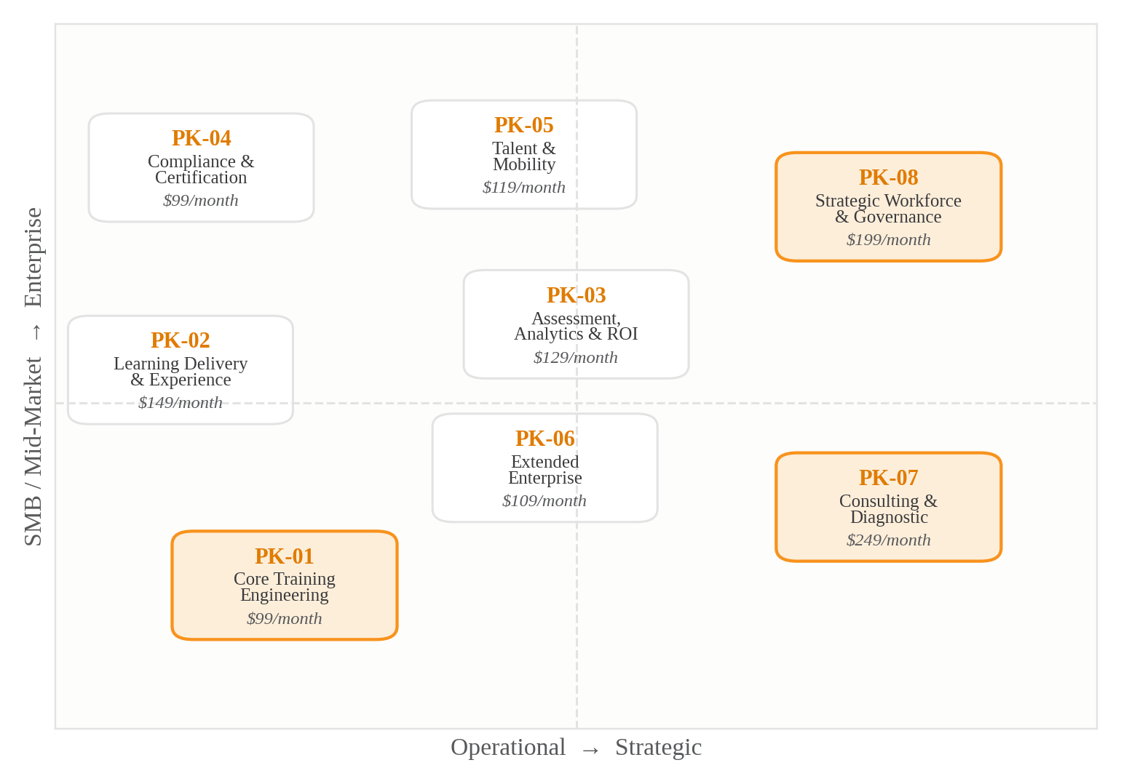
Figure 2.2 — Pack positioning map, with base monthly price.

2.3 Price Comparison
Base prices range from 99 to 249 USD per month. PK-07 is priced per engagement and PK-06 per external user; all other packs are priced per internal user.
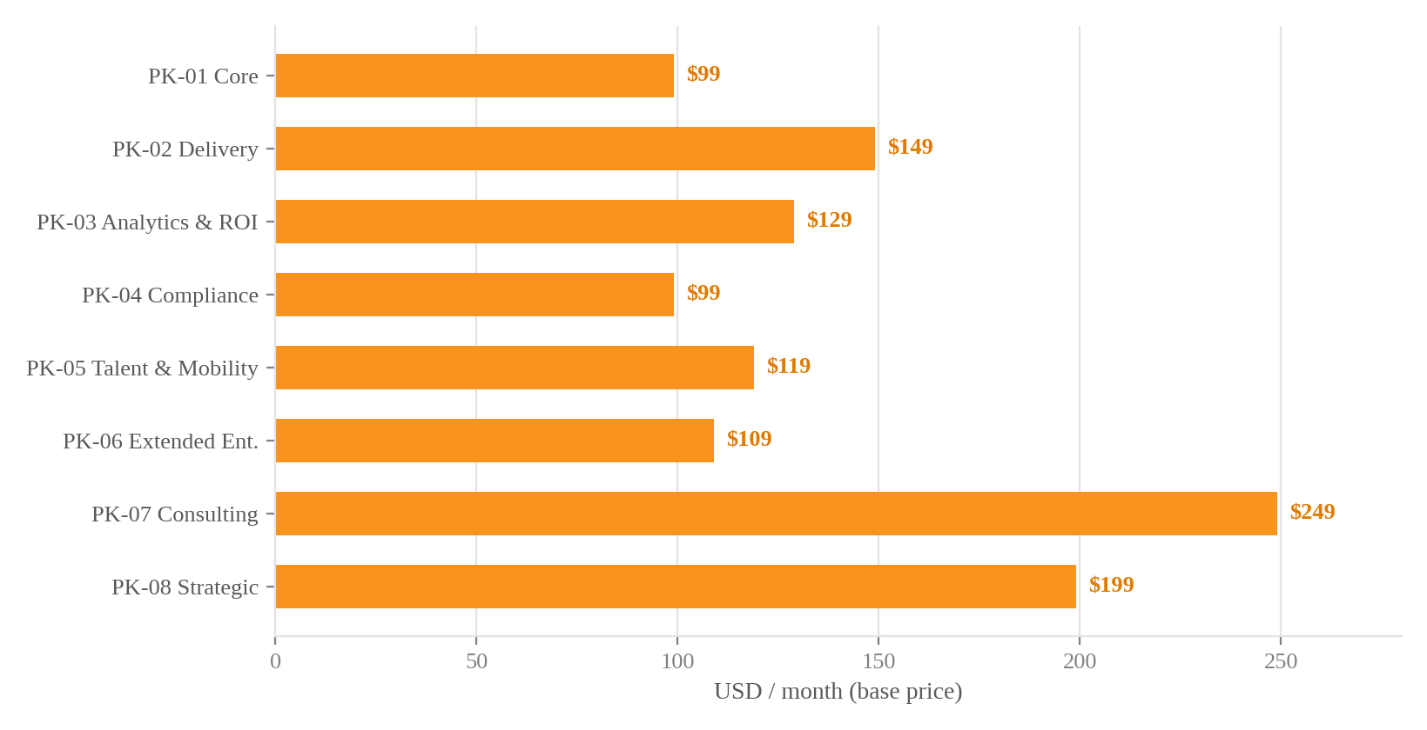
Figure 2.3 — Suggested base price per pack (USD/month, before overage).

SECTION 3

3. Detailed Pack Specifications
Each pack is described on its own page. The "Works best with" block is derived from the Integration and Add-On catalogs (Sections 4 and 5).

PACK · PK-01

PK-01: Core Training Engineering Pack
Pack ID | PK-01
Pack name | Core Training Engineering Pack
Target segment | SMB (50–500 employees), Mid-Market (500–5,000 employees), L&D teams starting their Training Engineering journey
Suggested price | $99 USD/month (up to 100 users); $0.75/user/month beyond 100 users

Value proposition
Behavior  What customers do today | L&D teams currently manage training needs with spreadsheets and disconnected tools.
Pain point  What hurts | They struggle to produce a formal Training Engineering Report and prioritized training roadmap, leading to reactive, ad-hoc training investments.
Hope  What they want | A single platform that starts from a structured Scope of Work, collects evidence through multi-channel questionnaires, automates needs analysis, produces the flagship Training Engineering Report, and generates a prioritized roadmap aligned to business strategy.

Related modules
ID | Module | ID | Module
M01 | Strategy Console | M05 | Design Studio
M02 | Skills Hub | M06 | Content Library
M03 | Needs Analyzer | M18 | Finance Console
M04 | Report & Roadmap Studio | M20 | Quality Center
M53 | Scope of Work Studio | M54 | Questionnaire Studio

Related macro processes
ID | Macro process
MP-01 | Strategy & Governance Alignment
MP-02 | Skills & Competency Management
MP-03 | Needs Analysis & Diagnosis
MP-04 | Training Engineering Report & Roadmap Elaboration
MP-05 | Learning Design & Curriculum Engineering
MP-06 | Content & Resource Management
MP-18 | Financial & Budget Management
MP-20 | Quality, Risk & Continuous Improvement
MP-53 | Scope of Work Definition & Management
MP-54 | Questionnaire Design, Distribution & Response Collection

Works best with
Integrations | INT-HR-01 HRIS/HCM Integration  INT-FIN-01 ERP/Finance System Integration  INT-TM-01 Performance Management Integration  INT-LMS-01 LMS/LXP Integration  INT-SSO-01 Identity & Access Management (IAM) / SSO  INT-SUR-01 Survey / Questionnaire Platform Integration
Add-ons | AD-08 Multi-Site / Multi-Entity Deployment ($55/month)  AD-11 Questionnaire Library & Multi-Channel Distribution ($49/month)

PACK · PK-02

PK-02: Learning Delivery & Experience Pack
Pack ID | PK-02
Pack name | Learning Delivery & Experience Pack
Target segment | SMB, Mid-Market, Enterprise; organizations focused on learner engagement and modern delivery
Suggested price | $149 USD/month (up to 250 users); $0.60/user/month beyond 250 users

Value proposition
Behavior  What customers do today | Employees are disengaged from traditional LMS-driven training; learning is seen as a checkbox exercise.
Pain point  What hurts | Low completion rates, poor learner experience, and inability to deliver learning in the flow of work.
Hope  What they want | A modern, personalized, engaging learning experience with microlearning, gamification, social learning, and AI-powered recommendations — driving measurable engagement and completion.

Related modules
ID | Module | ID | Module
M07 | Delivery Center | M21 | Coaching Hub
M08 | Learner Portal | M24 | AI Personalization Engine
M09 | Assessment Engine | M25 | Microlearning Hub
M10 | Analytics Dashboard | M26 | Social Learning Hub
M11 | Admin Console | M27 | Gamification Engine
M12 | Community Hub

Related macro processes
ID | Macro process
MP-07 | Learning Delivery & Implementation
MP-08 | Learner Experience & Engagement
MP-09 | Assessment & Evaluation
MP-10 | Reporting & Analytics
MP-11 | Administration & Operations
MP-12 | Learning Culture & Knowledge Management
MP-21 | Learning Support & Coaching
MP-24 | AI-Powered Personalization
MP-25 | Microlearning
MP-26 | Social & Collaborative Learning
MP-27 | Gamification

Works best with
Integrations | INT-HR-01 HRIS/HCM Integration  INT-CON-01 Content Provider Aggregation  INT-LMS-01 LMS/LXP Integration  INT-VC-01 Virtual Classroom & Webinar Tools  INT-COM-01 Communication & Collaboration Platforms  INT-PROD-01 Productivity & Workflow Tools  INT-SSO-01 Identity & Access Management (IAM) / SSO
Add-ons | AD-01 Immersive Learning (VR/AR/Simulation) ($49/month)  AD-02 AI Personalization Engine ($59/month)  AD-04 Social & Collaborative Learning ($40/month)  AD-05 Gamification Engine ($40/month)  AD-06 Content Curation & Aggregation Engine ($49/month)

PACK · PK-03

PK-03: Assessment, Analytics & ROI Pack
Pack ID | PK-03
Pack name | Assessment, Analytics & ROI Pack
Target segment | Mid-Market, Enterprise; data-driven L&D organizations focused on proving impact
Suggested price | $129 USD/month (up to 500 users); $0.50/user/month beyond 500 users

Value proposition
Behavior  What customers do today | L&D leaders are under pressure to prove the business impact of training but rely on lagging indicators (completion rates, satisfaction scores).
Pain point  What hurts | Inability to connect training to business KPIs, calculate ROI, or predict future skill gaps.
Hope  What they want | A robust analytics suite that measures Kirkpatrick Levels 1–4, calculates ROI using the Phillips methodology, and uses predictive analytics to anticipate future skill needs — transforming L&D into a strategic business partner.

Related modules
ID | Module | ID | Module
M09 | Assessment Engine | M28 | Predictive Analytics Hub
M10 | Analytics Dashboard | M32 | ROI Dashboard
M20 | Quality Center

Related macro processes
ID | Macro process
MP-09 | Assessment & Evaluation
MP-10 | Reporting & Analytics
MP-20 | Quality, Risk & Continuous Improvement
MP-28 | Predictive Learning Analytics & Intelligence
MP-32 | Learning ROI & Business Impact Measurement

Works best with
Integrations | INT-FIN-01 ERP/Finance System Integration  INT-TM-01 Performance Management Integration  INT-TM-03 Skills Intelligence / Talent Marketplace  INT-ASM-01 Assessment & Certification Systems  INT-BI-01 Business Intelligence (BI) Tools  INT-DATA-01 Data Warehouses & Data Lakes  INT-SSO-01 Identity & Access Management (IAM) / SSO  INT-SUR-01 Survey / Questionnaire Platform Integration
Add-ons | AD-02 AI Personalization Engine ($59/month)  AD-03 Predictive Analytics ($69/month)

PACK · PK-04

PK-04: Compliance & Certification Pack
Pack ID | PK-04
Pack name | Compliance & Certification Pack
Target segment | Regulated industries (healthcare, finance, pharma, agro-food, aviation, energy); organizations with mandatory training requirements
Suggested price | $99 USD/month (up to 300 users); $0.55/user/month beyond 300 users

Value proposition
Behavior  What customers do today | Compliance officers and L&D teams manage mandatory training and certifications manually, with high risk of non-compliance.
Pain point  What hurts | Audit failures, expired certifications, regulatory fines, and inability to track completion across sites.
Hope  What they want | An automated compliance engine that assigns, tracks, and renews certifications, with full audit trails, regulatory validation workflows (e.g., OFPPT, GIAC-Agro), and real-time compliance dashboards.

Related modules
ID | Module | ID | Module
M14 | Compliance Center | M09 | Assessment Engine
M41 | Regulatory Console | M10 | Analytics Dashboard

Related macro processes
ID | Macro process
MP-14 | Compliance & Certification Management
MP-41 | External Training Plan Validation & Regulatory Compliance
MP-09 | Assessment & Evaluation
MP-10 | Reporting & Analytics

Works best with
Integrations | INT-ASM-01 Assessment & Certification Systems  INT-SSO-01 Identity & Access Management (IAM) / SSO
Add-ons | AD-05 Gamification Engine ($40/month)  AD-09 External Training Plan Validation (Regulatory) ($45/month)

PACK · PK-05

PK-05: Talent & Mobility Pack
Pack ID | PK-05
Pack name | Talent & Mobility Pack
Target segment | Mid-Market, Enterprise; organizations focused on retention, internal mobility, and career development
Suggested price | $119 USD/month (up to 300 users); $0.65/user/month beyond 300 users

Value proposition
Behavior  What customers do today | Employees feel stuck in their roles; managers struggle to fill critical positions internally.
Pain point  What hurts | High turnover, lack of career visibility, and inability to match internal talent to opportunities.
Hope  What they want | A skills-based talent marketplace that connects employees to internal opportunities, automates onboarding and rapid upskilling, and provides clear career paths — improving retention and reducing external hiring costs.

Related modules
ID | Module | ID | Module
M13 | Career Center | M02 | Skills Hub
M31 | Talent Marketplace | M08 | Learner Portal
M35 | Onboarding Hub

Related macro processes
ID | Macro process
MP-13 | Talent & Career Development
MP-31 | Skills-Based Talent Marketplace & Internal Mobility
MP-35 | Onboarding & Rapid Upskilling
MP-02 | Skills & Competency Management
MP-08 | Learner Experience & Engagement

Works best with
Integrations | INT-HR-01 HRIS/HCM Integration  INT-TM-01 Performance Management Integration  INT-TM-02 Talent Management / Succession Planning Integration  INT-TM-03 Skills Intelligence / Talent Marketplace  INT-REC-01 Recruitment / ATS Integration  INT-COM-01 Communication & Collaboration Platforms  INT-PROD-01 Productivity & Workflow Tools  INT-SSO-01 Identity & Access Management (IAM) / SSO
Add-ons | AD-02 AI Personalization Engine ($59/month)  AD-04 Social & Collaborative Learning ($40/month)  AD-07 Expert Knowledge Capture & Transfer ($45/month)  AD-10 Leadership Maturity Assessment & Development ($69/month)

PACK · PK-06

PK-06: Extended Enterprise Pack
Pack ID | PK-06
Pack name | Extended Enterprise Pack
Target segment | Training providers, consulting firms, enterprises training partners, resellers, and customers
Suggested price | $109 USD/month (up to 200 external users); $0.80/external user/month beyond 200 users

Value proposition
Behavior  What customers do today | Organizations want to monetize training for external audiences but lack the infrastructure.
Pain point  What hurts | Manual enrollment, payment processing, and certification tracking for partners and customers; inability to scale external training.
Hope  What they want | A multi-tenant, branded portal with e-commerce, certification tracking, and content curation — turning training into a revenue stream and strengthening partner/customer relationships.

Related modules
ID | Module | ID | Module
M22 | Extended Enterprise Portal | M18 | Finance Console
M07 | Delivery Center | M29 | Curation Engine
M14 | Compliance Center

Related macro processes
ID | Macro process
MP-22 | Extended Enterprise & External Training
MP-07 | Learning Delivery & Implementation
MP-14 | Compliance & Certification Management
MP-18 | Financial & Budget Management
MP-29 | Content Curation & Aggregation Engine

Works best with
Integrations | INT-FIN-01 ERP/Finance System Integration  INT-CRM-01 CRM Integration  INT-CON-01 Content Provider Aggregation  INT-LMS-01 LMS/LXP Integration  INT-ASM-01 Assessment & Certification Systems  INT-VC-01 Virtual Classroom & Webinar Tools  INT-SSO-01 Identity & Access Management (IAM) / SSO  INT-PAY-01 E-Commerce & Payment Gateways
Add-ons | AD-06 Content Curation & Aggregation Engine ($49/month)  AD-08 Multi-Site / Multi-Entity Deployment ($55/month)

PACK · PK-07

PK-07: Consulting & Diagnostic Pack
Pack ID | PK-07
Pack name | Consulting & Diagnostic Pack
Target segment | L&D consulting firms, training engineering consultancies, enterprise L&D teams running diagnostic engagements
Suggested price | $249 USD/month (up to 50 concurrent engagements); $5/engagement/month beyond 50

Value proposition
Behavior  What customers do today | Consulting firms manage Training Engineering engagements with Word documents, Excel spreadsheets, and manual interviews.
Pain point  What hurts | Lack of structured diagnostic frameworks, manual report generation, and difficulty scaling consulting engagements.
Hope  What they want | A purpose-built consulting platform with multi-axis diagnostic, CMM maturity assessment, leadership maturity assessment, N-1 impact study, automated Training Engineering Report generation, and consulting-grade questionnaire libraries by sector and focus — enabling consultants to deliver faster, higher-quality engagements at scale.

Related modules
ID | Module | ID | Module
M36 | Engagement Console | M42 | Leadership Maturity Hub
M37 | Diagnostic Studio | M01 | Strategy Console
M38 | CMM Assessment Engine | M19 | Change Hub
M39 | Impact Study Hub | M20 | Quality Center
M53 | Scope of Work Studio | M54 | Questionnaire Studio

Related macro processes
ID | Macro process
MP-36 | Consulting Engagement Management
MP-37 | Multi-Axis Organizational Diagnostic
MP-38 | Organizational Maturity Assessment (CMM)
MP-39 | Training Plan Impact Study (N-1)
MP-40 | Multi-Site Training Plan Deployment
MP-41 | External Training Plan Validation
MP-42 | Leadership Maturity Assessment & Development
MP-53 | Scope of Work Definition & Management
MP-54 | Questionnaire Design, Distribution & Response Collection

Works best with
Integrations | INT-SSO-01 Identity & Access Management (IAM) / SSO  INT-SUR-01 Survey / Questionnaire Platform Integration
Add-ons | AD-01 Immersive Learning (VR/AR/Simulation) ($49/month)  AD-07 Expert Knowledge Capture & Transfer ($45/month)  AD-09 External Training Plan Validation (Regulatory) ($45/month)  AD-10 Leadership Maturity Assessment & Development ($69/month)  AD-11 Questionnaire Library & Multi-Channel Distribution ($49/month)

PACK · PK-08

PK-08: Strategic Workforce & Governance Pack
Pack ID | PK-08
Pack name | Strategic Workforce & Governance Pack
Target segment | Large enterprises, multinationals, holding companies, government agencies
Suggested price | $199 USD/month (up to 500 users); $0.45/user/month beyond 500 users

Value proposition
Behavior  What customers do today | L&D is disconnected from strategic workforce planning, job architecture, and governance.
Pain point  What hurts | No visibility into future skills needs, fragmented job descriptions, no GPEC integration, and weak governance over data, AI, and change.
Hope  What they want | A strategic platform that integrates Forward Planning of Jobs and Skills (GPEC), job architecture, competitive intelligence, MS/MO/OP performance assessment, functional SWOT, and enterprise governance — positioning L&D as a strategic driver of organizational transformation.

Related modules
ID | Module | ID | Module
M43 | Competitive Intelligence Hub | M49 | Prioritization Hub
M44 | Job Architecture Hub | M50 | Roadmap Hub
M45 | GPEC Hub | M16 | Data Governance Console
M46 | Demand Collection Hub | M17 | Security Center
M47 | Performance Assessment Hub | M19 | Change Hub
M48 | Functional SWOT Hub | M20 | Quality Center
M53 | Scope of Work Studio | M54 | Questionnaire Studio

Related macro processes
ID | Macro process
MP-43 | Strategic & Competitive Intelligence
MP-44 | Job Architecture & Position Description Management
MP-45 | GPEC & HR Strategic Integration (Forward Planning of Jobs and Skills)
MP-46 | Training Demand Collection & Consolidation
MP-47 | Performance Level Assessment & Visualization (MS/MO/OP)
MP-48 | Functional SWOT & Improvement Axes Analysis
MP-49 | Training Plan Prioritization & Resource Planning
MP-50 | Post-Engagement Roadmap & Continuous Improvement
MP-16 | Data, AI & Integration Governance
MP-17 | Identity, Access & Security Management
MP-19 | Change Management & Adoption
MP-20 | Quality, Risk & Continuous Improvement
MP-53 | Scope of Work Definition & Management
MP-54 | Questionnaire Design, Distribution & Response Collection

Works best with
Integrations | INT-HR-01 HRIS/HCM Integration  INT-FIN-01 ERP/Finance System Integration  INT-TM-02 Talent Management / Succession Planning Integration  INT-TM-03 Skills Intelligence / Talent Marketplace  INT-REC-01 Recruitment / ATS Integration  INT-BI-01 Business Intelligence (BI) Tools  INT-DATA-01 Data Warehouses & Data Lakes  INT-SSO-01 Identity & Access Management (IAM) / SSO  INT-SUR-01 Survey / Questionnaire Platform Integration
Add-ons | AD-03 Predictive Analytics ($69/month)  AD-08 Multi-Site / Multi-Entity Deployment ($55/month)  AD-10 Leadership Maturity Assessment & Development ($69/month)  AD-11 Questionnaire Library & Multi-Channel Distribution ($49/month)

SECTION 4

4. Integration Catalog
Integrations connect CortexSkills to the customer's existing systems. They are grouped in seven families. SSO (INT-SSO-01) is included in all packs.

4.0 Integration-to-Pack Matrix
ID | Integration | PK-01 | PK-02 | PK-03 | PK-04 | PK-05 | PK-06 | PK-07 | PK-08
INT-HR-01 | HRIS/HCM Integration | ● | ● |  |  | ● |  |  | ●
INT-FIN-01 | ERP/Finance System Integration | ● |  | ● |  |  | ● |  | ●
INT-CRM-01 | CRM Integration |  |  |  |  |  | ●
INT-TM-01 | Performance Management Integration | ● |  | ● |  | ●
INT-TM-02 | Talent Management / Succession Planning Integration |  |  |  |  | ● |  |  | ●
INT-TM-03 | Skills Intelligence / Talent Marketplace |  |  | ● |  | ● |  |  | ●
INT-REC-01 | Recruitment / ATS Integration |  |  |  |  | ● |  |  | ●
INT-CON-01 | Content Provider Aggregation |  | ● |  |  |  | ●
INT-LMS-01 | LMS/LXP Integration | ● | ● |  |  |  | ●
INT-ASM-01 | Assessment & Certification Systems |  |  | ● | ● |  | ●
INT-VC-01 | Virtual Classroom & Webinar Tools |  | ● |  |  |  | ●
INT-COM-01 | Communication & Collaboration Platforms |  | ● |  |  | ●
INT-PROD-01 | Productivity & Workflow Tools |  | ● |  |  | ●
INT-BI-01 | Business Intelligence (BI) Tools |  |  | ● |  |  |  |  | ●
INT-DATA-01 | Data Warehouses & Data Lakes |  |  | ● |  |  |  |  | ●
INT-SSO-01 | Identity & Access Management (IAM) / SSO | ● | ● | ● | ● | ● | ● | ● | ●
INT-PAY-01 | E-Commerce & Payment Gateways |  |  |  |  |  | ●
INT-SUR-01 | Survey / Questionnaire Platform Integration | ● |  | ● |  |  |  | ● | ●

Table 4.0 — Which packs benefit from each integration (● = related pack).

4.1 Enterprise Systems
INTEGRATION · INT-HR-01

INT-HR-01: HRIS/HCM Integration
Goals | Synchronize employee data (profiles, roles, org charts, hierarchies) automatically; ensure user provisioning/deprovisioning is seamless and accurate.
Example applications | Workday, SAP SuccessFactors, Oracle HCM, ADP, BambooHR, Personio, DarwinBox
Related pack(s) | PK-01, PK-02, PK-05, PK-08

Behavior  What customers do today | HR and L&D work in silos with manual data transfers.
Pain point  What hurts | Constant battle to keep user lists updated; error-prone reporting; security risks from former employees retaining access.
Hope  What they want | A single source of truth where employee changes in the HRIS automatically update the learning platform, freeing L&D to focus on strategy.

INTEGRATION · INT-FIN-01

INT-FIN-01: ERP/Finance System Integration
Goals | Automate budget tracking, cost allocation, and vendor invoice processing related to training activities.
Example applications | SAP ERP, Oracle Financials, Microsoft Dynamics 365, NetSuite
Related pack(s) | PK-01, PK-03, PK-06, PK-08

Behavior  What customers do today | L&D leaders manage training budgets with complex, static spreadsheets.
Pain point  What hurts | Nearly impossible to get a real-time view of spending vs. budget; reconciling vendor invoices is a major headache.
Hope  What they want | Real-time financial visibility and automated reconciliation, enabling data-driven budget decisions.

INTEGRATION · INT-CRM-01

INT-CRM-01: CRM Integration
Goals | Manage and track training programs for customers, partners, and resellers; connect sales performance data to training outcomes.
Example applications | Salesforce, HubSpot, Microsoft Dynamics CRM
Related pack(s) | PK-06

Behavior  What customers do today | Sales and training teams operate independently.
Pain point  What hurts | Company invests in partner/customer training but cannot correlate it with improved sales, satisfaction, or reduced churn.
Hope  What they want | Direct line of sight from training completion to revenue generated, proving the business value of extended enterprise training.

4.2 Talent & Performance Management
INTEGRATION · INT-TM-01

INT-TM-01: Performance Management Integration
Goals | Pull performance review data (ratings, manager feedback, goal progress) to trigger training needs analysis, personalize learning paths, and measure training impact on performance.
Example applications | Cornerstone Performance, Lattice, 15Five, ClearCompany
Related pack(s) | PK-01, PK-03, PK-05

Behavior  What customers do today | Performance reviews identify skill gaps, but follow-up training is disconnected and manual.
Pain point  What hurts | Training feels disconnected from performance outcomes; managers struggle to use learning as an improvement tool.
Hope  What they want | A closed-loop system where a performance improvement plan automatically triggers a targeted learning path, and subsequent performance gains are measured.

INTEGRATION · INT-TM-02

INT-TM-02: Talent Management / Succession Planning Integration
Goals | Align training and development with career paths, succession plans, and internal mobility opportunities.
Example applications | Workday Talent & Succession, SAP SuccessFactors Succession, 365Talents, Fuel50
Related pack(s) | PK-05, PK-08

Behavior  What customers do today | Career pathing and succession planning are often theoretical exercises.
Pain point  What hurts | Employees feel they lack clear development paths; managers have no ready pipeline for critical roles.
Hope  What they want | A dynamic talent marketplace where employees see skills required for their desired next role and are automatically recommended the training to get there.

INTEGRATION · INT-TM-03

INT-TM-03: Skills Intelligence / Talent Marketplace
Goals | Enrich the platform's skills ontology with real-time data from the market; power internal talent matching.
Example applications | Degreed (Skills Intelligence), Gloat, 365Talents
Related pack(s) | PK-03, PK-05, PK-08

Behavior  What customers do today | L&D is disconnected from the real-time skills landscape of the business and external market.
Pain point  What hurts | Skills taxonomy becomes stale quickly; training is designed based on outdated assumptions.
Hope  What they want | A self-updating skills database that reflects current business needs and market trends, ensuring training investments are always relevant.

INTEGRATION · INT-REC-01

INT-REC-01: Recruitment / ATS Integration
Goals | Connect job requisitions to the skills framework; enable "build vs. buy" analysis; align onboarding with pre-hire expectations.
Example applications | SAP SuccessFactors Recruiting, Oracle Taleo, Workday Recruiting, Greenhouse
Related pack(s) | PK-05, PK-08

Behavior  What customers do today | Recruitment and L&D teams do not communicate, leading to hiring for skills that could have been developed internally.
Pain point  What hurts | Organization spends heavily on external hiring when a more cost-effective option could be reskilling an internal candidate.
Hope  What they want | Ability to instantly see if skills for a new job opening exist internally, prompting a reskilling initiative instead of an external hire.

4.3 Learning Content & Ecosystem
INTEGRATION · INT-CON-01

INT-CON-01: Content Provider Aggregation
Goals | Seamlessly integrate external content libraries directly into the learning platform, providing a vast and diverse catalog without manual import.
Example applications | LinkedIn Learning, Coursera, Udemy Business, Pluralsight, Skillsoft, O'Reilly, OpenSesame, getAbstract
Related pack(s) | PK-02, PK-06

Behavior  What customers do today | L&D teams struggle to find and curate high-quality external content, often resulting in outdated or unengaging courses.
Pain point  What hurts | Purchasing individual courses is expensive; managing multiple vendor platforms is chaotic.
Hope  What they want | A single, unified search experience that pulls content from multiple world-class providers, giving learners choice and L&D powerful curation tools.

INTEGRATION · INT-LMS-01

INT-LMS-01: LMS/LXP Integration
Goals | Act as an operational layer for scheduling, resource planning, and reporting for training activities managed in another LMS, or vice versa.
Example applications | Docebo, Cornerstone OnDemand, 360Learning, Absorb LMS
Related pack(s) | PK-01, PK-02, PK-06

Behavior  What customers do today | Many organizations have multiple learning platforms, creating a fragmented experience.
Pain point  What hurts | Learner data and completion records are scattered across systems, making it impossible to get a holistic view.
Hope  What they want | A single operational hub that orchestrates all training, regardless of where content is hosted, creating a seamless experience for learners and admins.

INTEGRATION · INT-ASM-01

INT-ASM-01: Assessment & Certification Systems
Goals | Integrate advanced assessment engines and issue verifiable digital badges and certifications.
Example applications | Questionmark, Credly, ProctorU, PSI
Related pack(s) | PK-03, PK-04, PK-06

Behavior  What customers do today | Assessment is often a basic quiz function within an LMS.
Pain point  What hurts | Inability to conduct high-stakes or remotely proctored exams; lack of standardized way to issue and track credentials.
Hope  What they want | Ability to deliver robust, secure assessments and issue digital badges that employees can share on LinkedIn, enhancing the value of the certification.

INTEGRATION · INT-VC-01

INT-VC-01: Virtual Classroom & Webinar Tools
Goals | Schedule, launch, and track attendance for live instructor-led training sessions (ILT/VILT) directly from the platform.
Example applications | Zoom, Microsoft Teams, Google Meet, Webex, GoToMeeting
Related pack(s) | PK-02, PK-06

Behavior  What customers do today | Training administrators manually schedule sessions in a separate tool and share links via email.
Pain point  What hurts | Easy to make mistakes in scheduling and communication, leading to low attendance and frustrating experiences.
Hope  What they want | A one-click workflow where scheduling a VILT session in the platform automatically creates the Zoom/Teams meeting, invites all learners, and syncs attendance data back.

4.4 Learning in the Flow of Work
INTEGRATION · INT-COM-01

INT-COM-01: Communication & Collaboration Platforms
Goals | Deliver contextual microlearning, notifications, and AI-powered learning recommendations directly within the tools employees use daily.
Example applications | Slack, Microsoft Teams, WhatsApp
Related pack(s) | PK-02, PK-05

Behavior  What customers do today | Employees are often too busy to log into a separate learning portal.
Pain point  What hurts | Learning is perceived as a separate activity from "real work," leading to low engagement and forgotten knowledge.
Hope  What they want | Learning becomes an integrated part of the workflow. An employee can get a quick answer or a relevant learning nudge without leaving their communication tool.

INTEGRATION · INT-PROD-01

INT-PROD-01: Productivity & Workflow Tools
Goals | Provide just-in-time performance support and microlearning within the applications where tasks are executed.
Example applications | Microsoft 365, Google Workspace, Salesforce, Jira
Related pack(s) | PK-02, PK-05

Behavior  What customers do today | Employees often struggle with a specific feature in software they are using.
Pain point  What hurts | Searching for help externally is slow and disruptive.
Hope  What they want | A learning sidebar or integration that provides relevant, bite-sized tutorials or guidance directly within the software, solving the problem in the moment and improving productivity.

4.5 Data & Analytics
INTEGRATION · INT-BI-01

INT-BI-01: Business Intelligence (BI) Tools
Goals | Export rich, structured learning and skills data to enterprise BI platforms for advanced analytics, custom reporting, and correlation with business KPIs.
Example applications | Tableau, Microsoft Power BI, Looker, Qlik
Related pack(s) | PK-03, PK-08

Behavior  What customers do today | L&D reports are often basic and siloed within the LMS, disconnected from business metrics.
Pain point  What hurts | Inability to answer critical questions like "What is the correlation between this sales training and our quarterly revenue?"
Hope  What they want | Ability to combine learning data with business data in a single dashboard, providing undeniable proof of L&D's strategic impact and ROI.

INTEGRATION · INT-DATA-01

INT-DATA-01: Data Warehouses & Data Lakes
Goals | Create a centralized, scalable repository of all learning and talent data for advanced AI/ML modeling and long-term trend analysis.
Example applications | Snowflake, Databricks, Google BigQuery, Amazon Redshift
Related pack(s) | PK-03, PK-08

Behavior  What customers do today | Data is stuck in operational systems and difficult to access for advanced data science projects.
Pain point  What hurts | Organization wants to build predictive models for attrition or future skills needs but lacks a unified data foundation.
Hope  What they want | A future-proof data architecture where all people data can be aggregated and analyzed, unlocking powerful predictive capabilities for strategic workforce planning.

4.6 Core Platform & Security
INTEGRATION · INT-SSO-01

INT-SSO-01: Identity & Access Management (IAM) / SSO
Goals | Provide secure, streamlined login and automated user provisioning/deprovisioning (SCIM) for all employees.
Example applications | Okta, Microsoft Entra ID (formerly Azure AD), Ping Identity
Related pack(s) | PK-01 to PK-08 (all packs)

Behavior  What customers do today | Users manage multiple passwords; IT administers accounts manually across systems.
Pain point  What hurts | Poor user experience with forgotten passwords; security vulnerabilities from orphaned accounts.
Hope  What they want | A seamless, secure login experience where users can access all applications with a single set of credentials, and user access is automatically managed based on HR status.

INTEGRATION · INT-PAY-01

INT-PAY-01: E-Commerce & Payment Gateways
Goals | Enable monetization of training for external audiences (partners, customers) by providing secure payment processing.
Example applications | Stripe, PayPal, Adyen
Related pack(s) | PK-06

Behavior  What customers do today | Company wants to sell its training programs to external partners but lacks a secure way to collect payments.
Pain point  What hurts | Managing payments, invoices, and sales tax manually is a massive barrier to scaling an extended enterprise training business.
Hope  What they want | A fully integrated e-commerce capability that makes selling training as simple as selling any other product, opening up a new revenue stream.

4.7 Survey & Feedback
INTEGRATION · INT-SUR-01

INT-SUR-01: Survey / Questionnaire Platform Integration
Goals | Connect CortexSkills to external survey tools for questionnaire distribution, response collection and analytics, so that responses flow back into the needs analysis, diagnostic and Training Engineering Report.
Example applications | Qualtrics, SurveyMonkey, Microsoft Forms, Google Forms, LimeSurvey, Typeform
Related pack(s) | PK-01, PK-03, PK-07, PK-08

Behavior  What customers do today | L&D teams and consultants build questionnaires in a separate survey tool, export the responses to spreadsheets and re-key them into the needs analysis.
Pain point  What hurts | Responses are scattered across tools and channels, consolidation is manual and slow, consent is hard to prove, and results reach the needs analysis late.
Hope  What they want | Questionnaires dispatched and collected through the survey tool the organization already uses, with responses flowing back automatically into CortexSkills — traced to the Scope of Work and ready for analysis.

SECTION 5

5. Add-On Catalog
Add-Ons are optional modules that can be purchased on top of any Pack to extend capabilities. They are designed for customers who need specialized functionality without upgrading to a higher-tier pack.

5.0 Add-On-to-Pack Matrix
ID | Add-on (price/month) | PK-01 | PK-02 | PK-03 | PK-04 | PK-05 | PK-06 | PK-07 | PK-08
AD-01 | Immersive Learning (VR/AR/Simulation) ($49) |  | ● |  |  |  |  | ●
AD-02 | AI Personalization Engine ($59) |  | ● | ● |  | ●
AD-03 | Predictive Analytics ($69) |  |  | ● |  |  |  |  | ●
AD-04 | Social & Collaborative Learning ($40) |  | ● |  |  | ●
AD-05 | Gamification Engine ($40) |  | ● |  | ●
AD-06 | Content Curation & Aggregation Engine ($49) |  | ● |  |  |  | ●
AD-07 | Expert Knowledge Capture & Transfer ($45) |  |  |  |  | ● |  | ●
AD-08 | Multi-Site / Multi-Entity Deployment ($55) | ● |  |  |  |  | ● |  | ●
AD-09 | External Training Plan Validation (Regulatory) ($45) |  |  |  | ● |  |  | ●
AD-10 | Leadership Maturity Assessment & Development ($69) |  |  |  |  | ● |  | ● | ●
AD-11 | Questionnaire Library & Multi-Channel Distribution ($49) | ● |  |  |  |  |  | ● | ●

Table 5.0 — Packs that benefit most from each add-on (● = related pack). Add-ons can be bought with any pack.

5.1 Add-On Details
ADD-ON · AD-01

AD-01: Immersive Learning (VR/AR/Simulation)
Goals | Create experiential, safe-to-fail learning environments using VR, AR, and simulation technologies.
Related pack(s) | PK-02, PK-07
Suggested price | $49 USD/month

Behavior  What customers do today | Learners need hands-on practice in high-risk or high-cost environments but cannot practice on real equipment.
Pain point  What hurts | Training is theoretical; learners cannot safely practice dangerous or expensive tasks.
Hope  What they want | A realistic, safe environment where learners can practice, fail, and improve without risk — accelerating mastery and reducing on-the-job errors.

ADD-ON · AD-02

AD-02: AI Personalization Engine
Goals | Deliver real-time adaptation to individual learner needs using AI; personalize content, pace, and pathways at scale.
Related pack(s) | PK-02, PK-03, PK-05
Suggested price | $59 USD/month

Behavior  What customers do today | Learners receive generic, one-size-fits-all training that does not match their skill level or role.
Pain point  What hurts | Low engagement and wasted time on irrelevant content.
Hope  What they want | A personalized learning experience that adapts to each learner's knowledge, pace, and goals — maximizing engagement and time-to-competency.

ADD-ON · AD-03

AD-03: Predictive Analytics
Goals | Forecast skill gaps before they materialize; use predictive models to anticipate future learning needs.
Related pack(s) | PK-03, PK-08
Suggested price | $69 USD/month

Behavior  What customers do today | L&D reacts to current skill gaps but cannot anticipate future ones.
Pain point  What hurts | Constant firefighting; training investments are always behind business needs.
Hope  What they want | A forward-looking capability that predicts which skills will be needed in 6–18 months, enabling proactive training investments.

ADD-ON · AD-04

AD-04: Social & Collaborative Learning
Goals | Build peer-to-peer knowledge ecosystems that enable social learning and collaboration.
Related pack(s) | PK-02, PK-05
Suggested price | $40 USD/month

Behavior  What customers do today | Employees learn in isolation; knowledge stays trapped in silos.
Pain point  What hurts | No easy way to share expertise, ask questions, or learn from peers.
Hope  What they want | A vibrant community where employees help each other, share best practices, and collectively solve problems — accelerating learning and reducing dependence on formal training.

ADD-ON · AD-05

AD-05: Gamification Engine
Goals | Apply behavioral science-driven motivation to increase learner engagement and completion.
Related pack(s) | PK-02, PK-04
Suggested price | $40 USD/month

Behavior  What customers do today | Learners lack motivation; training feels like a chore.
Pain point  What hurts | Low completion rates, especially for mandatory or compliance training.
Hope  What they want | A gamified experience with points, badges, leaderboards, and challenges that makes learning engaging, competitive, and fun — boosting completion and retention.

ADD-ON · AD-06

AD-06: Content Curation & Aggregation Engine
Goals | AI-driven discovery and curation of internal and external content to build a rich learning ecosystem.
Related pack(s) | PK-02, PK-06
Suggested price | $49 USD/month

Behavior  What customers do today | L&D spends hours manually searching for and curating content.
Pain point  What hurts | Content library is either too small or cluttered with low-quality resources.
Hope  What they want | An intelligent engine that automatically discovers, classifies, and curates the best internal and external content — building a world-class learning library without manual effort.

ADD-ON · AD-07

AD-07: Expert Knowledge Capture & Transfer
Goals | Preserve institutional knowledge before it walks out the door; capture and transfer expert knowledge.
Related pack(s) | PK-05, PK-07
Suggested price | $45 USD/month

Behavior  What customers do today | When experts leave or retire, critical knowledge is lost forever.
Pain point  What hurts | New employees take months to become productive; repeated mistakes due to lost know-how.
Hope  What they want | A structured process to capture expert knowledge, document it, and transfer it to successors — preserving institutional memory and accelerating onboarding.

ADD-ON · AD-08

AD-08: Multi-Site / Multi-Entity Deployment
Goals | Adapt and deploy training plans across multiple sites, entities, or business units, ensuring local relevance while maintaining strategic alignment.
Related pack(s) | PK-01, PK-06, PK-08
Suggested price | $55 USD/month

Behavior  What customers do today | Organizations with multiple sites struggle to deploy consistent training while respecting local needs.
Pain point  What hurts | Different sites use different processes, leading to inconsistency and compliance risks.
Hope  What they want | A centralized platform with site-specific customization, enabling consistent strategic alignment while respecting local context.

ADD-ON · AD-09

AD-09: External Training Plan Validation (Regulatory)
Goals | Manage external validation and regulatory compliance for training plans, including submission to regulatory bodies (e.g., OFPPT, GIAC-Agro).
Related pack(s) | PK-04, PK-07
Suggested price | $45 USD/month

Behavior  What customers do today | Compliance teams manage regulatory submissions manually, with high risk of errors and delays.
Pain point  What hurts | Audit failures, rejected submissions, and wasted time on administrative back-and-forth.
Hope  What they want | An automated regulatory submission workflow with templates, status tracking, and audit trails — ensuring compliance and reducing administrative burden.

ADD-ON · AD-10

AD-10: Leadership Maturity Assessment & Development
Goals | Assess and develop leadership maturity across five levels: Personal Productivity → Personal Leadership → Team Leadership → Organizational Unit Leadership → Whole Organization Leadership.
Related pack(s) | PK-05, PK-07, PK-08
Suggested price | $69 USD/month

Behavior  What customers do today | Leadership development is ad-hoc, with no clear framework for assessing or developing leaders.
Pain point  What hurts | High-potential leaders are promoted without the skills to lead effectively; leadership pipeline is weak.
Hope  What they want | A structured leadership maturity framework that assesses current leaders, identifies development gaps, and delivers targeted development — building a strong leadership pipeline.

ADD-ON · AD-11

AD-11: Questionnaire Library & Multi-Channel Distribution
Goals | Provide pre-built questionnaire templates tailored to Focus (All training needs, Digital, AI, Custom) and sector, with multi-channel distribution (Face-to-Face, Email, WhatsApp, Application, or a Combination played in sequence), RACSI allocation per section and structured response collection. Lifts the per-Pack questionnaire volume limit.
Related pack(s) | PK-01, PK-07, PK-08
Suggested price | $49 USD/month

Behavior  What customers do today | Teams rewrite questionnaires from scratch for every engagement and send them by e-mail only, missing shop-floor and field staff.
Pain point  What hurts | Inconsistent questions across sites and sectors, low response rates from operational levels, and no clear ownership of each questionnaire section.
Hope  What they want | A ready-to-use library of sector- and focus-specific questionnaires, distributed through the channel each respondent actually uses, with clear RACSI ownership and higher, comparable response rates.

SECTION 6

6. Pricing Summary & Packaging Rules

6.1 Pack Pricing
Pack ID | Pack name | Price (USD/month) | Included | Overage (USD/month)
PK-01 | Core Training Engineering Pack | $99 | 100 | $0.75 per user
PK-02 | Learning Delivery & Experience Pack | $149 | 250 | $0.60 per user
PK-03 | Assessment, Analytics & ROI Pack | $129 | 500 | $0.50 per user
PK-04 | Compliance & Certification Pack | $99 | 300 | $0.55 per user
PK-05 | Talent & Mobility Pack | $119 | 300 | $0.65 per user
PK-06 | Extended Enterprise Pack | $109 | 200 external users | $0.80 per external user
PK-07 | Consulting & Diagnostic Pack | $249 | 50 engagements | $5.00 per engagement
PK-08 | Strategic Workforce & Governance Pack | $199 | 500 | $0.45 per user

Table 6.1 — Base price, included users (or engagements) and overage per pack.
Note on version 2.0
No base price changes. M53 Scope of Work Studio and M54 Questionnaire Studio are included in PK-01, PK-07 and PK-08. Questionnaire volume limits per Pack apply (100 questionnaires per month per tenant); Add-On AD-11 removes the limit on any Pack.

6.2 Add-On Pricing
ID | Add-on | Price (USD/month)
AD-01 | Immersive Learning (VR/AR/Simulation) | $49
AD-02 | AI Personalization Engine | $59
AD-03 | Predictive Analytics | $69
AD-04 | Social & Collaborative Learning | $40
AD-05 | Gamification Engine | $40
AD-06 | Content Curation & Aggregation Engine | $49
AD-07 | Expert Knowledge Capture & Transfer | $45
AD-08 | Multi-Site / Multi-Entity Deployment | $55
AD-09 | External Training Plan Validation (Regulatory) | $45
AD-10 | Leadership Maturity Assessment & Development | $69
AD-11 | Questionnaire Library & Multi-Channel Distribution | $49

6.3 Packaging Rules
Rule | Description
Optimized number of packs | 8 packs cover the full spectrum of customer needs — from SMB to Enterprise, from operational to strategic, from internal to extended enterprise.
Minimum price | Every pack and add-on is priced at or above $40 USD/month, ensuring tangible value delivery.
Scalability | Each pack has a base user limit and a per-user overage price, enabling growth without friction.
Modularity | Add-Ons allow customers to extend capabilities without upgrading packs.
Integration accessibility | All integrations are available across relevant packs, with SSO included in all packs.
Consulting-specific pricing | PK-07 uses engagement-based pricing to align with consulting firms' business models.
Extended enterprise pricing | PK-06 prices based on external users to align with monetization potential.

6.4 Bundle Discounts (Optional)
Bundle | Packs included | Discount | List price | Bundle price
Starter Bundle | PK-01 + PK-02 | 10% off | $248 | $223.20
Growth Bundle | PK-01 + PK-02 + PK-03 | 15% off | $377 | $320.45
Enterprise Bundle | PK-01 to PK-05 | 20% off | $595 | $476
Strategic Bundle | PK-01 to PK-06 + PK-08 | 25% off | $903 | $677.25
Full Suite | PK-01 to PK-08 | 30% off | $1,152 | $806.40

Table 6.4 — Bundle discounts. List and bundle prices are calculated from base monthly prices (before overage) for illustration.
Each bundle includes 500 users, with $0.45 per additional user per month. The Full Suite opens every module of the platform.

6.5 SME Packs
Three packs priced for small and medium enterprises combine packs at a single price. They run the SME tracks of the application (Essential, Standard, Advanced), with fewer gates and a shorter duration than the full Training Engineering cycle.
ID | SME pack | Contents | Price (USD/month) | Included users | Overage | Segment
SME-ESS | SME Essentials Pack | PK-01 + AD-11 | $49 | 25 | $1.20 per user | Micro, Small
SME-GRO | SME Growth Pack | PK-01, PK-02, PK-03 | $129 | 50 | $1.00 per user | Small, Medium
SME-CMP | SME Complete Pack | PK-01 to PK-08 (every module) | $249 | 100 | $0.90 per user | Medium

Table 6.5 — SME packs. Prices respect the $40 minimum; a minimum of 5 users applies.

6.6 Compliance & Security Standards
Compliance and security standards are switched on one by one, independently of the pack (module M52). Switching a standard on requires accepting its disclosure and adds its controls to the organization’s control register, each mapped to a COSO component. Standards are priced per standard on quotation; they are not part of the price list.
Standard | Controls added | Examples
GDPR | 4 | Records of processing activities; data-subject rights; breach notification within 72 hours; impact assessment
ISO/IEC 27001 | 4 | Information security policy; access control review; supplier security; security risk assessment
SOC 2 | 4 | Change management; logical access; system monitoring; incident communication
ISO/IEC 27701 | 2 | Privacy information management roles; privacy by design
ISO 9001 | 3 | Competence and awareness (clause 7.2); internal audit programme; corrective action
Law 09-08 (CNDP, Morocco) | 3 | Prior declaration to the CNDP; consent of data subjects; cross-border transfer authorisation

Table 6.6 — Compliance and security standards available in the application.

6.7 Entitlements, Quotas & AI Tiers
The offer an organization subscribes to decides the modules it can open, its quotas and its AI tier. The Platform Shell (M00) and the Configuration & Licensing Console (M51) are included in every offer. A creation beyond a quota is refused with a message naming the limit.
Offer | Projects | OBS nodes | Custom AI use cases | Questionnaires / month | AI tier
PK-01, PK-02, PK-04, PK-05, PK-06 | 25 | 200 | 5 | 100 | Assistive
PK-03, PK-08 | 25 | 200 | 5 | 100 | Assistive + Augmented
PK-07 | 50 | 200 | 5 | 100 | Assistive + Augmented
Starter Bundle | 100 | 1,000 | 20 | 100 | Assistive
Growth, Enterprise and Strategic Bundles | 100 | 1,000 | 20 | 100 | Assistive + Augmented
Full Suite | 200 | 1,000 | 20 | 100 | Assistive + Augmented
SME-ESS | 5 | 60 | 3 | 100 | Assistive
SME-GRO | 20 | 60 | 3 | 100 | Assistive + Augmented
SME-CMP | 20 | 60 | 10 | 100 | Assistive + Augmented

Table 6.7 — Quotas and AI tier per offer. AD-11 removes the questionnaire limit; the number of users is set by the licence.
- Assistive: AI proposes content — questions, step entries, report sections — that a person reviews and validates before it is saved.
- Assistive + Augmented: also opens the AI use cases classed Augmented, which analyse the organization’s data; their results are validated by a person in the same way. No AI use case acts autonomously.
- Platform limits (every offer): 600 API requests per minute and 100 concurrent users per organization; 30 AI Assistant questions per minute per user.

6.8 Deployment, Licensing & Customer Edition
Topic | Rule
Deployment models | Private cloud or on-premises: the customer runs the CortexSkills package (Docker) on its own server. SaaS is not offered at this stage.
Licence | A licence file signed by POWERACT and bound to the customer’s organization. It carries the offer (pack, bundle or SME pack), the maximum number of users, the add-ons and the end date.
Changes | In an installation, the offer, the users and the add-ons cannot be changed locally. An upgrade, a renewal or an extra add-on is a new licence version issued by POWERACT and installed by the customer.
End date and revocation | After the end date the installation switches to read-only until a renewed licence is installed. A licence revoked by POWERACT (for example on contract termination) is removed from the installation.
Customer edition | The package delivered to customers shows no price and no commercial information: no price list, no quotation screen, no price in the catalog. The runtime is delivered without source code.
Quotation (POWERACT) | Monthly total = base price + (users beyond the included users × overage price). Bundles: list price minus the bundle discount.

Table 6.8 — Deployment and licensing rules.

SECTION 7

7. Strategic Conclusion
This commercial architecture positions CortexSkills as the most comprehensive, flexible, and value-driven Training Engineering solution on the market. The 8 optimized packs cover every segment from SMB to Enterprise, the integration catalog ensures the platform is the central nervous system of the customer's L&D ecosystem, and the add-on catalog provides endless extensibility.
Key differentiators
- PK-01 delivers the flagship Training Engineering Report — no competitor owns this as a first-class capability.
- PK-07 is the only consulting-grade Training Engineering platform on the market.
- PK-08 integrates GPEC (Forward Planning of Jobs and Skills), job architecture, and strategic workforce planning — capabilities no LMS or LXP currently offers.
- PK-01 now includes structured Scope of Work definition and multi-channel questionnaire management.
- PK-07 adds consulting-grade questionnaire libraries by sector and focus.
- AD-11 removes the monthly questionnaire limit on any Pack.
- Three SME packs from $49 per month bring the Training Engineering cycle to micro, small and medium enterprises.
- Private-cloud and on-premises installations run under a licence signed by POWERACT, with a customer edition free of prices and source code.
- Integrations are mapped to specific packs, making the value proposition crystal clear for each customer segment.
- Add-Ons enable customers to grow without friction.
In one sentence
This is the commercial blueprint for CortexSkills, the #1 Training Engineering application in the market.

