

INSTALLATION & LICENSING — EDITOR
CortexSkills
Your signing workspace, the customer bundle, installation on your laptop and on a VPS with Docker, and licence activation
Version 1.15.0 · 2026-10-15
Internal — AI Value

Table of Contents
1. The pieces and where they live 3
2. One time: your signing workspace and your key pair 4
3. Prepare what you send to a customer 5
3.1 The Docker bundle with your public key 5
3.2 Optional: the prebuilt image 5
3.3 What to send 5
4. Scenario 1 — CortexSkills on your laptop (localhost) 6
4.1 Install 6
4.2 Docker on your laptop (alternative) 7
5. Scenario 1 — Activate the licence of a customer on your laptop 8
5.1 Create the customer organization (application folder) 8
5.2 Sign the licence (signing workspace) 8
5.3 Install and check (application folder) 8
6. Scenario 2 — CortexSkills on your VPS with Docker (editor version) 9
6.1 Prepare the VPS (once) 9
6.2 Install 9
6.3 Run it 10
7. Scenario 2 — Activate the licence of a customer on the VPS 11
8. A customer installing on its own servers 12
8.1 Your licence register 12
9. Security and limits 13
10. Troubleshooting 14
11. Command reference 15

1. The pieces and where they live
CortexSkills is sold for installation by the customer (private cloud or on premises), in OnPrem mode: each customer organization needs a licence file signed with your private key. The rule that protects your business: the private key never leaves your signing workspace.
Piece | Content | Where it goes
CortexSkills-source.zip | All the source code and tools, including the signing tool (npm run sign-licence). | Your laptop only: the signing workspace (section 2). Never to a customer, never to the VPS.
vendor-private.pem | Your Ed25519 private key: it creates licences. | Signing workspace + an offline encrypted backup. Nowhere else.
vendor-public.pem | The matching public key: it only checks licences. The same for every customer. | In every installation (zip or Docker image).
CortexSkills-app.zip | The application, ready to install with Node.js. No signing tool, no key. | Scenario 1: your laptop (a folder separate from the signing workspace).
CortexSkills-docker-1.15.0.zip | Dockerfile, compose files, settings template and the application. No signing tool, no private key. | Scenario 2 (your VPS) and every customer installing with Docker.
Customer Installation Guide (PDF) | Docker on Linux, settings, licence request and installation, operation. No commercial content. | Sent to each customer with the bundle.
<Customer>.lic | Licence of one organization: company, Organization ID, plan, users, end date, signature. | To the customer (or to your laptop/VPS for scenarios 1 and 2).

Two folders on your laptop, never one
Signing workspace (source code + private key), for example ~/CortexSkills-signing — and the application you run, for example ~/CortexSkills. The application refuses to start in OnPrem production mode if it finds vendor-private.pem in its own tools/keys folder.

2. One time: your signing workspace and your key pair
Install Node.js 22.13 or newer (nodejs.org, LTS).
Unzip CortexSkills-source.zip into a dedicated folder, for example ~/CortexSkills-signing (Windows: C:\CortexSkills-signing).
Install the server libraries and create the key pair:
cd ~/CortexSkills-signing/server
npm ci --no-audit --no-fund
node --no-warnings --input-type=module -e "const m = await import('./tools/sign-licence.js'); m.ensureKeys(); console.log('keys ready')"
ls tools/keys # vendor-private.pem vendor-public.pem
Back up the private key now, offline and encrypted (encrypted USB key, password manager vault). If it is lost you cannot renew any licence; if it leaks, anyone can create licences. In both cases every customer would need a new public key and new licences.
Record the fingerprint of the public key (customers can compare it):
openssl pkey -pubin -in tools/keys/vendor-public.pem -outform DER | sha256sum
The key pair is created once. Do not run ensureKeys on another computer: it would create a different pair.

3. Prepare what you send to a customer

3.1 The Docker bundle with your public key
In the signing workspace (Linux, macOS, or Windows with WSL or Git Bash):
cd ~/CortexSkills-signing
bash tools/package-docker.sh server/tools/keys/vendor-public.pem
# → deliverables/CortexSkills-docker-1.15.0.zip : Dockerfile, compose files, app/, vendor-public.pem
The script leaves out the signing tool, the keys folder, the tests, the data and any .env, and checks that no private key is in the bundle. Alternative without the script: take the CortexSkills-docker-1.15.0.zip delivered with this guide and add your vendor-public.pem at its root (next to the Dockerfile).

3.2 Optional: the prebuilt image
Sending the image built by you means the customer builds nothing and runs exactly what you tested. On a machine with Docker (your laptop with Docker Desktop, or the VPS):
unzip CortexSkills-docker-1.15.0.zip && cd CortexSkills-docker-1.15.0
docker build -t cortexskills:1.15.0 .
docker save cortexskills:1.15.0 | gzip > cortexskills-image-1.15.0.tar.gz # about 150 MB
sha256sum CortexSkills-docker-1.15.0.zip cortexskills-image-1.15.0.tar.gz > SHA256SUMS.txt
For a customer on arm64 servers, build with docker buildx build --platform linux/arm64 (or both platforms and push to a registry the customer can reach).

3.3 What to send
Send | Do not send
CortexSkills-docker-1.15.0.zip (with vendor-public.pem) | CortexSkills-source.zip, the signing tool, vendor-private.pem
cortexskills-image-1.15.0.tar.gz (optional) and SHA256SUMS.txt | Your price list or contract terms inside the technical package
Customer Installation Guide (PDF) | A licence before you have the customer’s Organization ID

4. Scenario 1 — CortexSkills on your laptop (localhost)
Use it to demonstrate, train or pilot with a customer organization, at http://localhost:4000, in the same OnPrem production mode as a customer installation.

4.1 Install
Unzip CortexSkills-app.zip into its own folder, for example ~/CortexSkills (Windows: C:\CortexSkills) — not inside the signing workspace.
Copy only the public key into the application:
mkdir -p ~/CortexSkills/server/tools/keys
cp ~/CortexSkills-signing/server/tools/keys/vendor-public.pem ~/CortexSkills/server/tools/keys/
# Windows (PowerShell):
# New-Item -ItemType Directory C:\CortexSkills\server\tools\keys -Force
# Copy-Item C:\CortexSkills-signing\server\tools\keys\vendor-public.pem C:\CortexSkills\server\tools\keys\
Create the settings file ~/CortexSkills/server/.env with this content (generate the two secrets with npm run secrets in the server folder, after step 4):
NODE_ENV=production
DEPLOYMENT_MODE=onprem
PORT=4000
PUBLIC_URL=http://localhost:4000
CORS_ORIGIN=http://localhost:4000
JWT_SECRET=<first value of npm run secrets>
CHANNEL_SECRET_KEY=<second value>
ADMIN_EMAIL=you@aivalue.ma
ADMIN_NAME=Your Name
ADMIN_PASSWORD=<12+ characters, upper/lower case, digit, symbol>
Install the libraries, create the database, start:
cd ~/CortexSkills/server
npm ci --omit=dev --no-audit --no-fund
npm run secrets # copy JWT_SECRET and CHANNEL_SECRET_KEY into .env
npm run init # empty production database + your platform administrator
npm start # keep this window open
Open http://localhost:4000. Remove ADMIN_PASSWORD from .env. To stop: Ctrl+C in the window; to start again: npm start.
Demonstration data instead
For a demo with the 59 sample organizations (including the private-clinic case), use a second folder without NODE_ENV=production and with DEPLOYMENT_MODE=saas, then npm run seed. Never mix the demonstration database with a customer’s production data.

4.2 Docker on your laptop (alternative)
With Docker Desktop or Docker Engine, the bundle of section 3.1 works on the laptop too: in .env set PUBLIC_URL and CORS_ORIGIN to http://localhost:4000, then docker build -t cortexskills:1.15.0 . and docker compose up -d. The commands of section 5.2 then apply, with docker compose exec cortexskills cortexskills-admin in place of npm run admin --.

5. Scenario 1 — Activate the licence of a customer on your laptop

5.1 Create the customer organization (application folder)
cd ~/CortexSkills/server
npm run admin -- org-create --name "Clinique Exemple" --domain clinique-exemple.ma \
--admin-email admin@clinique-exemple.ma --admin-name "Admin Clinique" \
--admin-password 'Str0ng#Passw0rd2026' --lang fr --sector HCPR --segment SME
npm run admin -- licence-request --org clinique-exemple.ma
licence-request prints the Company, the Organization ID, and the plan and users currently requested. Keep the Organization ID.

5.2 Sign the licence (signing workspace)
cd ~/CortexSkills-signing/server
npm run sign-licence -- --company "Clinique Exemple" --companyId <Organization ID> \
--expiry 2027-12-31 --maxUsers 50 --plan SME-GRO --features analytics,export \
--output ~/licences/Clinique_Exemple.lic
Option | Meaning | Rules
--company | Customer name written in the licence. | As agreed in the contract.
--companyId | Organization ID printed by licence-request. | Exactly; the licence works only for this organization.
--expiry | End date (YYYY-MM-DD). | Warning 30 days before; read-only after.
--maxUsers | Maximum active users. | Creating a user beyond it is refused.
--plan | Pack, bundle or SME pack (list: npm run admin -- packs). | PK-01…PK-08, BND-01…BND-05, SME-ESS, SME-GRO, SME-CMP. Sets the modules of the organization.
--features | Comma-separated list recorded in the licence. | Informative (shown to the administrator).
--output | File to write. | Keep a copy of every licence you issue (register below).

5.3 Install and check (application folder)
cd ~/CortexSkills/server
npm run admin -- licence-install --file ~/licences/Clinique_Exemple.lic
No restart is needed. Sign in at http://localhost:4000 with the organization administrator; Administration › Configuration & licence shows Active, the plan, the users and the end date. Renewal: sign a new file with the new date or users and install it the same way (or upload it in that screen).

6. Scenario 2 — CortexSkills on your VPS with Docker (editor version)
Use it for a hosted pilot or demonstration reachable over the Internet, for example on a HeberJahiz Cloud 2 VPS (2 vCores, 4 GB RAM, 25 GB) with Ubuntu 24.04. The “editor version” is the same image as the customers’ one, with the HTTPS front end and your own settings — the private key and the signing tool stay on your laptop.

6.1 Prepare the VPS (once)
Create a DNS record A: skills.yourdomain.com → public IP of the VPS.
Connect with SSH, create an administrator user, use SSH keys, and open only the needed ports:
sudo apt update && sudo apt -y upgrade
sudo ufw allow OpenSSH && sudo ufw allow 80/tcp && sudo ufw allow 443/tcp && sudo ufw enable
curl -fsSL https://get.docker.com -o get-docker.sh && sudo sh get-docker.sh
sudo usermod -aG docker $USER && sudo systemctl enable docker # log out and back in

6.2 Install
# from your laptop
scp CortexSkills-docker-1.15.0.zip user@skills.yourdomain.com:/tmp/
# on the VPS
sudo mkdir -p /opt/cortexskills && sudo chown $USER /opt/cortexskills && cd /opt/cortexskills
unzip /tmp/CortexSkills-docker-1.15.0.zip && cd CortexSkills-docker-1.15.0
docker build -t cortexskills:1.15.0 . # or: docker load -i cortexskills-image-1.15.0.tar.gz
cp env.example .env && chmod 600 .env && nano .env
Setting | Value on the VPS
PUBLIC_URL, CORS_ORIGIN | https://skills.yourdomain.com
DOMAIN | skills.yourdomain.com
JWT_SECRET, CHANNEL_SECRET_KEY | Two different values of openssl rand -base64 48 | tr -d "\n=+/"
ADMIN_EMAIL, ADMIN_NAME, ADMIN_PASSWORD | Your platform administrator (remove the password after the first start).
SMTP_* | Your outgoing mail account, so invitations and reminders really leave.
docker compose -f docker-compose.yml -f compose.https.yml up -d
docker compose logs -f cortexskills # wait for "CortexSkills API is running"
curl -s https://skills.yourdomain.com/api/health
Caddy obtains the certificate at the first request (a few seconds). Then remove ADMIN_PASSWORD from .env and run the same up -d command again. Tip: define an alias to type less — alias csk="docker compose -f docker-compose.yml -f compose.https.yml".

6.3 Run it
- Backups off the VPS every night — on your laptop or another server, for example with cron on the VPS: docker compose exec -T cortexskills cortexskills-admin backup, then docker compose cp cortexskills:/data/backups /opt/cortexskills/backups and rsync that folder to your backup host.
- Updates: same procedure as the customers (Customer guide, section 10.4).
- Several customer organizations can be activated on the same VPS: one org-create and one licence each; the licence file of the installation keeps one entry per organization.
- Cloud 2 sizing fits a pilot of up to about 100 active users; above, move to 4 vCPU / 8 GB.

7. Scenario 2 — Activate the licence of a customer on the VPS
Create the organization on the VPS (in /opt/cortexskills/CortexSkills-docker-1.15.0):
docker compose exec cortexskills cortexskills-admin org-create --name "Clinique Exemple" --domain clinique-exemple.ma \
--admin-email admin@clinique-exemple.ma --admin-name "Admin Clinique" --admin-password 'Str0ng#Passw0rd2026' --lang fr
docker compose exec cortexskills cortexskills-admin licence-request --org clinique-exemple.ma
Sign on your laptop (signing workspace) with the Organization ID printed, exactly as in section 5.2.
Copy the file to the VPS into the licence/ folder of the bundle:
scp ~/licences/Clinique_Exemple.lic user@skills.yourdomain.com:/opt/cortexskills/CortexSkills-docker-1.15.0/licence/
Install (no restart):
docker compose exec cortexskills cortexskills-admin licence-install --file /licence/Clinique_Exemple.lic
Check at https://skills.yourdomain.com: sign in with the customer administrator, Administration › Configuration & licence shows Active.
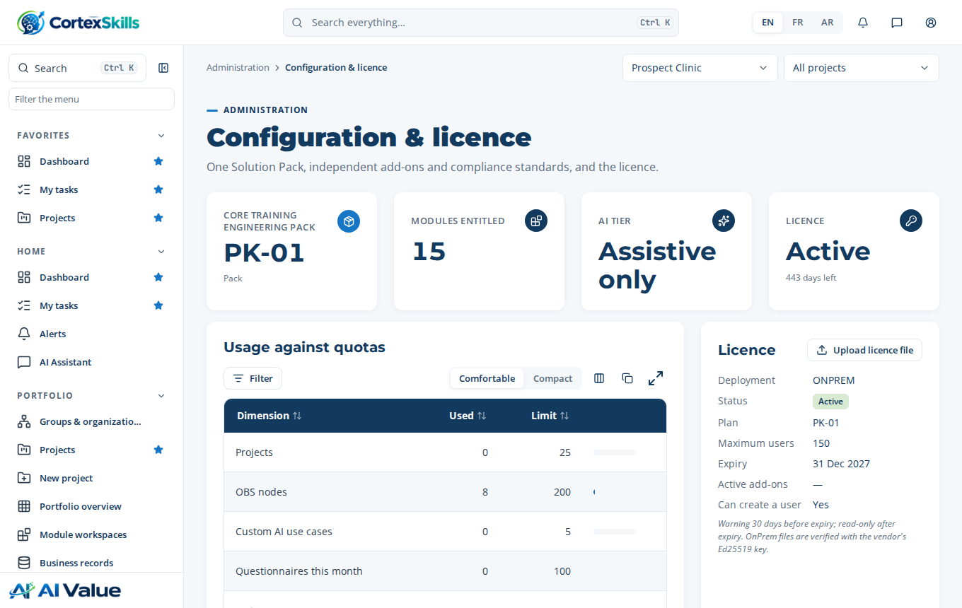
The licence installed and active, as tested on the Docker image of this release

8. A customer installing on its own servers
The customer follows the Customer Installation Guide. Your part:
Send the bundle (with your public key), optionally the prebuilt image, the checksums and the Customer Installation Guide.
Receive the lines printed by licence-request (Company and Organization ID).
Sign the licence in your signing workspace (section 5.2) and record it in your register.
Send the .lic file by e-mail. The customer installs it with licence-install; no restart, no remote access needed.
Renewal, more users, another plan: sign a new file with the same Organization ID; the customer installs it the same way or uploads it in the application.

8.1 Your licence register
Keep one line per licence issued (a spreadsheet is enough):
Date | Company | Organization ID | Plan | Users | End date | File
2026-10-16 | Clinique Exemple | a35218b4-… | SME-GRO | 50 | 2027-12-31 | Clinique_Exemple.lic

9. Security and limits
- The licence check uses an Ed25519 signature: a modified file, or one signed with another key, is refused. The public key sits at a fixed, read-only place in the image; no setting can point the application to another key.
- The application refuses to start in OnPrem production mode if a private key is present in its folder.
- As with any software installed at the customer, a determined administrator with full access to the server could alter the installation. The licence is a strong, auditable control, not an absolute lock: keep the licence terms in your contract (right to audit, number of users, end date).
- Never send the source code, the signing tool or the private key; never copy the private key to the VPS.

10. Troubleshooting
What you see | Cause | What to do
“The vendor PRIVATE key must never be on a customer server” | vendor-private.pem is in the application’s tools/keys folder. | Move it back to the signing workspace only; keep vendor-public.pem.
“OnPrem mode needs the vendor public key” | vendor-public.pem missing from server/tools/keys (zip) or from the bundle (Docker). | Copy your public key there (zip) or rebuild the bundle with package-docker.sh.
licence-install: “signature is not valid” on every customer | Licences signed with another key pair than the public key shipped. | Check the fingerprints (section 2); sign again in the right workspace.
Laptop: “PUBLIC_URL must be the public HTTPS address” | PUBLIC_URL is not http://localhost:<port> or https://… | Use http://localhost:4000 on the laptop.
npm run sign-licence fails (module not found) | You are in the application folder: it has no signing tool. | Go to the signing workspace: ~/CortexSkills-signing/server.

11. Command reference
Where | Command | Purpose
Signing workspace | npm run sign-licence -- --company … --companyId … --expiry … --maxUsers … --plan … --output … | Sign a licence
Signing workspace | bash tools/package-docker.sh server/tools/keys/vendor-public.pem | Build the customer Docker bundle
Laptop application | npm run init · npm start · npm run admin -- help · npm run backup · npm run restore -- <file> | Install, run, administer
Docker (VPS or customer) | docker compose exec cortexskills cortexskills-admin help | org-create | org-list | licence-request | licence-install | backup | Administer the container
Docker (VPS or customer) | docker compose run --rm --no-deps --entrypoint cortexskills-admin cortexskills restore <file> | Restore (container stopped)

