

INSTALLATION GUIDE — CUSTOMER
CortexSkills
Install and run CortexSkills on your own Linux server with Docker (private cloud or on premises)
Version 1.15.0 · 2026-10-15
Prepared by AI Value

Table of Contents
1. What you install 3
2. Requirements 4
2.1 Server 4
2.2 Network 4
2.3 What you receive from the editor 4
3. Install Docker and unpack the bundle 5
3.1 Install Docker (Ubuntu or Debian) 5
3.2 Unpack and check 5
4. Get the image 6
4.1 Option A — load the image built by the editor (recommended) 6
4.2 Option B — build the image from the bundle 6
5. Settings (.env) 7
6. HTTPS 8
6.1 Option A — Caddy provided (automatic certificates) 8
6.2 Option B — your own reverse proxy or load balancer 8
7. First start 9
8. Create your organization 10
9. Activate the licence 11
9.1 Renewal and changes 12
10. Operation 13
10.1 Everyday commands 13
10.2 Backups 13
10.3 Restore 13
10.4 Update to a new version 13
10.5 Uninstall 14
11. Security 15
12. Troubleshooting 16
13. Support 17

1. What you install
CortexSkills runs on your own infrastructure as one Docker container. Your data never leaves your servers: the database, the attached files and the backups are kept in a Docker volume on your host. Nothing is sent to the editor, and the application does not need an Internet connection to run (only to send e-mails or WhatsApp messages, if you configure them).
Element | What it is
Container cortexskills | The application: server and web screens, from the image cortexskills:1.15.0. It runs as a non-root user on a read-only file system.
Volume cortexskills_cortexskills-data | Mounted at /data in the container: database, attached files, daily backups and the installed licence. This is the only data to protect.
Folder licence/ (on the host) | Where you put the licence file sent by the editor. Mounted read-only at /licence.
File .env (on the host) | Your settings: public address, secrets, administrator, e-mail server.
HTTPS reverse proxy | Either the Caddy container provided (compose.https.yml, automatic certificates), or your own proxy or load balancer.

What is in the image — and what is not
In the image: Node.js 22 runtime, the CortexSkills server, the built web screens, and the editor’s public key (it can only check a licence, not create one).
Not in the image: your licence, your settings and secrets, your data, any signing tool or private key, any build tool.
The container listens on port 4000 and is published on 127.0.0.1 only: users reach it through HTTPS.

2. Requirements

2.1 Server
Item | Minimum | Recommended (300+ users)
Operating system | Linux x86-64 or arm64 with a 64-bit kernel | Ubuntu 22.04/24.04 LTS, Debian 12, RHEL/Rocky/AlmaLinux 9
CPU | 2 vCPU | 4 vCPU
Memory | 4 GB | 8 GB
Disk | 20 GB free (image about 650 MB, data and backups) | 50 GB on backed-up storage
Docker | Docker Engine 24 or newer with the compose plugin (docker compose) | Latest stable Docker Engine

2.2 Network
Need | Detail
DNS name | For example skills.yourcompany.com, pointing to the server (internal DNS is enough for an intranet).
Inbound | 443/TCP for users (and 80/TCP if Caddy obtains a Let’s Encrypt certificate). Port 4000 stays closed: it is bound to 127.0.0.1.
Outbound (optional) | Your SMTP server (usually 587/TCP) for e-mails; 443/TCP to graph.facebook.com for WhatsApp Business.
Browsers | Recent Chrome, Edge, Firefox or Safari.

2.3 What you receive from the editor
File | Use
CortexSkills-docker-1.15.0.zip | The installation bundle: Dockerfile, compose files, settings template, the application and the editor public key (vendor-public.pem).
cortexskills-image-1.15.0.tar.gz (optional) | The image already built by the editor. With it you do not build anything (section 4.1).
SHA-256 checksums | To check that the files are intact (section 3).
This guide | Installation and operation.

3. Install Docker and unpack the bundle

3.1 Install Docker (Ubuntu or Debian)
Skip this section if docker compose version already answers. Otherwise, as an administrator (sudo):
curl -fsSL https://get.docker.com -o get-docker.sh
sudo sh get-docker.sh
sudo usermod -aG docker $USER # then log out and back in
docker version && docker compose version
On RHEL, Rocky or AlmaLinux, follow the official procedure at docs.docker.com/engine/install (package docker-ce and docker-compose-plugin), then: sudo systemctl enable --now docker.

3.2 Unpack and check
sudo mkdir -p /opt/cortexskills && sudo chown $USER /opt/cortexskills && cd /opt/cortexskills
sha256sum CortexSkills-docker-1.15.0.zip # compare with the checksum sent by the editor
unzip CortexSkills-docker-1.15.0.zip && cd CortexSkills-docker-1.15.0
ls -a
In the folder | Role
Dockerfile, .dockerignore | Builds the runtime image (section 4.2).
docker-compose.yml | The CortexSkills service, its data volume and its security options.
compose.https.yml, Caddyfile | Optional HTTPS front end with automatic certificates.
env.example | Template of the settings file .env.
entrypoint.sh, cortexskills-admin | Start script (creates the database on the first start) and administration console.
vendor-public.pem | Editor public key that checks the licence file. Do not modify it.
app/ | The application (server and built web screens).
licence/ | Put the licence file here when you receive it.

4. Get the image

4.1 Option A — load the image built by the editor (recommended)
sha256sum cortexskills-image-1.15.0.tar.gz
docker load -i cortexskills-image-1.15.0.tar.gz
docker image ls cortexskills

4.2 Option B — build the image from the bundle
The build downloads the Node.js base image and the server libraries from the Internet (registry.npmjs.org and Docker Hub, or your internal mirrors). It takes 2 to 5 minutes.
docker build -t cortexskills:1.15.0 .
The build stops with an explicit message if vendor-public.pem is missing or is not a public key. Behind a proxy, add --build-arg HTTPS_PROXY=http://proxy:port. To use an internal registry mirror of the official Node image: --build-arg BASE_IMAGE=registry.yourcompany.com/library/node:22-bookworm-slim.

5. Settings (.env)
cp env.example .env && chmod 600 .env
openssl rand -base64 48 | tr -d "\n=+/"; echo # run twice: one value per secret
nano .env
Setting | What to put | Example
PUBLIC_URL | The address users type, in HTTPS. Used in the links sent by e-mail and WhatsApp. | https://skills.yourcompany.com
CORS_ORIGIN | The same address. | https://skills.yourcompany.com
DOMAIN | Only with compose.https.yml: the DNS name. | skills.yourcompany.com
HOST_PORT | Port of the host where the container is published, on 127.0.0.1. | 4000
JWT_SECRET | Random value of 32+ characters (signs the sessions). | output of openssl rand
CHANNEL_SECRET_KEY | Another random value of 32+ characters (encrypts stored credentials). | output of openssl rand
ADMIN_EMAIL, ADMIN_NAME, ADMIN_PASSWORD | The platform administrator created at the first start. Password: 12+ characters, upper and lower case, digit, symbol. Remove ADMIN_PASSWORD after the first start. | it.ops@yourcompany.com
BACKUP_RETENTION_DAYS | Days a daily backup is kept in the volume. | 30
SMTP_* | Your mail server for invitations, reminders and notifications (each organization can also set its own). | smtp.yourcompany.com, 587
WHATSAPP_* | Optional: WhatsApp Business Cloud API. | —
Production checks at start-up
The container refuses to start while a setting is unsafe — a short or default secret, the same value for both secrets, an address that is not HTTPS, an open CORS policy — and lists each problem in its log. http://localhost:4000 is accepted only for an evaluation on the server itself.
Keep a copy of .env in your secret vault: changing JWT_SECRET signs every user out; losing CHANNEL_SECRET_KEY makes the stored e-mail and WhatsApp credentials unreadable.

6. HTTPS

6.1 Option A — Caddy provided (automatic certificates)
The DNS name must point to the server and ports 80 and 443 must be reachable (from the Internet for Let’s Encrypt). Caddy obtains and renews the certificate itself.
docker compose -f docker-compose.yml -f compose.https.yml up -d
For an internal certificate authority, replace the first line of the Caddyfile by the name followed by a tls directive with your certificate and key files, mounted in the Caddy container.

6.2 Option B — your own reverse proxy or load balancer
Start only CortexSkills (docker compose up -d) and forward HTTPS to http://127.0.0.1:4000. Example for nginx:
server {
listen 443 ssl http2; server_name skills.yourcompany.com;
ssl_certificate /etc/ssl/skills.crt; ssl_certificate_key /etc/ssl/skills.key;
client_max_body_size 20m;
location / {
proxy_pass http://127.0.0.1:4000;
proxy_set_header Host $host;
proxy_set_header X-Forwarded-For $proxy_add_x_forwarded_for;
proxy_set_header X-Forwarded-Proto https;
}
}
If the proxy runs on another machine, publish the port on the server’s private address instead of 127.0.0.1 (docker-compose.yml, ports) and restrict it with your firewall to the proxy only.

7. First start
docker compose up -d # or with compose.https.yml, section 6.1
docker compose logs -f # Ctrl+C to leave the logs
curl -s http://127.0.0.1:4000/api/health
On the first start the container creates the database (reference catalog, templates and the platform administrator) in about 5 seconds, then starts. The health check answers:
{"status":"ok","initialized":true,"mode":"onprem","version":"1.15.0"}
Docker also reports the state: docker compose ps shows “healthy”. Then remove ADMIN_PASSWORD from .env and run docker compose up -d again.
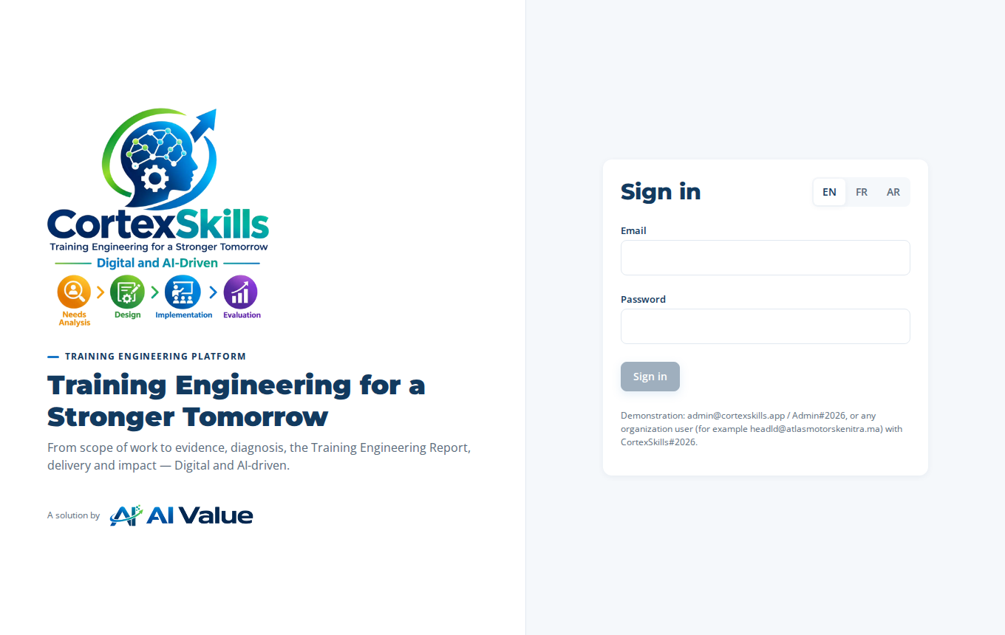
The sign-in page at your public address

8. Create your organization
An organization is your company in CortexSkills, with its own users, projects and licence. Create it from the administration console of the container:
docker compose exec cortexskills cortexskills-admin org-create \
--name "Your Company" --domain yourcompany.com \
--admin-email jane.doe@yourcompany.com --admin-name "Jane Doe" \
--admin-password 'Str0ng#Passw0rd2026' \
--lang en --country Morocco --city Casablanca
Option | Meaning
--name | Company name as shown in the application.
--domain | E-mail domain of your users; it identifies the organization in the commands below.
--admin-email, --admin-name, --admin-password | The first administrator of your organization (full rights). Strong password required.
--lang | Default language: en, fr or ar. Each user can switch language later.
--sector, --segment, --employees, --country, --city | Optional profile; can be completed later in the application.
The command prints the Organization ID. Your users cannot sign in until the licence is installed (section 9).

9. Activate the licence
The licence is a small signed file (.lic) issued by the editor for your Organization ID. It sets the number of users, the scope and the end date. It is checked with the editor public key included in the image: any change to the file makes it invalid.
Request. Print the information to send to the editor:
docker compose exec cortexskills cortexskills-admin licence-request --org yourcompany.com
Send the lines printed (Company and Organization ID) to the editor by e-mail. The Organization ID is not secret, but it must be copied exactly.
Receive. The editor sends you a file such as Your_Company.lic. Copy it into the licence/ folder of the bundle:
cp ~/Your_Company.lic /opt/cortexskills/CortexSkills-docker-1.15.0/licence/
Install. No restart is needed:
docker compose exec cortexskills cortexskills-admin licence-install --file /licence/Your_Company.lic
The console confirms the scope, the number of users and the end date. A modified file, or one issued for another Organization ID, is refused with an explicit message.
Check. Sign in with the organization administrator, then open Administration › Configuration & licence: the licence shows Active, the number of users and the end date.
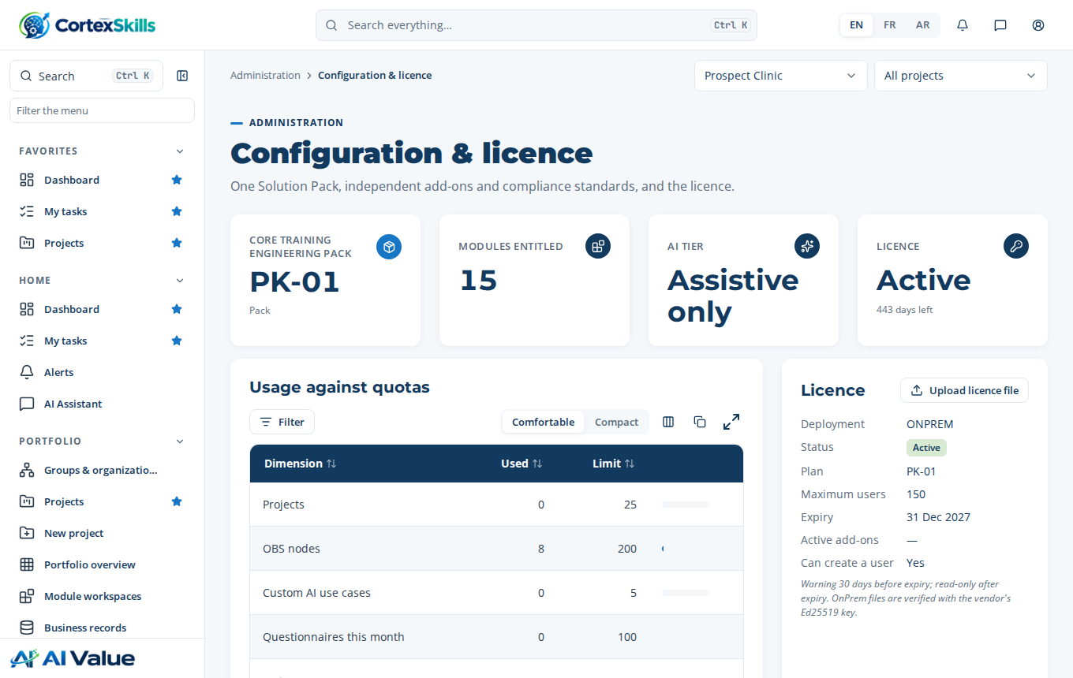
Administration › Configuration & licence after activation

9.1 Renewal and changes
Before the end date the application warns the administrators (30 days ahead). After it, the application becomes read-only until a new licence is installed. For a renewal or a change in the number of users, the editor sends a new .lic file: install it with the same command, or upload it in Administration › Configuration & licence › Upload licence file.

10. Operation

10.1 Everyday commands
Action | Command (in the bundle folder)
Start / stop / restart | docker compose up -d · docker compose stop · docker compose restart
State and health | docker compose ps · curl -s http://127.0.0.1:4000/api/health
Logs | docker compose logs -f --tail 200
Console help | docker compose exec cortexskills cortexskills-admin help
Reset a user password | docker compose exec cortexskills cortexskills-admin password --email john@yourcompany.com --password 'New#Passw0rd2026'
The container restarts by itself after a reboot of the server (restart: unless-stopped), as long as the Docker service is enabled (sudo systemctl enable docker).

10.2 Backups
The application writes a backup of the database every day in /data/backups and keeps it BACKUP_RETENTION_DAYS days. Take an extra one before any change, and copy the backups out of the server every day:
docker compose exec cortexskills cortexskills-admin backup
docker compose cp cortexskills:/data/backups ./backups-$(date +%F)
# then copy that folder to your backup storage (rsync, object storage, tape...)
Attached files are in /data/attachments: copy them the same way (docker compose cp cortexskills:/data/attachments ./attachments-$(date +%F)), or back up the whole Docker volume with your usual tool.

10.3 Restore
docker compose stop
docker compose run --rm --no-deps --entrypoint cortexskills-admin cortexskills restore # lists the backups
docker compose run --rm --no-deps --entrypoint cortexskills-admin cortexskills restore <file.db>
docker compose start
The current database is kept beside the backups as before-restore-<date>.db. A backup from an earlier version is upgraded automatically at start-up.

10.4 Update to a new version
Take a backup (10.2).
Load or build the new image (section 4) — for example cortexskills:1.16.0.
Set the new tag in docker-compose.yml (image:), then run docker compose up -d. The data volume and the licence are kept; the database is migrated at start-up.
Check the health and the version (curl …/api/health).
To go back, set the previous tag again and restore the backup taken in step 1.

10.5 Uninstall
docker compose down stops and removes the container but keeps the data volume. docker compose down -v also deletes the volume and therefore all data: take and copy a backup first.

11. Security
- The container runs as an unprivileged user, with a read-only file system, no Linux capabilities and no privilege escalation (docker-compose.yml).
- Port 4000 is published on 127.0.0.1 only; only the HTTPS front end is exposed.
- Keep .env readable by administrators only (chmod 600) and store its secrets in your vault.
- Passwords are stored hashed; sessions expire after JWT_TTL (12 hours by default); every administrative change is written to the audit log.
- Apply your operating system updates; update Docker Engine; install the CortexSkills updates sent by the editor.

12. Troubleshooting
What you see | Cause | What to do
“will not start in production mode” in the logs | A setting of .env is missing or unsafe. | Read the list printed in the logs; each line names the setting to fix. Then docker compose up -d.
“First start: set ADMIN_EMAIL and ADMIN_PASSWORD” | First start without an administrator. | Fill ADMIN_EMAIL and ADMIN_PASSWORD in .env, start again, then remove ADMIN_PASSWORD.
Users get “The licence of this Organization is not active” | No licence installed, or expired. | Section 9. Check the end date in Administration › Configuration & licence.
licence-install: “signature is not valid” | The file was modified, or not issued by the editor. | Ask the editor for the file again; do not edit it.
licence-install: “Organization ID … does not exist” | The file was issued for another ID. | Compare with cortexskills-admin org-list and send the right ID to the editor.
The build stops on vendor-public.pem | Key missing from the bundle folder. | Ask the editor for the bundle with its key, or use the prebuilt image.
Links in e-mails point to the wrong address | PUBLIC_URL is not the address users type. | Fix PUBLIC_URL and CORS_ORIGIN, then docker compose up -d.
Caddy cannot get a certificate | DNS not pointing to the server, or port 80/443 closed. | Check the DNS record and the firewall; docker compose logs caddy.

13. Support
When you contact the editor, send: the version (…/api/health), the output of docker compose ps, and the last 200 lines of docker compose logs. Never send the .env file or the secrets it contains.

