


PRESENTATION
Healthcare full case — Training engineering project
Santéora Private Clinics Group
Version 1.10.0 · 2026-10-12
50 slides · demonstration data, fictional organization
Prepared by AI Value

Table of Contents
1. Title 3
2. How the case is presented 4
3. A complete AI skills cycle, documented end to end 5
01. The clinic group and the project 6
5. Santéora Private Clinics Group 7
6. Key dates and SWOT of the clinic group 8
7. AI Skills Full Run 2026 — Santéora Private Clinics Group 9
8. Functions and decision levels in scope 10
9. Six phases, each closed by a gate with its deliverables 11
10. Work packages and the Gantt chart 12
11. 40 people consulted across every function 13
02. Diagnosis 14
13. 35 of 40 people answered 15
14. What the teams said about the last training plan 16
15. Five axes scored, maturity one level below target 17
16. Where each function stands at each decision level 18
17. The competences people asked for, by number of mentions 19
18. Self-assessment of the respondents, weakest first 20
19. From measured gaps to a validated needs register 21
20. Clinical Care & Nursing 22
21. How the teams use AI and what holds them back 23
22. What the respondents want the training to change 24
03. Training Engineering Report 25
24. Training Engineering Report and Training Plan 26
25. Needs linked to the strategy and to the HR orientations 27
26. Four initiatives deployed in three waves 28
27. Each risk reduced by named controls 29
28. Indicators followed every month during the run 30
04. Training Plan 31
30. Six themes ranked by impact and urgency 32
31. Two programs, six trainings, clear prerequisites 33
32. TR-AI-01 — AI triage and clinical decision support 34
33. AI triage and clinical decision support — half-day by half-day 35
34. Why each audience should take the training 36
35. Paths, modules and content assets 37
36. Allocated, committed, spent and refunds expected 38
05. Delivery, evaluation and audit 39
38. Four sessions delivered with their enrolments 40
39. Results measured at three Kirkpatrick levels 41
40. Phillips ROI and the indicators of the ROI study 42
41. Audit report — Santéora Private Clinics Group 43
42. REX — AI triage and clinical decision support 44
06. Documents produced 45
44. Every end-to-end process leaves its document 46
45. Documents produced (continued) 47
46. Every number of the report comes from a record 48
47. The Training Plan as the users see it 49
48. The project workspace and the dashboard 50
49. What the clinic group has at the end of the cycle 51
50. Closing 52

1. Title
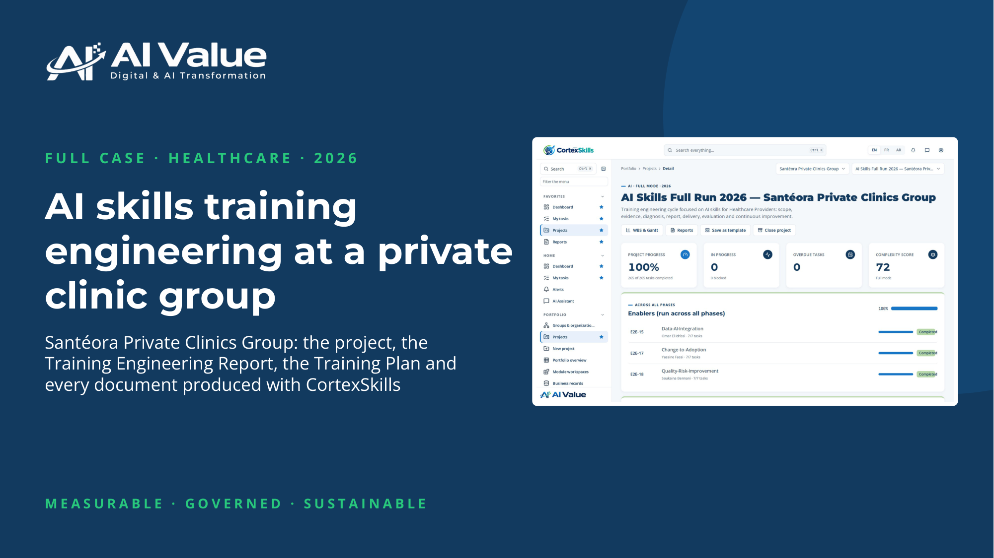

2. How the case is presented
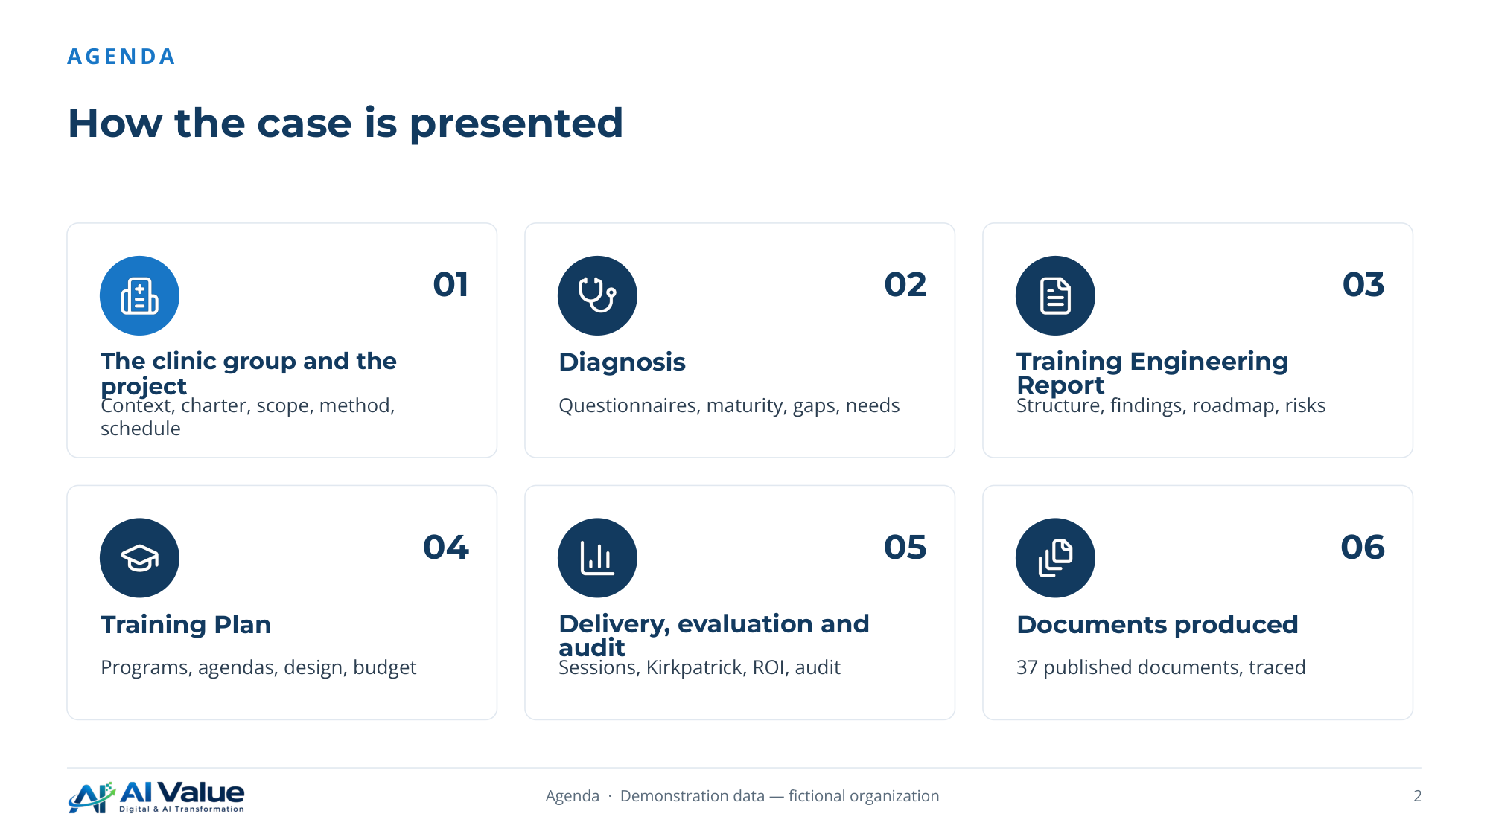

3. A complete AI skills cycle, documented end to end
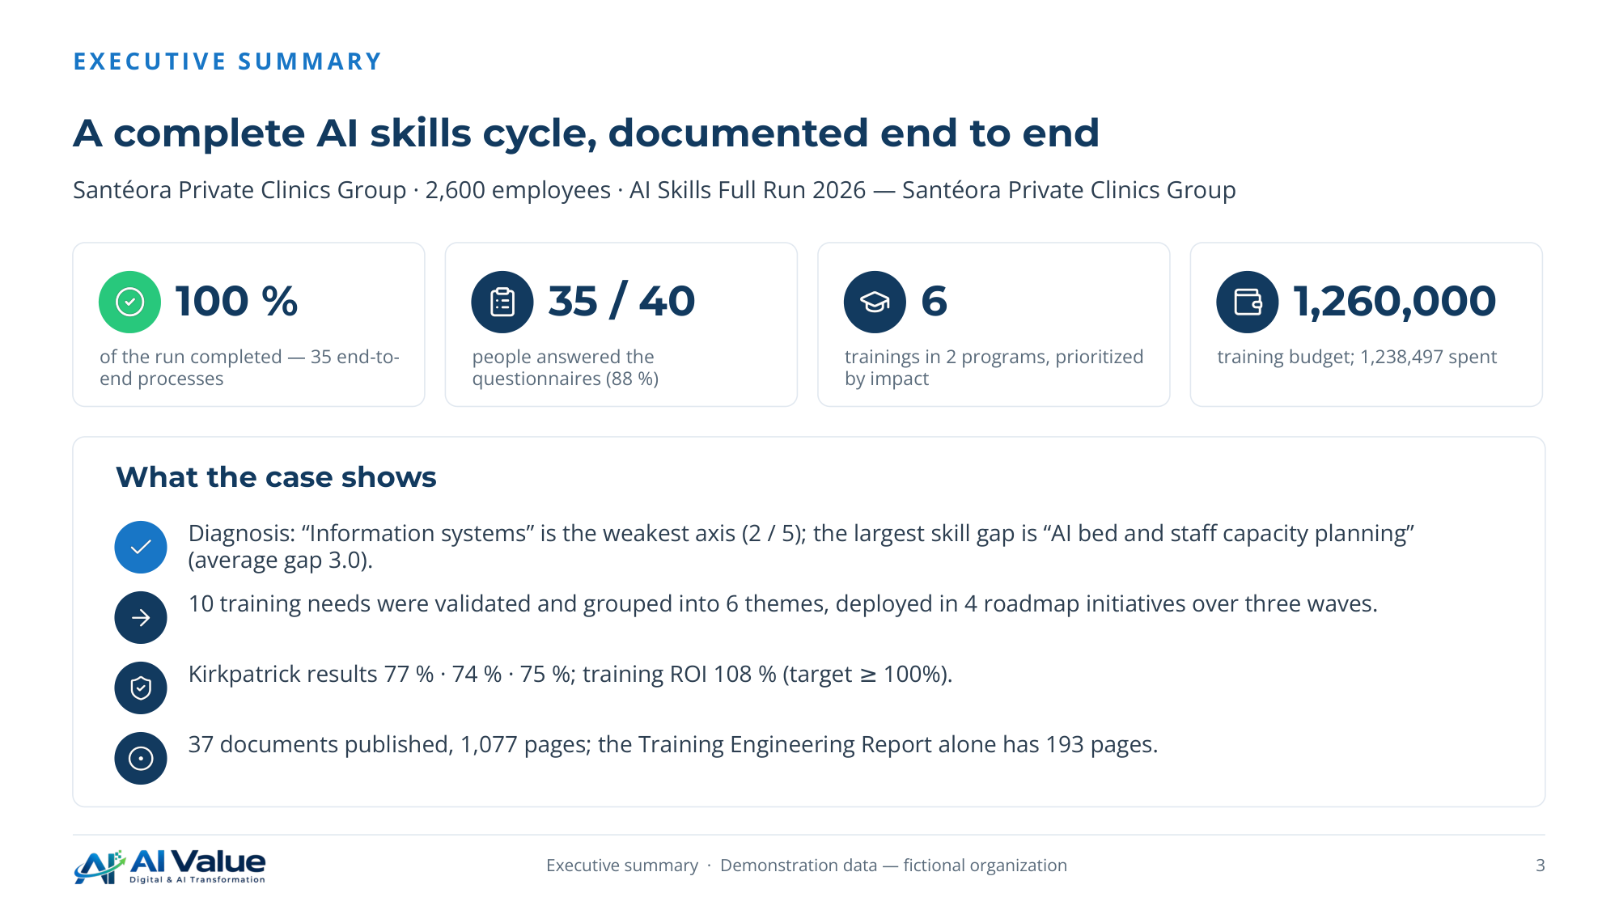

01. The clinic group and the project
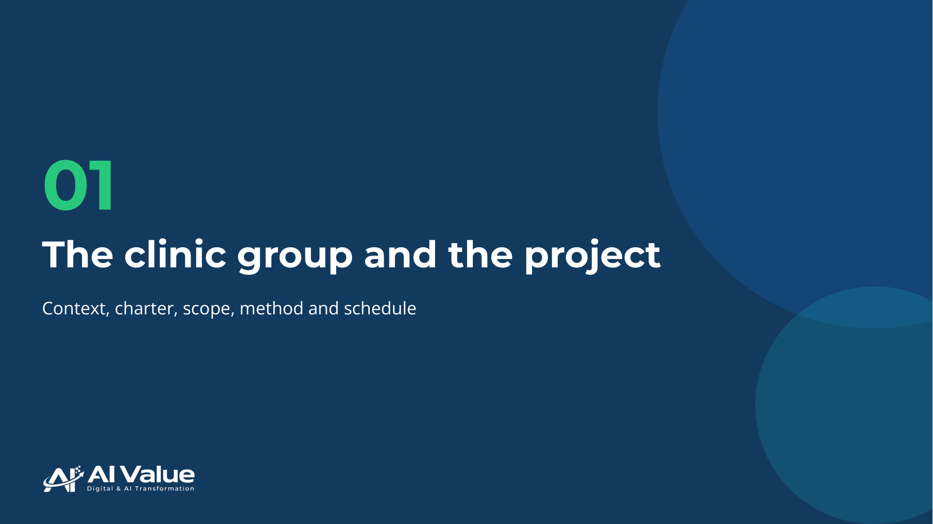

5. Santéora Private Clinics Group
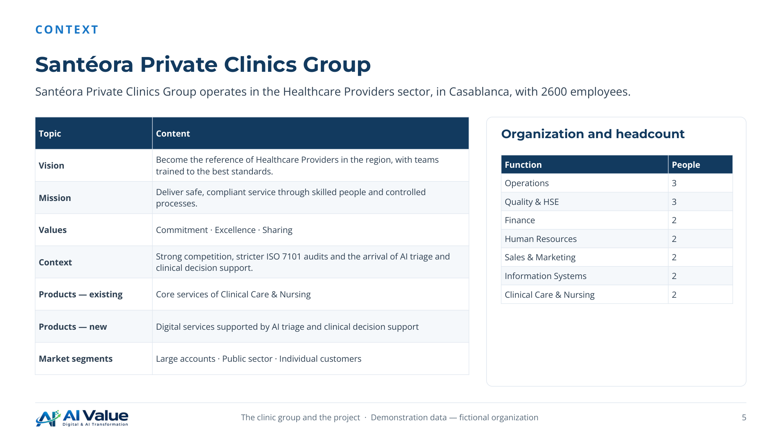

6. Key dates and SWOT of the clinic group
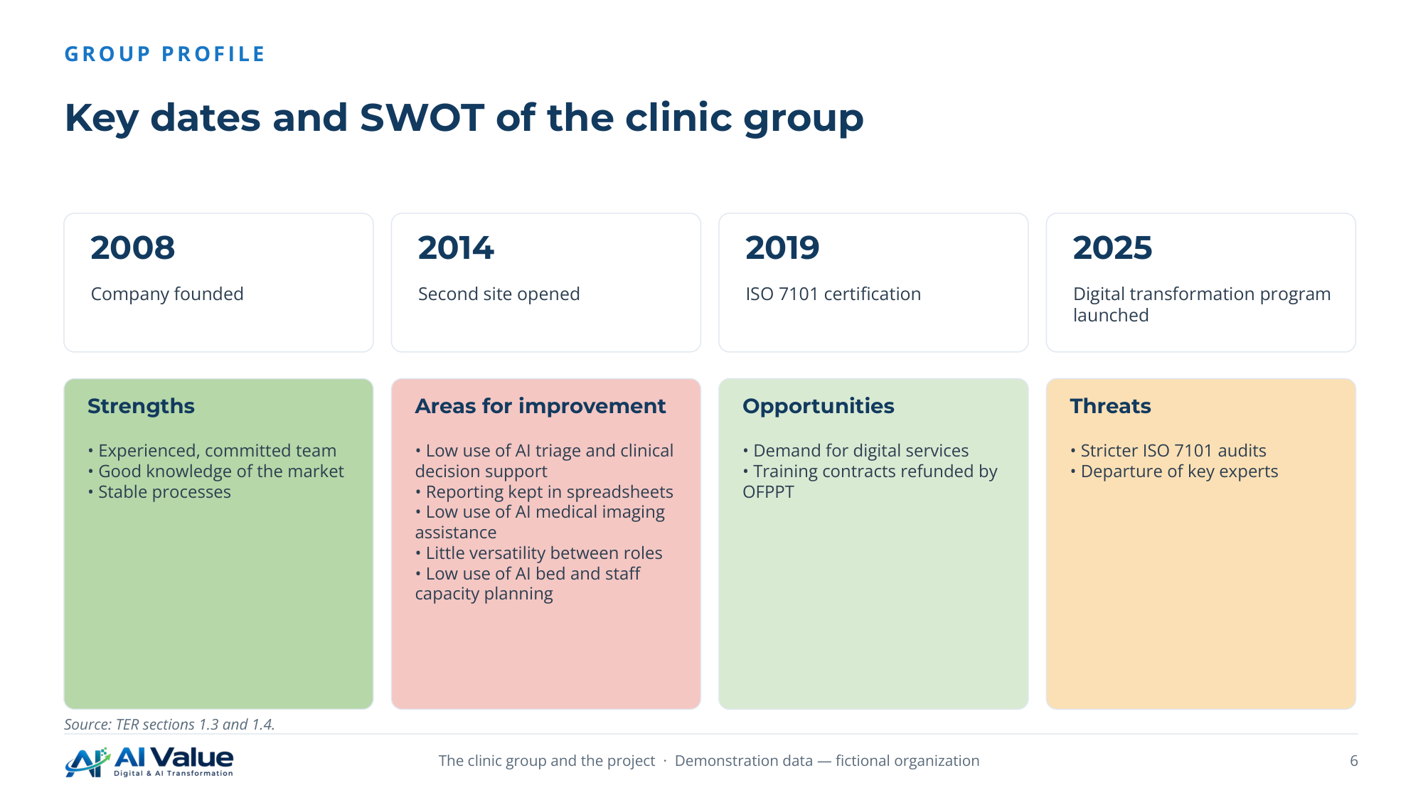

7. AI Skills Full Run 2026 — Santéora Private Clinics Group
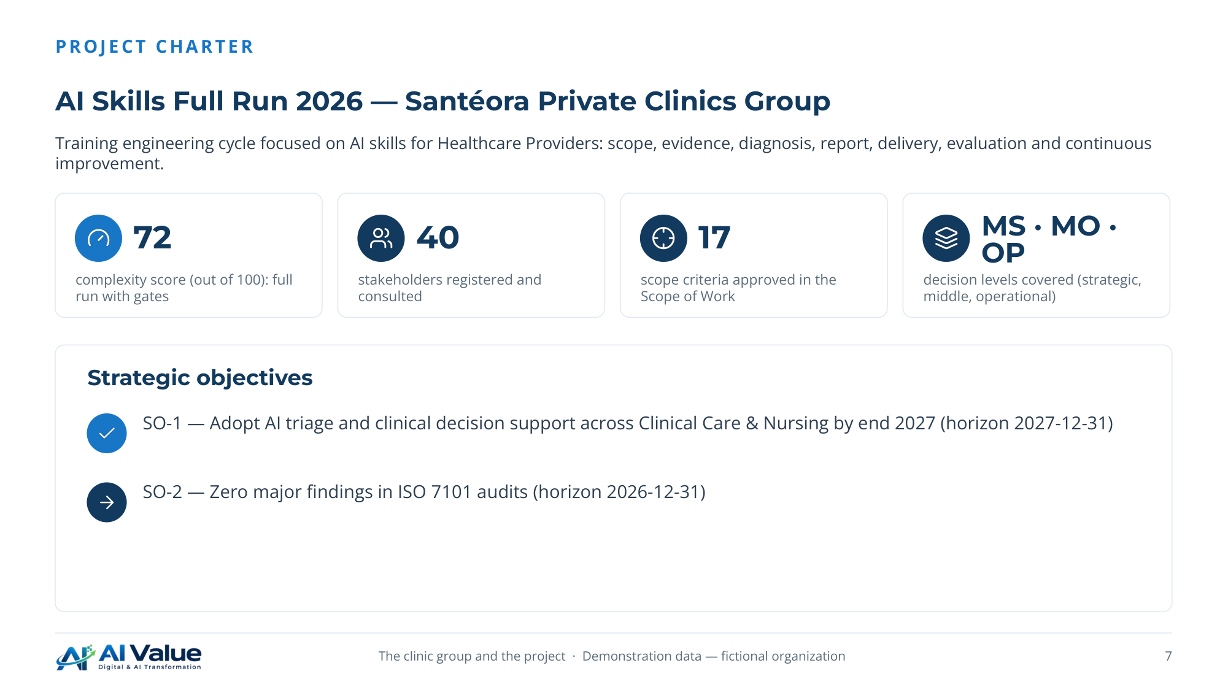

8. Functions and decision levels in scope
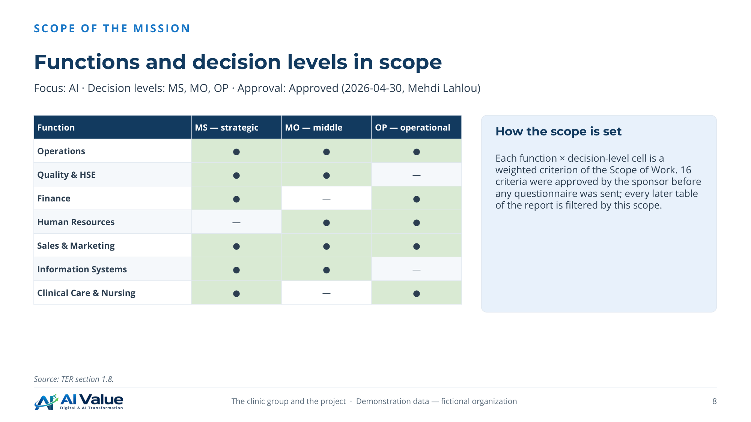

9. Six phases, each closed by a gate with its deliverables
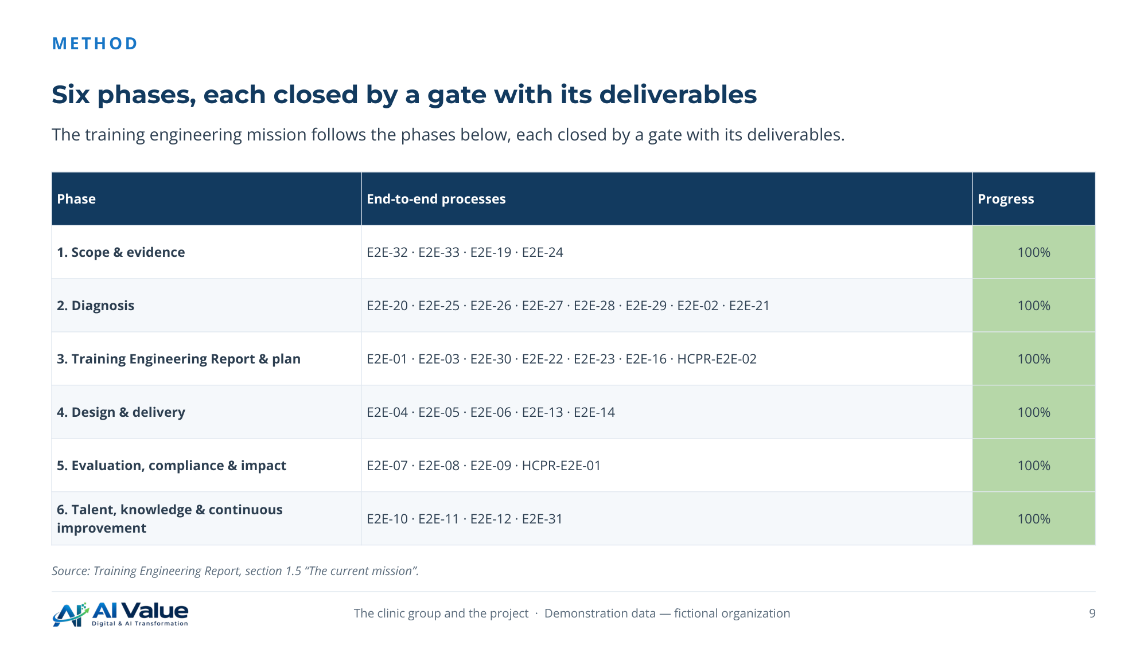

10. Work packages and the Gantt chart
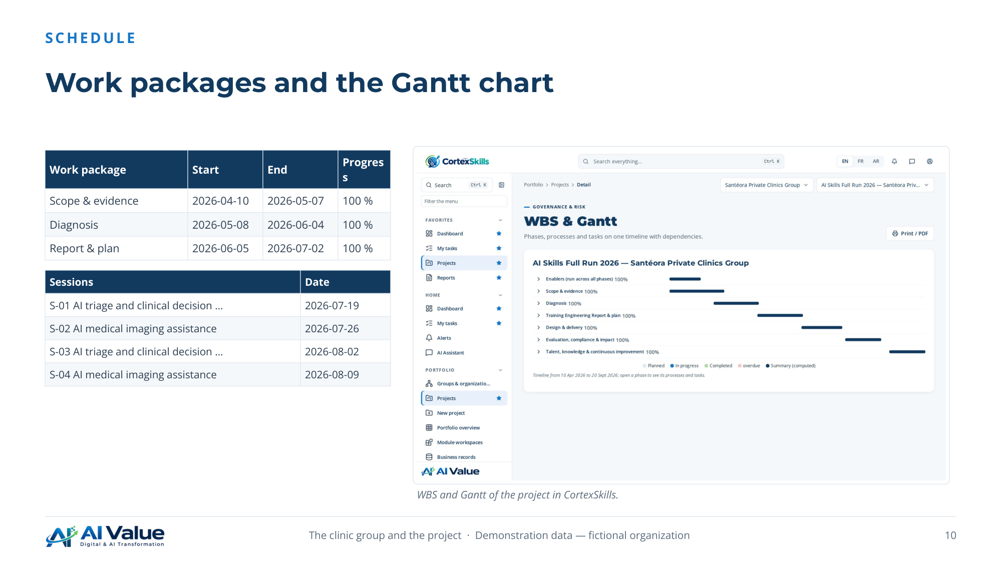

11. 40 people consulted across every function
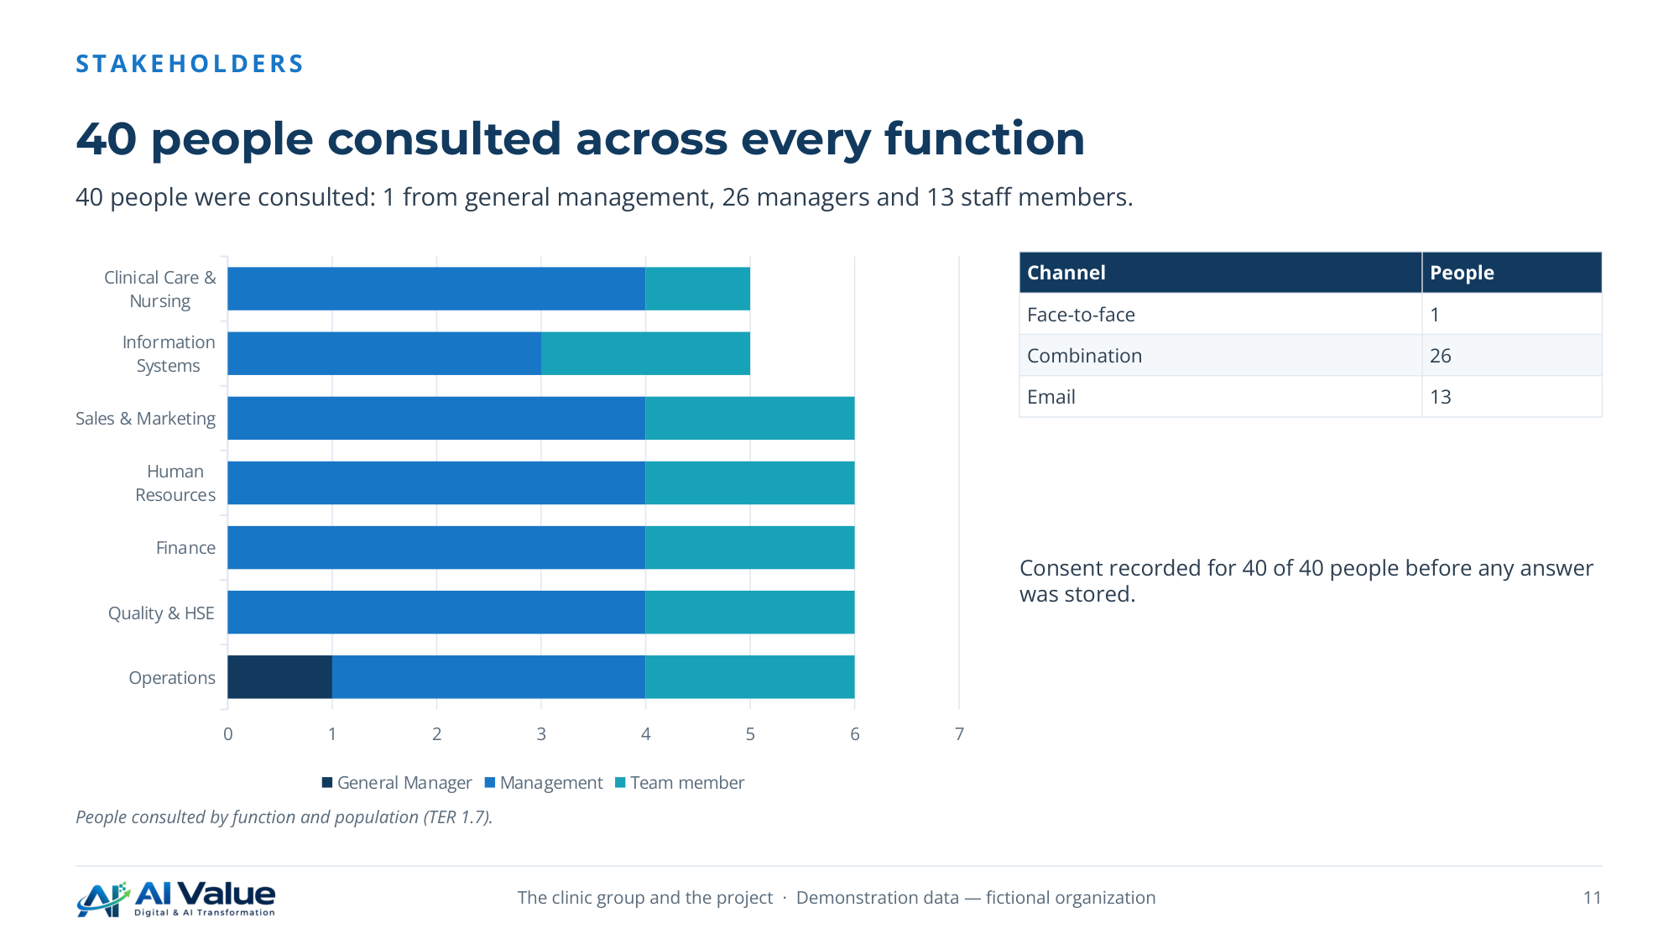

02. Diagnosis
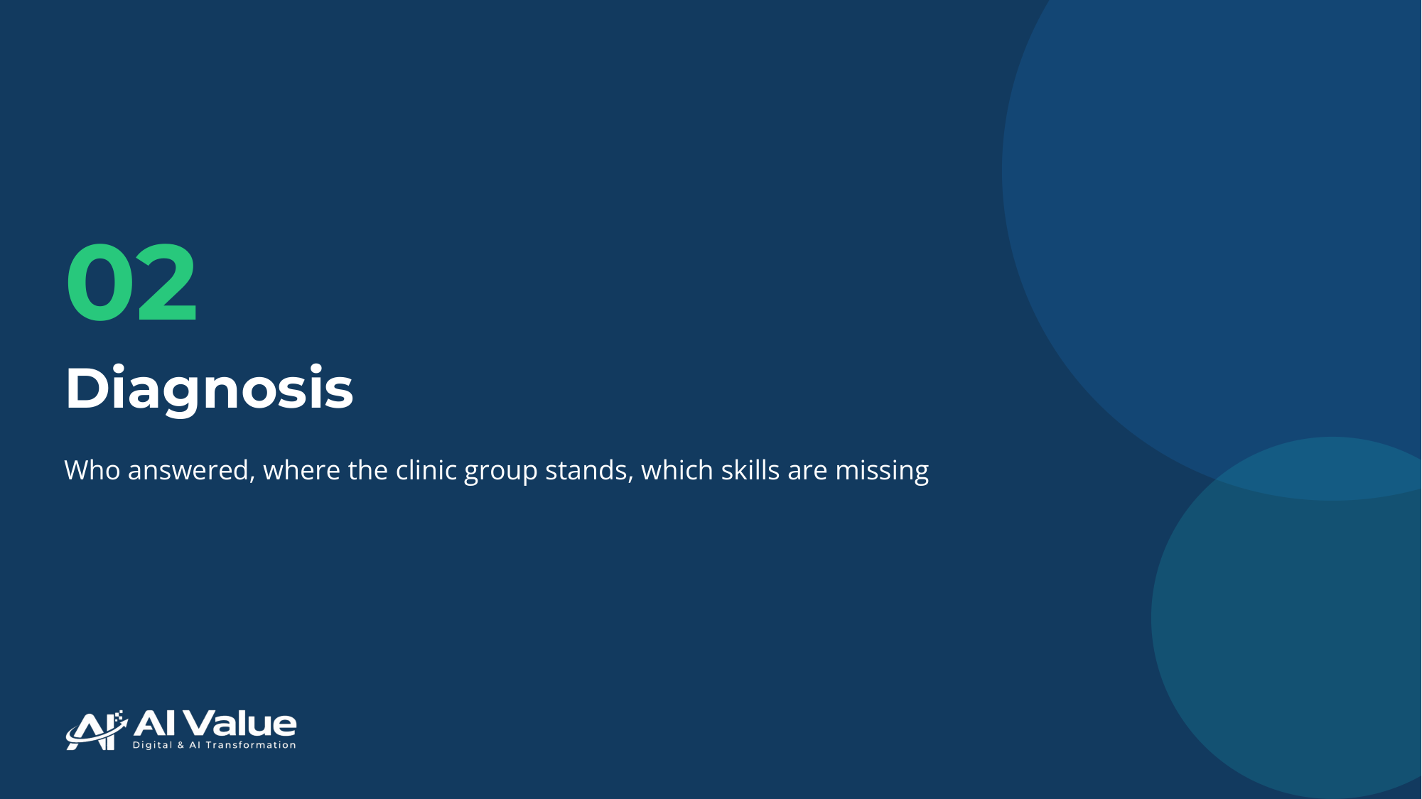

13. 35 of 40 people answered
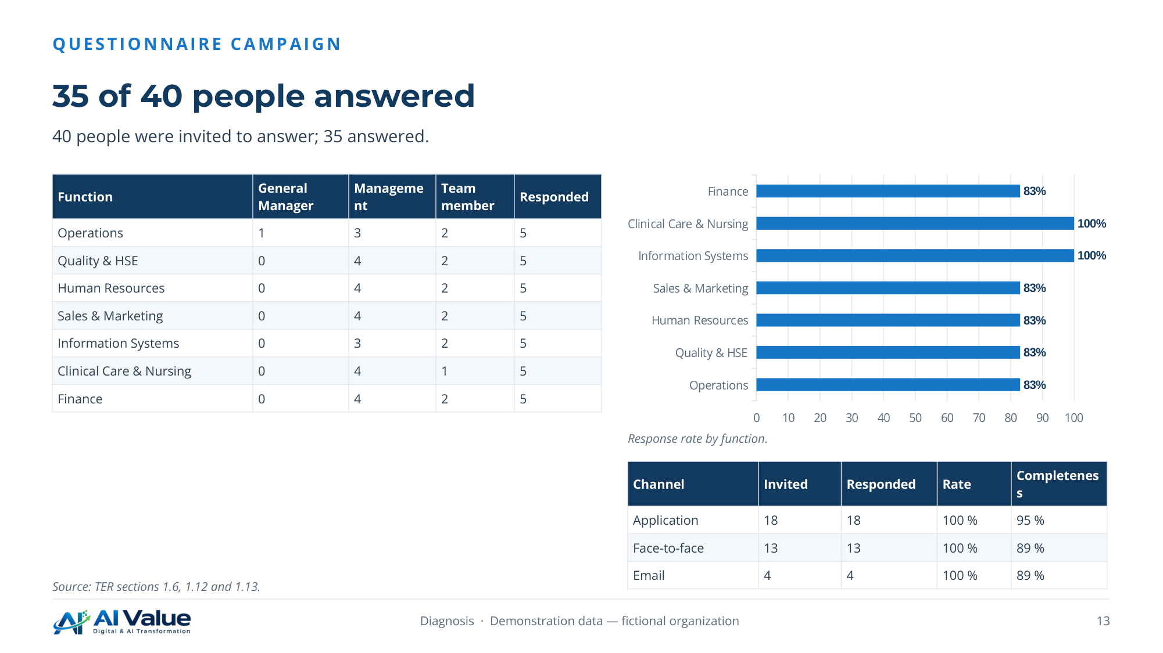

14. What the teams said about the last training plan
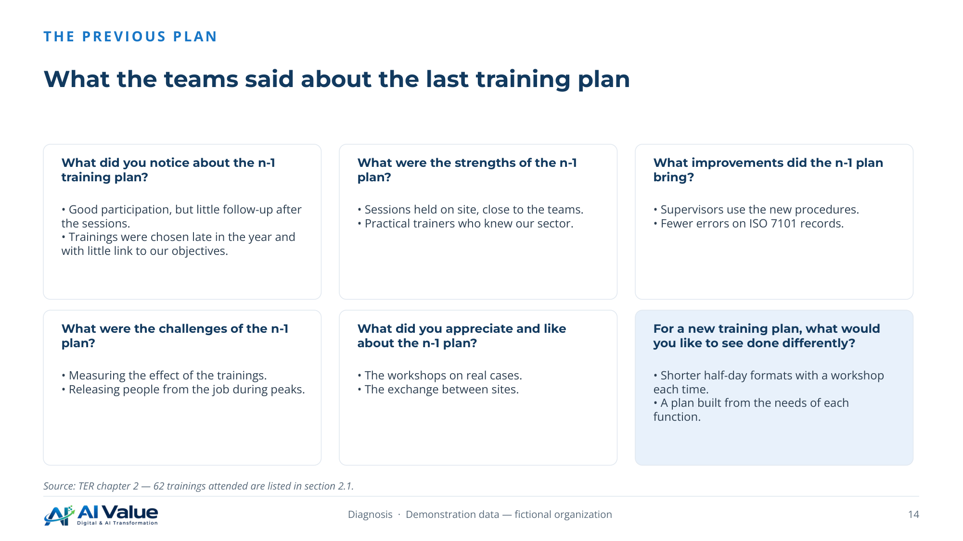

15. Five axes scored, maturity one level below target
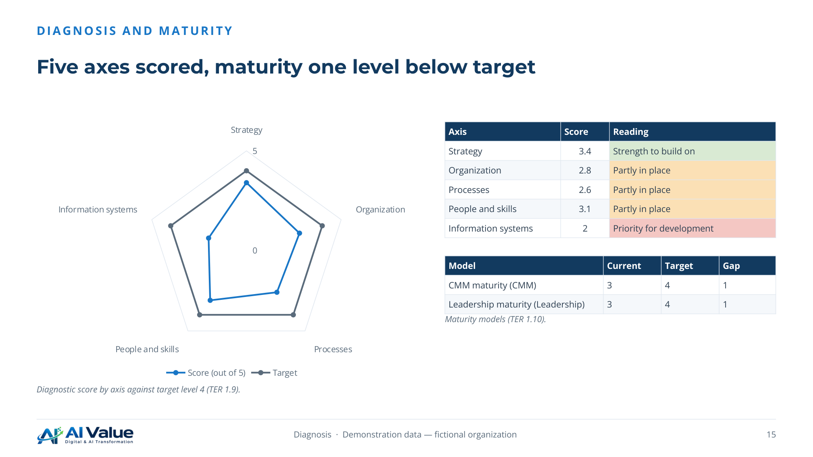

16. Where each function stands at each decision level
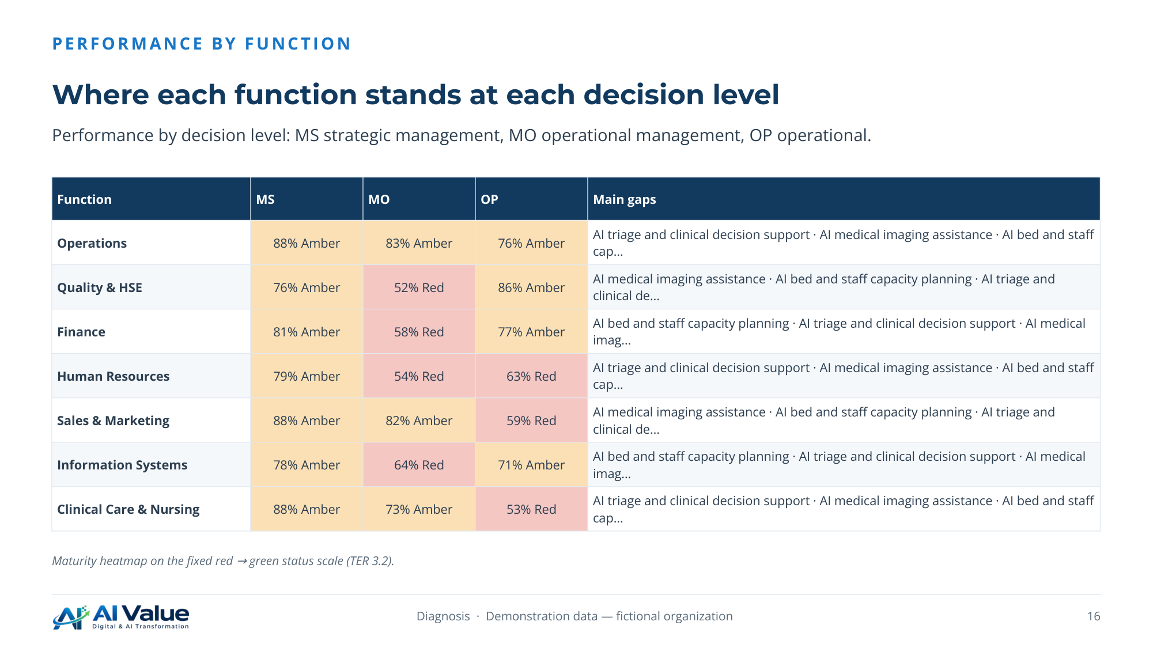

17. The competences people asked for, by number of mentions
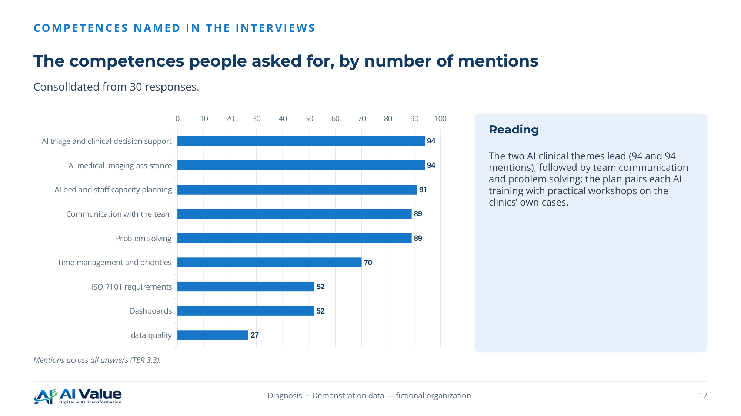

18. Self-assessment of the respondents, weakest first
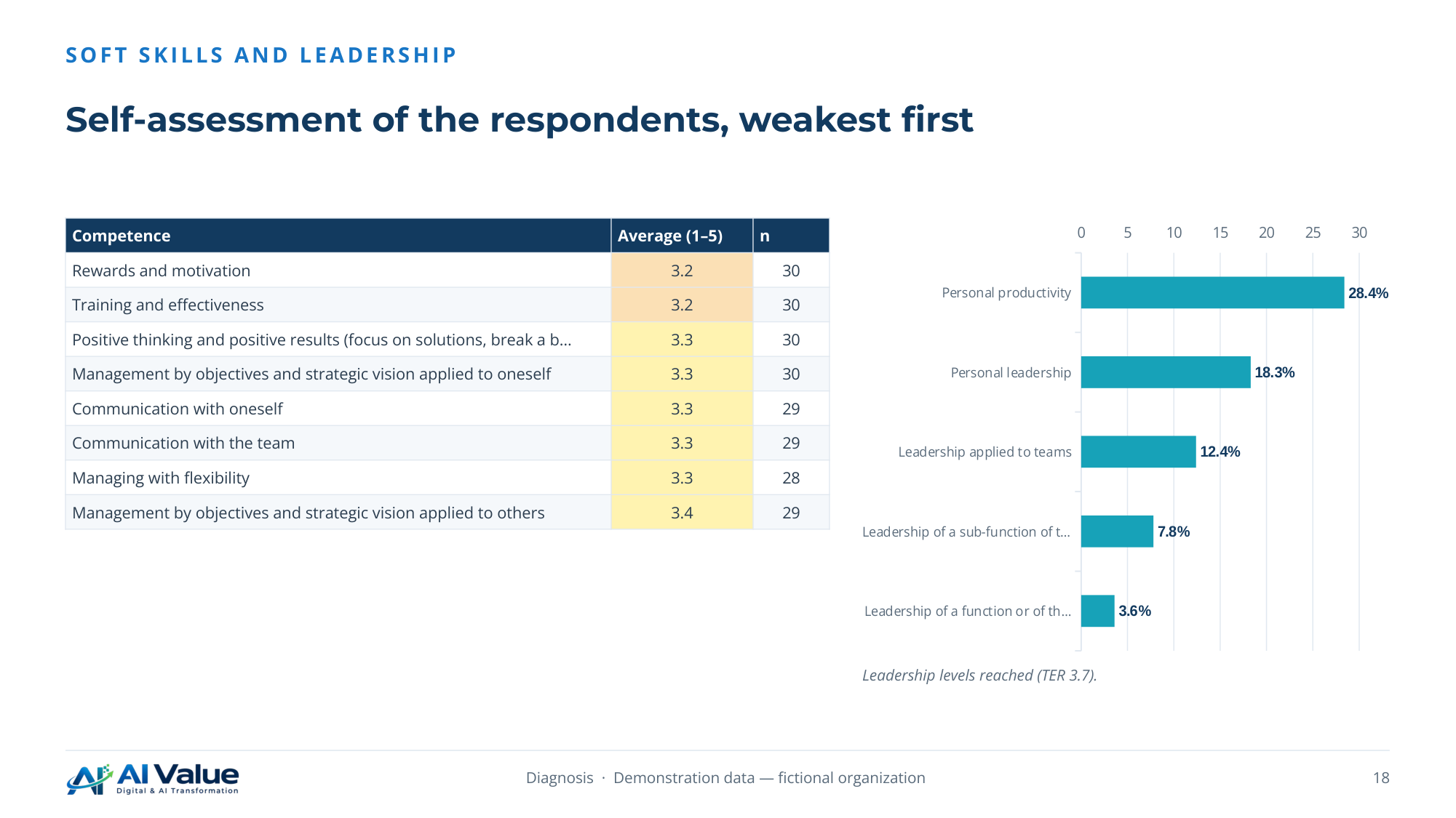

19. From measured gaps to a validated needs register
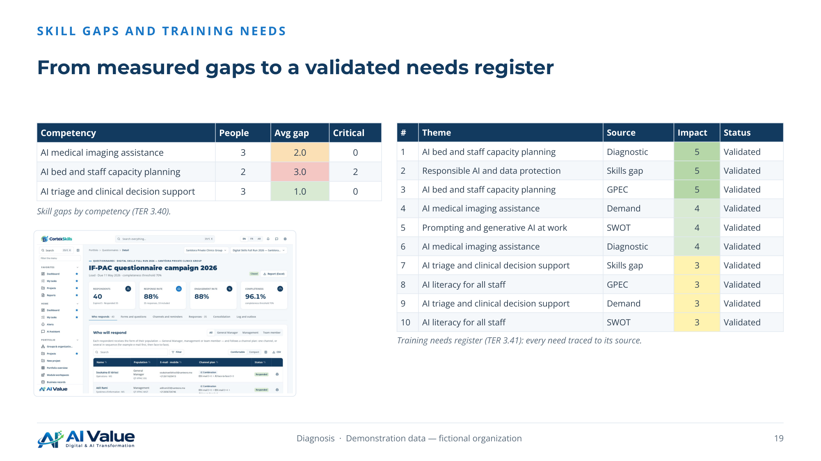

20. Clinical Care & Nursing
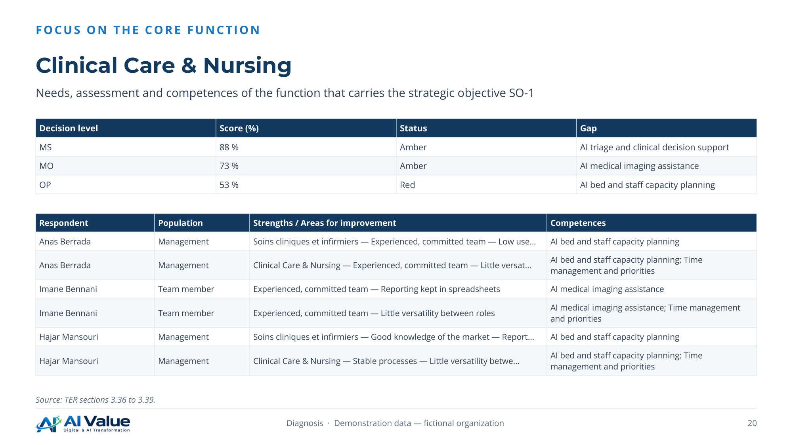

21. How the teams use AI and what holds them back
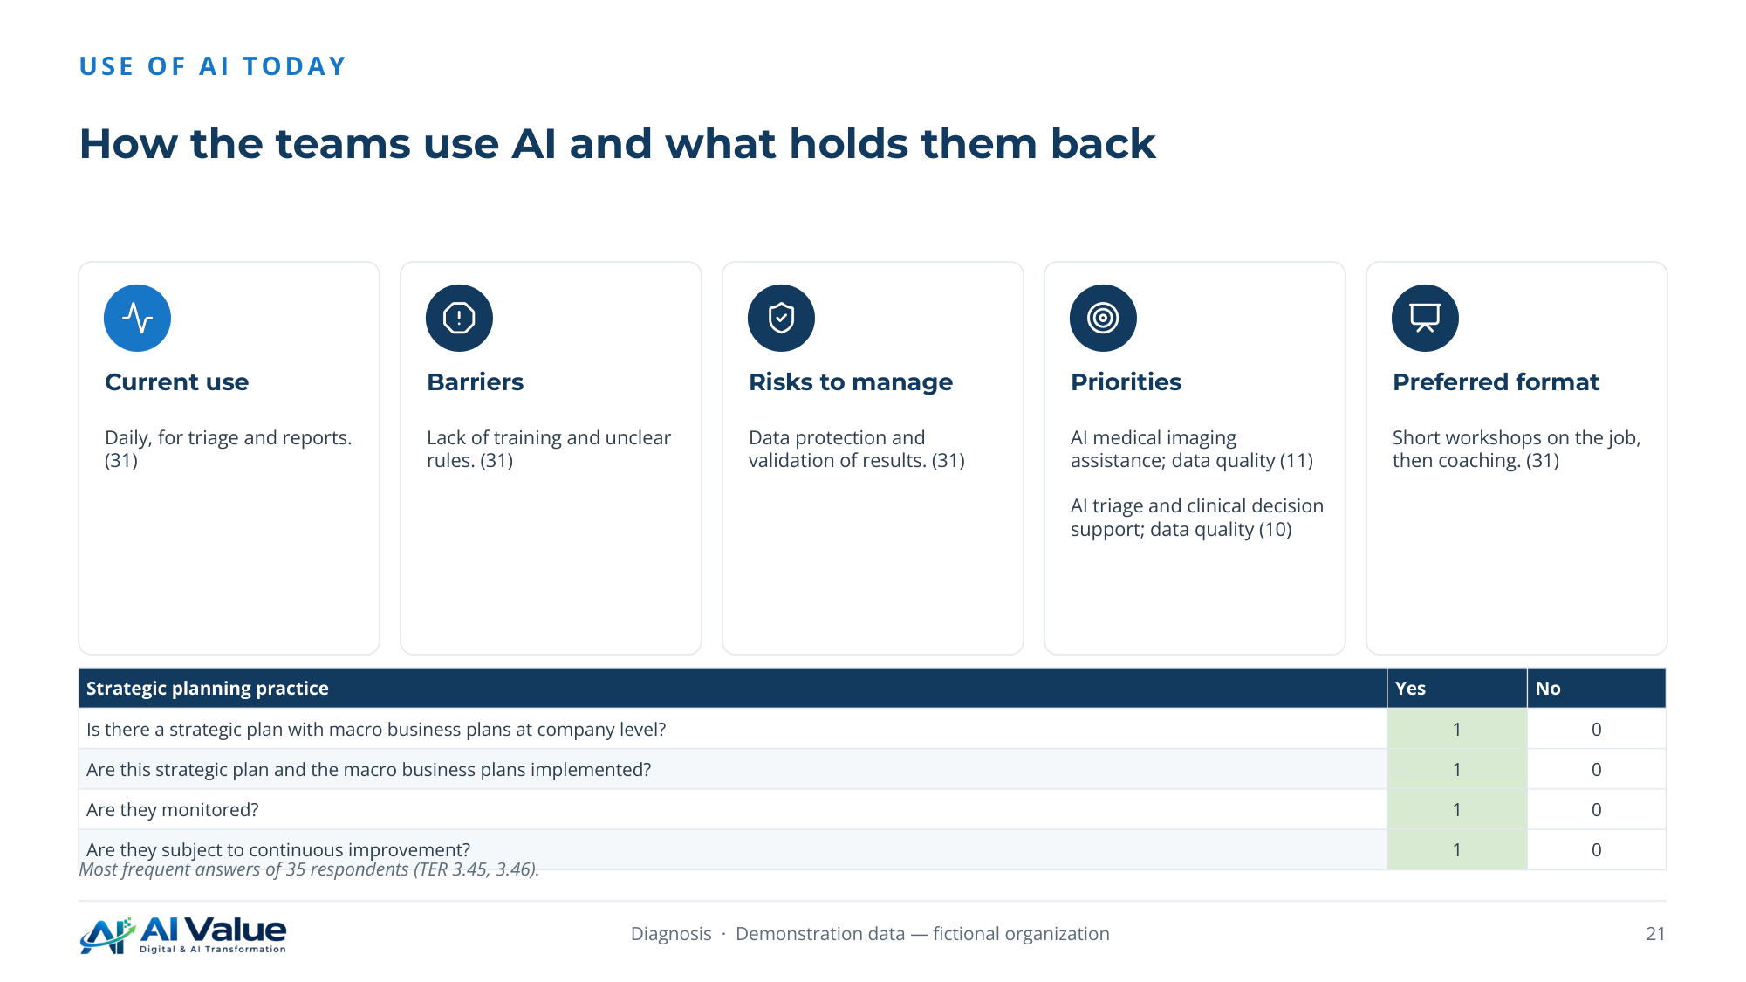

22. What the respondents want the training to change
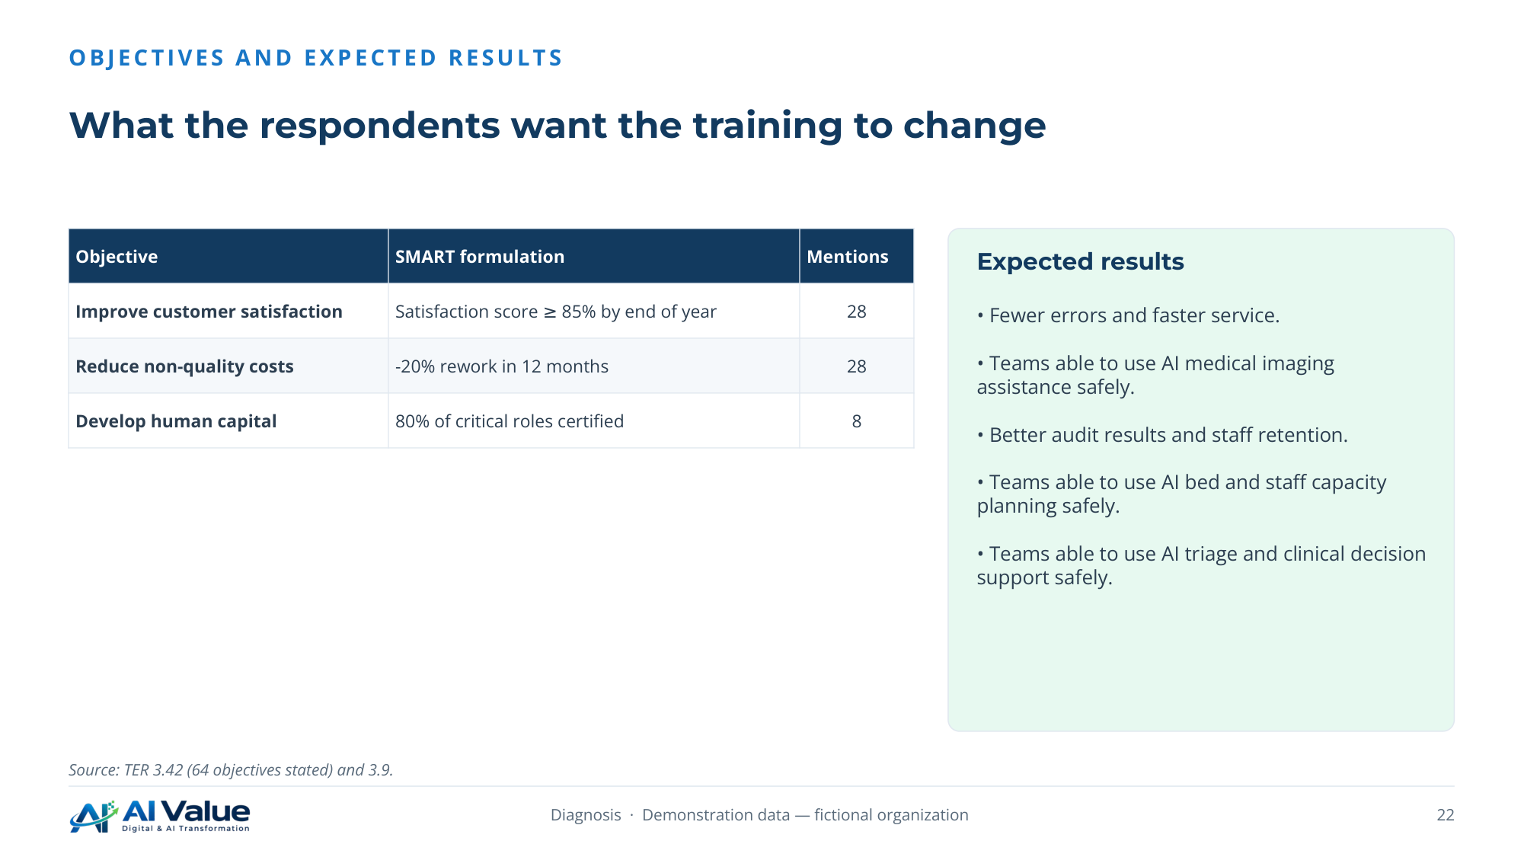

03. Training Engineering Report
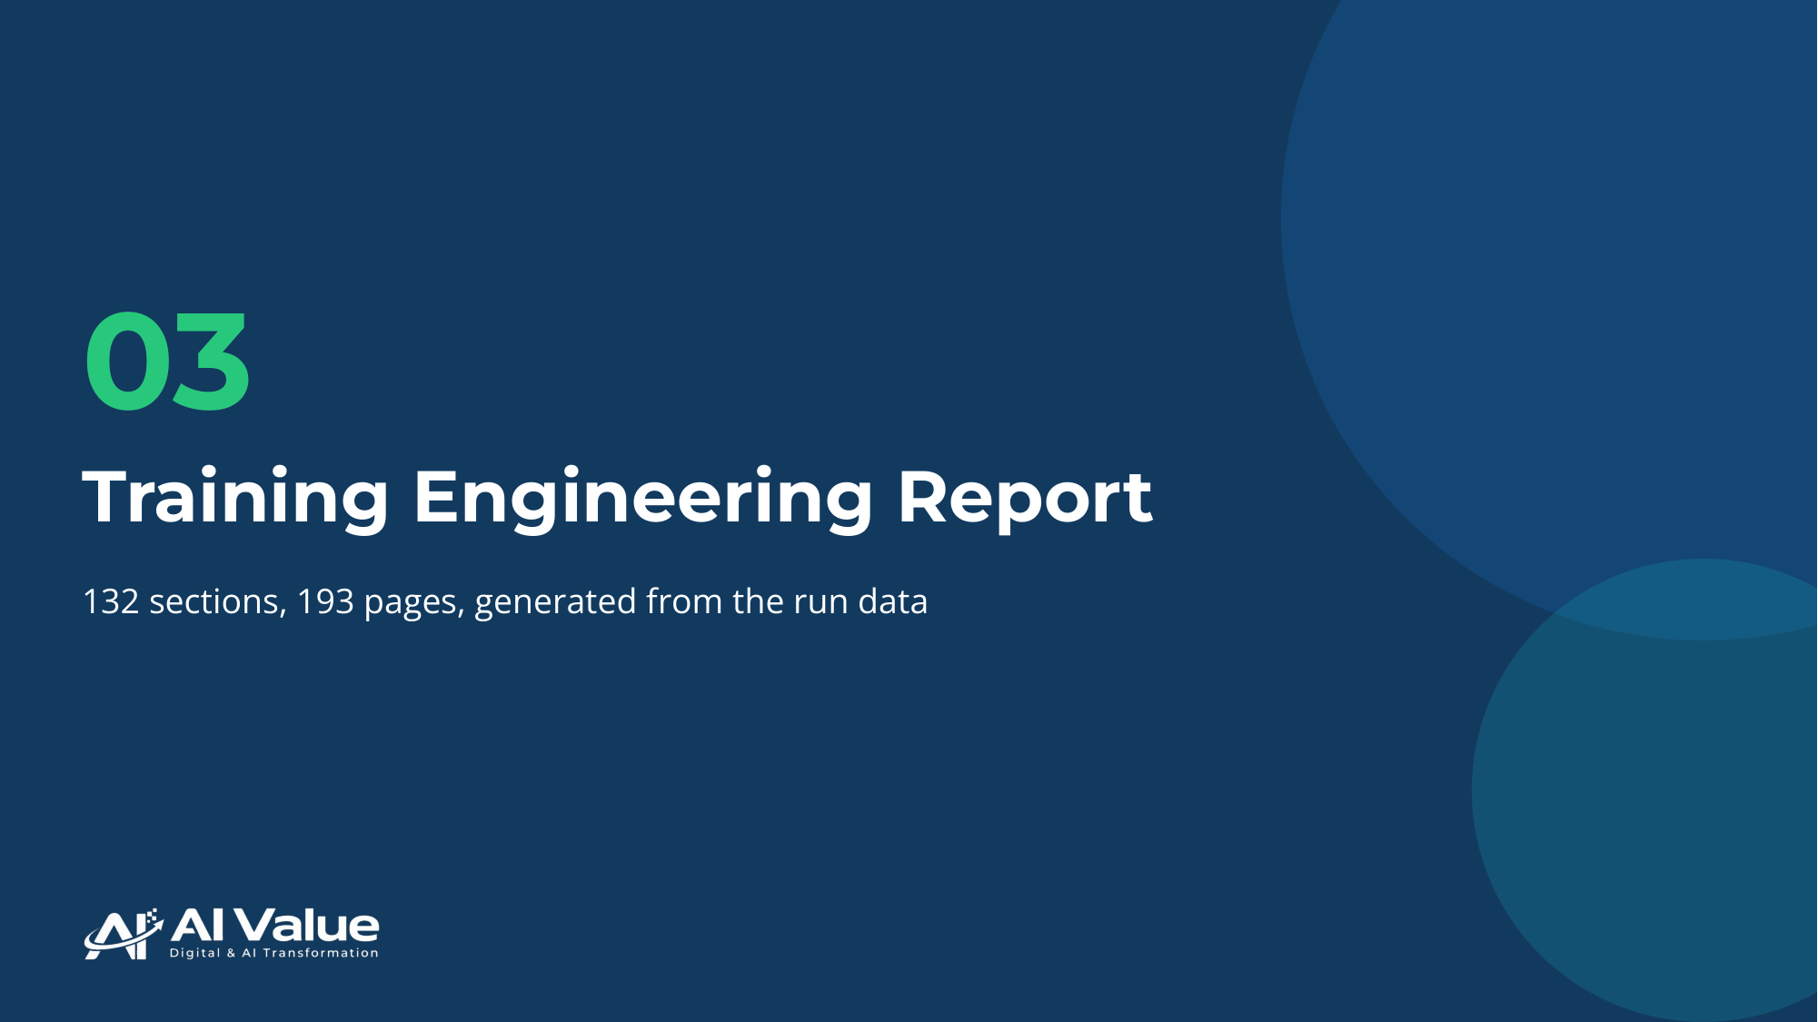

24. Training Engineering Report and Training Plan
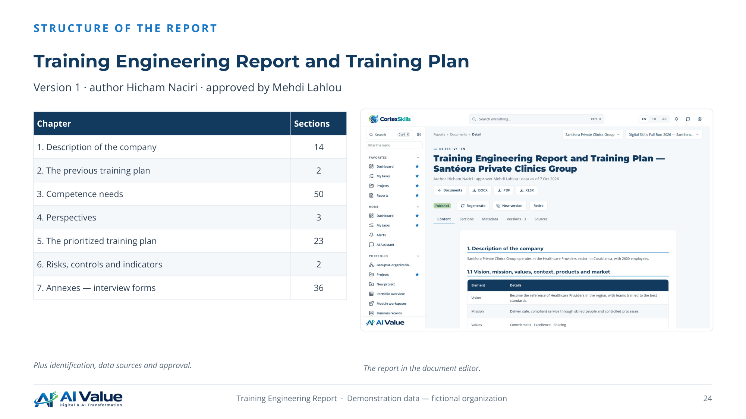

25. Needs linked to the strategy and to the HR orientations
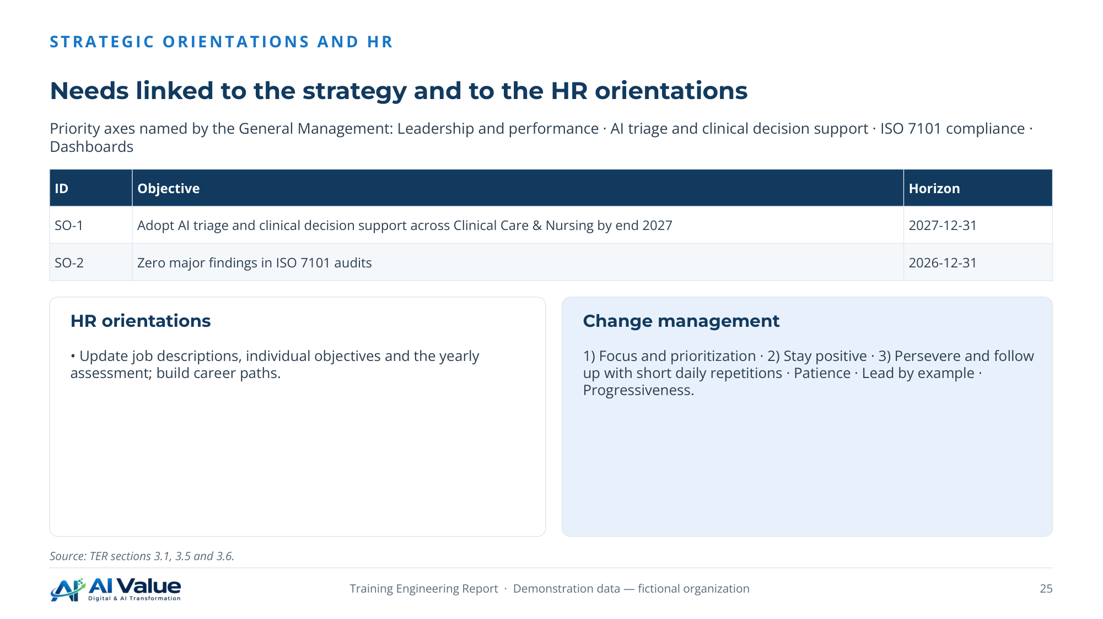

26. Four initiatives deployed in three waves
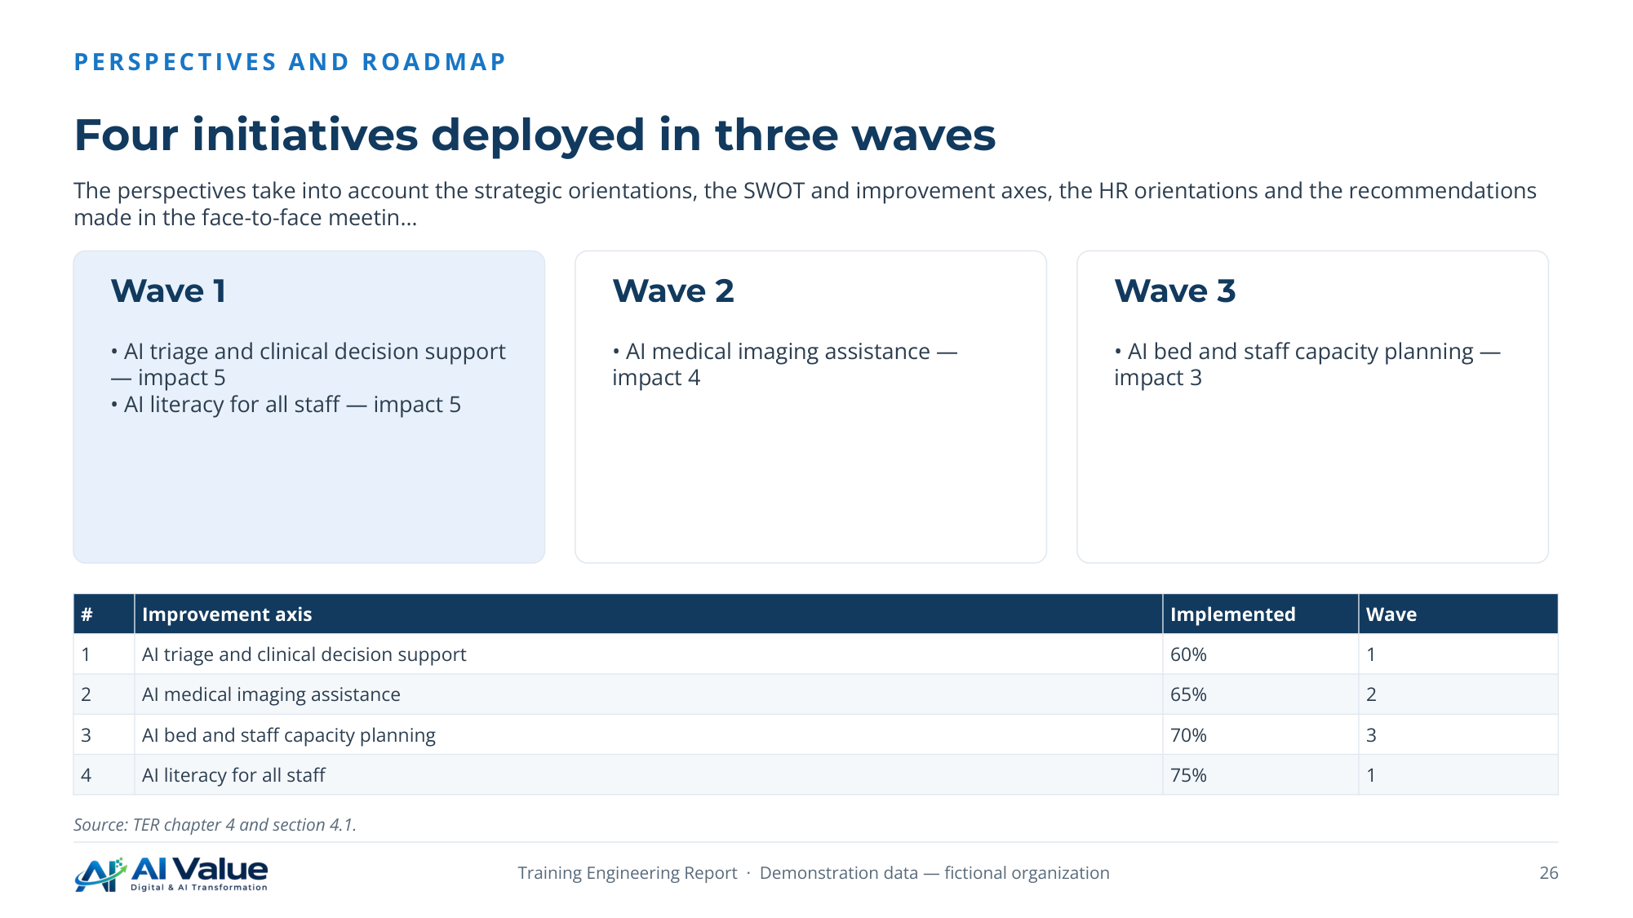

27. Each risk reduced by named controls
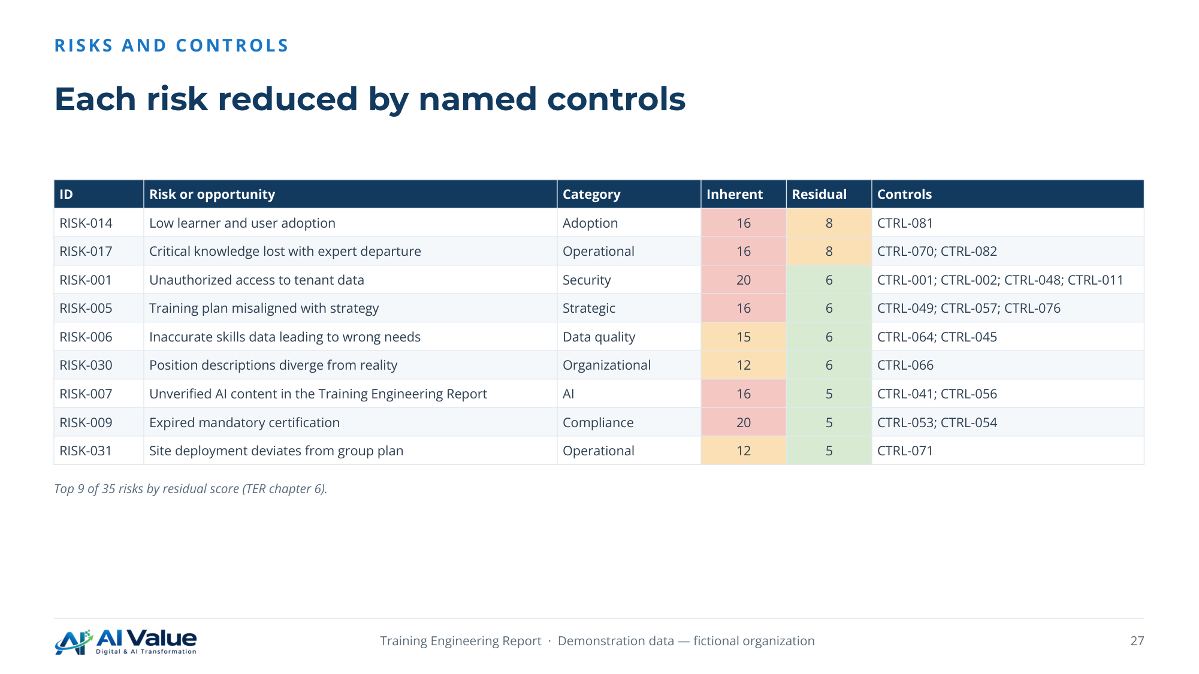

28. Indicators followed every month during the run
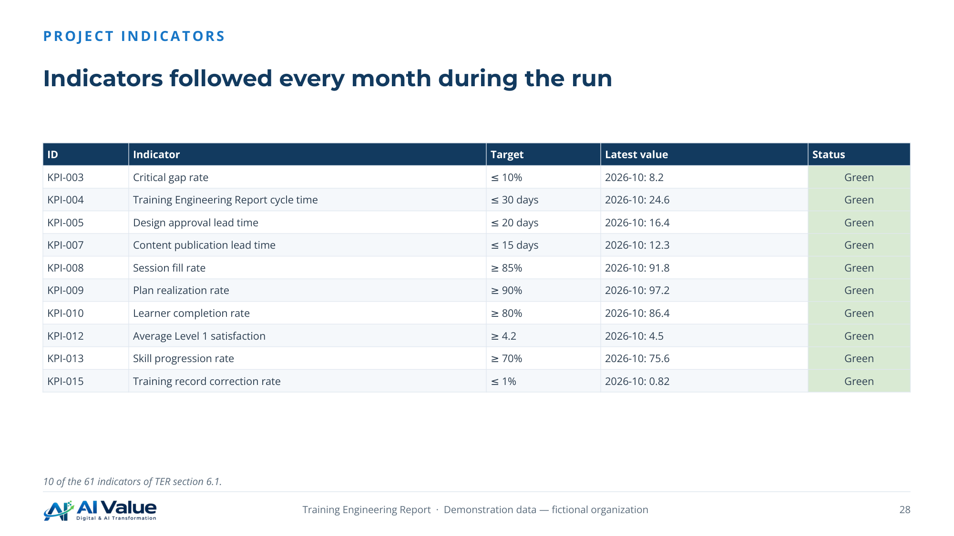

04. Training Plan
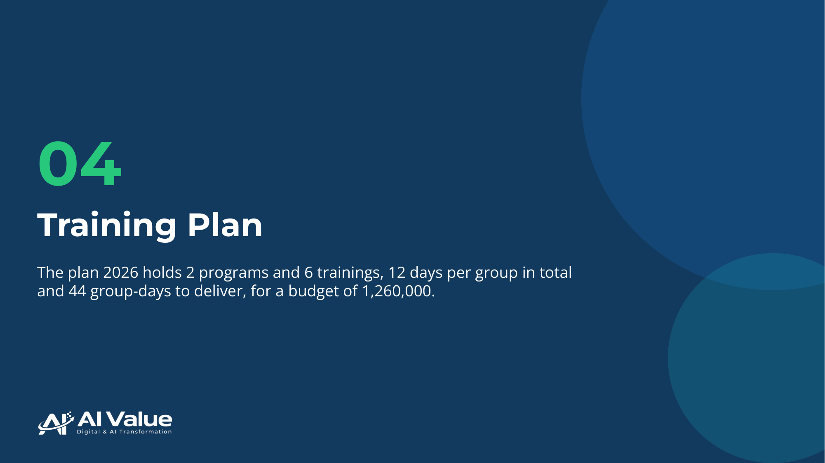

30. Six themes ranked by impact and urgency
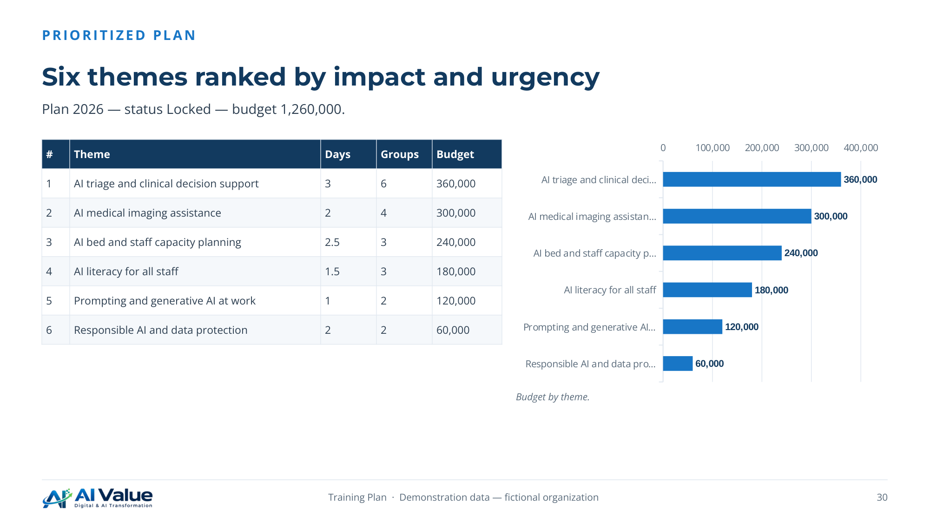

31. Two programs, six trainings, clear prerequisites
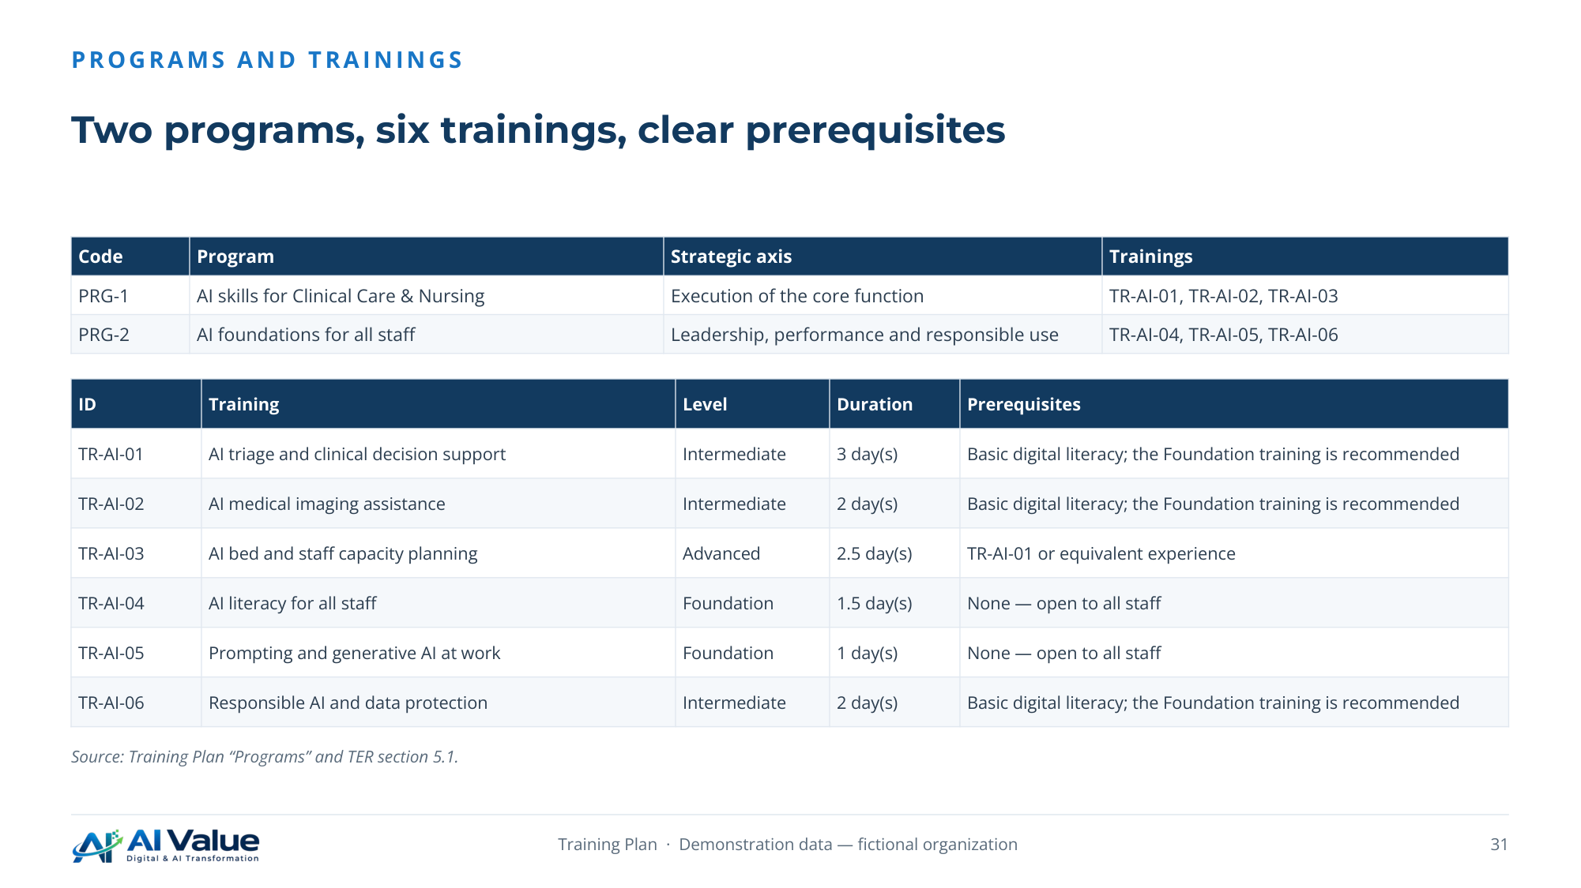

32. TR-AI-01 — AI triage and clinical decision support
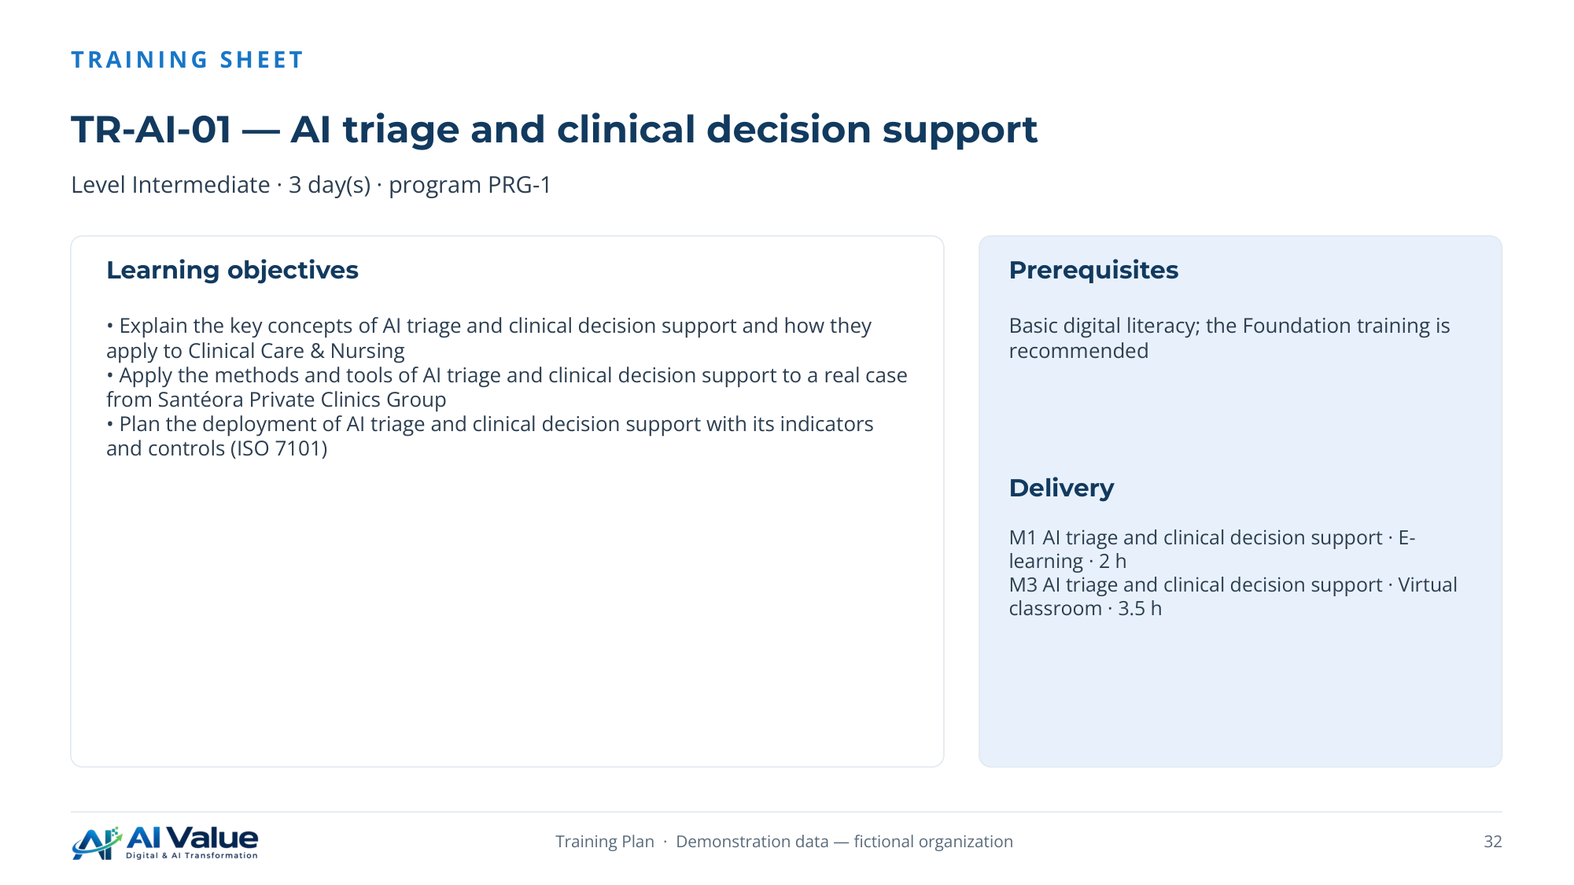

33. AI triage and clinical decision support — half-day by half-day
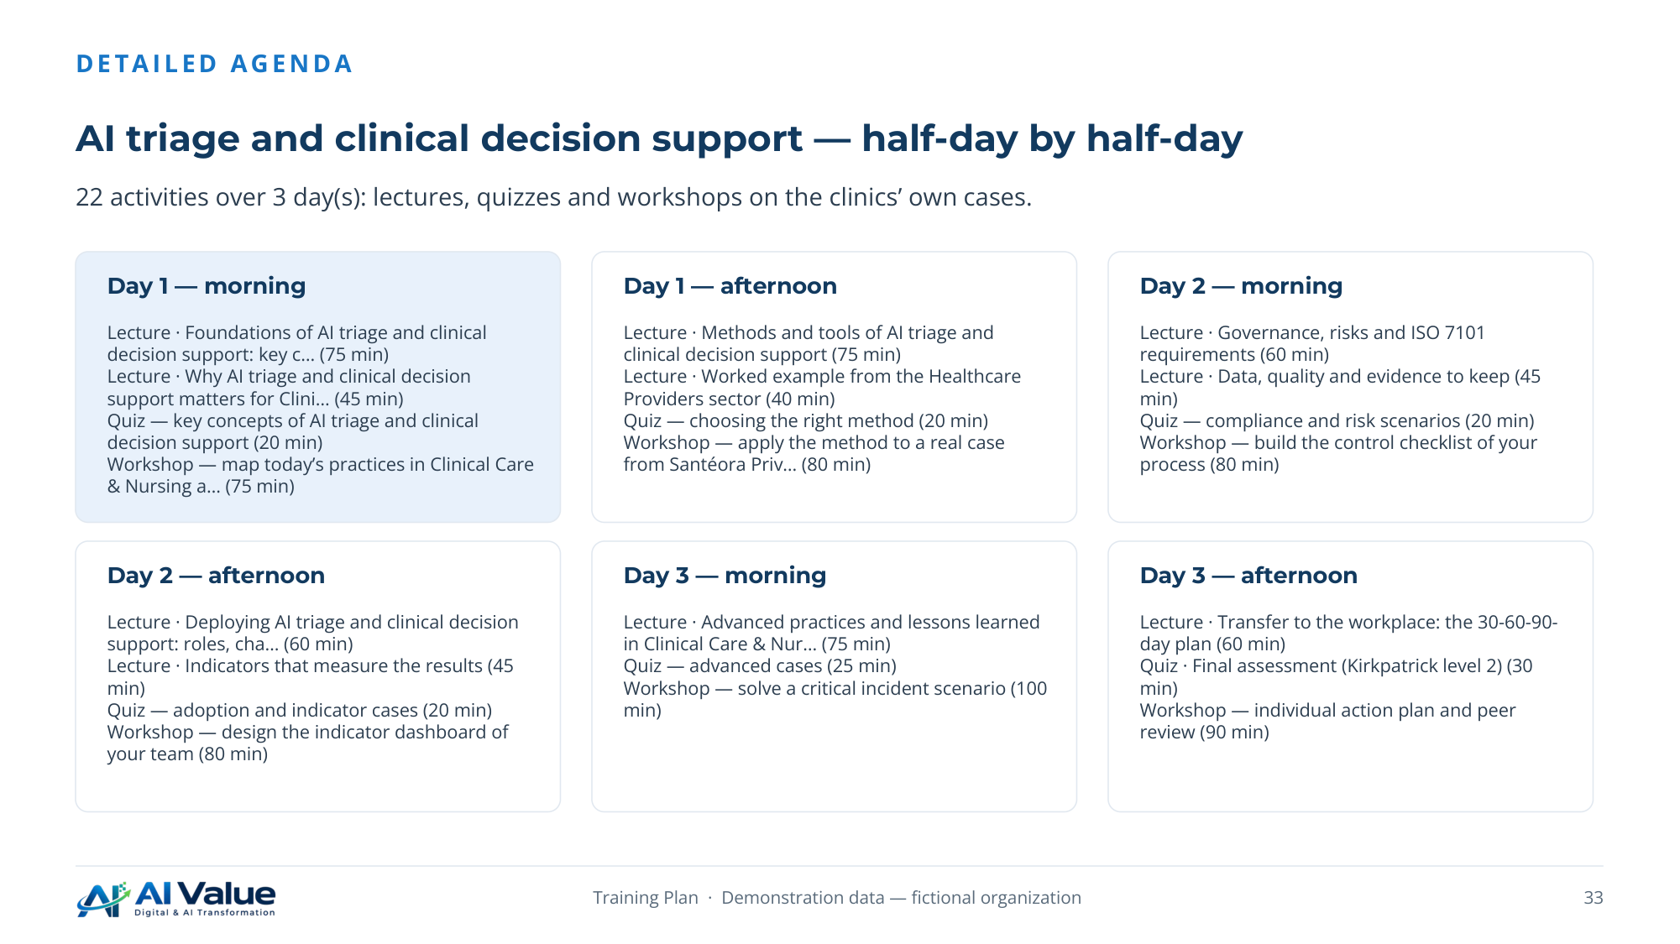

34. Why each audience should take the training
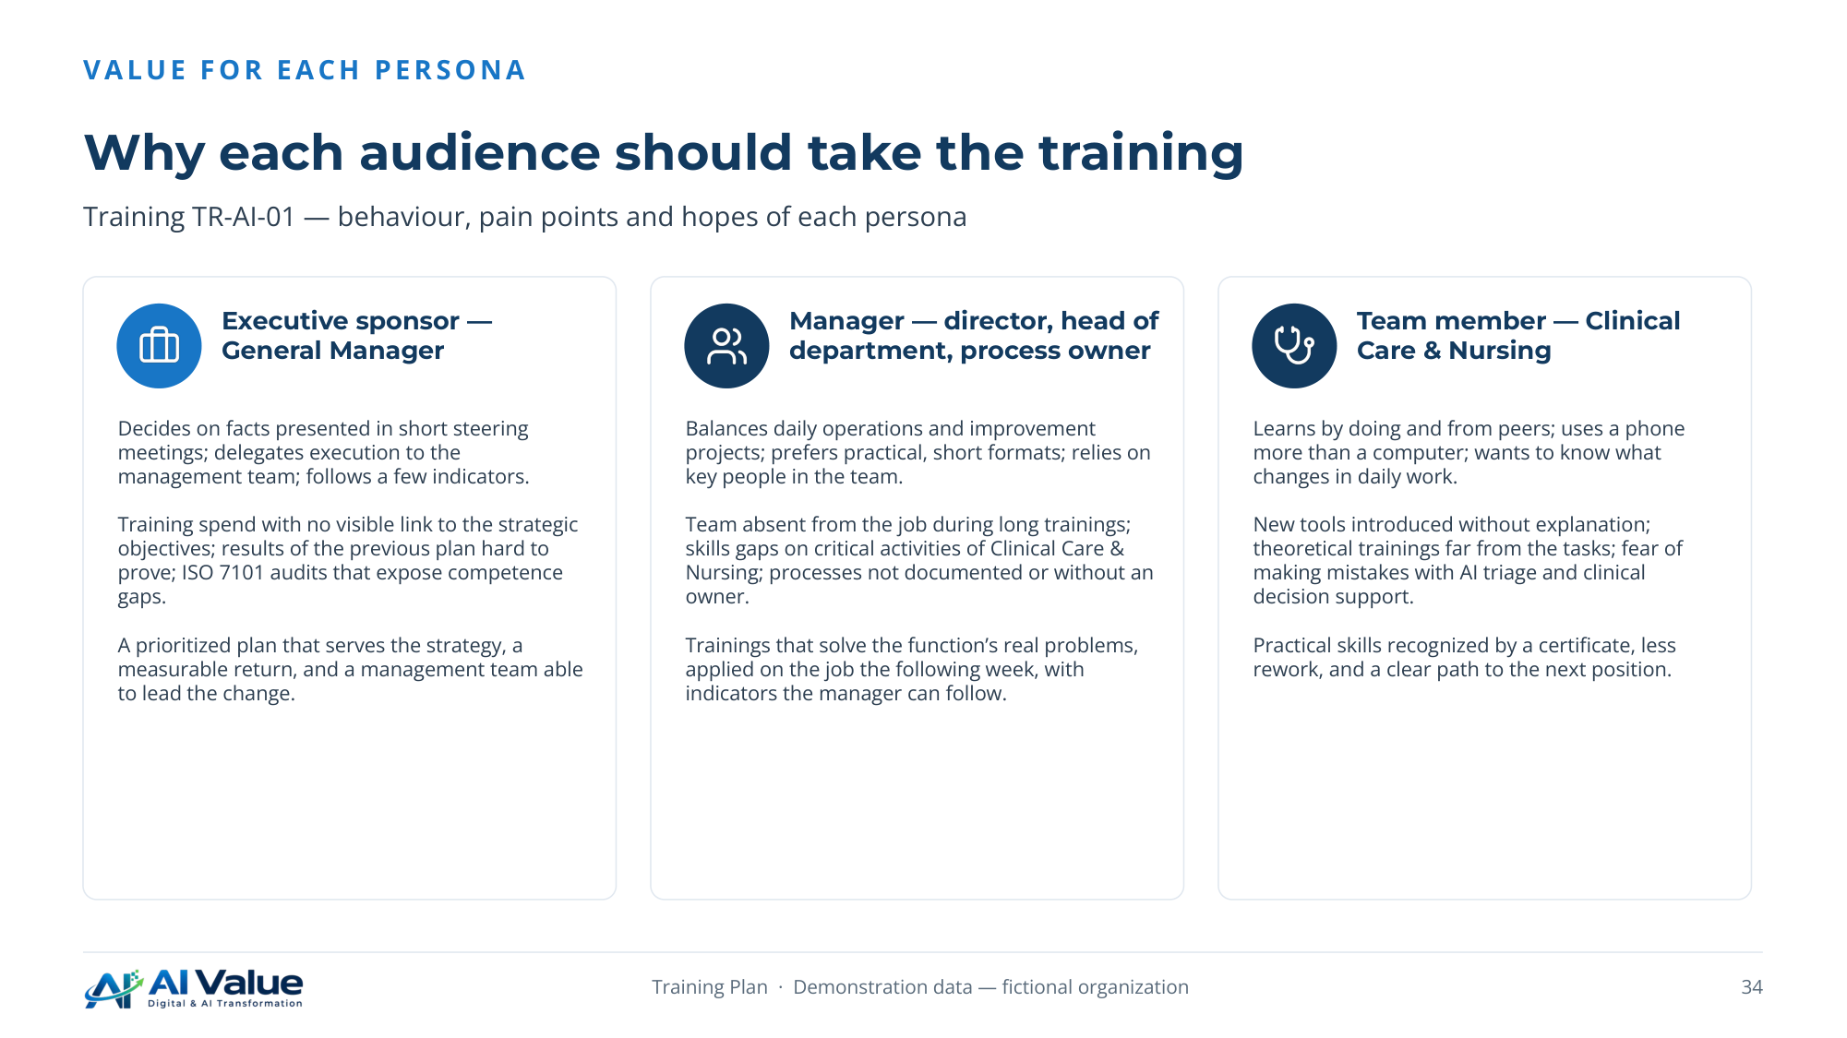

35. Paths, modules and content assets
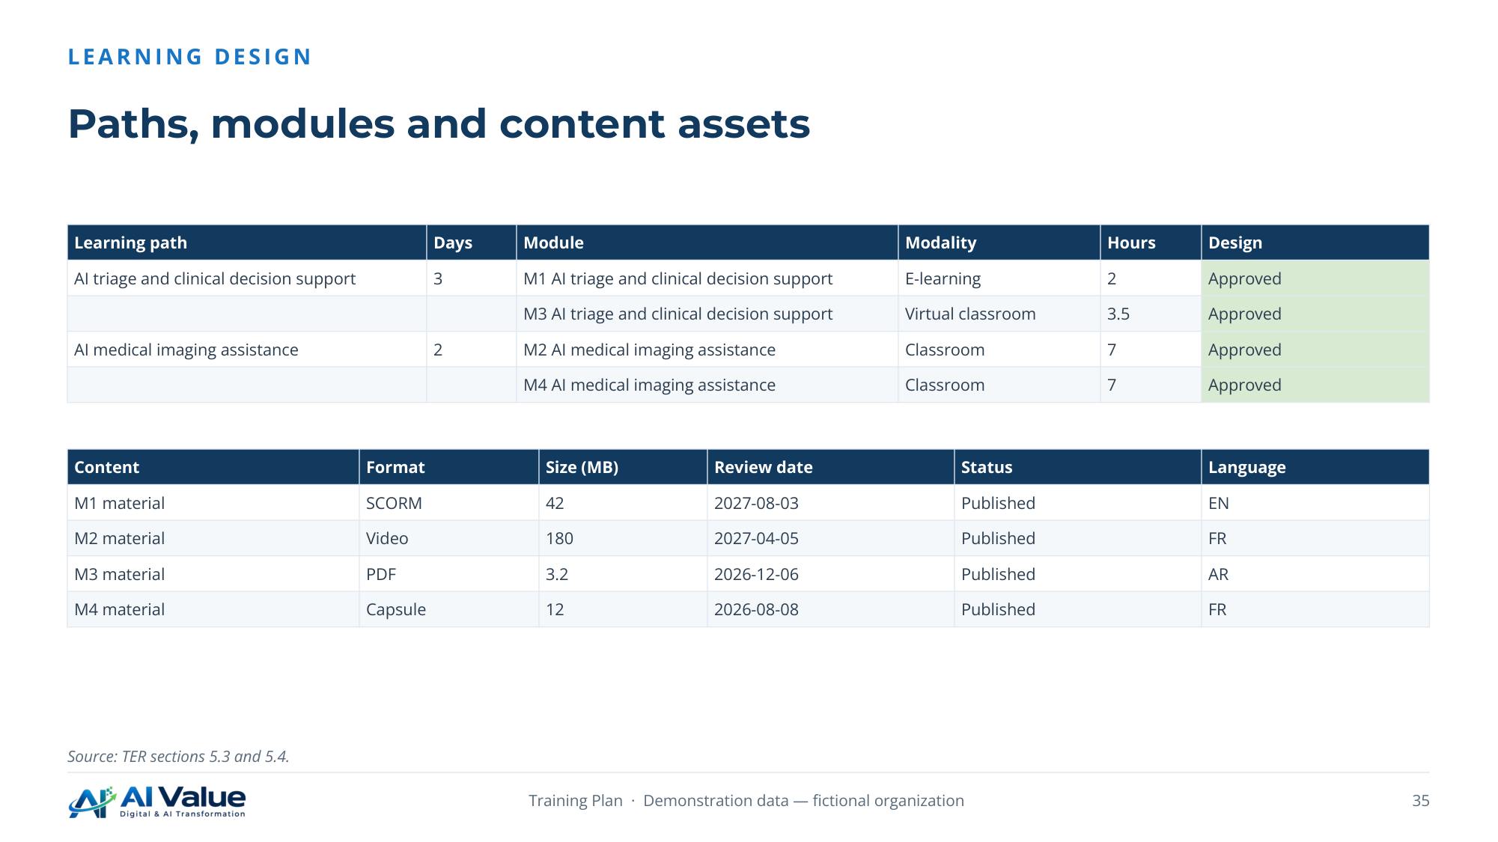

36. Allocated, committed, spent and refunds expected
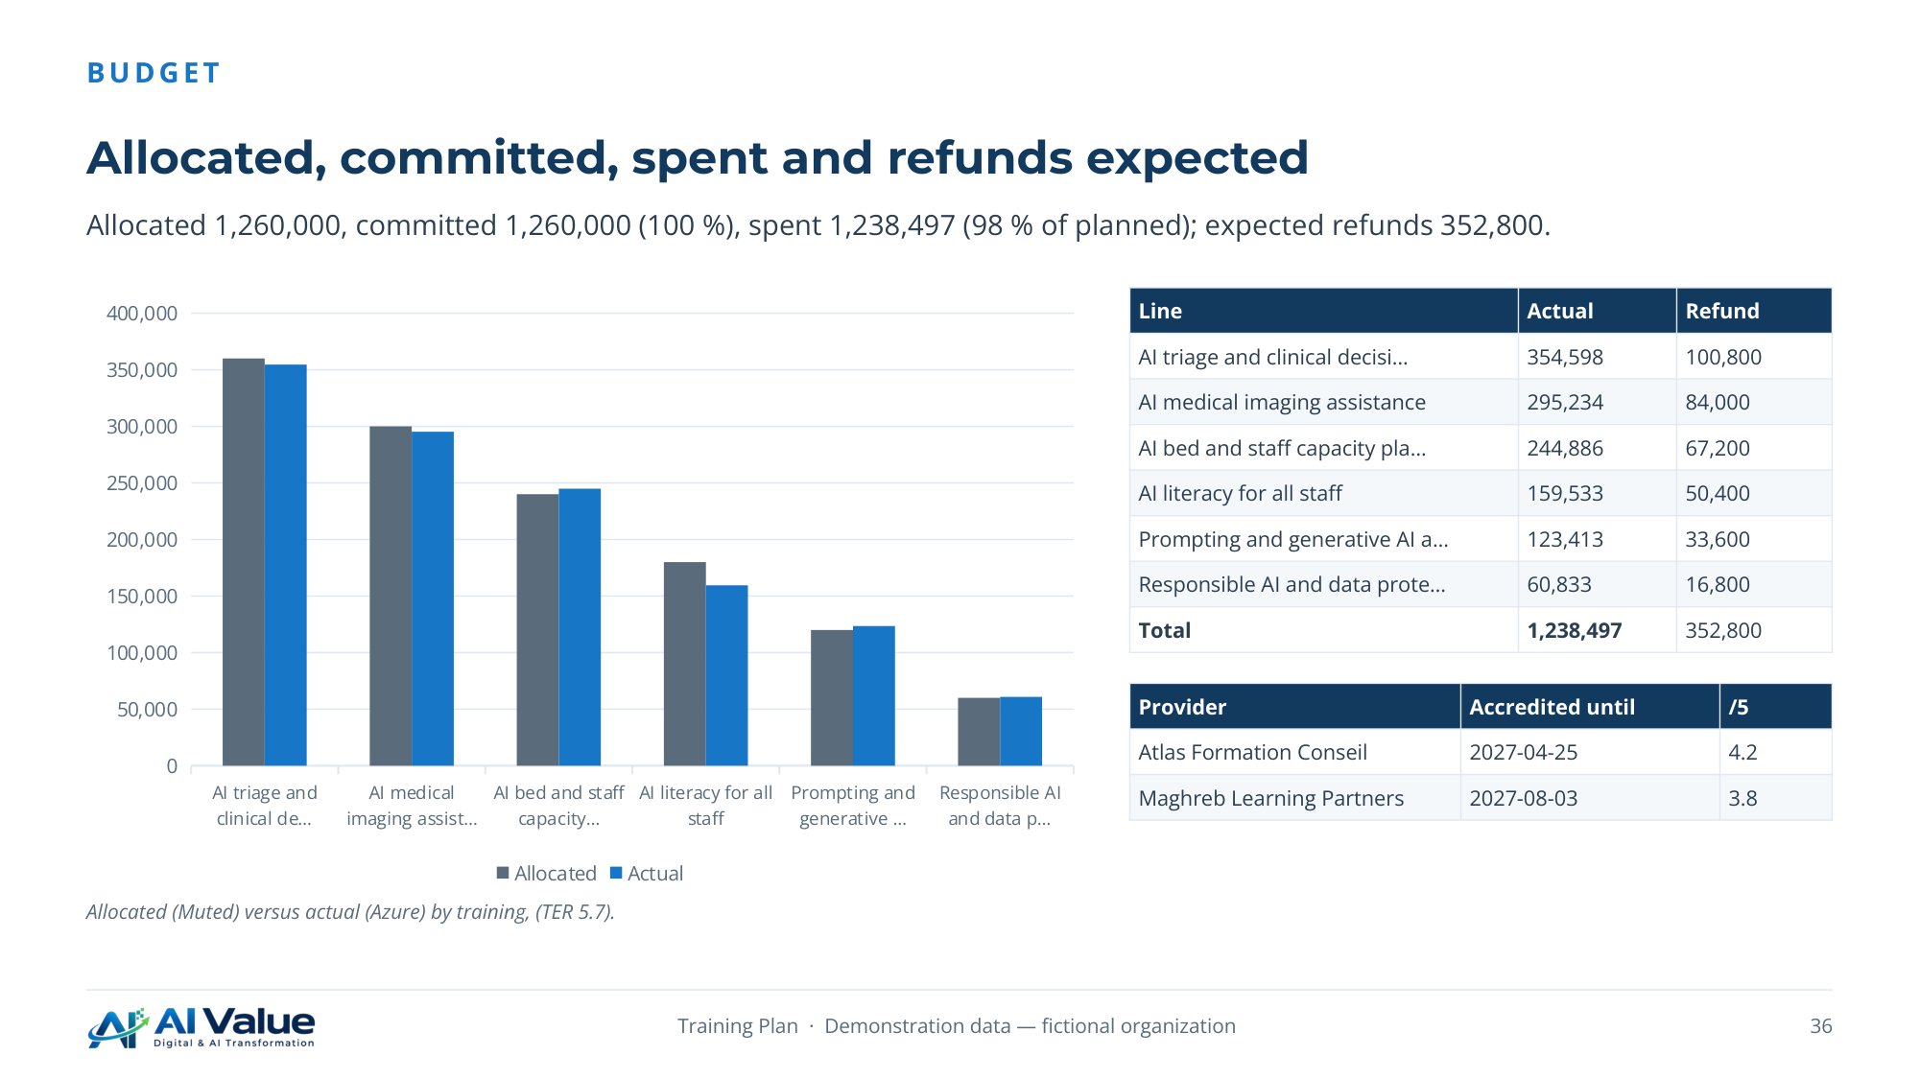

05. Delivery, evaluation and audit
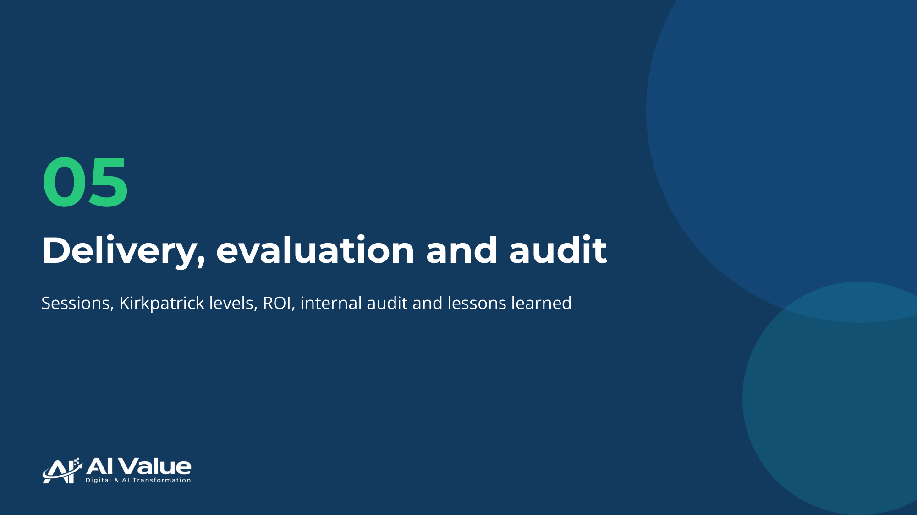

38. Four sessions delivered with their enrolments
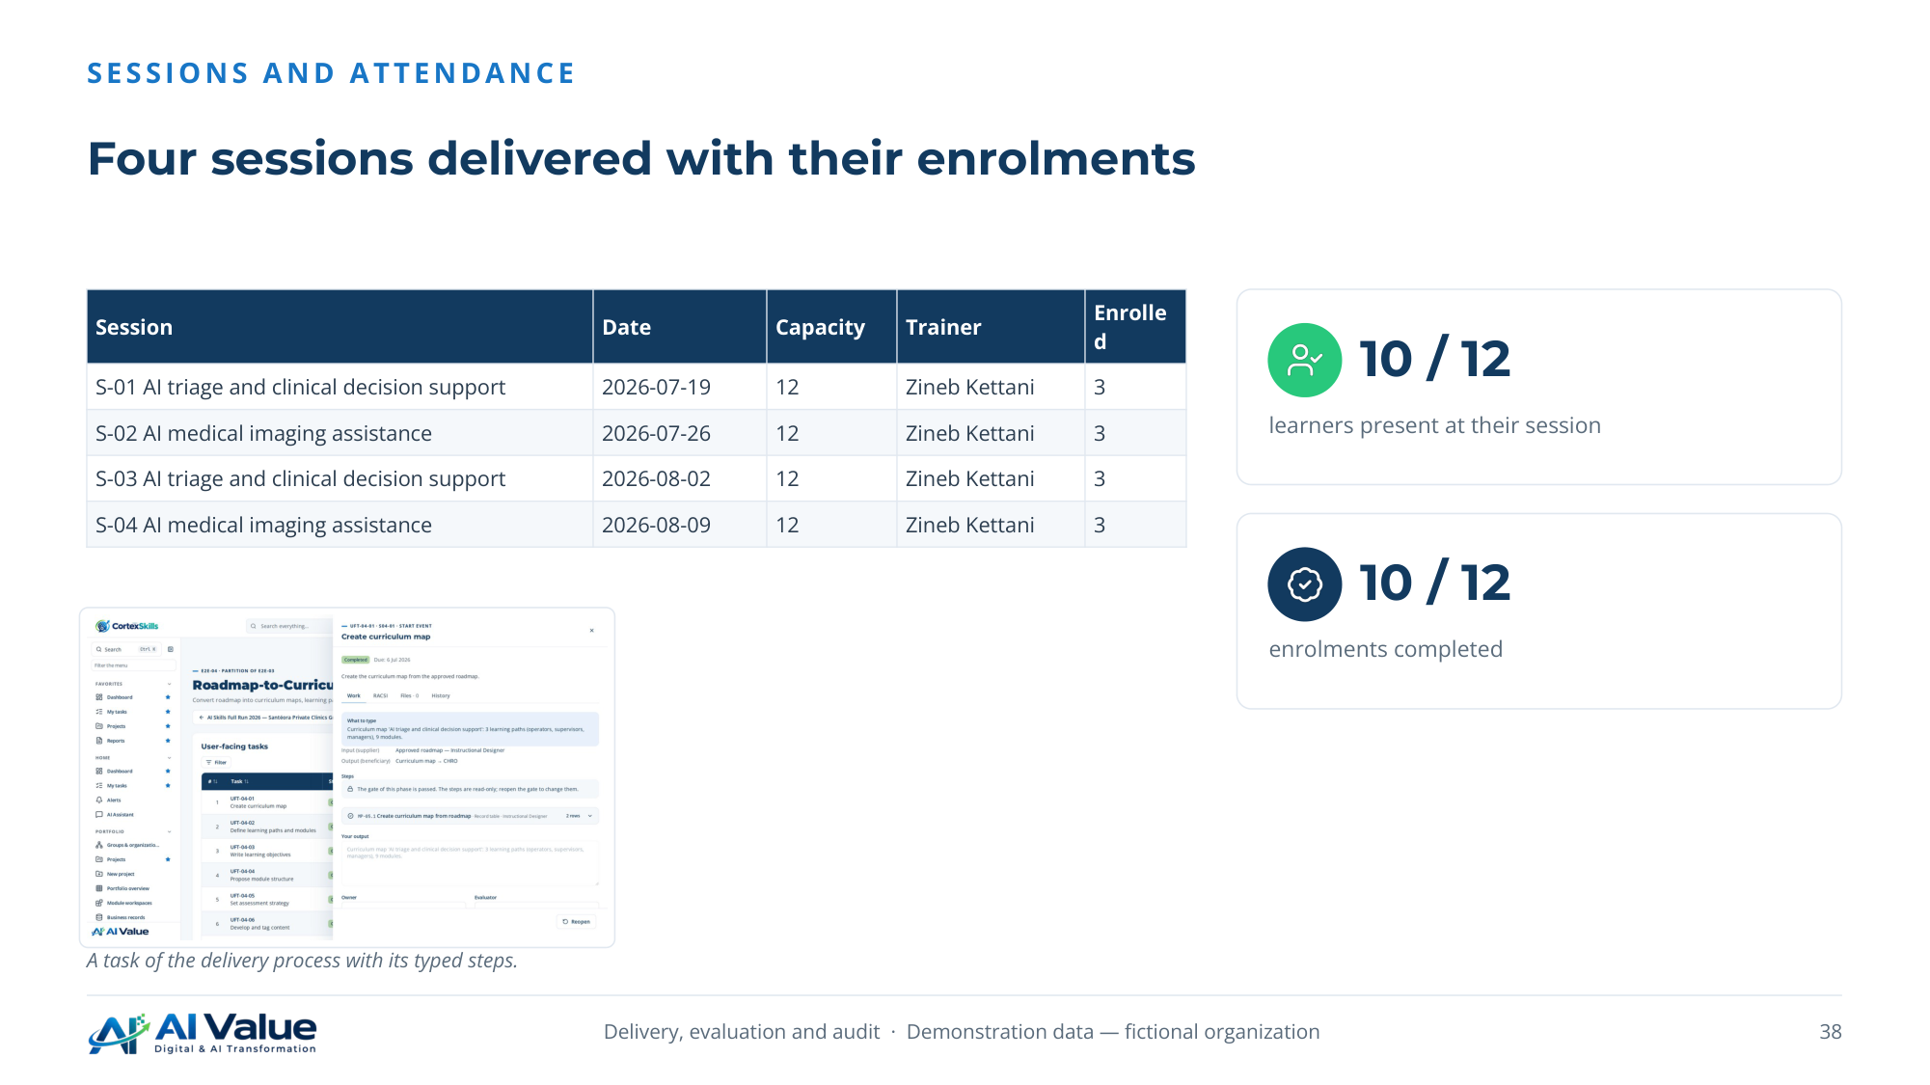

39. Results measured at three Kirkpatrick levels
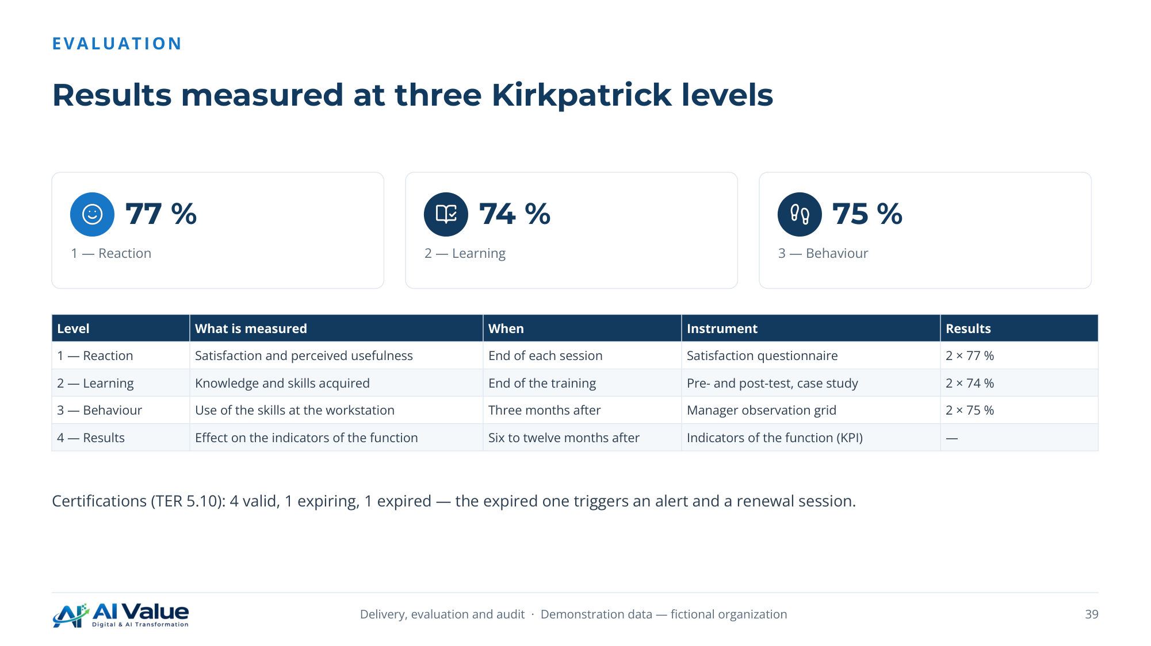

40. Phillips ROI and the indicators of the ROI study
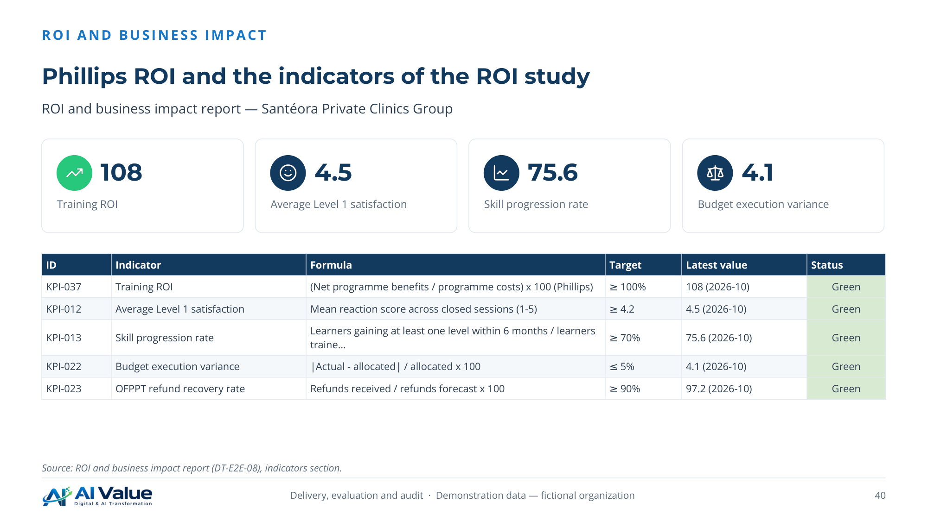

41. Audit report — Santéora Private Clinics Group
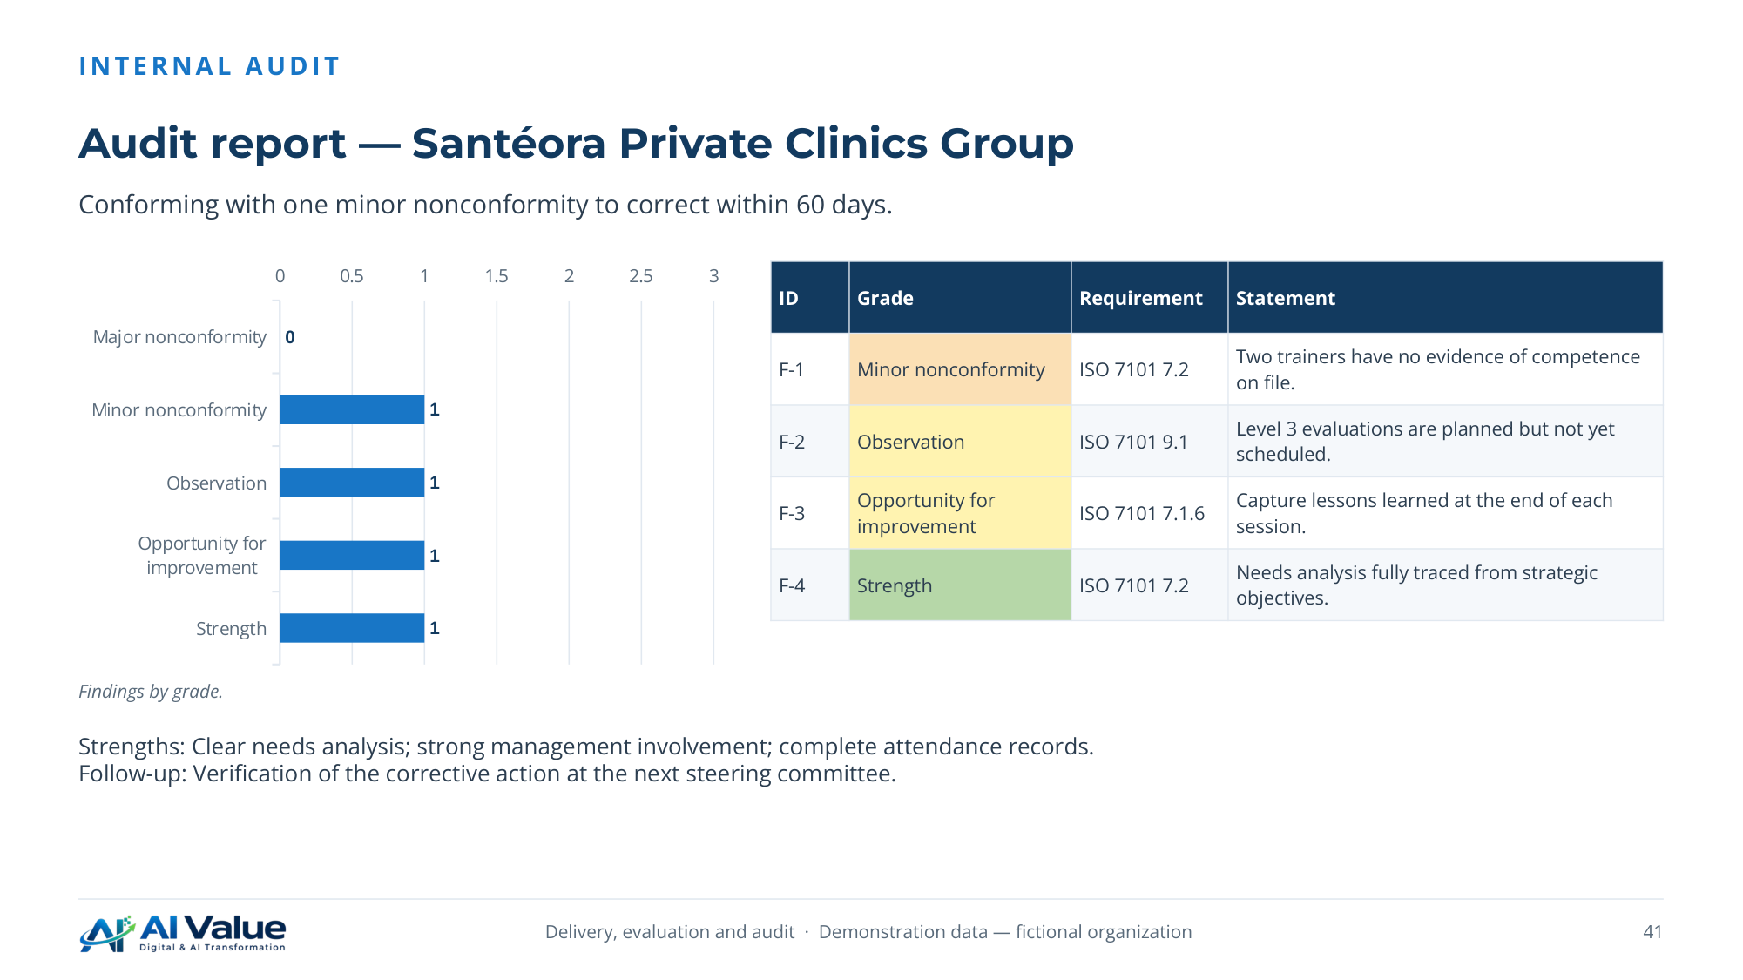

42. REX — AI triage and clinical decision support
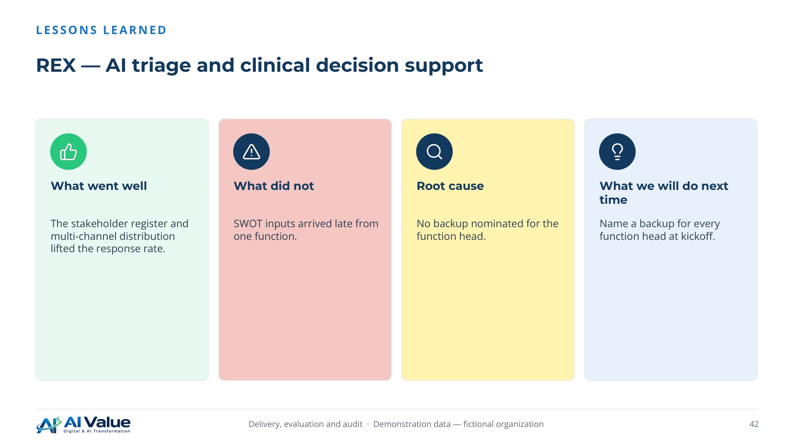

06. Documents produced


44. Every end-to-end process leaves its document
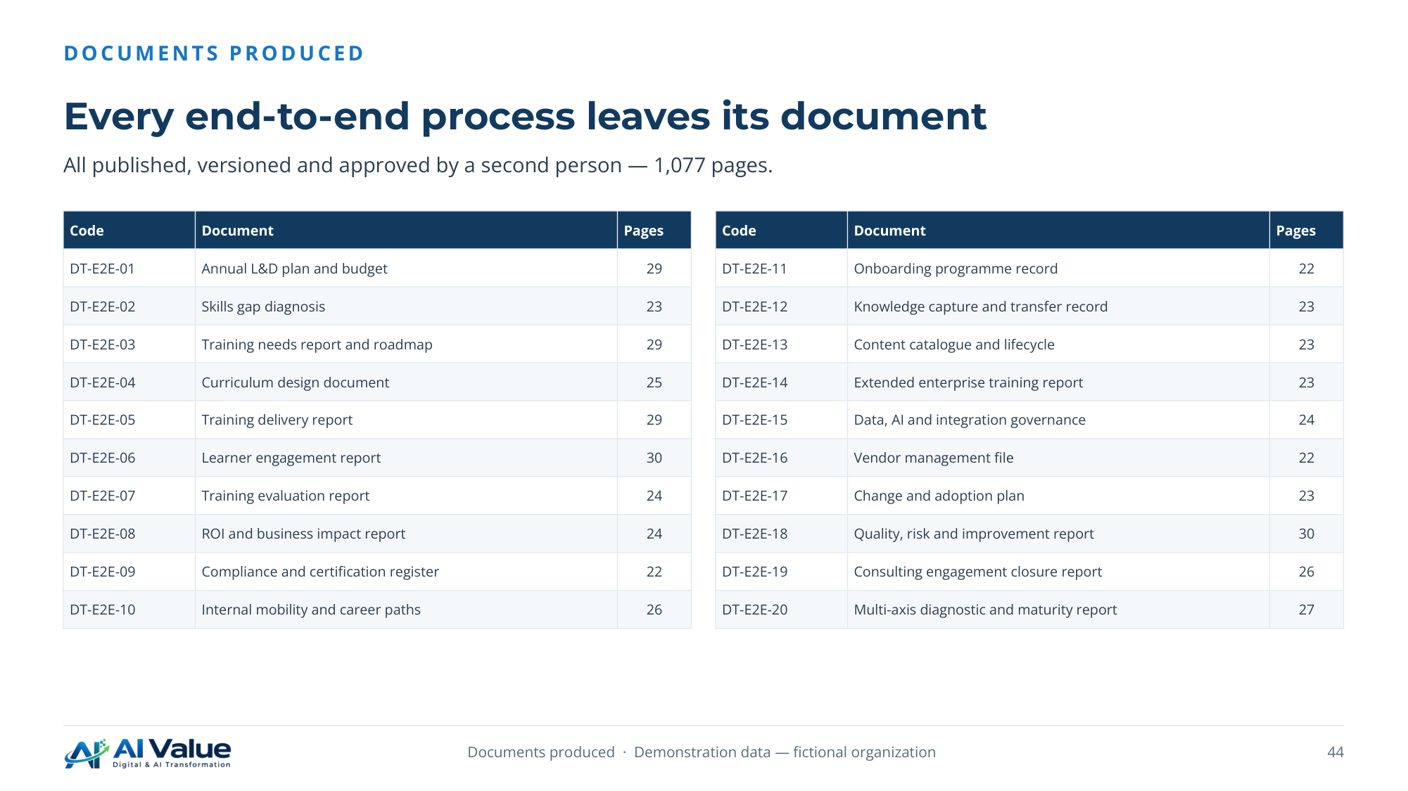

45. Documents produced (continued)
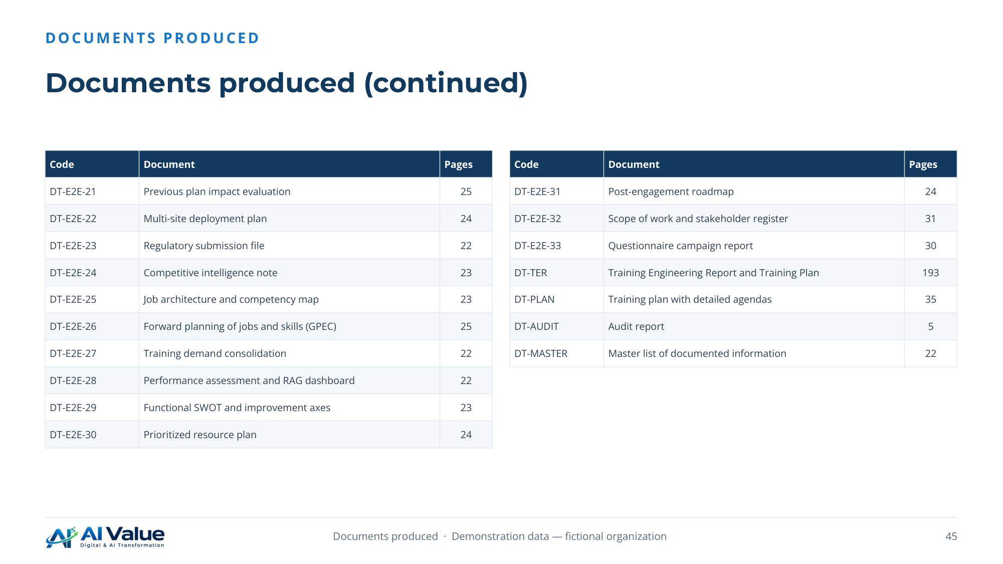

46. Every number of the report comes from a record
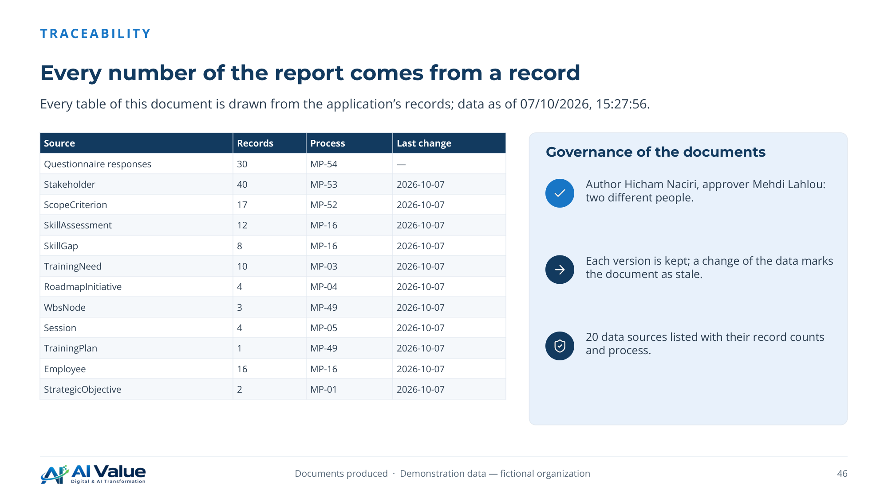

47. The Training Plan as the users see it
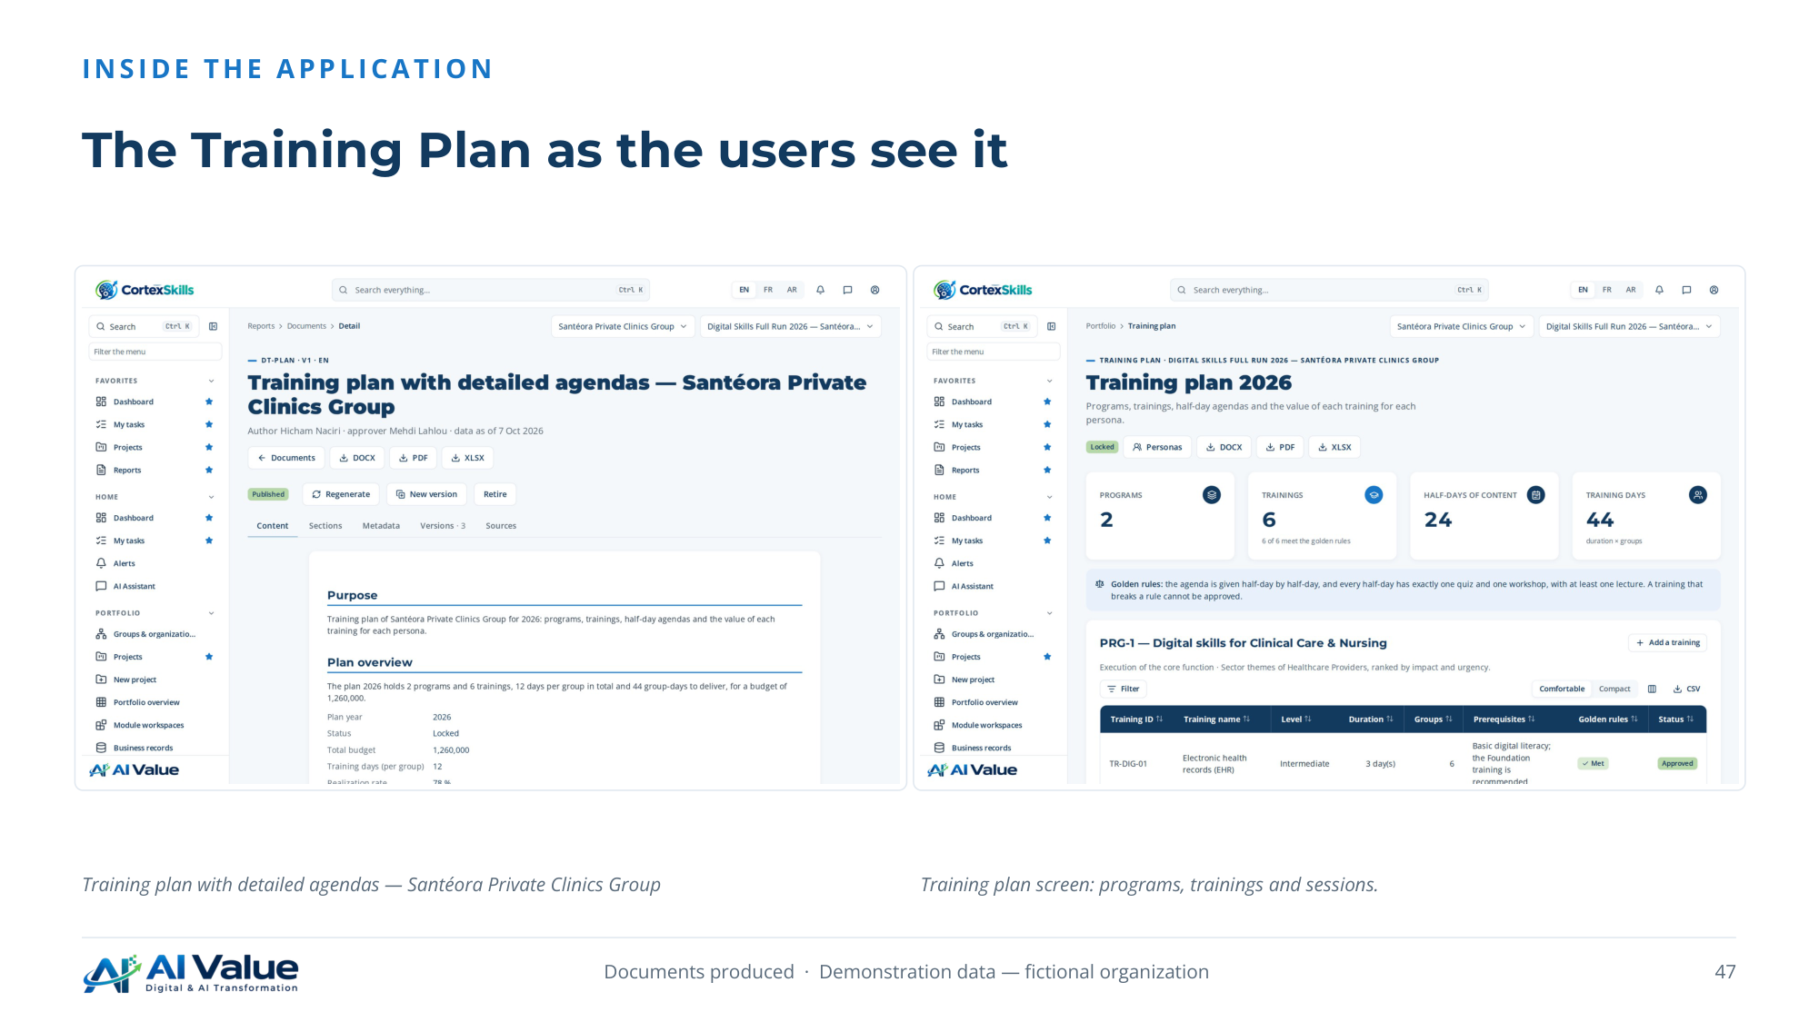

48. The project workspace and the dashboard
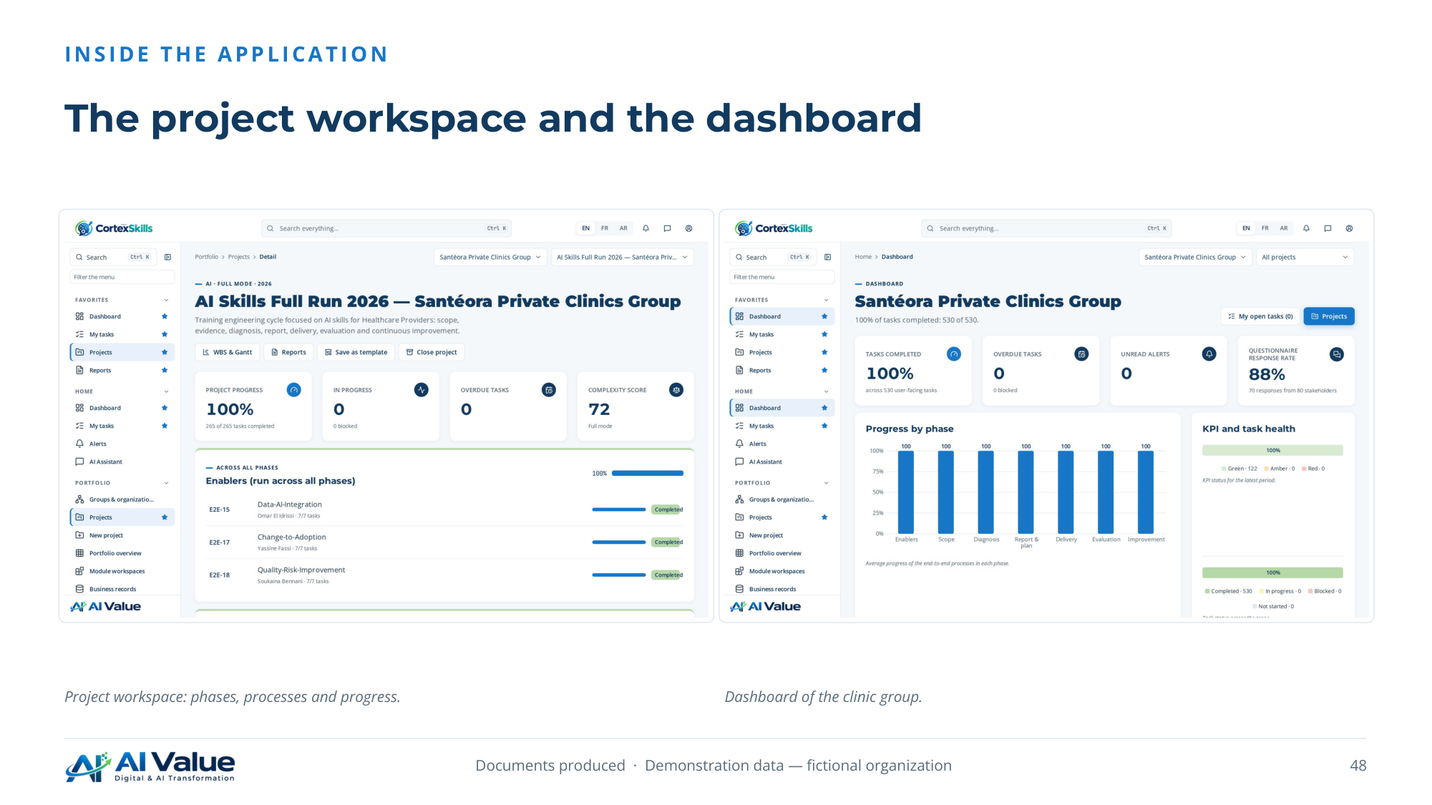

49. What the clinic group has at the end of the cycle
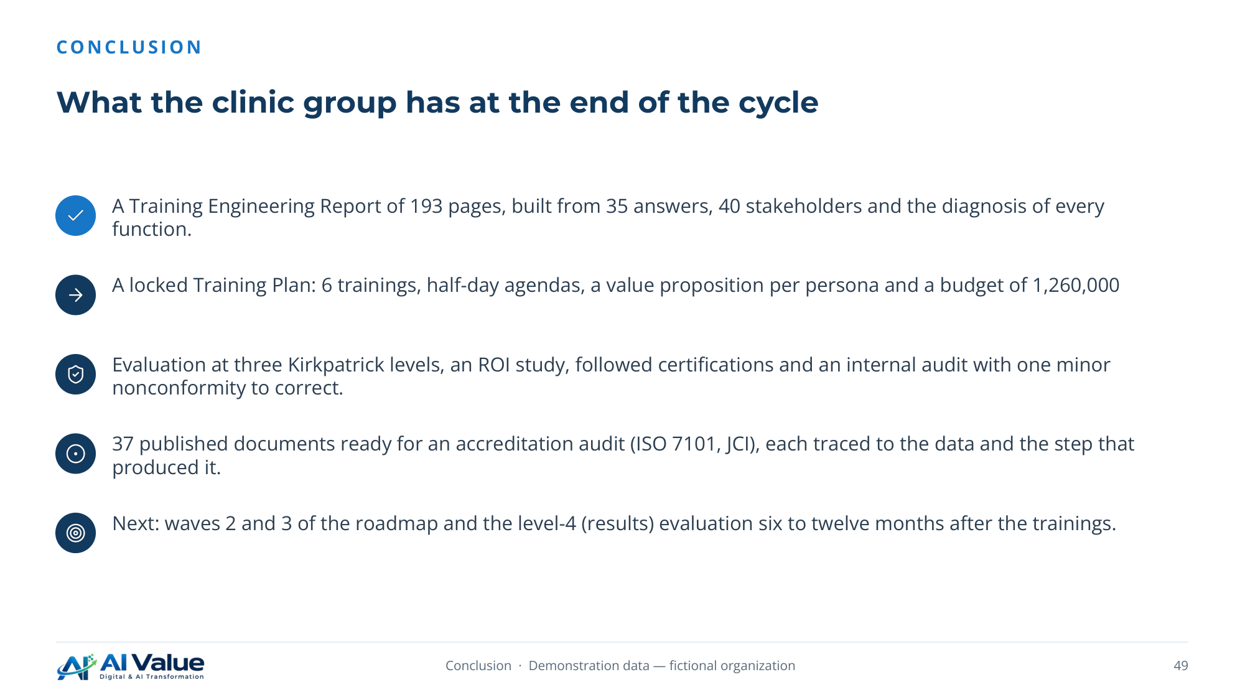

50. Closing


