


APPLICATION SCREENSHOTS
CortexSkills
Santéora Private Clinics Group
Version 1.10.0 · 2026-10-12
70 screens · demonstration data, fictional organization
Prepared by AI Value

Table of Contents
1. About these screenshots 5
2. Sign-in and home 8
Sign in 8
Santéora Private Clinics Group 8
My tasks 9
Alerts 10
AI Assistant 10
Profile menu 11
Change password 12
3. Portfolio and projects 13
Groups & organizations 13
Projects 13
New project 14
AI Skills Full Run 2026 — Santéora Private Clinics Group 15
WBS & Gantt 15
Roadmap-to-Curriculum Design 16
Roadmap-to-Curriculum Design 17
Portfolio overview 17
Module workspaces 18
Platform Shell & Common Services 19
Business records 19
Questionnaires 20
Template library 21
IF-PAC questionnaire campaign 2026 21
Training plan 2026 22
4. Process design 23
Process design 23
Macro processes 23
End-to-end processes 24
Chain diagram 25
Coverage matrix 25
BPMN diagrams 26
Verticals 27
SME tracks & scoring 27
Project templates 28
Gate library 29
Checklist library 29
Information model 30
5. Governance 31
Business rules 31
Controls (COSO) 31
Risks & opportunities 32
KPIs 33
Alert settings 33
RACSI 34
Organization (OBS) 35
Registers 35
Audits 36
Return on experience 37
WBS & Gantt 37
6. Artificial intelligence 39
AI use cases 39
AI usage log 39
Knowledge base 40
Live AI model 41
AI settings 41
7. Reports and documents 43
Reports 43
Documents 43
Training Engineering Report and Training Plan — Santéora Private Clinics Group 44
Training plan with detailed agendas — Santéora Private Clinics Group 45
Document templates 46
Document layout 47
Master list 47
Internal benchmarking 48
8. Administration 49
Users 49
Permission matrix 49
Configuration & licence 50
Packs & pricing 51
Integrations 51
Channels (e-mail, WhatsApp) 52
SME onboarding 53
Audit log 53
Backups & health 54
Requirement traceability 55
9. Settings, help and profile 56
My settings 56
Help centre 56

1. About these screenshots
Every screen of CortexSkills as seen by the users of Santéora Private Clinics Group, in English, at 1440 × 900 pixels. The project screens show the AI skills run of the organization; the Administration screens are taken with the organization administrator account, Backups & health with the platform administrator.
# | Screen | Address | File
1 | Sign in | /login | 000_login.png
2 | Santéora Private Clinics Group | / | 001_dashboard.png
3 | My tasks | /my-tasks | 002_my_tasks.png
4 | Alerts | /alerts | 003_alerts.png
5 | AI Assistant | /assistant | 004_assistant.png
6 | Groups & organizations | /tenancy | 005_groups_organizations.png
7 | Projects | /projects | 006_projects.png
8 | New project | /projects/new | 007_new_project.png
9 | AI Skills Full Run 2026 — Santéora Private Clinics Group | /projects/:id | 008_project_workspace.png
10 | WBS & Gantt | /projects/:id/gantt | 009_project_gantt.png
11 | Roadmap-to-Curriculum Design | /runs/:id | 010_run.png
12 | Roadmap-to-Curriculum Design | /runs/:id?task=:id | 011_run_task_steps.png
13 | Portfolio overview | /portfolio | 012_portfolio.png
14 | Module workspaces | /modules | 013_modules.png
15 | Platform Shell & Common Services | /modules/M00 | 014_module_workspace.png
16 | Business records | /records | 015_business_records.png
17 | Questionnaires | /questionnaires | 016_questionnaires.png
18 | Template library | /questionnaires/templates | 017_questionnaire_templates.png
19 | IF-PAC questionnaire campaign 2026 | /questionnaires/:id | 018_questionnaire.png
20 | Training plan 2026 | /training-plan | 019_training_plan.png
21 | Process design | /process/design | 020_process_design.png
22 | Macro processes | /process/mp | 021_macro_processes.png
23 | End-to-end processes | /process/e2e | 022_e2e_processes.png
24 | Chain diagram | /process/chain | 023_e2e_chain.png
25 | Coverage matrix | /process/coverage | 024_coverage.png
26 | BPMN diagrams | /process/bpmn | 025_bpmn.png
27 | Verticals | /process/verticals | 026_sectors.png
28 | SME tracks & scoring | /process/sme | 027_sme_tracks.png
29 | Project templates | /process/templates | 028_project_templates.png
30 | Gate library | /process/gates | 029_gates.png
31 | Checklist library | /process/checklists | 030_checklists.png
32 | Information model | /process/model | 031_information_model.png
33 | Business rules | /gov/rules | 032_business_rules.png
34 | Controls (COSO) | /gov/controls | 033_controls.png
35 | Risks & opportunities | /gov/risks | 034_risks.png
36 | KPIs | /gov/kpis | 035_kpis.png
37 | Alert settings | /gov/alert-settings | 036_alert_settings.png
38 | RACSI | /gov/racsi | 037_racsi.png
39 | Organization (OBS) | /gov/obs | 038_obs.png
40 | Registers | /registers | 039_registers.png
41 | Audits | /gov/audits | 040_audits.png
42 | Return on experience | /gov/rex | 041_lessons_learned.png
43 | WBS & Gantt | /gov/gantt | 042_gantt_portfolio.png
44 | AI use cases | /ai/use-cases | 043_ai_use_cases.png
45 | AI usage log | /ai/usage | 044_ai_usage.png
46 | Knowledge base | /ai/kb | 045_knowledge_base.png
47 | Live AI model | /ai/model | 046_ai_model.png
48 | AI settings | /ai/settings | 047_ai_settings.png
49 | Reports | /reports | 048_reports.png
50 | Documents | /documents | 049_documents.png
51 | Training Engineering Report and Training Plan — Santéora Private Clinics Group | /documents/:id | 050_document_training_engineering_report.png
52 | Training plan with detailed agendas — Santéora Private Clinics Group | /documents/:id | 051_document_training_plan.png
53 | Document templates | /documents/templates | 052_document_templates.png
54 | Document layout | /documents/layout | 053_document_layout.png
55 | Master list | /documents/master-list | 054_master_list.png
56 | Internal benchmarking | /benchmark | 055_benchmark.png
57 | Users | /admin/users | 056_users.png
58 | Permission matrix | /admin/permissions | 057_permission_matrix.png
59 | Configuration & licence | /admin/config | 058_configuration_licence.png
60 | Packs & pricing | /admin/pricing | 059_pricing.png
61 | Integrations | /admin/integrations | 060_integrations.png
62 | Channels (e-mail, WhatsApp) | /admin/channels | 061_channels.png
63 | SME onboarding | /admin/onboarding | 062_sme_onboarding.png
64 | Audit log | /admin/audit | 063_audit_trail.png
65 | Backups & health | /admin/backups | 064_backups_health.png
66 | Requirement traceability | /admin/traceability | 065_traceability.png
67 | My settings | /settings | 066_settings.png
68 | Help centre | /help | 067_help.png
69 | Profile menu | / | 068_profile_menu.png
70 | Change password | / | 069_change_password.png

Files
The PNG files are in the folder “screens” of this pack, in the order of this album.

2. Sign-in and home

Sign in
Address: /login
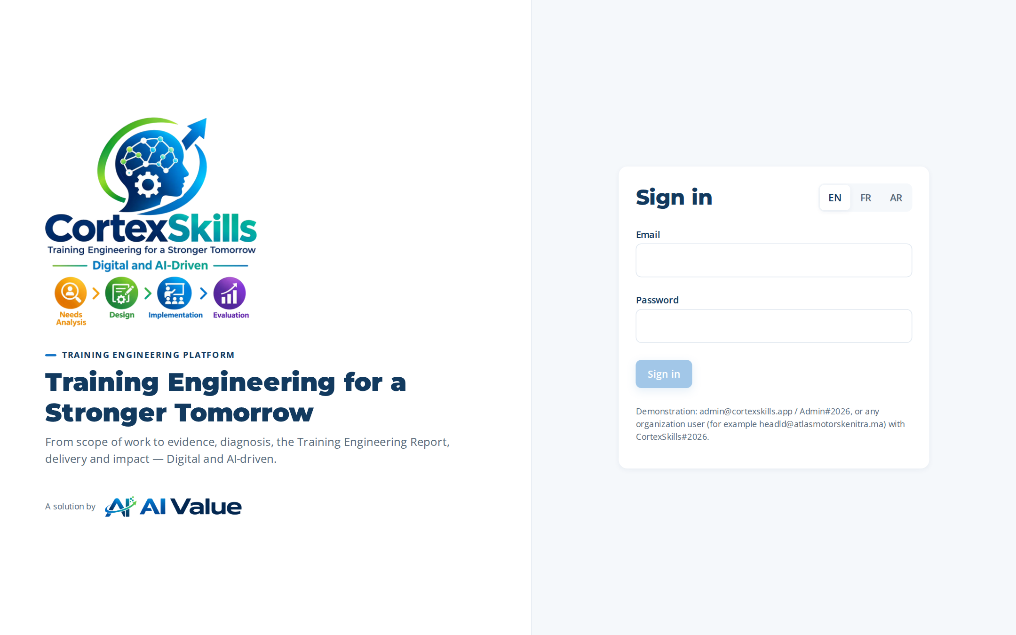
Figure 1 — Sign in

Santéora Private Clinics Group
Address: /
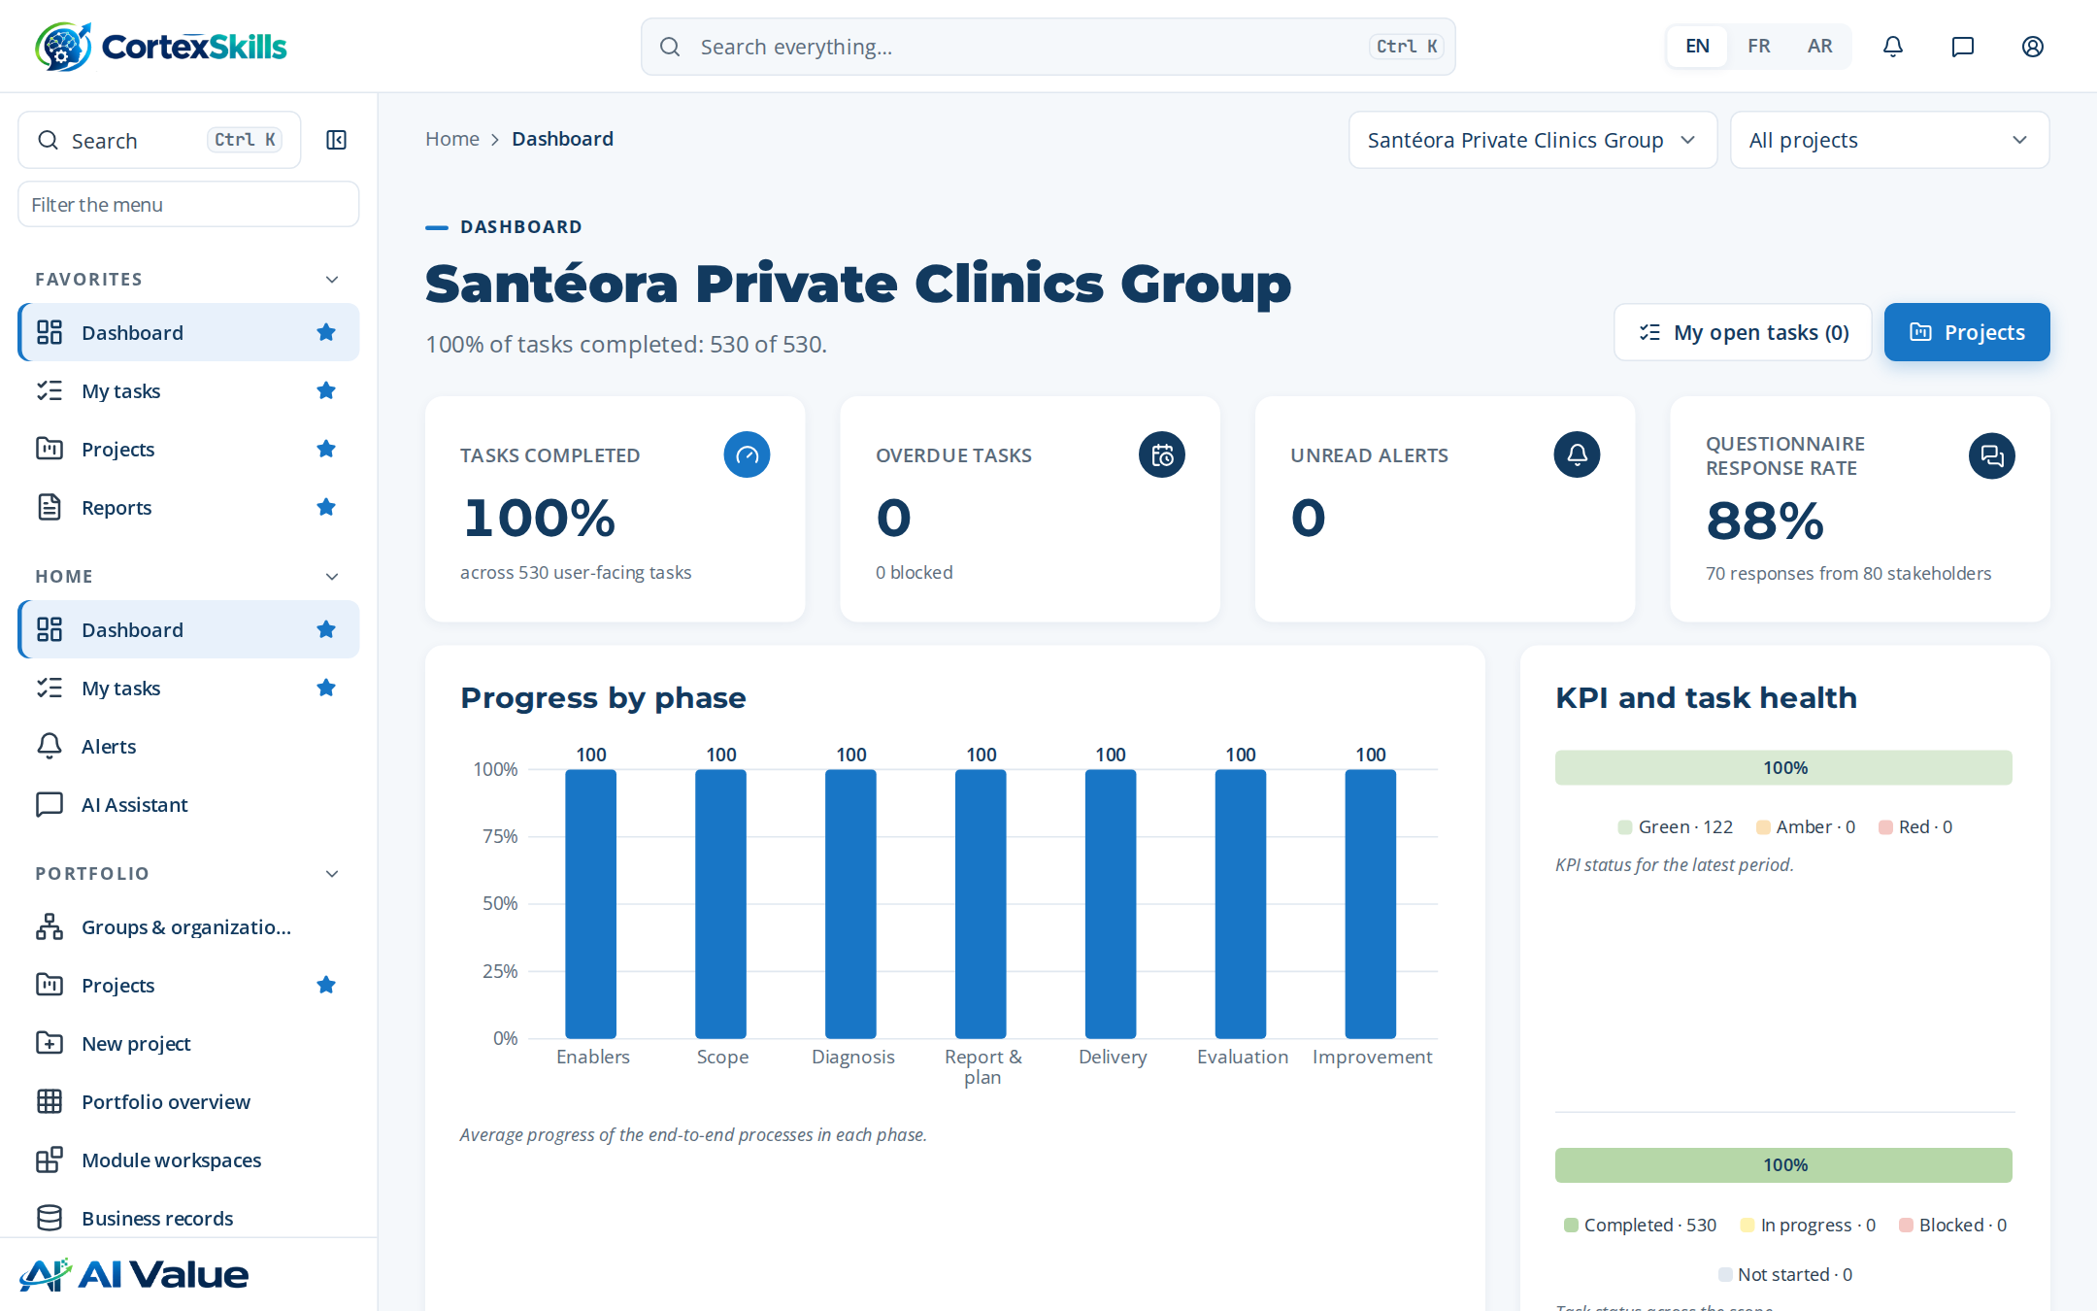
Figure 2 — Santéora Private Clinics Group

My tasks
Address: /my-tasks
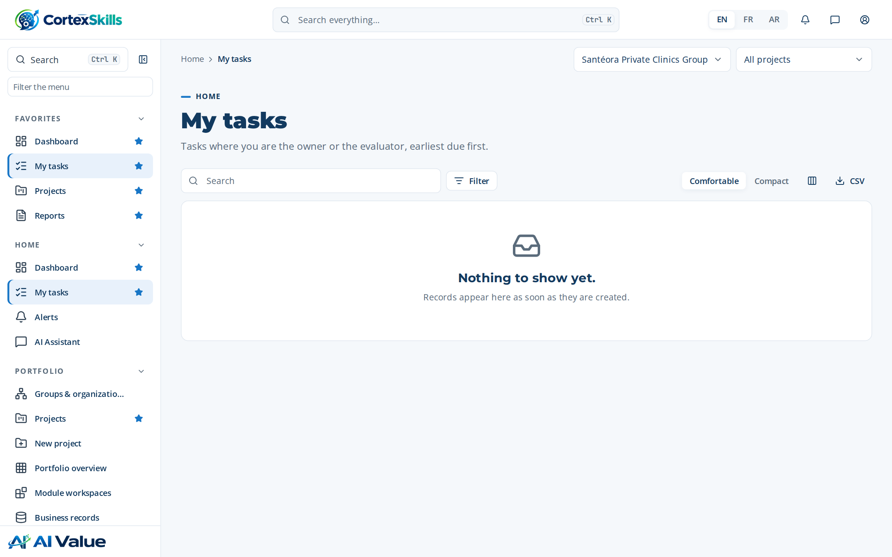
Figure 3 — My tasks

Alerts
Address: /alerts
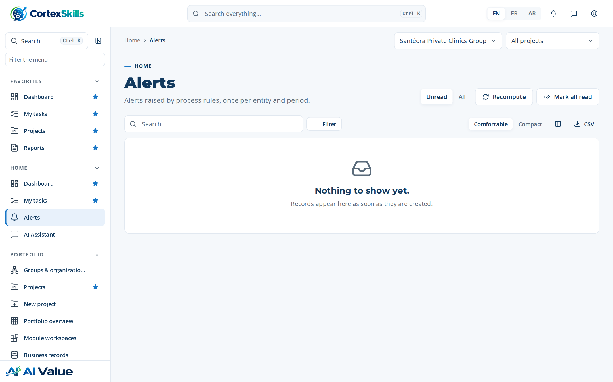
Figure 4 — Alerts

AI Assistant
Address: /assistant
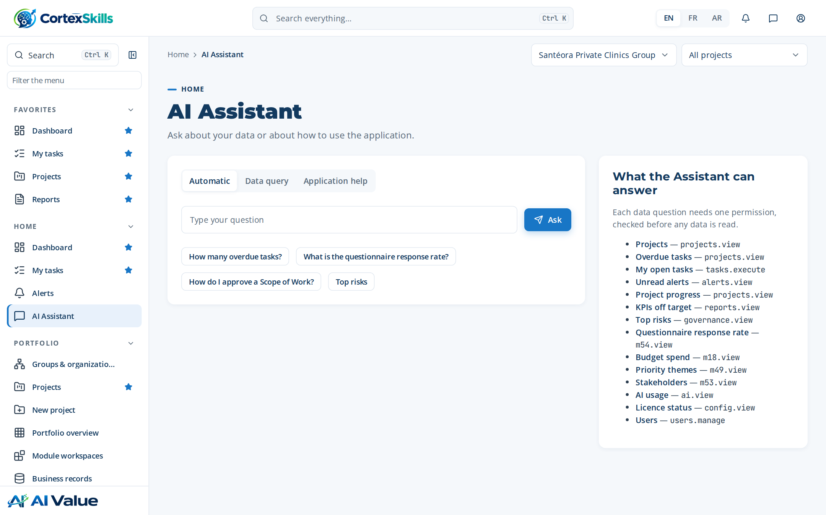
Figure 5 — AI Assistant

Profile menu
Address: /
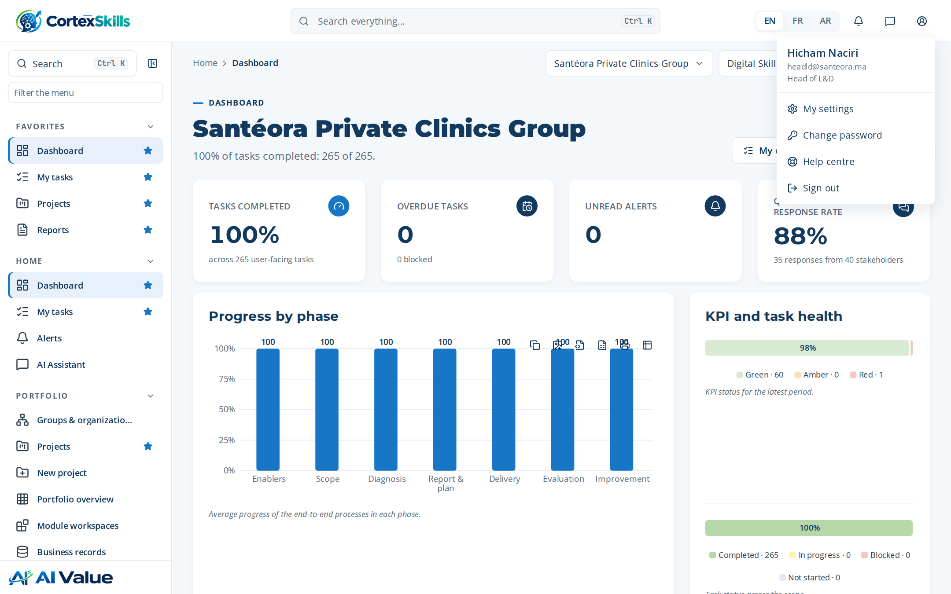
Figure 6 — Profile menu

Change password
Address: /
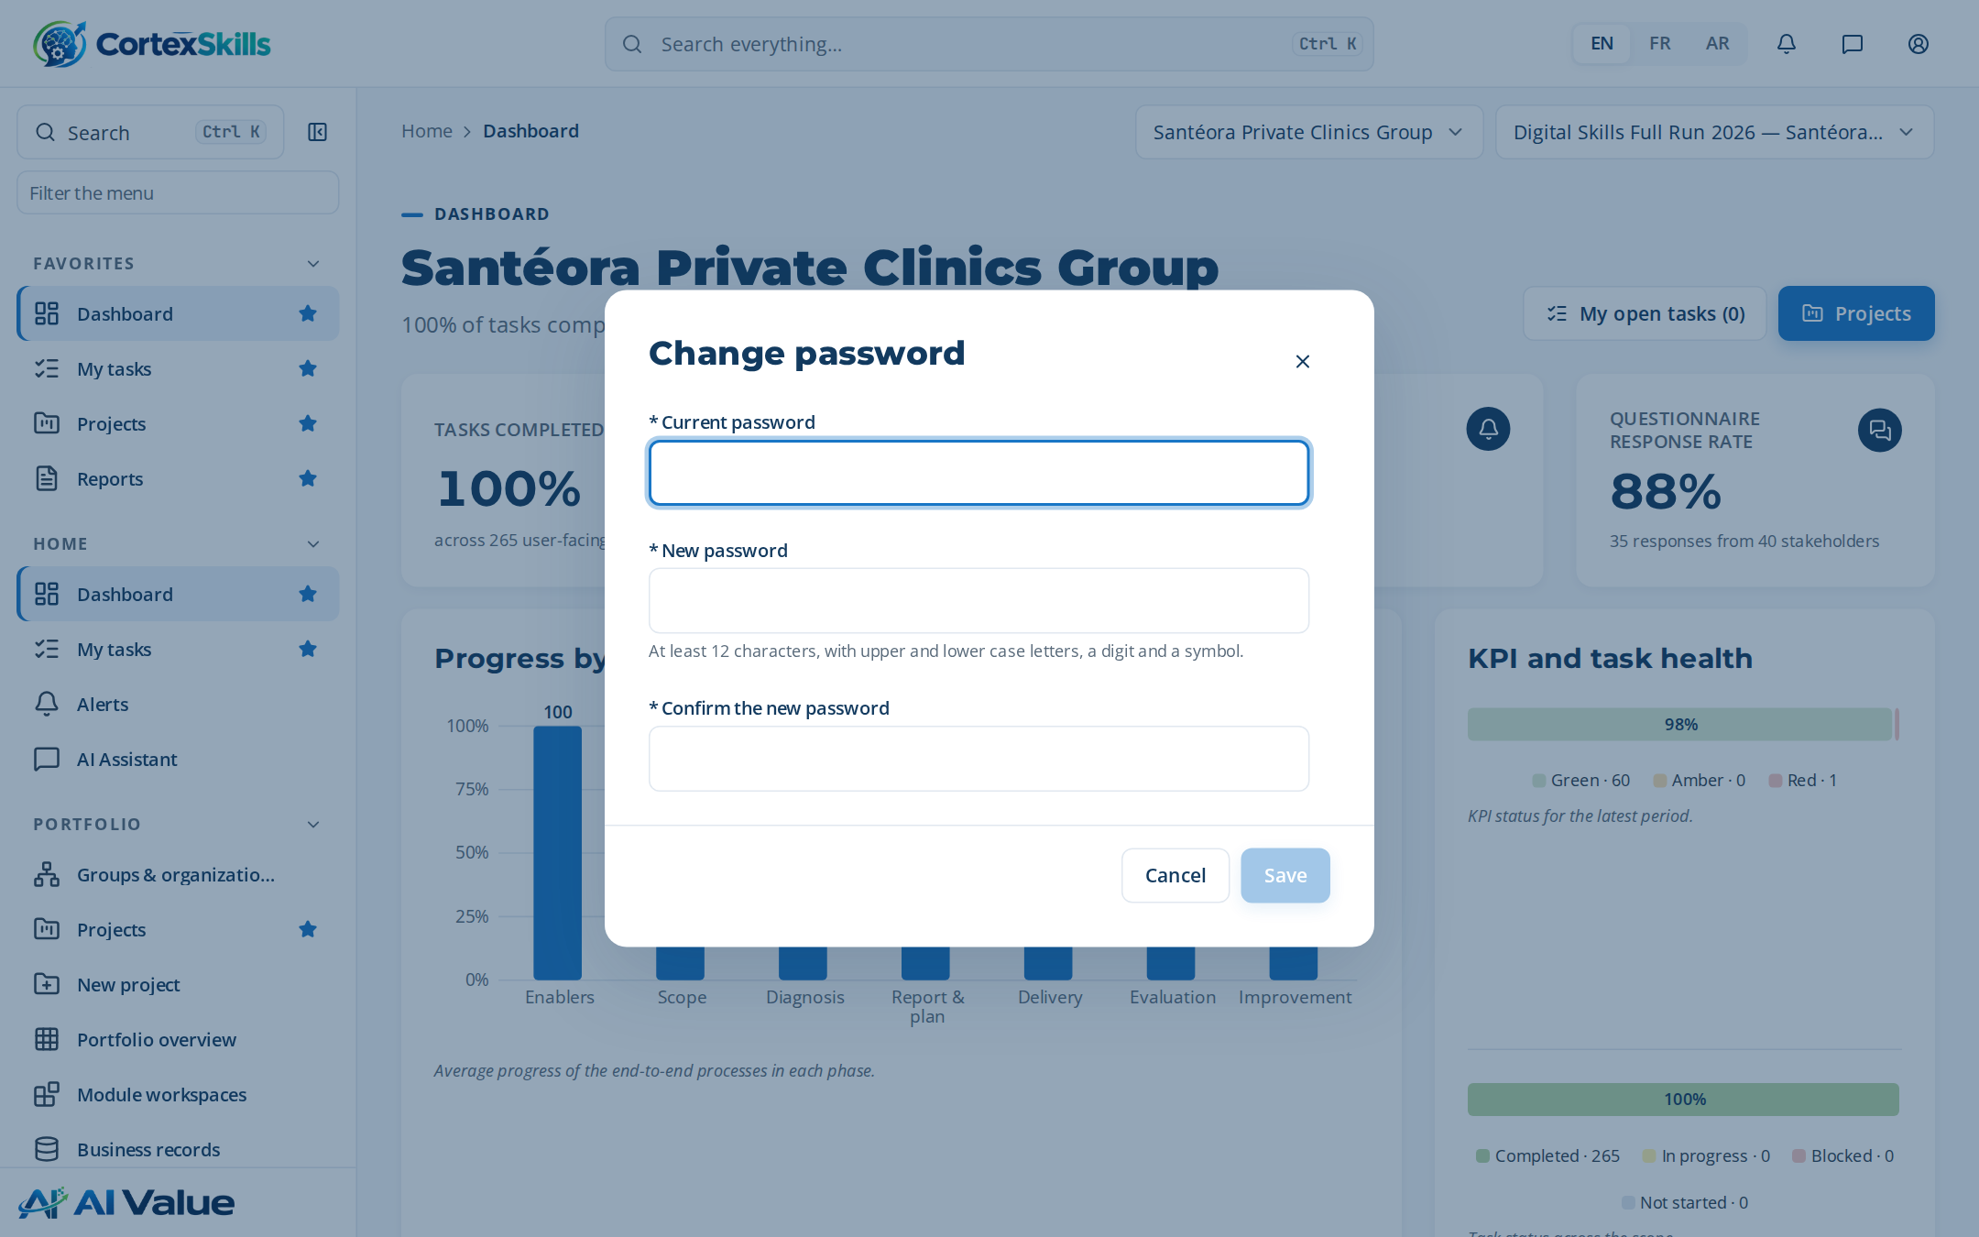
Figure 7 — Change password

3. Portfolio and projects

Groups & organizations
Address: /tenancy
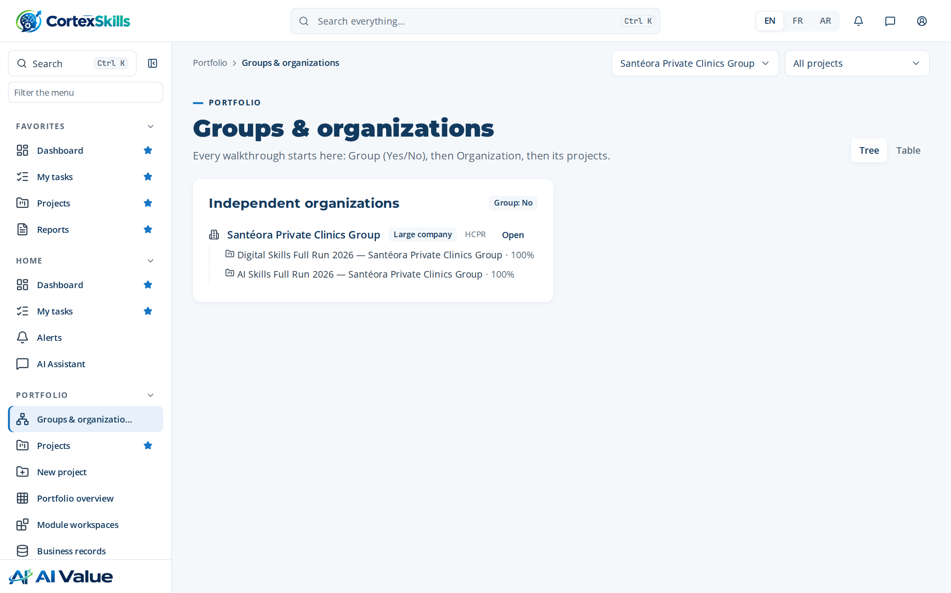
Figure 8 — Groups & organizations

Projects
Address: /projects
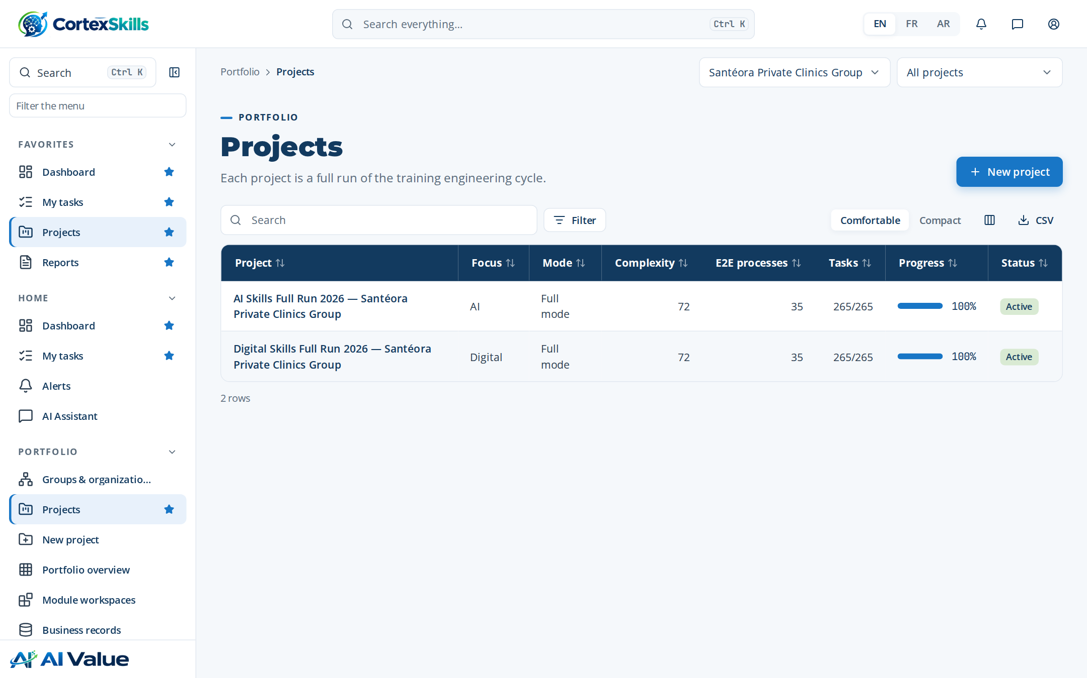
Figure 9 — Projects

New project
Address: /projects/new
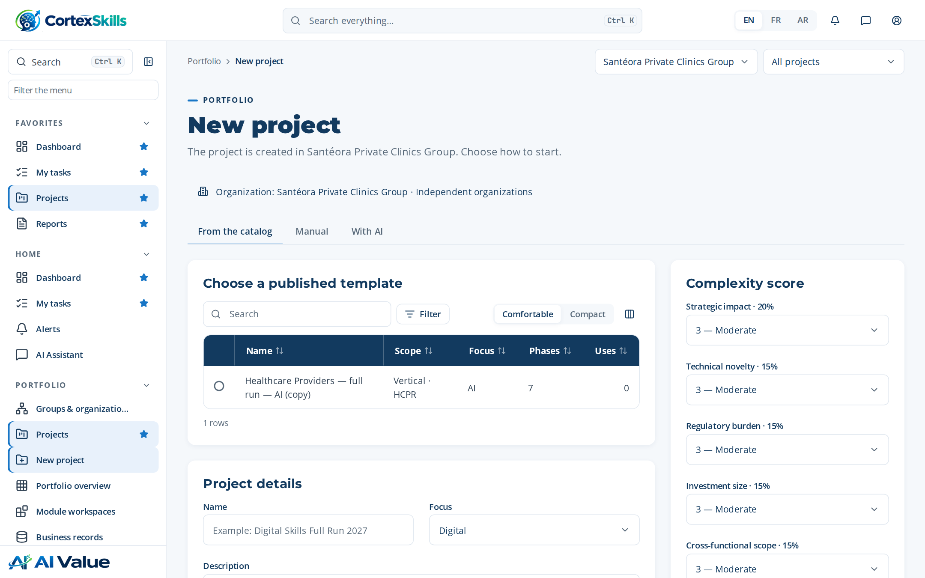
Figure 10 — New project

AI Skills Full Run 2026 — Santéora Private Clinics Group
Address: /projects/:id
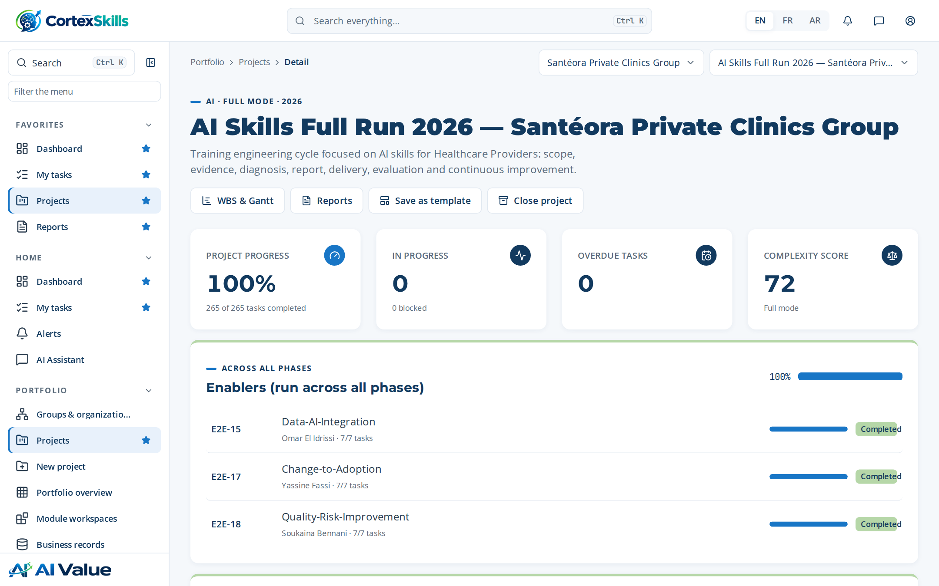
Figure 11 — AI Skills Full Run 2026 — Santéora Private Clinics Group

WBS & Gantt
Address: /projects/:id/gantt
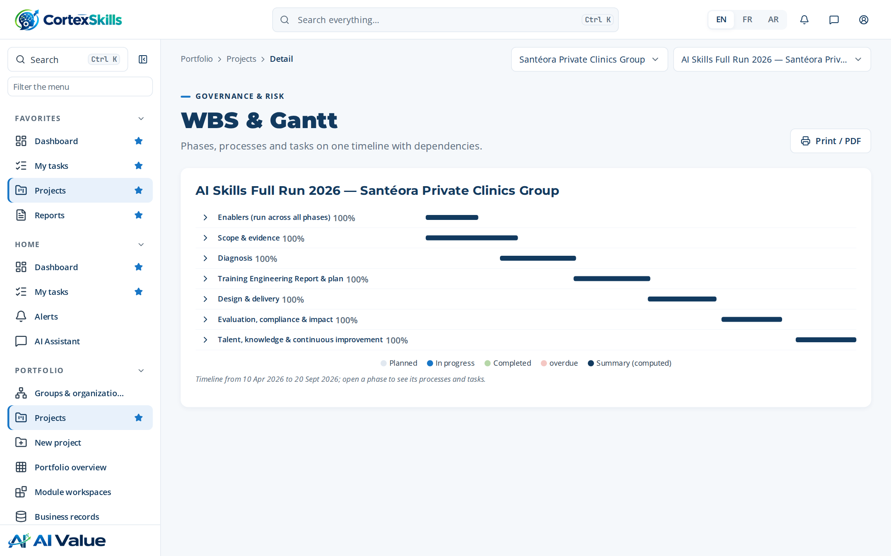
Figure 12 — WBS & Gantt

Roadmap-to-Curriculum Design
Address: /runs/:id
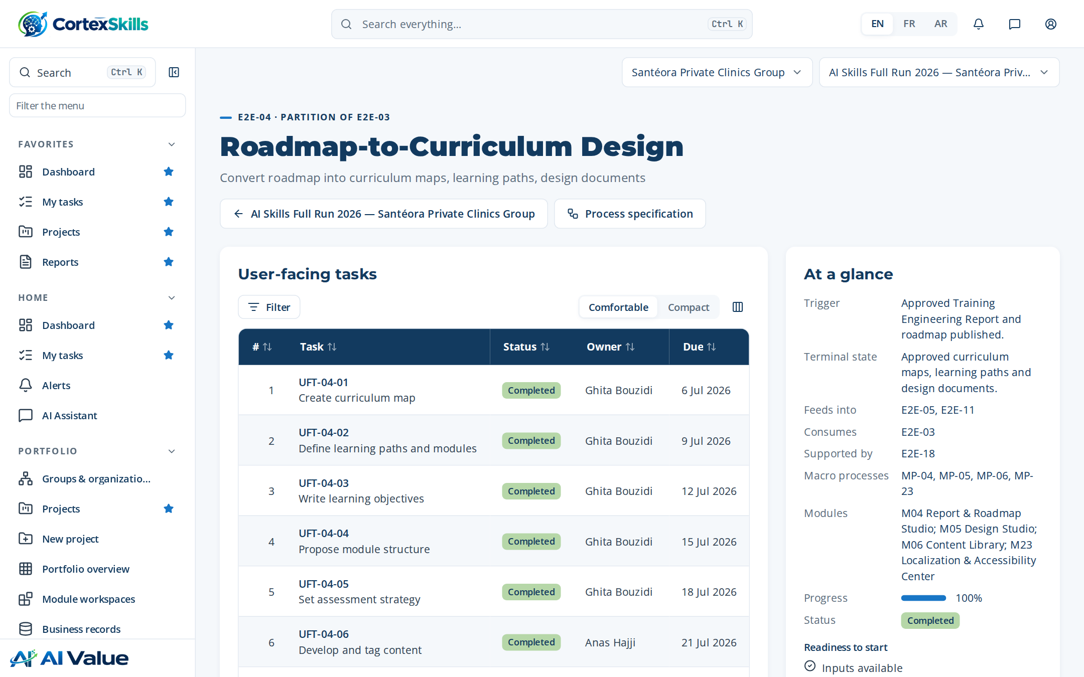
Figure 13 — Roadmap-to-Curriculum Design

Roadmap-to-Curriculum Design
Address: /runs/:id?task=:id
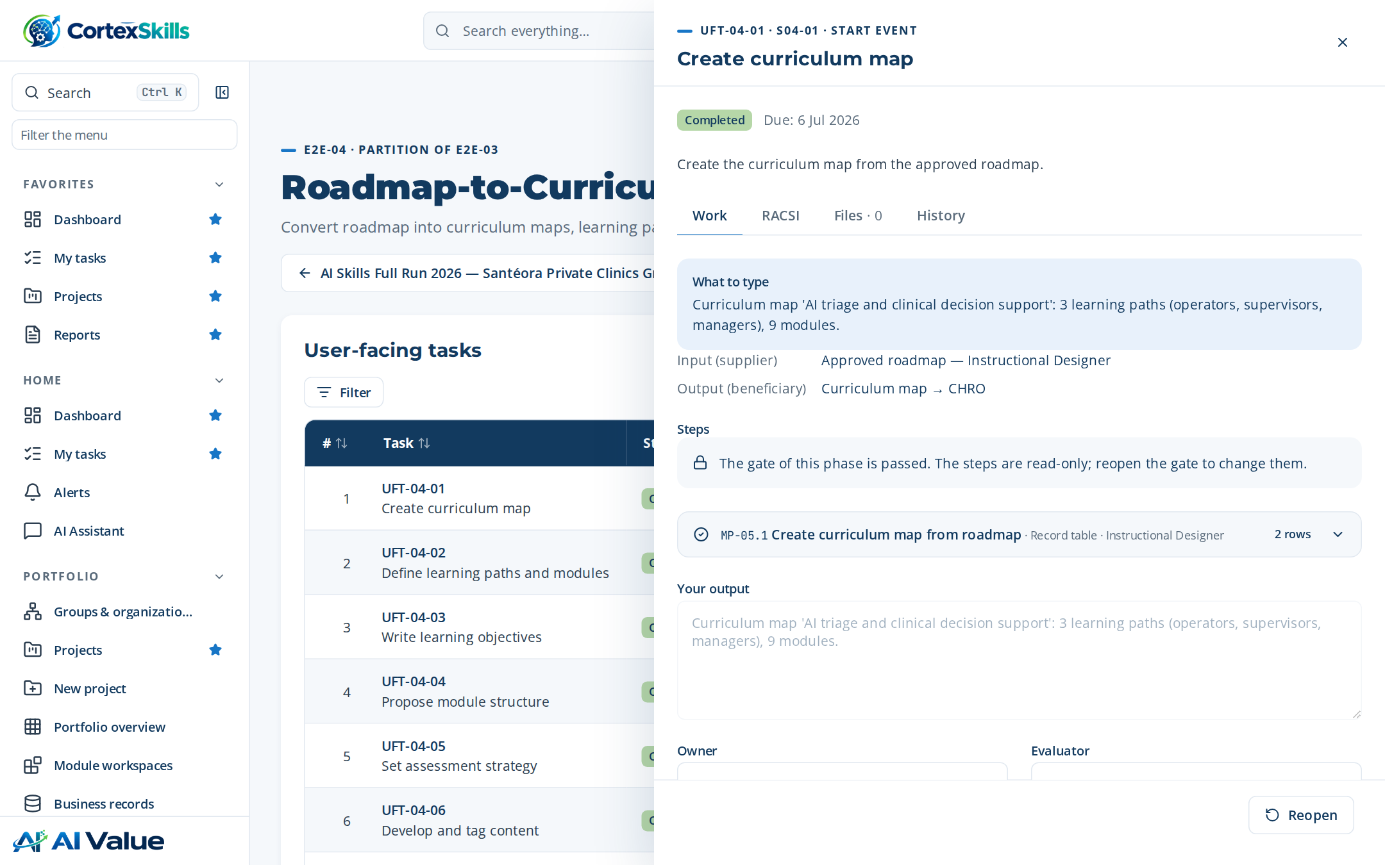
Figure 14 — Roadmap-to-Curriculum Design

Portfolio overview
Address: /portfolio
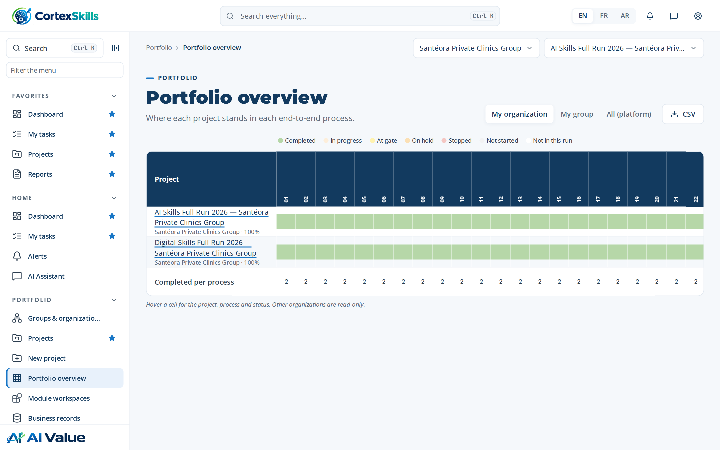
Figure 15 — Portfolio overview

Module workspaces
Address: /modules
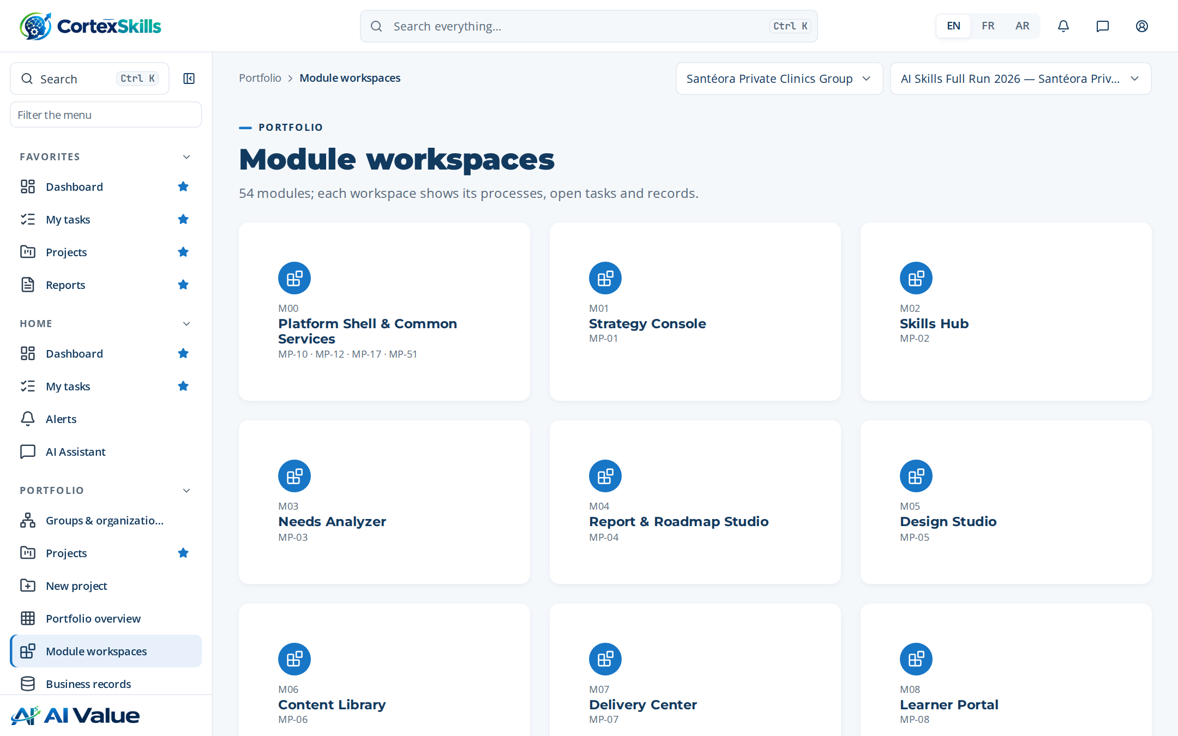
Figure 16 — Module workspaces

Platform Shell & Common Services
Address: /modules/M00
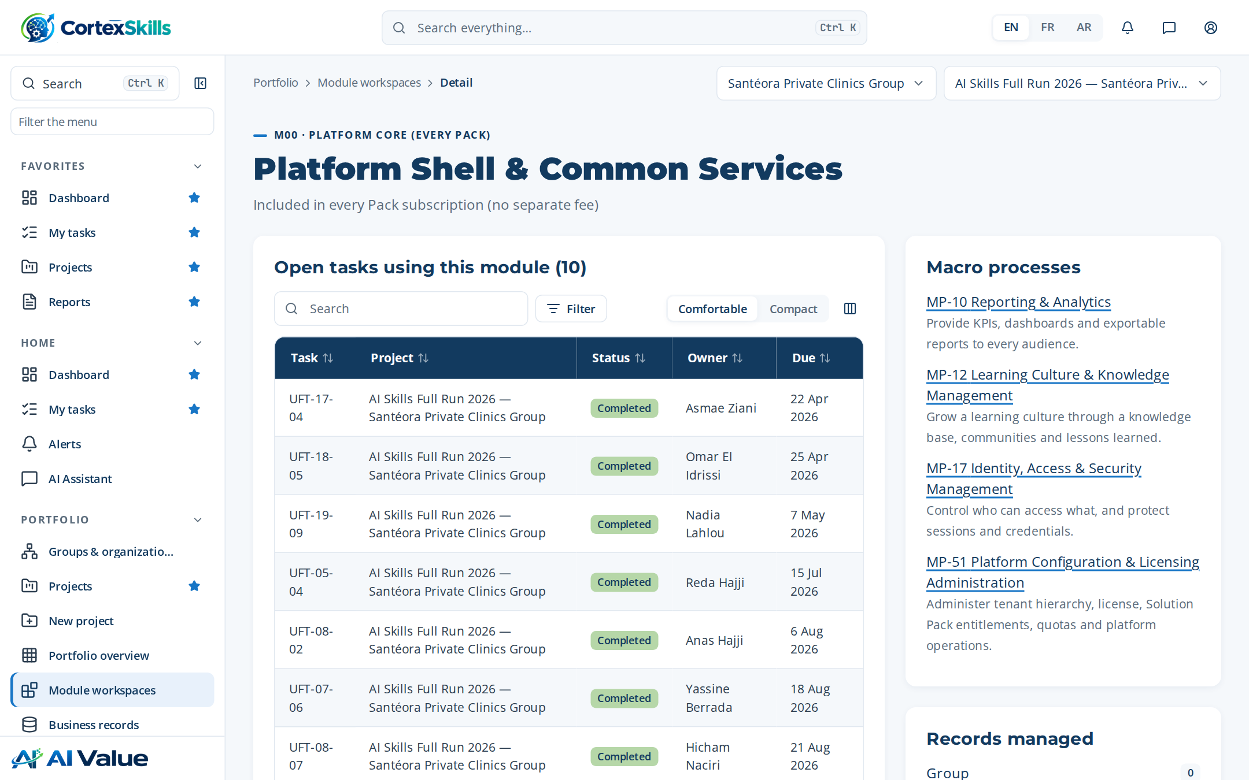
Figure 17 — Platform Shell & Common Services

Business records
Address: /records
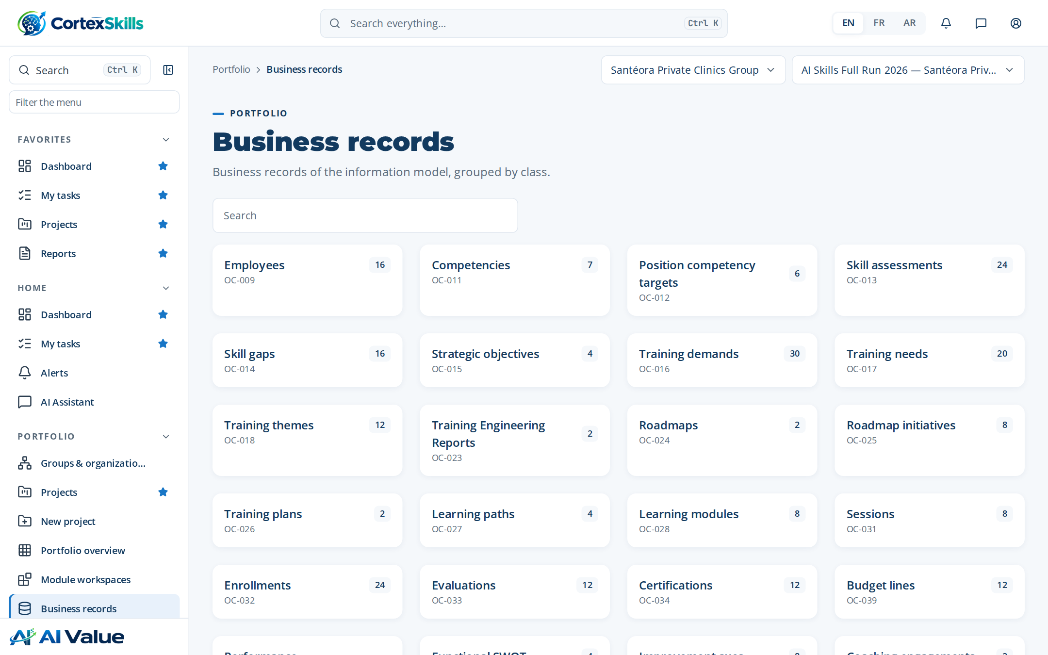
Figure 18 — Business records

Questionnaires
Address: /questionnaires
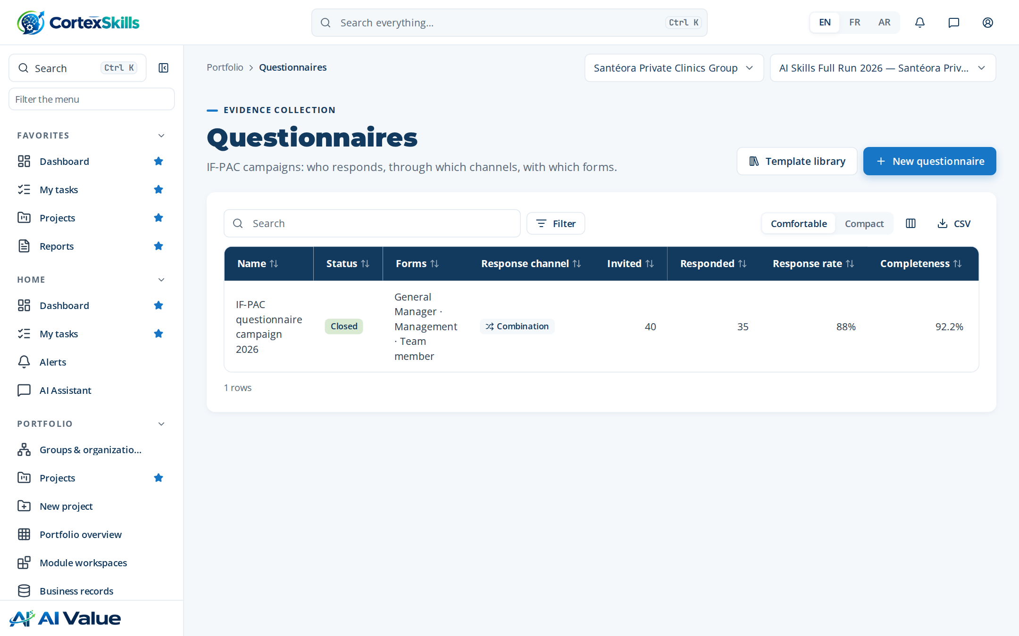
Figure 19 — Questionnaires

Template library
Address: /questionnaires/templates
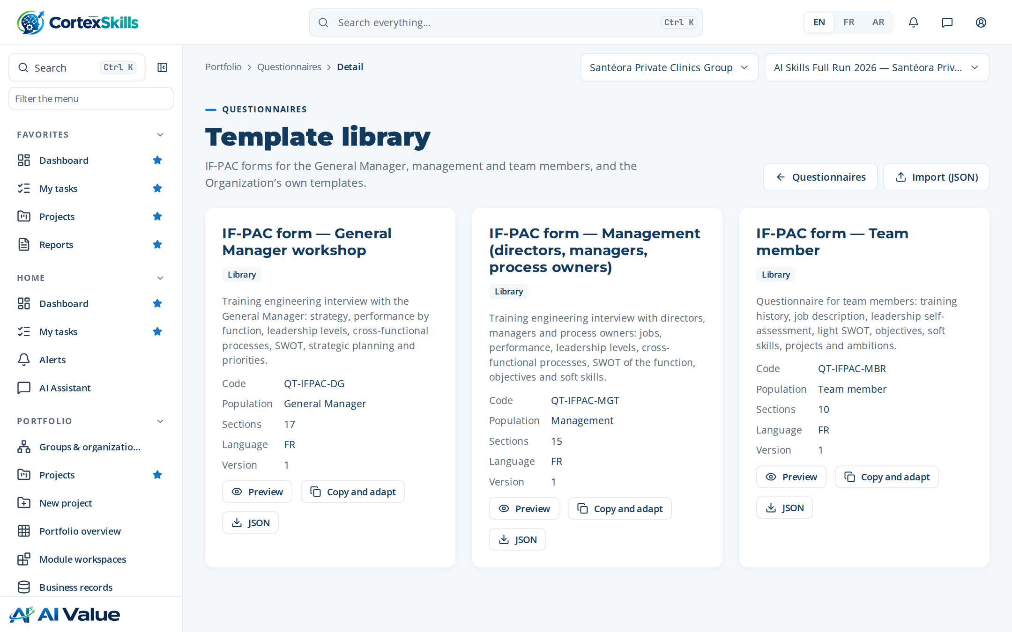
Figure 20 — Template library

IF-PAC questionnaire campaign 2026
Address: /questionnaires/:id
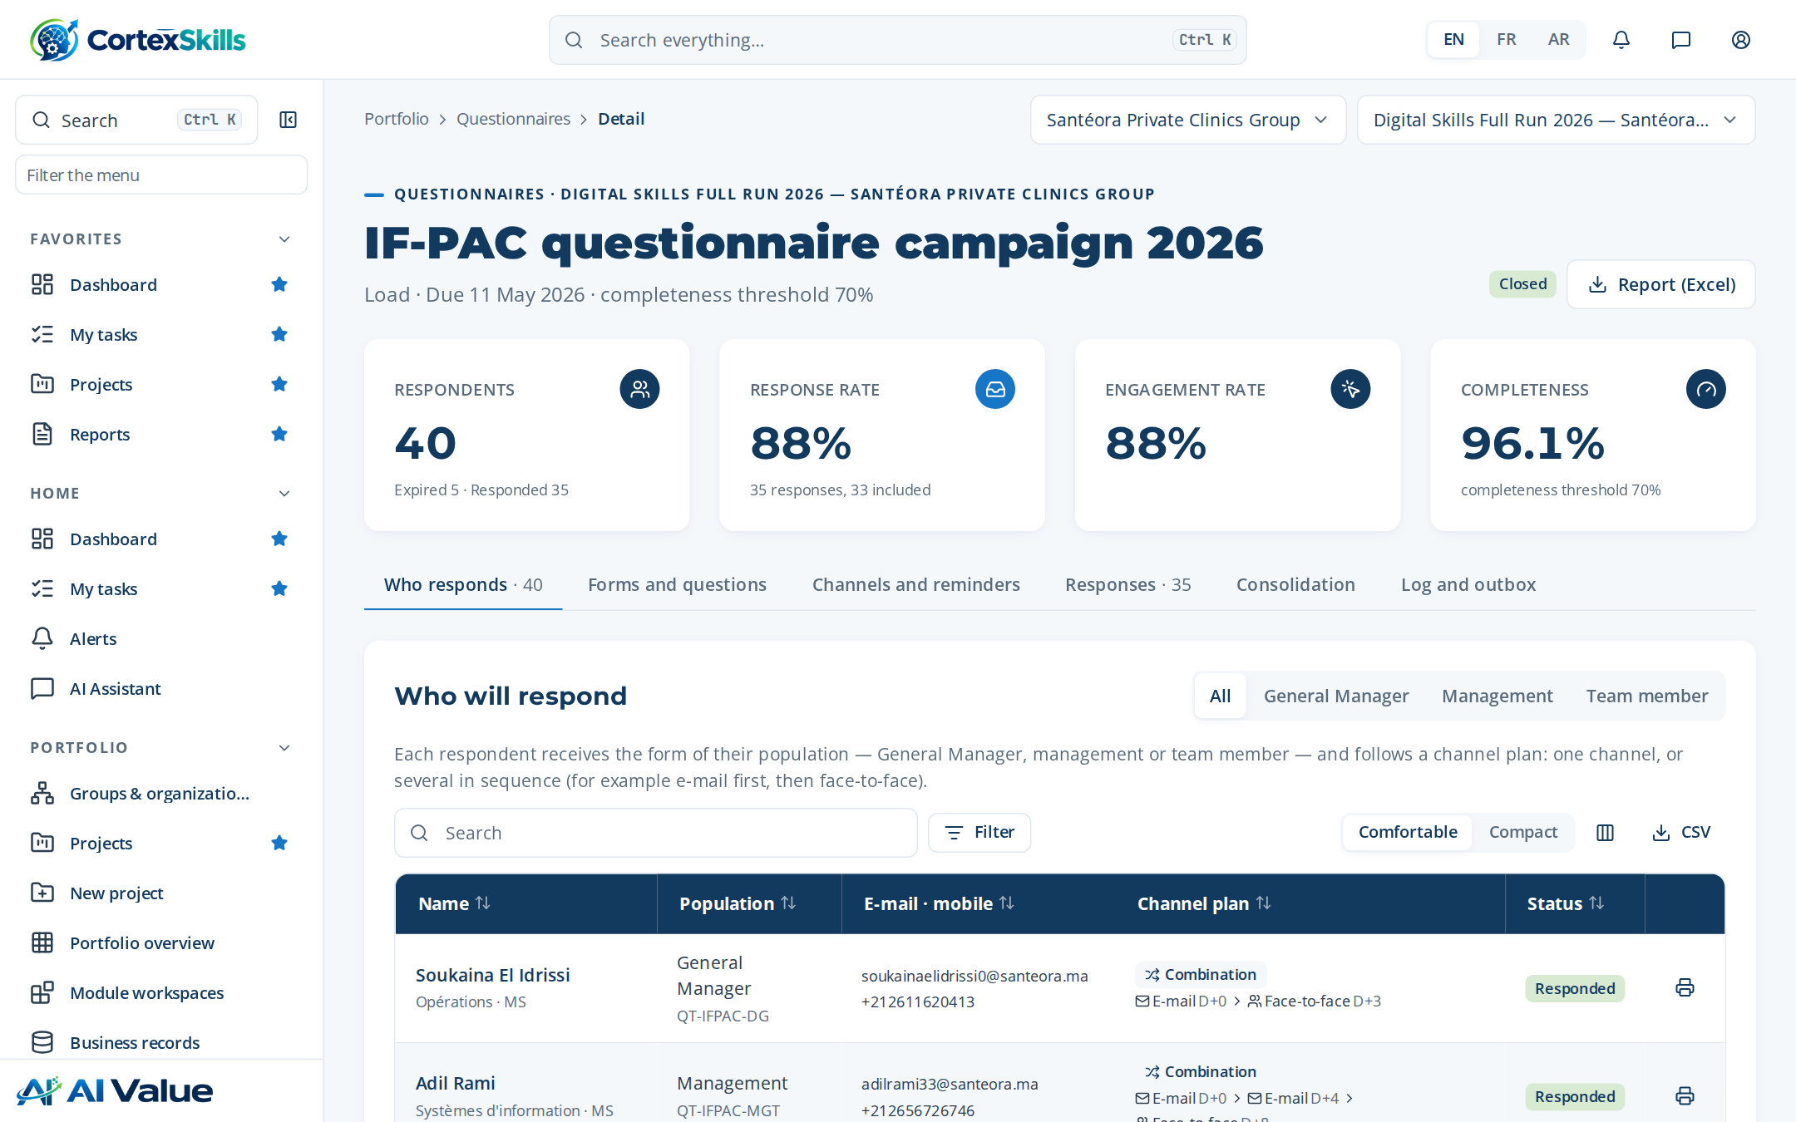
Figure 21 — IF-PAC questionnaire campaign 2026

Training plan 2026
Address: /training-plan
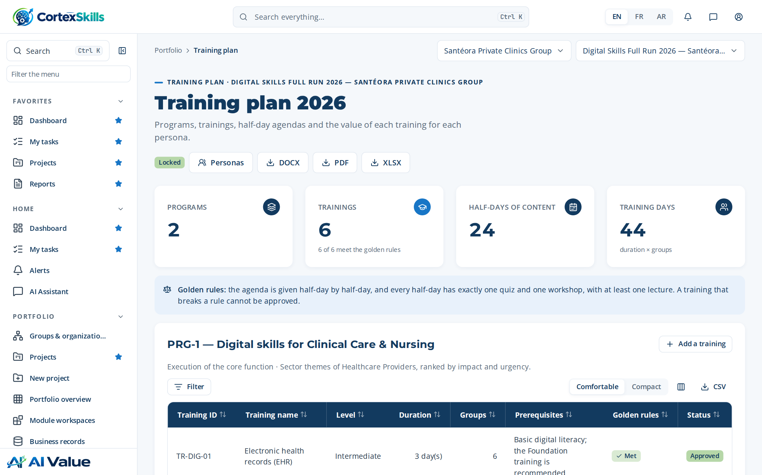
Figure 22 — Training plan 2026

4. Process design

Process design
Address: /process/design
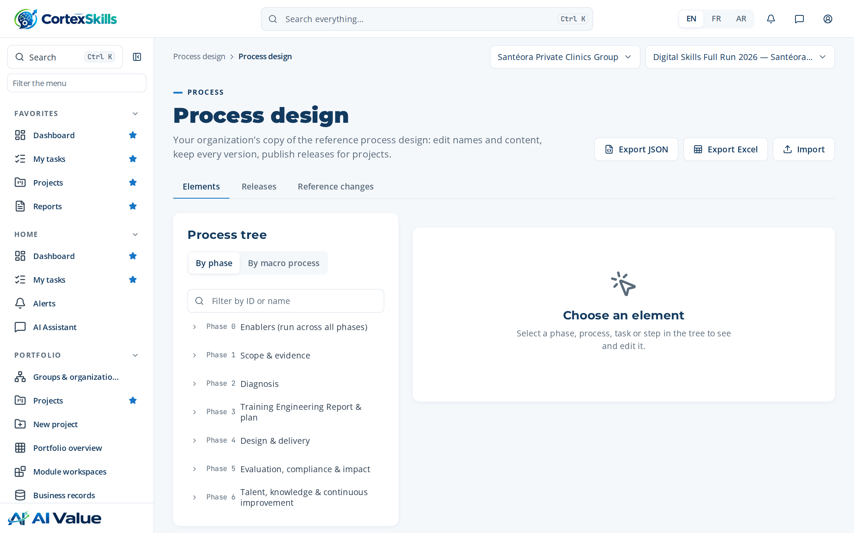
Figure 23 — Process design

Macro processes
Address: /process/mp
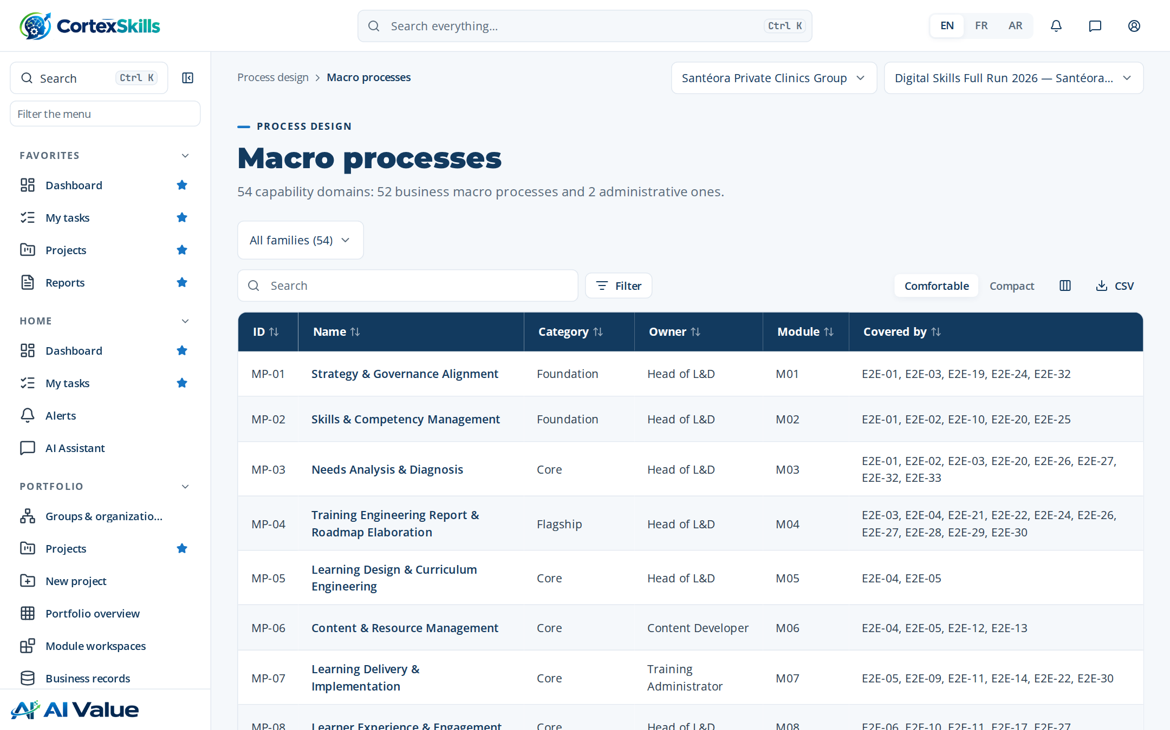
Figure 24 — Macro processes

End-to-end processes
Address: /process/e2e
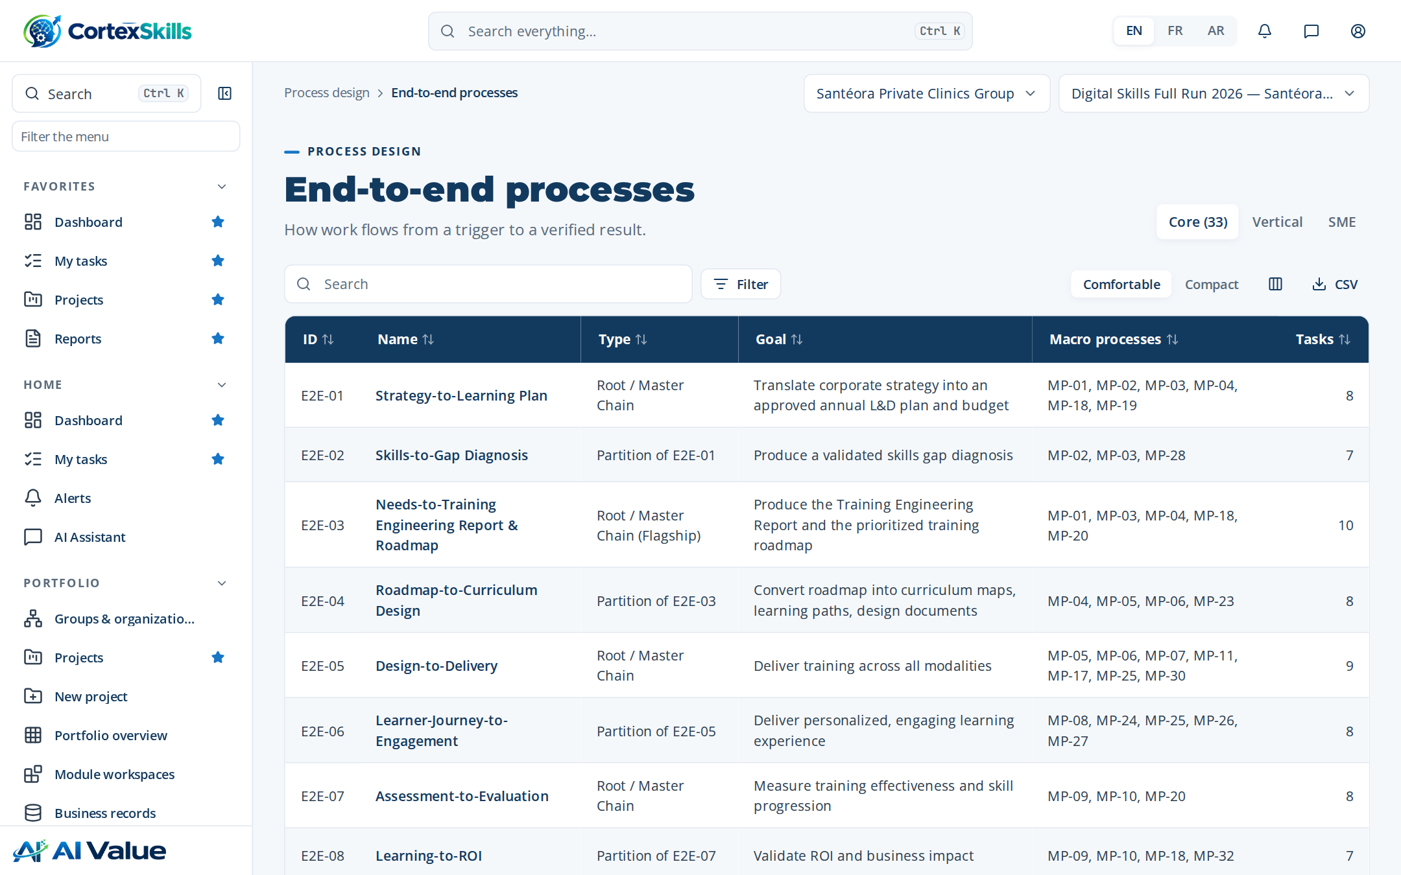
Figure 25 — End-to-end processes

Chain diagram
Address: /process/chain
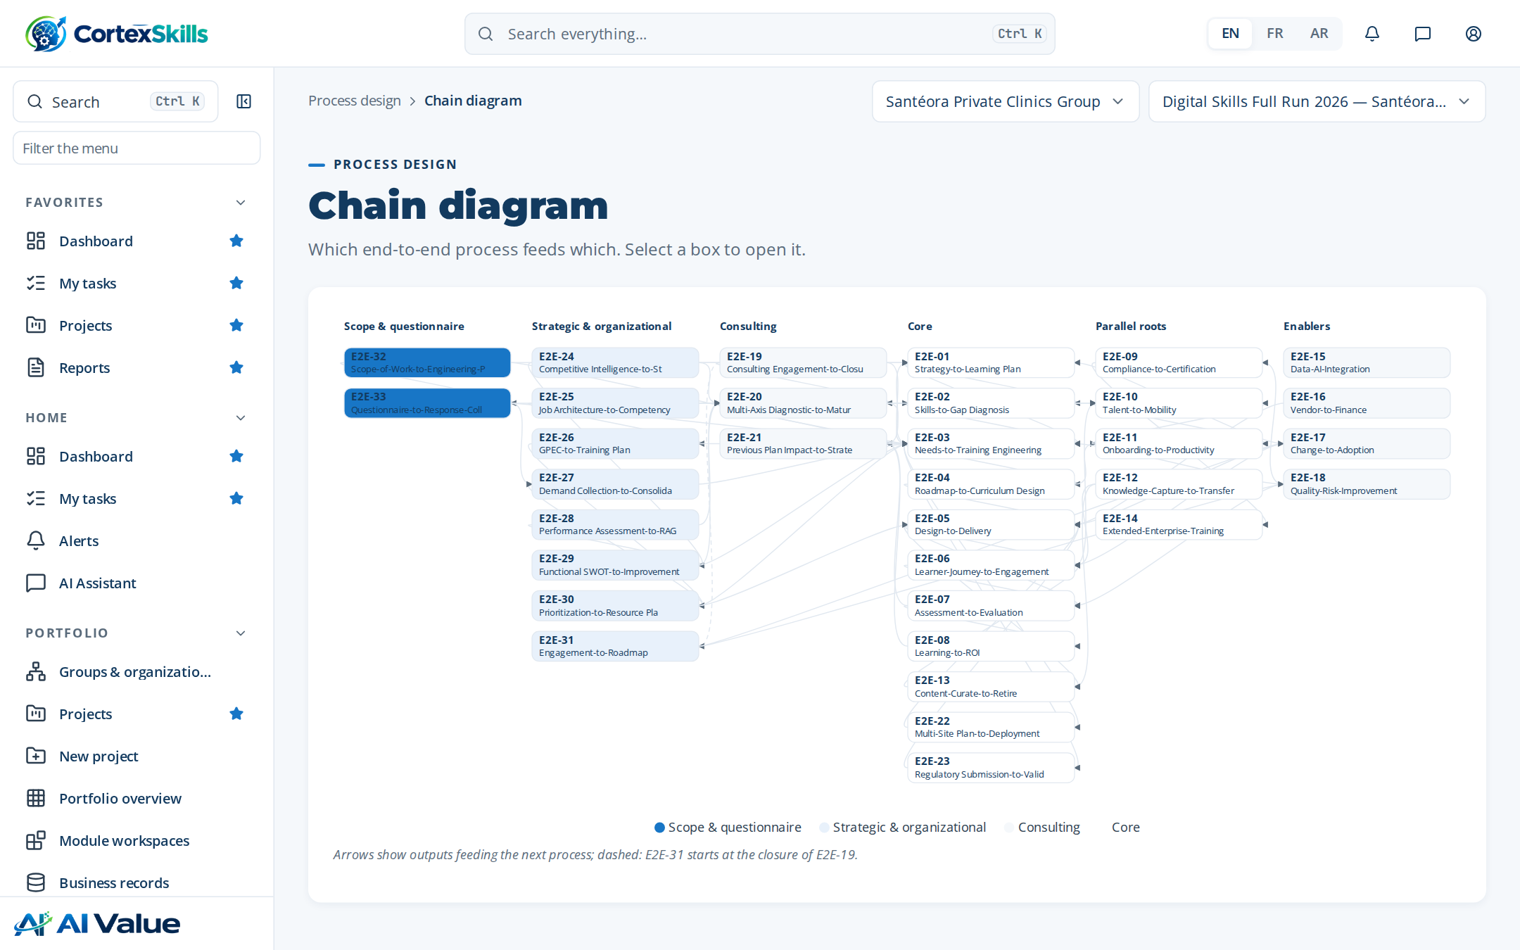
Figure 26 — Chain diagram

Coverage matrix
Address: /process/coverage
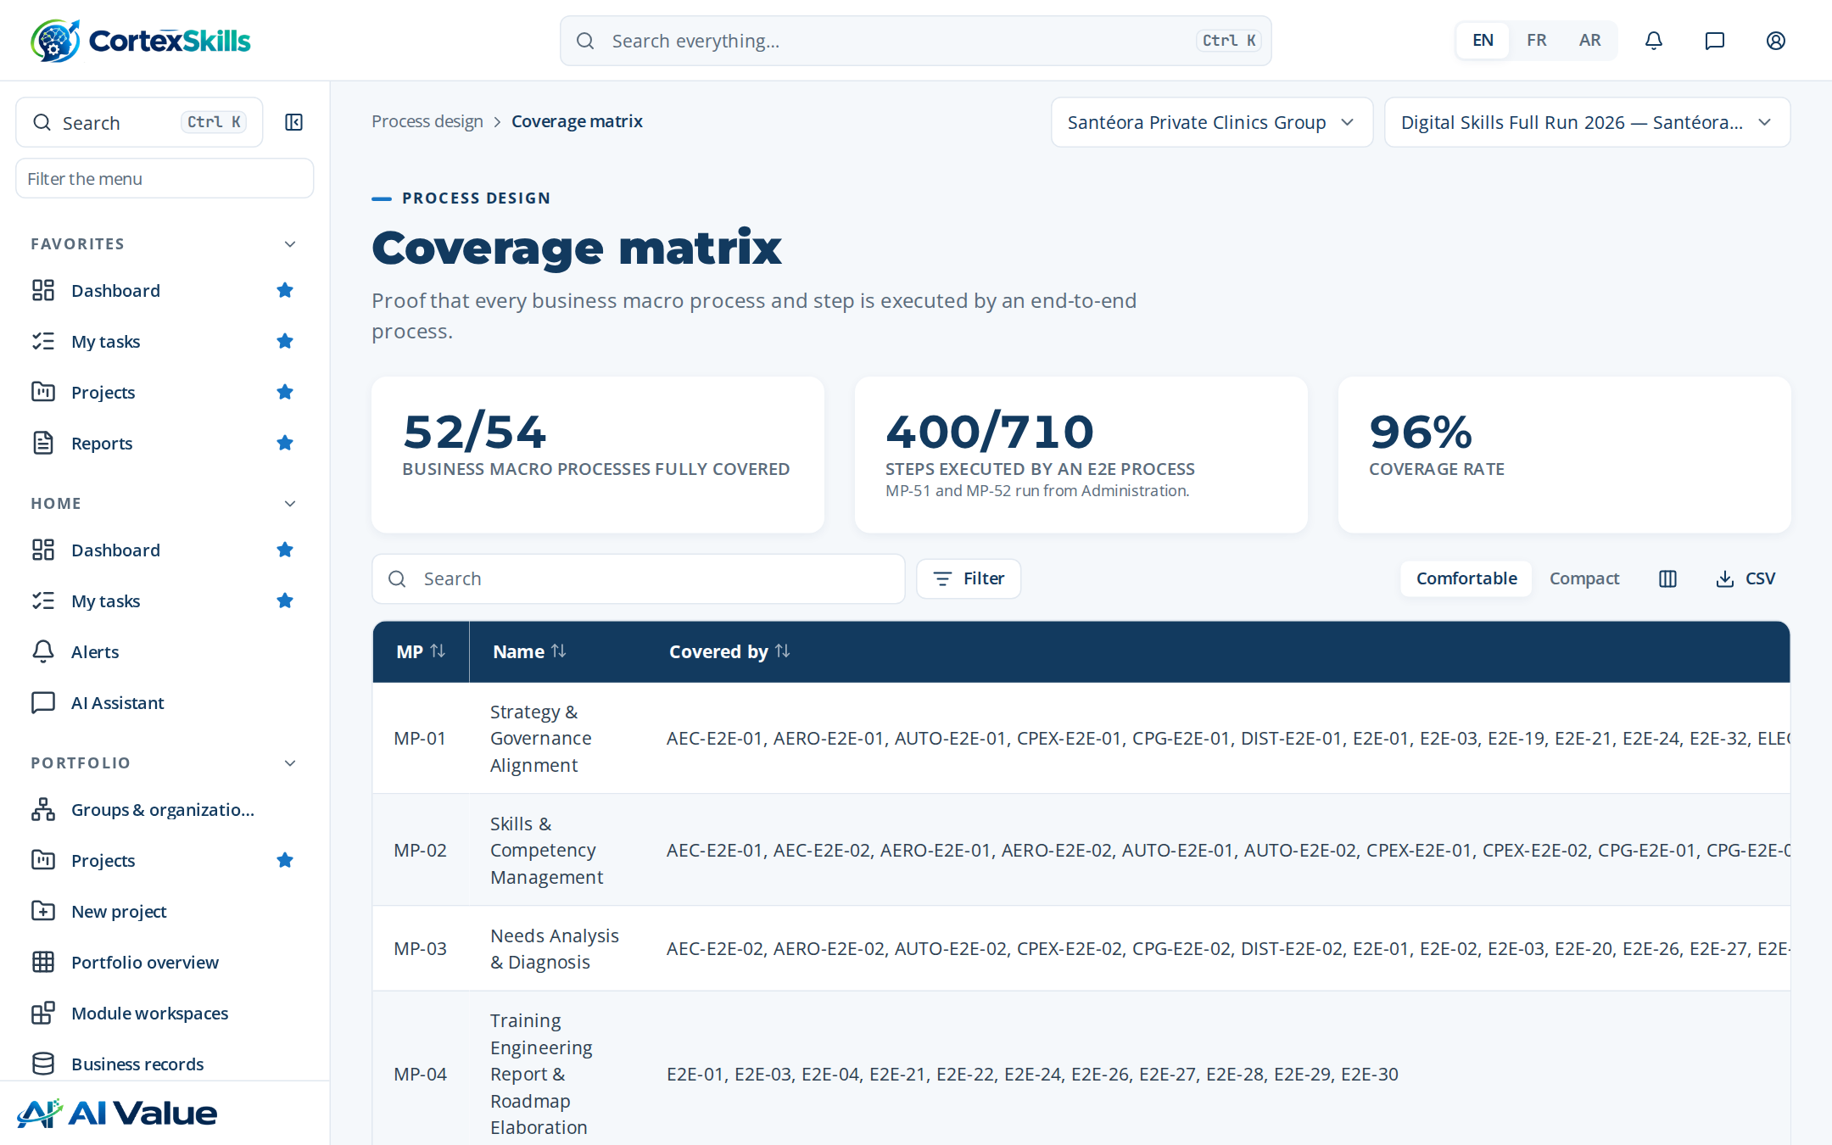
Figure 27 — Coverage matrix

BPMN diagrams
Address: /process/bpmn
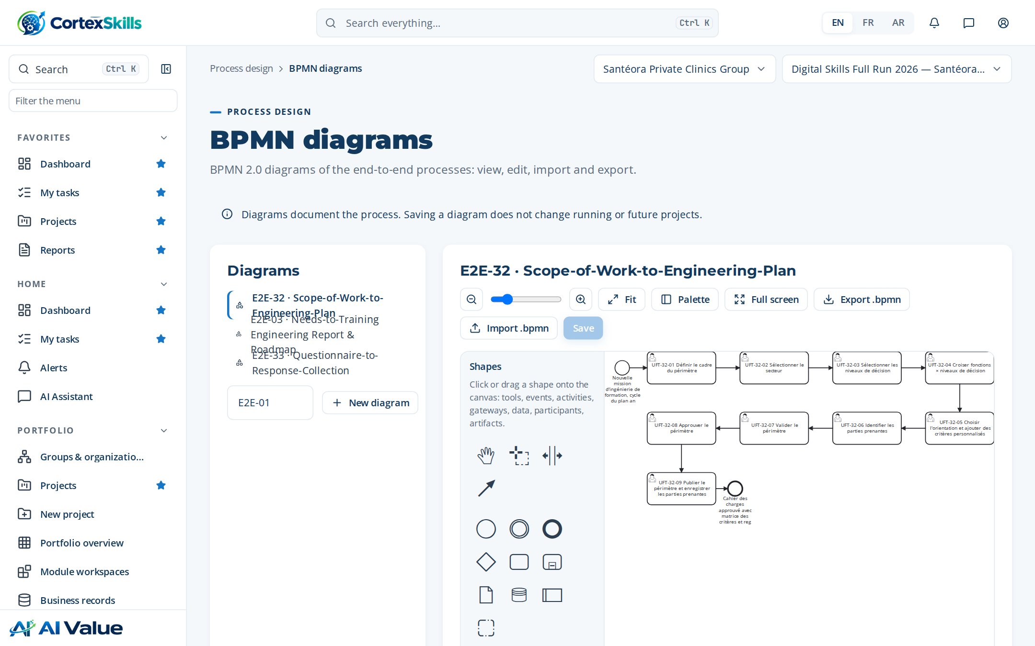
Figure 28 — BPMN diagrams

Verticals
Address: /process/verticals
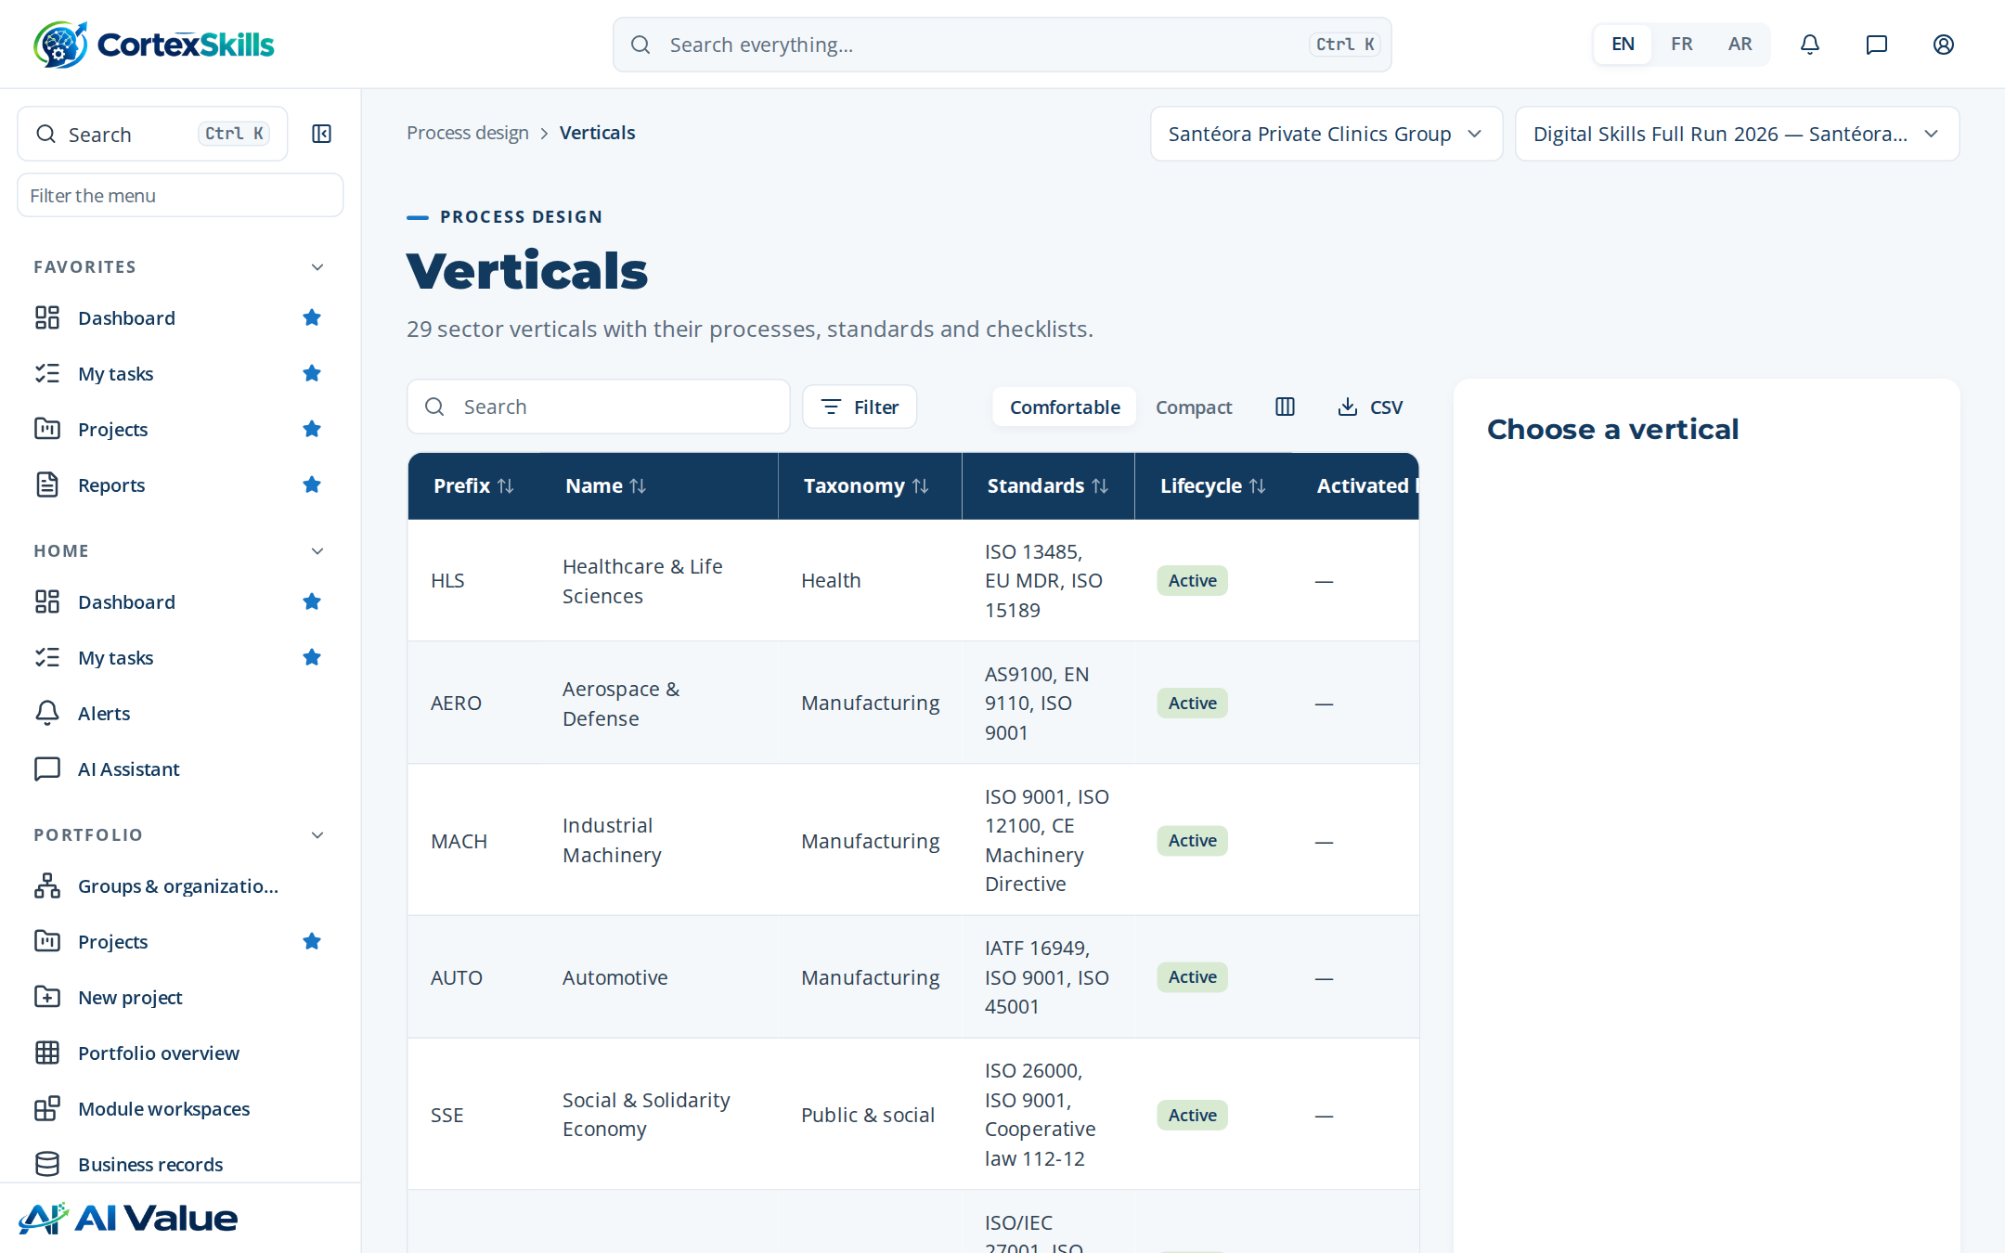
Figure 29 — Verticals

SME tracks & scoring
Address: /process/sme
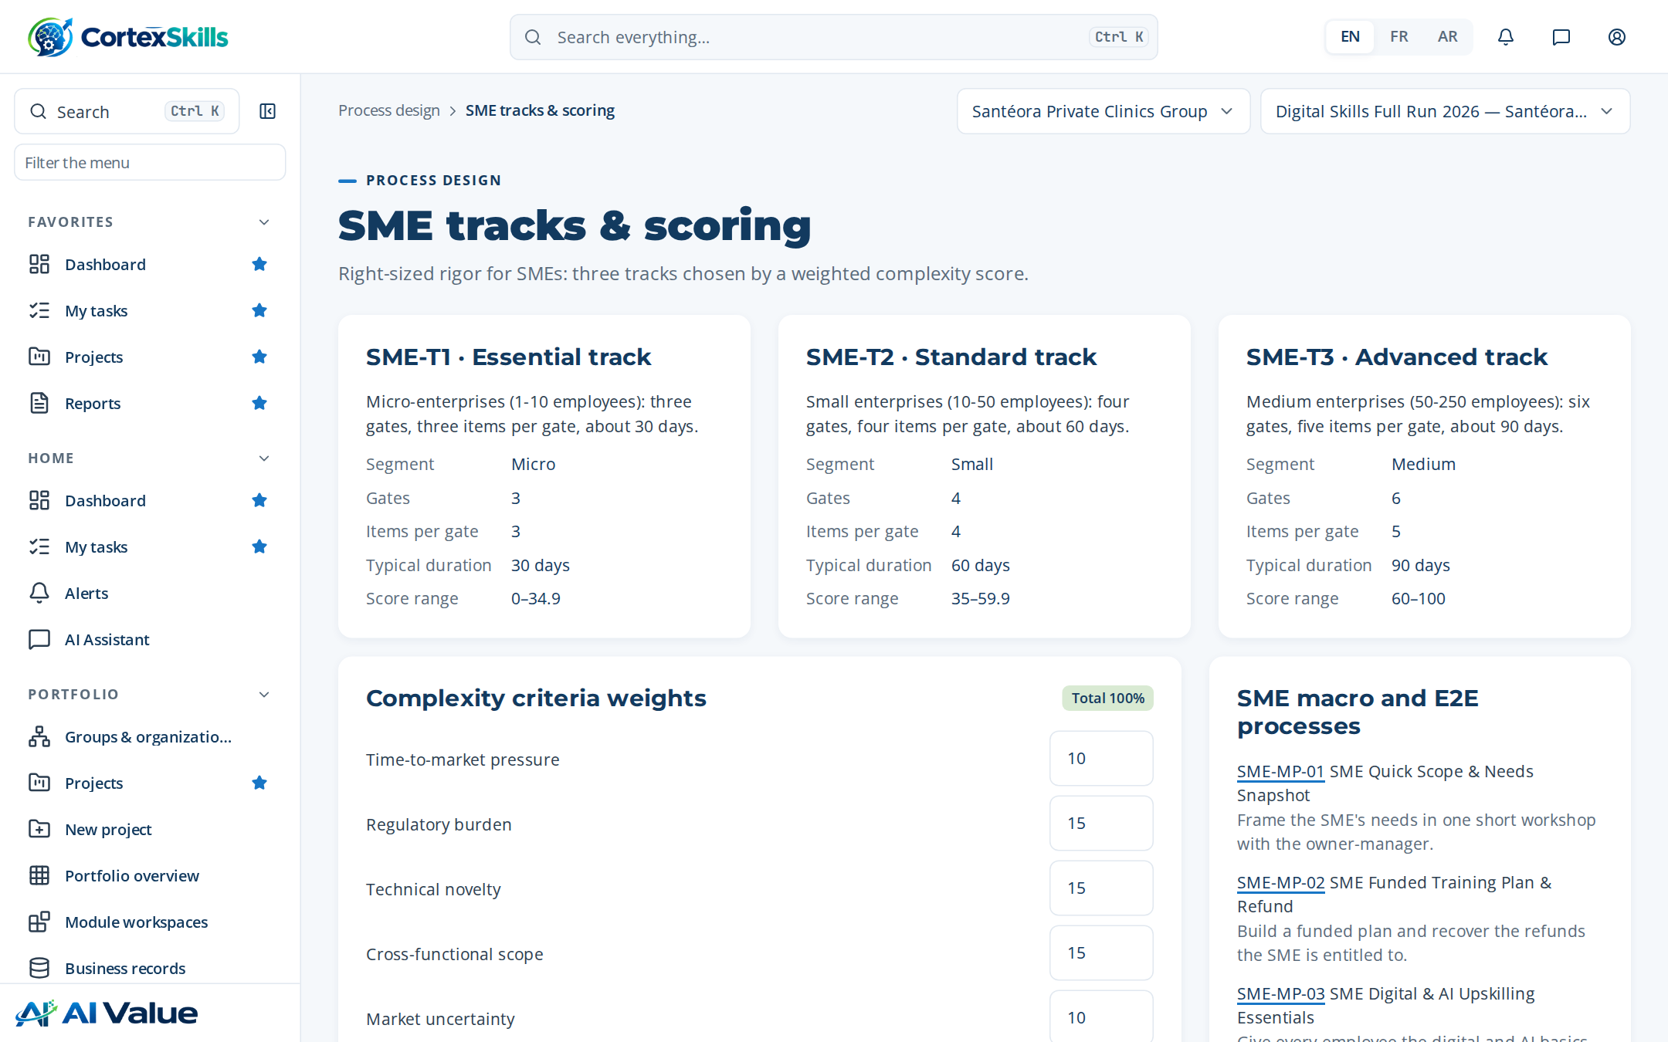
Figure 30 — SME tracks & scoring

Project templates
Address: /process/templates
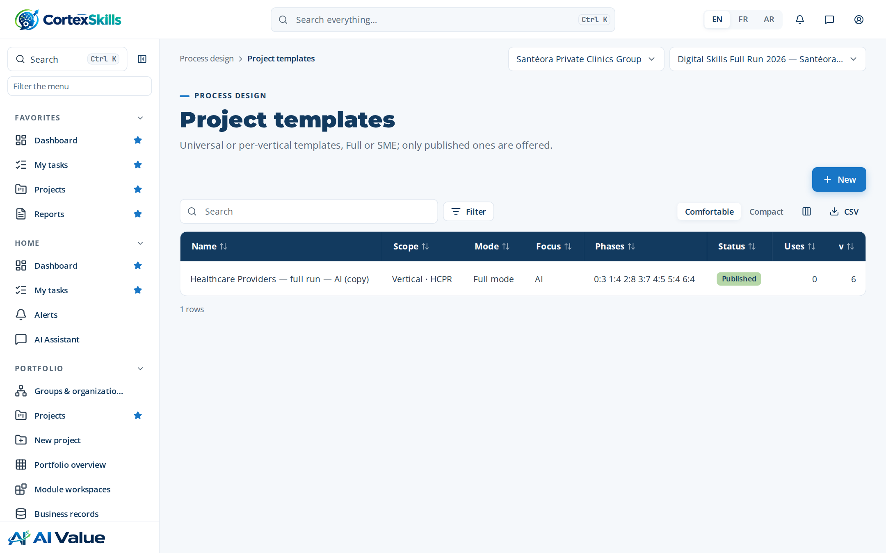
Figure 31 — Project templates

Gate library
Address: /process/gates
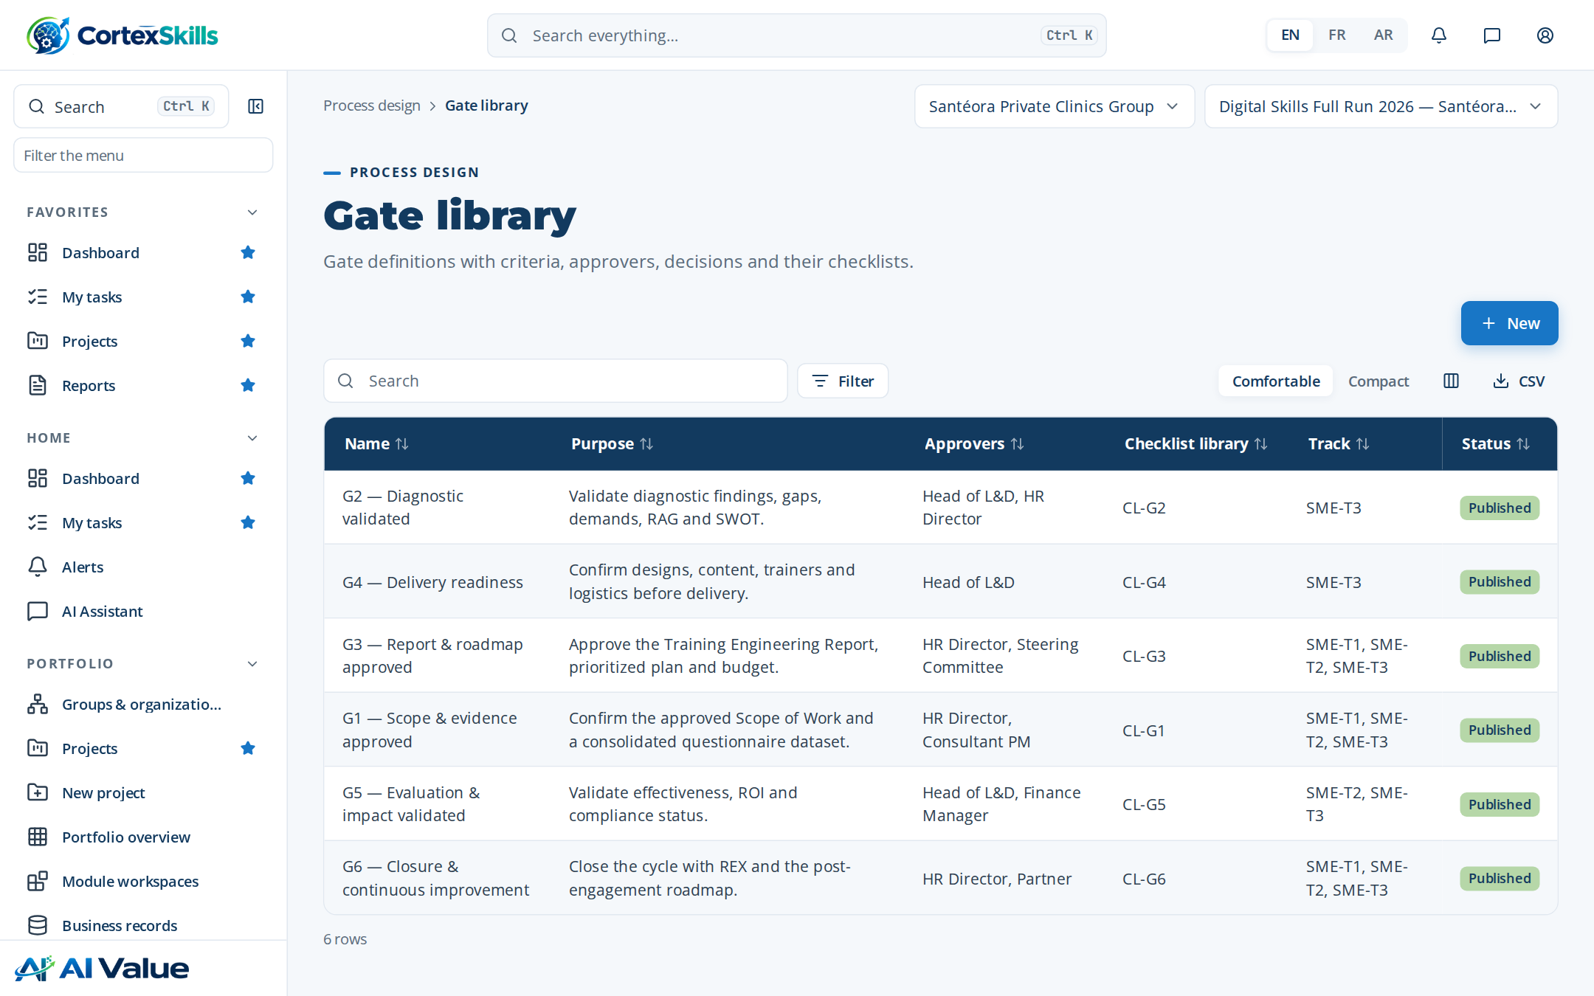
Figure 32 — Gate library

Checklist library
Address: /process/checklists
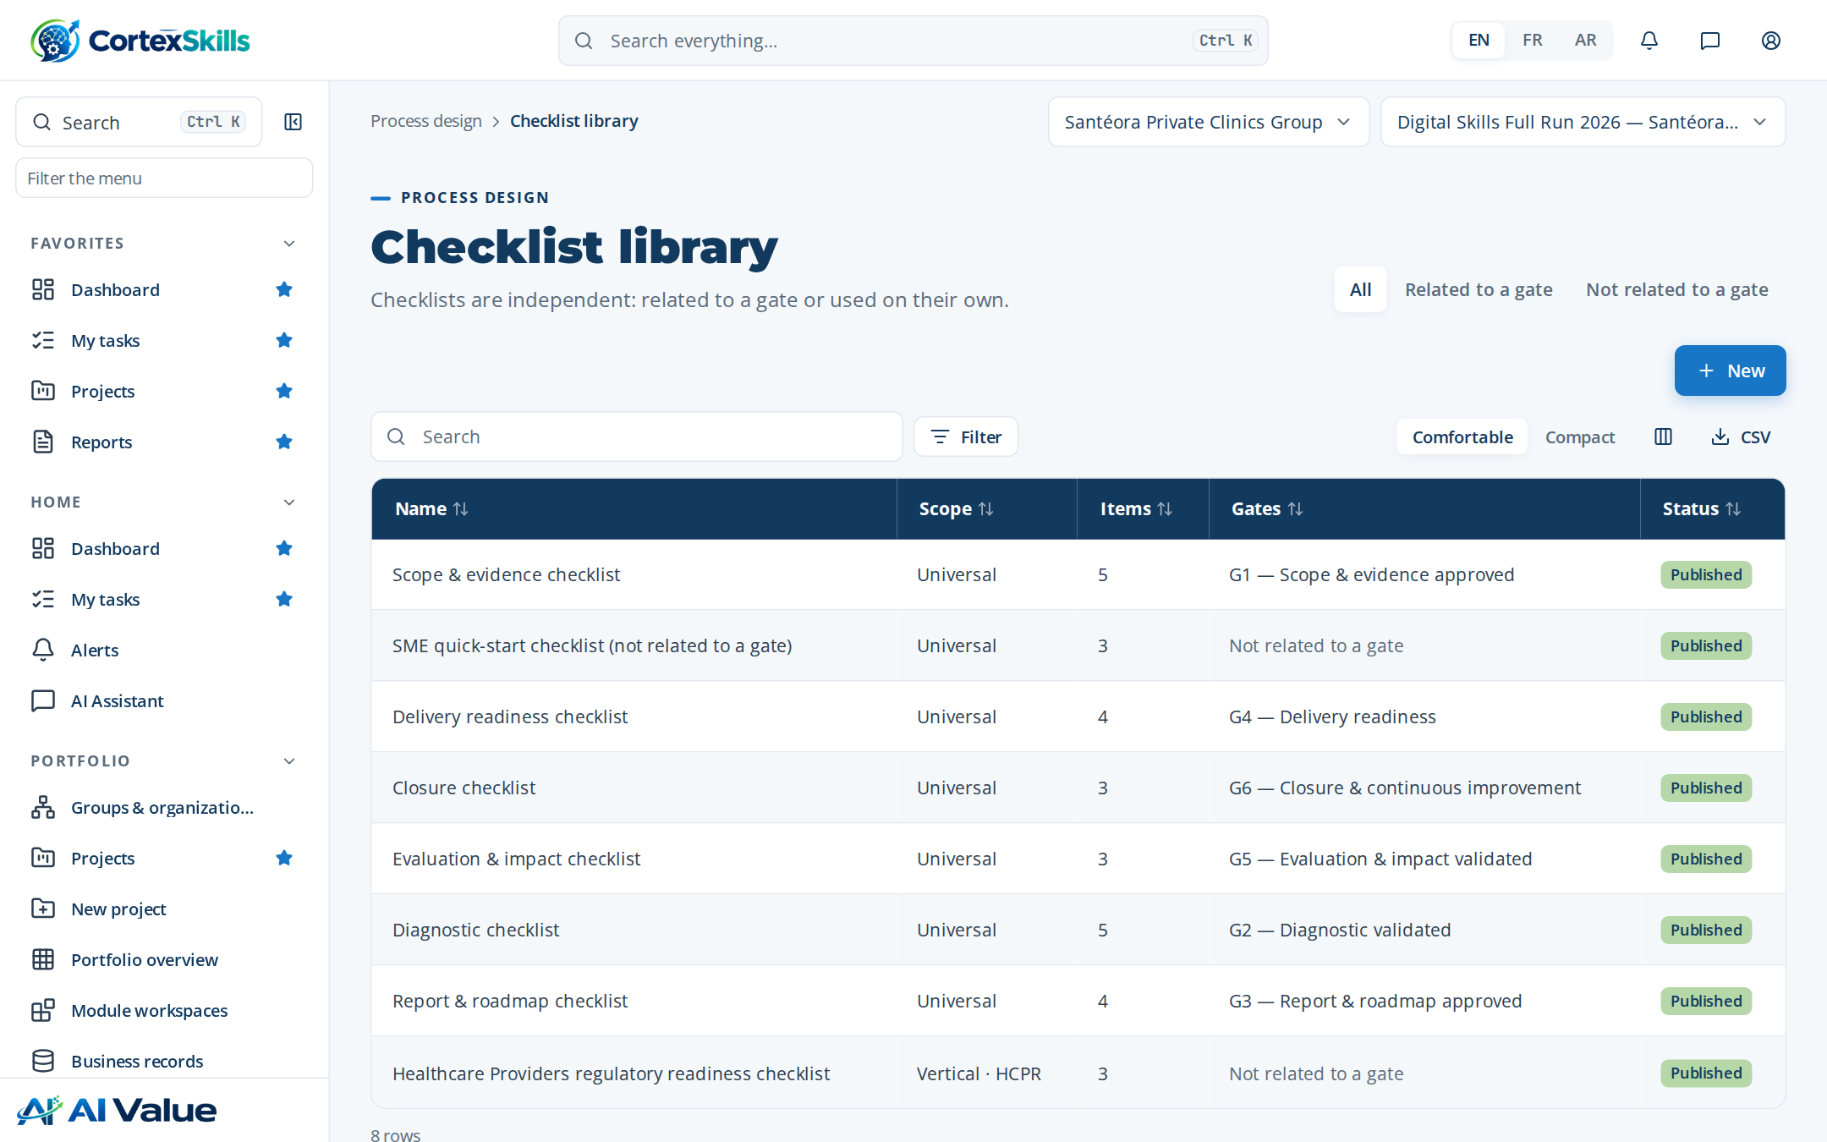
Figure 33 — Checklist library

Information model
Address: /process/model
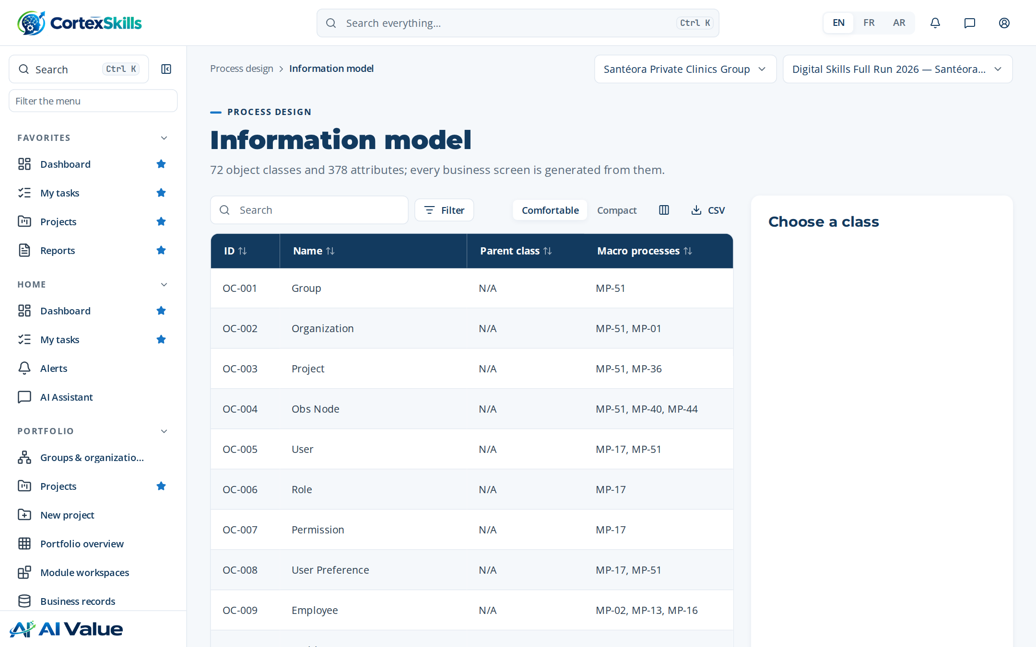
Figure 34 — Information model

5. Governance

Business rules
Address: /gov/rules
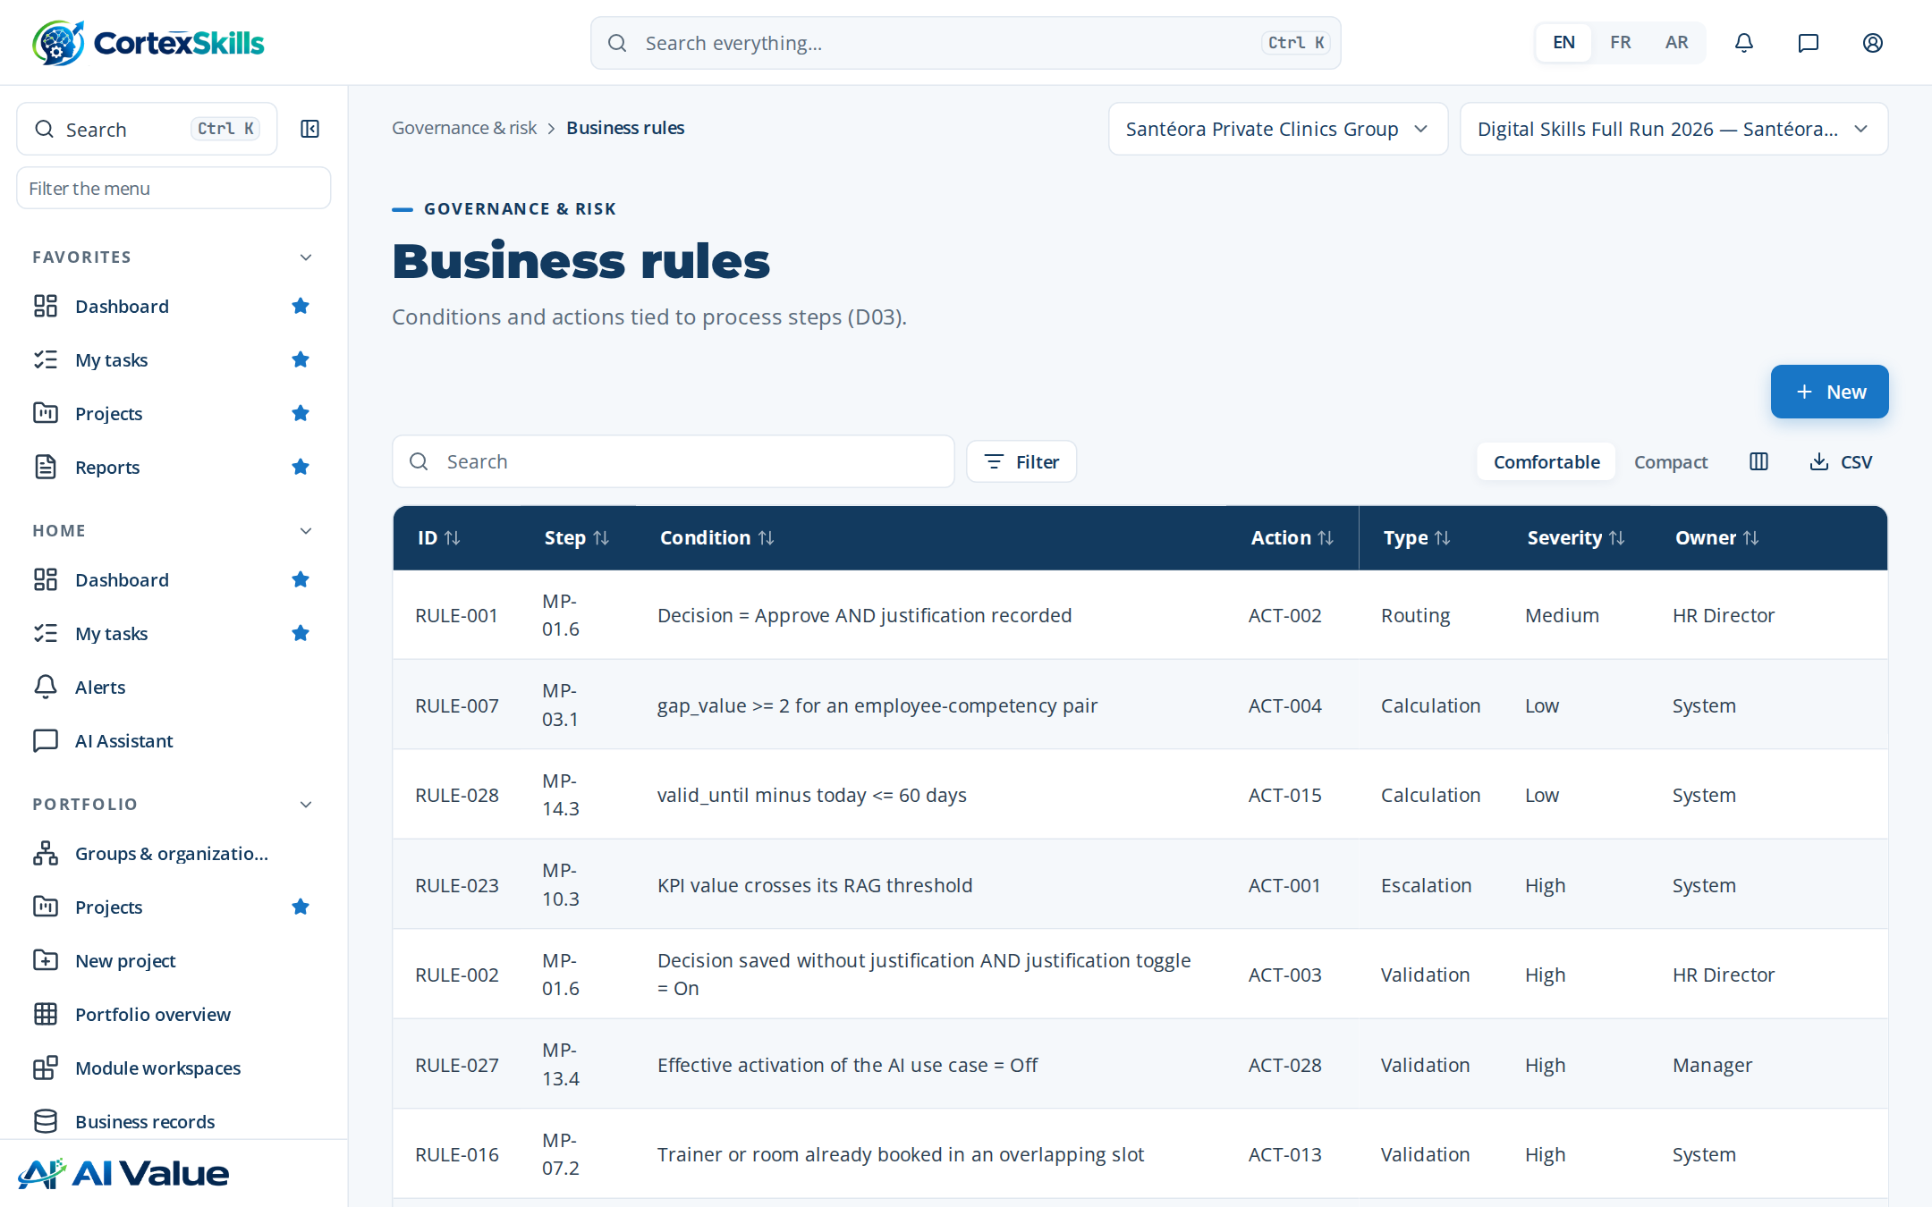
Figure 35 — Business rules

Controls (COSO)
Address: /gov/controls
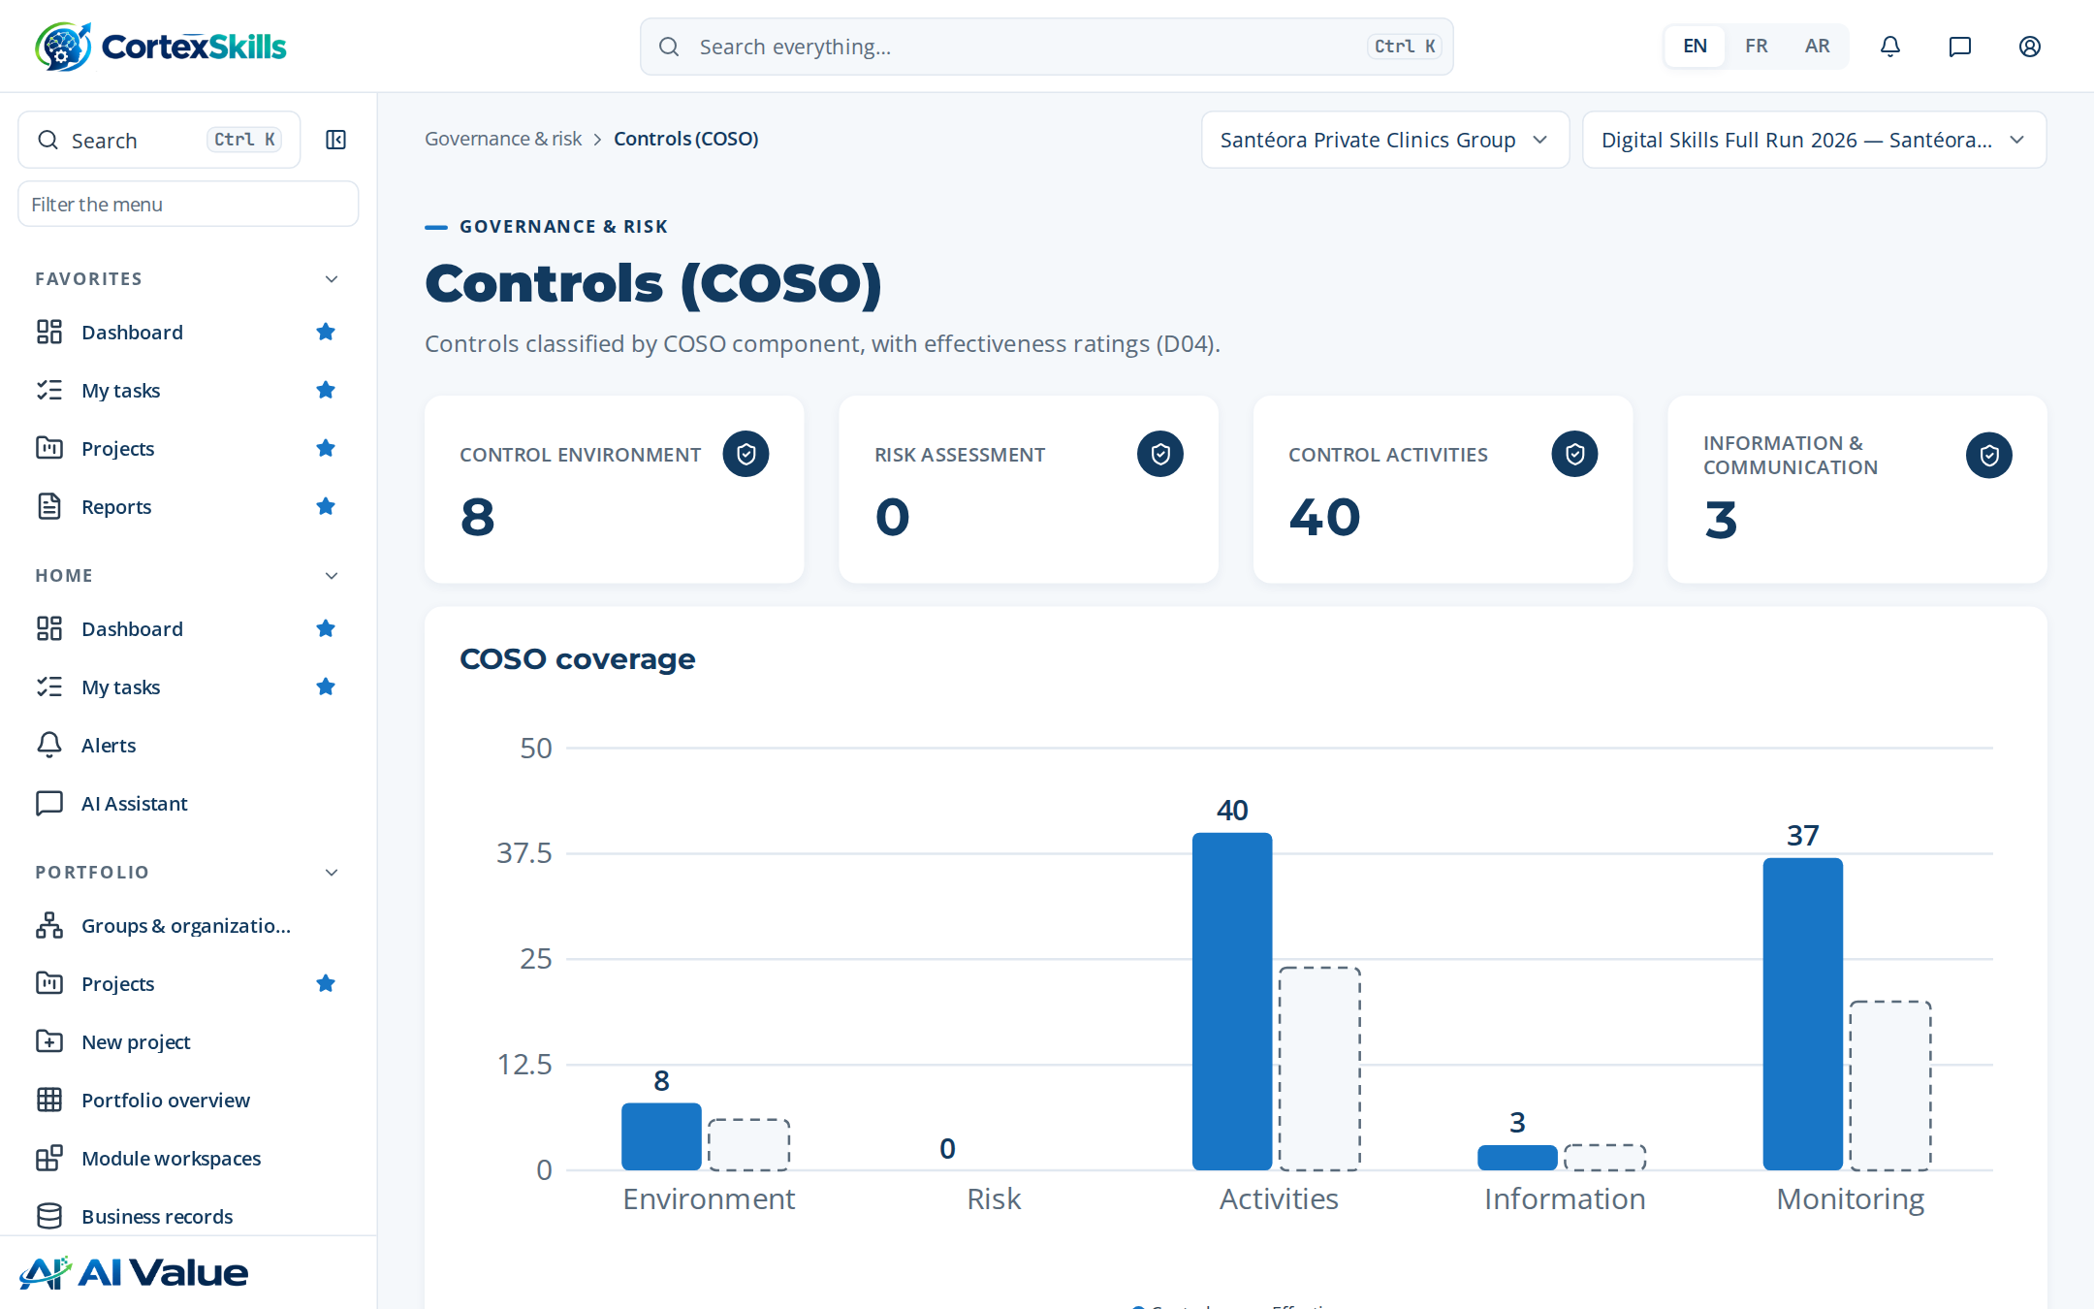
Figure 36 — Controls (COSO)

Risks & opportunities
Address: /gov/risks
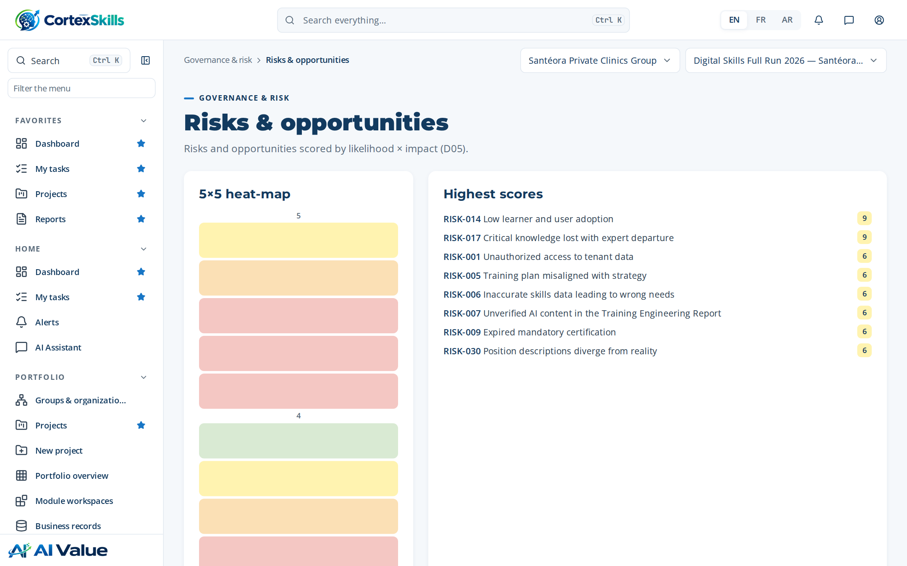
Figure 37 — Risks & opportunities

KPIs
Address: /gov/kpis
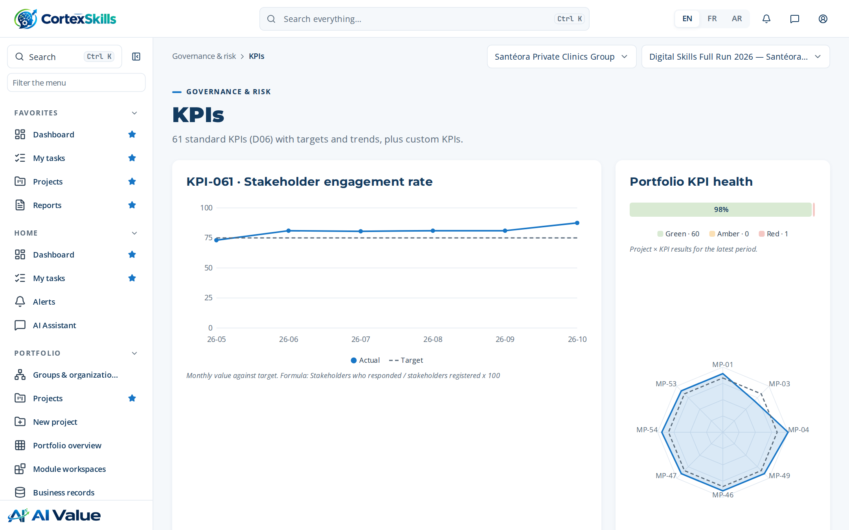
Figure 38 — KPIs

Alert settings
Address: /gov/alert-settings
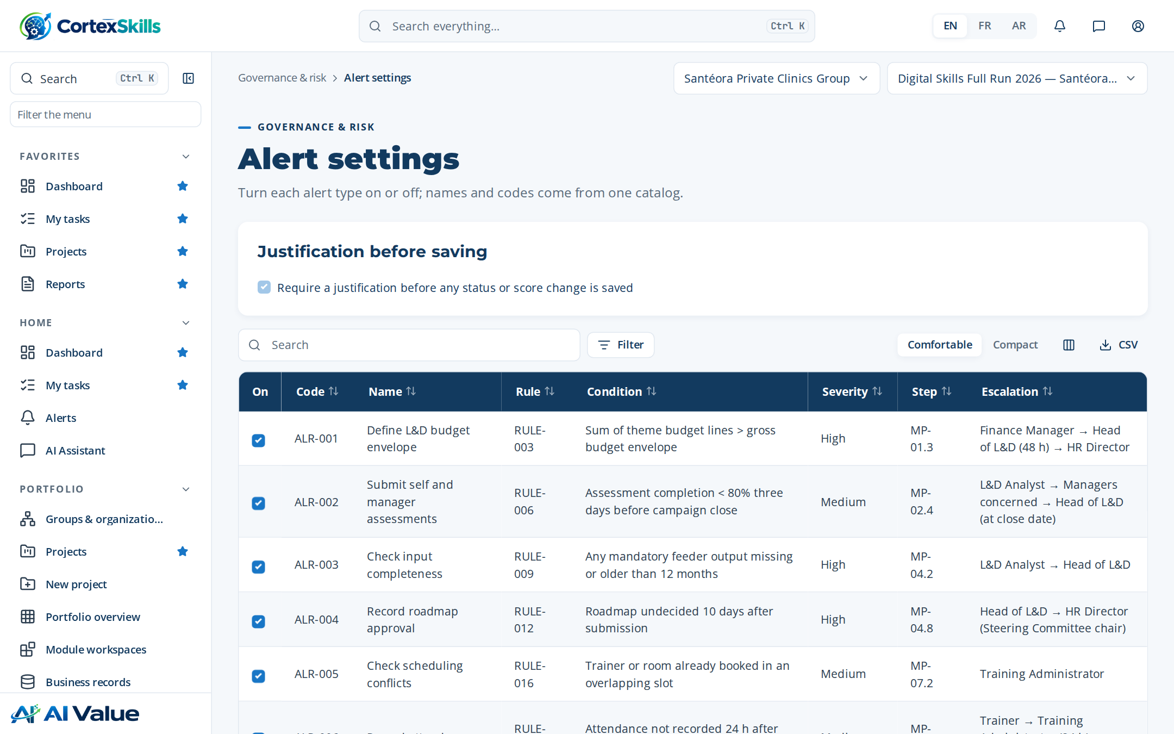
Figure 39 — Alert settings

RACSI
Address: /gov/racsi
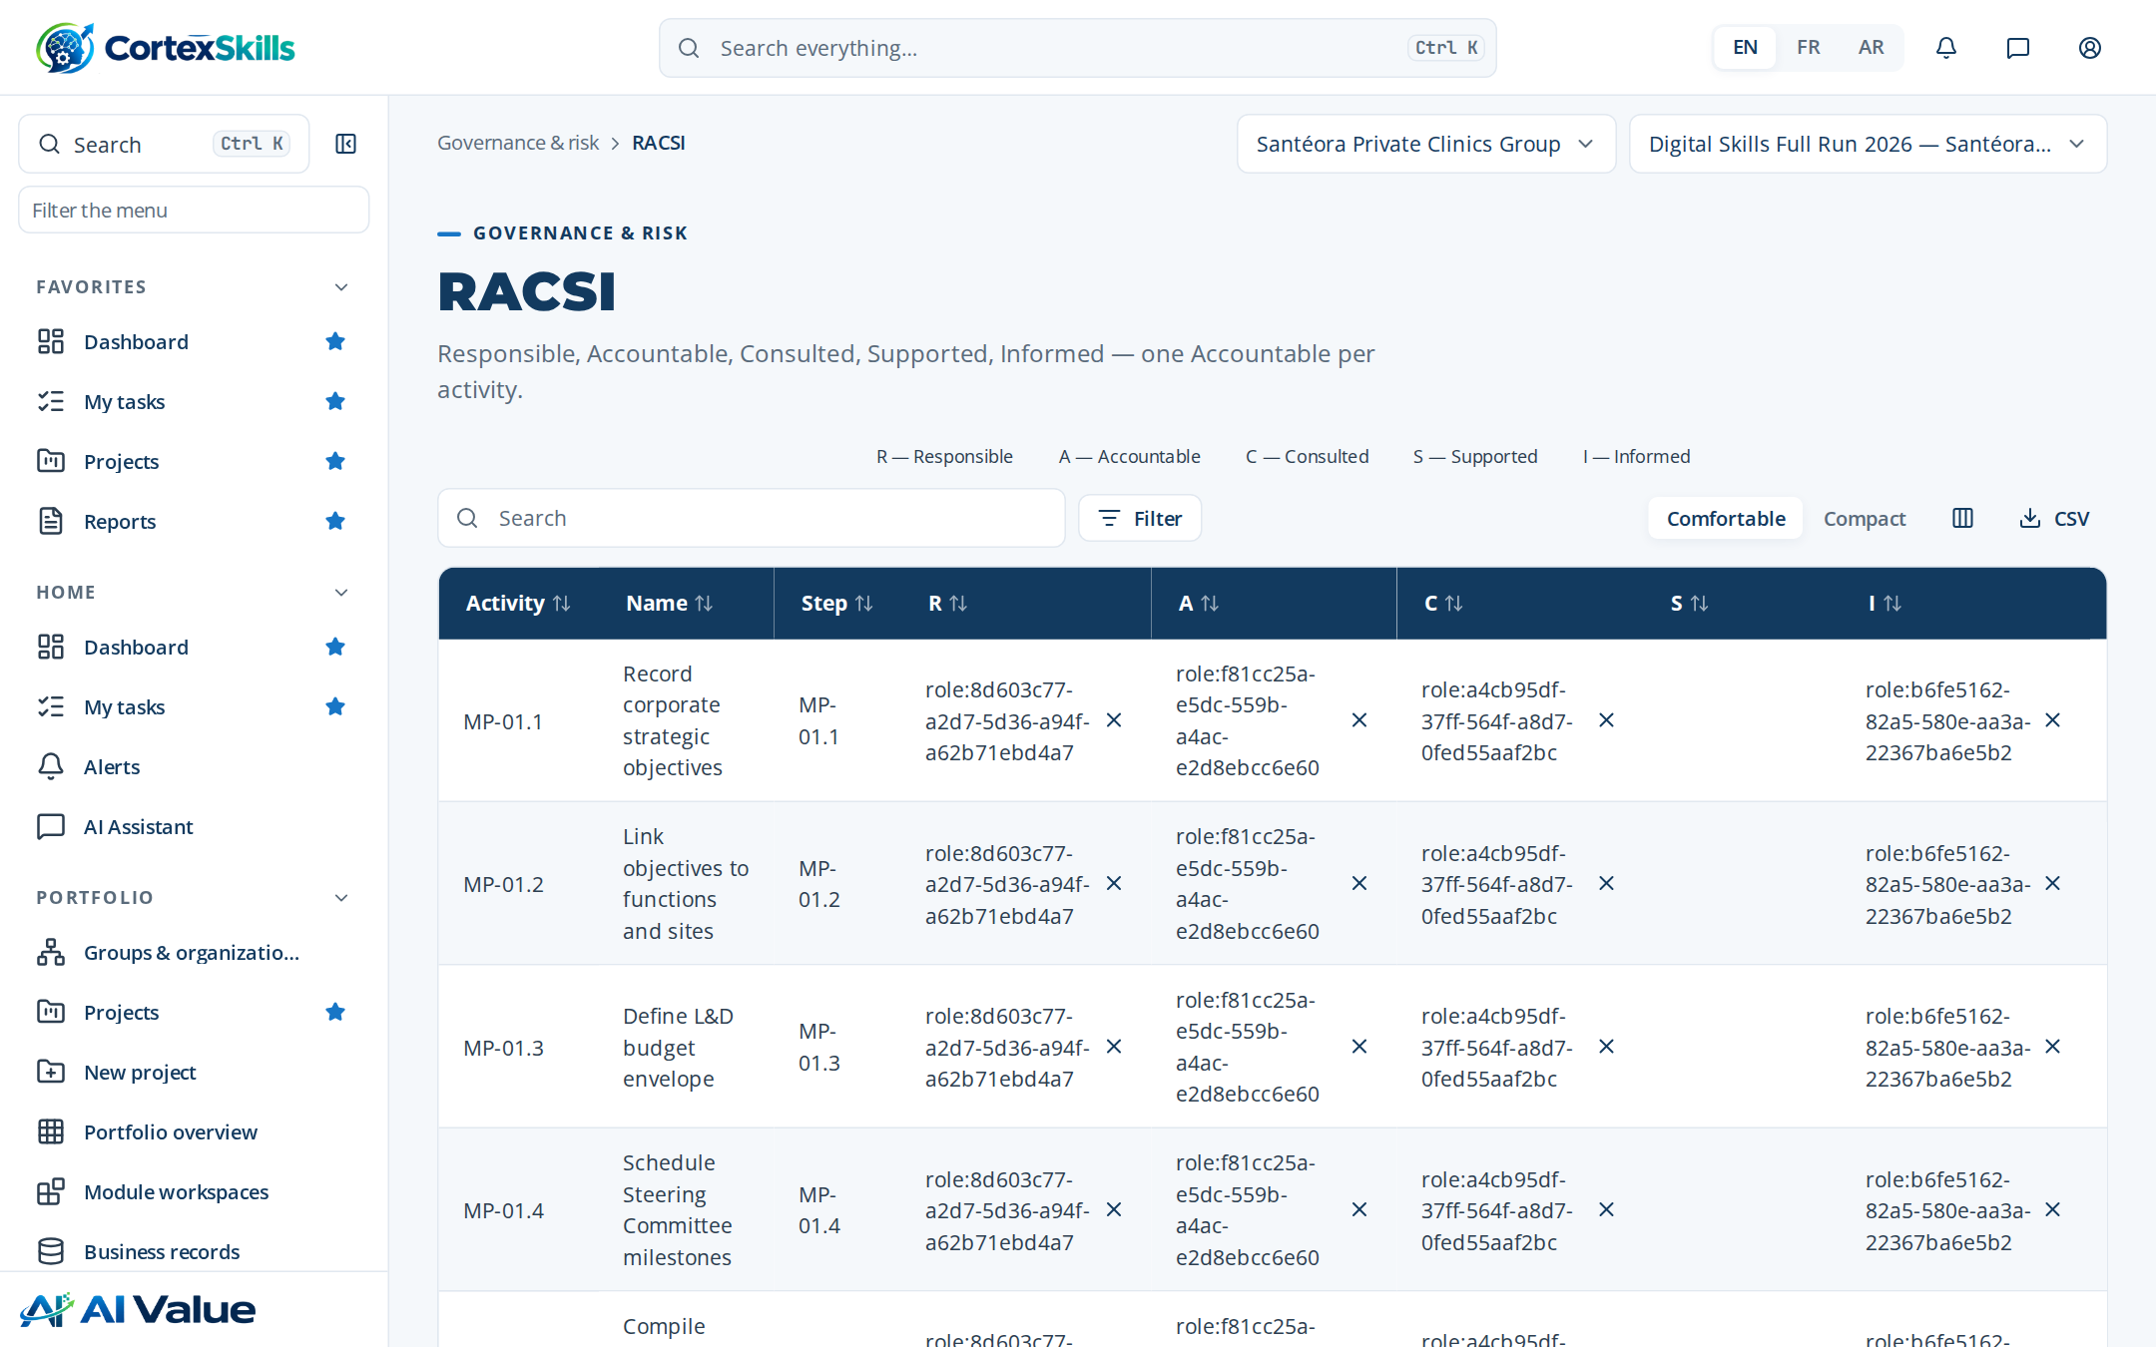
Figure 40 — RACSI

Organization (OBS)
Address: /gov/obs
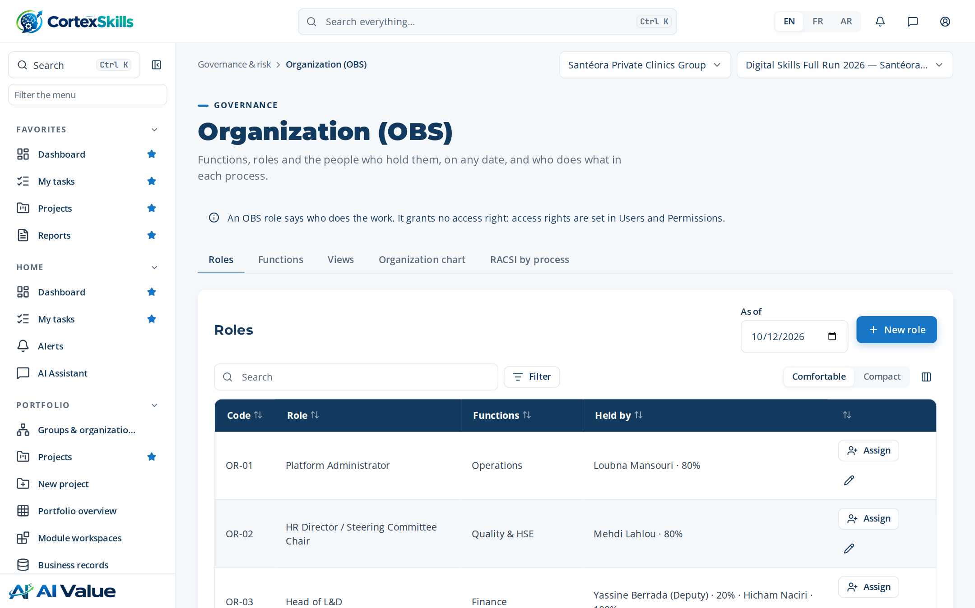
Figure 41 — Organization (OBS)

Registers
Address: /registers
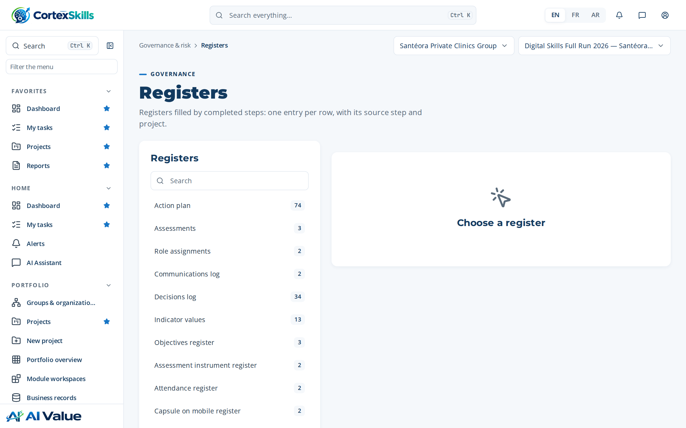
Figure 42 — Registers

Audits
Address: /gov/audits
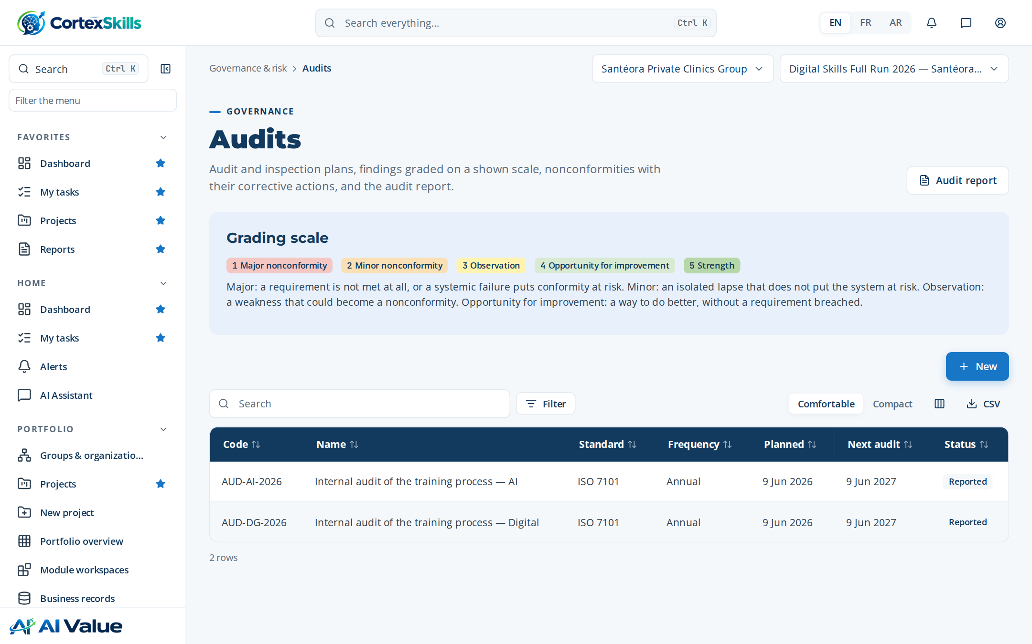
Figure 43 — Audits

Return on experience
Address: /gov/rex
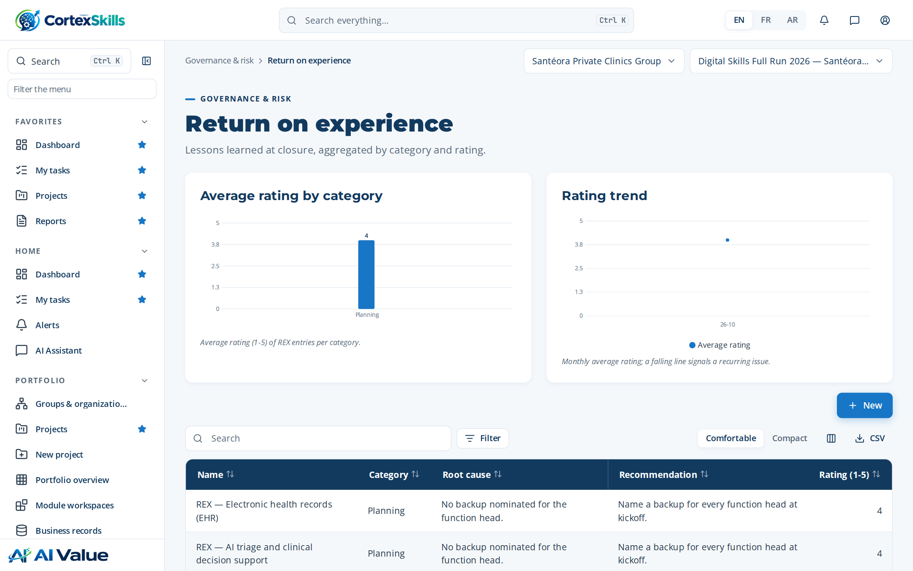
Figure 44 — Return on experience

WBS & Gantt
Address: /gov/gantt
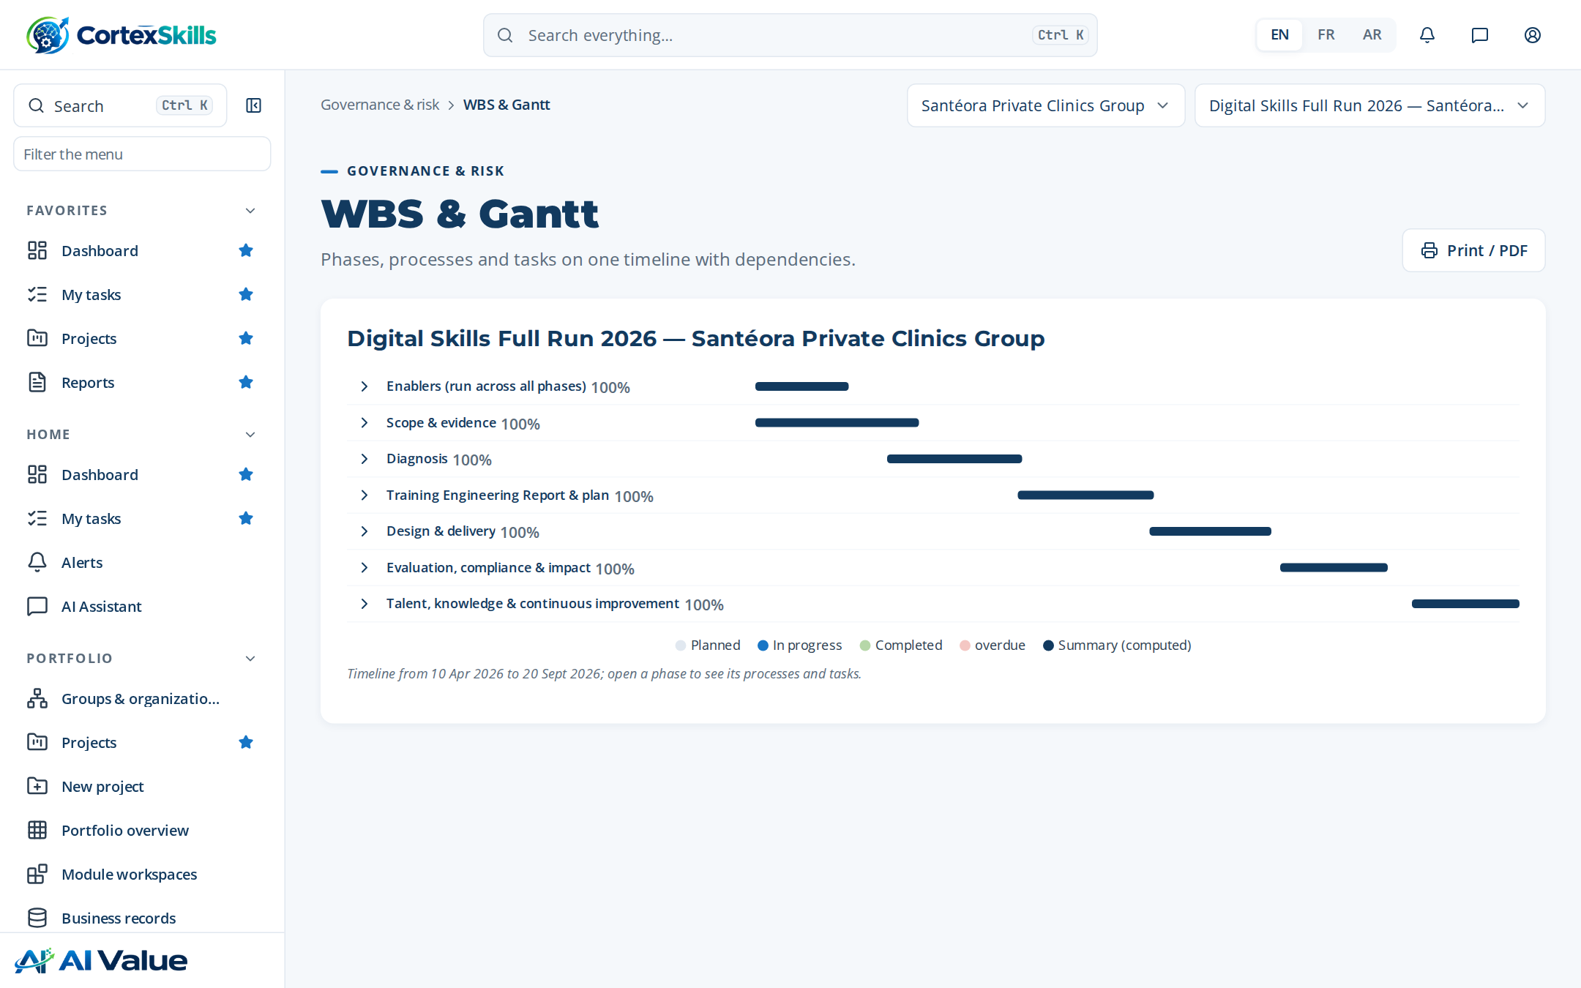
Figure 45 — WBS & Gantt

6. Artificial intelligence

AI use cases
Address: /ai/use-cases
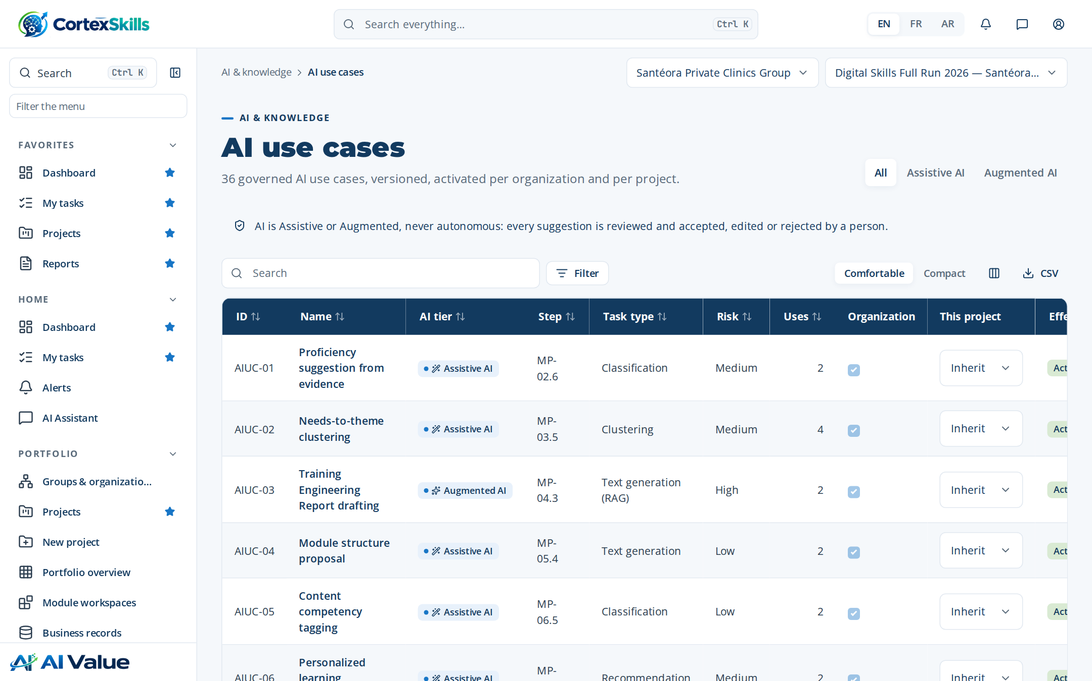
Figure 46 — AI use cases

AI usage log
Address: /ai/usage
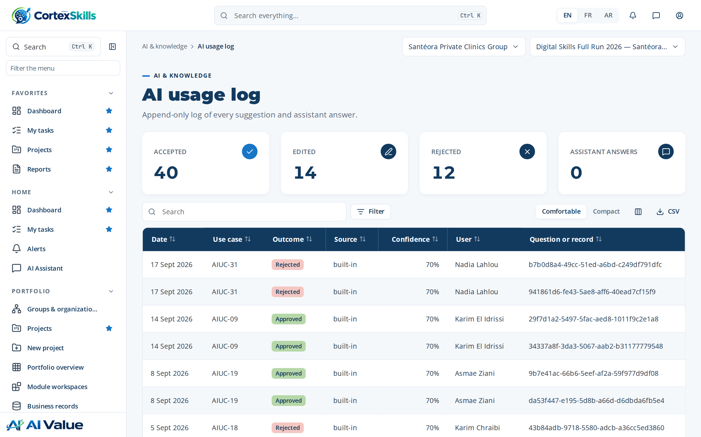
Figure 47 — AI usage log

Knowledge base
Address: /ai/kb
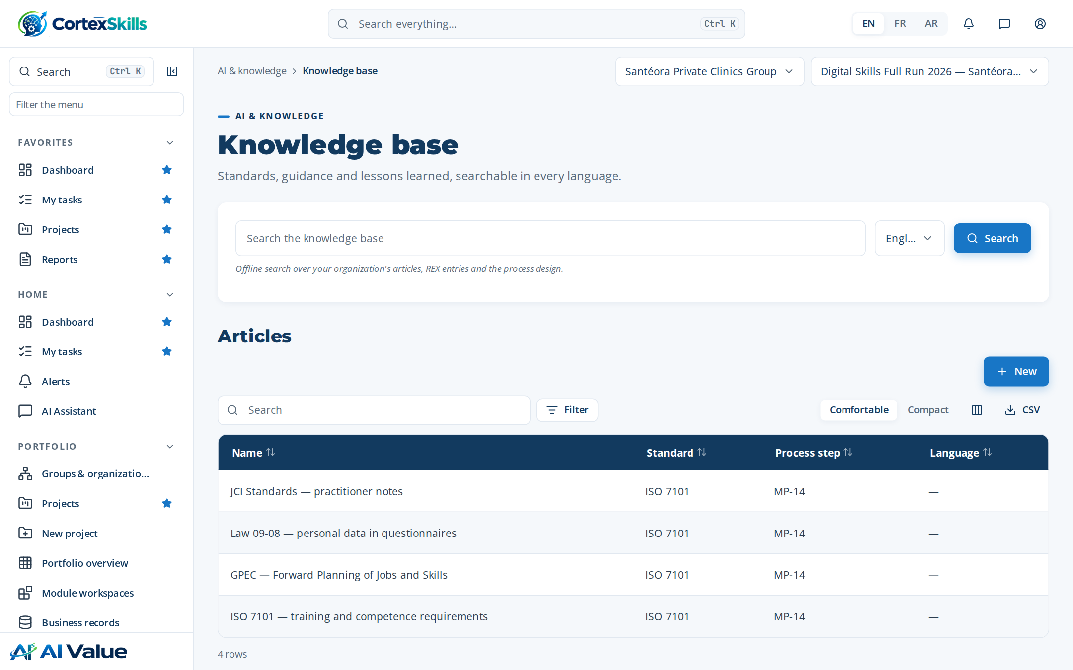
Figure 48 — Knowledge base

Live AI model
Address: /ai/model
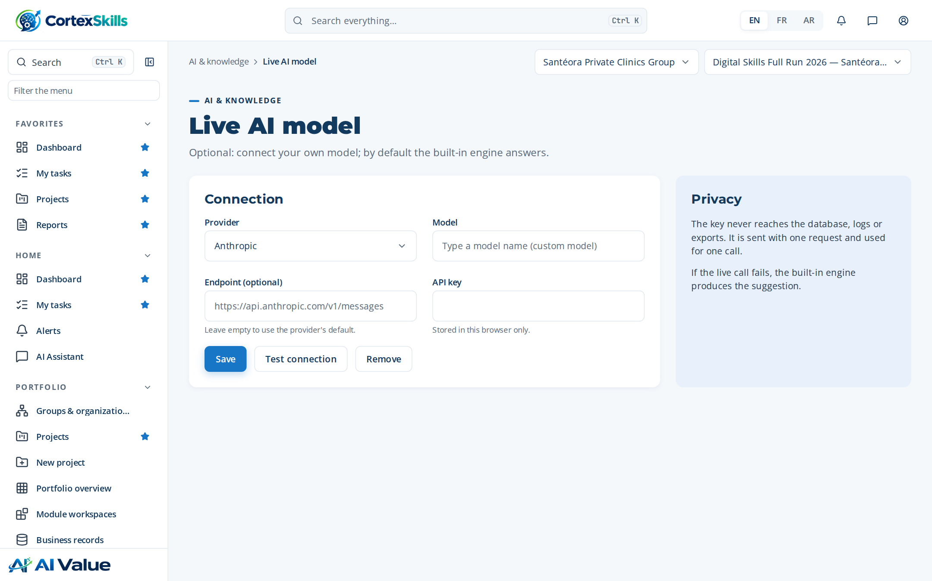
Figure 49 — Live AI model

AI settings
Address: /ai/settings
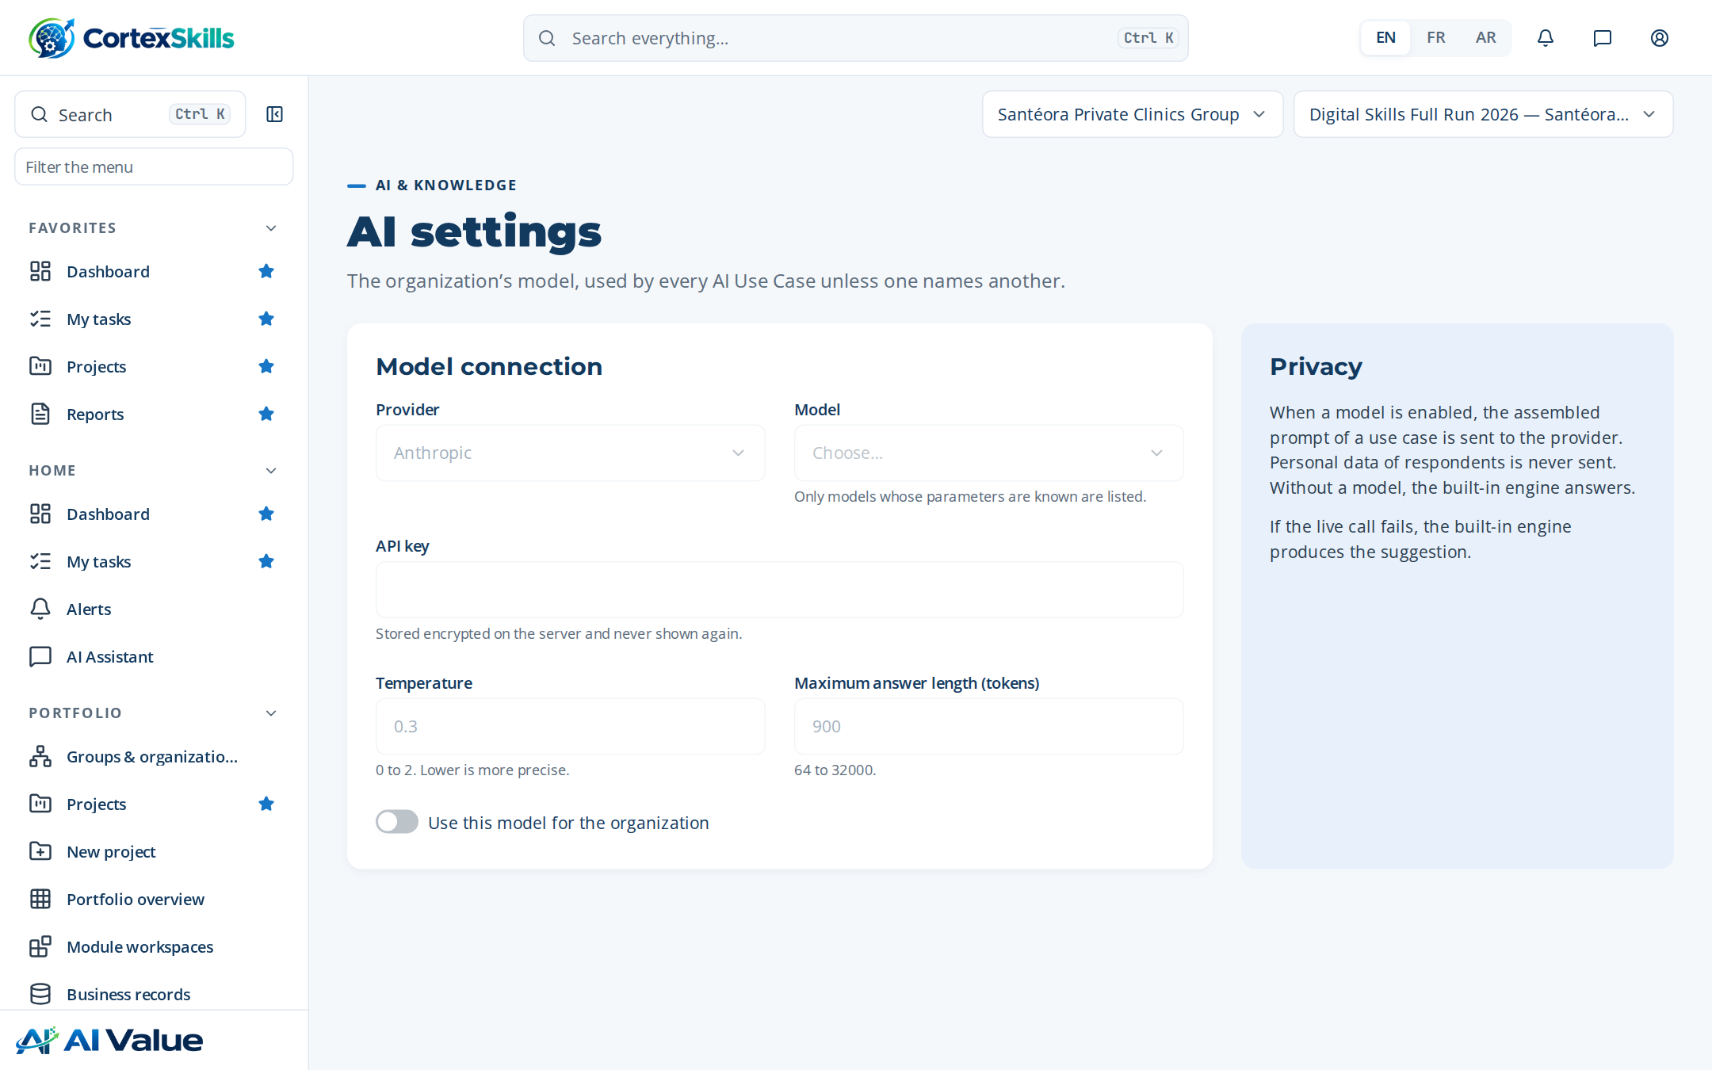
Figure 50 — AI settings

7. Reports and documents

Reports
Address: /reports
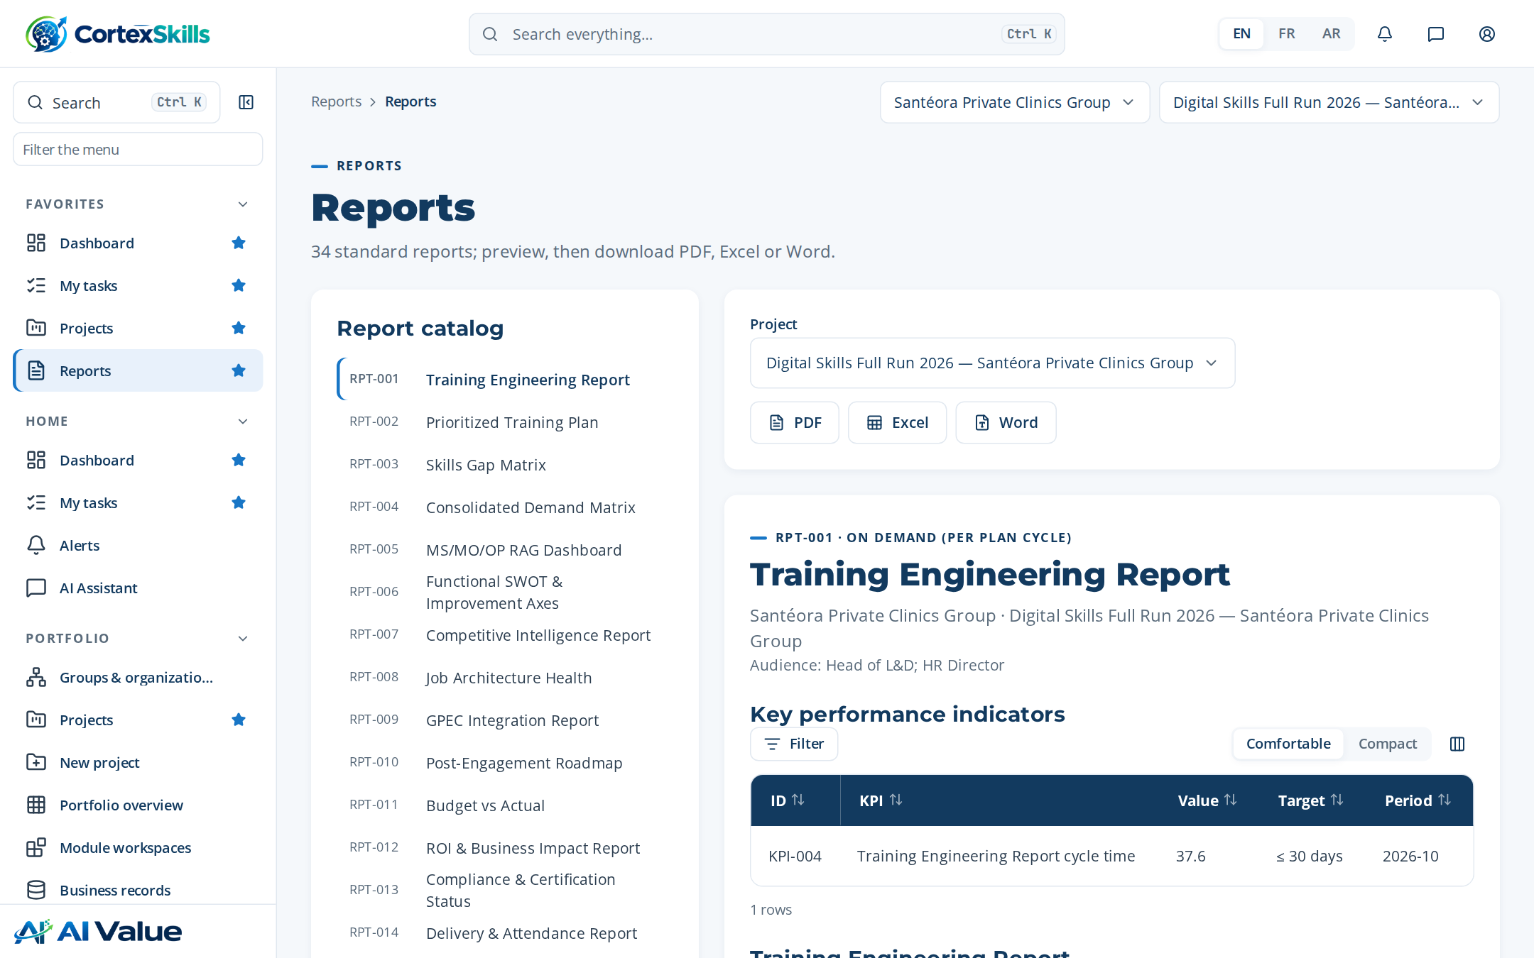
Figure 51 — Reports

Documents
Address: /documents
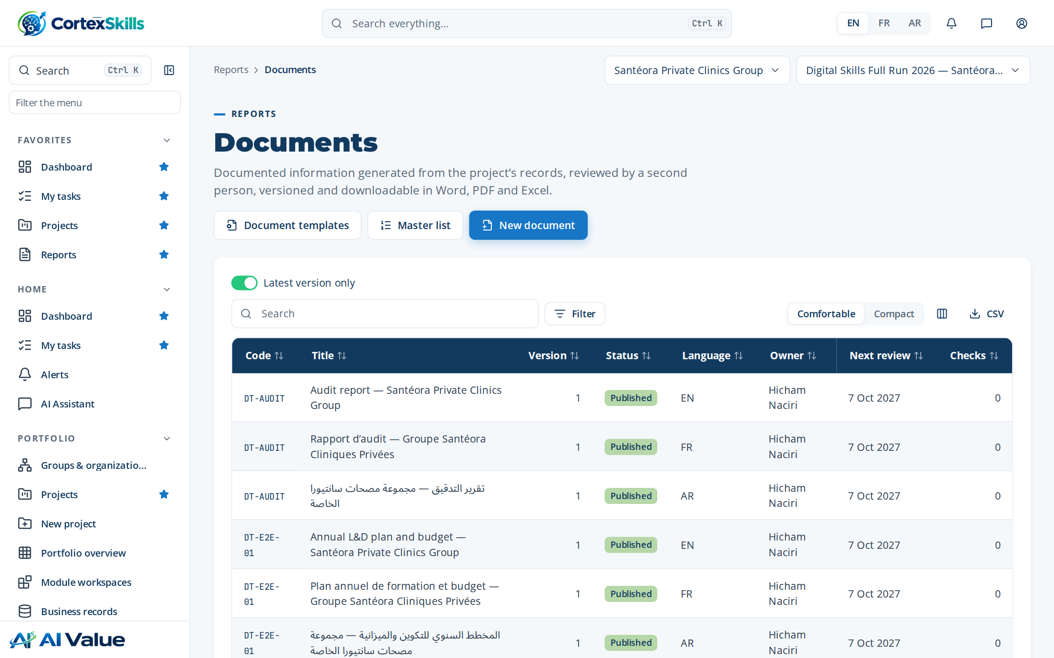
Figure 52 — Documents

Training Engineering Report and Training Plan — Santéora Private Clinics Group
Address: /documents/:id
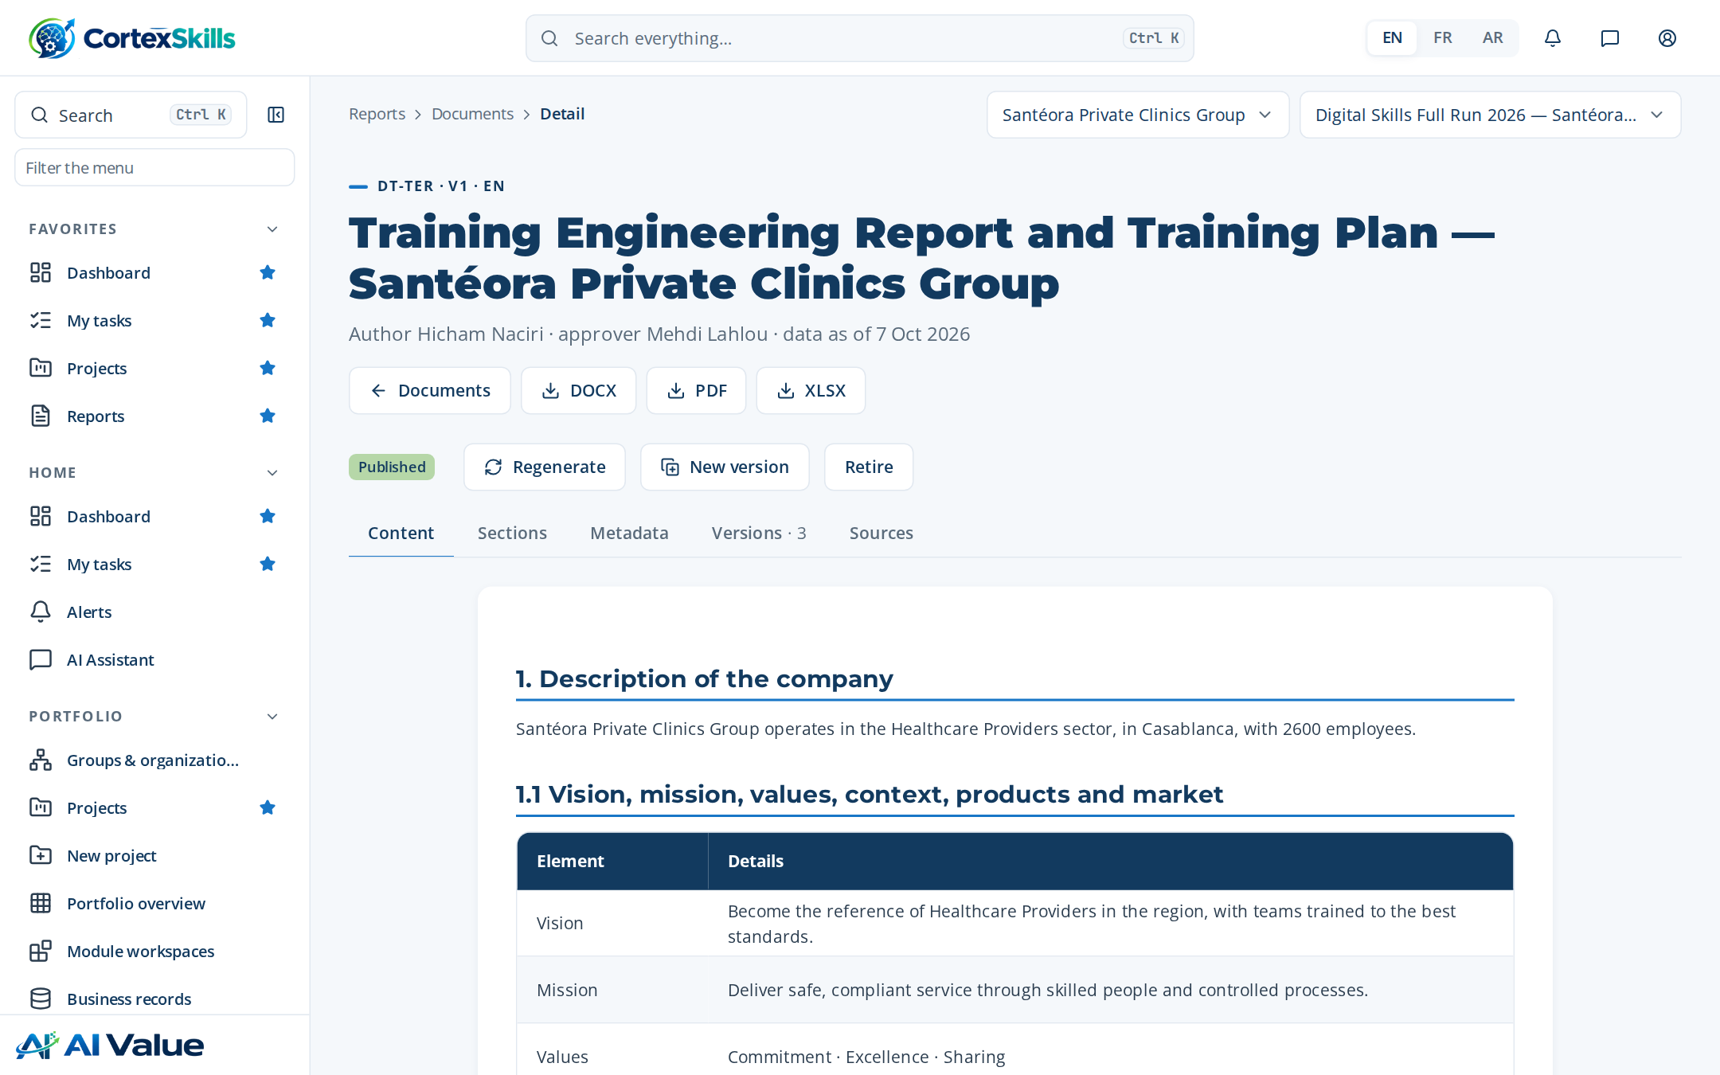
Figure 53 — Training Engineering Report and Training Plan — Santéora Private Clinics Group

Training plan with detailed agendas — Santéora Private Clinics Group
Address: /documents/:id
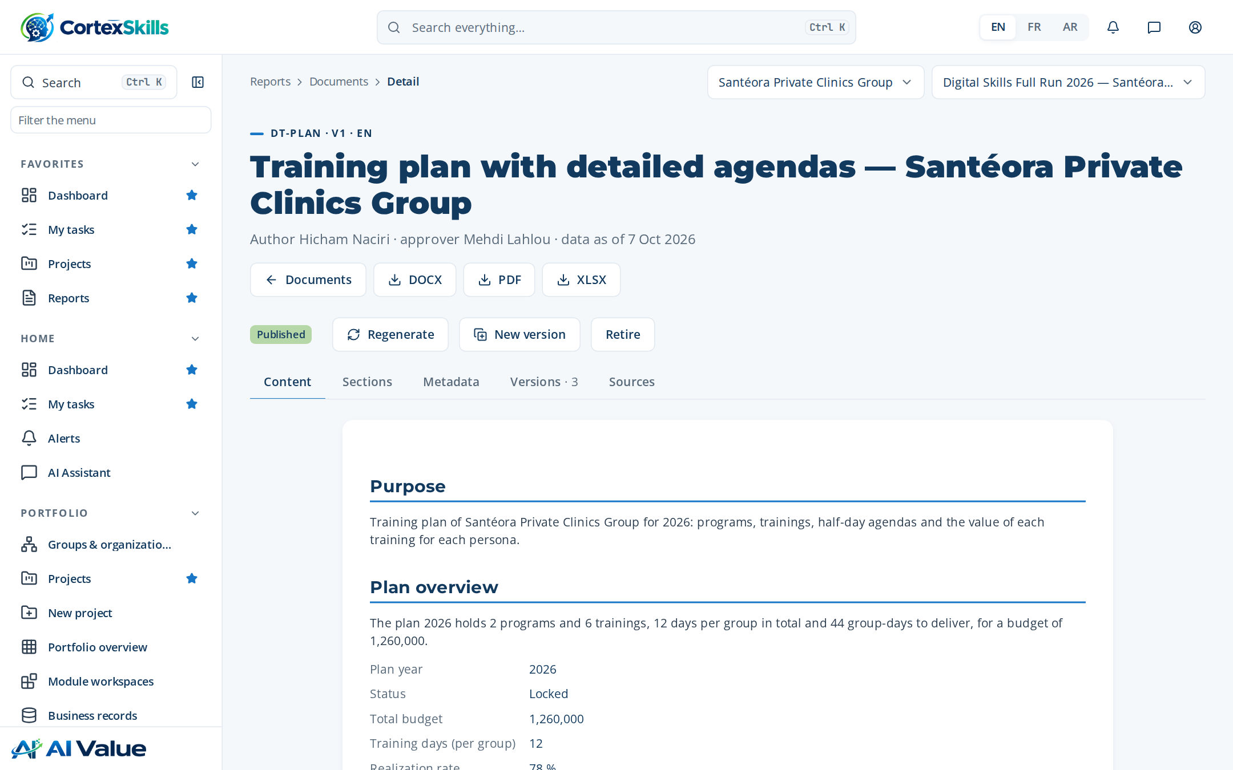
Figure 54 — Training plan with detailed agendas — Santéora Private Clinics Group

Document templates
Address: /documents/templates
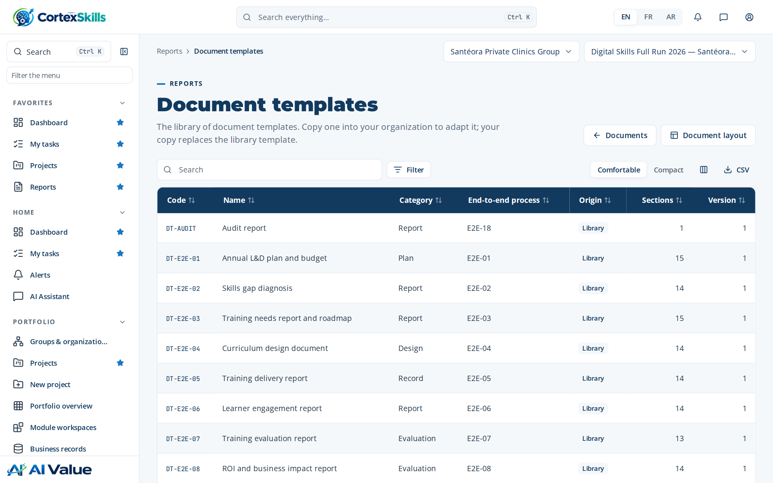
Figure 55 — Document templates

Document layout
Address: /documents/layout
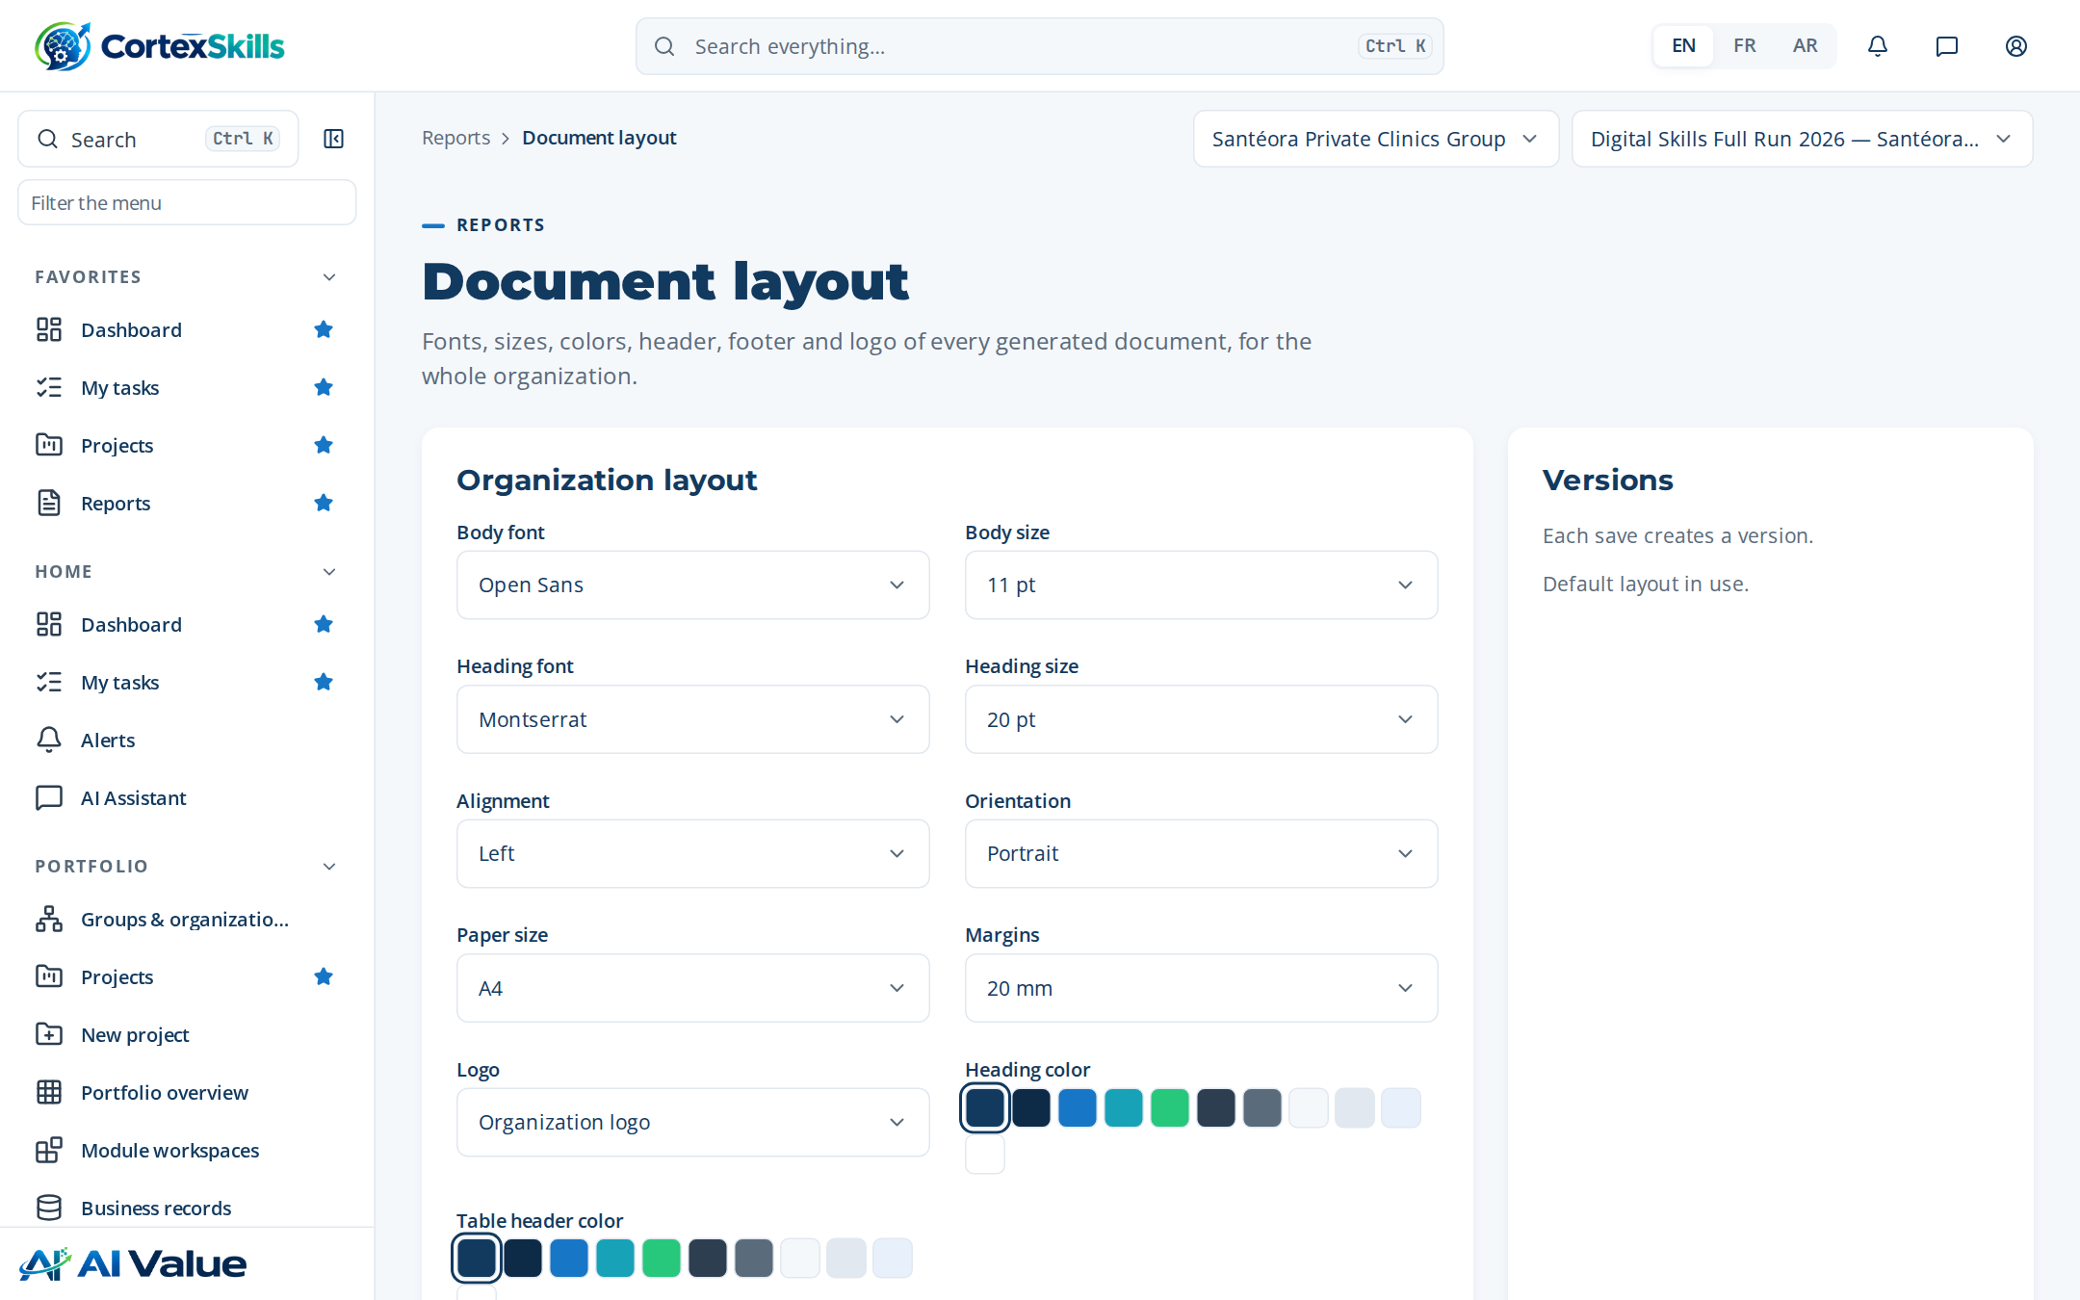
Figure 56 — Document layout

Master list
Address: /documents/master-list
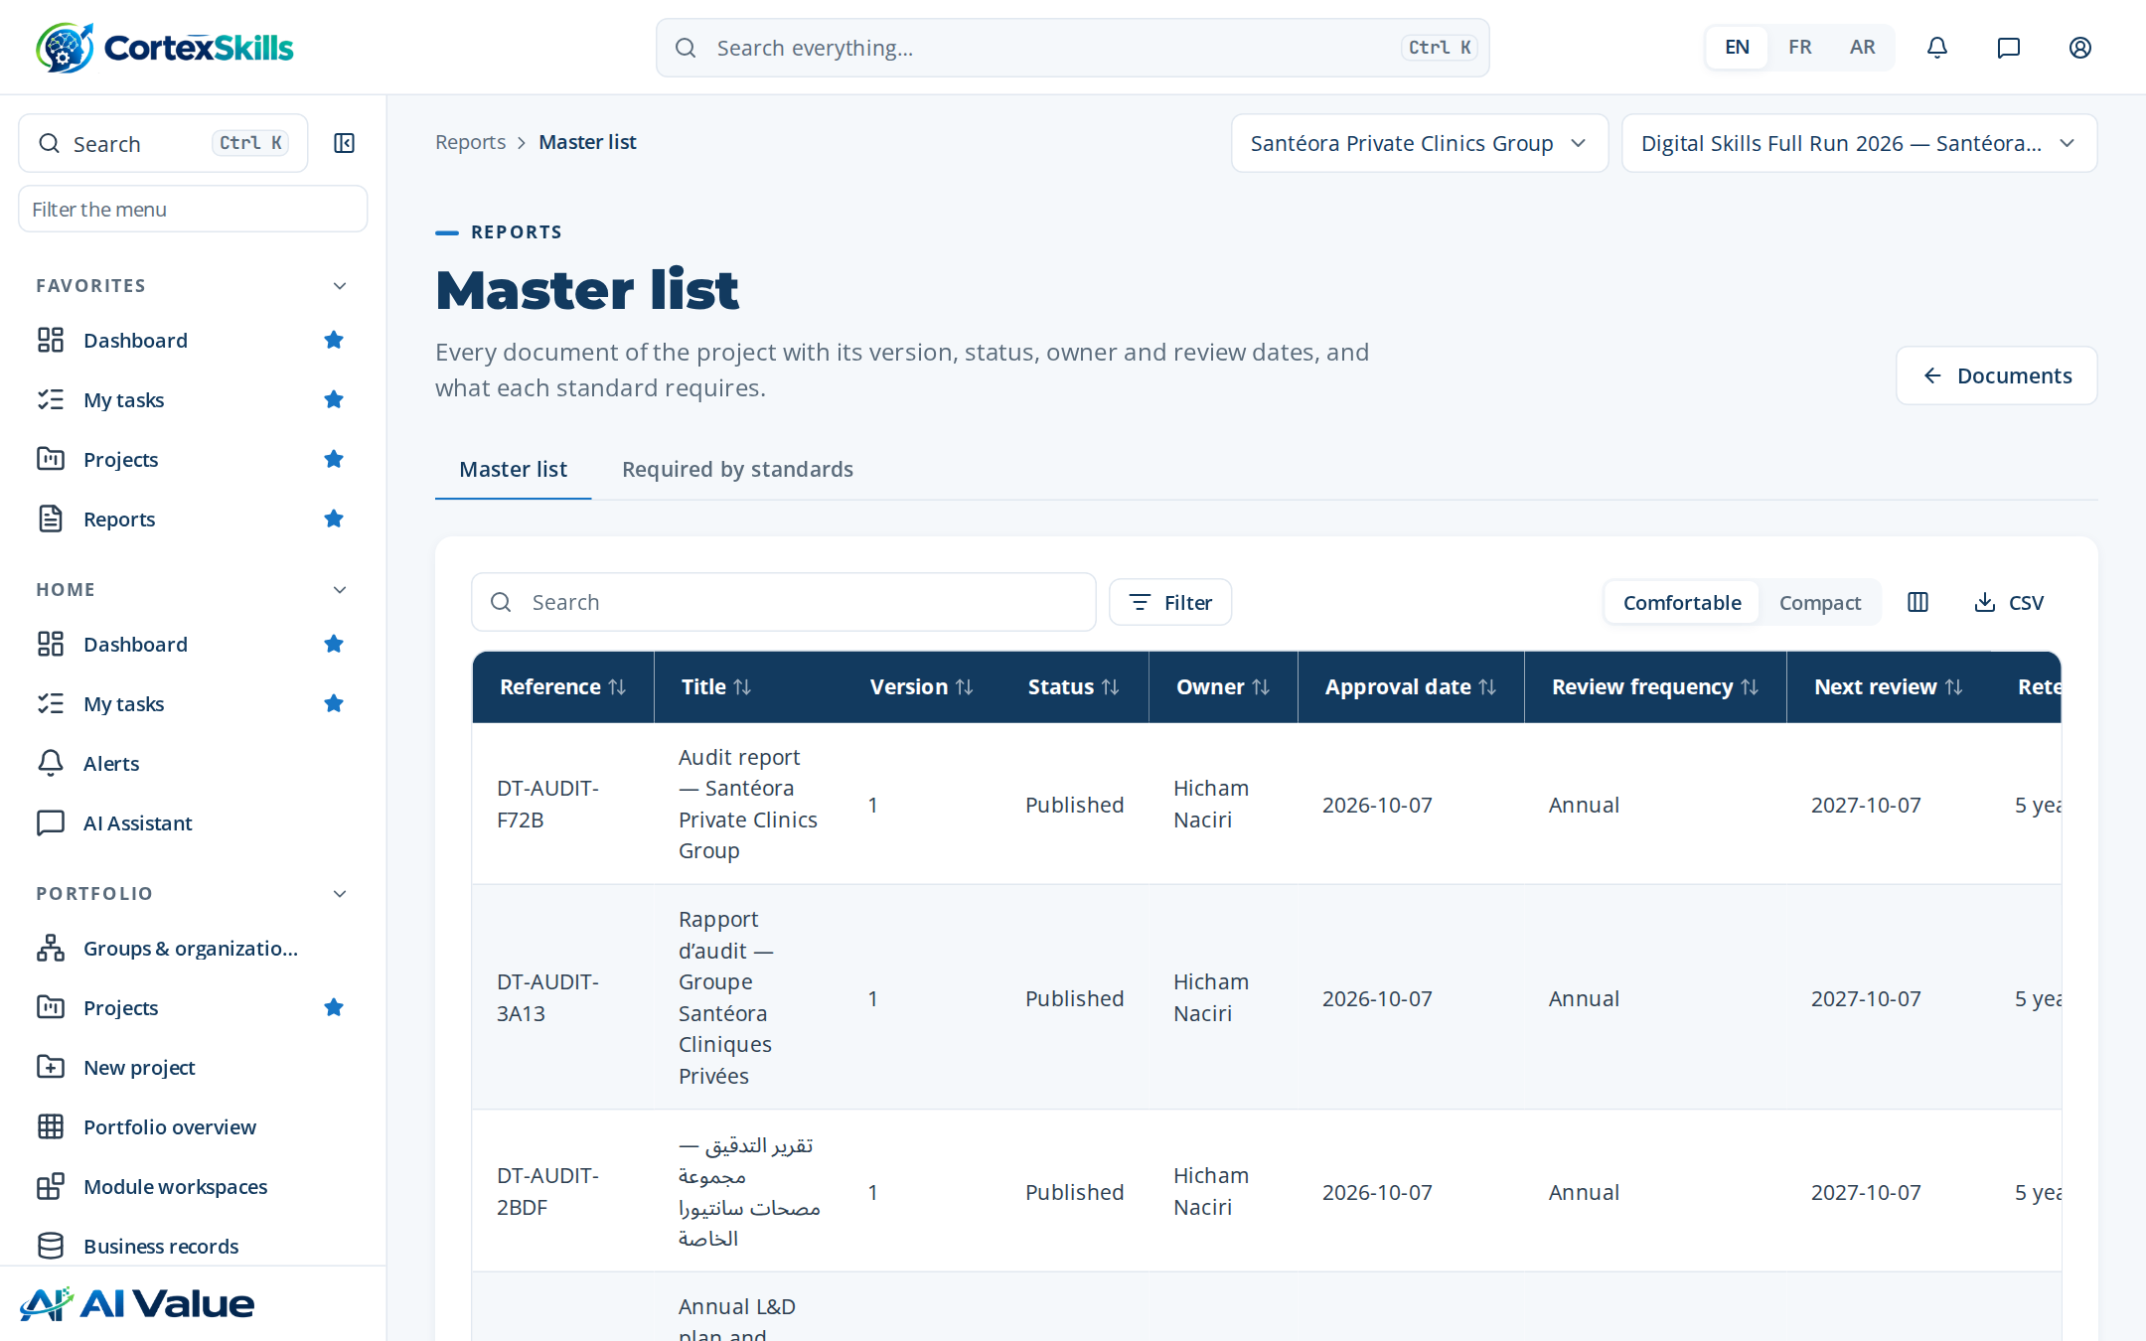
Figure 57 — Master list

Internal benchmarking
Address: /benchmark
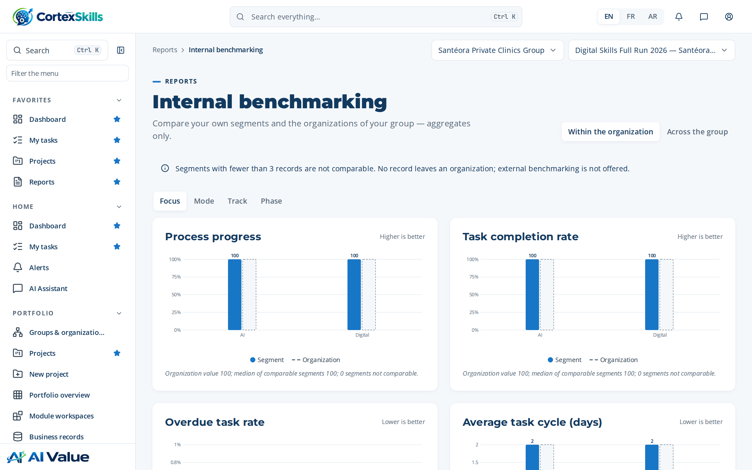
Figure 58 — Internal benchmarking

8. Administration

Users
Address: /admin/users
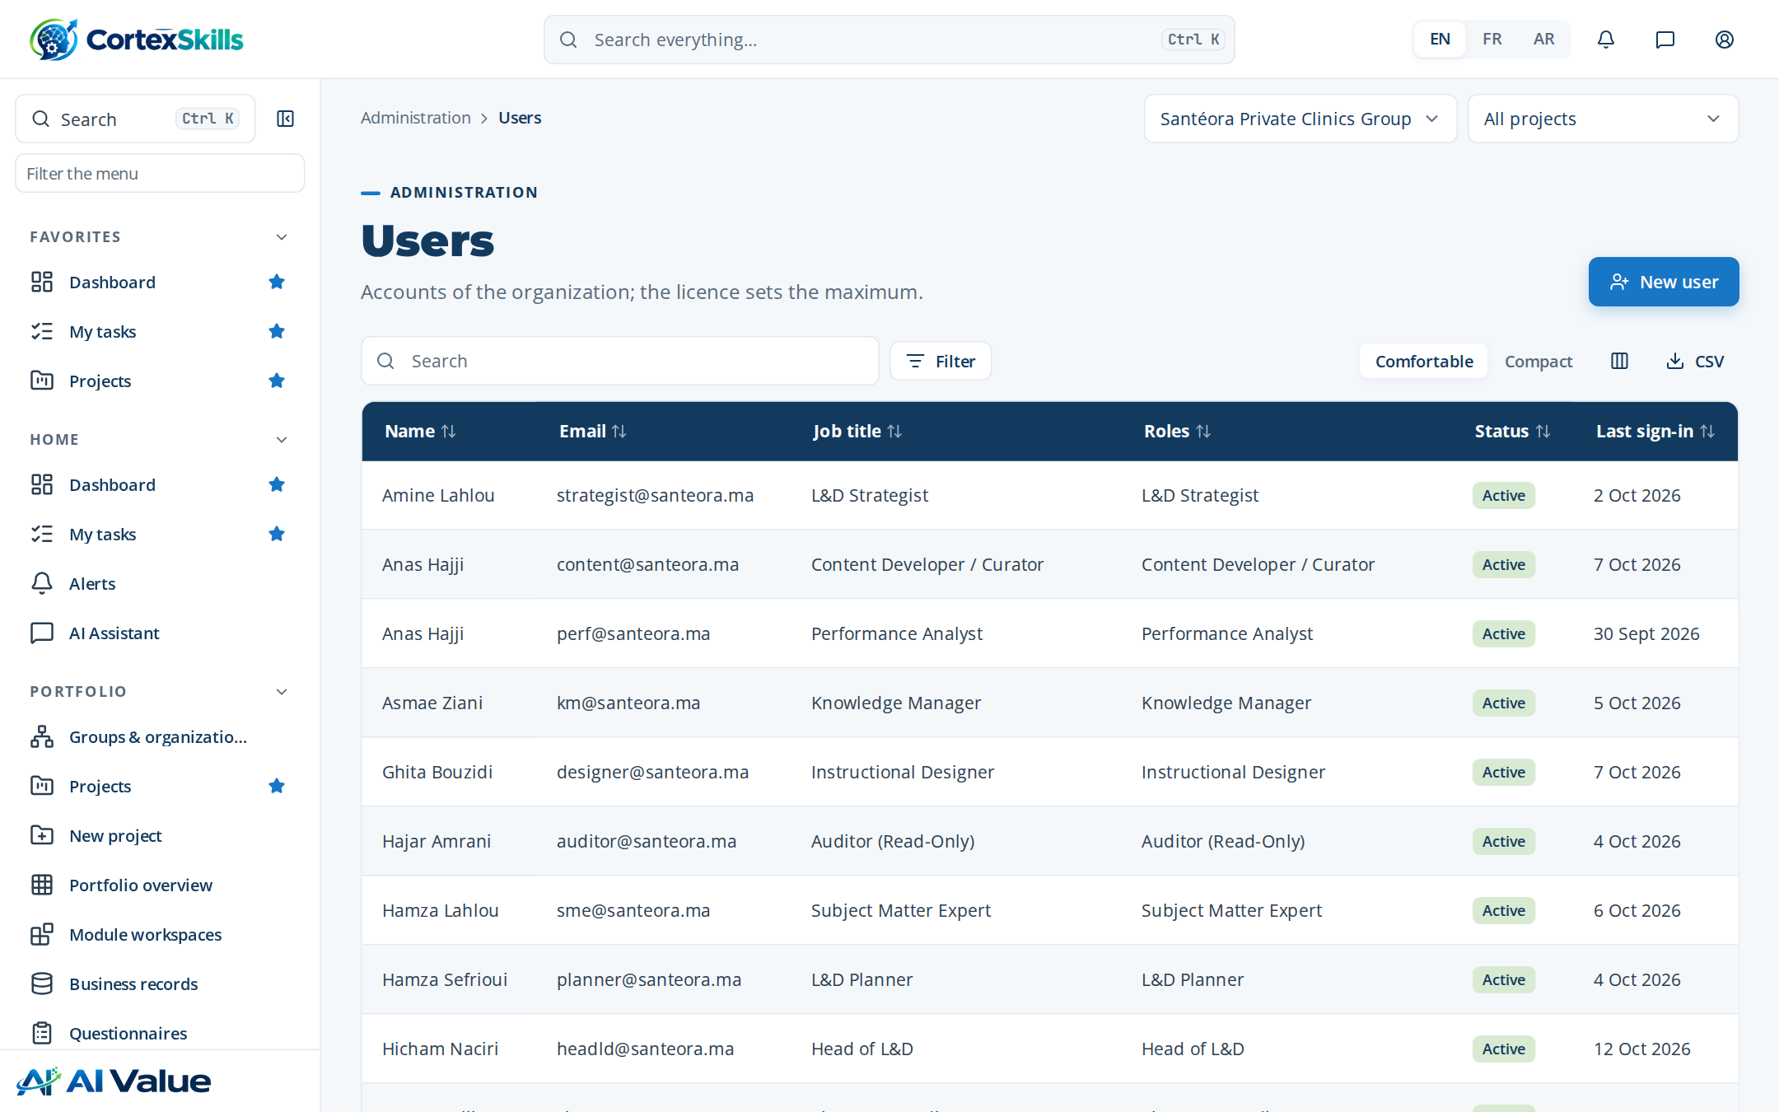
Figure 59 — Users

Permission matrix
Address: /admin/permissions
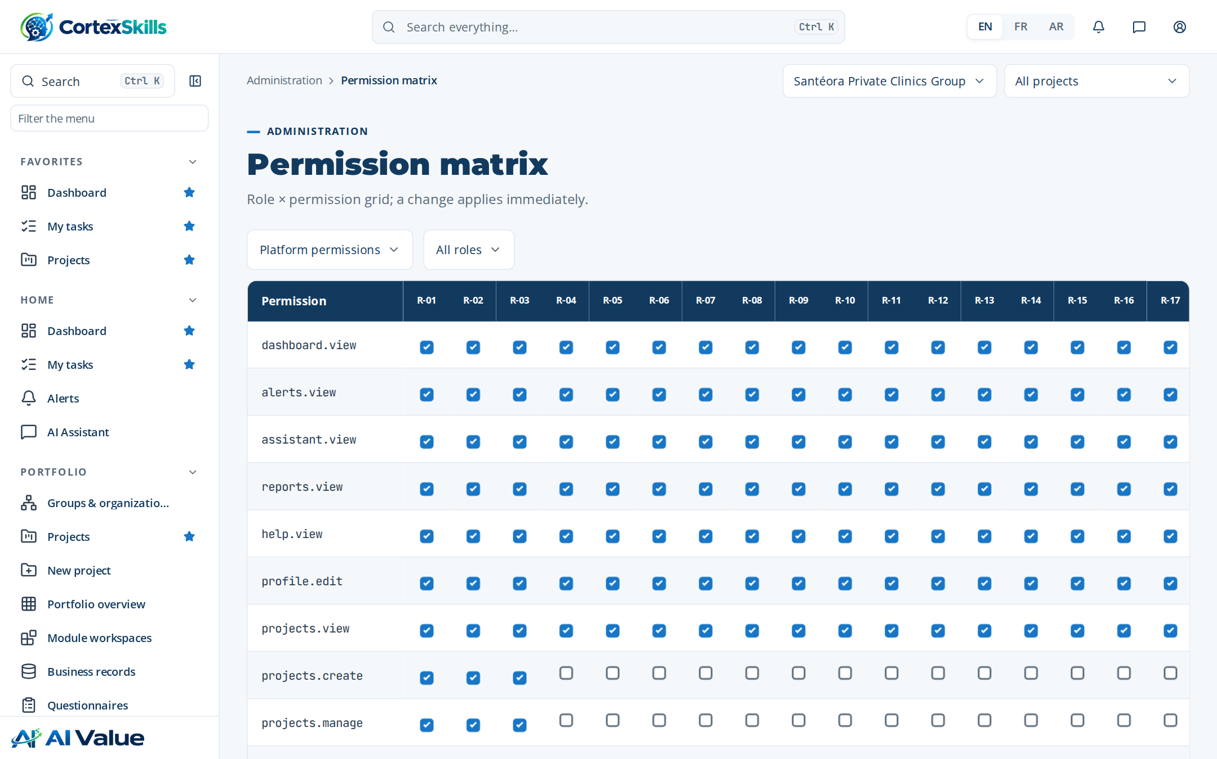
Figure 60 — Permission matrix

Configuration & licence
Address: /admin/config
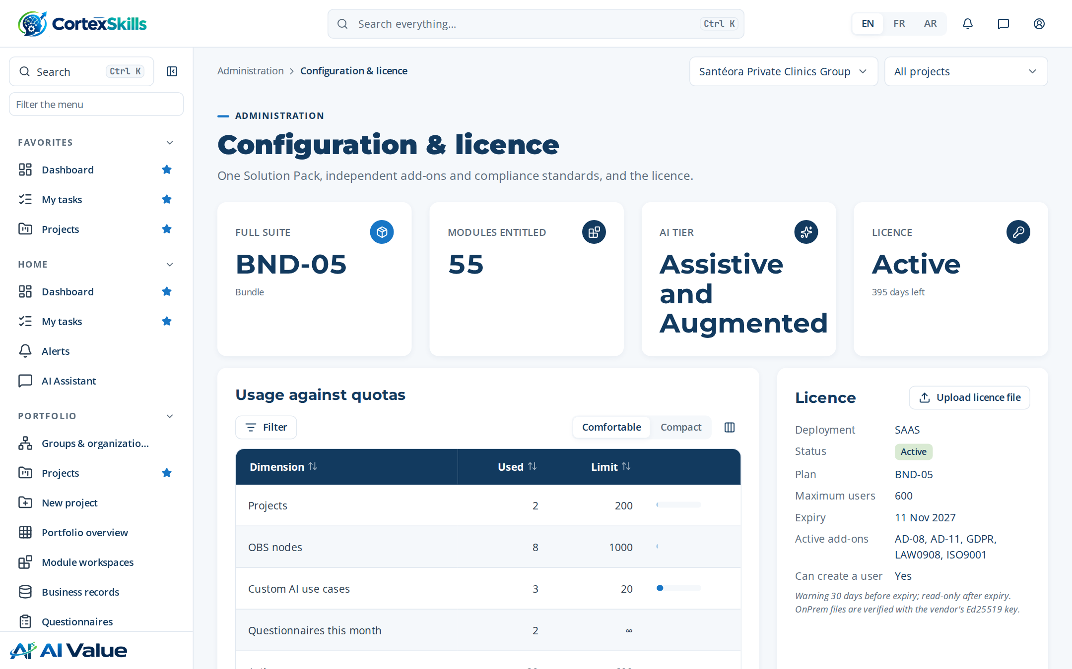
Figure 61 — Configuration & licence

Packs & pricing
Address: /admin/pricing
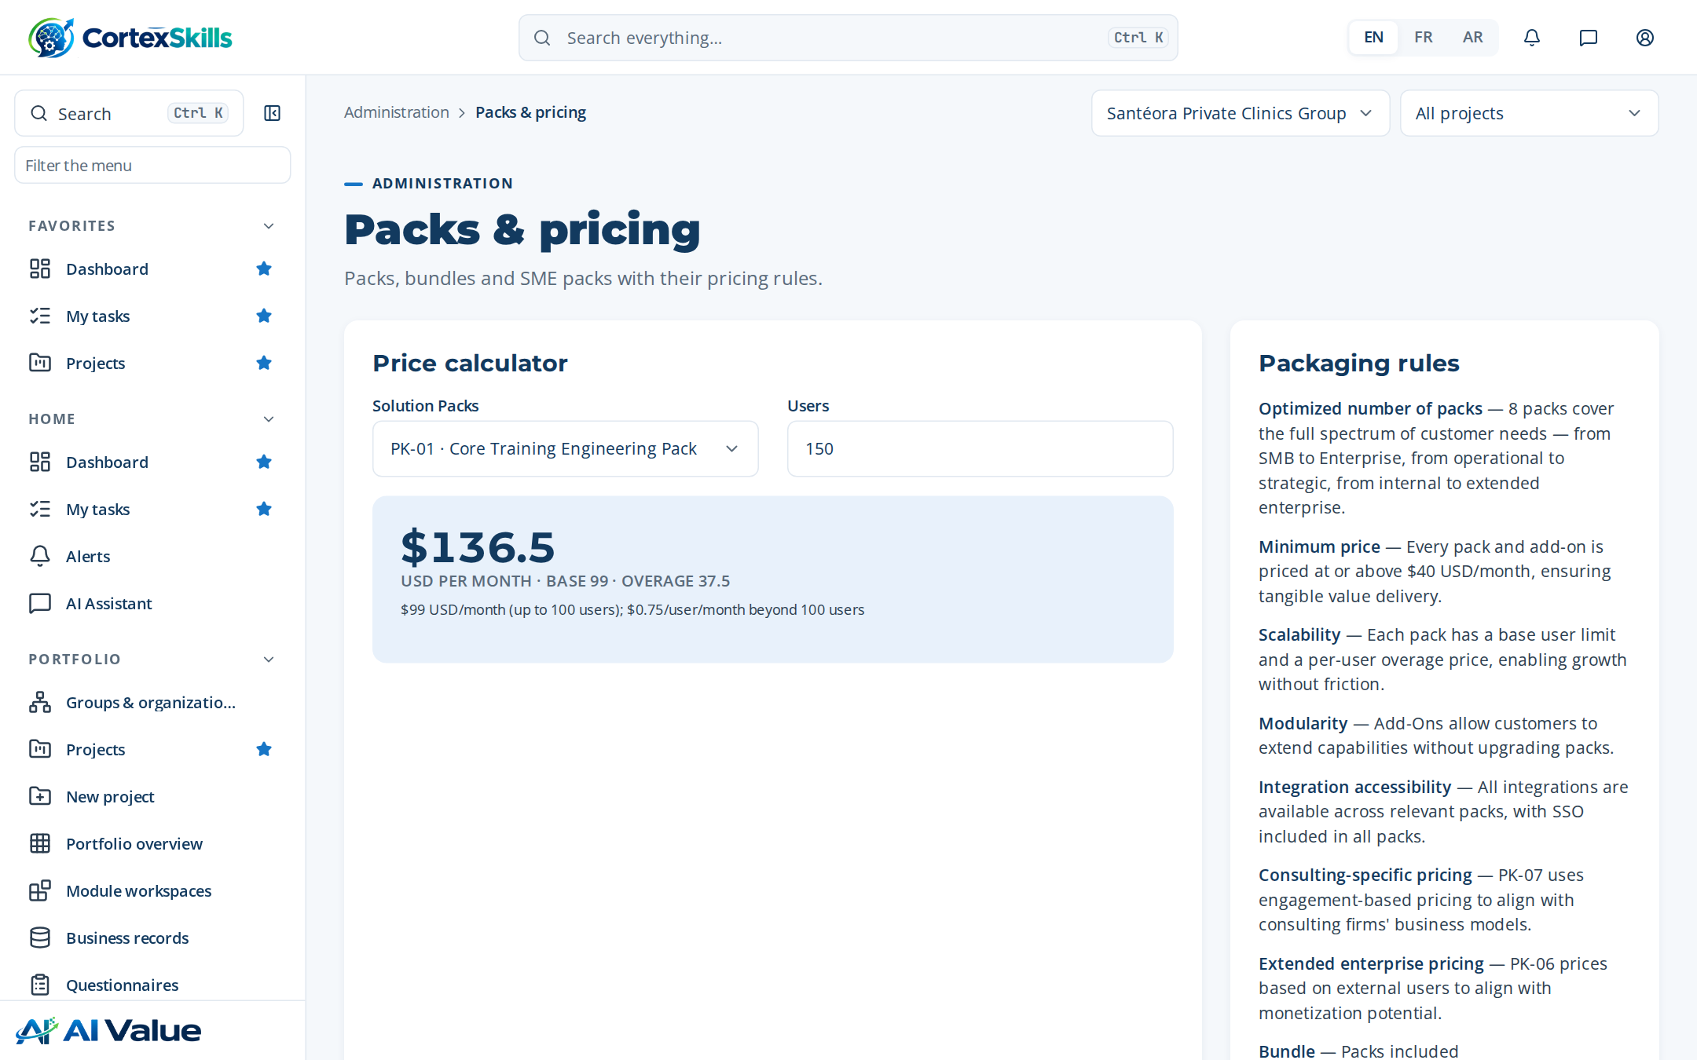
Figure 62 — Packs & pricing

Integrations
Address: /admin/integrations
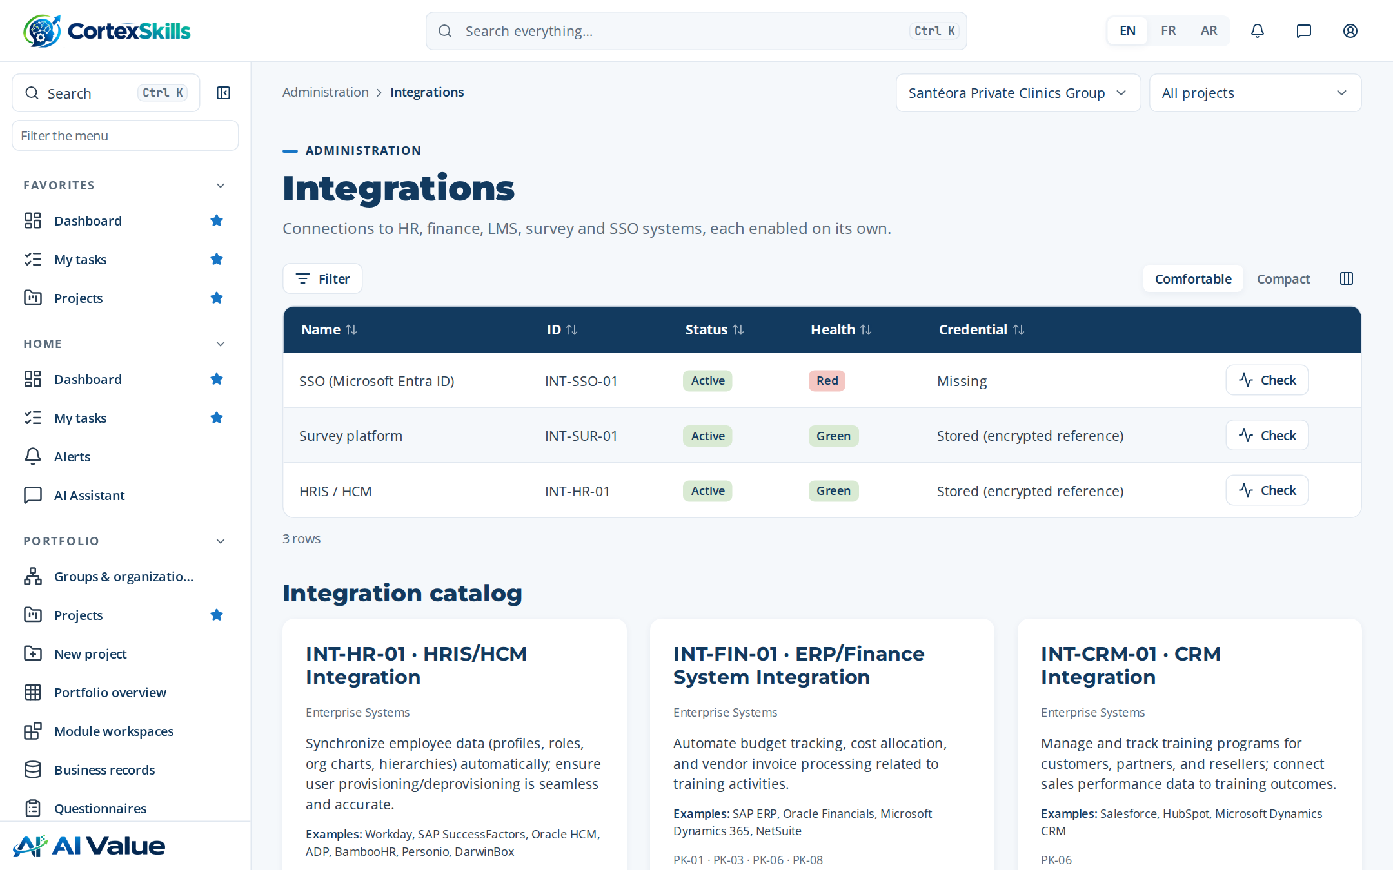
Figure 63 — Integrations

Channels (e-mail, WhatsApp)
Address: /admin/channels
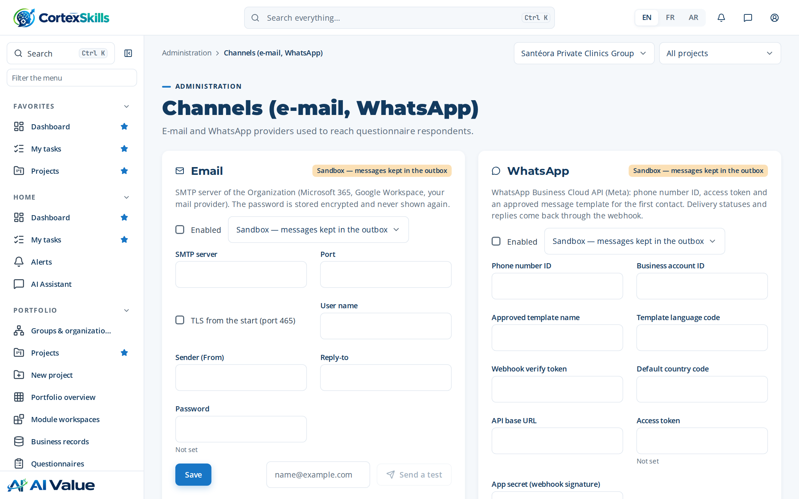
Figure 64 — Channels (e-mail, WhatsApp)

SME onboarding
Address: /admin/onboarding
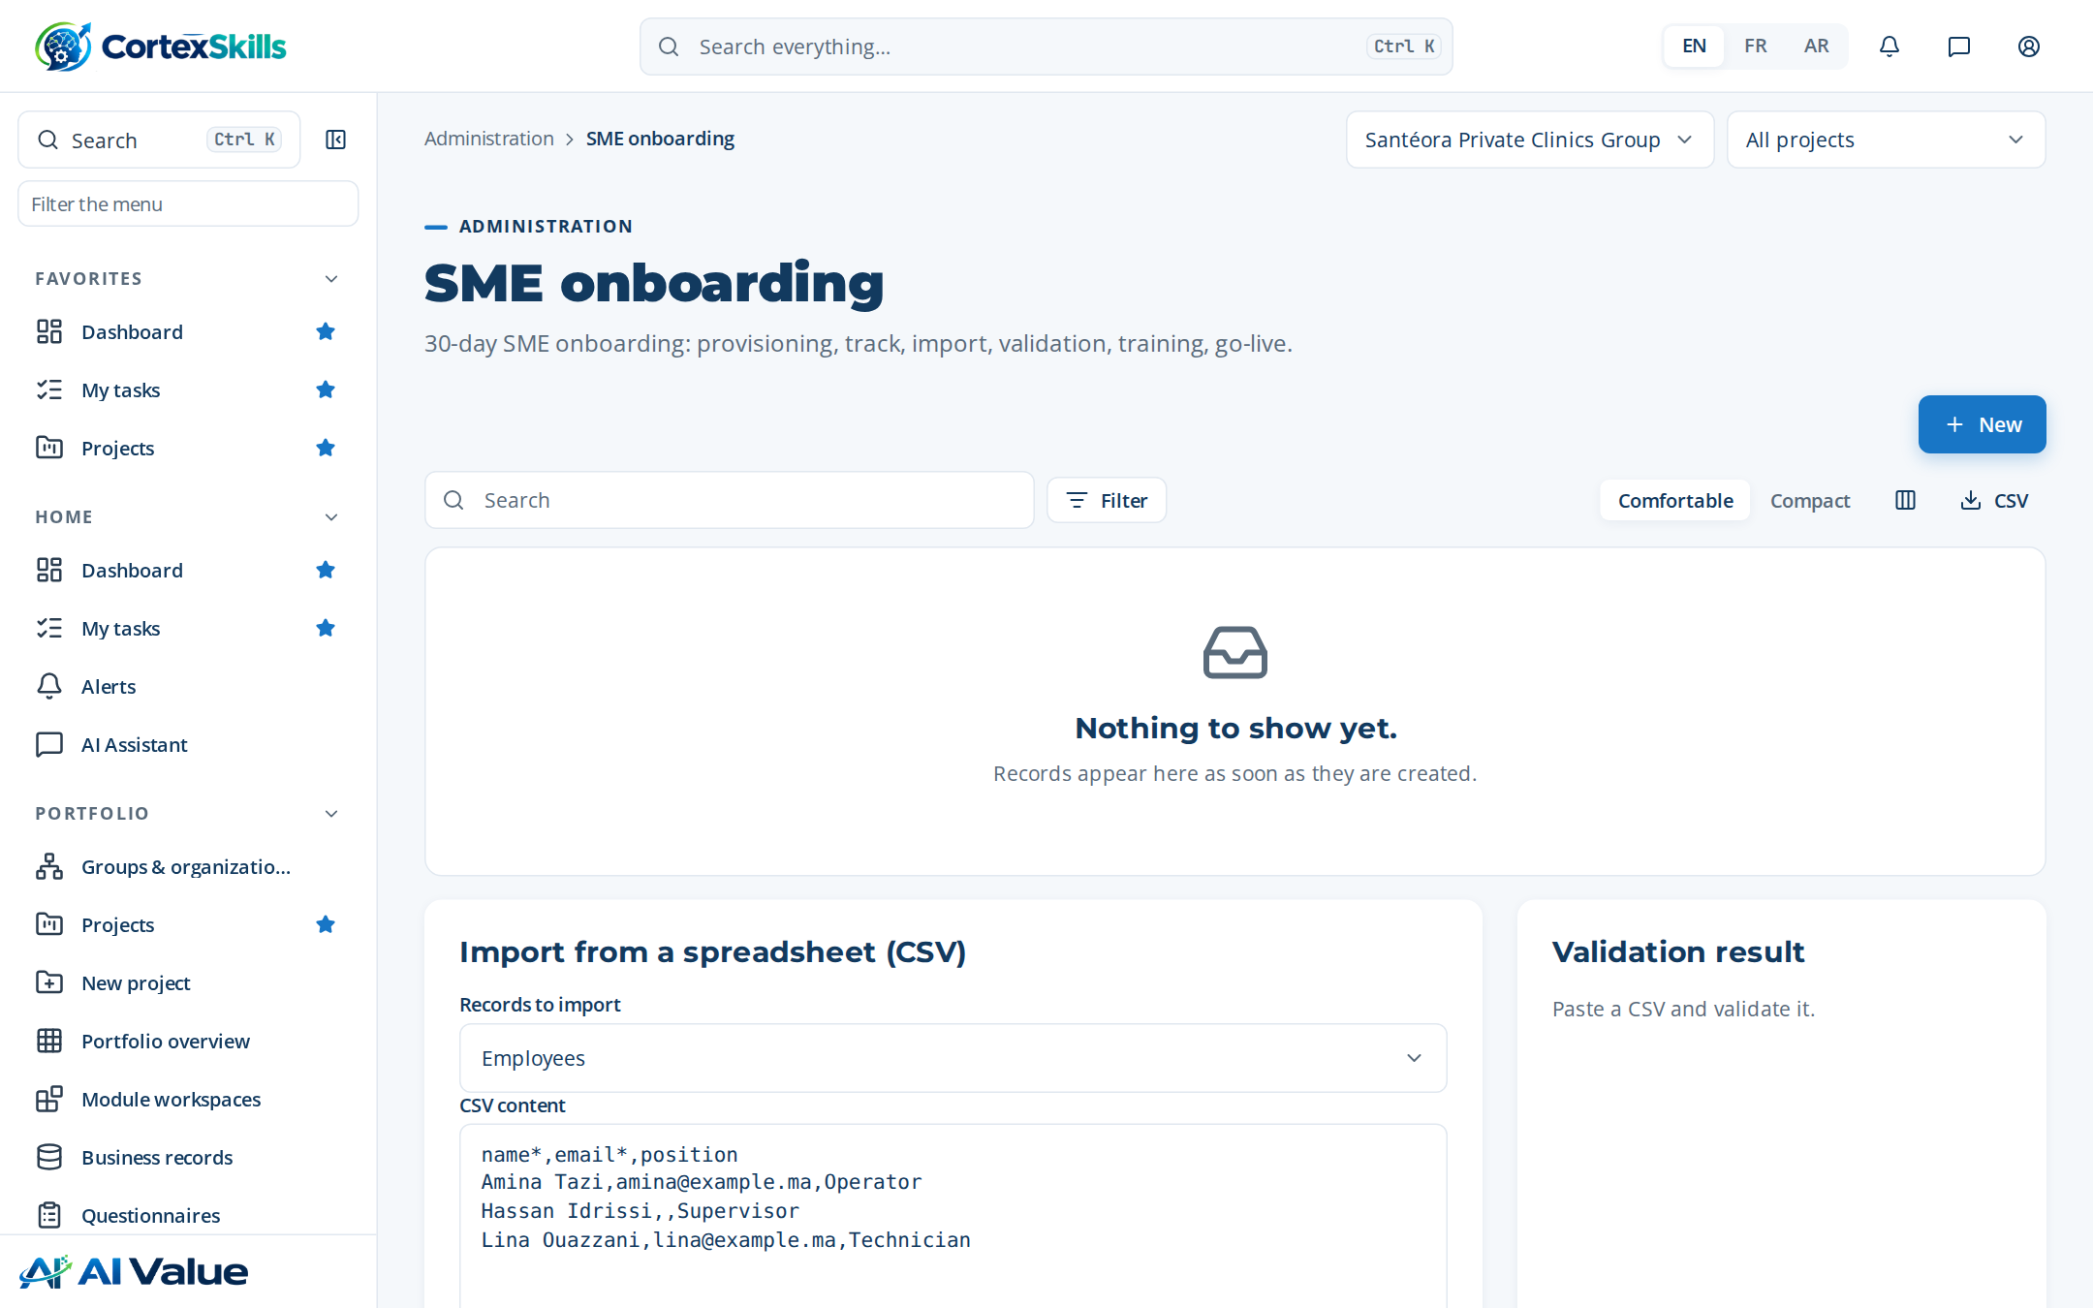
Figure 65 — SME onboarding

Audit log
Address: /admin/audit
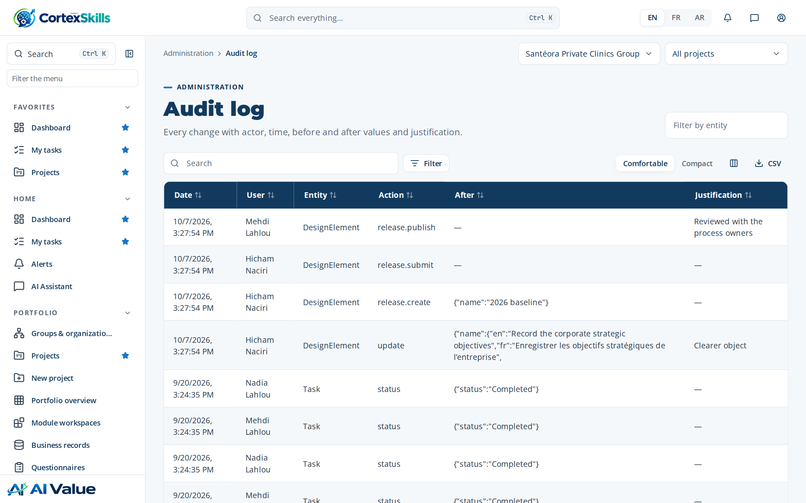
Figure 66 — Audit log

Backups & health
Address: /admin/backups
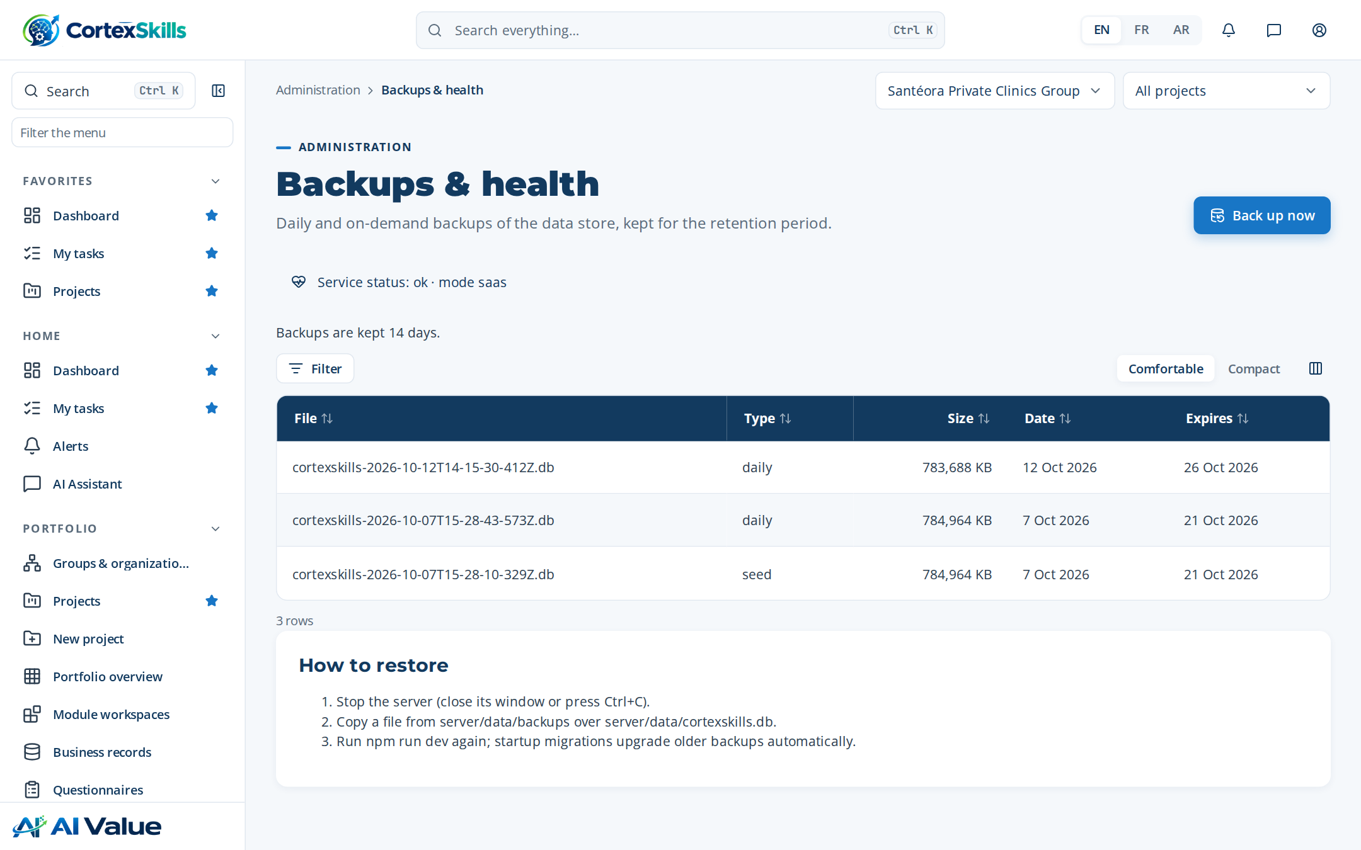
Figure 67 — Backups & health

Requirement traceability
Address: /admin/traceability
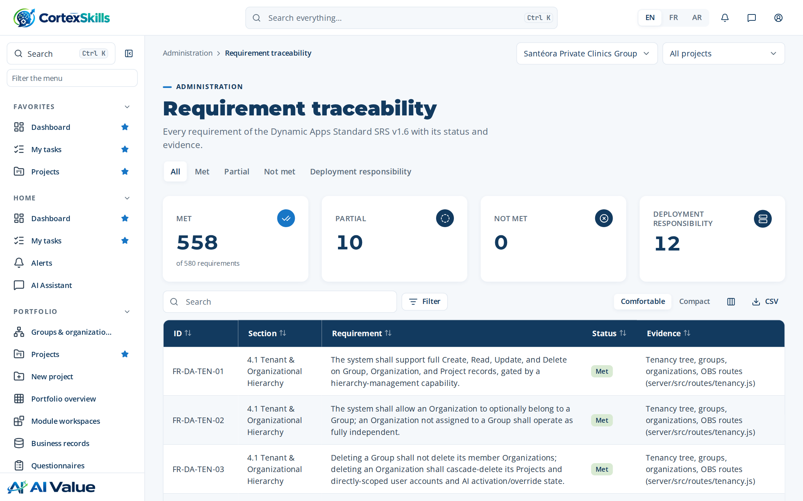
Figure 68 — Requirement traceability

9. Settings, help and profile

My settings
Address: /settings
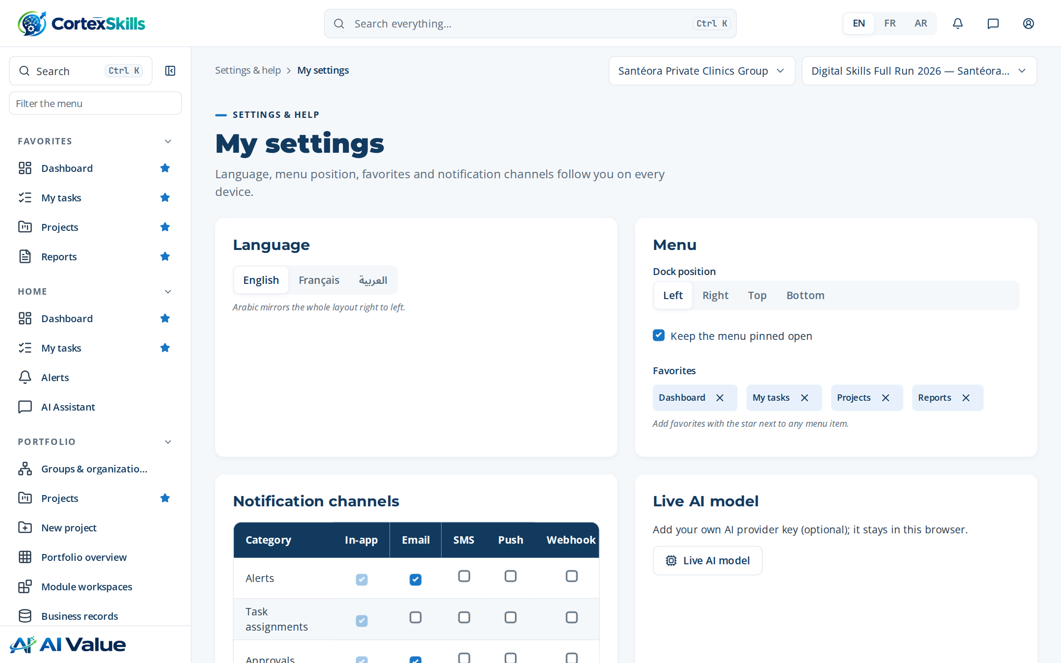
Figure 69 — My settings

Help centre
Address: /help
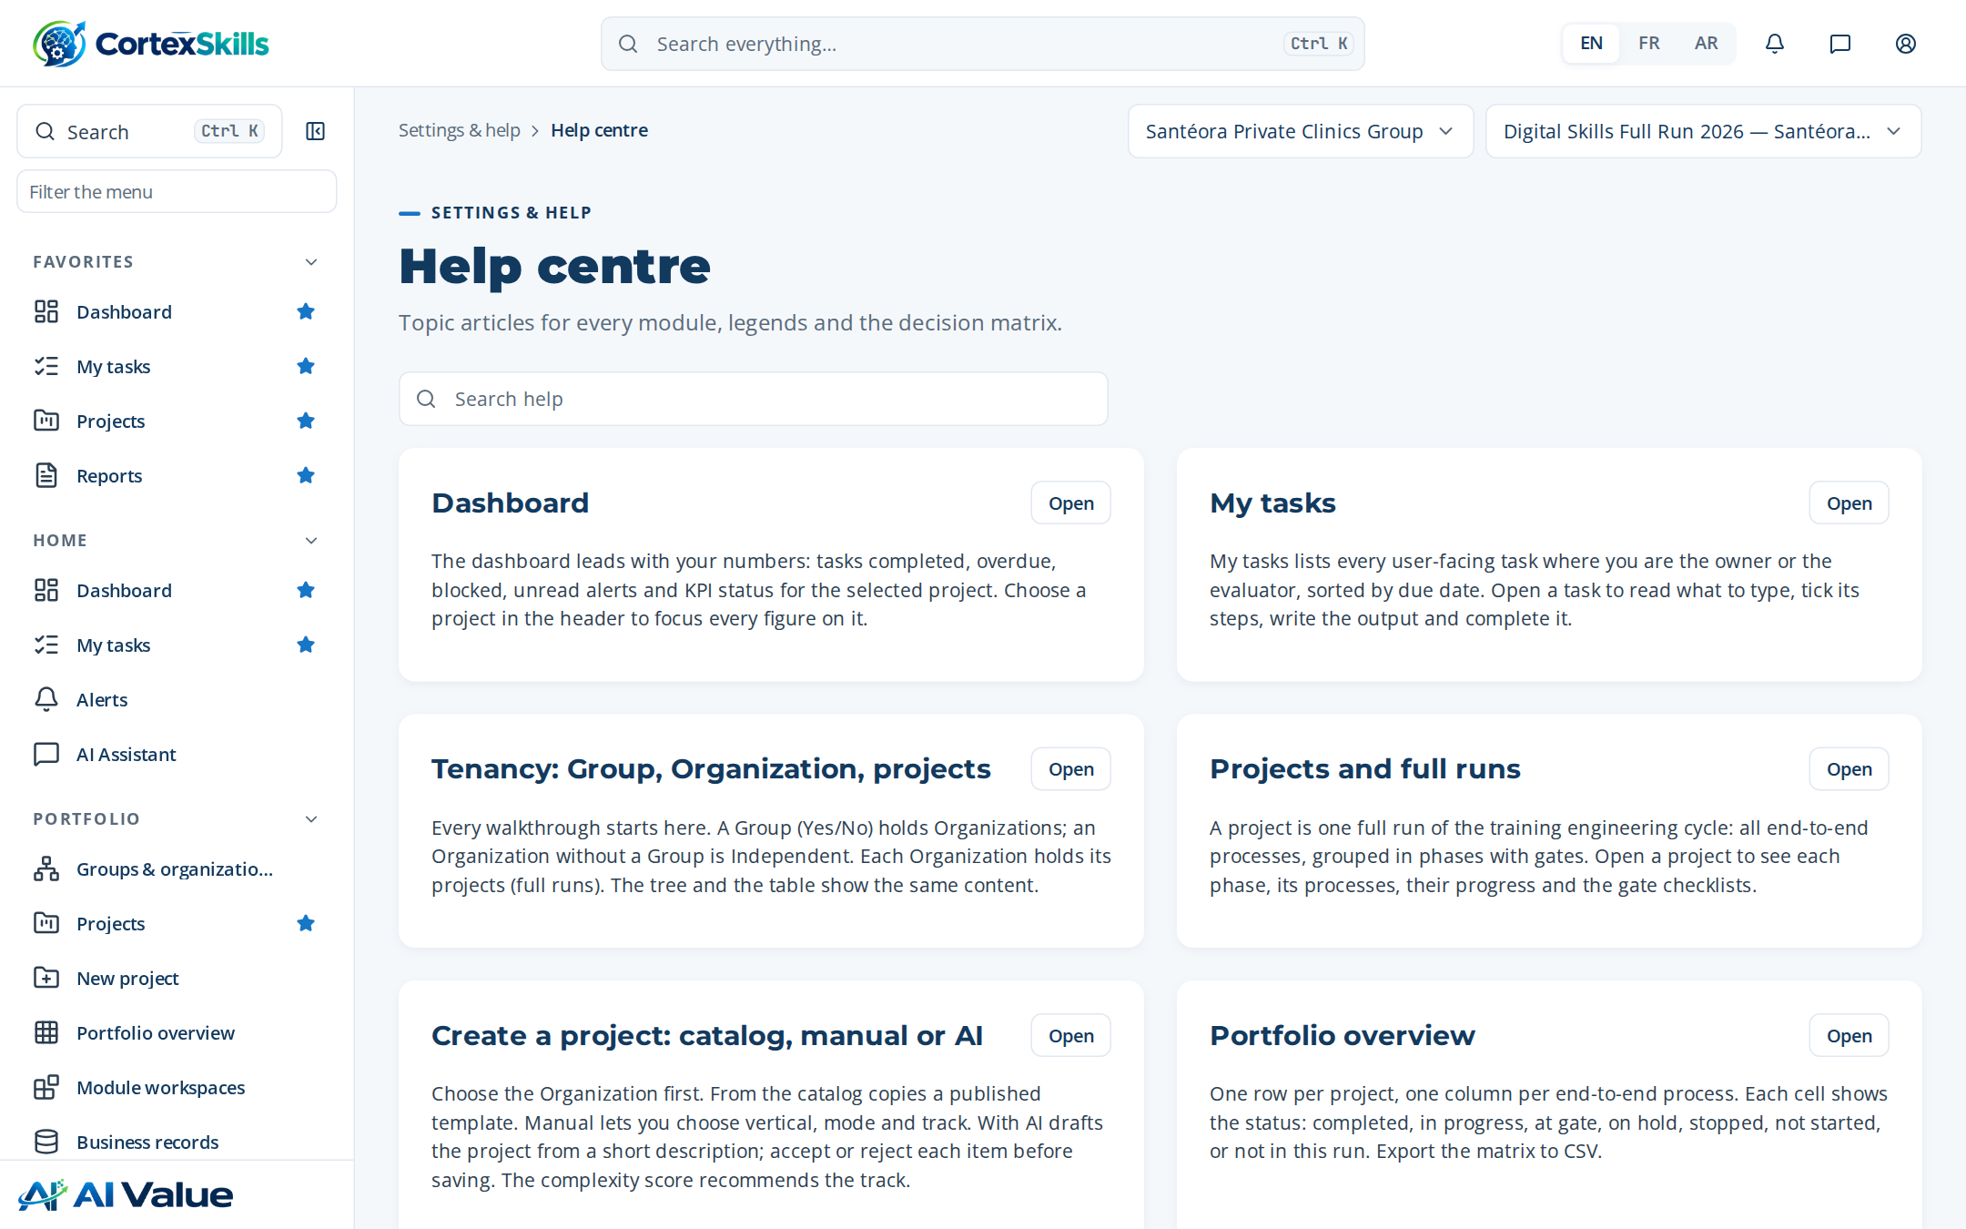
Figure 70 — Help centre

