

INSTALLATION GUIDE — MINIFIED RUNTIME — CUSTOMER SIDE — LINUX
CortexSkills
Install the CortexSkills production runtime on your Linux server (private cloud or on-premises), without Docker, with the reference data of every vertical and SMEs, and activate your licence
Version 1.15.1 · 2026-10-16
AI Value

Table of Contents
1. What you install 3
1.1 The reference data 4
2. Prerequisites 5
2.1 Server 5
2.2 Network 5
2.3 What you receive from the vendor 6
3. Install Node.js 22 7
4. Check and extract the package 8
5. Settings (.env) 9
6. Install the service and start 10
7. HTTPS (Nginx) 11
7.1 The reference organizations 12
8. Create your organization 14
9. Activate the licence 15
9.1 View the installed licence 16
9.2 What the licence decides 16
9.3 Renewal, change, end 16
10. Operation 17
10.1 Everyday commands 17
10.2 Backups 17
10.3 Restore 17
10.4 Update 17
10.5 Uninstall 18
11. Security 19
12. Troubleshooting 20
13. Support 21

1. What you install
CortexSkills is delivered as a single compressed file, Runtime_Customer_Linux_CortexSkills_1.15.1.tar.xz: a folder to extract on your server, which holds the production runtime. It runs with Node.js 22 installed on the server; no build and no Internet access are needed. Your data does not leave your servers: the database, attachments and backups are in the data/ folder. Nothing is sent to the vendor.
Item | Role
cortexskills | The launcher: start, admin (installation console), secrets, backup, restore, version.
installer-service.sh | Installs the Linux service (systemd): dedicated system user, folder rights, start at boot.
app/ | The application, read-only for the service.
data/ | Database, attachments, daily backups and installed licence. This is the only data to protect.
.env | Your settings: address, secrets, administrator, mail (created from env.example).
config/ | cortexskills.service (hardened systemd unit) and nginx-cortexskills.conf (HTTPS).
licence/ | Where you put the licence file received from the vendor.
LISEZMOI.txt · README.txt | Reminder of the essential commands, in French and English.

What the package contains — and what it does not
The production runtime: the minified server (file by file, without comments, internal names shortened), the compiled and minified web client (split per page, pre-compressed with Brotli and gzip, without source maps) and the libraries needed at run time.
The vendor public key: it verifies the licence, it cannot create one.
No readable source code, no test, no source map, no signing tool, no private key.
Node.js is not included: it is a prerequisite of the machine (Node.js 22 LTS, 22.13 or newer; validated version: 22.22.2). This keeps the package to a single compressed file.
Run-time optimisations: only the screens opened are loaded (the first display loads about 370 KB of JavaScript instead of 2.2 MB), static files are served pre-compressed and cached by the browser for a year (their name changes with each version), and Node.js keeps the compiled code between two starts (data/.node-compile-cache).

1.1 The reference data
At first start, the installation loads 61 reference organizations: 32 large companies and 29 SMEs, in every vertical (29 sectors and a universal case). Each has two complete projects (Digital and AI focus) with its processes, tasks, steps, questionnaires, plans, documents and indicators: they are examples to look at, in English, French and Arabic.
No demonstration account
The sign-in page names no account; no demonstration password exists in this production version.
The people of the reference organizations cannot sign in: their accounts are disabled and their password, drawn at random at installation, is known to nobody.
Only the platform administrator (ADMIN_EMAIL) signs in at first; they look at the reference organizations read-only (Portfolio › Groups and organizations). Your own users are those of your organization (chapter 8).
They have no licence: they do not count in the number of users of your licence. For an empty database, set REFERENCE_DATA=non in .env before the first start.

2. Prerequisites

2.1 Server
Item | Minimum | Recommended (300 users and more)
System | Linux 64-bit x86-64 with glibc 2.28 or newer | Ubuntu 22.04 / 24.04 LTS, Debian 12, RHEL / Rocky / AlmaLinux 9
Node.js | 22 LTS, 22.13 or newer (chapter 3) | 22.22.2
Processor | 2 vCPU | 4 vCPU
Memory | 4 GB | 8 GB
Disk | 20 GB free: application (about 80 MB), database with the reference data (about 0.9 GB), daily backups (about 0.8 GB each, 7 days by default) | 50 GB on backed-up storage
Software | systemd; tar and xz; sha256sum; an HTTPS reverse proxy (Nginx recommended) | Nginx and Certbot (Let’s Encrypt) or your company’s certificate
Alpine Linux (musl) and arm64 processors are not supported by this package: use the Docker package, or ask the vendor for the matching version.

2.2 Network
Need | Detail
DNS name | For example skills.your-company.com, pointing to the server (an internal DNS is enough for an intranet).
Inbound | 443/TCP for the users (and 80/TCP to obtain the Let’s Encrypt certificate). Port 4000 stays closed: the application only listens on 127.0.0.1.
Installation | No Internet access needed if Node.js is installed from the official archive (isolated server possible).
Outbound in operation (optional) | Your SMTP server (often 587/TCP); graph.facebook.com on 443/TCP for WhatsApp Business.
Browsers | Recent Chrome, Edge, Firefox or Safari.

2.3 What you receive from the vendor
File | Role
Runtime_Customer_Linux_CortexSkills_1.15.1.tar.xz | The runtime: a single compressed file (xz) with the minified application, the launcher, the service, the Nginx example, the settings template and the list of checksums.
Runtime_Customer_Linux_CortexSkills_1.15.1.tar.xz.sha256 | The SHA-256 checksum of the file, to check it is intact.
Installation_Guide_Runtime_Customer_Linux_CortexSkills_EN.docx / .pdf | This guide.
User_Guide_Customer_CortexSkills_EN.docx / .pdf | The User Guide: use of the application on a complete real case.
Later: <Your_company>.lic | Your licence file, sent by the vendor after your request (chapter 9).

3. Install Node.js 22
Node.js 22 LTS (22.13 or newer) must be installed on the server. Two methods; then check with node -v.
Method 1 — official archive (also works without Internet on the server). Download node-v22.22.2-linux-x64.tar.xz and SHASUMS256.txt from https://nodejs.org/dist/v22.22.2/ (on a connected workstation, then copy them to the server):
grep " node-v22.22.2-linux-x64.tar.xz$" SHASUMS256.txt | sha256sum -c -
sudo tar -xJf node-v22.22.2-linux-x64.tar.xz -C /usr/local --strip-components=1
node -v # v22.22.2
Method 2 — NodeSource repository (server connected to the Internet).
# Ubuntu, Debian
curl -fsSL https://deb.nodesource.com/setup_22.x | sudo -E bash - && sudo apt-get install -y nodejs
# RHEL, Rocky, AlmaLinux
curl -fsSL https://rpm.nodesource.com/setup_22.x | sudo bash - && sudo dnf install -y nodejs
node -v # v22.x (22.13 or newer)
The nodejs package of the standard Ubuntu or Debian repositories is too old (18 or 20): do not use “apt install nodejs” without NodeSource. If Node.js is installed elsewhere, give its path in the CORTEXSKILLS_NODE variable (for example /opt/node22/bin/node).

4. Check and extract the package
As administrator (sudo). The recommended folder is /opt/cortexskills: the systemd service protects the home folders (/home), do not install the application there.
cd ~ # folder holding the files received
sha256sum -c Runtime_Customer_Linux_CortexSkills_1.15.1.tar.xz.sha256 # must answer: Runtime_Customer_Linux_CortexSkills_1.15.1.tar.xz: OK
sudo mkdir -p /opt/cortexskills
sudo tar -xJf Runtime_Customer_Linux_CortexSkills_1.15.1.tar.xz -C /opt/cortexskills --strip-components=1
cd /opt/cortexskills && sha256sum -c --quiet SHA256SUMS.txt && echo "content intact"
./cortexskills version
The last command shows “CortexSkills 1.15.1 · customer edition · Node.js 22.22.2 · data /opt/cortexskills/data”. If a check fails, do not install: ask the vendor for a new copy.

5. Settings (.env)
sudo cp env.example .env
./cortexskills secrets # shows JWT_SECRET and CHANNEL_SECRET_KEY (and a third value, not used here)
sudo nano .env
Setting | Value | Example
PUBLIC_URL | The address users type, in HTTPS; it appears in the links sent by e-mail and WhatsApp. | https://skills.your-company.com
CORS_ORIGIN | The same address. | https://skills.your-company.com
HOST, PORT | Listening interface and port. 127.0.0.1: only the reverse proxy (or the local browser) reaches it. | 127.0.0.1, 4000
JWT_SECRET | Random value of 32 characters or more (signs the sessions). | shown by “cortexskills secrets”
CHANNEL_SECRET_KEY | Another random value (encrypts the stored credentials). | shown by “cortexskills secrets”
ADMIN_EMAIL, ADMIN_NAME, ADMIN_PASSWORD | The platform administrator, created at first start. Password: 12 characters min., upper case, lower case, digit, symbol. Clear ADMIN_PASSWORD afterwards. | it.ops@your-company.com
REFERENCE_DATA | First start: “oui” loads the reference organizations; “non” creates an empty database. | oui
DATA_DIR | Optional: data folder. By default data/ in the package folder. | /var/lib/cortexskills
BACKUP_RETENTION_DAYS | Days the daily backups are kept (about 0.8 GB each). | 7
SMTP_* | Your mail server for invitations, reminders and notifications. | smtp.your-company.com, 587
WHATSAPP_* | Optional: WhatsApp Business Cloud API. | —
The package enforces the on-premises mode (signed licence required) and hides all commercial information, whatever the value of DEPLOYMENT_MODE or COMMERCIAL_INFO in .env: these settings are ignored.
Start-up checks
The application refuses to start while a setting is dangerous — short or default secret, two identical secrets, address not in HTTPS, open CORS, vendor private key present — and lists each problem in its log.
Keep a copy of .env in your vault: changing JWT_SECRET signs every user out; losing CHANNEL_SECRET_KEY makes the stored mail credentials unreadable.

6. Install the service and start
cd /opt/cortexskills
sudo ./installer-service.sh
journalctl -u cortexskills -f # Ctrl+C to quit
installer-service.sh checks Node.js (22.13 or newer), creates the “cortexskills” system user (no shell, no password), makes app/ read-only (owned by root), gives data/ to the service only, restricts .env to root and the service, installs /etc/systemd/system/cortexskills.service with the path of Node.js, then starts the service and enables it at server start.
At first start, the application creates the production database — reference catalog, templates, platform administrator and reference organizations (1.1) — then starts. This step takes 5 to 15 minutes depending on the server: do not interrupt it. The log shows “Production database ready … 61 reference organizations (no account can sign in)”, then “CortexSkills API is running”. Health check, on the server:
curl -s http://127.0.0.1:4000/api/health
{"status":"ok","initialized":true,"mode":"onprem","version":"1.15.1","demoAccounts":false}
Then clear the value of ADMIN_PASSWORD in .env (sudo nano .env), then sudo systemctl restart cortexskills.
Service protection (config/cortexskills.service) | Effect
User=cortexskills, NoNewPrivileges | The process has no privilege and cannot obtain any.
ProtectSystem=strict, ReadWritePaths=…/data | The whole file system is read-only for the service, except data/.
ProtectHome, PrivateTmp, PrivateDevices | No access to home folders, to the others’ /tmp, or to devices.
UMask=0077 | The files created (database, backups, attachments) are readable by the service only.
TimeoutStartSec=30min | Leaves time for the first start to load the reference data.

7. HTTPS (Nginx)
sudo apt -y install nginx certbot python3-certbot-nginx
sudo cp config/nginx-cortexskills.conf /etc/nginx/conf.d/cortexskills.conf
sudo nano /etc/nginx/conf.d/cortexskills.conf # your DNS name and your certificate
sudo certbot certonly --nginx -d skills.your-company.com
sudo nginx -t && sudo systemctl reload nginx
The file redirects port 80 to HTTPS, accepts only TLS 1.2 and 1.3, allows 30 MB attachments and forwards to http://127.0.0.1:4000 with the X-Forwarded-* headers. Another reverse proxy (Apache, HAProxy, F5, IIS ARR, Traefik) works the same way. Then open your address:
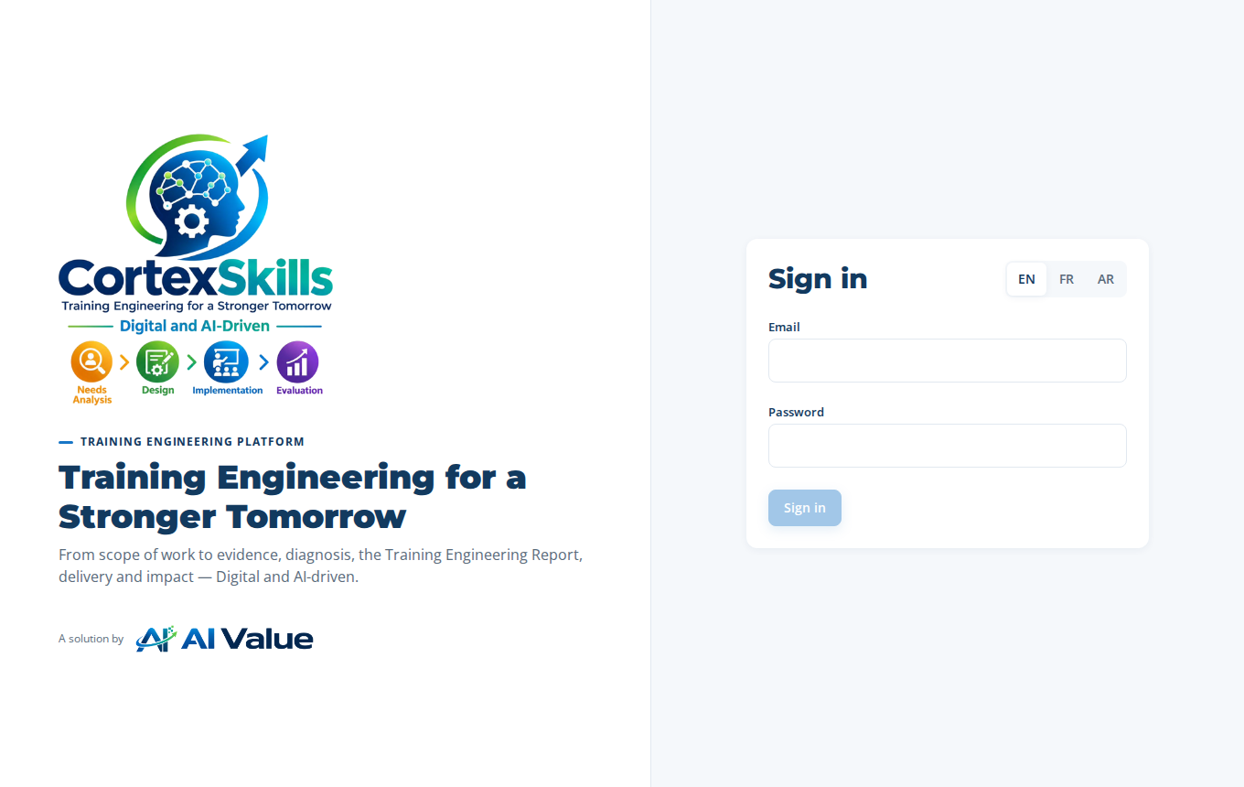
The sign-in page at your address: no demonstration account
Sign in with ADMIN_EMAIL and its password: the reference organizations are in Portfolio › Groups and organizations.
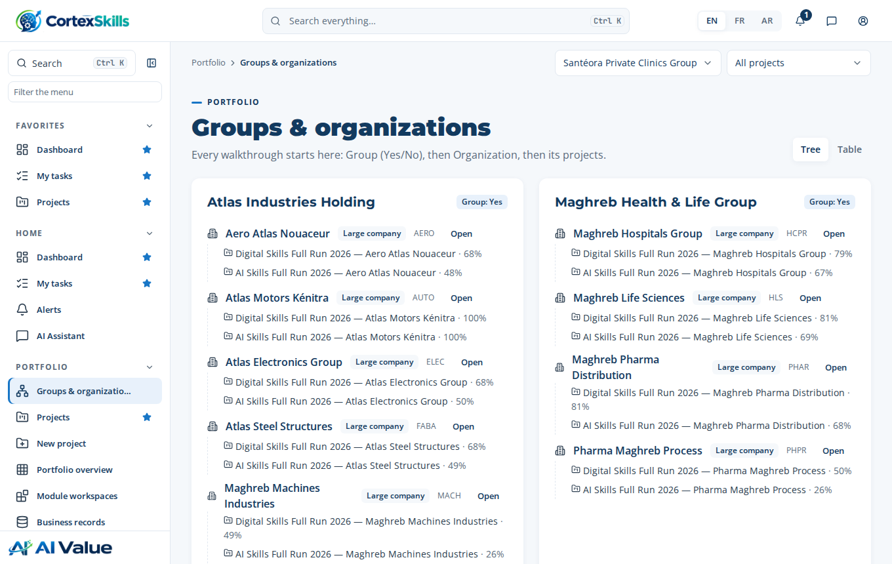
The reference organizations, seen by the platform administrator

7.1 The reference organizations
Sector | Large companies | SMEs
AEC & Construction (AEC) | Oasis Construction & Engineering | Souss BTP Solutions
Aerospace & Defense (AERO) | Aero Atlas Nouaceur | Precision Aero Composites
Automotive (AUTO) | Atlas Motors Kénitra | Tanger Auto Parts
Consumer Packaged Goods (CPG) | Sahel Consumer Brands | Savonnerie Beldi
Consumer Products Extended (CPEX) | Sahel Home & Living | Poterie Safi Design
Distribution (DIST) | Horizon Distribution | Distri Oriental
Electronics & High-Tech (ELEC) | Atlas Electronics Group | Circuitec Oujda
Energy & Utilities (ENUT) | Oasis Energy & Utilities | Solaris Maintenance Services
Fabrication & Assembly (FABA) | Atlas Steel Structures | Atelier Métal Berrechid
Food & Beverage (FNB) | Sahel Agro Industries | Coopérative Laitière Al Baraka
Footwear & Apparel (FTAP) | Atlas Textile & Footwear | Atelier Cuir Fès
Healthcare & Life Sciences (HLS) | Maghreb Life Sciences | BioLab Diagnostics Rabat
Healthcare Providers (HCPR) | Maghreb Hospitals Group ; Santéora Private Clinics Group ; Regional Hospital Centre | Clinique Al Amal
Industrial Machinery (MACH) | Maghreb Machines Industries | Fès Mécanique de Précision
Infrastructure (INFR) | Autoroutes & Ouvrages du Nord | Géo Inspect Maroc
Logistics (LOGI) | Horizon Logistics Tanger Med | Trans Atlas Express
Manufacturing (Generic) (MFGG) | Atlas Manufacturing Group | Plasti Meknès
Pharma (PHAR) | Maghreb Pharma Distribution | PharmaLog Services
Pharmaceutical & Process (PHPR) | Pharma Maghreb Process | Galénix Laboratoires
Private Education (PRED) | Horizon Private Universities | École Al Manar
Process / Packaged Goods (PKGD) | Sahel Packaging & Bottling | Emballages Kénitra
Process / Petrochemical (PETR) | Atlantique Petrochemicals | Chem Services Safi
Process Industries (PROC) | Phosphates & Minerals Atlas | Minerals Lab Khouribga
Public Education (PUED) | Académie Régionale Rabat-Salé | Lycée Pilote Ibn Sina
Retail (RETL) | Sahel Retail Stores | Marrakech Concept Store
Semiconductor & Electronics (SEMI) | Atlas Semiconductor Packaging | MicroTest Engineering
Shipbuilding (SHIP) | Chantiers Navals du Détroit | Marine Outfitting Agadir
Social & Solidarity Economy (SSE) | Fédération Nationale des Coopératives | Coopérative Argan Tiznit
Telecommunications (TELC) | Oasis Telecom | NetConnect Services
Universal (all sectors) (UNI) | Horizon Services Group | —

8. Create your organization
The organization is your company in CortexSkills, with its users, projects and licence. In /opt/cortexskills:
sudo -u cortexskills ./cortexskills admin org-create \
--name "Your company" --domain your-company.com \
--admin-email first.last@your-company.com --admin-name "First Last" \
--admin-password 'Str0ng#Passw0rd2026' --lang en --country Morocco --city Casablanca
Option | Meaning
--name | Name shown in the application.
--domain | E-mail domain of your users; it names the organization in the next commands.
--admin-email, --admin-name, --admin-password | First administrator of the organization (all rights). Strong password required.
--lang | Default language: fr, en or ar. Each user can change it.
--sector, --segment, --employees, --country, --city | Optional profile, can be completed later in the application.
The console runs as the service user (sudo -u cortexskills), the only one allowed to write in data/. It shows the Organization ID. Your users cannot sign in before the licence is installed.

9. Activate the licence
The licence is a small signed file (.lic) issued by the vendor for your Organization ID. It sets the plan, the number of users, the add-ons and the end date. It is verified with the public key included in the package: any change to the file makes it invalid.
Request. Show the information to send:
sudo -u cortexskills ./cortexskills admin licence-request --org your-company.com
Send the vendor, by e-mail, the lines shown (company and Organization ID). The Organization ID is not secret but must be copied exactly.
Receive. The vendor sends you a file such as L-0012_v1_Your_company.lic. Copy it into licence/:
sudo cp ~/L-0012_v1_Your_company.lic /opt/cortexskills/licence/ && sudo chmod 644 /opt/cortexskills/licence/*.lic
Install (no restart):
sudo -u cortexskills ./cortexskills admin licence-install --file licence/L-0012_v1_Your_company.lic
The console confirms the plan, the number of users and the end date, and copies the licence to data/license.lic. A modified file, or one issued for another Organization ID, is refused with a clear message.
Check. Sign in with the organization administrator, then open Administration › Configuration and licence: the licence is “Active”, with the plan, the number of users and the end date.
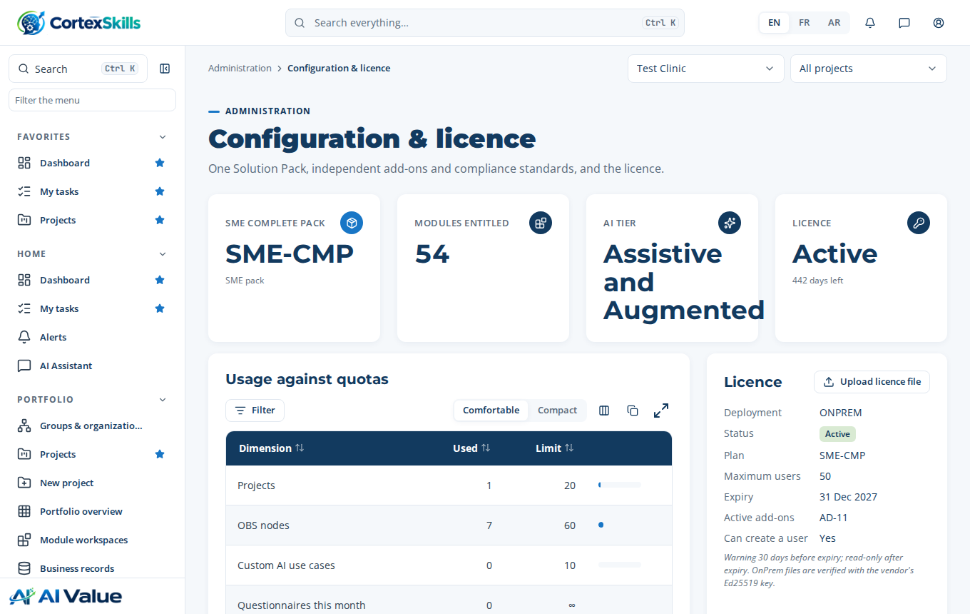
Administration › Configuration and licence after activation

9.1 View the installed licence
sudo -u cortexskills ./cortexskills admin licence-list
sudo -u cortexskills ./cortexskills admin licence-show --org your-company.com

9.2 What the licence decides
The plan, the number of users and the add-ons come only from the licence: they are changed neither in the application nor through the console. The screen says so:
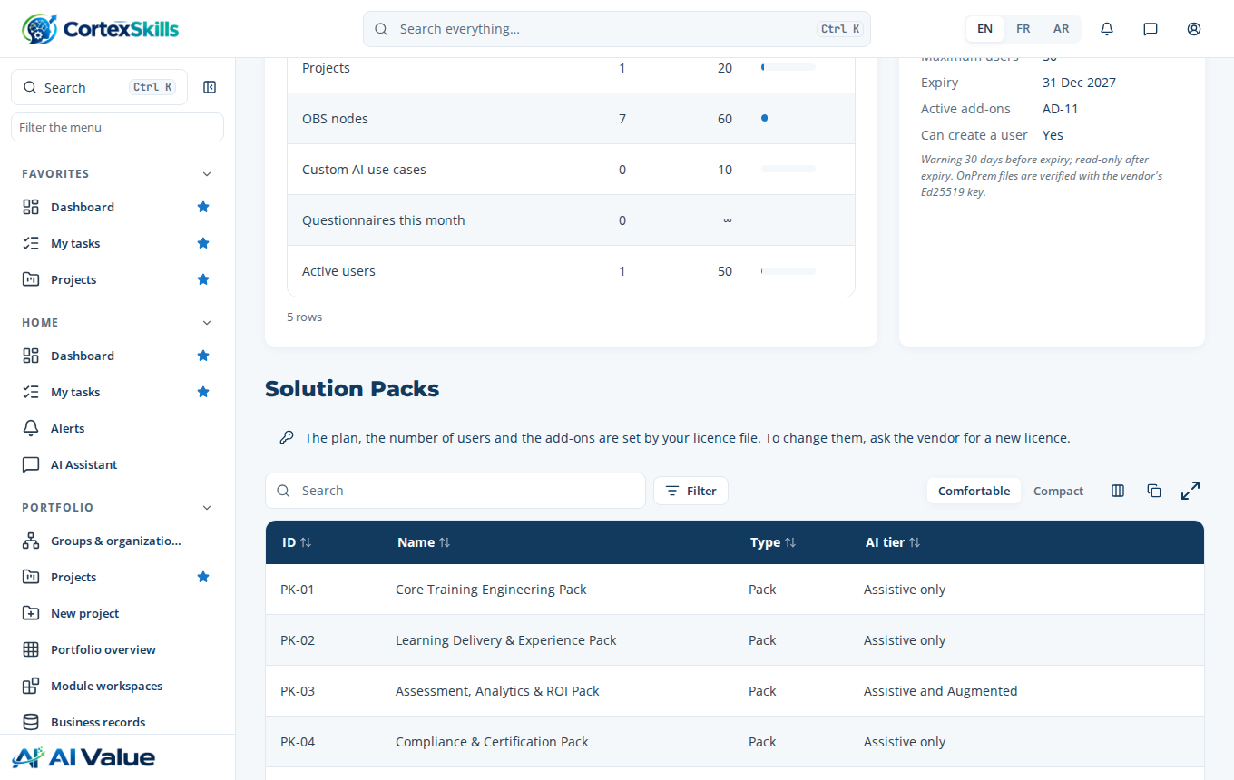
The plan is set by the licence

9.3 Renewal, change, end
- The application warns the administrators 30 days before the end date; after that date, it becomes read-only until a new licence is installed.
- For a renewal, more users, another plan or an add-on: ask the vendor for a new licence and install it the same way (licence-install) or through Administration › Configuration and licence › Upload the licence. It replaces the previous one.
- Removing a licence (end of contract): licence-remove --org your-company.com --yes. The users of the organization can no longer sign in; the data stays in data/.

10. Operation

10.1 Everyday commands
Action | Command (in /opt/cortexskills)
Start / stop / restart | sudo systemctl start · stop · restart cortexskills
Status and health | systemctl status cortexskills · curl -s http://127.0.0.1:4000/api/health
Log | journalctl -u cortexskills -f -n 200
Version | ./cortexskills version
Console help | sudo -u cortexskills ./cortexskills admin help
New password for a user | sudo -u cortexskills ./cortexskills admin password --email john@your-company.com --password 'N3w#2026Passw0rd'

10.2 Backups
The application writes a daily database backup in data/backups (about 0.8 GB each with the reference data; BACKUP_RETENTION_DAYS days kept). Before any intervention, and every day, copy the backups and attachments off the server:
sudo -u cortexskills ./cortexskills backup
sudo rsync -a /opt/cortexskills/data/backups/ /opt/cortexskills/data/attachments/ backup@storage:/cortexskills/
# or a scheduled task: sudo crontab -e
30 2 * * * rsync -a /opt/cortexskills/data/ backup@storage:/cortexskills/

10.3 Restore
sudo systemctl stop cortexskills
sudo -u cortexskills ./cortexskills restore # lists the backups
sudo -u cortexskills ./cortexskills restore <file.db>
sudo systemctl start cortexskills
The current database is kept next to the backups (before-restore-<date>.db). A backup from an earlier version is upgraded at start.

10.4 Update
A new version replaces app/, config/ and the scripts; .env, data/ and licence/ are kept:
sudo -u cortexskills /opt/cortexskills/cortexskills backup
sha256sum -c Runtime_Customer_Linux_CortexSkills_<version>.tar.xz.sha256
mkdir -p /tmp/cs-new && tar -xJf Runtime_Customer_Linux_CortexSkills_<version>.tar.xz -C /tmp/cs-new --strip-components=1
sudo systemctl stop cortexskills
cd /opt/cortexskills && sudo rm -rf app config
sudo cp -r /tmp/cs-new/{app,config,cortexskills,installer-service.sh,env.example,LISEZMOI.txt,README.txt,SHA256SUMS.txt} .
sudo ./installer-service.sh # re-applies the rights and restarts; the database is migrated at start
./cortexskills version

10.5 Uninstall
sudo systemctl disable --now cortexskills, then sudo rm /etc/systemd/system/cortexskills.service. The /opt/cortexskills folder holds all the data (data/): make and copy a backup before deleting it.

11. Security
- The service runs as an unprivileged system user, on a file system that is read-only except data/ (chapter 6).
- The application only listens on 127.0.0.1; only the reverse proxy’s HTTPS is exposed.
- Keep .env readable by root and the service only (installer-service.sh sets this) and its secrets in your vault.
- Passwords stored hashed; sessions limited to JWT_TTL (12 h by default); every administration action is written to the audit log. No demonstration account: only the platform administrator and the users you create can sign in.
- Do not change the files of app/: the licence of use forbids it, and a change is overwritten at the next update.
- Apply the updates of the system, of Node.js 22 (patch releases) and of Nginx, and the CortexSkills updates sent by the vendor.

12. Troubleshooting
What you see | Cause | What to do
“Node.js 22 not found” | Node.js is not installed, or not in the PATH. | Chapter 3; or CORTEXSKILLS_NODE=/path/to/node.
“needs Node.js 22.13 or newer” | Node.js version too old (distribution package). | Install Node.js 22 from the official archive or NodeSource (chapter 3).
“will not start in production mode” in the log | A setting of .env is missing or dangerous. | Read the list in the log: each line names the setting to fix, then sudo systemctl restart cortexskills.
“First start: set ADMIN_EMAIL and ADMIN_PASSWORD” | First start without an administrator. | Fill them in .env, restart, then clear ADMIN_PASSWORD.
systemctl status: “activating” for several minutes | First start: loading the reference data. | Normal (5 to 15 minutes): follow journalctl -u cortexskills -f. Do not restart during this step.
“Port 4000 is already in use” | Another application, or CortexSkills started twice. | Stop the other process, or change PORT in .env and in the Nginx configuration.
“EACCES” or “read-only file system” at start | data/ folder moved or rights changed; or installation under /home. | Run sudo ./installer-service.sh again; install in /opt/cortexskills.
“GLIBC_2.28 not found” or “cannot execute binary file” | System too old, Alpine (musl) or arm64 processor. | Use a recent Linux x86-64 (2.1), or the Docker package.
502 Bad Gateway in the browser | The service is stopped or still in its first start. | systemctl status cortexskills; journalctl -u cortexskills.
An account of a reference organization is refused | These accounts cannot sign in (1.1). | Sign in with the platform administrator or with the accounts of your organization.
“No space left on device” | Disk full (backups). | Free space, reduce BACKUP_RETENTION_DAYS and copy the backups off the server.
sha256sum: “FAILED” | Incomplete or altered file. | Ask for a new copy.
“The licence of this Organization is not active” | Licence not installed or expired. | Chapter 9; check the end date.
licence-install: “signature is not valid” | File modified or not issued by the vendor. | Ask for the file again; do not open it in a text editor that would reformat it.
licence-install: “Organization ID … does not exist” | Licence issued for another ID. | Compare with org-list and send the right ID to the vendor.
Changing plan or add-on is refused | The plan and add-ons are set by the licence. | Ask the vendor for a new licence.

13. Support
To contact the vendor, attach: the output of ./cortexskills version, that of systemctl status cortexskills and the last 200 lines of journalctl -u cortexskills. Never send the .env file or its secrets.

