


USER GUIDE · CUSTOMER SIDE · REAL CASE
CortexSkills — Al Amal Clinic
A first complete cycle of AI skills development in a private clinic: what to type, what to paste, what to check — with real questions, real messages and real answers
Version 1.15.1 · 2026-10-16
Prepared by AI Value

Table of Contents
1. The case and this guide 5
1.1 The path 5
1.2 The accounts of the case 5
1.3 The three ways to fill a step 6
2. Prepare the application (administrator) 7
2.1 The public address of the application 7
2.2 E-mail (SMTP server) 7
2.3 WhatsApp (Meta WhatsApp Business Cloud API) 8
2.4 Sandbox or live 8
2.5 The employee directory (optional) 9
3. The respondents of the case 11
4. Create the project 13
5. Phase 1 — The scope of work (E2E-32) 14
UFT-32-01 — Define scope frame 14
UFT-32-02 — Select sector 15
UFT-32-03 — Select decision levels 16
UFT-32-04 — Map functions × decision levels 17
UFT-32-05 — Select focus and add custom criteria 17
UFT-32-06 — Identify stakeholders 18
UFT-32-07 — Validate scope 22
UFT-32-08 — Approve scope 22
UFT-32-09 — Publish scope and register stakeholders 24
6. Phase 1 — The questionnaire campaign (E2E-33) 26
UFT-33-01 — Select questionnaire template 26
UFT-33-02 — Elaborate questionnaire 27
UFT-33-03 — Tailor and validate content 28
UFT-33-04 — Allocate RACSI 29
UFT-33-05 — Select distribution channels 30
UFT-33-06 — Distribute questionnaire 32
Assign the sections, sub-sections and questions to the respondents 33
UFT-33-07 — Send reminders 37
UFT-33-08 — Collect responses 38
What the respondent sees 38
UFT-33-09 — Validate completeness 40
UFT-33-10 — Consolidate responses 40
UFT-33-11 — Check consent and release dataset 41
UFT-33-12 — Report on response and engagement 42
Gate G1 — Scope & evidence approved 43
7. Phase 2 — The skill-gap diagnosis (E2E-02) 44
UFT-02-01 — Maintain competency framework 44
UFT-02-02 — Set target levels per position 44
UFT-02-03 — Launch assessment campaign 46
UFT-02-04 — Collect self and manager assessments 50
UFT-02-05 — Suggest proficiency from evidence 51
UFT-02-06 — Validate skills inventory 55
UFT-02-07 — Compute and forecast gaps 56
8. Phase 3 — The training plan (E2E-01) 59
UFT-01-01 — Record strategic objectives 59
UFT-01-02 — Link objectives to functions and sites 59
UFT-01-03 — Frame skills priorities 60
UFT-01-04 — Pre-scope training needs 62
UFT-01-05 — Define budget envelope 63
UFT-01-06 — Plan change and adoption 66
UFT-01-07 — Compile plan approval pack 68
UFT-01-08 — Approve and lock annual L&D plan 69
Gate G3 — Report & roadmap approved 70
9. Phase 4 — Design and delivery (E2E-05) 72
UFT-05-01 — Publish content to catalog 72
UFT-05-02 — Book logistics 74
UFT-05-03 — Schedule sessions 77
UFT-05-04 — Enroll learners and send convocations 78
UFT-05-05 — Push microlearning capsules 82
UFT-05-06 — Run immersive simulations 85
UFT-05-07 — Record attendance 90
UFT-05-08 — Close sessions 91
UFT-05-09 — Reconcile and archive period 92
10. Phase 5 — The evaluation of effectiveness (E2E-07) 94
UFT-07-01 — Create assessment instrument 94
UFT-07-02 — Draft question bank 94
UFT-07-03 — Collect reaction survey (Level 1) 97
UFT-07-04 — Record learning results (Level 2) 98
UFT-07-05 — Record on-the-job observation (Level 3) 99
UFT-07-06 — Compute skill progression 100
UFT-07-07 — Review evaluation results 101
UFT-07-08 — Publish evaluation report 103
Gate G5 — Evaluation & impact validated 105
11. Troubleshooting 106
Appendix A — The questions of the three forms 108
IF-PAC form — General Manager workshop 108
IF-PAC form — Management (directors, managers, process owners) 109
IF-PAC form — Team member 111

1. The case and this guide
This guide runs a simple, complete case: Al Amal Clinic, a private clinic in Marrakech (95 employees), launches its first artificial intelligence skills project, focused on patient triage in the emergency department and on the image-reading aid. The project goes from the scope of work to the evaluation of the training’s effectiveness.
Everything is real. This guide was produced by running this case in the CortexSkills 1.15.1 application: every value, every question, every message and every screenshot comes from that run. The questionnaire questions are the ones the respondents receive; the messages really leave by e-mail and WhatsApp as soon as the channels are configured (chapter 2); the respondents open their personal link, answer, and their answers arrive in the application.

1.1 The path
Phase | Process | Tasks | Gate at the end
Phase 1 | E2E-32 — Scope-of-Work-to-Engineering-Plan | 9 | G1 — Scope & evidence approved
Phase 1 | E2E-33 — Questionnaire-to-Response-Collection | 12 | G1 — Scope & evidence approved
Phase 2 | E2E-02 — Skills-to-Gap Diagnosis | 7 | —
Phase 3 | E2E-01 — Strategy-to-Learning Plan | 8 | G3 — Report & roadmap approved
Phase 4 | E2E-05 — Design-to-Delivery | 9 | —
Phase 5 | E2E-07 — Assessment-to-Evaluation | 8 | G5 — Evaluation & impact validated
In all: 6 processes, 53 tasks, 91 steps, and the end-of-phase gates. The project template “Private clinic — simple path — AI skills (6 processes)” keeps only these six processes: this is what makes this case a simple one.

1.2 The accounts of the case
Role in the case | Name | E-mail in the case
Head of Learning & Development (project lead) | Ayoub Bennani | headld@cliniquealamal.ma
Training analyst | Karim Tazi | analyst@cliniquealamal.ma
HR Director, chair of the steering committee (gates) | Hajar Tazi | hrd@cliniquealamal.ma
Administrator (channels, integrations) | Anas Amrani | admin@cliniquealamal.ma
These people are those of the case. In your installation, your organization’s administrator creates your own accounts (Administration › Users, or the installation console) and gives them these roles; no demonstration account exists in the delivered version.

1.3 The three ways to fill a step
Each table or form step can be filled in three ways, which you can combine: you start from a proposal, correct it, and complete it by hand.
Way | Button |  | What the application does
Manual entry | Add a row · Paste (Ctrl+V) |  | You type the values, or you paste a table whose first row holds the exact column titles; the Paste preview checks each cell before “Apply”.
From the template | “From the template” |  | Proposes rows taken from the sector library and from the data already entered in the project (framework, targets, gaps, sessions…). You accept, edit or reject each row.
AI proposal | “Propose rows with AI” |  | Goes through the AI use case linked to the step: it reasons on the project’s records (for example the critical gaps) and explains its choices. Each row is validated by a person; the use is logged.
Type of step |  | What you do
Table |  | Several rows of the same type, filled in one of the three ways; “Complete step” creates the project’s records (competencies, targets, sessions, enrolments…).
Form |  | A single record (a decision, a review): type, or pre-fill from the template or AI, then “Apply these values”.
Work panel |  | The step works on the real object: its buttons send the links (assessments, invitations, tests), remind, compute (gaps, progression, indicators). It completes when its result exists.
Automatic step |  | The platform performs it; you check its result.
Before pasting
Set the interface to English (EN button): numbers such as “3.5” are read in the interface language; the dates of this guide (YYYY-MM-DD) are read in every language.
The tables of this guide can be edited before being copied: replace the values with those of your clinic.

2. Prepare the application (administrator)
Three settings make the case real: the public address of the application (so the links work on a phone), the e-mail server and the WhatsApp Business account. They are made once, with the administrator account.

2.1 The public address of the application
The links sent to the respondents are built with the public address of the server. A “localhost” address only opens on the server’s computer: for respondents to open their link from their phone, the application must be reachable from the Internet (or from the clinic’s Wi-Fi network) and its address declared in the server’s settings file:
PUBLIC_URL=https://competences.cliniquealamal.ma
Then restart the server. For a trial on the local network, an address such as http://192.168.1.20:4000 works for phones connected to the same Wi-Fi.

2.2 E-mail (SMTP server)
Menu Administration › Channels (e-mail, WhatsApp), “E-mail” card. Tick “Enabled”, choose the mode “Live — sent by the provider”, then fill in:
Field | Microsoft 365 | Google Workspace / Gmail | Other provider
SMTP server | smtp.office365.com | smtp.gmail.com | the provider’s
Port | 587 | 587 | 587 (or 465)
TLS from the connection (port 465) | Not ticked | Not ticked | Ticked if port 465
User name | formation@cliniquealamal.ma | your.account@gmail.com | the SMTP login
Password | account password (or app password) | app password (16 characters) | SMTP password
Sender (From) | Al Amal Clinic <formation@cliniquealamal.ma> | Al Amal Clinic <your.account@gmail.com> | the authorised address
Reply-to address | formation@cliniquealamal.ma | your.account@gmail.com | optional
Click “Save”, type your address in “Test recipient”, then “Send a test”: the message “The provider accepted the message.” confirms that e-mail really leaves. The password is encrypted and is never shown again.

2.3 WhatsApp (Meta WhatsApp Business Cloud API)
- In Meta Business Manager, create (or use) a WhatsApp Business account and add the clinic’s number.
- In the Meta developer application, note the “Phone number ID” and the “WhatsApp Business account ID”, and create a permanent access token (system user).
- Create a message template of category “Utility”, in English, for example “cortexskills_invitation”, with this body: “Hello {{1}}, {{2}} invites you to answer the questionnaire “{{3}}”: {{4}} (answer before {{5}}).” Wait for its approval by Meta.
- In CortexSkills, “WhatsApp” card: tick “Enabled”, mode “Live”, then fill in the fields below and “Save”.
- Declare at Meta the webhook URL shown on the card (…/api/public/whatsapp/webhook) with the “Webhook verification token”: delivery statuses and replies come back to the application.
- Send a test to your own number.
Field | Value
Phone number ID | the identifier given by Meta (a series of digits)
Business account ID | the identifier of the WhatsApp Business account
Approved template name | cortexskills_invitation
Template language code | en
Webhook verification token | a password of your choice, also entered at Meta
Default country code | 212
API base URL | https://graph.facebook.com/v21.0 (default value)
Access token | the permanent token (encrypted, never shown again)
App secret | the secret of the Meta app (webhook signature)
WhatsApp rule to know
The first message sent by the clinic must use an approved template: this is why the template name is asked. Free text is only accepted within 24 hours of a message from the respondent.
The template variables are filled in this order: {{1}} respondent’s name, {{2}} organization, {{3}} questionnaire title, {{4}} personal link, {{5}} deadline.

2.4 Sandbox or live
While a channel is in “Sandbox” mode, the messages are composed and kept in the outbox (Administration › Channels, and the questionnaire log), without leaving. This is useful for a rehearsal. Switch to “Live” for the real run: the same messages then leave through the provider.
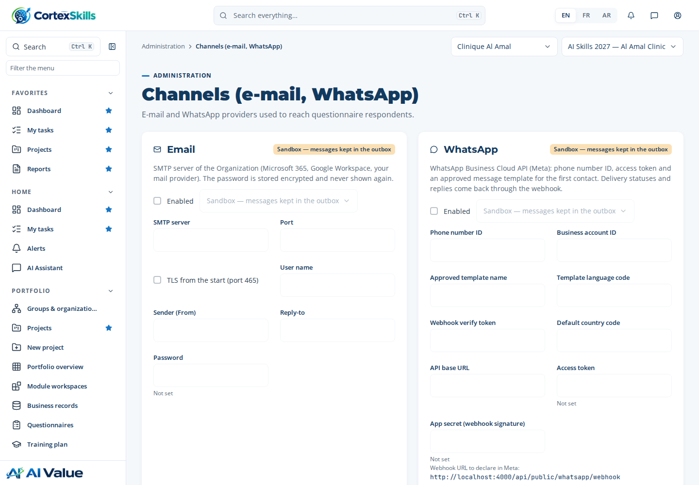
Administration › Channels: e-mail and WhatsApp, their mode and the outbox

2.5 The employee directory (optional)
If the clinic has an HRIS, the directory is updated from an export. Administration › Integrations, “HRIS / HCM” line: “Test” checks the connection, “Synchronise (HRIS file)” reads a CSV file whose first row holds the HRIS field names. The report gives the employees created, updated and the records rejected with their reason (unknown position, missing employee number).
employee_id | full_name | email | phone | position | department
EMP-0101 | Samira Ouazzani | infirmiere.urgences@cliniquealamal.ma | +212661000007 | Operator — Clinical and nursing care | Clinical and nursing care
EMP-0102 | Rachid Amrani | radiologie@cliniquealamal.ma | +212661000008 | Operator — Clinical and nursing care | Clinical and nursing care
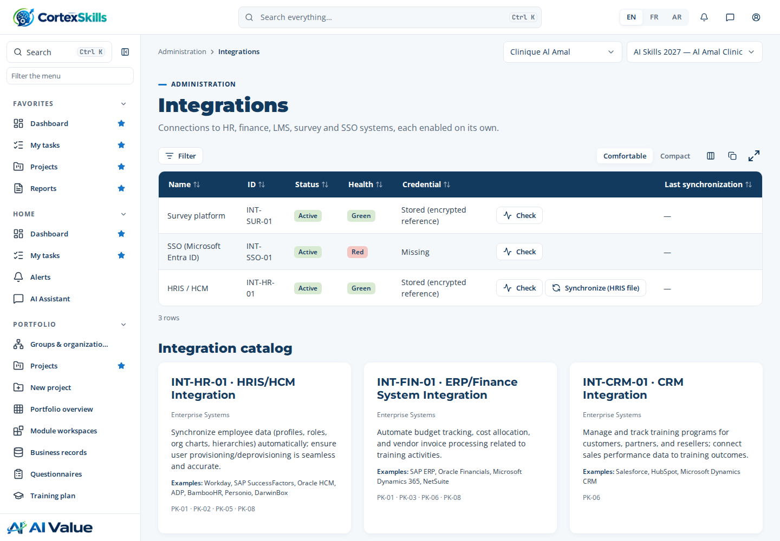
Administration › Integrations: test a connection, synchronise the HRIS

3. The respondents of the case
The questionnaire is sent to the 11 people below, entered at step MP-53.8. Their addresses and numbers are fictitious: for a real trial, replace them before pasting the table (chapter 5, task UFT-32-06) with addresses and numbers that you receive yourself or whose holders have agreed.
Name | E-mail of the case | Phone (WhatsApp) | Level | Preferred channel
Dr Salma Benjelloun | dg.salma@cliniquealamal.ma | +212 6 61 00 00 01 | MS — strategic (management system) | E-mail
Hajar Tazi | hrd@cliniquealamal.ma | +212 6 61 00 00 02 | MS — strategic (management system) | E-mail
Dr Youssef Alaoui | directeur.medical@cliniquealamal.ma | +212 6 61 00 00 03 | MS — strategic (management system) | Hybrid
Nadia Berrada | cadre.sante@cliniquealamal.ma | +212 6 61 00 00 04 | MO — middle management | Hybrid
Omar El Fassi | urgences@cliniquealamal.ma | +212 6 61 00 00 05 | MO — middle management | WhatsApp
Leila Chraibi | qualite@cliniquealamal.ma | +212 6 61 00 00 06 | MO — middle management | E-mail
Samira Ouazzani | infirmiere.urgences@cliniquealamal.ma | +212 6 61 00 00 07 | OP — operational | WhatsApp
Rachid Amrani | radiologie@cliniquealamal.ma | +212 6 61 00 00 08 | OP — operational | WhatsApp
Mehdi Tahiri | infirmier.urgences2@cliniquealamal.ma | +212 6 61 00 00 09 | OP — operational | WhatsApp
Youssra Bennis | infirmiere.hospit@cliniquealamal.ma | +212 6 61 00 00 10 | OP — operational | E-mail
Imane Zerouali | radiologie2@cliniquealamal.ma | +212 6 61 00 00 11 | OP — operational | WhatsApp
Receive every message yourself
With a Gmail address, add “+word” before the @ sign: first.last+ceo@gmail.com, first.last+nurse@gmail.com… All these messages arrive in your mailbox, each with its personal link.
For WhatsApp, use the numbers of volunteer colleagues, in international format (+212 6…).

4. Create the project
Sign in as Head of Learning & Development (headld@cliniquealamal.ma), interface in EN. Menu Portfolio › New project, “From the catalog” tab. The fields are filled in this order:
Field | Value to type or choose
Name | AI Skills 2027 — Al Amal Clinic
Focus | AI
Description | First complete cycle of AI skills development at the clinic: emergency triage and image-reading aid.
Template | Private clinic — simple path — AI skills (6 processes) (group “Your organization”)
Track | Use the recommended track
The “Template” list holds the whole published library: your organization’s templates, those of your sector, the universal templates and those of the other sectors. Finally click “Create project”.
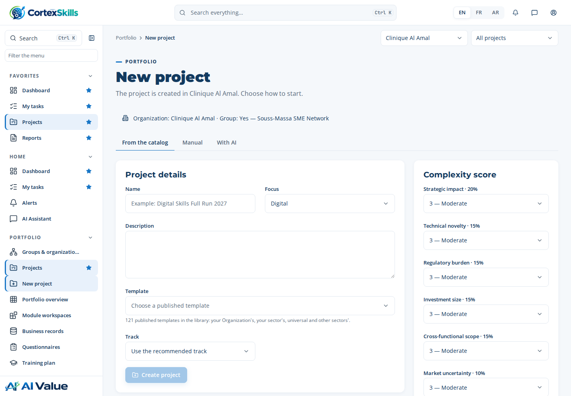
New project: Name, Focus, Description, then Template
The project opens with its six processes and the gates G1, G3 and G5. Open a process, then a task: the task panel opens on the right, with its steps, “Your result” and the “Previous task” / “Next task” buttons.

5. Phase 1 — The scope of work (E2E-32)
Nine tasks set the scope of the mission and record the stakeholders — who become the respondents of the questionnaire.

UFT-32-01 — Define scope frame
Item | Content
Who · Approver | Head of L&D · HR Director
Account to use | headld@cliniquealamal.ma
Input → Output | Engagement request → Scope frame
What to do | Group scope: choose Yes when the organization belongs to a group, No otherwise; then choose the organization of the engagement in the list.
Step MP-53.1 · Define scope frame (Group Yes/No) Form · Head of L&D
Type these values in the step’s form; each field is saved when you leave it. A list is chosen in one click (the choice is saved by that same click).
Field | Value to type or choose
Group scope (required) | Yes — list
Group name | Souss-Massa SME Network
Rationale | The clinic belongs to the group; the mission covers Al Amal Clinic only.
Decision date (required) | 2026-10-16 — date
Decided by (required) | Ayoub Bennani — list

Step MP-53.2 · Select Organization Form · Head of L&D
Type these values in the step’s form; each field is saved when you leave it. A list is chosen in one click (the choice is saved by that same click).
Field | Value to type or choose
Group (required) | Yes — list
Organization (required) | Clinique Al Amal — list
Rationale | Mission limited to the Marrakech clinic (95 employees).
Decision date (required) | 2026-10-16 — date
Decided by (required) | Ayoub Bennani — list

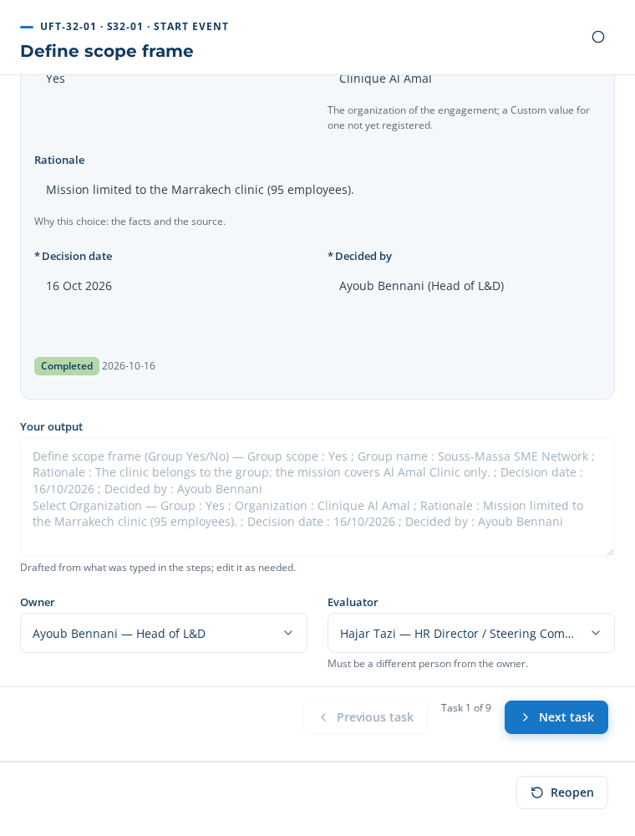
UFT-32-01: the form with its lists, and “Your result” drafted from the steps
Close the task: the “Your result” field is already drafted from what you entered; read it, then click “Complete”. Go to the next task with “Next task”.
Your result (proposed by the application): Define scope frame (Group Yes/No) — Group scope : Yes ; Group name : Souss-Massa SME Network ; Rationale : The clinic belongs to the group; the mission covers Al Amal Clinic only. ; Decision date : 16/10/2026 ; Decided by : Ayoub Bennani / Select Organization — Group : Yes ; Organization : Clinique Al Amal ; Rationale : Mission limited to the Marrakech clinic (95 employees). ; Decision date : 16/10/2026 ; Decided by : Ayoub Bennani

UFT-32-02 — Select sector
Item | Content
Who · Approver | L&D Analyst · Head of L&D
Account to use | headld@cliniquealamal.ma
Input → Output | Sector reference list → Sector
What to do | Sector: choose Healthcare Providers in the list (or a Custom value).
Step MP-53.3 · Select sector Form · L&D Analyst
Type these values in the step’s form; each field is saved when you leave it. A list is chosen in one click (the choice is saved by that same click).
Field | Value to type or choose
Sector (required) | Healthcare Providers — list
Rationale | Private healthcare facility: JCI and ISO 7101 standards.
Decision date (required) | 2026-10-16 — date
Decided by (required) | Ayoub Bennani — list

Close the task: the “Your result” field is already drafted from what you entered; read it, then click “Complete”. Go to the next task with “Next task”.
Your result (proposed by the application): Select sector — Sector : Healthcare Providers ; Rationale : Private healthcare facility: JCI and ISO 7101 standards. ; Decision date : 16/10/2026 ; Decided by : Ayoub Bennani

UFT-32-03 — Select decision levels
Item | Content
Who · Approver | L&D Analyst · Head of L&D
Account to use | headld@cliniquealamal.ma
Input → Output | MS/MO/OP framework → Decision levels
What to do | Decision levels: tick MS, MO and OP when the three levels take part; add a custom level if the organization has one.
Step MP-53.4 · Select decision level (MS/MO/OP/Custom) Form · L&D Analyst
Type these values in the step’s form; each field is saved when you leave it. A list is chosen in one click (the choice is saved by that same click).
Field | Value to type or choose
Decision levels (required) | MS — strategic (management system), MO — middle management, OP — operational — check boxes
Rationale | Management, supervisors and caregivers answer the diagnostic.
Decision date (required) | 2026-10-16 — date
Decided by (required) | Ayoub Bennani — list

Close the task: the “Your result” field is already drafted from what you entered; read it, then click “Complete”. Go to the next task with “Next task”.
Your result (proposed by the application): Select decision level (MS/MO/OP/Custom) — Decision levels : MS — strategic (management system), MO — middle management, OP — operational ; Rationale : Management, supervisors and caregivers answer the diagnostic. ; Decision date : 16/10/2026 ; Decided by : Ayoub Bennani

UFT-32-04 — Map functions × decision levels
Item | Content
Who · Approver | L&D Analyst · Head of L&D
Account to use | headld@cliniquealamal.ma
Input → Output | Job architecture → Criteria matrix
What to do | Matrix: Clinical Care & Nursing × MS/MO/OP; Quality × MO/OP; Finance × MS/MO; HR × MS/MO.
Step MP-53.5 · Map functions × decision level Table to paste · L&D Analyst
Copy this table (✥ handle at the top left, Ctrl+C) and paste it in the step’s table (Ctrl+V), then “Apply”. Required columns: Function.
Function | MS — strategic | MO — middle | OP — operational | Comment
Clinical Care & Nursing | Yes | Yes | Yes | Emergency, inpatient care, imaging
Quality & HSE | No | Yes | Yes | Accreditation, risk management
Human Resources | Yes | Yes | No | Training plan, workforce planning
Information Systems | No | Yes | Yes | Electronic patient record, AI tools
Operations | Yes | Yes | No | General management, admissions

Close the task: the “Your result” field is already drafted from what you entered; read it, then click “Complete”. Go to the next task with “Next task”.
Your result (proposed by the application): Map functions × decision level (5) : / • Clinical Care & Nursing · MS — strategic · MO — middle · OP — operational · Emergency, inpatient care, imaging / • Quality & HSE · MO — middle · OP — operational · Accreditation, risk management …

UFT-32-05 — Select focus and add custom criteria
Item | Content
Who · Approver | Head of L&D · HR Director
Account to use | headld@cliniquealamal.ma
Input → Output | Strategic objectives → Focus and custom criteria
What to do | Focus: AI. Custom criterion: 'Readiness for AI triage and clinical decision support' (weight 2.00).
Step MP-53.6 · Select focus (All/Digital/AI/Custom) Form · Head of L&D
Type these values in the step’s form; each field is saved when you leave it. A list is chosen in one click (the choice is saved by that same click).
Field | Value to type or choose
Orientation (required) | AI — list
Custom orientation (name) | —
Rationale | Management priority: AI-assisted triage and imaging.
Decision date (required) | 2026-10-16 — date
Decided by (required) | Ayoub Bennani — list

Step MP-53.7 · Add custom criteria Table to paste · Consultant PM
Copy this table (✥ handle at the top left, Ctrl+C) and paste it in the step’s table (Ctrl+V), then “Apply”. Required columns: Custom criterion.
Custom criterion | Orientation | Weight | Description | Owner | Source
Readiness for AI-assisted triage in the emergency department | AI | 2 | Ability of the reception teams to use and check the triage proposal. | Ayoub Bennani | Function head
Command of health data protection | AI | 1.5 | Law 09-08 and CNDP rules applied to AI tools. | Ayoub Bennani | Interview
Lists: Orientation = All | Digital | AI | Custom ; Source = HRIS export | Organization chart | Function head | Interview.
Close the task: the “Your result” field is already drafted from what you entered; read it, then click “Complete”. Go to the next task with “Next task”.
Your result (proposed by the application): Select focus (All/Digital/AI/Custom) — Orientation : AI ; Rationale : Management priority: AI-assisted triage and imaging. ; Decision date : 16/10/2026 ; Decided by : Ayoub Bennani / Add custom criteria (2) : / • Readiness for AI-assisted triage in the emergency department · AI · 2 · Ability of the reception teams to use and check the triage proposal. · Ayoub Bennani …

UFT-32-06 — Identify stakeholders
Item | Content
Who · Approver | HR Business Partner · Head of L&D
Account to use | analyst@cliniquealamal.ma
Input → Output | Employee directory → Stakeholder list
What to do | Register each stakeholder of the scope: name, e-mail, phone (WhatsApp, with the country code), role, function, level, site, preferred channel (e-mail, WhatsApp, on site or hybrid). They become the respondents of the questionnaire.
Step MP-53.8 · Identify stakeholders Table to paste · HR Business Partner
The table to paste is on the next page, in landscape.
Step MP-53.8 · Identify stakeholders — wide table, shown in landscape
Copy this table (✥ handle at the top left, Ctrl+C) and paste it in the step’s table (Ctrl+V), then “Apply”. Required columns: Stakeholder name, Role, Function, Level, Preferred channel.
Stakeholder name | E-mail | Phone (WhatsApp) | Role | Function | Level | Site | Preferred channel | Category | Description | Owner | Source
Dr Salma Benjelloun | dg.salma@cliniquealamal.ma | +212 6 61 00 00 01 | Chief Executive Officer | Operations | MS — strategic (management system) | Marrakech | E-mail | Sponsor | Sponsor of the mission; validates the priority areas. | Ayoub Bennani | Organization chart
Hajar Tazi | hrd@cliniquealamal.ma | +212 6 61 00 00 02 | HR Director / steering committee chair | Human Resources | MS — strategic (management system) | Marrakech | E-mail | Decision maker | Chairs the steering committee. | Ayoub Bennani | Organization chart
Dr Youssef Alaoui | directeur.medical@cliniquealamal.ma | +212 6 61 00 00 03 | Medical Director | Clinical Care & Nursing | MS — strategic (management system) | Marrakech | Hybrid | Decision maker | Leads the AI-assisted triage project. | Ayoub Bennani | Organization chart
Nadia Berrada | cadre.sante@cliniquealamal.ma | +212 6 61 00 00 04 | Head nurse | Clinical Care & Nursing | MO — middle management | Marrakech | Hybrid | Change relay | Manages 24 nurses; change relay. | Ayoub Bennani | Organization chart
Omar El Fassi | urgences@cliniquealamal.ma | +212 6 61 00 00 05 | Head of emergency department | Clinical Care & Nursing | MO — middle management | Marrakech | WhatsApp | Respondent | Pilot department of AI triage. | Ayoub Bennani | Organization chart
Leila Chraibi | qualite@cliniquealamal.ma | +212 6 61 00 00 06 | Quality manager | Quality & HSE | MO — middle management | Marrakech | E-mail | Subject-matter expert | Accreditation and risk management lead. | Ayoub Bennani | Organization chart
Samira Ouazzani | infirmiere.urgences@cliniquealamal.ma | +212 6 61 00 00 07 | Nurse | Clinical Care & Nursing | OP — operational | Marrakech | WhatsApp | Respondent | Emergency reception and triage nurse. | Ayoub Bennani | Organization chart
Rachid Amrani | radiologie@cliniquealamal.ma | +212 6 61 00 00 08 | Radiology technician | Clinical Care & Nursing | OP — operational | Marrakech | WhatsApp | Respondent | User of the image-reading aid. | Ayoub Bennani | Organization chart
Mehdi Tahiri | infirmier.urgences2@cliniquealamal.ma | +212 6 61 00 00 09 | Nurse | Clinical Care & Nursing | OP — operational | Marrakech | WhatsApp | Respondent | Emergency reception nurse (night shift). | Ayoub Bennani | Organization chart
Youssra Bennis | infirmiere.hospit@cliniquealamal.ma | +212 6 61 00 00 10 | Nurse | Clinical Care & Nursing | OP — operational | Marrakech | E-mail | Respondent | Inpatient nurse, reinforcement in the emergency department. | Ayoub Bennani | Organization chart
Imane Zerouali | radiologie2@cliniquealamal.ma | +212 6 61 00 00 11 | Radiology technician | Clinical Care & Nursing | OP — operational | Marrakech | WhatsApp | Respondent | Radiographer. | Ayoub Bennani | Organization chart
Lists: Level = MS — strategic (management system) | MO — middle management | OP — operational ; Site = Marrakech ; Preferred channel = E-mail | WhatsApp | On site | Hybrid ; Category = Sponsor | Decision maker | Respondent | Change relay | Subject-matter expert ; Source = HRIS export | Organization chart | Function head | Interview.
What happens when you paste this table
Each row creates the stakeholder record (stakeholder register) with its e-mail, phone, level and preferred channel.
These records are the ones the distribution step (UFT-33-06) proposes as respondents. A Chief Executive Officer receives the “General Manager” form, the MS and MO levels the “Management” form, the OP level the “Team member” form.
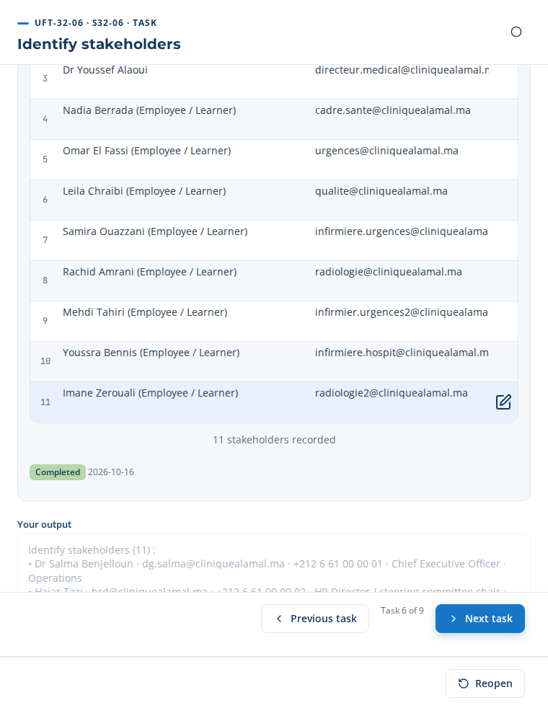
UFT-32-06: the 11 stakeholders recorded
Close the task: the “Your result” field is already drafted from what you entered; read it, then click “Complete”. Go to the next task with “Next task”.
Your result (proposed by the application): Identify stakeholders (11) : / • Dr Salma Benjelloun · dg.salma@cliniquealamal.ma · +212 6 61 00 00 01 · Chief Executive Officer · Operations / • Hajar Tazi · hrd@cliniquealamal.ma · +212 6 61 00 00 02 · HR Director / steering committee chair · Human Resources …

UFT-32-07 — Validate scope
Item | Content
Who · Approver | Head of L&D · HR Director
Account to use | headld@cliniquealamal.ma
Input → Output | Draft scope → Validated scope
What to do | Validation: check that every function in scope has at least one stakeholder and that each stakeholder has an e-mail or a phone.
Step MP-53.9 · Validate and approve scope Form · HR Director
Type these values in the step’s form; each field is saved when you leave it. A list is chosen in one click (the choice is saved by that same click).
Field | Value to type or choose
Decision (required) | Approved — list
Scope (required) | {object}
Rationale (required) | Every function in scope has at least one respondent; completeness 100%.
Conditions | —
Decision date (required) | 2026-10-16 — date
Decided by | Ayoub Bennani — list

Close the task: the “Your result” field is already drafted from what you entered; read it, then click “Complete”. Go to the next task with “Next task”.
Your result (proposed by the application): Validate and approve scope — Decision : Approved ; Scope : Scope ; Rationale : Every function in scope has at least one respondent; completeness 100%. ; Decision date : 16/10/2026 ; Decided by : Ayoub Bennani

UFT-32-08 — Approve scope
Item | Content
Who · Approver | HR Director / Consultant PM · HR Director
Account to use | hrd@cliniquealamal.ma
Input → Output | Validated scope → Approved Scope of Work
What to do | Approval status: Approved (version 1). Justification: scope aligned with SO-1 and SO-2.
Step MP-53.9 · Validate and approve scope Form · HR Director
Type these values in the step’s form; each field is saved when you leave it. A list is chosen in one click (the choice is saved by that same click).
Field | Value to type or choose
Decision (required) | Approved — list
Scope (required) | {object}
Rationale (required) | Scope aligned with the clinic’s 2027 medical project.
Conditions | —
Decision date (required) | 2026-10-16 — date
Decided by | Hajar Tazi — list

Step MP-53.10 · Publish scope and register stakeholders Work panel · System
Step MP-53.10 is a work panel: click “Generate a new version” to produce the scope of work (template DT-E2E-32). Each generation creates a dated version; each version downloads as DOCX, PDF or XLSX, and the standard report RPT-033 downloads as PDF, DOCX or XLSX. The “Documents” tab of each task gives the documents of its process.
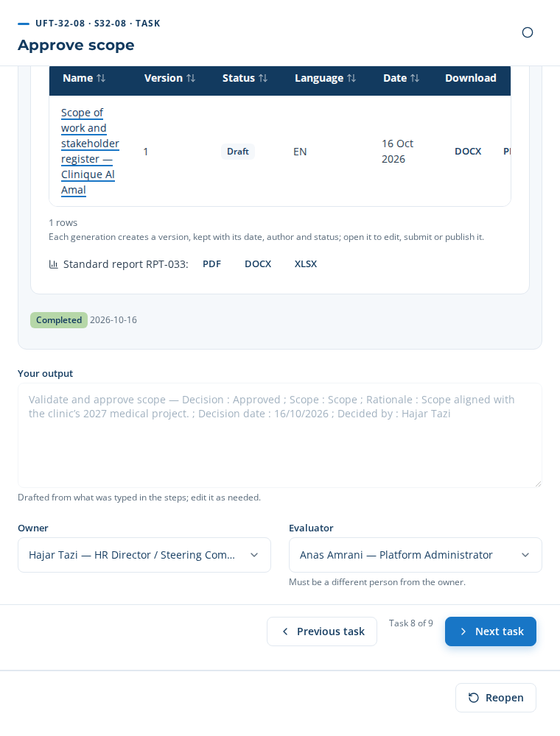
MP-53.10: the generated document, its version, its formats
Close the task: the “Your result” field is already drafted from what you entered; read it, then click “Complete”. Go to the next task with “Next task”.
Your result (proposed by the application): Validate and approve scope — Decision : Approved ; Scope : Scope ; Rationale : Scope aligned with the clinic’s 2027 medical project. ; Decision date : 16/10/2026 ; Decided by : Hajar Tazi

UFT-32-09 — Publish scope and register stakeholders
Item | Content
Who · Approver | L&D Analyst · Head of L&D
Account to use | analyst@cliniquealamal.ma
Input → Output | Approved Scope of Work → Published SOW and stakeholder register
What to do | Generate the scope of work document (DT-E2E-32, with report RPT-033) in the step; the stakeholders are released to the questionnaire.
Step MP-53.10 · Publish scope and register stakeholders Work panel · System
Close the task: the “Your result” field is already drafted from what you entered; read it, then click “Complete”. Go to the next task with “Next task”.
Your result (proposed by the application): Generate the scope of work document (DT-E2E-32, with report RPT-033) in the step; the stakeholders are released to the questionnaire.

6. Phase 1 — The questionnaire campaign (E2E-33)
Twelve tasks run the campaign end to end, on the project’s real questionnaire: “Questionnaire campaign — AI Skills 2027 — Al Amal Clinic”. The work-panel steps show the questionnaire itself — its questions, its respondents, the messages sent and the answers received.

UFT-33-01 — Select questionnaire template
Item | Content
Who · Approver | L&D Analyst · Head of L&D
Account to use | analyst@cliniquealamal.ma
Input → Output | Approved SOW → Selected template
What to do | Templates: choose one questionnaire template per population (general management, management, staff); the questionnaire of the project is created from them when the step is completed.
Step MP-54.1 · Select questionnaire template by focus Form · L&D Analyst
Type these values in the step’s form; each field is saved when you leave it. A list is chosen in one click (the choice is saved by that same click).
Field | Value to type or choose
Decision (required) | Approved — list
Questionnaire templates (required) | QT-IFPAC-DG — IF-PAC form — General Manager workshop, QT-IFPAC-MGT — IF-PAC form — Management (directors, managers, process owners), QT-IFPAC-MBR — IF-PAC form — Team member — check boxes
Rationale | One form per population: general management (workshop), management (supervisors) and employees (caregivers).
Decision date (required) | 2026-10-16 — date
Decided by (required) | Karim Tazi — list

When the step is completed, the project’s questionnaire is created with the three forms chosen; the “Open the questionnaire” link appears in the step.
Form | Population | Sections | Questions and tables
IF-PAC form — General Manager workshop | General management | 18 | 96
IF-PAC form — Management (directors, managers, process owners) | Management | 16 | 81
IF-PAC form — Team member | Team members | 11 | 58
Close the task: the “Your result” field is already drafted from what you entered; read it, then click “Complete”. Go to the next task with “Next task”.
Your result (proposed by the application): Select questionnaire template by focus — Decision : Approved ; Questionnaire templates : QT-IFPAC-DG — IF-PAC form — General Manager workshop, QT-IFPAC-MGT — IF-PAC form — Management (directors, managers, process owners), QT-IFPAC-MBR — IF-PAC form — Team member ; Rationale : One form per population: general management (workshop), management (supervisors) and employees (caregivers). ; Decision date : 16/10/2026 ; Decided by : Karim Tazi

UFT-33-02 — Elaborate questionnaire
Item | Content
Who · Approver | L&D Analyst · Head of L&D
Account to use | analyst@cliniquealamal.ma
Input → Output | Template, AI prompts → Draft questionnaire
What to do | Questions: read the questions loaded from the templates, generate the AI questions tailored to Healthcare Providers and the AI focus, and add your own questions where needed.
Step MP-54.2 · Elaborate questionnaire (Load/AI/Manual) Work panel · L&D Analyst
The panel lists every question of each form, section by section (the full list is in appendix A). Three actions:
- Template questions: they are loaded from the three templates chosen at the previous step.
- “Tailor with AI”: adds to each form a “Sector-specific questions” section generated for healthcare facilities and the AI focus, marked AI and to be validated by a person.
- “Add a question”: in the section of your choice; type the text, then “Save”.
The questions generated by AI in this case (Team member form):
No. | Question | Origin
1 | In your department, how often do you use a digital tool to direct a patient at the emergency reception? | AI (to validate)
2 | What prevents you today from using AI medical imaging assistance in Clinical Care & Nursing? | AI (to validate)
3 | Which ISO 7101 requirements should a training on AI triage and clinical decision support cover? | AI (to validate)
4 | Which skills do you need to apply AI bed and staff capacity planning safely? | AI (to validate)
5 | How would you prefer to learn: classroom, e-learning, coaching or on the job? | AI (to validate)
6 | Which emergency triage tasks would you like AI to assist with, and which must remain entirely human? | Added manually
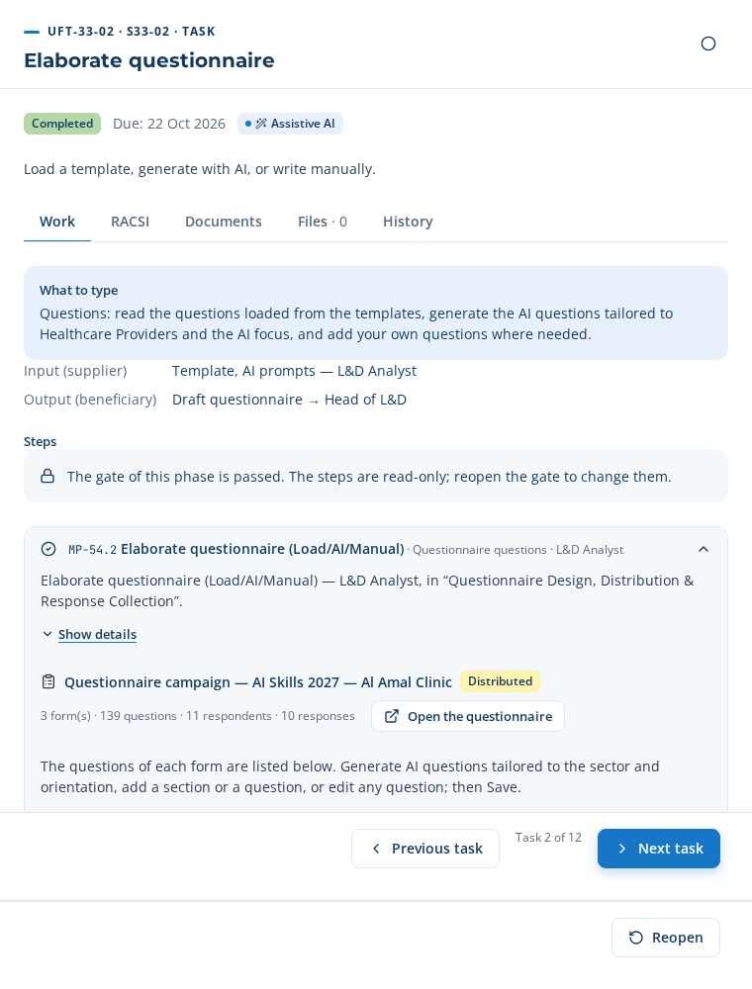
UFT-33-02: the project’s questionnaire in the step
Close the task: the “Your result” field is already drafted from what you entered; read it, then click “Complete”. Go to the next task with “Next task”.
Your result (proposed by the application): Questions: read the questions loaded from the templates, generate the AI questions tailored to Healthcare Providers and the AI focus, and add your own questions where needed.

UFT-33-03 — Tailor and validate content
Item | Content
Who · Approver | L&D Analyst · Head of L&D
Account to use | analyst@cliniquealamal.ma
Input → Output | Draft questionnaire → Validated questionnaire
What to do | Validate each AI question, reword questions in the vocabulary of Clinical Care & Nursing, delete duplicates, then save.
Step MP-54.3 · Tailor to sector and focus Work panel · L&D Analyst
Validate each AI question (✓) or all at once (“Validate all”), reword as needed, delete duplicates, then “Save”. In this case, one question was reworded with the vocabulary of the emergency department:
Before (AI) | After (reworded)
How often do you use AI triage and clinical decision support in your work today, and for which tasks? | In your department, how often do you use a digital tool to direct a patient at the emergency reception?
The step only completes when no AI question is left to validate.
Close the task: the “Your result” field is already drafted from what you entered; read it, then click “Complete”. Go to the next task with “Next task”.
Your result (proposed by the application): Validate each AI question, reword questions in the vocabulary of Clinical Care & Nursing, delete duplicates, then save.

UFT-33-04 — Allocate RACSI
Item | Content
Who · Approver | Head of L&D · HR Director
Account to use | headld@cliniquealamal.ma
Input → Output | Validated questionnaire → RACSI allocation
What to do | RACSI: one row per role, tick R, A, C, S or I; exactly one A per section.
Step MP-54.4 · Allocate RACSI per section Table to paste · Head of L&D
Copy this table (✥ handle at the top left, Ctrl+C) and paste it in the step’s table (Ctrl+V), then “Apply”. Required columns: Role.
Role | R — Responsible | A — Accountable | C — Consulted | S — Support | I — Informed | Sections | Comment
L&D Analyst | Yes | No | No | No | No |  | Designs and follows the questionnaire
Head of L&D | No | Yes | No | No | No |  | A single A per section
Consultant (PM / Partner) | No | No | Yes | No | No
Manager / Hiring Manager | No | No | No | Yes | No |  | Reminds their teams
HR Director / Steering Committee Chair | No | No | No | No | Yes

The RACSI is written one row per role: tick R, A, C, S or I. An empty Sections column means “all sections”. On completion, the application checks there is exactly one A per section and writes the RACSI into each section of the questionnaire.
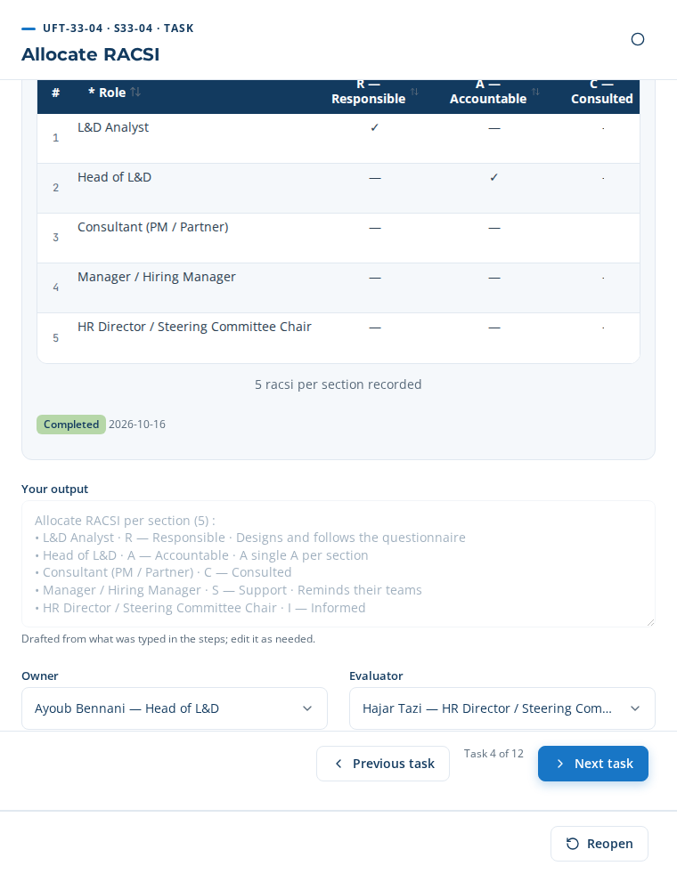
UFT-33-04: the RACSI per role, R A C S I in columns
Close the task: the “Your result” field is already drafted from what you entered; read it, then click “Complete”. Go to the next task with “Next task”.
Your result (proposed by the application): Allocate RACSI per section (5) : / • L&D Analyst · R — Responsible · Designs and follows the questionnaire / • Head of L&D · A — Accountable · A single A per section …

UFT-33-05 — Select distribution channels
Item | Content
Who · Approver | Survey Administrator · Head of L&D
Account to use | analyst@cliniquealamal.ma
Input → Output | Stakeholder register → Channel plan
What to do | Channels: for each decision level, the preferred channels in their order of use (the first invites, the next ones remind) and the reminder cadence.
Step MP-54.5 · Select distribution channels Table to paste · L&D Analyst
Copy this table (✥ handle at the top left, Ctrl+C) and paste it in the step’s table (Ctrl+V), then “Apply”. Required columns: Decision level, Preferred channels.
Decision level | Preferred channels | Population | Reminder every (days) | Number of reminders | Comment
MS — strategic (management system) | E-mail, Face to face (on site) | Management | 3 | 2 | Face-to-face workshop for management
MO — middle management | E-mail, WhatsApp | Management | 3 | 2
OP — operational | WhatsApp, E-mail | Staff member | 2 | 2 | Caregivers on shifts
Lists: Decision level = MS — strategic (management system) | MO — middle management | OP — operational ; Preferred channels = E-mail | WhatsApp | Face to face (on site) | In the application (several choices, separated by commas) ; Population = General management | Management | Staff member.
The channels are chosen per decision level, in their order of use: the first invites, the next ones remind at the chosen pace; “Face-to-face” adds an interview after the reminders. Here are the plans obtained for the respondents of the case:
Respondent | Population | Channel plan (day)
Dr Salma Benjelloun | Management | E-mail D+0 → E-mail D+3 → E-mail D+6 → Face-to-face D+9
Dr Youssef Alaoui | Management | E-mail D+0 → E-mail D+3 → E-mail D+6 → Face-to-face D+9
Hajar Tazi | Management | E-mail D+0 → E-mail D+3 → E-mail D+6 → Face-to-face D+9
Leila Chraibi | Management | E-mail D+0 → WhatsApp D+3 → WhatsApp D+6
Nadia Berrada | Management | E-mail D+0 → WhatsApp D+3 → WhatsApp D+6
Omar El Fassi | Management | E-mail D+0 → WhatsApp D+3 → WhatsApp D+6
Imane Zerouali | Team member | WhatsApp D+0 → E-mail D+2 → E-mail D+4
Mehdi Tahiri | Team member | WhatsApp D+0 → E-mail D+2 → E-mail D+4
Rachid Amrani | Team member | WhatsApp D+0 → E-mail D+2 → E-mail D+4
Samira Ouazzani | Team member | WhatsApp D+0 → E-mail D+2 → E-mail D+4
Youssra Bennis | Team member | WhatsApp D+0 → E-mail D+2 → E-mail D+4
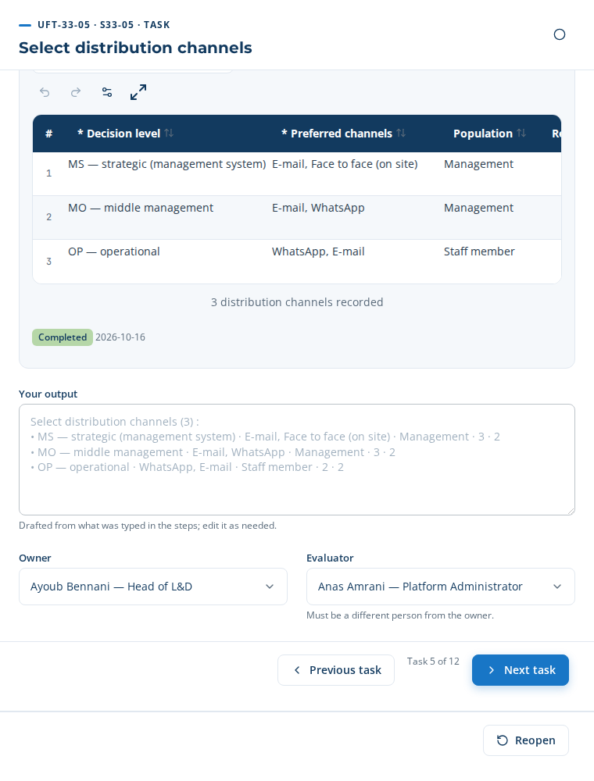
UFT-33-05: preferred channels, multiple choice
Close the task: the “Your result” field is already drafted from what you entered; read it, then click “Complete”. Go to the next task with “Next task”.
Your result (proposed by the application): Select distribution channels (3) : / • MS — strategic (management system) · E-mail, Face to face (on site) · Management · 3 · 2 / • MO — middle management · E-mail, WhatsApp · Management · 3 · 2 …

UFT-33-06 — Distribute questionnaire
Item | Content
Who · Approver | Survey Administrator · Head of L&D
Account to use | analyst@cliniquealamal.ma
Input → Output | Channel plan → Dispatch log
What to do | Add the stakeholders as respondents, check their e-mail and phone, then distribute: each respondent receives a personal link by e-mail or WhatsApp.
Step MP-54.6 · Distribute to stakeholders Work panel · System
The panel shows the state of the channels (live or sandbox), the “Who answers” list, then “Assign sections, sub-sections and questions”. Three actions, in this order:
- “Add respondents”: tick “Select all”: the stakeholders of UFT-32-06 are added, each with their form and channel plan.
- Assign the questions: choose who receives each section, sub-section or question (see below). Without an assignment, each respondent receives their whole form.
- “Distribute now to 11 respondent(s)”: each respondent immediately receives their first message, with their personal link to their own questions only.

Assign the sections, sub-sections and questions to the respondents
A form is made of sections; the questions of a section can be grouped in sub-sections (for example the three process families of the “Cross-functional process management” grid). Each element can be given to one or more respondents. The rule:
- A question goes to the respondents chosen for it; otherwise to those of its sub-section; otherwise to those of its section.
- An element left empty (“All”) goes to every respondent of the form.
- A section with no question meant for a respondent disappears from their form; their personal link opens only their questions, and their completeness is computed on those questions only.
Where: in step MP-54.6 (under the list of respondents), or in the questionnaire, “Who answers what” tab. Choose the form (General Manager, Management, Team member) at the top of the panel; each row is a section, a sub-section or a question, with its list of respondents to tick.
Three ways to fill it, all three used in this case:
1. “Automatic proposal”. The application proposes an assignment from the role and function of each respondent: the HR section to the HR function, the questions that name a field (triage, imaging, planning…) to the positions of that field. It only proposes strict subsets. In this case, 9 elements proposed, accepted then saved:
Form | Level | Element | Respondents | Reason
Management | Section | HR orientations (HR function only) | Hajar Tazi | HR function
Management | Question | How often do you use AI triage and clinical decision support in your work today, and for which tasks? | Dr Youssef Alaoui, Nadia Berrada, Omar El Fassi | Job title
Management | Question | What prevents you today from using AI medical imaging assistance in Clinical Care & Nursing? | Dr Youssef Alaoui | Job title
Management | Question | Which ISO 7101 requirements should a training on AI triage and clinical decision support cover? | Dr Youssef Alaoui, Nadia Berrada, Omar El Fassi | Job title
Management | Question | Which skills do you need to apply AI bed and staff capacity planning safely? | Dr Youssef Alaoui, Hajar Tazi, Leila Chraibi, Nadia Berrada, Omar El Fassi | Job title
Team members | Question | In your department, how often do you use a digital tool to direct a patient at the emergency reception? | Mehdi Tahiri, Samira Ouazzani, Youssra Bennis | Job title
Team members | Question | What prevents you today from using AI medical imaging assistance in Clinical Care & Nursing? | Imane Zerouali, Rachid Amrani | Job title
Team members | Question | Which ISO 7101 requirements should a training on AI triage and clinical decision support cover? | Mehdi Tahiri, Samira Ouazzani, Youssra Bennis | Job title
Team members | Question | Which emergency triage tasks would you like AI to assist with, and which must remain entirely human? | Mehdi Tahiri, Samira Ouazzani, Youssra Bennis | Job title
2. Manual change. Open the list of a row, tick or untick respondents, then “Save”. Three changes in this case:
Level | Element | Respondents kept | Why
Question | Which emergency triage tasks would you like AI to assist with, and which must remain enti… | Mehdi Tahiri, Samira Ouazzani | Youssra Bennis works on the inpatient ward: she does not triage at the emergency reception.
Sub-section | Production equipment / network infrastructure | Dr Youssef Alaoui, Leila Chraibi | Equipment and capacity: medical management and quality.
Sub-section | Products / services / marketing / PLM | Dr Youssef Alaoui | Care offering: medical management.
3. “Paste a table”. One row per element: level (optional), element as displayed, respondents (names, e-mails or job titles, separated by commas). Copy from Excel (columns separated by a tab) or separate with semicolons. “Check” flags the rows not understood; “Apply” adds them to the assignment. Table pasted in this case:
Level | Element | Respondents
Section | Performance by function and decision level (1 – 5; 5: highest) | Dr Youssef Alaoui, Hajar Tazi
Section | Projects under way | Head nurse, Head of emergency department, Quality manager
Result: 2 row(s) read, 2 element(s) assigned, 0 row(s) not understood. A job title (“Head nurse”) means every respondent who holds that position; an element present in several forms (“Projects under way”) is assigned in the form of the respondents named.
What each respondent receives. The “What each respondent receives” table, under the assignment, counts the questions and sections received; the eye opens the form exactly as the respondent will see it. The application refuses the distribution while a respondent receives no question.
Respondent | Form | Questions received | Sections received
Dr Salma Benjelloun | Management | 65 / 81 | 13 / 16
Dr Youssef Alaoui | Management | 79 / 81 | 14 / 16
Hajar Tazi | Management | 68 / 81 | 15 / 16
Leila Chraibi | Management | 73 / 81 | 14 / 16
Nadia Berrada | Management | 69 / 81 | 14 / 16
Omar El Fassi | Management | 69 / 81 | 14 / 16
Imane Zerouali | Team members | 55 / 58 | 11 / 11
Mehdi Tahiri | Team members | 57 / 58 | 11 / 11
Rachid Amrani | Team members | 55 / 58 | 11 / 11
Samira Ouazzani | Team members | 57 / 58 | 11 / 11
Youssra Bennis | Team members | 56 / 58 | 11 / 11
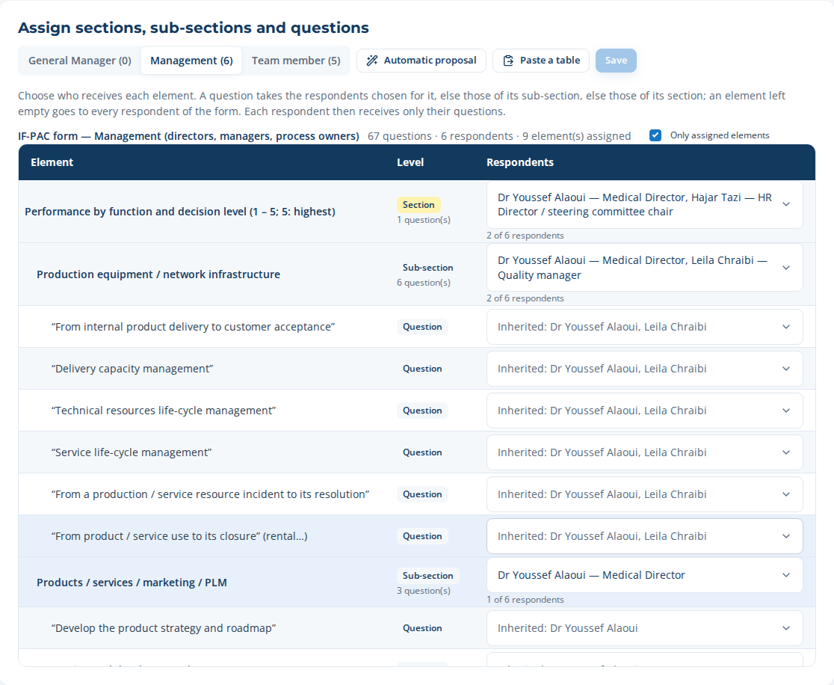
Who answers what: Management form, assigned elements only
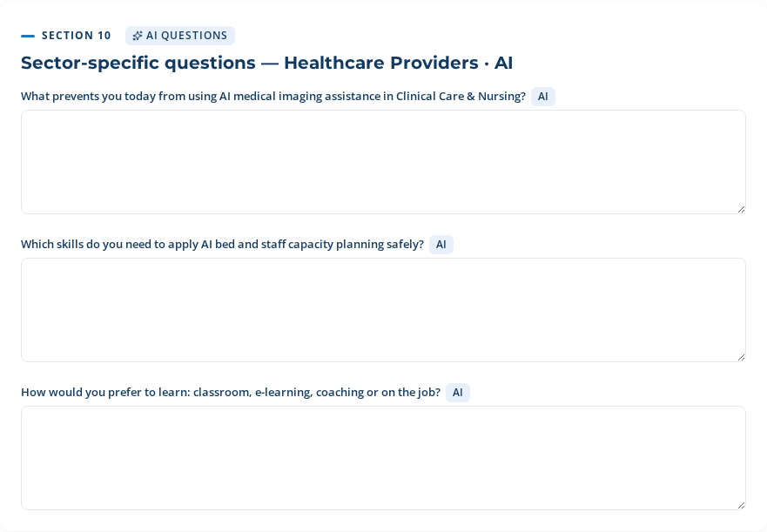
Preview (the eye): Rachid Amrani, radiology technician, receives only 3 of the sector-specific questions — the triage questions go to the nurses
The message actually sent by e-mail (example):
Subject: Clinique Al Amal — Questionnaire campaign — AI Skills 2027 — Al Amal Clinic: your input is requested
Hello Leila Chraibi,
Clinique Al Amal is preparing its training plan and would value your input in the questionnaire “Questionnaire campaign — AI Skills 2027 — Al Amal Clinic”.
Answer online, at your own pace (your draft is saved): https://competences.cliniquealamal.ma/respond/<personal link>
Deadline: 6 November 2026.
Your answers are used only for the training engineering of Clinique Al Amal and are stored only after your consent. Reply STOP to stop these messages.
And by WhatsApp (with the approved template, the same information fills its variables):
Hello Imane Zerouali,
Clinique Al Amal is preparing its training plan and would value your input in the questionnaire “Questionnaire campaign — AI Skills 2027 — Al Amal Clinic”.
Answer online, at your own pace (your draft is saved): https://competences.cliniquealamal.ma/respond/<personal link>
Deadline: 6 November 2026.
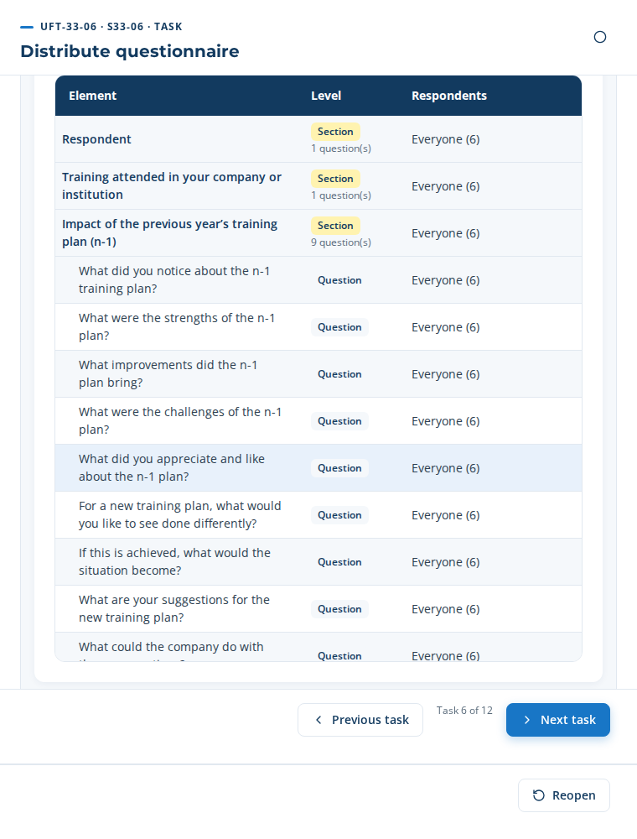
UFT-33-06: the respondents, their contact details and their channel plan
Close the task: the “Your result” field is already drafted from what you entered; read it, then click “Complete”. Go to the next task with “Next task”.
Your result (proposed by the application): Add the stakeholders as respondents, check their e-mail and phone, then distribute: each respondent receives a personal link by e-mail or WhatsApp.

UFT-33-07 — Send reminders
Item | Content
Who · Approver | Survey Administrator · Head of L&D
Account to use | analyst@cliniquealamal.ma
Input → Output | Dispatch log → Reminder log
What to do | Follow the respondents who have not answered; send the reminders now if needed (they also leave at the chosen cadence).
Step MP-54.7 · Send reminders on cadence Work panel · System
The panel counts the respondents still to answer. Reminders leave by themselves at the pace of step MP-54.5; “Send the reminders now” sends one immediately to each respondent who has not answered (in this case: 11 sent, 0 failed). The log at the bottom of the panel lists each message with its delivery status (sent, delivered, read, failed).
Close the task: the “Your result” field is already drafted from what you entered; read it, then click “Complete”. Go to the next task with “Next task”.
Your result (proposed by the application): Follow the respondents who have not answered; send the reminders now if needed (they also leave at the chosen cadence).

UFT-33-08 — Collect responses
Item | Content
Who · Approver | Stakeholders · Survey Administrator
Account to use | analyst@cliniquealamal.ma
Input → Output | Questionnaire → Raw responses
What to do | Responses arrive when respondents submit their form; capture the face-to-face interviews in the application.
Step MP-54.8 · Collect responses Work panel · Stakeholder

What the respondent sees
- They open their link (e-mail or WhatsApp): the page opens in their language, with their name and the deadline, and shows only the questions assigned to them.
- They tick “I agree that my answers are recorded and used”: without consent, nothing is recorded.
- They answer section by section; “Save draft” lets them come back later; the “Filled” bar shows their progress.
- They click “Send my answers”: “Thank you, your answers have been recorded.”
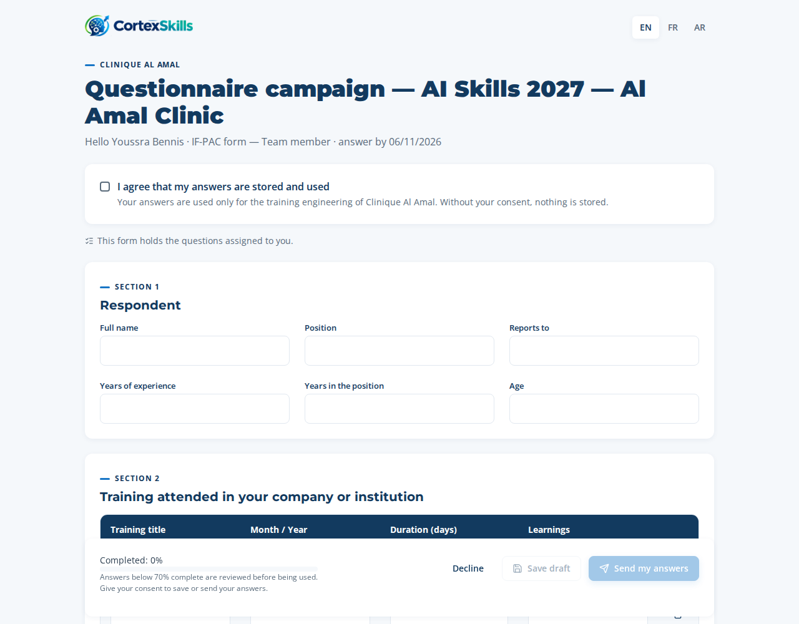
The respondent’s page: consent, then the sections of the form
In this case, 10 respondents out of 11 answered from their link. For a face-to-face interview (general management), the “Enter the answers (interview)” button of the respondents list opens the same form for the interviewer.
Respondent | Form
Dr Salma Benjelloun | Management
Dr Youssef Alaoui | Management
Hajar Tazi | Management
Leila Chraibi | Management
Nadia Berrada | Management
Omar El Fassi | Management
Imane Zerouali | Team members
Mehdi Tahiri | Team members
Rachid Amrani | Team members
Samira Ouazzani | Team members
Close the task: the “Your result” field is already drafted from what you entered; read it, then click “Complete”. Go to the next task with “Next task”.
Your result (proposed by the application): Responses arrive when respondents submit their form; capture the face-to-face interviews in the application.

UFT-33-09 — Validate completeness
Item | Content
Who · Approver | L&D Analyst · Head of L&D
Account to use | analyst@cliniquealamal.ma
Input → Output | Raw responses → Validated responses
What to do | Completeness: review the responses below the threshold and include or exclude them with a justification.
Step MP-54.9 · Validate completeness and consent Work panel · System
Result of the case: 11 respondents, 10 responses, response rate 91%, completeness 100%. A response under the 70% threshold is flagged; “Include” / “Exclude” asks for a justification.
Close the task: the “Your result” field is already drafted from what you entered; read it, then click “Complete”. Go to the next task with “Next task”.
Your result (proposed by the application): Completeness: review the responses below the threshold and include or exclude them with a justification.

UFT-33-10 — Consolidate responses
Item | Content
Who · Approver | L&D Analyst · Head of L&D
Account to use | analyst@cliniquealamal.ma
Input → Output | Validated responses → Consolidated dataset
What to do | Consolidated dataset: check the results by population, function and level.
Step MP-54.10 · Consolidate responses Work panel · System
The consolidated dataset groups the included responses by population, function and level. The competencies cited most in this case:
Competency | Mentions | Populations
Communication with the team | 26 | Management, Team members
Problem solving | 26 | Management, Team members
AI medical imaging assistance | 20 | Management, Team members
Time management and priorities | 19 | Management, Team members
AI triage and clinical decision support | 18 | Management, Team members
ISO 7101 requirements | 16 | Management, Team members
Dashboards | 16 | Management, Team members
AI bed and staff capacity planning | 14 | Management, Team members
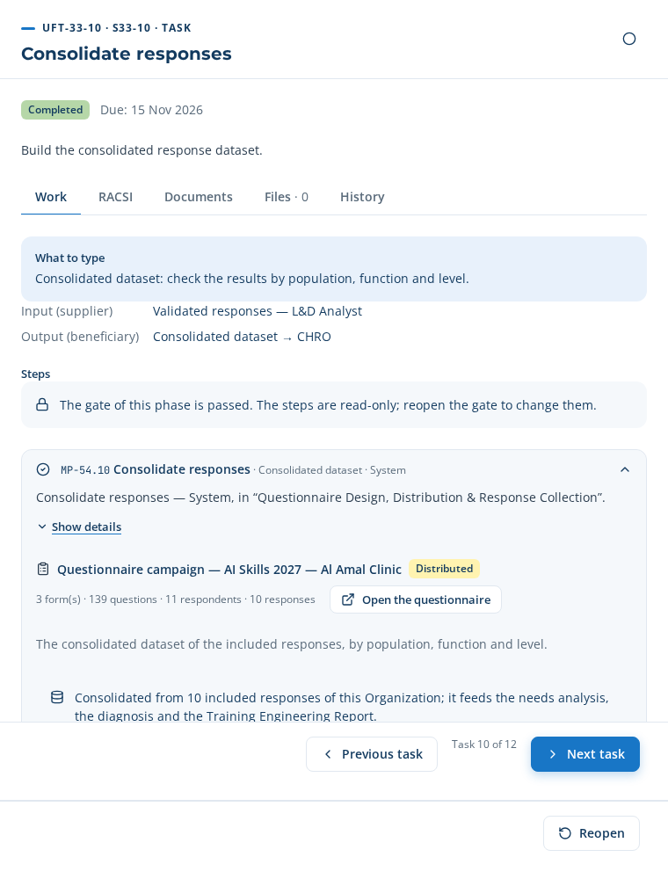
UFT-33-10: the consolidated dataset
Close the task: the “Your result” field is already drafted from what you entered; read it, then click “Complete”. Go to the next task with “Next task”.
Your result (proposed by the application): Consolidated dataset: check the results by population, function and level.

UFT-33-11 — Check consent and release dataset
Item | Content
Who · Approver | L&D Analyst · Head of L&D
Account to use | analyst@cliniquealamal.ma
Input → Output | Consolidated dataset → Released dataset
What to do | Send the dataset to the needs analysis (training needs are created), then generate the campaign report.
Step MP-54.11 · Feed responses to needs analysis and diagnostic Work panel · System
Step MP-54.12 · Report on response rate and engagement Work panel · L&D Analyst
“Send to the needs analysis” creates the project’s training needs from the competencies cited (in this case: 12 needs created from 10 responses). Step MP-54.12 then generates the campaign report (document DT-E2E-33, report RPT-034), downloadable as DOCX, PDF or XLSX.
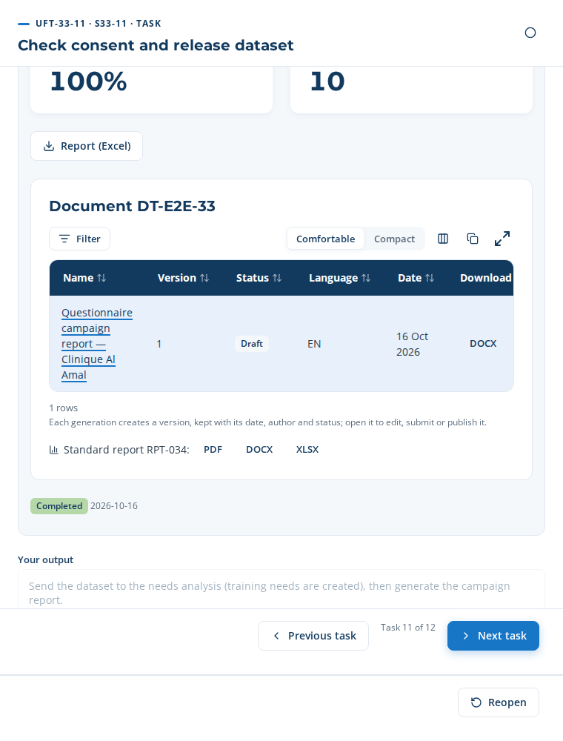
The campaign report: indicators, document and formats
Close the task: the “Your result” field is already drafted from what you entered; read it, then click “Complete”. Go to the next task with “Next task”.
Your result (proposed by the application): Send the dataset to the needs analysis (training needs are created), then generate the campaign report.

UFT-33-12 — Report on response and engagement
Item | Content
Who · Approver | L&D Analyst · Head of L&D
Account to use | analyst@cliniquealamal.ma
Input → Output | Dispatch and response logs → Response analytics report
What to do | Report the response rate, the engagement rate and the completeness (document DT-E2E-33 and report RPT-034).
Step MP-54.12 · Report on response rate and engagement Work panel · L&D Analyst
Close the task: the “Your result” field is already drafted from what you entered; read it, then click “Complete”. Go to the next task with “Next task”.
Your result (proposed by the application): Report the response rate, the engagement rate and the completeness (document DT-E2E-33 and report RPT-034).

Gate G1 — Scope & evidence approved
Sign in as HR Director (hrd@cliniquealamal.ma). In the project, open the gate checklist, tick each point checked, then decide “Go” with a justification. The tasks of the next phase only start after this “Go”.
Point to check | Ticked
Scope frame recorded (Group Yes/No, Organization, sector) | Yes
Decision levels and functions mapped in the criteria matrix | Yes
Stakeholder register complete with channels | Yes
Every AI-generated question validated by a person | Yes
Consent confirmed for every stored response | Yes
Decision: Go — Scope approved, 10 responses out of 11 collected and consolidated.

7. Phase 2 — The skill-gap diagnosis (E2E-02)
From the needs created by the campaign, the analyst formalises the competency framework, assesses the levels and computes the gaps.

UFT-02-01 — Maintain competency framework
Who: L&D Analyst (approver: Head of L&D) · account analyst@cliniquealamal.ma · Input → output: Job architecture → Competency framework
Step MP-02.1 · Define competency families and levels Table to paste · L&D Analyst
Three ways: Manual — type or paste the rows · From the template ✓ — 5 row(s) proposed · AI — 8 row(s) proposed (use case AIUC-F01)
In the case: From the template (proposal edited before being saved) — The template proposes the AI themes of the sector; the line on AI bed and staff planning was deleted (out of the scope of this first cycle) and the codes renumbered C-01 to C-04.
Copy this table (✥ handle at the top left, Ctrl+C) and paste it in the step’s table (Ctrl+V), then “Apply”. Required columns: Competency, Family.
Code | Competency | Family | What mastery looks like | Level scale | Owner | Source
C-01 | AI triage and clinical decision support | AI | Competency “AI triage and clinical decision support”: uses the AI tool in daily work, checks each suggestion against clinical judgement and records the decision. | 1-4 | Karim Tazi | Sector library
C-02 | AI medical imaging assistance | AI | Competency “AI medical imaging assistance”: uses the AI tool in daily work, checks each suggestion against clinical judgement and records the decision. | 1-4 | Karim Tazi | Sector library
C-03 | Ethics and protection of health data when using AI | Regulatory | Competency “Ethics and protection of health data when using AI”: knows and applies the rules of the domain and knows when to alert. | 1-4 | Karim Tazi | Sector library
C-04 | Critical thinking about AI results | Behavioural | Competency “Critical thinking about AI results”: shows it in practice and explains the reasons of each decision. | 1-4 | Karim Tazi | Sector library
Lists: Family = Technical | Behavioural | Managerial | Digital | AI | Regulatory ; Source = Needs questionnaire | Sector library | Job description | Interview.
Close the task: “Your result” is drafted from the steps; read it, then “Complete” and “Next task”.

UFT-02-02 — Set target levels per position
Who: HR Business Partner (approver: Head of L&D) · account analyst@cliniquealamal.ma · Input → output: Competency framework → Position targets
Step MP-02.2 · Set target levels per position Table to paste · HR Business Partner
Three ways: Manual — type or paste the rows · From the template — 20 row(s) proposed · AI ✓ — 14 row(s) proposed (use case AIUC-F02)
In the case: AI proposal — AI links each competency to the positions concerned (triage for emergency and care, imaging for radiology) and proposes the criticality.
Copy this table (✥ handle at the top left, Ctrl+C) and paste it in the step’s table (Ctrl+V), then “Apply”. Required columns: Position, Competency, Target level.
Position | Competency | Target level | Criticality | Headcount | Deadline | Owner
Head nurse | C-01 — AI triage and clinical decision support | 3 — Autonomous | Critical | 1 | 2026-12-31 | Karim Tazi
Head nurse | C-03 — Ethics and protection of health data when using AI | 3 — Autonomous | Important | 1 | 2026-12-31 | Karim Tazi
Head nurse | C-04 — Critical thinking about AI results | 3 — Autonomous | Useful | 1 | 2026-12-31 | Karim Tazi
Head of emergency department | C-01 — AI triage and clinical decision support | 3 — Autonomous | Critical | 1 | 2026-12-31 | Karim Tazi
Head of emergency department | C-03 — Ethics and protection of health data when using AI | 3 — Autonomous | Important | 1 | 2026-12-31 | Karim Tazi
Head of emergency department | C-04 — Critical thinking about AI results | 3 — Autonomous | Useful | 1 | 2026-12-31 | Karim Tazi
Quality manager | C-03 — Ethics and protection of health data when using AI | 3 — Autonomous | Important | 1 | 2026-12-31 | Karim Tazi
Quality manager | C-04 — Critical thinking about AI results | 3 — Autonomous | Useful | 1 | 2026-12-31 | Karim Tazi
Nurse | C-01 — AI triage and clinical decision support | 3 — Autonomous | Critical | 3 | 2026-12-31 | Karim Tazi
Nurse | C-03 — Ethics and protection of health data when using AI | 2 — Practice with support | Important | 3 | 2026-12-31 | Karim Tazi
Nurse | C-04 — Critical thinking about AI results | 2 — Practice with support | Useful | 3 | 2026-12-31 | Karim Tazi
Radiology technician | C-02 — AI medical imaging assistance | 3 — Autonomous | Critical | 2 | 2026-12-31 | Karim Tazi
Radiology technician | C-03 — Ethics and protection of health data when using AI | 2 — Practice with support | Important | 2 | 2026-12-31 | Karim Tazi
Radiology technician | C-04 — Critical thinking about AI results | 2 — Practice with support | Useful | 2 | 2026-12-31 | Karim Tazi
Lists: Competency = C-01 — AI triage and clinical decision support | C-02 — AI medical imaging assistance | C-03 — Ethics and protection of health data when using AI | C-04 — Critical thinking about AI results ; Target level = 1 — Notions | 2 — Practice with support | 3 — Autonomous | 4 — Expert ; Criticality = Critical | Important | Useful.
Close the task: “Your result” is drafted from the steps; read it, then “Complete” and “Next task”.

UFT-02-03 — Launch assessment campaign
Who: L&D Analyst (approver: Head of L&D) · account analyst@cliniquealamal.ma · Input → output: Position targets → Open campaign
Step MP-02.3 · Launch assessment campaign Table to paste · L&D Analyst
Three ways: Manual — type or paste the rows · From the template — 8 row(s) proposed · AI ✓ — 8 row(s) proposed (use case AIUC-F03)
In the case: AI proposal — AI takes the OP and MO stakeholders whose position has targets, and names the manager of the same function.
The table to paste is on the next page, in landscape.
Step MP-02.3 · Launch assessment campaign — wide table, shown in landscape
Copy this table (✥ handle at the top left, Ctrl+C) and paste it in the step’s table (Ctrl+V), then “Apply”. Required columns: Person assessed, Position, Manager (assessor), Channel.
Person assessed | E-mail | Phone (WhatsApp) | Position | Manager (assessor) | Manager e-mail | Manager phone | Channel | Site
Nadia Berrada (Head nurse) | cadre.sante@cliniquealamal.ma | +212 6 61 00 00 04 | Head nurse | Dr Youssef Alaoui (Medical Director) | directeur.medical@cliniquealamal.ma | +212 6 61 00 00 03 | E-mail | Marrakech
Omar El Fassi (Head of emergency department) | urgences@cliniquealamal.ma | +212 6 61 00 00 05 | Head of emergency department | Dr Youssef Alaoui (Medical Director) | directeur.medical@cliniquealamal.ma | +212 6 61 00 00 03 | WhatsApp | Marrakech
Leila Chraibi (Quality manager) | qualite@cliniquealamal.ma | +212 6 61 00 00 06 | Quality manager | Dr Salma Benjelloun (Chief Executive Officer) | dg.salma@cliniquealamal.ma | +212 6 61 00 00 01 | E-mail | Marrakech
Samira Ouazzani (Nurse) | infirmiere.urgences@cliniquealamal.ma | +212 6 61 00 00 07 | Nurse | Nadia Berrada (Head nurse) | cadre.sante@cliniquealamal.ma | +212 6 61 00 00 04 | WhatsApp | Marrakech
Rachid Amrani (Radiology technician) | radiologie@cliniquealamal.ma | +212 6 61 00 00 08 | Radiology technician | Nadia Berrada (Head nurse) | cadre.sante@cliniquealamal.ma | +212 6 61 00 00 04 | WhatsApp | Marrakech
Mehdi Tahiri (Nurse) | infirmier.urgences2@cliniquealamal.ma | +212 6 61 00 00 09 | Nurse | Nadia Berrada (Head nurse) | cadre.sante@cliniquealamal.ma | +212 6 61 00 00 04 | WhatsApp | Marrakech
Youssra Bennis (Nurse) | infirmiere.hospit@cliniquealamal.ma | +212 6 61 00 00 10 | Nurse | Nadia Berrada (Head nurse) | cadre.sante@cliniquealamal.ma | +212 6 61 00 00 04 | E-mail | Marrakech
Imane Zerouali (Radiology technician) | radiologie2@cliniquealamal.ma | +212 6 61 00 00 11 | Radiology technician | Nadia Berrada (Head nurse) | cadre.sante@cliniquealamal.ma | +212 6 61 00 00 04 | WhatsApp | Marrakech
Lists: Position = Head nurse | Head of emergency department | Quality manager | Nurse | Radiology technician ; Channel = E-mail | WhatsApp ; Site = Marrakech.
On completing the step: 16 link(s) sent by e-mail or WhatsApp.
On completing the step: 16 message(s) sent.
Links sent: 16 · Answers: 0 / 16 · Deadline: 30/10/2026
Who answers what
Person | Form | Channel | Status | Last message | Answered on
Nadia Berrada | Self-assessment | E-mail | Invited | 16/10/2026 | —
Dr Youssef Alaoui | Manager → Nadia Berrada | E-mail | Invited | 16/10/2026 | —
Omar El Fassi | Self-assessment | WhatsApp | Invited | 16/10/2026 | —
Dr Youssef Alaoui | Manager → Omar El Fassi | WhatsApp | Invited | 16/10/2026 | —
Leila Chraibi | Self-assessment | E-mail | Invited | 16/10/2026 | —
Dr Salma Benjelloun | Manager → Leila Chraibi | E-mail | Invited | 16/10/2026 | —

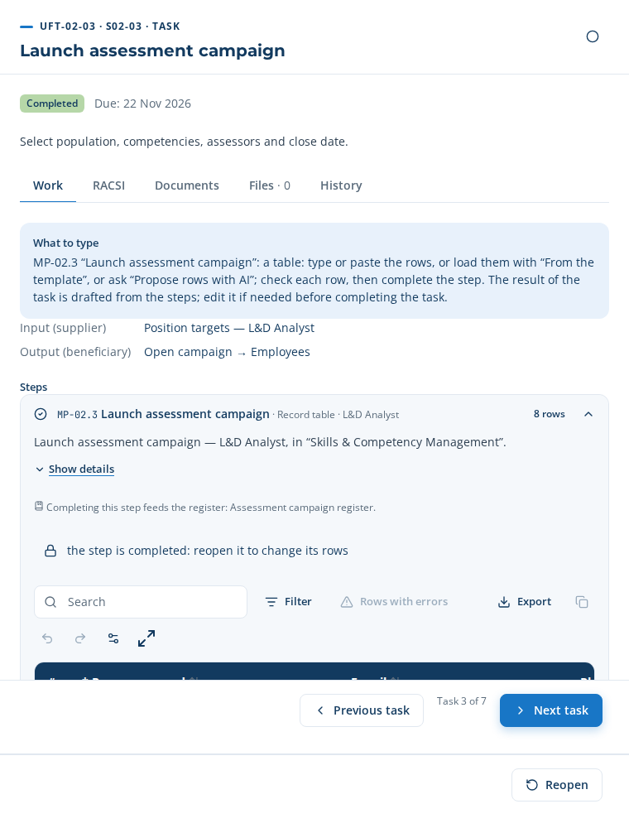
UFT-02-03 in the application
The message received by a person assessed (example):
Subject: Clinique Al Amal — Self-assessment — Head nurse Hello Nadia Berrada, Clinique Al Amal is assessing the skills of its teams before building the training plan. Please fill in: “Self-assessment — Head nurse” (5 minutes). Your link: http://localhost:4000/respond/MX_VDBLGI02aylxGe2cVyncY4b_Mb9Zm Deadline: 30 October 2026. Your answers are used only for the training engineering of Clinique Al Amal and are stored only after your consent. Reply STOP to stop these messages.
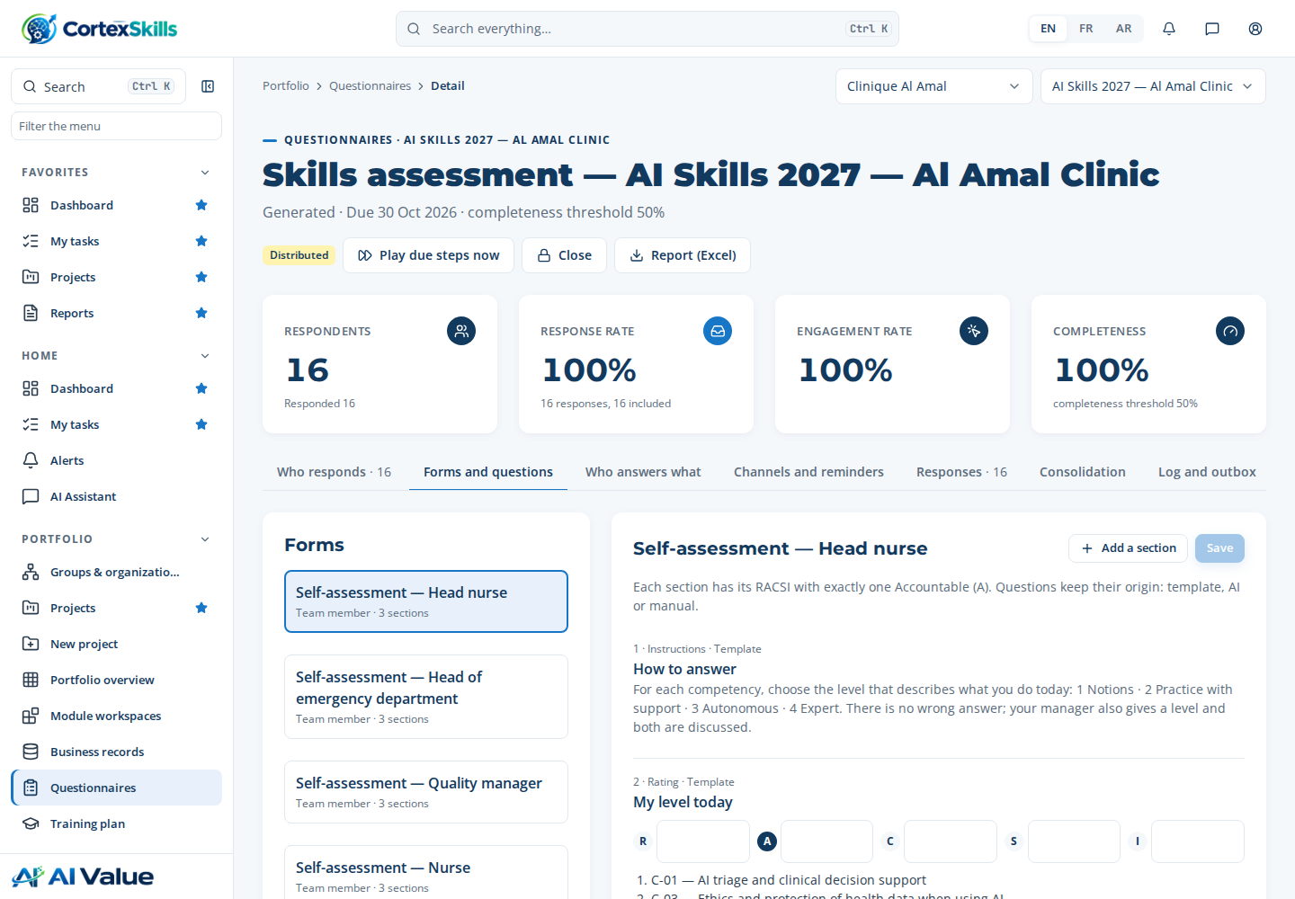
The self-assessment form as the person receives it
Close the task: “Your result” is drafted from the steps; read it, then “Complete” and “Next task”.

UFT-02-04 — Collect self and manager assessments
Who: Manager (approver: Head of L&D) · account headld@cliniquealamal.ma · Input → output: Open campaign → Consolidated assessments
Step MP-02.4 · Submit self and manager assessments Work panel · Manager
16 answer(s) received on the personal links, for example: Nadia Berrada, Dr Youssef Alaoui, Omar El Fassi.
Links sent: 16 · Answers: 16 / 16 · Deadline: 30/10/2026
Who answers what
Person | Form | Channel | Status | Last message | Answered on
Nadia Berrada | Self-assessment | E-mail | Answered | 16/10/2026 | 16/10/2026
Dr Youssef Alaoui | Manager → Nadia Berrada | E-mail | Answered | 16/10/2026 | 16/10/2026
Omar El Fassi | Self-assessment | WhatsApp | Answered | 16/10/2026 | 16/10/2026
Dr Youssef Alaoui | Manager → Omar El Fassi | WhatsApp | Answered | 16/10/2026 | 16/10/2026
Leila Chraibi | Self-assessment | E-mail | Answered | 16/10/2026 | 16/10/2026
Dr Salma Benjelloun | Manager → Leila Chraibi | E-mail | Answered | 16/10/2026 | 16/10/2026

Step MP-02.5 · Consolidate assessment results Work panel · System
Panel button (consolidate): 23 row(s) computed
People assessed: 8 · Lines: 23 · Average self / manager: 2 / 2
The answers of the people and of their managers are joined here, one line per person and competency.
Consolidated assessments
Person | Position | Competency | Self | Manager
Nadia Berrada | Head nurse | C-01 — AI triage and clinical decision support | 2 | 2
Nadia Berrada | Head nurse | C-03 — Ethics and protection of health data when using AI | 3 | 2
Nadia Berrada | Head nurse | C-04 — Critical thinking about AI results | 2 | 2
Omar El Fassi | Head of emergency department | C-01 — AI triage and clinical decision support | 3 | 2
Omar El Fassi | Head of emergency department | C-03 — Ethics and protection of health data when using AI | 2 | 2
Omar El Fassi | Head of emergency department | C-04 — Critical thinking about AI results | 2 | 2

Close the task: “Your result” is drafted from the steps; read it, then “Complete” and “Next task”.

UFT-02-05 — Suggest proficiency from evidence
Who: L&D Analyst (approver: Head of L&D) · account analyst@cliniquealamal.ma · Input → output: Consolidated assessments → Suggested levels
Step MP-02.6 · Suggest proficiency from evidence Table to paste · L&D Analyst
Three ways: Manual — type or paste the rows · From the template — 23 row(s) proposed · AI ✓ — 23 row(s) proposed (use case AIUC-01)
In the case: AI proposal — AI rule: the manager’s level counts double; a two-level gap between self-assessment and manager is flagged.
Copy this table (✥ handle at the top left, Ctrl+C) and paste it in the step’s table (Ctrl+V), then “Apply”. Required columns: Employee, Competency, Proposed level.
Employee | Competency | Self-assessment | Manager assessment | Proposed level | Evidence | Main source
Nadia Berrada (Head nurse) | C-01 — AI triage and clinical decision support | 2 | 2 | 2 — Practice with support | Self 2, manager 2: 2 kept (manager counts double). Observed on the ward over the last weeks (Assessment of Nadia Berrada). | Manager assessment
Nadia Berrada (Head nurse) | C-03 — Ethics and protection of health data when using AI | 3 | 2 | 2 — Practice with support | Self 3, manager 2: 2 kept (manager counts double). Observed on the ward over the last weeks (Assessment of Nadia Berrada). | Manager assessment
Nadia Berrada (Head nurse) | C-04 — Critical thinking about AI results | 2 | 2 | 2 — Practice with support | Self 2, manager 2: 2 kept (manager counts double). Observed on the ward over the last weeks (Assessment of Nadia Berrada). | Manager assessment
Omar El Fassi (Head of emergency department) | C-01 — AI triage and clinical decision support | 3 | 2 | 2 — Practice with support | Self 3, manager 2: 2 kept (manager counts double). Observed on the ward over the last weeks (Assessment of Omar El Fassi). | Manager assessment
Omar El Fassi (Head of emergency department) | C-03 — Ethics and protection of health data when using AI | 2 | 2 | 2 — Practice with support | Self 2, manager 2: 2 kept (manager counts double). Observed on the ward over the last weeks (Assessment of Omar El Fassi). | Manager assessment
Omar El Fassi (Head of emergency department) | C-04 — Critical thinking about AI results | 2 | 2 | 2 — Practice with support | Self 2, manager 2: 2 kept (manager counts double). Observed on the ward over the last weeks (Assessment of Omar El Fassi). | Manager assessment
Leila Chraibi (Quality manager) | C-03 — Ethics and protection of health data when using AI | 3 | 2 | 2 — Practice with support | Self 3, manager 2: 2 kept (manager counts double). Observed on the ward over the last weeks (Assessment of Leila Chraibi). | Manager assessment
Leila Chraibi (Quality manager) | C-04 — Critical thinking about AI results | 2 | 2 | 2 — Practice with support | Self 2, manager 2: 2 kept (manager counts double). Observed on the ward over the last weeks (Assessment of Leila Chraibi). | Manager assessment
Samira Ouazzani (Nurse) | C-01 — AI triage and clinical decision support | 2 | 2 | 2 — Practice with support | Self 2, manager 2: 2 kept (manager counts double). Observed on the ward over the last weeks (Assessment of Samira Ouazzani). | Manager assessment
Samira Ouazzani (Nurse) | C-03 — Ethics and protection of health data when using AI | 2 | 2 | 2 — Practice with support | Self 2, manager 2: 2 kept (manager counts double). Observed on the ward over the last weeks (Assessment of Samira Ouazzani). | Manager assessment
Samira Ouazzani (Nurse) | C-04 — Critical thinking about AI results | 2 | 2 | 2 — Practice with support | Self 2, manager 2: 2 kept (manager counts double). Observed on the ward over the last weeks (Assessment of Samira Ouazzani). | Manager assessment
Rachid Amrani (Radiology technician) | C-02 — AI medical imaging assistance | 2 | 2 | 2 — Practice with support | Self 2, manager 2: 2 kept (manager counts double). Observed on the ward over the last weeks (Assessment of Rachid Amrani). | Manager assessment
Rachid Amrani (Radiology technician) | C-03 — Ethics and protection of health data when using AI | 2 | 2 | 2 — Practice with support | Self 2, manager 2: 2 kept (manager counts double). Observed on the ward over the last weeks (Assessment of Rachid Amrani). | Manager assessment
Rachid Amrani (Radiology technician) | C-04 — Critical thinking about AI results | 2 | 2 | 2 — Practice with support | Self 2, manager 2: 2 kept (manager counts double). Observed on the ward over the last weeks (Assessment of Rachid Amrani). | Manager assessment
Mehdi Tahiri (Nurse) | C-01 — AI triage and clinical decision support | 2 | 2 | 2 — Practice with support | Self 2, manager 2: 2 kept (manager counts double). Observed on the ward over the last weeks (Assessment of Mehdi Tahiri). | Manager assessment
Mehdi Tahiri (Nurse) | C-03 — Ethics and protection of health data when using AI | 1 | 2 | 2 — Practice with support | Self 1, manager 2: 2 kept (manager counts double). Observed on the ward over the last weeks (Assessment of Mehdi Tahiri). | Manager assessment
Mehdi Tahiri (Nurse) | C-04 — Critical thinking about AI results | 2 | 2 | 2 — Practice with support | Self 2, manager 2: 2 kept (manager counts double). Observed on the ward over the last weeks (Assessment of Mehdi Tahiri). | Manager assessment
Youssra Bennis (Nurse) | C-01 — AI triage and clinical decision support | 1 | 2 | 2 — Practice with support | Self 1, manager 2: 2 kept (manager counts double). Observed on the ward over the last weeks (Assessment of Youssra Bennis). | Manager assessment
Youssra Bennis (Nurse) | C-03 — Ethics and protection of health data when using AI | 2 | 2 | 2 — Practice with support | Self 2, manager 2: 2 kept (manager counts double). Observed on the ward over the last weeks (Assessment of Youssra Bennis). | Manager assessment
Youssra Bennis (Nurse) | C-04 — Critical thinking about AI results | 2 | 2 | 2 — Practice with support | Self 2, manager 2: 2 kept (manager counts double). Observed on the ward over the last weeks (Assessment of Youssra Bennis). | Manager assessment
Imane Zerouali (Radiology technician) | C-02 — AI medical imaging assistance | 1 | 2 | 2 — Practice with support | Self 1, manager 2: 2 kept (manager counts double). Observed on the ward over the last weeks (Assessment of Imane Zerouali). | Manager assessment
Imane Zerouali (Radiology technician) | C-03 — Ethics and protection of health data when using AI | 2 | 2 | 2 — Practice with support | Self 2, manager 2: 2 kept (manager counts double). Observed on the ward over the last weeks (Assessment of Imane Zerouali). | Manager assessment
Imane Zerouali (Radiology technician) | C-04 — Critical thinking about AI results | 2 | 2 | 2 — Practice with support | Self 2, manager 2: 2 kept (manager counts double). Observed on the ward over the last weeks (Assessment of Imane Zerouali). | Manager assessment
Lists: Competency = C-01 — AI triage and clinical decision support | C-02 — AI medical imaging assistance | C-03 — Ethics and protection of health data when using AI | C-04 — Critical thinking about AI results ; Proposed level = 1 — Notions | 2 — Practice with support | 3 — Autonomous | 4 — Expert ; Main source = Self-assessment | Manager assessment | Observation at work | Certificate.
Close the task: “Your result” is drafted from the steps; read it, then “Complete” and “Next task”.

UFT-02-06 — Validate skills inventory
Who: Head of L&D (approver: HR Director) · account headld@cliniquealamal.ma · Input → output: Suggested levels → Validated inventory
Step MP-02.7 · Validate skills inventory Form · Head of L&D
Three ways: Manual — type each field · From the template — 3 field(s) pre-filled · AI ✓ — 3 field(s) pre-filled
In the case: AI proposal
Type these values in the step’s form; each field is saved when you leave it. A list is chosen in one click (the choice is saved by that same click).
Field | Value to type or choose
Decision (required) | Approved — list
Skills inventory (required) | Skills inventory: 8 people, 4 competencies
Rationale (required) | 23 lines, 100 % with both assessments; average proposed level 2; 0 line(s) with two levels or more between self and manager.
Conditions | —
Decision date (required) | —
Decided by (required) | —

Close the task: “Your result” is drafted from the steps; read it, then “Complete” and “Next task”.

UFT-02-07 — Compute and forecast gaps
Who: L&D Analyst (approver: Head of L&D) · account analyst@cliniquealamal.ma · Input → output: Validated inventory → Skills gap diagnosis
Step MP-03.1 · Compute gap matrix Work panel · System
Panel button (gaps): 23 row(s) computed
Average gap: 0.6 · Critical gaps: 7 / 23 · People with a gap: 8
Gap = target level of the position − validated level. “!” marks a critical gap (two levels or more, or one level on a critical competency).
Gap matrix (person × competency)
Person | Position | C-01 | C-03 | C-04 | C-02
Nadia Berrada | Head nurse | 1 ! | 1 | 1 | —
Omar El Fassi | Head of emergency department | 1 ! | 1 | 1 | —
Leila Chraibi | Quality manager | — | 1 | 1 | —
Samira Ouazzani | Nurse | 1 ! | 0 | 0 | —
Rachid Amrani | Radiology technician | — | 0 | 0 | 1 !
Mehdi Tahiri | Nurse | 1 ! | 0 | 0 | —

Step MP-03.2 · Review gap matrix by site and function Form · L&D Analyst
Three ways: Manual — type each field · From the template — 2 field(s) pre-filled · AI ✓ — 3 field(s) pre-filled
In the case: AI proposal
Type these values in the step’s form; each field is saved when you leave it. A list is chosen in one click (the choice is saved by that same click).
Field | Value to type or choose
Gap matrix by site and function (required) | —
Findings (required) | Average gap 0.6 on 23 person-competency pairs; 7 critical gap(s); 8 people concerned. • C-01 AI triage and clinical decision support: average gap 1, 5 critical • C-02 AI medical imaging assistance: average gap 1, 2 critical • C-03 Ethics and protection of health data when using AI: average gap 0.4, 0 critical • Site Marrakech: 0.6
Conclusion (required) | Minor corrections — list
Follow-up actions | Treat C-01 AI triage and clinical decision support first in the plan (average gap 1). Treat C-02 AI medical imaging assistance first in the plan (average gap 1).
Review date (required) | —

Step MP-28.3 · Forecast skill gaps Table to paste · Performance Analyst
Three ways: Manual — type or paste the rows · From the template — 4 row(s) proposed · AI ✓ — 4 row(s) proposed (use case AIUC-15)
In the case: AI proposal
Copy this table (✥ handle at the top left, Ctrl+C) and paste it in the step’s table (Ctrl+V), then “Apply”. Required columns: Competency.
Competency | Average gap today | Gap in 6 months | Gap in 12 months | Assumption | Status
C-01 — AI triage and clinical decision support | 1 | 0.5 | 0 | If the plan trains the 5 people concerned: one level gained within 12 months, half of it in 6 months. | Green
C-02 — AI medical imaging assistance | 1 | 0.5 | 0 | If the plan trains the 2 people concerned: one level gained within 12 months, half of it in 6 months. | Green
C-03 — Ethics and protection of health data when using AI | 0.4 | 0 | 0 | If the plan trains the 3 people concerned: one level gained within 12 months, half of it in 6 months. | Green
C-04 — Critical thinking about AI results | 0.4 | 0 | 0 | If the plan trains the 3 people concerned: one level gained within 12 months, half of it in 6 months. | Green
Lists: Competency = C-01 — AI triage and clinical decision support | C-02 — AI medical imaging assistance | C-03 — Ethics and protection of health data when using AI | C-04 — Critical thinking about AI results ; Status = Green | Amber | Red.
Step MP-28.1 · Build analytics dataset Work panel · System
The dataset joins the targets, validated levels and gaps; download it as CSV for any further analysis.
Dataset
Person | Position | Site | Competency | Target | Validated | Gap
Nadia Berrada | Head nurse | Marrakech | C-01 | 3 | 2 | 1
Nadia Berrada | Head nurse | Marrakech | C-03 | 3 | 2 | 1
Nadia Berrada | Head nurse | Marrakech | C-04 | 3 | 2 | 1
Omar El Fassi | Head of emergency department | Marrakech | C-01 | 3 | 2 | 1
Omar El Fassi | Head of emergency department | Marrakech | C-03 | 3 | 2 | 1
Omar El Fassi | Head of emergency department | Marrakech | C-04 | 3 | 2 | 1

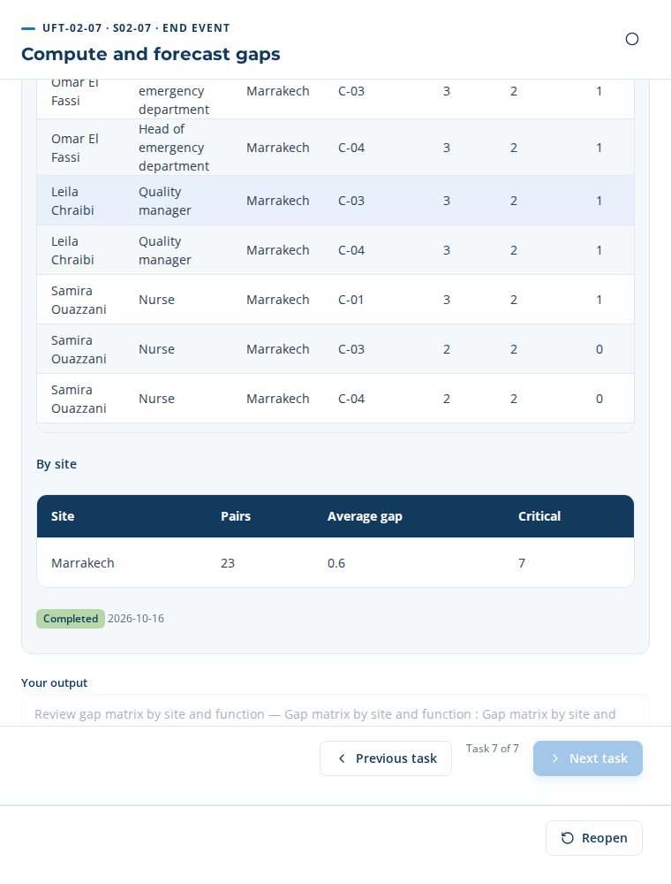
UFT-02-07 in the application
Close the task: “Your result” is drafted from the steps; read it, then “Complete” and “Next task”.

8. Phase 3 — The training plan (E2E-01)
The training plan links the clinic’s objectives to the priority themes, with budget, schedule and indicators.

UFT-01-01 — Record strategic objectives
Who: Head of L&D (approver: HR Director) · account headld@cliniquealamal.ma · Input → output: Corporate strategy → Strategic objectives register
Step MP-01.1 · Record the corporate strategic objectives Table to paste · Head of L&D
Three ways: Manual — type or paste the rows · From the template — 3 row(s) proposed · AI ✓ — 4 row(s) proposed (use case AIUC-F06)
In the case: AI proposal
Copy this table (✥ handle at the top left, Ctrl+C) and paste it in the step’s table (Ctrl+V), then “Apply”. Required columns: Strategic objective, Target, Deadline.
Code | Strategic objective | Indicator | Baseline | Target | Deadline | Owner
OS-1 | Raise the average level in AI triage and clinical decision support from 2 to 3 | Average validated level C-01 (1–4) | 2 | 3 | 2026-12-31 | Ayoub Bennani
OS-2 | Raise the average level in AI medical imaging assistance from 2 to 3 | Average validated level C-02 (1–4) | 2 | 3 | 2026-12-31 | Ayoub Bennani
OS-3 | Raise the average level in Ethics and protection of health data when using AI from 2 to 3 | Average validated level C-03 (1–4) | 2 | 3 | 2026-12-31 | Ayoub Bennani
OS-4 | Bring the critical skill gaps under 10 % | Critical gap rate (KPI-003) | 30 % | ≤ 10 % | 2026-12-31 | Ayoub Bennani

Close the task: “Your result” is drafted from the steps; read it, then “Complete” and “Next task”.

UFT-01-02 — Link objectives to functions and sites
Who: L&D Strategist (approver: Head of L&D) · account analyst@cliniquealamal.ma · Input → output: Strategic objectives register → Objective-function map
Step MP-01.2 · Link objectives to functions and sites Table to paste · L&D Strategist
Three ways: Manual — type or paste the rows · From the template — 16 row(s) proposed · AI ✓ — 6 row(s) proposed (use case AIUC-F07)
In the case: AI proposal
Copy this table (✥ handle at the top left, Ctrl+C) and paste it in the step’s table (Ctrl+V), then “Apply”. Required columns: Objective, Function.
Objective | Function | Site | Contribution | How the function contributes | Owner
OS-1 — Raise the average level in AI triage and clinical decision support from 2 to 3 | Clinical Care & Nursing | Marrakech | Primary | 5 person(s) of this function have a gap on the competencies of the objective. | Karim Tazi
OS-2 — Raise the average level in AI medical imaging assistance from 2 to 3 | Clinical Care & Nursing | Marrakech | Primary | 2 person(s) of this function have a gap on the competencies of the objective. | Karim Tazi
OS-3 — Raise the average level in Ethics and protection of health data when using AI from 2 to 3 | Clinical Care & Nursing | Marrakech | Primary | 2 person(s) of this function have a gap on the competencies of the objective. | Karim Tazi
OS-3 — Raise the average level in Ethics and protection of health data when using AI from 2 to 3 | Quality & HSE | Marrakech | Secondary | 1 person(s) of this function have a gap on the competencies of the objective. | Karim Tazi
OS-4 — Bring the critical skill gaps under 10 % | Clinical Care & Nursing | Marrakech | Primary | 11 person(s) of this function have a gap on the competencies of the objective. | Karim Tazi
OS-4 — Bring the critical skill gaps under 10 % | Quality & HSE | Marrakech | Primary | 2 person(s) of this function have a gap on the competencies of the objective. | Karim Tazi
Lists: Objective = OS-1 — Raise the average level in AI triage and clinical decision support from 2 to 3 | OS-2 — Raise the average level in AI medical imaging assistance from 2 to 3 | OS-3 — Raise the average level in Ethics and protection of health data when using AI from 2 to 3 | OS-4 — Bring the critical skill gaps under 10 % ; Site = Marrakech ; Contribution = Primary | Secondary.
Close the task: “Your result” is drafted from the steps; read it, then “Complete” and “Next task”.

UFT-01-03 — Frame skills priorities
Who: L&D Analyst (approver: Head of L&D) · account analyst@cliniquealamal.ma · Input → output: Objective-function map → Priority competency list
Step MP-02.1 · Rank the priority competencies Table to paste · L&D Analyst
Three ways: Manual — type or paste the rows · From the template — 4 row(s) proposed · AI ✓ — 4 row(s) proposed (use case AIUC-F01)
In the case: AI proposal
Copy this table (✥ handle at the top left, Ctrl+C) and paste it in the step’s table (Ctrl+V), then “Apply”. Required columns: Competency, Priority.
Competency | Average gap | People with a gap | Priority | Objective served | Rationale
C-01 — AI triage and clinical decision support | 1 | 5 | 1 — High | OS-1 — Raise the average level in AI triage and clinical decision support from 2 to 3 | Score 3 = average gap 1 × share of critical gaps × objective OS-1.
C-02 — AI medical imaging assistance | 1 | 2 | 1 — High | OS-2 — Raise the average level in AI medical imaging assistance from 2 to 3 | Score 3 = average gap 1 × share of critical gaps × objective OS-2.
C-03 — Ethics and protection of health data when using AI | 0.4 | 3 | 2 — Medium | OS-3 — Raise the average level in Ethics and protection of health data when using AI from 2 to 3 | Score 0.6 = average gap 0.4 × share of critical gaps × objective OS-3.
C-04 — Critical thinking about AI results | 0.4 | 3 | 3 — Low |  | Score 0.4 = average gap 0.4 × share of critical gaps.
Lists: Competency = C-01 — AI triage and clinical decision support | C-02 — AI medical imaging assistance | C-03 — Ethics and protection of health data when using AI | C-04 — Critical thinking about AI results ; Priority = 1 — High | 2 — Medium | 3 — Low ; Objective served = OS-1 — Raise the average level in AI triage and clinical decision support from 2 to 3 | OS-2 — Raise the average level in AI medical imaging assistance from 2 to 3 | OS-3 — Raise the average level in Ethics and protection of health data when using AI from 2 to 3 | OS-4 — Bring the critical skill gaps under 10 %.
Step MP-02.2 · Set the targets of the plan Table to paste · HR Business Partner
Three ways: Manual — type or paste the rows · From the template ✓ — 7 row(s) proposed · AI — 7 row(s) proposed (use case AIUC-F02)
In the case: From the template
Copy this table (✥ handle at the top left, Ctrl+C) and paste it in the step’s table (Ctrl+V), then “Apply”. Required columns: Competency, Position, Level at the end of the plan.
Competency | Position | Average level today | Level at the end of the plan | Deadline | Owner
C-01 — AI triage and clinical decision support | Head nurse | 2 | 3 — Autonomous | 2026-12-31
C-01 — AI triage and clinical decision support | Head of emergency department | 2 | 3 — Autonomous | 2026-12-31
C-01 — AI triage and clinical decision support | Nurse | 2 | 3 — Autonomous | 2026-12-31
C-02 — AI medical imaging assistance | Radiology technician | 2 | 3 — Autonomous | 2026-12-31
C-03 — Ethics and protection of health data when using AI | Head nurse | 2 | 3 — Autonomous | 2026-12-31
C-03 — Ethics and protection of health data when using AI | Head of emergency department | 2 | 3 — Autonomous | 2026-12-31
C-03 — Ethics and protection of health data when using AI | Quality manager | 2 | 3 — Autonomous | 2026-12-31
Lists: Competency = C-01 — AI triage and clinical decision support | C-02 — AI medical imaging assistance | C-03 — Ethics and protection of health data when using AI | C-04 — Critical thinking about AI results ; Position = Head nurse | Head of emergency department | Quality manager | Nurse | Radiology technician ; Level at the end of the plan = 1 — Notions | 2 — Practice with support | 3 — Autonomous | 4 — Expert.
Close the task: “Your result” is drafted from the steps; read it, then “Complete” and “Next task”.

UFT-01-04 — Pre-scope training needs
Who: L&D Analyst (approver: Head of L&D) · account analyst@cliniquealamal.ma · Input → output: Priority competency list → Pre-scoped needs
Step MP-03.1 · Build the training needs from the priorities Work panel · System
Panel button (needs): 7 need(s) built
Needs from the gaps: 7 · Learners: 8 · Needs from the questionnaire: 12
One need per priority competency and position: the people whose validated level is below the target of the plan.
Training needs
Need | Position | People | Level → target | Priority | Who
C-01 — AI triage and clinical decision support | Head nurse | 1 | 2 → 3 | 1 | Nadia Berrada
C-01 — AI triage and clinical decision support | Head of emergency department | 1 | 2 → 3 | 1 | Omar El Fassi
C-01 — AI triage and clinical decision support | Nurse | 3 | 2 → 3 | 1 | Samira Ouazzani, Mehdi Tahiri, Youssra Bennis
C-02 — AI medical imaging assistance | Radiology technician | 2 | 2 → 3 | 1 | Rachid Amrani, Imane Zerouali
C-03 — Ethics and protection of health data when using AI | Head nurse | 1 | 2 → 3 | 2 | Nadia Berrada
C-03 — Ethics and protection of health data when using AI | Head of emergency department | 1 | 2 → 3 | 2 | Omar El Fassi

Step MP-03.2 · Review the pre-framed needs Form · L&D Analyst
Three ways: Manual — type each field · From the template ✓ — 2 field(s) pre-filled · AI — 2 field(s) pre-filled
In the case: From the template
Type these values in the step’s form; each field is saved when you leave it. A list is chosen in one click (the choice is saved by that same click).
Field | Value to type or choose
Pre-framed training needs (required) | —
Findings (required) | 7 need(s) built from the priority gaps, 8 learner(s). • C-01 AI triage and clinical decision support — Head nurse : 1 (Nadia Berrada) • C-01 AI triage and clinical decision support — Head of emergency department : 1 (Omar El Fassi) • C-01 AI triage and clinical decision support — Nurse : 3 (Samira Ouazzani, Mehdi Tahiri, Youssra Bennis) • C-02 AI medical imaging assistance — Radiology technician : 2 (Rachid Amrani, Imane Zerouali) • C-03 Ethics and protection of health data when using AI — Head nurse : 1 (Nadia Berrada) • C-03 Ethics and protection of health data when using AI — Head of emergency department : 1 (Omar El Fassi) • C-03 Ethics and protection of health data when using AI — Quality manager : 1 (Leila Chraibi)
Conclusion (required) | Conforming — list
Follow-up actions | —
Review date (required) | —

Close the task: “Your result” is drafted from the steps; read it, then “Complete” and “Next task”.

UFT-01-05 — Define budget envelope
Who: Finance Manager (approver: CFO) · account headld@cliniquealamal.ma · Input → output: Pre-scoped needs → Budget envelope
Step MP-01.3 · Define L&D budget envelope Form · Finance Manager
Three ways: Manual — type each field · From the template — 6 field(s) pre-filled · AI ✓ — 6 field(s) pre-filled
In the case: AI proposal
Type these values in the step’s form; each field is saved when you leave it. A list is chosen in one click (the choice is saved by that same click).
Field | Value to type or choose
Envelope amount (required) | 34100
Currency | MAD — list
Plan year (required) | 2026
Funding | Training budget — list
Contingency (%) | 10
Rationale (required) | Built from the needs: AI triage and clinical decision support 1 group(s) × 2 day(s) external; AI medical imaging assistance 1 group(s) × 2 day(s) external; Ethics and protection of health data when using AI 1 group(s) × 1 day(s) internal; total 31,000 MAD + 10 % contingency.
Decision date (required) | —
Decided by (required) | —

Step MP-18.1 · Allocate budget by theme and site Table to paste · Finance Manager
Three ways: Manual — type or paste the rows · From the template — 3 row(s) proposed · AI ✓ — 3 row(s) proposed (use case AIUC-F10)
In the case: AI proposal
The table to paste is on the next page, in landscape.
Step MP-18.1 · Allocate budget by theme and site — wide table, shown in landscape
Copy this table (✥ handle at the top left, Ctrl+C) and paste it in the step’s table (Ctrl+V), then “Apply”. Required columns: Training theme, Budget.
Training theme | Competency | Site | Learners | Groups | Days per group | Cost per day | Budget | Currency | Modality | Provider | Owner
AI triage and clinical decision support | C-01 — AI triage and clinical decision support | Marrakech | 5 | 1 | 2 | 7000 | 14000 | MAD | On site | External | Ayoub Bennani
AI medical imaging assistance | C-02 — AI medical imaging assistance | Marrakech | 2 | 1 | 2 | 7000 | 14000 | MAD | On site | External | Ayoub Bennani
Ethics and protection of health data when using AI | C-03 — Ethics and protection of health data when using AI | Marrakech | 3 | 1 | 1 | 3000 | 3000 | MAD | Blended | Internal | Ayoub Bennani
Lists: Competency = C-01 — AI triage and clinical decision support | C-02 — AI medical imaging assistance | C-03 — Ethics and protection of health data when using AI | C-04 — Critical thinking about AI results ; Site = Marrakech ; Currency = MAD | EUR | USD ; Modality = On site | Remote | Blended | E-learning ; Provider = Internal | External.
Step MP-18.2 · Forecast OFPPT refunds Table to paste · Finance Manager
Three ways: Manual — type or paste the rows · From the template — 3 row(s) proposed · AI ✓ — 3 row(s) proposed (use case AIUC-F11)
In the case: AI proposal
Copy this table (✥ handle at the top left, Ctrl+C) and paste it in the step’s table (Ctrl+V), then “Apply”. Required columns: Training theme, Refund scheme.
Training theme | Budget | Currency | Refund scheme | Refund rate (%) | Expected refund | Filing date
AI triage and clinical decision support | 14000 |  | Special training contracts (CSF) | 70 | 9800 | 2026-11-15
AI medical imaging assistance | 14000 |  | Special training contracts (CSF) | 70 | 9800 | 2026-11-15
Ethics and protection of health data when using AI | 3000 |  | Not eligible | 0 | 0 | 2026-11-15
Lists: Currency = MAD | EUR | USD ; Refund scheme = Special training contracts (CSF) | GIAC | Not eligible.
Close the task: “Your result” is drafted from the steps; read it, then “Complete” and “Next task”.

UFT-01-06 — Plan change and adoption
Who: Change Manager (approver: Head of L&D) · account headld@cliniquealamal.ma · Input → output: Budget envelope → Adoption plan
Step MP-19.1 · Assess change impact Table to paste · Change Manager
Three ways: Manual — type or paste the rows · From the template — 25 row(s) proposed · AI ✓ — 25 row(s) proposed (use case AIUC-F12)
In the case: AI proposal
Copy this table (✥ handle at the top left, Ctrl+C) and paste it in the step’s table (Ctrl+V), then “Apply”. Required columns: Population, Criterion, Score (1–5).
Population | Criterion | Weight (%) | Score (1–5) | Facts behind the score
Head nurse | Change in practices | 20 | 4 | AI suggestions enter the clinical routine.
Head nurse | Workload | 20 | 3 | Training time to free in the schedule.
Head nurse | New skills | 20 | 3 | Average gap 1 on 3 pair(s).
Head nurse | New tools | 20 | 4 | New AI tools to learn.
Head nurse | Likely resistance | 20 | 2
Head of emergency department | Change in practices | 20 | 4 | AI suggestions enter the clinical routine.
Head of emergency department | Workload | 20 | 3 | Training time to free in the schedule.
Head of emergency department | New skills | 20 | 3 | Average gap 1 on 3 pair(s).
Head of emergency department | New tools | 20 | 4 | New AI tools to learn.
Head of emergency department | Likely resistance | 20 | 2
Quality manager | Change in practices | 20 | 3
Quality manager | Workload | 20 | 3 | Training time to free in the schedule.
Quality manager | New skills | 20 | 3 | Average gap 1 on 2 pair(s).
Quality manager | New tools | 20 | 2
Quality manager | Likely resistance | 20 | 2
Nurse | Change in practices | 20 | 4 | AI suggestions enter the clinical routine.
Nurse | Workload | 20 | 3 | Training time to free in the schedule.
Nurse | New skills | 20 | 2 | Average gap 0.3 on 9 pair(s).
Nurse | New tools | 20 | 4 | New AI tools to learn.
Nurse | Likely resistance | 20 | 2
Radiology technician | Change in practices | 20 | 4 | AI suggestions enter the clinical routine.
Radiology technician | Workload | 20 | 3 | Training time to free in the schedule.
Radiology technician | New skills | 20 | 2 | Average gap 0.3 on 6 pair(s).
Radiology technician | New tools | 20 | 4 | New AI tools to learn.
Radiology technician | Likely resistance | 20 | 2
Lists: Population = Head nurse | Head of emergency department | Quality manager | Nurse | Radiology technician ; Criterion = Change in practices | Workload | New skills | New tools | Likely resistance ; Score (1–5) = 1 | 2 | 3 | 4 | 5.
Step MP-19.2 · Build adoption plan Table to paste · Change Manager
Three ways: Manual — type or paste the rows · From the template — 5 row(s) proposed · AI ✓ — 6 row(s) proposed (use case AIUC-F13)
In the case: AI proposal
Copy this table (✥ handle at the top left, Ctrl+C) and paste it in the step’s table (Ctrl+V), then “Apply”. Required columns: Adoption action, Owner.
Adoption action | Owner | For whom | Start | End | Budget | Currency | Deliverable
Launch message from the sponsor to all staff concerned | Dr Salma Benjelloun (Chief Executive Officer) |  | 2026-10-23 | 2026-10-23 | 0 |  | Message sent
Name one AI referent per service | Nadia Berrada (Head nurse) |  | 2026-10-23 | 2026-11-06 | 0 |  | List of referents
Demonstration workshop of the tools before the sessions | Ayoub Bennani (Head of L&D) |  | 2026-11-06 | 2026-11-13 | 0 |  | Workshop held
Questions and answers channel open to the staff | Ayoub Bennani (Head of L&D) |  | 2026-10-23 | 2026-12-31 | 0 |  | FAQ updated
Adoption check 30 days after the last session | Ayoub Bennani (Head of L&D) |  | 2027-02-13 | 2027-02-13 | 0 |  | Adoption note
Nadia Berrada relays the plan to the Head nurse team and reports the difficulties | Nadia Berrada (Head nurse) | Head nurse | 2026-10-30 | 2027-02-13 | 0 |  | Monthly feedback
Lists: For whom = Head nurse | Head of emergency department | Quality manager | Nurse | Radiology technician ; Currency = MAD | EUR | USD.
Close the task: “Your result” is drafted from the steps; read it, then “Complete” and “Next task”.

UFT-01-07 — Compile plan approval pack
Who: Head of L&D (approver: HR Director) · account headld@cliniquealamal.ma · Input → output: Adoption plan → Approval pack
Step MP-01.4 · Schedule Steering Committee milestones Table to paste · Head of L&D
Three ways: Manual — type or paste the rows · From the template ✓ — 3 row(s) proposed · AI — 5 row(s) proposed (use case AIUC-F14)
In the case: From the template
Copy this table (✥ handle at the top left, Ctrl+C) and paste it in the step’s table (Ctrl+V), then “Apply”. Required columns: Steering milestone, Date.
Steering milestone | Owner | Date | Agenda | Deliverable
Launch of the plan | Dr Salma Benjelloun (Chief Executive Officer) | 2026-10-23 | Plan, budget, calendar, roles | Minutes
Mid-term review | Dr Salma Benjelloun (Chief Executive Officer) | 2027-01-14 | Sessions held, attendance, satisfaction, budget used | Minutes
End-of-plan review | Dr Salma Benjelloun (Chief Executive Officer) | 2026-12-31 | Kirkpatrick levels 1 to 3, objectives reached, next plan | Minutes

Step MP-01.5 · Compile plan approval pack Work panel · System
Document generated: DT-E2E-01 — Annual L&D plan and budget — Clinique Al Amal (version 1, Draft).
Step MP-04.1 · Consolidate feeder outputs Work panel · System
Each deliverable of the previous steps must exist before the plan goes to the steering committee.
Upstream deliverables
Deliverable | Records | Ready
Competency framework | 4 | ✓
Targets per position | 14 | ✓
Validated inventory | 23 | ✓
Gaps | 23 | ✓
Strategic objectives | 4 | ✓
Training needs | 7 | ✓

Close the task: “Your result” is drafted from the steps; read it, then “Complete” and “Next task”.

UFT-01-08 — Approve and lock annual L&D plan
Who: HR Director (approver: CHRO) · account hrd@cliniquealamal.ma · Input → output: Approval pack → Approved annual L&D plan
Step MP-01.6 · Record Steering Committee decision Form · HR Director
Three ways: Manual — type each field · From the template — 2 field(s) pre-filled · AI ✓ — 3 field(s) pre-filled
In the case: AI proposal
Type these values in the step’s form; each field is saved when you leave it. A list is chosen in one click (the choice is saved by that same click).
Field | Value to type or choose
Decision (required) | Approved — list
Annual training plan (required) | —
Rationale (required) | 3 theme(s), 8 learner(s), 5 training day(s), budget 31,000 MAD within an envelope of 34,100. The objectives, gaps and budget are consistent.
Conditions | Start with the priority-1 themes: AI triage and clinical decision support, AI medical imaging assistance.
Decision date (required) | —
Decided by (required) | —

Step MP-01.7 · Lock and distribute approved plan Work panel · System
Panel button (diffuse): 6 message(s) sent
3 theme(s), 8 learner(s), 5 training day(s), budget 31,000 MAD within an envelope of 34,100.
Recipients
Name | Role | Channel | Message
Dr Salma Benjelloun | Chief Executive Officer | E-mail | simulated
Hajar Tazi | HR Director / steering committee chair | E-mail | simulated
Dr Youssef Alaoui | Medical Director | E-mail | simulated
Nadia Berrada | Head nurse | E-mail | simulated
Omar El Fassi | Head of emergency department | WhatsApp | simulated
Leila Chraibi | Quality manager | E-mail | simulated

Close the task: “Your result” is drafted from the steps; read it, then “Complete” and “Next task”.

Gate G3 — Report & roadmap approved
Sign in as HR Director (hrd@cliniquealamal.ma). In the project, open the gate checklist, tick each point checked, then decide “Go” with a justification. The tasks of the next phase only start after this “Go”.
Point to check | Ticked
Every report section completed and reviewed | Yes
Themes prioritized with days, groups and trainers | Yes
Budget within the approved envelope | Yes
Roadmap linked to strategic objectives | Yes
Decision: Go — 2027 training plan approved by the steering committee.

9. Phase 4 — Design and delivery (E2E-05)
The actions of the plan become sessions: providers, programmes, invitations, attendance and immediate evaluations.

UFT-05-01 — Publish content to catalog
Who: Content Developer (approver: Head of L&D) · account headld@cliniquealamal.ma · Input → output: Approved design → Published catalog
Step MP-06.3 · Submit the content to the expert review Table to paste · System
Three ways: Manual — type or paste the rows · From the template — 3 row(s) proposed · AI ✓ — 3 row(s) proposed (use case AIUC-F16)
In the case: AI proposal
Copy this table (✥ handle at the top left, Ctrl+C) and paste it in the step’s table (Ctrl+V), then “Apply”. Required columns: Course, Reviewing expert, Expert e-mail.
Course | Format | Duration (hours) | Reviewing expert | Expert e-mail | Answer by
TR-01 — AI triage and clinical decision support | On site | 14 | Dr Youssef Alaoui (Medical Director) | directeur.medical@cliniquealamal.ma | 2026-10-23
TR-02 — AI medical imaging assistance | On site | 14 | Rachid Amrani (Radiology technician) | radiologie@cliniquealamal.ma | 2026-10-23
TR-03 — Ethics and protection of health data when using AI | Blended | 7 | Leila Chraibi (Quality manager) | qualite@cliniquealamal.ma | 2026-10-23
Lists: Course = TR-01 — AI triage and clinical decision support | TR-02 — AI medical imaging assistance | TR-03 — Ethics and protection of health data when using AI ; Format = On site | Remote | Blended | E-learning.
On completing the step: 3 link(s) sent by e-mail or WhatsApp.
On completing the step: 3 message(s) sent.
Review requests
Course | Expert | Status | Approves | Comments
TR-01 | Dr Youssef Alaoui | Invited | — | —
TR-02 | Rachid Amrani | Invited | — | —
TR-03 | Leila Chraibi | Invited | — | —

Step MP-06.4 · Record review decision Table to paste · Subject Matter Expert
Three ways: Manual — type or paste the rows · From the template ✓ — 3 row(s) proposed · AI — 3 row(s) proposed (use case AIUC-F17)
In the case: From the template
Copy this table (✥ handle at the top left, Ctrl+C) and paste it in the step’s table (Ctrl+V), then “Apply”. Required columns: Course, Review decision.
Course | Review decision | Comments | Expert | Date
TR-01 — AI triage and clinical decision support | Approved | Consistent with the department’s protocols. — Nothing to add | Dr Youssef Alaoui (Medical Director) | 2026-10-16
TR-02 — AI medical imaging assistance | Approved | Add a case on an elderly patient with multiple conditions. — Plan 30 minutes of hands-on practice. | Rachid Amrani (Radiology technician) | 2026-10-16
TR-03 — Ethics and protection of health data when using AI | Approved | Add a case on an elderly patient with multiple conditions. — Plan 30 minutes of hands-on practice. | Leila Chraibi (Quality manager) | 2026-10-16
Lists: Course = TR-01 — AI triage and clinical decision support | TR-02 — AI medical imaging assistance | TR-03 — Ethics and protection of health data when using AI ; Review decision = Approved | To correct | Rejected.
3 answer(s) received on the personal links, for example: Dr Youssef Alaoui, Rachid Amrani, Leila Chraibi.
Step MP-06.6 · Publish content to catalog Table to paste · Content Developer
Three ways: Manual — type or paste the rows · From the template — 3 row(s) proposed · AI ✓ — 3 row(s) proposed (use case AIUC-F18)
In the case: AI proposal
Copy this table (✥ handle at the top left, Ctrl+C) and paste it in the step’s table (Ctrl+V), then “Apply”. Required columns: Course, Channel, Message.
Course | Audience (positions) | Channel | Message | Date
TR-01 | Head nurse, Head of emergency department, Nurse | E-mail | A new course is open in the catalogue: AI triage and clinical decision support (14 h, On site). It targets level 3 and is planned for Head nurse, Head of emergency department, Nurse. You will receive your invitation with the date and the room. | 2026-10-16
TR-02 | Radiology technician | E-mail | A new course is open in the catalogue: AI medical imaging assistance (14 h, On site). It targets level 3 and is planned for Radiology technician. You will receive your invitation with the date and the room. | 2026-10-16
TR-03 | Head nurse, Head of emergency department, Quality manager | E-mail | A new course is open in the catalogue: Ethics and protection of health data when using AI (7 h, Blended). It targets level 3 and is planned for Head nurse, Head of emergency department, Quality manager. You will receive your invitation with the date and the room. | 2026-10-16
Lists: Audience (positions) = Head nurse | Head of emergency department | Quality manager | Nurse | Radiology technician (several choices, separated by commas) ; Channel = E-mail | WhatsApp | In the application.
On completing the step: 10 message(s) sent.
Announcements sent
To | Channel | Subject | Status | Sent
cadre.sante@cliniquealamal.ma | E-mail | New course: AI triage and clinical decision support | simulated | 16/10/2026
urgences@cliniquealamal.ma | E-mail | New course: AI triage and clinical decision support | simulated | 16/10/2026
infirmiere.urgences@cliniquealamal.ma | E-mail | New course: AI triage and clinical decision support | simulated | 16/10/2026
infirmier.urgences2@cliniquealamal.ma | E-mail | New course: AI triage and clinical decision support | simulated | 16/10/2026
infirmiere.hospit@cliniquealamal.ma | E-mail | New course: AI triage and clinical decision support | simulated | 16/10/2026
radiologie@cliniquealamal.ma | E-mail | New course: AI medical imaging assistance | simulated | 16/10/2026

Close the task: “Your result” is drafted from the steps; read it, then “Complete” and “Next task”.

UFT-05-02 — Book logistics
Who: Training Administrator (approver: Head of L&D) · account headld@cliniquealamal.ma · Input → output: Published catalog → Logistics plan
Step MP-11.1 · Book rooms and equipment Table to paste · Training Administrator
Three ways: Manual — type or paste the rows · From the template — 1 row(s) proposed · AI ✓ — 2 row(s) proposed (use case AIUC-F19)
In the case: AI proposal
Copy this table (✥ handle at the top left, Ctrl+C) and paste it in the step’s table (Ctrl+V), then “Apply”. Required columns: Room or equipment.
Room or equipment | Site | Capacity | Available from | Available until | Cost | Currency | Equipment
Training room — Marrakech | Marrakech | 12 | 2026-10-30 | 2026-12-31 | 0 |  | Projector, screen, 12 laptops
Simulation room (emergency box) — Marrakech | Marrakech | 6 | 2026-10-30 | 2026-12-31 | 0 |  | Patient monitor, workstation with the AI tool
Lists: Site = Marrakech ; Currency = MAD | EUR | USD.
Step MP-11.2 · Manage trainer calendars Table to paste · Training Administrator
Three ways: Manual ✓ — type or paste the rows · From the template — 1 row(s) proposed · AI — 3 row(s) proposed (use case AIUC-F20)
In the case: Manual entry (or paste) — Manual entry: the clinic’s internal trainer and an external trainer.
The table to paste is on the next page, in landscape.
Step MP-11.2 · Manage trainer calendars — wide table, shown in landscape
Copy this table (✥ handle at the top left, Ctrl+C) and paste it in the step’s table (Ctrl+V), then “Apply”. Required columns: Trainer.
Trainer | Organisation | E-mail | Phone | Available from | Available until | Courses | Day rate
Hicham Tazi | Internal | trainer@cliniquealamal.ma | +212 6 61 00 00 12 | 2026-11-01 | 2027-12-31 | TR-03 — Ethics and protection of health data when using AI | 0
Dr Karim Lahlou | Maghreb Learning Partners | k.lahlou@maghreb-lp.ma | +212 6 61 00 00 13 | 2026-11-15 | 2027-06-30 | TR-01 — AI triage and clinical decision support, TR-02 — AI medical imaging assistance | 7000
Lists: Organisation = Internal | Atlas Formation Conseil | Maghreb Learning Partners ; Courses = TR-01 — AI triage and clinical decision support | TR-02 — AI medical imaging assistance | TR-03 — Ethics and protection of health data when using AI (several choices, separated by commas).
Close the task: “Your result” is drafted from the steps; read it, then “Complete” and “Next task”.

UFT-05-03 — Schedule sessions
Who: Training Administrator (approver: Head of L&D) · account headld@cliniquealamal.ma · Input → output: Logistics plan → Session schedule
Step MP-07.1 · Create training session Table to paste · Training Administrator
Three ways: Manual — type or paste the rows · From the template — 3 row(s) proposed · AI ✓ — 3 row(s) proposed (use case AIUC-F21)
In the case: AI proposal
Copy this table (✥ handle at the top left, Ctrl+C) and paste it in the step’s table (Ctrl+V), then “Apply”. Required columns: Session, Course, Date.
Session | Course | Date | Start time | Hours | Room | Trainer | Capacity | Modality
S-01 | TR-01 — AI triage and clinical decision support | 2026-11-15 | 09:00 | 14 | Simulation room (emergency box) — Marrakech (6) | Dr Karim Lahlou — Maghreb Learning Partners | 6 | On site
S-02 | TR-02 — AI medical imaging assistance | 2026-11-16 | 09:00 | 14 | Training room — Marrakech (12) | Dr Karim Lahlou — Maghreb Learning Partners | 12 | On site
S-03 | TR-03 — Ethics and protection of health data when using AI | 2026-11-17 | 09:00 | 7 | Training room — Marrakech (12) | Hicham Tazi — Internal | 12 | Blended
Lists: Course = TR-01 — AI triage and clinical decision support | TR-02 — AI medical imaging assistance | TR-03 — Ethics and protection of health data when using AI ; Room = Training room — Marrakech (12) | Simulation room (emergency box) — Marrakech (6) ; Trainer = Hicham Tazi — Internal | Dr Karim Lahlou — Maghreb Learning Partners ; Modality = On site | Remote | Blended | E-learning.
Step MP-07.2 · Check scheduling conflicts Work panel · System
Sessions: 3 · Conflicts: 0
No conflict: rooms, trainers, dates and capacities are consistent.
Schedule
Session | Course | Date | Room | Trainer | Capacity
S-01 | TR-01 — AI triage and clinical decision support | 15/11/2026 09:00 | Simulation room (emergency box) — Marrakech | Dr Karim Lahlou | 6
S-02 | TR-02 — AI medical imaging assistance | 16/11/2026 09:00 | Training room — Marrakech | Dr Karim Lahlou | 12
S-03 | TR-03 — Ethics and protection of health data when using AI | 17/11/2026 09:00 | Training room — Marrakech | Hicham Tazi | 12

Close the task: “Your result” is drafted from the steps; read it, then “Complete” and “Next task”.

UFT-05-04 — Enroll learners and send convocations
Who: Training Administrator (approver: Head of L&D) · account headld@cliniquealamal.ma · Input → output: Session schedule → Enrollments
Step MP-07.3 · Enroll learners into session Table to paste · Training Administrator
Three ways: Manual — type or paste the rows · From the template — 10 row(s) proposed · AI ✓ — 10 row(s) proposed (use case AIUC-F22)
In the case: AI proposal
The table to paste is on the next page, in landscape.
Step MP-07.3 · Enroll learners into session — wide table, shown in landscape
Copy this table (✥ handle at the top left, Ctrl+C) and paste it in the step’s table (Ctrl+V), then “Apply”. Required columns: Session, Learner, Invitation channel.
Session | Learner | E-mail | Phone (WhatsApp) | Invitation channel | Manager
S-01 — TR-01 · 15/11/2026 | Nadia Berrada (Head nurse) | cadre.sante@cliniquealamal.ma | +212 6 61 00 00 04 | E-mail | Dr Youssef Alaoui (Medical Director)
S-01 — TR-01 · 15/11/2026 | Omar El Fassi (Head of emergency department) | urgences@cliniquealamal.ma | +212 6 61 00 00 05 | WhatsApp | Dr Youssef Alaoui (Medical Director)
S-01 — TR-01 · 15/11/2026 | Samira Ouazzani (Nurse) | infirmiere.urgences@cliniquealamal.ma | +212 6 61 00 00 07 | WhatsApp | Nadia Berrada (Head nurse)
S-01 — TR-01 · 15/11/2026 | Mehdi Tahiri (Nurse) | infirmier.urgences2@cliniquealamal.ma | +212 6 61 00 00 09 | WhatsApp | Nadia Berrada (Head nurse)
S-01 — TR-01 · 15/11/2026 | Youssra Bennis (Nurse) | infirmiere.hospit@cliniquealamal.ma | +212 6 61 00 00 10 | E-mail | Nadia Berrada (Head nurse)
S-02 — TR-02 · 16/11/2026 | Rachid Amrani (Radiology technician) | radiologie@cliniquealamal.ma | +212 6 61 00 00 08 | WhatsApp | Nadia Berrada (Head nurse)
S-02 — TR-02 · 16/11/2026 | Imane Zerouali (Radiology technician) | radiologie2@cliniquealamal.ma | +212 6 61 00 00 11 | WhatsApp | Nadia Berrada (Head nurse)
S-03 — TR-03 · 17/11/2026 | Nadia Berrada (Head nurse) | cadre.sante@cliniquealamal.ma | +212 6 61 00 00 04 | E-mail | Dr Youssef Alaoui (Medical Director)
S-03 — TR-03 · 17/11/2026 | Omar El Fassi (Head of emergency department) | urgences@cliniquealamal.ma | +212 6 61 00 00 05 | WhatsApp | Dr Youssef Alaoui (Medical Director)
S-03 — TR-03 · 17/11/2026 | Leila Chraibi (Quality manager) | qualite@cliniquealamal.ma | +212 6 61 00 00 06 | E-mail | Dr Salma Benjelloun (Chief Executive Officer)
Lists: Session = S-01 — TR-01 · 15/11/2026 | S-02 — TR-02 · 16/11/2026 | S-03 — TR-03 · 17/11/2026 ; Invitation channel = E-mail | WhatsApp.
Step MP-07.4 · Send convocations Work panel · System
Panel button (send): 10 link(s) sent
10 answer(s) received on the personal links, for example: Nadia Berrada, Omar El Fassi, Samira Ouazzani.
Learners: 10 · Invitations sent: 10 · Confirmed: 9
Invitations
Session | Learner | Channel | Status | Confirmed
S-01 | Nadia Berrada | E-mail | Answered | Yes
S-01 | Omar El Fassi | WhatsApp | Answered | Yes
S-01 | Samira Ouazzani | WhatsApp | Answered | Yes
S-01 | Mehdi Tahiri | WhatsApp | Answered | Yes
S-01 | Youssra Bennis | E-mail | Answered | No — On leave that day.
S-02 | Rachid Amrani | WhatsApp | Answered | Yes

Step MP-17.1 · Provision users via SSO Work panel · System
Panel button (provision): 0 account(s) created
Each learner with an e-mail address gets a learner account (single sign-on of the organization; no password is sent).
Learner accounts
Learner | E-mail | Account
Nadia Berrada | cadre.sante@cliniquealamal.ma | Learner account
Omar El Fassi | urgences@cliniquealamal.ma | Learner account
Samira Ouazzani | infirmiere.urgences@cliniquealamal.ma | Learner account
Mehdi Tahiri | infirmier.urgences2@cliniquealamal.ma | Learner account
Youssra Bennis | infirmiere.hospit@cliniquealamal.ma | Learner account
Rachid Amrani | radiologie@cliniquealamal.ma | Learner account

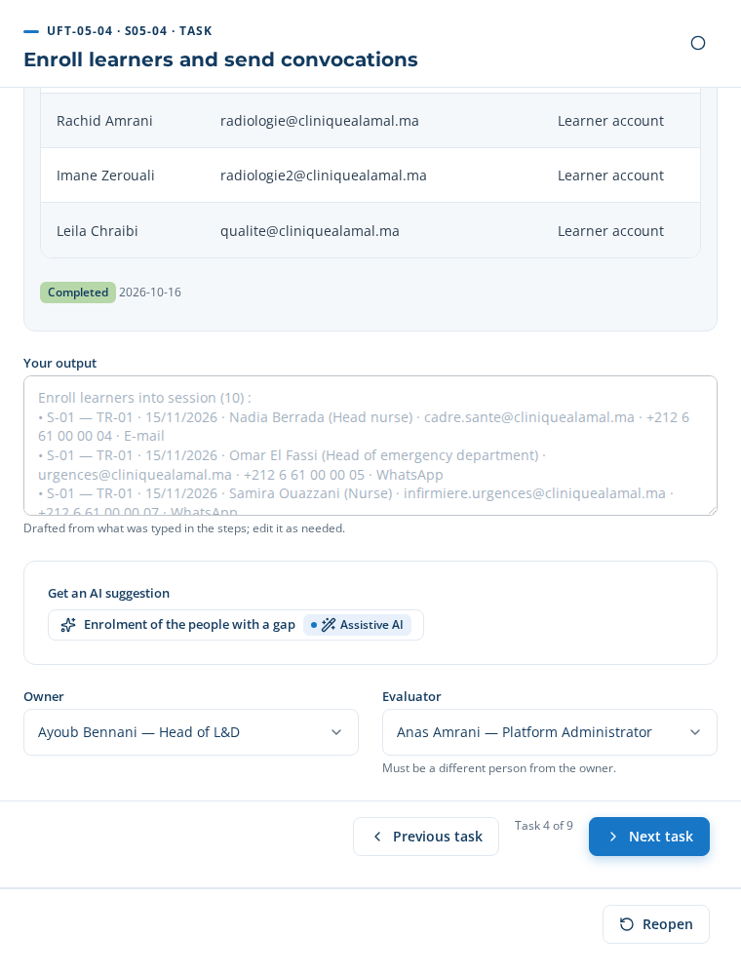
UFT-05-04 in the application
The invitation received by a learner (example):
Subject: Clinique Al Amal — Invitation — AI triage and clinical decision support — 15/11/2026 09:00 Hello Nadia Berrada, You are invited to a training session: Invitation — AI triage and clinical decision support — 15/11/2026 09:00. The details (room, trainer, duration) and the confirmation are on your link: http://localhost:4000/respond/qs_ZBK_89ie393A4YekoBZFA6Q54qgXm Please confirm your attendance. You receive this message because you are enrolled in a training of Clinique Al Amal. Reply STOP to stop these messages.
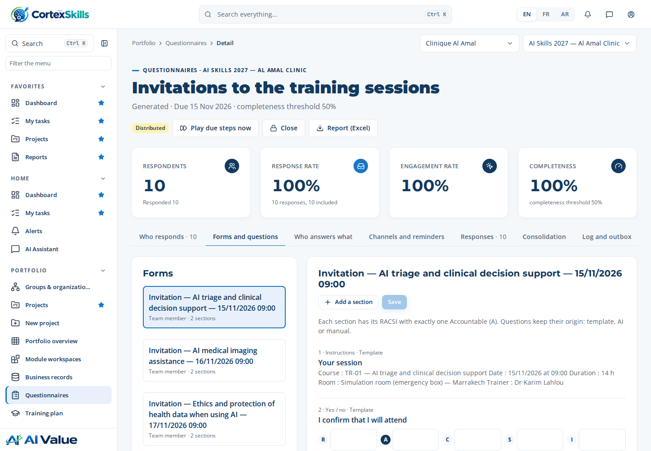
The invitation: session details and attendance confirmation
Close the task: “Your result” is drafted from the steps; read it, then “Complete” and “Next task”.

UFT-05-05 — Push microlearning capsules
Who: Instructional Designer (approver: Head of L&D) · account headld@cliniquealamal.ma · Input → output: Enrollments → Capsules in flow of work
Step MP-25.1 · Author microlearning capsule Table to paste · Instructional Designer
Three ways: Manual — type or paste the rows · From the template — 3 row(s) proposed · AI ✓ — 3 row(s) proposed (use case AIUC-F23)
In the case: AI proposal
Copy this table (✥ handle at the top left, Ctrl+C) and paste it in the step’s table (Ctrl+V), then “Apply”. Required columns: Capsule, Capsule text, Channel.
Capsule | Course | Capsule text | Reading time (min) | Channel | Send on
The essentials — AI triage and clinical decision support | TR-01 — AI triage and clinical decision support | AI triage and clinical decision support in 3 points: • Explain the principles and limits of AI triage and clinical decision support • Apply AI triage and clinical decision support in the situations of the position, at level 3 • Check the result and record the decision taken Question: in which situation of your day will you use it first? | 3 | WhatsApp | 2026-11-17
The essentials — AI medical imaging assistance | TR-02 — AI medical imaging assistance | AI medical imaging assistance in 3 points: • Explain the principles and limits of AI medical imaging assistance • Apply AI medical imaging assistance in the situations of the position, at level 3 • Check the result and record the decision taken Question: in which situation of your day will you use it first? | 3 | WhatsApp | 2026-11-18
The essentials — Ethics and protection of health data when using AI | TR-03 — Ethics and protection of health data when using AI | Ethics and protection of health data when using AI in 3 points: • Explain the principles and limits of Ethics and protection of health data when using AI • Apply Ethics and protection of health data when using AI in the situations of the position, at level 3 • Check the result and record the decision taken Question: in which situation of your day will you use it first? | 3 | WhatsApp | 2026-11-19
Lists: Course = TR-01 — AI triage and clinical decision support | TR-02 — AI medical imaging assistance | TR-03 — Ethics and protection of health data when using AI ; Channel = E-mail | WhatsApp.
Step MP-25.2 · Generate capsule draft from source Table to paste · Instructional Designer
Three ways: Manual — type or paste the rows · From the template ✓ — 3 row(s) proposed · AI — 3 row(s) proposed (use case AIUC-14)
In the case: From the template
Copy this table (✥ handle at the top left, Ctrl+C) and paste it in the step’s table (Ctrl+V), then “Apply”. Required columns: Source document, Draft capsule, Draft text.
Source document | Course | Draft capsule | Draft text | Status
Course material — AI triage and clinical decision support | TR-01 — AI triage and clinical decision support | Check before you act — AI triage and clinical decision support | Summary of the course material of AI triage and clinical decision support. | To validate
Course material — AI medical imaging assistance | TR-02 — AI medical imaging assistance | Check before you act — AI medical imaging assistance | Summary of the course material of AI medical imaging assistance. | To validate
Course material — Ethics and protection of health data when using AI | TR-03 — Ethics and protection of health data when using AI | Check before you act — Ethics and protection of health data when using AI | Summary of the course material of Ethics and protection of health data when using AI. | To validate
Lists: Course = TR-01 — AI triage and clinical decision support | TR-02 — AI medical imaging assistance | TR-03 — Ethics and protection of health data when using AI ; Status = Draft | To validate.
Step MP-25.3 · Push capsule to collaboration channel Work panel · System
Panel button (push): 10 link(s) sent
7 answer(s) received on the personal links, for example: Nadia Berrada, Omar El Fassi, Mehdi Tahiri.
Capsules sent: 10 · Opened: 100 %
By capsule
Capsule | Sent | Opened | Answered
The essentials — AI triage and clinical decision support | 5 | 5 | 4
The essentials — AI medical imaging assistance | 2 | 2 | 1
The essentials — Ethics and protection of health data when using AI | 3 | 3 | 2

Step MP-25.4 · Consume capsule on mobile Table to paste · Learner
Three ways: Manual — type or paste the rows · From the template ✓ — 10 row(s) proposed · AI — Not offered for this step
In the case: From the template
Copy this table (✥ handle at the top left, Ctrl+C) and paste it in the step’s table (Ctrl+V), then “Apply”. Required columns: Learner, Capsule, Read.
Learner | Capsule | Read | Date | Comment
Nadia Berrada | The essentials — AI triage and clinical decision support | Yes | 2026-10-16 | Peu utile
Omar El Fassi | The essentials — AI triage and clinical decision support | Yes | 2026-10-16 | Utile
Samira Ouazzani | The essentials — AI triage and clinical decision support | Yes | 2026-10-16
Mehdi Tahiri | The essentials — AI triage and clinical decision support | Yes | 2026-10-16 | Utile
Rachid Amrani | The essentials — AI medical imaging assistance | Yes | 2026-10-16
Youssra Bennis | The essentials — AI triage and clinical decision support | Yes | 2026-10-16 | Peu utile
Imane Zerouali | The essentials — AI medical imaging assistance | Yes | 2026-10-16 | Utile
Nadia Berrada | The essentials — Ethics and protection of health data when using AI | Yes | 2026-10-16 | Utile
Omar El Fassi | The essentials — Ethics and protection of health data when using AI | Yes | 2026-10-16
Leila Chraibi | The essentials — Ethics and protection of health data when using AI | Yes | 2026-10-16 | Utile
Lists: Read = Yes | No.
Step MP-25.5 · Track capsule completion Work panel · System
Capsules sent: 10 · Opened: 100 %
By capsule
Capsule | Sent | Opened | Answered
The essentials — AI triage and clinical decision support | 5 | 5 | 4
The essentials — AI medical imaging assistance | 2 | 2 | 1
The essentials — Ethics and protection of health data when using AI | 3 | 3 | 2

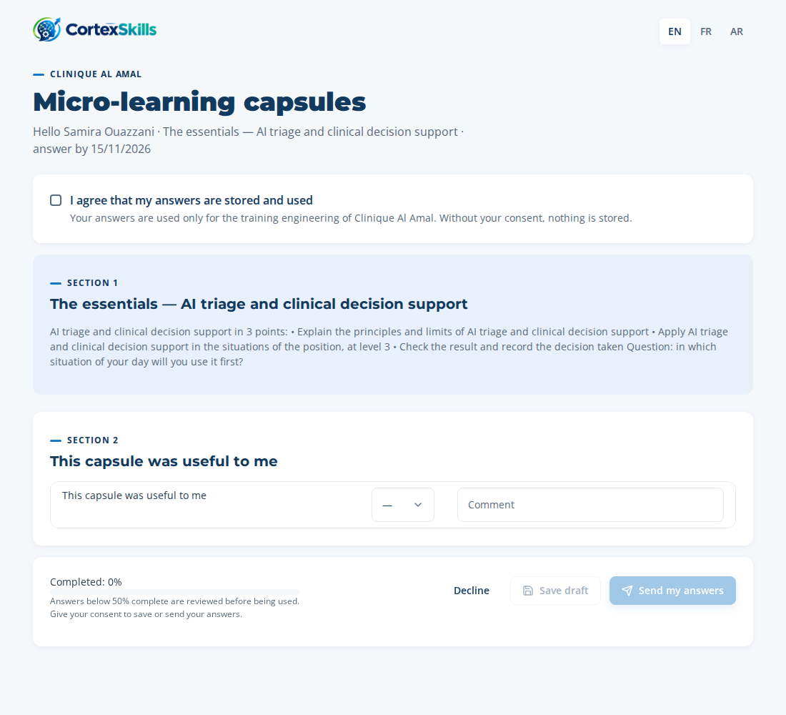
A capsule opened from the link received on WhatsApp
Close the task: “Your result” is drafted from the steps; read it, then “Complete” and “Next task”.

UFT-05-06 — Run immersive simulations
Who: Trainer (approver: Head of L&D) · account headld@cliniquealamal.ma · Input → output: Enrollments → Simulation results
Step MP-30.1 · Define simulation scenario Table to paste · Instructional Designer
Three ways: Manual — type or paste the rows · From the template — 3 row(s) proposed · AI ✓ — 3 row(s) proposed (use case AIUC-F24)
In the case: AI proposal
Copy this table (✥ handle at the top left, Ctrl+C) and paste it in the step’s table (Ctrl+V), then “Apply”. Required columns: Scenario, Course, Situation.
Scenario | Course | Situation | Expected behaviour | Owner
Case — AI triage and clinical decision support | TR-01 — AI triage and clinical decision support | A 67-year-old patient arrives at the emergency room with chest pain. The AI triage tool proposes a priority level. Check the data entered, decide the priority and explain your choice. | Explain the principles and limits of AI triage and clinical decision support ; Apply AI triage and clinical decision support in the situations of the position, at level 3 ; Check the result and record the decision taken | Ayoub Bennani
Case — AI medical imaging assistance | TR-02 — AI medical imaging assistance | A chest X-ray is flagged by the AI tool as “suspicion of nodule”. Review the image and the flag, decide what to report to the radiologist and record it. | Explain the principles and limits of AI medical imaging assistance ; Apply AI medical imaging assistance in the situations of the position, at level 3 ; Check the result and record the decision taken | Ayoub Bennani
Case — Ethics and protection of health data when using AI | TR-03 — Ethics and protection of health data when using AI | A real situation of the position where Ethics and protection of health data when using AI is needed. | Explain the principles and limits of Ethics and protection of health data when using AI ; Apply Ethics and protection of health data when using AI in the situations of the position, at level 3 ; Check the result and record the decision taken | Ayoub Bennani
Lists: Course = TR-01 — AI triage and clinical decision support | TR-02 — AI medical imaging assistance | TR-03 — Ethics and protection of health data when using AI.
Step MP-30.2 · Configure simulation scoring Table to paste · Instructional Designer
Three ways: Manual — type or paste the rows · From the template ✓ — 12 row(s) proposed · AI — 12 row(s) proposed (use case AIUC-F25)
In the case: From the template
Copy this table (✥ handle at the top left, Ctrl+C) and paste it in the step’s table (Ctrl+V), then “Apply”. Required columns: Scenario, Scoring criterion.
Scenario | Scoring criterion | Weight (%) | Pass mark (%)
Case — AI triage and clinical decision support | Collects and checks the data | 25 | 70
Case — AI triage and clinical decision support | Uses the AI tool correctly | 25 | 70
Case — AI triage and clinical decision support | Decision and its justification | 30 | 70
Case — AI triage and clinical decision support | Communication and record | 20 | 70
Case — AI medical imaging assistance | Collects and checks the data | 25 | 70
Case — AI medical imaging assistance | Uses the AI tool correctly | 25 | 70
Case — AI medical imaging assistance | Decision and its justification | 30 | 70
Case — AI medical imaging assistance | Communication and record | 20 | 70
Case — Ethics and protection of health data when using AI | Collects and checks the data | 25 | 70
Case — Ethics and protection of health data when using AI | Uses the AI tool correctly | 25 | 70
Case — Ethics and protection of health data when using AI | Decision and its justification | 30 | 70
Case — Ethics and protection of health data when using AI | Communication and record | 20 | 70

Step MP-30.3 · Launch simulation session Table to paste · Trainer
Three ways: Manual — type or paste the rows · From the template — 3 row(s) proposed · AI ✓ — 3 row(s) proposed (use case AIUC-F26)
In the case: AI proposal
Copy this table (✥ handle at the top left, Ctrl+C) and paste it in the step’s table (Ctrl+V), then “Apply”. Required columns: Session, Scenario, Date, Channel, Message to the learners.
Session | Scenario | Date | Channel | Message to the learners
S-01 — TR-01 · 15/11/2026 | Case — AI triage and clinical decision support | 2026-11-15 | WhatsApp | During the session, you will take part in a simulation: “Case — AI triage and clinical decision support”. It takes about 20 minutes and is assessed on a grid shared beforehand.
S-02 — TR-02 · 16/11/2026 | Case — AI medical imaging assistance | 2026-11-16 | WhatsApp | During the session, you will take part in a simulation: “Case — AI medical imaging assistance”. It takes about 20 minutes and is assessed on a grid shared beforehand.
S-03 — TR-03 · 17/11/2026 | Case — Ethics and protection of health data when using AI | 2026-11-17 | WhatsApp | During the session, you will take part in a simulation: “Case — Ethics and protection of health data when using AI”. It takes about 20 minutes and is assessed on a grid shared beforehand.
Lists: Session = S-01 — TR-01 · 15/11/2026 | S-02 — TR-02 · 16/11/2026 | S-03 — TR-03 · 17/11/2026 ; Channel = E-mail | WhatsApp.
On completing the step: 10 link(s) sent by e-mail or WhatsApp.
On completing the step: 10 message(s) sent.
Messages to the learners
Learner | Status
Nadia Berrada | Invited
Omar El Fassi | Invited
Samira Ouazzani | Invited
Mehdi Tahiri | Invited
Youssra Bennis | Invited
Rachid Amrani | Invited

Step MP-30.4 · Capture the performance in the simulation Table to paste · System
Three ways: Manual — type or paste the rows · From the template ✓ — 10 row(s) proposed · AI — Not offered for this step
In the case: From the template (proposal edited before being saved) — The template lists the learners of each session; the trainer enters the score and the observation.
Copy this table (✥ handle at the top left, Ctrl+C) and paste it in the step’s table (Ctrl+V), then “Apply”. Required columns: Learner, Scenario, Score (%).
Learner | Scenario | Score (%) | Observation
Nadia Berrada | Case — AI triage and clinical decision support | 82 | Data checked, decision justified and recorded.
Omar El Fassi | Case — AI triage and clinical decision support | 90 | Data checked, decision justified and recorded.
Samira Ouazzani | Case — AI triage and clinical decision support | 78 | Data checked, decision justified and recorded.
Mehdi Tahiri | Case — AI triage and clinical decision support | 85 | Data checked, decision justified and recorded.
Rachid Amrani | Case — AI medical imaging assistance | 72 | Data checked, decision justified and recorded.
Imane Zerouali | Case — AI medical imaging assistance | 64 | AI flag sent without checking the image quality.
Nadia Berrada | Case — Ethics and protection of health data when using AI | 82 | Data checked, decision justified and recorded.
Omar El Fassi | Case — Ethics and protection of health data when using AI | 90 | Data checked, decision justified and recorded.
Leila Chraibi | Case — Ethics and protection of health data when using AI | 75 | Data checked, decision justified and recorded.

Step MP-30.5 · Debrief learner Table to paste · Trainer
Three ways: Manual — type or paste the rows · From the template — 9 row(s) proposed · AI ✓ — 9 row(s) proposed (use case AIUC-F27)
In the case: AI proposal
Copy this table (✥ handle at the top left, Ctrl+C) and paste it in the step’s table (Ctrl+V), then “Apply”. Required columns: Learner, Strengths, To improve.
Learner | Date | Strengths | To improve | Next step
Nadia Berrada | 2026-10-16 | Score 82 %: the decision is justified and recorded. Data checked, decision justified and recorded. | Say aloud the limits of the AI suggestion before deciding. | Apply at work; observation at day 30
Omar El Fassi | 2026-10-16 | Score 90 %: the decision is justified and recorded. Data checked, decision justified and recorded. | Say aloud the limits of the AI suggestion before deciding. | Apply at work; observation at day 30
Samira Ouazzani | 2026-10-16 | Score 78 %: the decision is justified and recorded. Data checked, decision justified and recorded. | Say aloud the limits of the AI suggestion before deciding. | Apply at work; observation at day 30
Mehdi Tahiri | 2026-10-16 | Score 85 %: the decision is justified and recorded. Data checked, decision justified and recorded. | Say aloud the limits of the AI suggestion before deciding. | Apply at work; observation at day 30
Rachid Amrani | 2026-10-16 | Score 72 %: the decision is justified and recorded. Data checked, decision justified and recorded. | Say aloud the limits of the AI suggestion before deciding. | Apply at work; observation at day 30
Imane Zerouali | 2026-10-16 | Score 64 %: data collected. AI flag sent without checking the image quality. | Check the data entered in the tool before reading its suggestion; justify the decision. | Second simulation at the next session
Nadia Berrada | 2026-10-16 | Score 82 %: the decision is justified and recorded. Data checked, decision justified and recorded. | Say aloud the limits of the AI suggestion before deciding. | Apply at work; observation at day 30
Omar El Fassi | 2026-10-16 | Score 90 %: the decision is justified and recorded. Data checked, decision justified and recorded. | Say aloud the limits of the AI suggestion before deciding. | Apply at work; observation at day 30
Leila Chraibi | 2026-10-16 | Score 75 %: the decision is justified and recorded. Data checked, decision justified and recorded. | Say aloud the limits of the AI suggestion before deciding. | Apply at work; observation at day 30

Step MP-30.6 · Record simulation evidence Work panel · System
Panel button (record): 9 evidence record(s) saved
Simulations recorded: 9 · Average score: 79.8 %
Simulation evidence
Learner | Score (%) | Passed
Nadia Berrada | 82 | ✓
Omar El Fassi | 90 | ✓
Samira Ouazzani | 78 | ✓
Mehdi Tahiri | 85 | ✓
Rachid Amrani | 72 | ✓
Imane Zerouali | 64 | ✗

Close the task: “Your result” is drafted from the steps; read it, then “Complete” and “Next task”.

UFT-05-07 — Record attendance
Who: Trainer (approver: Training Administrator) · account headld@cliniquealamal.ma · Input → output: Session schedule → Attendance records
Step MP-07.5 · Record attendance Table to paste · Trainer
Three ways: Manual — type or paste the rows · From the template ✓ — 10 row(s) proposed · AI — Not offered for this step
In the case: From the template
Copy this table (✥ handle at the top left, Ctrl+C) and paste it in the step’s table (Ctrl+V), then “Apply”. Required columns: Session, Learner, Attendance.
Session | Learner | Attendance | Hours attended | Sheet signed
S-01 — TR-01 · 15/11/2026 | Nadia Berrada | Present | 14 | Yes
S-01 — TR-01 · 15/11/2026 | Omar El Fassi | Present | 14 | Yes
S-01 — TR-01 · 15/11/2026 | Samira Ouazzani | Present | 14 | Yes
S-01 — TR-01 · 15/11/2026 | Mehdi Tahiri | Present | 14 | Yes
S-01 — TR-01 · 15/11/2026 | Youssra Bennis | Absent | 0 | No
S-02 — TR-02 · 16/11/2026 | Rachid Amrani | Present | 14 | Yes
S-02 — TR-02 · 16/11/2026 | Imane Zerouali | Present | 14 | Yes
S-03 — TR-03 · 17/11/2026 | Nadia Berrada | Present | 7 | Yes
S-03 — TR-03 · 17/11/2026 | Omar El Fassi | Present | 7 | Yes
S-03 — TR-03 · 17/11/2026 | Leila Chraibi | Present | 7 | Yes
Lists: Session = S-01 — TR-01 · 15/11/2026 | S-02 — TR-02 · 16/11/2026 | S-03 — TR-03 · 17/11/2026 ; Attendance = Present | Absent | Excused ; Sheet signed = Yes | No.
Close the task: “Your result” is drafted from the steps; read it, then “Complete” and “Next task”.

UFT-05-08 — Close sessions
Who: Training Administrator (approver: Head of L&D) · account hrd@cliniquealamal.ma · Input → output: Attendance records → Completion records
Step MP-07.6 · Close session and record completion Form · Training Administrator
Three ways: Manual — type each field · From the template — 3 field(s) pre-filled · AI ✓ — 3 field(s) pre-filled
In the case: AI proposal
Type these values in the step’s form; each field is saved when you leave it. A list is chosen in one click (the choice is saved by that same click).
Field | Value to type or choose
Decision (required) | Approved — list
Sessions closed (required) | S-01 — TR-01 · 15/11/2026, S-02 — TR-02 · 16/11/2026, S-03 — TR-03 · 17/11/2026 — check boxes
Rationale (required) | 3 session(s), 10 learner(s) enrolled, 9 present, 1 absent, 0 excused. To re-enrol in a next session: Youssra Bennis.
Decision date (required) | —
Decided by (required) | —

Close the task: “Your result” is drafted from the steps; read it, then “Complete” and “Next task”.

UFT-05-09 — Reconcile and archive period
Who: Training Administrator (approver: Head of L&D) · account headld@cliniquealamal.ma · Input → output: Completion records → Closed delivery period
Step MP-11.5 · Reconcile attendance with invoices Form · Training Administrator
Three ways: Manual — type each field · From the template — 2 field(s) pre-filled · AI ✓ — 3 field(s) pre-filled
In the case: AI proposal
Type these values in the step’s form; each field is saved when you leave it. A list is chosen in one click (the choice is saved by that same click).
Field | Value to type or choose
Attendance and invoices (required) | —
Findings (required) | • MLP-2026-118 (Maghreb Learning Partners, S-01) : 4 invoiced / 4 present ✓ • MLP-2026-119 (Maghreb Learning Partners, S-02) : 2 invoiced / 2 present ✓
Conclusion (required) | Conforming — list
Follow-up actions | Nothing to correct.
Review date (required) | —

Step MP-11.6 · Archive the records of the period (delivery report) Work panel · System
Document generated: DT-E2E-05 — Training delivery report — Clinique Al Amal (version 1, Draft).
Step MP-11.3 · Import external training records Table to paste · Training Administrator
Three ways: Manual — type or paste the rows · From the template ✓ — 2 row(s) proposed · AI — 2 row(s) proposed (use case AIUC-F30)
In the case: From the template (proposal edited before being saved) — The template computes the expected amount (hours × day rate) and the number present; the invoice number is entered from the invoice received.
Copy this table (✥ handle at the top left, Ctrl+C) and paste it in the step’s table (Ctrl+V), then “Apply”. Required columns: Provider, Invoice number, Amount.
Provider | Invoice number | Session | Amount | Currency | Participants invoiced | Invoice date
Maghreb Learning Partners | MLP-2026-118 | S-01 — TR-01 · 15/11/2026 | 14000 |  | 4 | 2026-10-16
Maghreb Learning Partners | MLP-2026-119 | S-02 — TR-02 · 16/11/2026 | 14000 |  | 2 | 2026-10-16
Lists: Provider = Internal | Atlas Formation Conseil | Maghreb Learning Partners ; Session = S-01 — TR-01 · 15/11/2026 | S-02 — TR-02 · 16/11/2026 | S-03 — TR-03 · 17/11/2026 ; Currency = MAD | EUR | USD.
Step MP-11.4 · Correct training record with justification Form · Training Administrator
Three ways: Manual — type each field · From the template — 2 field(s) pre-filled · AI ✓ — 3 field(s) pre-filled
In the case: AI proposal
Type these values in the step’s form; each field is saved when you leave it. A list is chosen in one click (the choice is saved by that same click).
Field | Value to type or choose
Training record corrected (required) | —
Findings (required) | • MLP-2026-118 (Maghreb Learning Partners, S-01) : 4 invoiced / 4 present ✓ • MLP-2026-119 (Maghreb Learning Partners, S-02) : 2 invoiced / 2 present ✓
Conclusion (required) | Conforming — list
Follow-up actions | Nothing to correct.
Review date (required) | —

Close the task: “Your result” is drafted from the steps; read it, then “Complete” and “Next task”.

10. Phase 5 — The evaluation of effectiveness (E2E-07)
Learning, transfer to the workplace and effectiveness are measured and compared with the objectives.

UFT-07-01 — Create assessment instrument
Who: Instructional Designer (approver: Head of L&D) · account headld@cliniquealamal.ma · Input → output: Assessment strategy → Assessment instrument
Step MP-09.1 · Create assessment instrument Table to paste · Instructional Designer
Three ways: Manual — type or paste the rows · From the template ✓ — 3 row(s) proposed · AI — 3 row(s) proposed (use case AIUC-F32)
In the case: From the template
Copy this table (✥ handle at the top left, Ctrl+C) and paste it in the step’s table (Ctrl+V), then “Apply”. Required columns: Instrument, Respondents.
Instrument | Courses | When | Pass mark (%) | Respondents
Satisfaction questionnaire (level 1) | TR-01 — AI triage and clinical decision support, TR-02 — AI medical imaging assistance, TR-03 — Ethics and protection of health data when using AI | End of session | 80 | Learners
Knowledge test (level 2) | TR-01 — AI triage and clinical decision support, TR-02 — AI medical imaging assistance, TR-03 — Ethics and protection of health data when using AI | End of session | 70 | Learners
Observation at work (level 3) | TR-01 — AI triage and clinical decision support, TR-02 — AI medical imaging assistance, TR-03 — Ethics and protection of health data when using AI | Day 90 | 70 | Managers
Lists: Instrument = Satisfaction questionnaire (level 1) | Knowledge test (level 2) | Observation at work (level 3) ; Courses = TR-01 — AI triage and clinical decision support | TR-02 — AI medical imaging assistance | TR-03 — Ethics and protection of health data when using AI (several choices, separated by commas) ; When = End of session | Day 30 | Day 90 ; Respondents = Learners | Managers.
Close the task: “Your result” is drafted from the steps; read it, then “Complete” and “Next task”.

UFT-07-02 — Draft question bank
Who: Instructional Designer (approver: Head of L&D) · account headld@cliniquealamal.ma · Input → output: Assessment instrument → Question bank
Step MP-09.2 · Generate question bank draft Table to paste · Instructional Designer
Three ways: Manual — type or paste the rows · From the template — 9 row(s) proposed · AI ✓ — 17 row(s) proposed (use case AIUC-07)
In the case: AI proposal
Copy this table (✥ handle at the top left, Ctrl+C) and paste it in the step’s table (Ctrl+V), then “Apply”. Required columns: Course, Question, Choices (A ; B ; C ; D), Right answer.
Course | Question | Choices (A ; B ; C ; D) | Right answer | Points
TR-01 — AI triage and clinical decision support | The AI triage tool proposes a low priority for a patient whose condition worries you. What do you do? | You follow the tool’s proposal ; You reassess the patient, decide on your clinical judgement, then record the gap ; You wait for a colleague’s opinion without noting anything ; You change the data entered to get another priority | B | 1
TR-01 — AI triage and clinical decision support | Before reading the triage tool’s proposal, you must first: | Check that the vital signs and the reason entered are complete and accurate ; Print the patient record ; Warn the head doctor ; Nothing in particular | A | 1
TR-01 — AI triage and clinical decision support | What must the record of an AI-assisted triage decision contain? | Only the final priority ; The proposed priority, the priority chosen and the reason for any gap ; The name of the software vendor ; The expected waiting time | B | 1
TR-01 — AI triage and clinical decision support | An AI triage tool is most likely to be wrong when: | The input data are incomplete or unusual ; The patient is known to the facility ; It is used during the day ; The department is quiet | A | 1
TR-01 — AI triage and clinical decision support | A suggestion from an AI tool must be: | Applied without checking ; Checked and compared with professional judgement before acting ; Always ignored ; Validated by the IT department | B | 1
TR-01 — AI triage and clinical decision support | Which behaviour shows the objective “Apply AI triage and clinical decision support in the situations of the position, at level 3”? | Doing it without checking ; Doing it, checking the result and recording the decision ; Asking someone else to do it ; Postponing it | B | 1
TR-02 — AI medical imaging assistance | The AI tool flags a “suspected nodule” on an X-ray. The right reflex is: | Consider the diagnosis made ; Send the flag to the radiologist with the image, without concluding yourself ; Delete the flag if it looks wrong ; Wait for the next examination | B | 1
TR-02 — AI medical imaging assistance | A “false positive” of the imaging tool means: | The tool flags an anomaly that does not exist ; The tool misses an anomaly that is present ; The image is blurred ; The patient refused the examination | A | 1
TR-02 — AI medical imaging assistance | Why check the image quality before the AI analysis? | To keep to the schedule ; Because a poor-quality image can distort the tool’s result ; To reduce the dose ; It is not useful | B | 1
TR-02 — AI medical imaging assistance | Who remains responsible for the final interpretation of the examination? | The tool vendor ; The technician alone ; The radiologist ; The administration | C | 1
TR-02 — AI medical imaging assistance | A suggestion from an AI tool must be: | Applied without checking ; Checked and compared with professional judgement before acting ; Always ignored ; Validated by the IT department | B | 1
TR-02 — AI medical imaging assistance | Which behaviour shows the objective “Apply AI medical imaging assistance in the situations of the position, at level 3”? | Doing it without checking ; Doing it, checking the result and recording the decision ; Asking someone else to do it ; Postponing it | B | 1
TR-03 — Ethics and protection of health data when using AI | A suggestion from an AI tool must be: | Applied without checking ; Checked and compared with professional judgement before acting ; Always ignored ; Validated by the IT department | B | 1
TR-03 — Ethics and protection of health data when using AI | Which data must never be entered in an unauthorised public AI tool? | The name of the course ; A patient’s identification data ; Today’s date ; The name of the department | B | 1
TR-03 — Ethics and protection of health data when using AI | What should you do if the AI tool gives an inconsistent result? | Report it and record the incident ; Start again until you get the expected result ; Say nothing ; Stop using the computer | A | 1
TR-03 — Ethics and protection of health data when using AI | A suggestion from an AI tool must be: | Applied without checking ; Checked and compared with professional judgement before acting ; Always ignored ; Validated by the IT department | B | 1
TR-03 — Ethics and protection of health data when using AI | Which behaviour shows the objective “Apply Ethics and protection of health data when using AI in the situations of the position, at level 3”? | Doing it without checking ; Doing it, checking the result and recording the decision ; Asking someone else to do it ; Postponing it | B | 1
Lists: Course = TR-01 — AI triage and clinical decision support | TR-02 — AI medical imaging assistance | TR-03 — Ethics and protection of health data when using AI ; Right answer = A | B | C | D.
Close the task: “Your result” is drafted from the steps; read it, then “Complete” and “Next task”.

UFT-07-03 — Collect reaction survey (Level 1)
Who: L&D Analyst (approver: Head of L&D) · account analyst@cliniquealamal.ma · Input → output: Completion records → Level 1 results
Step MP-09.3 · Collect reaction survey (Level 1) Work panel · System
Panel button (send): 9 link(s) sent
9 answer(s) received on the personal links, for example: Nadia Berrada, Omar El Fassi, Samira Ouazzani.
Learners asked: 9 · Answers: 9 · Average satisfaction: 4.2 / 5
Answers (level 1)
Learner | Course | Average /5 | Will apply | To improve
Nadia Berrada | TR-01 | 4.6 | Check the vital signs before reading the tool’s proposal. | Half a day more.
Omar El Fassi | TR-01 | 3.8 | Record the gap between the proposal and my decision. | More practical cases.
Samira Ouazzani | TR-01 | 4.8 | Send the flag with the image to the radiologist. | Half a day more.
Mehdi Tahiri | TR-01 | 3.4 | Check the vital signs before reading the tool’s proposal. | More practical cases.
Rachid Amrani | TR-02 | 4.4 | Record the gap between the proposal and my decision. | Half a day more.
Imane Zerouali | TR-02 | 4.6 | Send the flag with the image to the radiologist. | More practical cases.

Close the task: “Your result” is drafted from the steps; read it, then “Complete” and “Next task”.

UFT-07-04 — Record learning results (Level 2)
Who: Trainer (approver: Head of L&D) · account headld@cliniquealamal.ma · Input → output: Level 1 results → Level 2 results
Step MP-09.4 · Record learning results (Level 2) Work panel · Trainer
Panel button (send): 9 link(s) sent
9 answer(s) received on the personal links, for example: Nadia Berrada, Omar El Fassi, Samira Ouazzani.
Tests sent: 9 · Answers: 9 · Pass rate: 89 %
The scores are computed from the answers and the right answers of the question bank (step MP-09.2); the right answers are never shown to the learners.
Scores (level 2)
Learner | Course | Points | % | Passed
Nadia Berrada | TR-01 | 6/6 | 100 | ✓
Omar El Fassi | TR-01 | 6/6 | 100 | ✓
Samira Ouazzani | TR-01 | 4/6 | 67 | ✗
Mehdi Tahiri | TR-01 | 6/6 | 100 | ✓
Rachid Amrani | TR-02 | 5/6 | 83 | ✓
Imane Zerouali | TR-02 | 6/6 | 100 | ✓

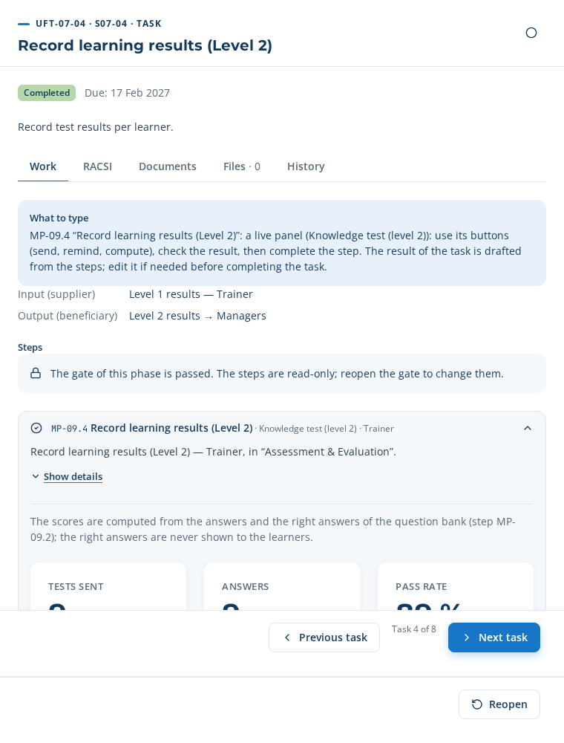
UFT-07-04 in the application
The test message (example):
Subject: Clinique Al Amal — Test — AI triage and clinical decision support Hello Nadia Berrada, Your knowledge test is ready: Test — AI triage and clinical decision support (about 5 minutes). Your link: http://localhost:4000/respond/TnlreOScsaTxzc3v47go9b3cVELJumqH Deadline: 26 October 2026. Your answers are used only for the training engineering of Clinique Al Amal and are stored only after your consent. Reply STOP to stop these messages.
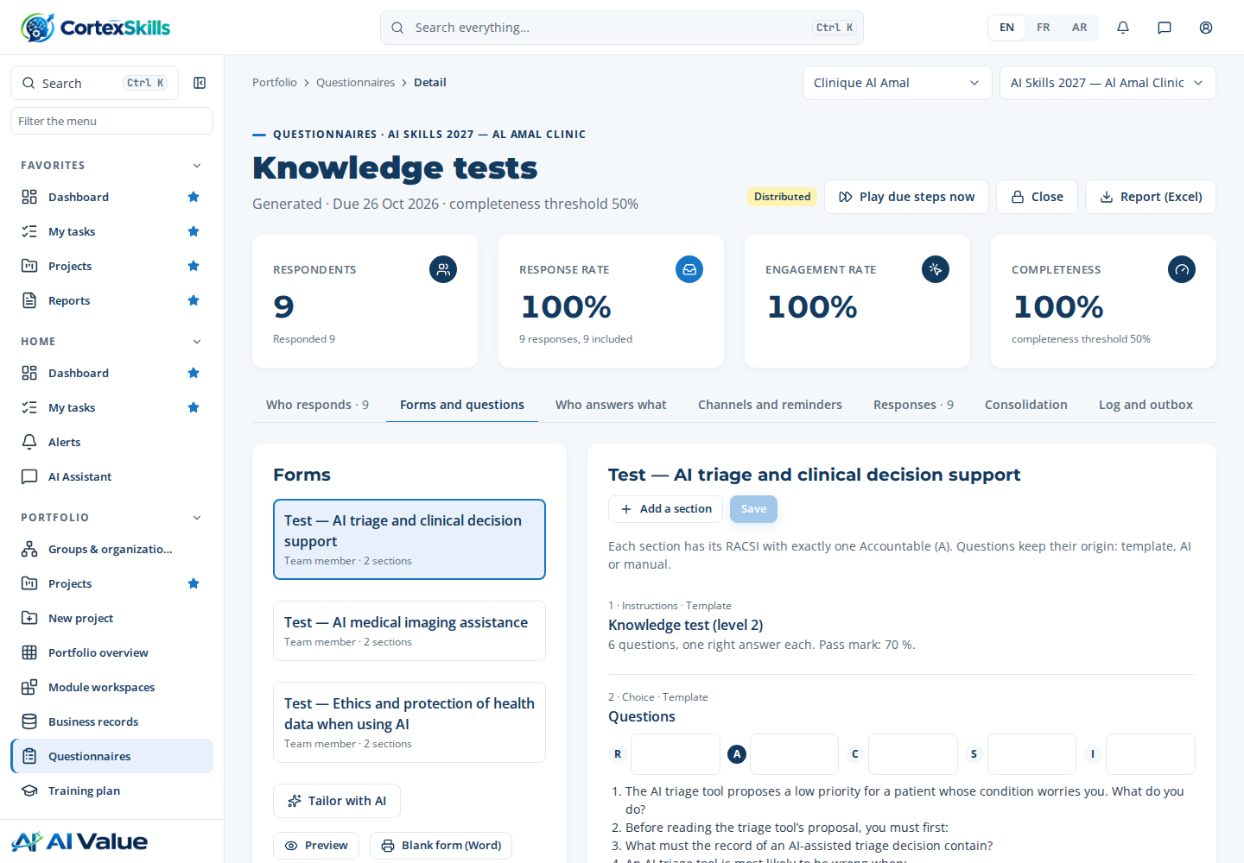
The knowledge test: one right answer per question, never shown to the learner
Close the task: “Your result” is drafted from the steps; read it, then “Complete” and “Next task”.

UFT-07-05 — Record on-the-job observation (Level 3)
Who: Manager (approver: Head of L&D) · account headld@cliniquealamal.ma · Input → output: Level 2 results → Level 3 results
Step MP-09.5 · Record on-the-job observation (Level 3) Work panel · Manager
Panel button (send): 9 link(s) sent
9 answer(s) received on the personal links, for example: Dr Youssef Alaoui, Dr Youssef Alaoui, Nadia Berrada.
Managers asked: 9 · Observations: 9
Observations (level 3)
Learner | Manager | Competency | Level observed | Facts
Nadia Berrada | Dr Youssef Alaoui | C-01 | 3 | Checks the data, decides and records the decision independently.
Omar El Fassi | Dr Youssef Alaoui | C-01 | 3 | Checks the data, decides and records the decision independently.
Samira Ouazzani | Nadia Berrada | C-01 | 3 | Checks the data, decides and records the decision independently.
Mehdi Tahiri | Nadia Berrada | C-01 | 2 | Uses the tool but still forgets to record the decision.
Rachid Amrani | Nadia Berrada | C-02 | 3 | Checks the data, decides and records the decision independently.
Imane Zerouali | Nadia Berrada | C-02 | 3 | Checks the data, decides and records the decision independently.

Close the task: “Your result” is drafted from the steps; read it, then “Complete” and “Next task”.

UFT-07-06 — Compute skill progression
Who: L&D Analyst (approver: Head of L&D) · account analyst@cliniquealamal.ma · Input → output: Level 3 results → Skill progression
Step MP-09.6 · Compute skill progression Work panel · System
Panel button (compute): 9 row(s) computed
Learners observed: 9 · Progressed or at target: 89 % · Average gain: 0.9
Before = level validated in the diagnosis; after = level observed by the manager (level 3).
Progression
Learner | Competency | Before | After | Target | Target reached
Nadia Berrada | C-01 | 2 | 3 | 3 | ✓
Nadia Berrada | C-03 | 2 | 3 | 3 | ✓
Omar El Fassi | C-01 | 2 | 3 | 3 | ✓
Omar El Fassi | C-03 | 2 | 3 | 3 | ✓
Leila Chraibi | C-03 | 2 | 3 | 3 | ✓
Samira Ouazzani | C-01 | 2 | 3 | 3 | ✓

Step MP-10.3 · Refresh KPI computation Work panel · System
Panel button (compute): 8 indicator(s) updated
Indicators of the plan
ID | Indicator | Value | Target | Status
KPI-012 | Average level-1 satisfaction (out of 5) | 4.2/5 | ≥ 4.2/5 | Green
KPI-013 | Skills progression rate | 89 % | ≥ 70 % | Green
FLOW-L2 | Level-2 test pass rate | 89 % | ≥ 80 % | Green
FLOW-ATT | Attendance rate | 90 % | ≥ 90 % | Green
KPI-008 | Session fill rate | 33 % | ≥ 85 % | Red
KPI-003 | Critical gap rate | 30 % | ≤ 10 % | Red

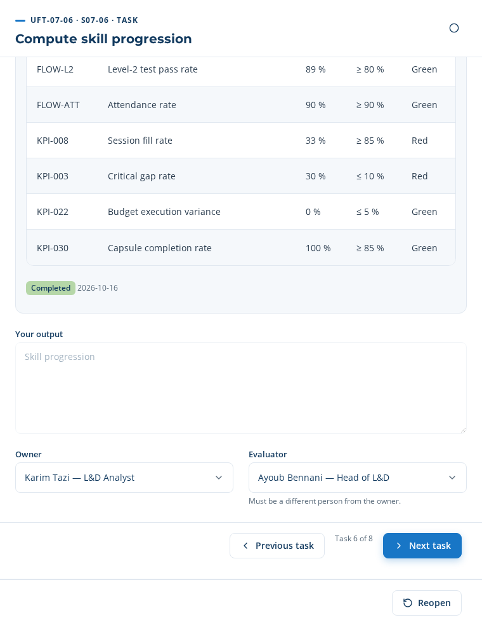
UFT-07-06 in the application
Close the task: “Your result” is drafted from the steps; read it, then “Complete” and “Next task”.

UFT-07-07 — Review evaluation results
Who: L&D Analyst (approver: Head of L&D) · account analyst@cliniquealamal.ma · Input → output: Skill progression → Evaluation review
Step MP-09.7 · Review evaluation results Form · L&D Analyst
Three ways: Manual — type each field · From the template — 2 field(s) pre-filled · AI ✓ — 3 field(s) pre-filled
In the case: AI proposal
Type these values in the step’s form; each field is saved when you leave it. A list is chosen in one click (the choice is saved by that same click).
Field | Value to type or choose
Evaluation results (required) | —
Findings (required) | • Average level-1 satisfaction (out of 5) : 4.2/5 (target ≥ 4.2) — Green • Skills progression rate : 89 % (target ≥ 70) — Green • Level-2 test pass rate : 89 % (target ≥ 80) — Green • Attendance rate : 90 % (target ≥ 90) — Green • Session fill rate : 33 % (target ≥ 85) — Red • Critical gap rate : 30 % (target ≤ 10) — Red • Budget execution variance : 0 % (target ≤ 5) — Green • Capsule completion rate : 100 % (target ≥ 85) — Green
Conclusion (required) | Major corrections — list
Follow-up actions | KPI-008: analyse the causes with the trainers and the managers; action in the quality review. KPI-003: analyse the causes with the trainers and the managers; action in the quality review.
Review date (required) | —

Step MP-20.5 · Run periodic quality review Table to paste · Quality Manager
Three ways: Manual — type or paste the rows · From the template — 8 row(s) proposed · AI ✓ — 8 row(s) proposed (use case AIUC-F34)
In the case: AI proposal
Copy this table (✥ handle at the top left, Ctrl+C) and paste it in the step’s table (Ctrl+V), then “Apply”. Required columns: Point reviewed, Finding, Status.
Point reviewed | Finding | Status | Action | Owner | Due
Average level-1 satisfaction (out of 5) | 4.2/5 — target ≥ 4.2/5 | Green
Skills progression rate | 89 % — target ≥ 70 % | Green
Level-2 test pass rate | 89 % — target ≥ 80 % | Green
Attendance rate | 90 % — target ≥ 90 % | Green
Session fill rate | 33 % — target ≥ 85 % | Red | Merge the sessions under-filled | Karim Tazi (L&D Analyst) | 2026-11-15
Critical gap rate | 30 % — target ≤ 10 % | Red | Keep the critical competencies in the next plan | Karim Tazi (L&D Analyst) | 2026-11-15
Budget execution variance | 0 % — target ≤ 5 % | Green
Capsule completion rate | 100 % — target ≥ 85 % | Green
Lists: Status = Green | Amber | Red.
Close the task: “Your result” is drafted from the steps; read it, then “Complete” and “Next task”.

UFT-07-08 — Publish evaluation report
Who: L&D Analyst (approver: Head of L&D) · account analyst@cliniquealamal.ma · Input → output: Evaluation review → Kirkpatrick evaluation report
Step MP-10.4 · Export the evaluation report Work panel · L&D Analyst
Document generated: DT-E2E-07 — Training evaluation report — Clinique Al Amal (version 1, Draft).
Step MP-10.6 · Share insight with stakeholders Table to paste · L&D Analyst
Three ways: Manual — type or paste the rows · From the template — 3 row(s) proposed · AI ✓ — 3 row(s) proposed (use case AIUC-F35)
In the case: AI proposal
Copy this table (✥ handle at the top left, Ctrl+C) and paste it in the step’s table (Ctrl+V), then “Apply”. Required columns: Audience, Channel, Message.
Audience | Channel | Message | Date
Sponsors and decision makers | E-mail | Results of the training plan: Average level-1 satisfaction (out of 5) : 4.2/5 ; Skills progression rate : 89 % ; Level-2 test pass rate : 89 % ; Attendance rate : 90 % ; Session fill rate : 33 %. 8 of 9 learners observed at their target level. | 2026-10-16
Managers of the learners | E-mail | Thank you for the observations. Keep supporting the learners below target: the referent will contact you. | 2026-10-16
Learners | WhatsApp | Thank you for taking part in the training. Your opinion and your results help us improve the next sessions. | 2026-10-16
Lists: Audience = Sponsors and decision makers | Managers of the learners | Learners | Change relays ; Channel = E-mail | WhatsApp.
On completing the step: 14 message(s) sent.
Messages sent
To | Channel | Status
dg.salma@cliniquealamal.ma | E-mail | simulated
hrd@cliniquealamal.ma | E-mail | simulated
directeur.medical@cliniquealamal.ma | E-mail | simulated
directeur.medical@cliniquealamal.ma | E-mail | simulated
cadre.sante@cliniquealamal.ma | E-mail | simulated
dg.salma@cliniquealamal.ma | E-mail | simulated

Step MP-10.2 · Configure dashboard widgets Table to paste · L&D Analyst
Three ways: Manual — type or paste the rows · From the template — 4 row(s) proposed · AI ✓ — 6 row(s) proposed (use case AIUC-F36)
In the case: AI proposal
Copy this table (✥ handle at the top left, Ctrl+C) and paste it in the step’s table (Ctrl+V), then “Apply”. Required columns: Indicator, Display.
Indicator | Display | Target | Visible to
KPI-008 — Session fill rate | Gauge | 85 | R-02 — HR Director / Steering Committee Chair, R-03 — Head of L&D, R-13 — Manager / Hiring Manager
KPI-003 — Critical gap rate | Gauge | 10 | R-02 — HR Director / Steering Committee Chair, R-03 — Head of L&D, R-13 — Manager / Hiring Manager
KPI-012 — Average level-1 satisfaction (out of 5) | Tile | 4.2 | R-02 — HR Director / Steering Committee Chair, R-03 — Head of L&D
KPI-013 — Skills progression rate | Gauge | 70 | R-02 — HR Director / Steering Committee Chair, R-03 — Head of L&D
FLOW-L2 — Level-2 test pass rate | Gauge | 80 | R-02 — HR Director / Steering Committee Chair, R-03 — Head of L&D
FLOW-ATT — Attendance rate | Gauge | 90 | R-02 — HR Director / Steering Committee Chair, R-03 — Head of L&D
Lists: Display = Tile | Bar chart | Gauge | Line.
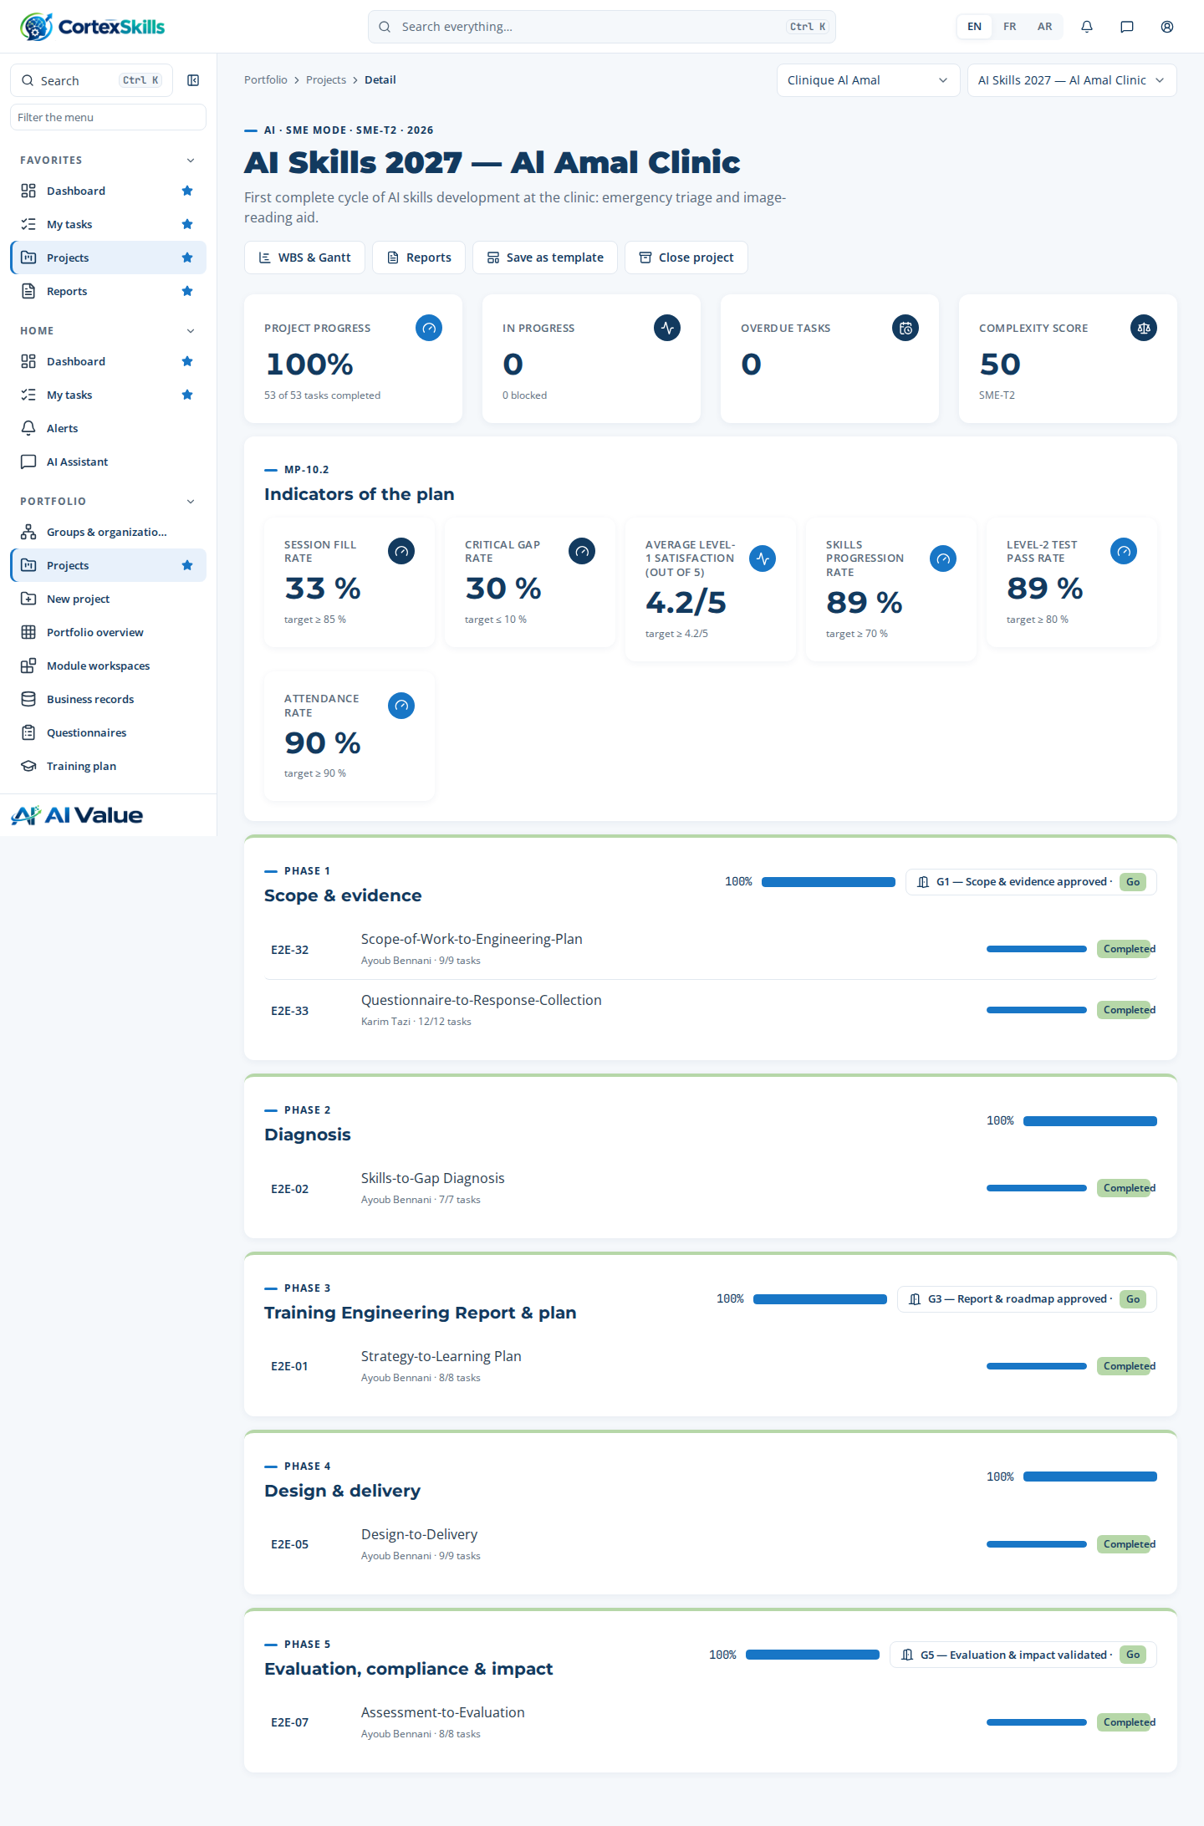
The indicators chosen in MP-10.2 on the project page
Close the task: “Your result” is drafted from the steps; read it, then “Complete” and “Next task”.

Gate G5 — Evaluation & impact validated
Sign in as HR Director (hrd@cliniquealamal.ma). In the project, open the gate checklist, tick each point checked, then decide “Go” with a justification. The tasks of the next phase only start after this “Go”.
Point to check | Ticked
Level 1, 2 and 3 evaluations recorded | Yes
ROI reviewed with finance | Yes
Certifications valid for mandatory roles | Yes
Decision: Go — Effectiveness evaluated at levels 1 to 3; improvement actions started.

11. Troubleshooting
What you see | Likely cause | What to do
Messages stay “Sandbox” / “simulated” | The channel is in sandbox mode or is not enabled. | Administration › Channels: tick “Enabled”, choose “Live”, save, then “Send a test”.
“The provider refused the message” (e-mail) | SMTP credentials, port or sender refused by the server. | Check the port (587 without immediate TLS, 465 with it), the app password, and that the sender is allowed for this account.
“Distribute” refused: a respondent receives no question | The assignment gives all the questions of their form to other people. | “Who answers what” tab: add them to at least one section, or empty a row to give it back to “All”.
“Paste a table”: row not understood | The element is not written as on screen, or the respondent is not in the respondents list. | Copy the exact title from the panel; name the respondent by name, e-mail or job title.
WhatsApp: “template” or “24 h” failure | No approved template, or wrong template name/language. | Enter the exact name of the approved template and its language code (en); wait for Meta’s approval.
The respondent cannot open their link | The link points to localhost or an internal address. | Declare PUBLIC_URL (chapter 2.1) and restart the server; send the message again (“Send now”).
“The project has no questionnaire yet” | Step MP-54.1 is not completed. | Choose the templates in MP-54.1 and complete the step; the questionnaire is created.
“Each section must have exactly one A” | No role or several roles ticked A for a section. | In MP-54.4, keep a single A (or specify the sections of each row).
“Some AI questions are not validated yet” | An AI question is waiting for its validation. | MP-54.3: “Validate all” or ✓ on each question, then complete the step.
“This cross-functional process starts after gate G3” | The adoption process (E2E-17) waits for the approved plan. | Normal: it starts after the “Go” of gate G3.
“An e-mail address or a number is missing…” | A person has the WhatsApp channel without a phone, or e-mail without an address. | Complete the row (the name chosen in the list fills in the known e-mail and phone), or change the channel.
“The budget per theme exceeds the envelope” | The sum of the rows of MP-18.1 is above the amount of MP-01.3. | Reduce groups or days, or reopen MP-01.3 to revise the envelope (with justification).
“The schedule has conflicts” | A trainer or a room is booked twice the same day, or outside their availability. | Panel MP-07.2 lists each conflict; correct the date, the room or the trainer in MP-07.1.
“Nothing has been sent yet” | The send button of the panel has not been used. | Click “Send…” in the step’s panel, then complete it.
“No answer received” | Nobody has answered their link yet. | Wait for the answers or “Remind”; the step completes from the first answer, the next ones are counted in the computation.
The paste puts the titles in a row | The “The first row contains the titles” box is unticked or a title has changed. | Tick it in the Paste preview, or copy the table again without changing its titles.

Appendix A — The questions of the three forms
Full list of the sections and questions as the respondents receive them. For table sections, the respondent adds rows with the columns shown.

IF-PAC form — General Manager workshop
1. Interviewer brief — workshop with the General Manager — During this meeting with the General Manager: 1) update the strategic vision; 2) ask an open question on the priority training axes; 3) validate the axes that came out of the face-to-face meetings with the other participants; 4) on request, validate the themes of some axes; and confirm the organization chart of the scope. Outcome of the face-to-face meetings: spread the training content over several years (2 years…).
2. Respondent
1) Full name 2) Position 3) Reports to 4) Years of experience 5) Years in the position 6) Age
3. Training attended in your company or institution — table: Training title | Month / Year | Duration (days) | Learnings
4. Impact of the previous year’s training plan (n-1)
1) What did you notice about the n-1 training plan? 2) What were the strengths of the n-1 plan? 3) What improvements did the n-1 plan bring? 4) What were the challenges of the n-1 plan? 5) What did you appreciate and like about the n-1 plan? 6) For a new training plan, what would you like to see done differently? 7) If this is achieved, what would the situation become? 8) What are your suggestions for the new training plan? 9) What could the company do with these suggestions?
5. Company organization chart
1) Organization chart of the scope in question confirmed
6. Current and future jobs (N-1 only: those reporting to the General Manager) — description and development planning — table: Job title | Existing or future job | Key activities (existing and future N-1) | Competence(s) to develop | Most critical activities with a high impact on performance
7. Strategic orientations and competence needs — columns: Details
1) Vision 2) Mission 3) Values 4) Context 5) Products — existing 6) Products — new 7) Market segments 8) Strategy(ies) adopted 9) Priority axes for training and human capital development 10) Actions under way or planned
8. Key dates of the company — table: Date | Event
9. Performance indicators — strategic objectives — table: Strategic objective | Description (SMART) | Link: Customer satisfaction | Link: Financial performance | Link: Operational and production efficiency | Link: HR / human capital | Link: Innovation (products, services, processes, business model) | Competences to develop to meet these objectives
10. Performance by function and decision level (1 – 5; 5: highest) — table: Function | Strategic management (MS) | Operational management (MO) | Operational (OP) | Competences required to improve performance (MS / MO / OP)
11. The 5 levels of leadership and excellence — columns: % of employees in the scope | Hierarchical level (director, manager, officer, team lead, technician…) | Details
1) Personal productivity 2) Personal leadership 3) Leadership applied to teams 4) Leadership of a sub-function of the organization 5) Leadership of a function or of the whole organization
12. Management of cross-functional processes — columns: Documented (yes, no) | Global (virtual) process owner in place | Current performance (1 – 5, 5: excellent)
1) “From prospect to cash” 2) “From a change request to its implementation” 3) “From a customer request to its answer” 4) “From product / service use to payment” (rental…) 5) “From a customer problem to its resolution” 6) “From a customer complaint to its resolution” 7) “From a termination request to its closure” 8) “From internal product delivery to customer acceptance” 9) “Delivery capacity management” 10) “Technical resources life-cycle management” 11) “Service life-cycle management” 12) “From a production / service resource incident to its resolution” 13) “From product / service use to its closure” (rental…) 14) “Develop the product strategy and roadmap” 15) “Design and develop a product” 16) “Monitor the performance of a product”
13. General SWOT
1) Strengths 2) Areas for improvement 3) Opportunities 4) Threats
14. Strategic planning and macro business plans
1) Is there a strategic plan with macro business plans at company level? 2) Are this strategic plan and the macro business plans implemented? 3) Are they monitored? 4) Are they subject to continuous improvement?
15. Self-assessment of management / leadership competences
1) Self-motivation and energy 2) Self-control and excellence 3) Positive thinking and positive results (focus on solutions, break a big challenge into small pieces, look ahead) 4) Management by objectives and strategic vision applied to oneself 5) Personal development plan and continuous learning 6) Time management and priorities 7) Management by objectives and strategic vision applied to others 8) Coaching others towards excellence 9) Communication with oneself 10) Communication with others 11) Communication with the team 12) Public speaking 13) Rewards and motivation 14) Training and effectiveness 15) Managing with flexibility 16) Management by values 17) Enterprise management: macro view of the company’s businesses and functions and how they are steered; overall dashboard 18) Continuous quality improvement — problem solving and solutions 19) Continuous quality improvement — conflict resolution and solutions 20) Continuous quality improvement — innovation and solutions 21) Change management (identify, plan, execute, follow up and update a change plan) 22) Effective recruitment
16. Projects under way — table: Project | Details | Start date | End date | Current state | Remarks | Competence(s) to develop
17. Sector-specific questions — Healthcare Providers · AI (AI, validated)
1) How often do you use AI triage and clinical decision support in your work today, and for which tasks? 2) What prevents you today from using AI medical imaging assistance in Clinical Care & Nursing? 3) Which ISO 7101 requirements should a training on AI triage and clinical decision support cover? 4) Which skills do you need to apply AI bed and staff capacity planning safely? 5) How would you prefer to learn: classroom, e-learning, coaching or on the job?
18. Ambitions, expected impact and recommendations
1) What are your current ambitions to improve overall performance? 2) Once these ambitions are achieved, how would you feel? 3) How will you know they are achieved? 4) What can you do to achieve them? 5) What will you do to achieve them? 6) What do you need to excel further in your position? 7) In your view, what impact and results do you expect from the competence development trainings? 8) Your recommendations

IF-PAC form — Management (directors, managers, process owners)
1. Respondent
1) Full name 2) Position 3) Reports to 4) Years of experience 5) Years in the position 6) Age
2. Training attended in your company or institution — table: Training title | Month / Year | Duration (days) | Learnings
3. Impact of the previous year’s training plan (n-1)
1) What did you notice about the n-1 training plan? 2) What were the strengths of the n-1 plan? 3) What improvements did the n-1 plan bring? 4) What were the challenges of the n-1 plan? 5) What did you appreciate and like about the n-1 plan? 6) For a new training plan, what would you like to see done differently? 7) If this is achieved, what would the situation become? 8) What are your suggestions for the new training plan? 9) What could the company do with these suggestions?
4. Company organization chart
1) Organization chart of the scope in question confirmed
5. Current and future jobs (N-1 only: those reporting to the General Manager) — description and development planning — table: Job title | Existing or future job | Key activities (existing and future N-1) | Competence(s) to develop | Most critical activities with a high impact on performance
6. Performance by function and decision level (1 – 5; 5: highest) — table: Function | Strategic management (MS) | Operational management (MO) | Operational (OP) | Competences required to improve performance (MS / MO / OP)
7. The 5 levels of leadership and excellence — columns: % of employees in the scope | Hierarchical level (director, manager, officer, team lead, technician…) | Details
1) Personal productivity 2) Personal leadership 3) Leadership applied to teams 4) Leadership of a sub-function of the organization 5) Leadership of a function or of the whole organization
8. Management of cross-functional processes — columns: Documented (yes, no) | Global (virtual) process owner in place | Current performance (1 – 5, 5: excellent)
1) “From prospect to cash” 2) “From a change request to its implementation” 3) “From a customer request to its answer” 4) “From product / service use to payment” (rental…) 5) “From a customer problem to its resolution” 6) “From a customer complaint to its resolution” 7) “From a termination request to its closure” 8) “From internal product delivery to customer acceptance” 9) “Delivery capacity management” 10) “Technical resources life-cycle management” 11) “Service life-cycle management” 12) “From a production / service resource incident to its resolution” 13) “From product / service use to its closure” (rental…) 14) “Develop the product strategy and roadmap” 15) “Design and develop a product” 16) “Monitor the performance of a product”
9. SWOT of the function — table: Job / function / detailed scope of action | Strengths | High-level areas for improvement (dysfunctions, problems, shortfalls) | Competence(s) to develop
10. Opportunities and threats
1) Opportunities 2) Threats
11. Performance indicators — strategic objectives — table: Strategic objective | Description (SMART) | Link: Customer satisfaction | Link: Financial performance | Link: Operational and production efficiency | Link: HR / human capital | Link: Innovation (products, services, processes, business model) | Competences to develop to meet these objectives
12. Self-assessment of management / leadership competences
1) Self-motivation and energy 2) Self-control and excellence 3) Positive thinking and positive results (focus on solutions, break a big challenge into small pieces, look ahead) 4) Management by objectives and strategic vision applied to oneself 5) Personal development plan and continuous learning 6) Time management and priorities 7) Management by objectives and strategic vision applied to others 8) Coaching others towards excellence 9) Communication with oneself 10) Communication with others 11) Communication with the team 12) Public speaking 13) Rewards and motivation 14) Training and effectiveness 15) Managing with flexibility 16) Management by values 17) Enterprise management: macro view of the company’s businesses and functions and how they are steered; overall dashboard 18) Continuous quality improvement — problem solving and solutions 19) Continuous quality improvement — conflict resolution and solutions 20) Continuous quality improvement — innovation and solutions 21) Change management (identify, plan, execute, follow up and update a change plan) 22) Effective recruitment
13. HR orientations (HR function only)
1) What are the HR orientations?
14. Projects under way — table: Project | Details | Start date | End date | Current state | Remarks | Competence(s) to develop
15. Sector-specific questions — Healthcare Providers · AI (AI, validated)
1) How often do you use AI triage and clinical decision support in your work today, and for which tasks? 2) What prevents you today from using AI medical imaging assistance in Clinical Care & Nursing? 3) Which ISO 7101 requirements should a training on AI triage and clinical decision support cover? 4) Which skills do you need to apply AI bed and staff capacity planning safely? 5) How would you prefer to learn: classroom, e-learning, coaching or on the job?
16. Ambitions, expected impact and recommendations
1) What are your current ambitions to improve overall performance? 2) Once these ambitions are achieved, how would you feel? 3) How will you know they are achieved? 4) What can you do to achieve them? 5) What will you do to achieve them? 6) What do you need to excel further in your position? 7) In your view, what impact and results do you expect from the competence development trainings? 8) Your recommendations

IF-PAC form — Team member
1. Respondent
1) Full name 2) Position 3) Reports to 4) Years of experience 5) Years in the position 6) Age
2. Training attended in your company or institution — table: Training title | Month / Year | Duration (days) | Learnings
3. Impact of the previous year’s training plan (n-1)
1) What did you notice about the n-1 training plan? 2) What were the strengths of the n-1 plan? 3) What improvements did the n-1 plan bring? 4) What were the challenges of the n-1 plan? 5) What did you appreciate and like about the n-1 plan? 6) For a new training plan, what would you like to see done differently? 7) If this is achieved, what would the situation become? 8) What are your suggestions for the new training plan? 9) What could the company do with these suggestions?
4. Job description — table: Tasks performed | Existing / new | Criticality (1 – 5, 5: very high impact on performance) | Performance (1 – 5, 5: excellent) | Competence(s) to develop
5. The levels of leadership and excellence — columns: Your assessment (1 – 5: excellent) | Details
1) Personal productivity 2) Personal leadership 3) Leadership applied to teams
6. My light SWOT — table: Strengths | High-level areas for improvement (dysfunctions, problems, shortfalls) | Competence(s) to develop
7. Performance indicators — my objectives — table: Objective | Description (SMART) | Link: Customer satisfaction | Link: Financial performance | Link: Operational and production efficiency | Link: HR / human capital | Link: Innovation (products, services, processes, business model) | Competences to develop to meet these objectives
8. Self-assessment of management / leadership competences
1) Self-motivation and energy 2) Self-control and excellence 3) Positive thinking and positive results (focus on solutions, break a big challenge into small pieces, look ahead) 4) Management by objectives and strategic vision applied to oneself 5) Personal development plan and continuous learning 6) Time management and priorities 7) Management by objectives and strategic vision applied to others 8) Coaching others towards excellence 9) Communication with oneself 10) Communication with others 11) Communication with the team 12) Public speaking 13) Rewards and motivation 14) Training and effectiveness 15) Managing with flexibility 16) Management by values 17) Continuous quality improvement — problem solving and solutions 18) Continuous quality improvement — conflict resolution and solutions 19) Continuous quality improvement — innovation and solutions 20) Change management (identify, plan, execute, follow up and update a change plan) 21) Effective recruitment
9. Projects under way — table: Project | Details | Start date | End date | Current state | Remarks | Competence(s) to develop
10. Sector-specific questions — Healthcare Providers · AI (AI, validated)
1) In your department, how often do you use a digital tool to direct a patient at the emergency reception? 2) What prevents you today from using AI medical imaging assistance in Clinical Care & Nursing? 3) Which ISO 7101 requirements should a training on AI triage and clinical decision support cover? 4) Which skills do you need to apply AI bed and staff capacity planning safely? 5) How would you prefer to learn: classroom, e-learning, coaching or on the job? 6) Which emergency triage tasks would you like AI to assist with, and which must remain entirely human?
11. Ambitions, expected impact and recommendations
1) What are your current ambitions to improve your performance? 2) Once these ambitions are achieved, how would you feel? 3) How will you know they are achieved? 4) What can you do to achieve them? 5) What will you do to achieve them? 6) What do you need to excel further in your position? 7) In your view, what impact and results do you expect from the competence development trainings? 8) Your recommendations

