

USER GUIDE — EDITOR SIDE
CortexSkills
Using CortexSkills on your installations: reference organizations, customer organizations and users, offers, prices and quotations, licences, running projects, platform settings, audit and backups
Version 1.15.1 · 2026-10-16
Internal — AI Value

Table of Contents
1. About this guide 3
1.1 Editor edition and customer edition 3
2. Sign in and find your way 4
3. The reference organizations 6
4. Customer organizations and users 8
4.1 Create a customer’s organization 8
4.2 Users and roles 8
5. Offers, prices and quotations 9
5.1 Packs 9
5.2 Bundles and SME packs 10
6. Licences in the application 11
7. Run a project with a customer 12
7.1 Project templates 12
8. Platform settings 14
8.1 Channels: e-mail and WhatsApp 14
8.2 AI 14
8.3 Document templates 15
9. Audit, traceability and backups 16
10. Good practices 17
11. Troubleshooting 18

1. About this guide
This guide is for the AI Value teams who use CortexSkills on their own installations (scenario a: private cloud or on-premises; scenario b: localhost on Windows): the platform administrator, the consultants who run projects with customers and the sales people who prepare offers. The installation itself and licence signing are described in the editor installation guide.
Document | Content
Installation_Guide_Runtime_Editor_Linux_Windows_CortexSkills_EN | Install the editor runtime (Linux, Windows), the signing workstation and licence management (cslic).
This guide | Use the application in the editor edition.
User_Guide_Customer_CortexSkills_EN | The complete run of a project on a real case (private clinic), step by step; it also applies to your installations.

1.1 Editor edition and customer edition
Item | Editor edition (this guide) | Customer edition
Packs & pricing screen, price calculator | Yes | No (page unavailable)
Prices in the catalog, packaging rules | Yes | Removed down to the database
Licence manager (cslic) | Yes, on the signing workstation | No
Signed licence required | Yes | Yes
Reference data (61 organizations) | Yes | Yes
Processes, tasks, steps, AI, documents | Identical | Identical

2. Sign in and find your way
Open the address of the installation (https://skills.mydomain.com in scenario a, http://localhost:4000 in scenario b). The sign-in page names no account: no demonstration account exists. At first, only the platform administrator (ADMIN_EMAIL of the .env file) can sign in.
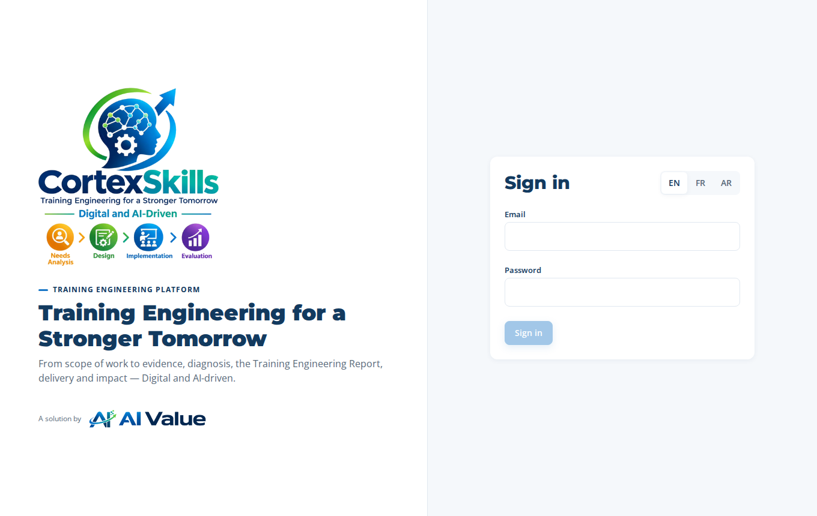
The sign-in page
Area | Use
Top bar | Global search (Ctrl K), language (EN · FR · AR), alerts, AI assistant, your account (password, sign out).
Context selectors | The group or organization, then the project the screens apply to. The platform administrator moves from one organization to another.
Left menu | Favorites, Home, Portfolio, Process design, Governance, AI & knowledge, Documents, Administration. The filter at the top of the menu finds an entry.
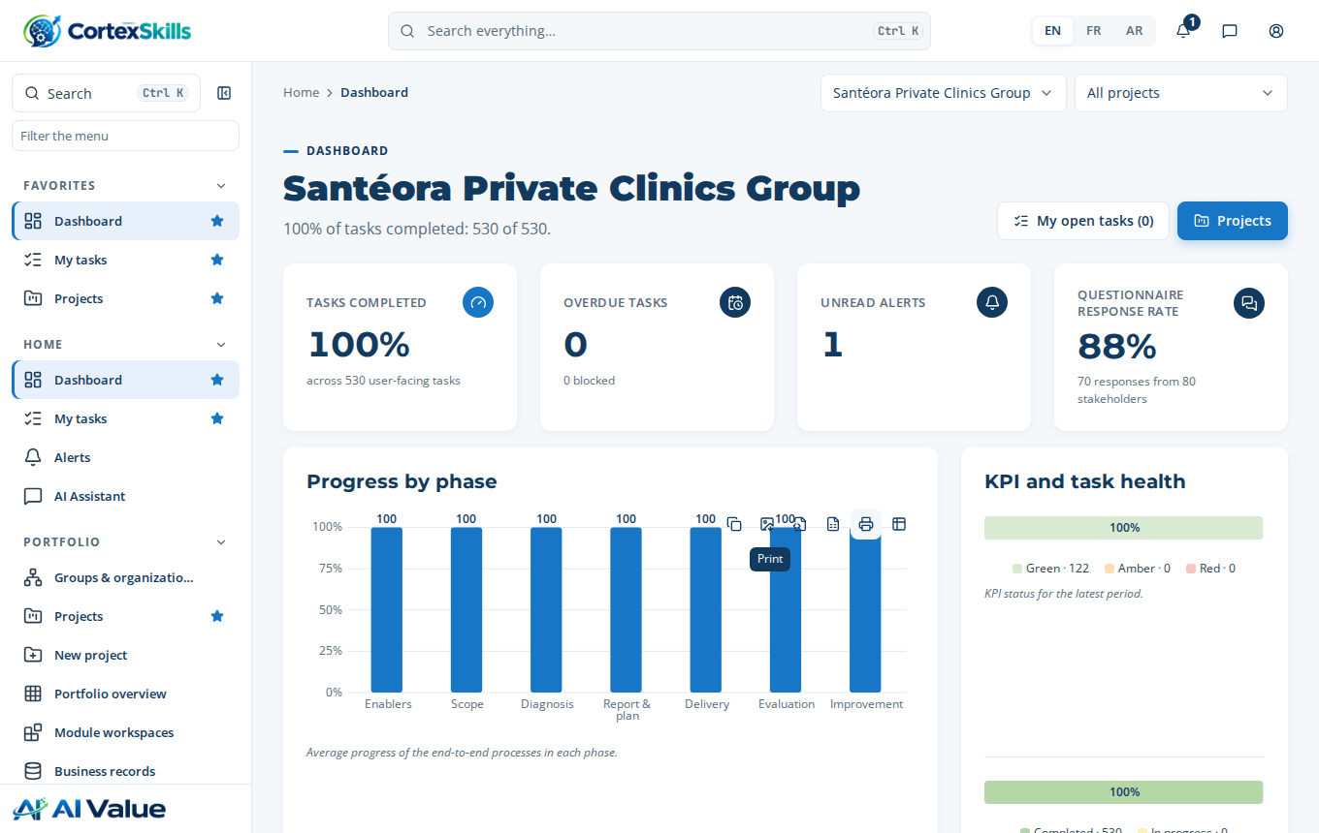
The dashboard of the organization chosen

3. The reference organizations
The installation holds 61 reference organizations: a large company and an SME for each sector, plus multi-sector groups. Each has two complete projects (Digital and AI), with all their processes, tasks, steps, questionnaires, plans, documents and indicators, in English, French and Arabic. They are a showcase and a model: demonstrations, training of your consultants, sample deliverables.
Portfolio › Groups and organizations: the tree of the groups, their organizations and their projects (Tree or Table view).
Click “Open” next to an organization, then a project: the project opens on its progress by phase.
In a project, open a process then a task: its steps, their entries, “Your result” and the Documents tab show what a completed project contains.
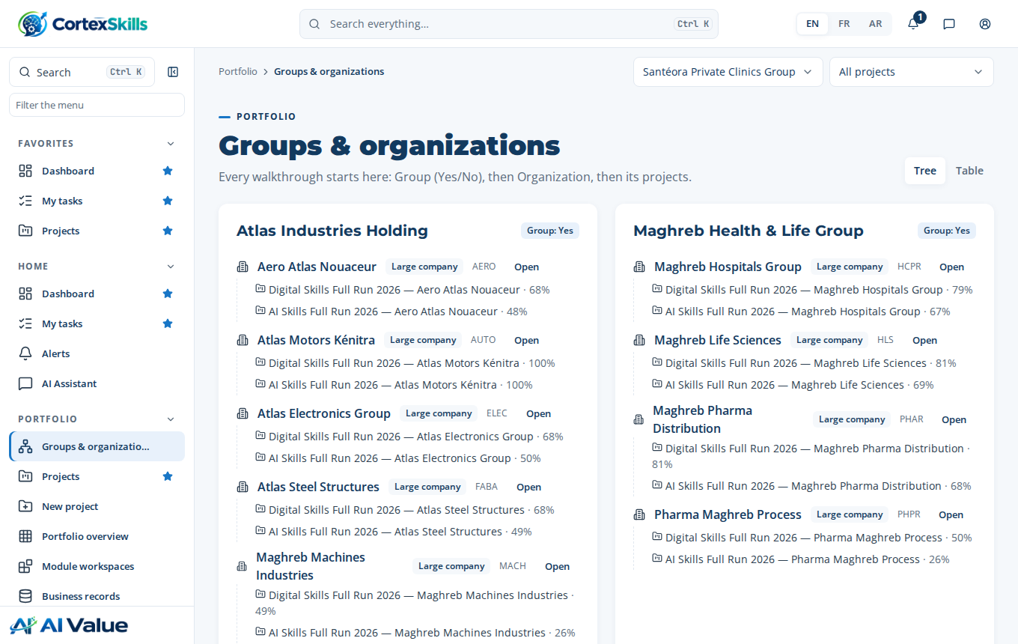
Portfolio › Groups and organizations
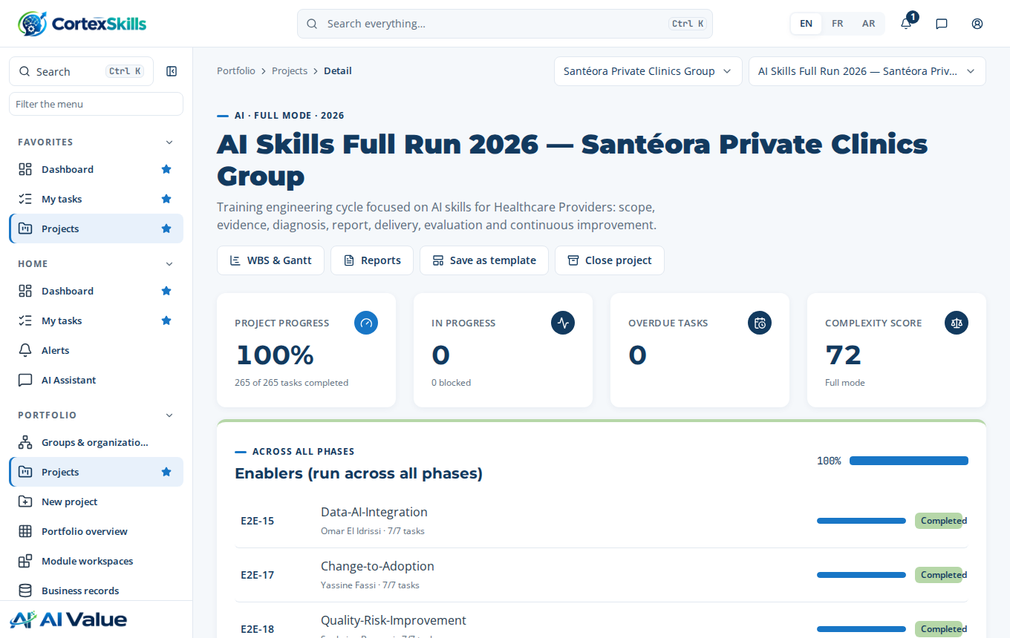
A completed reference project
Keep in mind
The people of the reference organizations cannot sign in: their accounts are disabled.
The reference organizations have no licence and count in no licence.
Do not run a real customer project in a reference organization: create the customer’s organization (chapter 4).

4. Customer organizations and users

4.1 Create a customer’s organization
On your installations, a customer’s organization is created with the installation console, then receives its licence (chapter 6). The command also creates the organization’s first administrator:
cortexskills admin org-create --name "Example Clinic" --domain example-clinic.com \
--admin-email admin@example-clinic.com --admin-name "Clinic Admin" --admin-password 'Str0ng#Passw0rd2026' \
--lang en --sector HCPR --segment SME --employees 95 --city Marrakech
cortexskills admin licence-request --org example-clinic.com
On a Linux server, prefix with sudo -u cortexskills ./; on Windows, use .\cortexskills.cmd. The sector code (--sector) links the organization to its vertical: the sector’s project templates, competencies, AI themes and questionnaires.

4.2 Users and roles
Administration › Users: the organization administrator creates the accounts of their teams, gives them one or more roles (head of L&D, analyst, HR director, manager…) and disables them when they leave. The number of active users is limited by the licence; a user beyond it is refused with a message naming the limit.
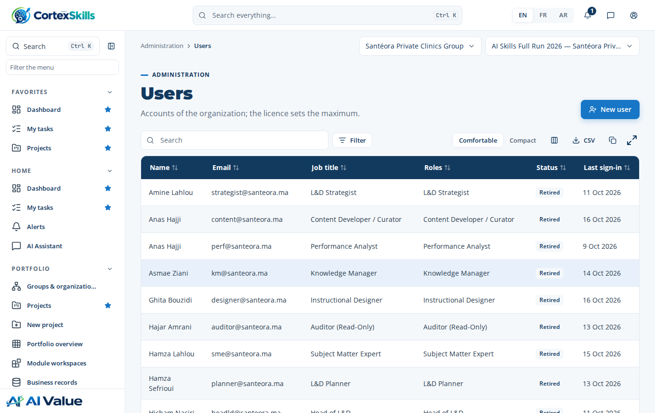
Administration › Users
A forgotten password is reset from this screen, or with the console: cortexskills admin password --email … --password …. Administration › Permissions shows what each role can see and do.

5. Offers, prices and quotations
Administration › Packs & pricing exists only in the editor edition. It shows the packs, bundles, SME packs and add-ons with their prices, and a calculator: choose an offer and a number of users, the screen gives the monthly amount (base price + users beyond those included × overage price).
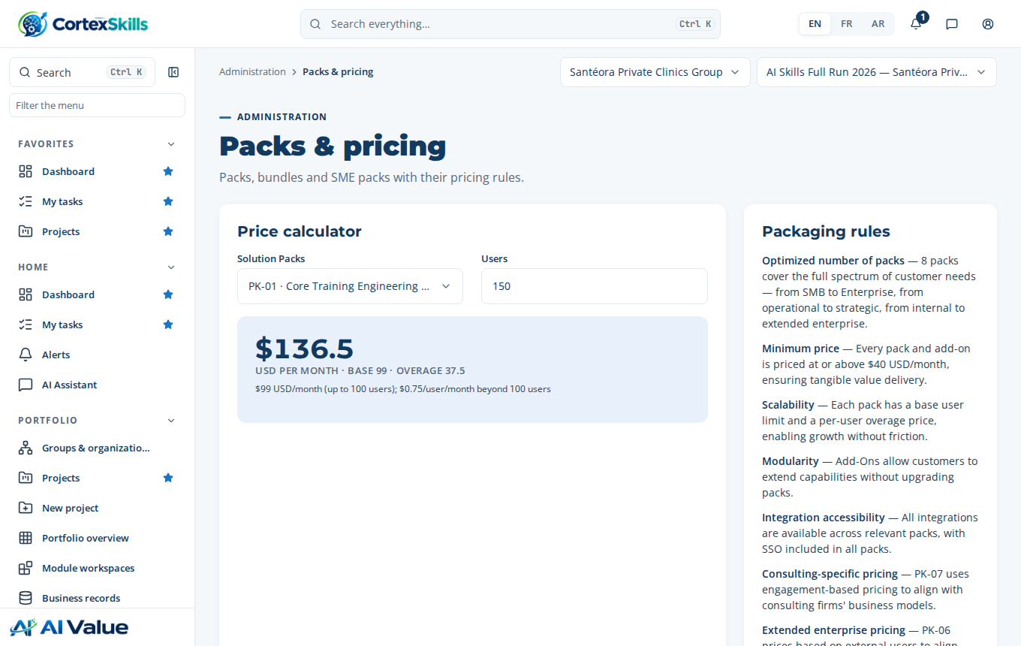
Administration › Packs & pricing: the calculator

5.1 Packs
Pack | Name | Price / month | Users included | Overage / user
PK-01 | Core Training Engineering Pack | $99 | 100 | $0.75
PK-02 | Learning Delivery & Experience Pack | $149 | 250 | $0.6
PK-03 | Assessment, Analytics & ROI Pack | $129 | 500 | $0.5
PK-04 | Compliance & Certification Pack | $99 | 300 | $0.55
PK-05 | Talent & Mobility Pack | $119 | 300 | $0.65
PK-06 | Extended Enterprise Pack | $109 | 200 | $0.8
PK-07 | Consulting & Diagnostic Pack | $249 | 50 | $5
PK-08 | Strategic Workforce & Governance Pack | $199 | 500 | $0.45

5.2 Bundles and SME packs
Offer | Content | Discount | Price / month
Starter Bundle | PK-01 + PK-02 | 10% | $223.2
Growth Bundle | PK-01 + PK-02 + PK-03 | 15% | $320.45
Enterprise Bundle | PK-01 to PK-05 | 20% | $476
Strategic Bundle | PK-01 to PK-06 + PK-08 | 25% | $677.25
Full Suite | PK-01 to PK-08 | 30% | $806.4

SME pack | Price / month | Users included | Overage / user
SME-ESS — SME Essentials Pack | $49 | 25 | $1.2
SME-GRO — SME Growth Pack | $129 | 50 | $1
SME-CMP — SME Complete Pack | $249 | 100 | $0.9
Each bundle includes 500 users. Add-ons: from $40 to $69 per month (full list on the screen and in chapter 8 of the editor installation guide). A minimum of 5 users applies to SME packs.
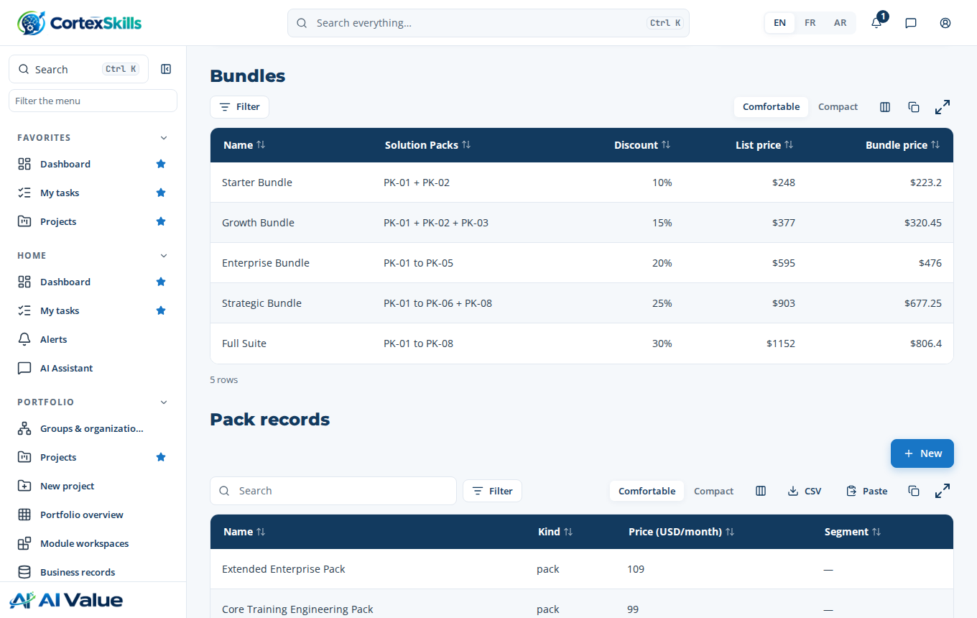
The bundles and the offer records, further down the same page
What customers see
No price, no quotation and no commercial rule appear in the customer edition: the Packs & pricing page is unavailable there.
The customer sees their plan, users, add-ons and end date in Administration › Configuration and licence.

6. Licences in the application
A licence is signed on your signing workstation (cslic, editor installation guide, chapter 6) for an organization’s Organization ID. It is installed on the installation concerned in two ways:
Console: cortexskills admin licence-install --file licence/<file>.lic (no restart).
Screen: the organization administrator opens Administration › Configuration and licence, then “Upload licence file”.
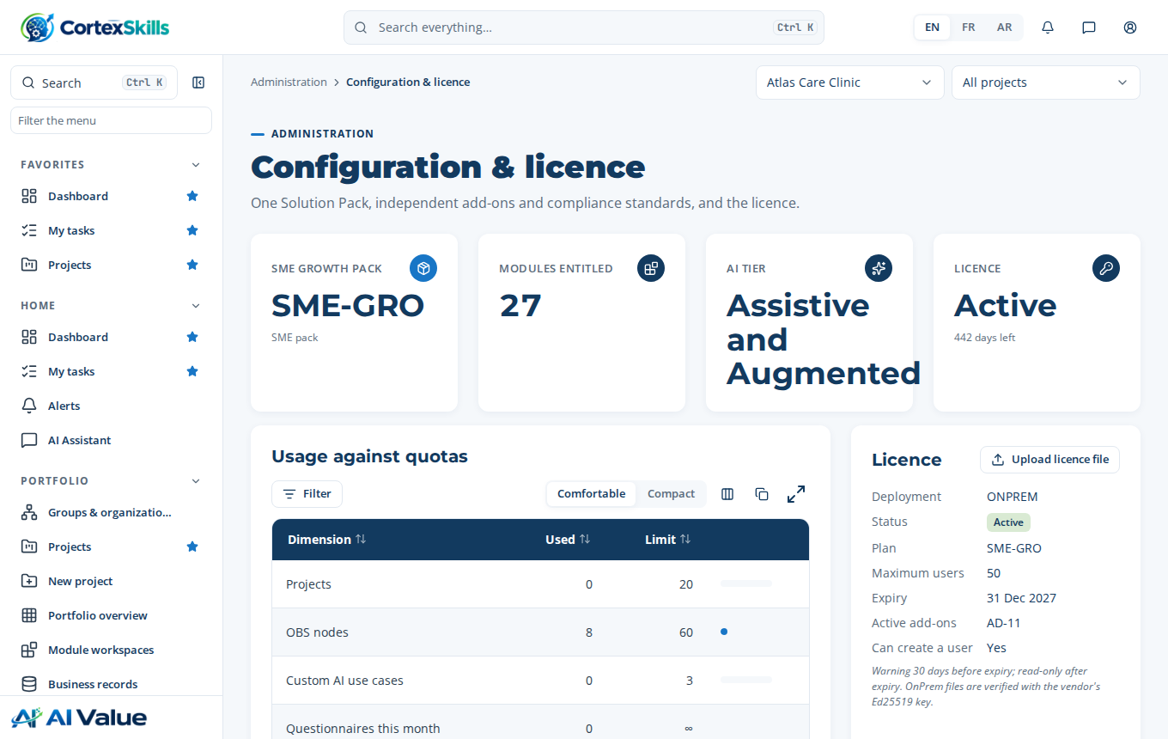
Administration › Configuration and licence of a licensed customer organization
Screen area | What it shows
Pack · Modules · AI tier · Licence | The licence’s plan, the number of modules opened, the AI tier (Assistive, or Assistive and Augmented) and the state of the licence with the days left.
Usage against quotas | Projects, OBS nodes, custom AI use cases, questionnaires this month: used and limit of the offer.
Licence | Deployment, status, plan, maximum users, expiry, active add-ons.
The plan, users and add-ons are not changed on screen: a change is a new version of the licence (cslic update or renew), installed the same way. Thirty days before the end, the administrators are warned; after the end, the organization becomes read-only.

7. Run a project with a customer
Projects are run the same way in the editor and customer editions. The complete run, with each step and what to type, is in the customer user guide (real case of a private clinic). The essentials:
Create the project: Portfolio › New project, “From the catalog” tab: Name, Focus (Digital, AI), Description, then Template. The template list holds those of the organization, of its sector, the universal templates and those of the other sectors.
Follow the phases: each end-to-end (E2E) process has its tasks and steps; the gates (G1 to G5) are decided “Go” by the steering committee chair.
Fill a step in three ways: manual entry or pasting a table, “From the template”, or “Propose rows with AI”; each proposal is read and validated by a person.
Produce the documents: each process generates its documents (DOCX, PDF, XLSX) from the data entered, as a dated version.
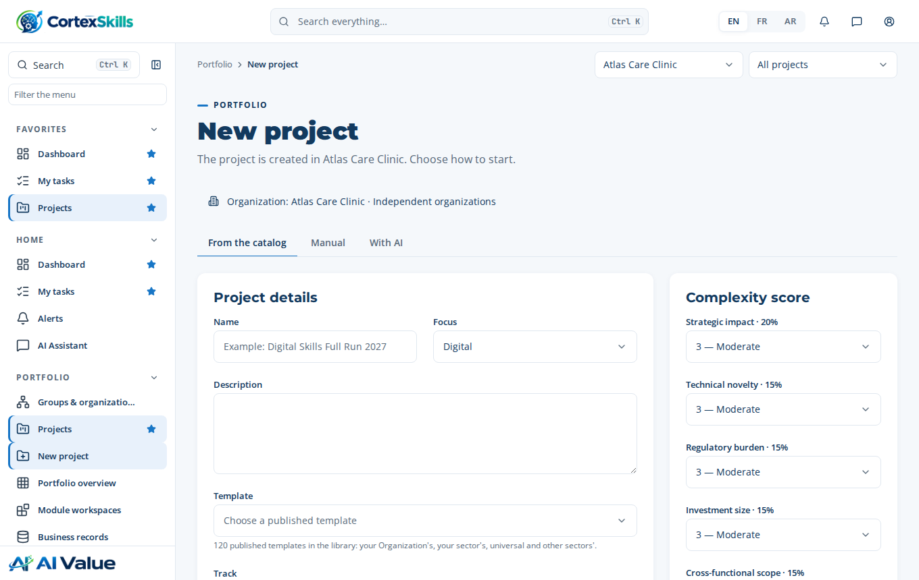
New project, in the customer organization

7.1 Project templates
Process design › Project templates: the published templates (universal or per sector, full or SME track). “Save as template” on a completed project creates a new one, to publish so it is offered at creation.
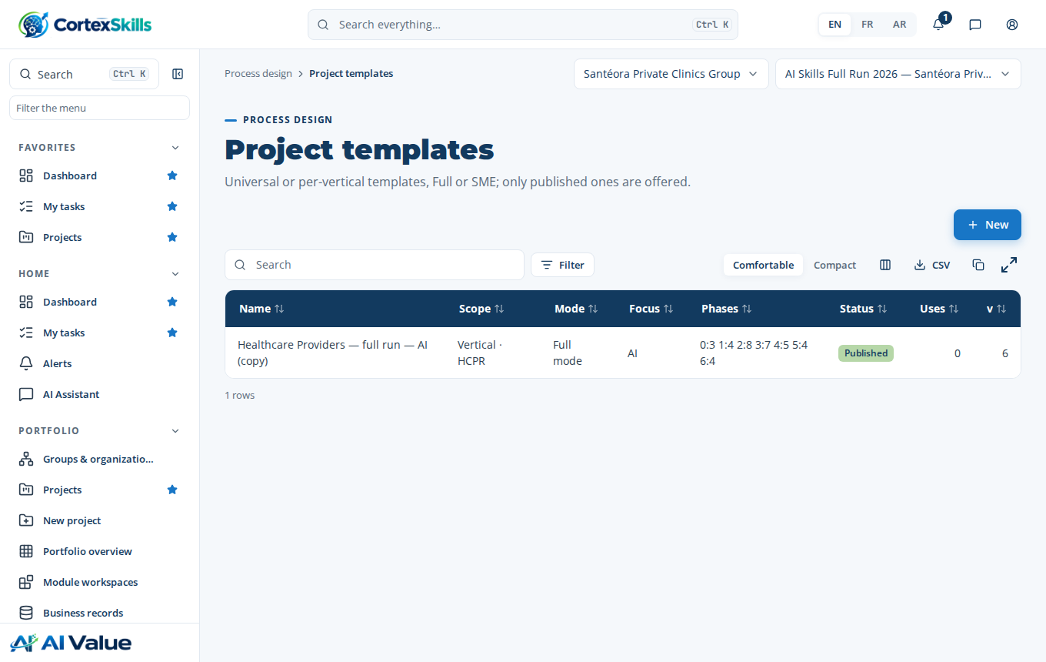
Process design › Project templates

8. Platform settings

8.1 Channels: e-mail and WhatsApp
Administration › Channels: the organization’s mail server (SMTP) and WhatsApp Business account, each in “Sandbox” (messages kept without leaving, to rehearse a demonstration) or “Live”. “Send a test” confirms the provider accepts the messages. The SMTP_* and WHATSAPP_* values of the .env file are used by default for organizations without their own setting.
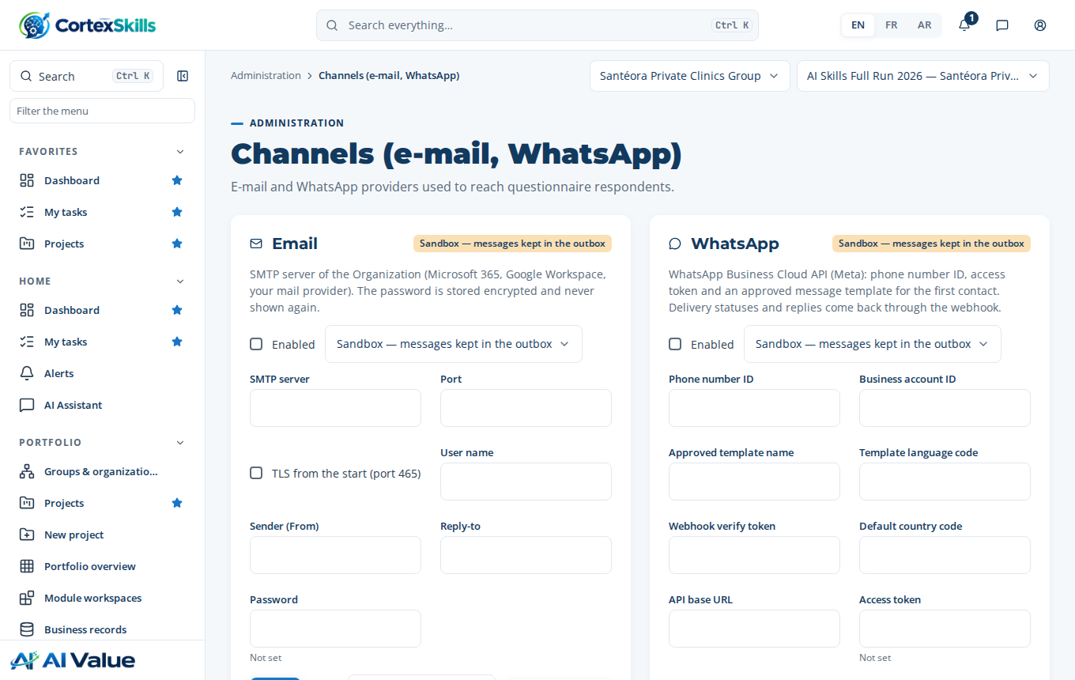
Administration › Channels

8.2 AI
AI & knowledge › AI settings: the provider and model used by the organization’s AI use cases, with an encrypted API key. Without an enabled model, the built-in engine produces the proposals. The respondents’ personal data is never sent to the provider; each proposal is validated by a person and logged (AI & knowledge › Usage).
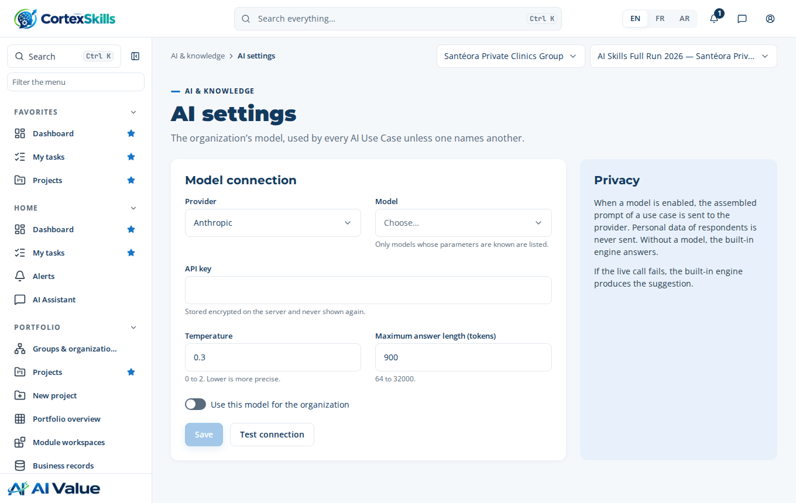
AI & knowledge › AI settings

8.3 Document templates
Documents › Templates: the library of document templates (scope of work, campaign reports, training plan, evaluation…). Documents › Layout applies the organization’s charter (logo, colours, fonts) to every generated document.
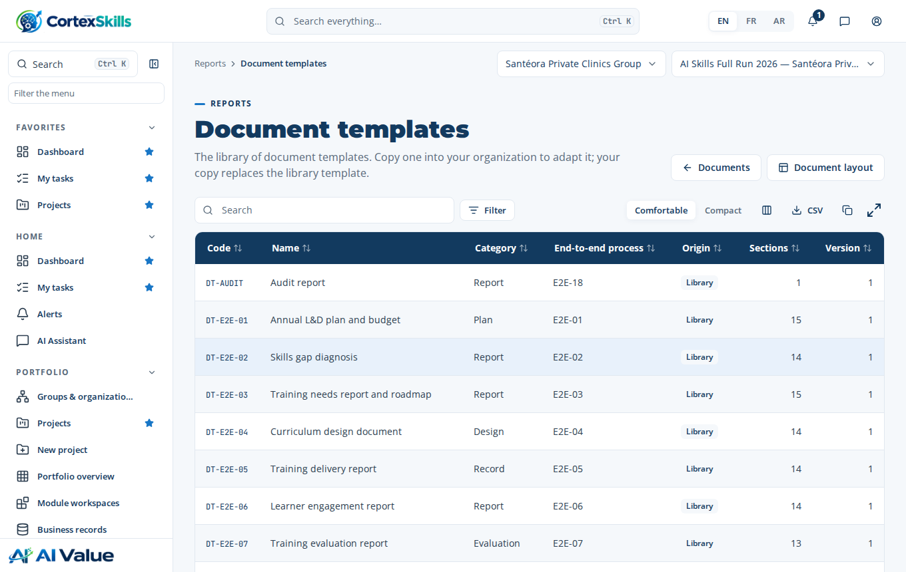
Documents › Templates

9. Audit, traceability and backups
Administration › Audit log: every administration action and every decision (user created, licence installed, gate decided, document published) with its date, author and before and after values. Administration › Traceability links requirements, processes and records.
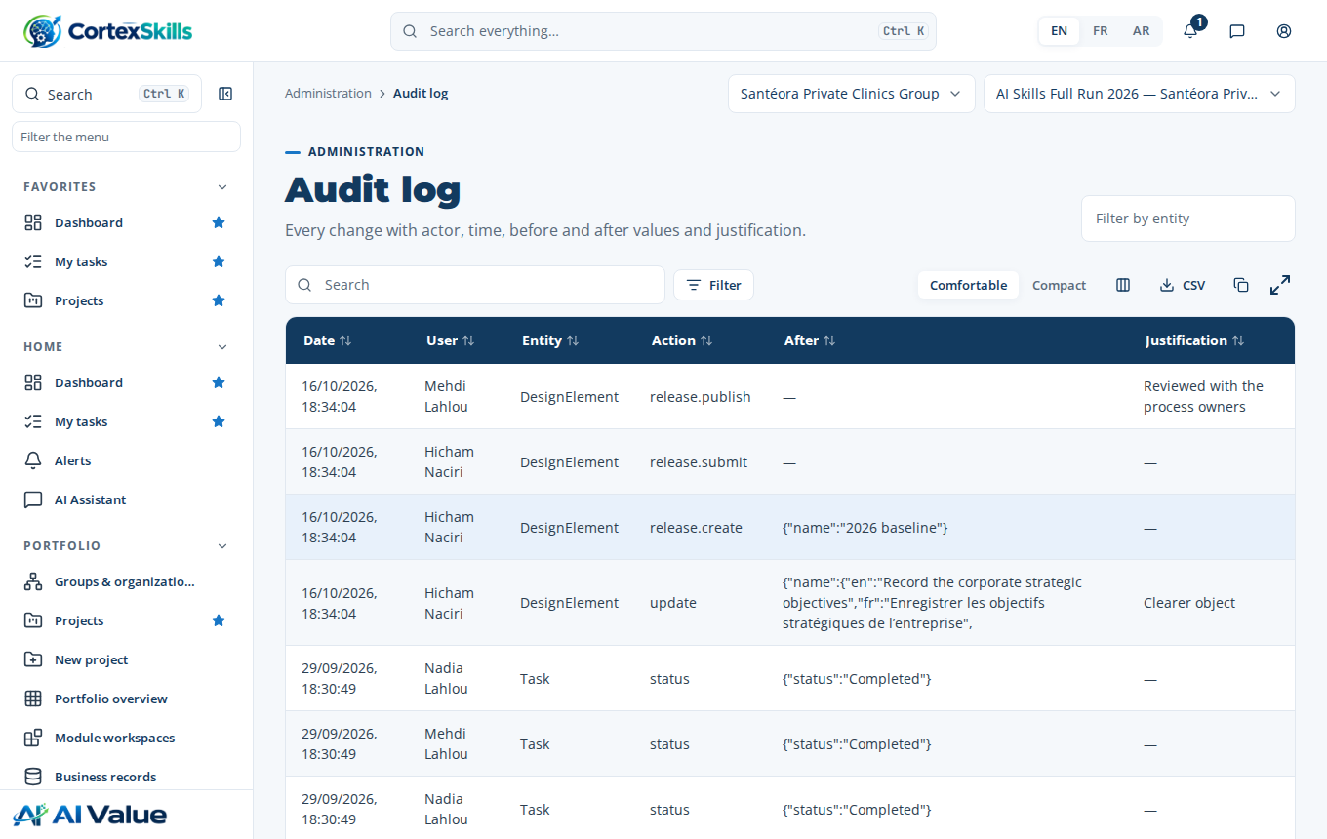
Administration › Audit log
Administration › Backups & health: the state of the service, the daily and on-demand backups (“Back up now”) and the restore procedure. Copy the backups off the server every day (editor installation guide, 4.4).
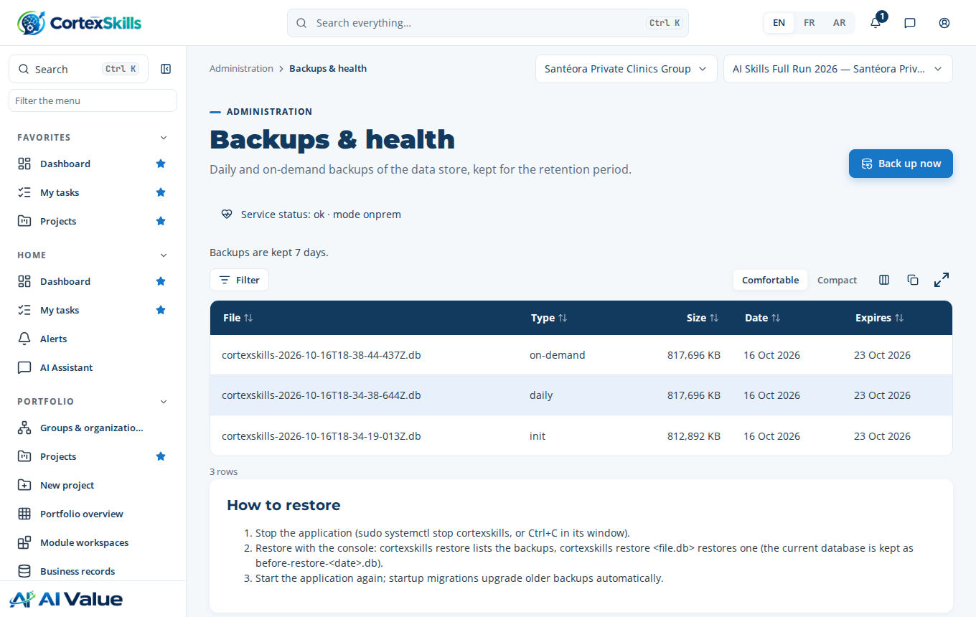
Administration › Backups & health

10. Good practices
- One organization per customer, one licence per organization; never mix the data of two customers in one organization.
- Demonstrations: use the reference organizations, or a demonstration organization under a short licence, with the channels in “Sandbox”.
- Before a pilot: set the channels to “Live”, check PUBLIC_URL (the links sent must open on a phone) and test a send.
- Never quote a price from a customer installation: prices do not exist there; prepare the quotation on your editor installation.
- Change your password at first sign-in and keep at least two administrators per organization (two-person rule to publish).

11. Troubleshooting
What you see | Cause | What to do
“The licence of this Organization is not active” | Licence not installed, expired or removed. | Install the licence (chapter 6); check its end date.
Creating a user is refused | Maximum number of users of the licence reached. | Disable an unused account or issue a new version of the licence (more users).
A module does not appear in the menu | The licence’s plan does not include it. | Change the plan or add the add-on with a new version of the licence.
An account of a reference organization is refused | These accounts cannot sign in. | Sign in as platform administrator.
The Packs & pricing page is unavailable | You are on a customer installation. | Use your editor installation.
Messages do not leave | Channel in “Sandbox” or not enabled. | Administration › Channels: “Enabled”, “Live”, then “Send a test”.

