



DOCUMENT TEMPLATES
IMS Document Templates
ISO 9001 · ISO 14001 · ISO 45001 — suggested templates, their sections and the project data that fills them

AI Value · DynamicMS 1.0 · October 2026
MEASURABLE · GOVERNED · SUSTAINABLE

Table of Contents
About this document 5
Documented information required by the standards 5
ISO 9001 6
ISO 14001 6
ISO 45001 7
Market practice applied to the documents 8
Template catalogue 9
Policies and scope 9
TPL-POL-Q — Quality policy 9
TPL-POL-IMS — Integrated QHSE policy 10
TPL-POL-E — Environmental policy 10
TPL-POL-OHS — Occupational health and safety policy 11
TPL-SCOPE — Scope of the management system 11
TPL-MAN — Management system manual 12
Context and planning 13
TPL-CTX — Context and interested parties analysis 13
TPL-REG-IP — Interested parties register 14
TPL-REG-RISK — Risks and opportunities register 15
TPL-OBJ — Objectives and action plan 15
TPL-LEGAL — Compliance obligations register 16
Processes and procedures 16
TPL-PMAP — Process map and interactions 16
TPL-PSHEET — Macro process sheet 17
TPL-PROC — Procedure 17
TPL-WI — Work instruction 18
TPL-RACSI — RACSI matrix 19
Support 19
TPL-COMP — Competence matrix and training records 20
TPL-CAL — Monitoring and measuring equipment register 20
TPL-COMM — Communication plan and records 21
TPL-DOCLIST — Master list of documented information 21
Operation 22
TPL-SUP — Supplier evaluation register 22
TPL-CTRL — Control plan 22
TPL-NCO — Nonconforming outputs register 23
TPL-REQ — Customer requirements review record 23
TPL-RELEASE — Release of products and services record 24
TPL-CHANGE — Control of changes record 24
Health, safety and environment 25
TPL-ASPECTS — Environmental aspects and impacts register 25
TPL-HIRA — Hazard identification and risk assessment (HIRA) 25
TPL-EPR — Emergency preparedness and response plan 26
TPL-INC — Incident investigation report 26
Performance evaluation 27
TPL-KPI — KPI dashboard and measurement results 27
TPL-AUDPRG — Internal audit programme 27
TPL-AUDREP — Internal audit report 28
TPL-MR — Management review minutes 29
Improvement 29
TPL-NC — Nonconformity and corrective action register 30
TPL-CAPA — Corrective action report (8D) 30
TPL-IMP — Improvement plan 31
Data that fills the templates 31
Using the templates in DynamicMS 38
Generate a document 38
Review, approve and download 38
Adapt the templates 38
Documents seeded in the demonstration 39
AT-UNI-QMS — QMS full run 2025–2026 — Atlas Universal SME 40
AT-UNI-QHSE — QHSE full run 2025–2026 — Atlas Universal SME 41
NV-AEC-QMS — QMS full run 2025–2026 — Nova Build & Construct 43
HZ-UNI-QMS — QMS full run 2025–2026 — Horizon Universal Holdings 45
HZ-UNI-QHSE — QHSE full run 2025–2026 — Horizon Universal Holdings 46
Appendix — Sample pages 48

About this document
AI Value proposes 37 templates for the documented information of an integrated management system. DynamicMS holds them as a library: each template lists its sections, and each section is either free text, an approval block, or a table or text filled from the project data (registers, step values, KPIs, risks, audits, nonconformities...). The application was seeded with these templates: 6,392 documents and 8,543 versions across 120 projects, ready to download in Word, PDF and Excel.
- Formats. Word and PDF documents have a cover page, a table of contents and numbered sections, except the policies (signed statement of one to two pages without cover or table of contents). Registers and plans are laid out landscape; Excel workbooks have a cover sheet and one sheet per table.
- One document per item. Procedures are generated per end-to-end phase, process sheets per macro process, audit reports per audit carried out and 8D reports per major or critical nonconformity.
- Diagrams. Procedures and process sheets contain BPMN diagrams drawn from the process design (swimlanes by role, Go / No-Go gateway); the process map is drawn as a diagram.
- Layout. The logo, colors, header and footer of the organization (Records › Documents › Layout) apply to every generated file, like a Word template.
- Versions. A document starts as a draft (0.1), goes to review, and is published by a person other than the author. A new version is either regenerated from the current project data or copied, then edited.
- Formatting and pictures. Each template has its own formatting (fonts and sizes, justified text, orientation, margins, cover page, table of contents, numbering, page numbers, colours, logo of the organization or of the template, logo in the page header, header and footer texts) and may contain picture sections (a site layout, an organization chart, a logo) with a caption, width and alignment; every section can be aligned, coloured, framed, start on a new page or hide its title.
- Tenant templates. An organization copies a library template to adapt its sections and texts, or creates a new template; its copy replaces the library template in its own library.

Documented information required by the standards
ISO standards distinguish documented information to maintain (a document kept up to date) and documented information to retain (a record kept as evidence). The matrix lists what each standard requires and the template that answers it.

ISO 9001
Clause | Documented information | Maintain / retain | Template
4.3 | Scope of the management system | Maintain (document) | TPL-SCOPE
4.4.2 | Process map and interactions | Maintain (document) | TPL-PMAP
5.2 | Quality policy | Maintain (document) | TPL-POL-Q
5.2 | Integrated QHSE policy | Maintain (document) | TPL-POL-IMS
6.2 | Objectives and action plan | Maintain (document) | TPL-OBJ
6.3, 8.5.6 | Control of changes record | Retain (record) | TPL-CHANGE
7.1.5 | Monitoring and measuring equipment register | Retain (record) | TPL-CAL
7.2 | Competence matrix and training records | Retain (record) | TPL-COMP
8.1, 8.5.1 | Control plan | Maintain (document) | TPL-CTRL
8.2.3.2 | Customer requirements review record | Retain (record) | TPL-REQ
8.4.1 | Supplier evaluation register | Retain (record) | TPL-SUP
8.6 | Release of products and services record | Retain (record) | TPL-RELEASE
8.7.2 | Nonconforming outputs register | Retain (record) | TPL-NCO
9.1.1, 9.1.3 | KPI dashboard and measurement results | Retain (record) | TPL-KPI
9.2.2 | Internal audit programme | Retain (record) | TPL-AUDPRG
9.2.2 | Internal audit report | Retain (record) | TPL-AUDREP
9.3 | Management review minutes | Retain (record) | TPL-MR
10.2.2 | Nonconformity and corrective action register | Retain (record) | TPL-NC

ISO 14001
Clause | Documented information | Maintain / retain | Template
4.3 | Scope of the management system | Maintain (document) | TPL-SCOPE
5.2 | Integrated QHSE policy | Maintain (document) | TPL-POL-IMS
5.2 | Environmental policy | Maintain (document) | TPL-POL-E
6.1.1 | Risks and opportunities register | Maintain (document) | TPL-REG-RISK
6.1.2 | Environmental aspects and impacts register | Maintain (document) | TPL-ASPECTS
6.1.3, 9.1.2 | Compliance obligations register | Maintain (document) | TPL-LEGAL
6.2 | Objectives and action plan | Maintain (document) | TPL-OBJ
7.2 | Competence matrix and training records | Retain (record) | TPL-COMP
7.4 | Communication plan and records | Retain (record) | TPL-COMM
8.2 | Emergency preparedness and response plan | Maintain (document) | TPL-EPR
9.1.1 | Monitoring and measuring equipment register | Retain (record) | TPL-CAL
9.1.1 | KPI dashboard and measurement results | Retain (record) | TPL-KPI
9.2.2 | Internal audit programme | Retain (record) | TPL-AUDPRG
9.2.2 | Internal audit report | Retain (record) | TPL-AUDREP
9.3 | Management review minutes | Retain (record) | TPL-MR
10.2.2 | Nonconformity and corrective action register | Retain (record) | TPL-NC

ISO 45001
Clause | Documented information | Maintain / retain | Template
4.3 | Scope of the management system | Maintain (document) | TPL-SCOPE
5.2 | Integrated QHSE policy | Maintain (document) | TPL-POL-IMS
5.2 | Occupational health and safety policy | Maintain (document) | TPL-POL-OHS
6.1.1 | Risks and opportunities register | Maintain (document) | TPL-REG-RISK
6.1.2, 8.1.2 | Hazard identification and risk assessment (HIRA) | Maintain (document) | TPL-HIRA
6.1.3, 9.1.2 | Compliance obligations register | Maintain (document) | TPL-LEGAL
6.2 | Objectives and action plan | Maintain (document) | TPL-OBJ
7.2 | Competence matrix and training records | Retain (record) | TPL-COMP
7.4 | Communication plan and records | Retain (record) | TPL-COMM
8.2 | Emergency preparedness and response plan | Maintain (document) | TPL-EPR
9.1.1 | Monitoring and measuring equipment register | Retain (record) | TPL-CAL
9.1.1 | KPI dashboard and measurement results | Retain (record) | TPL-KPI
9.2.2 | Internal audit programme | Retain (record) | TPL-AUDPRG
9.2.2 | Internal audit report | Retain (record) | TPL-AUDREP
9.3 | Management review minutes | Retain (record) | TPL-MR
10.2 | Incident investigation report | Retain (record) | TPL-INC
10.2.2 | Nonconformity and corrective action register | Retain (record) | TPL-NC

Note. ISO 9001 §8.3 (design and development records) is not applicable to organizations that do not design their products or services; the exclusion is justified in the scope of the management system (template TPL-SCOPE).

Market practice applied to the documents
The structure of every document follows what certified organizations and certification bodies expect. The main points:
Document | Structure
Policies | Vision and ambition; context and standards; strategic axes, each with its commitments and the measurable objectives linked to it; commitments of the chief executive, including the delegation to the management system manager; role of managers and of everyone; communication and review; signature of the chief executive. Modelled on the policy provided as an example.
Procedures | Identification, purpose and scope, references, definitions, responsibilities (RACSI), BPMN overview of the phase, then for each macro process its BPMN diagram, the SIPOC of each step (suppliers, inputs, outputs, customers, responsible) and its Go / No-Go criteria; the Go / No-Go decision of the phase gate (criteria, checklist with evidence, Go / No-Go / Hold / Recycle rules, decision recorded); records with retention; indicators; risks and controls.
Audit programme | Objectives, extent, risks and resources; frequency per process according to importance and past results; planned audits with frequency chosen from a list (monthly to every 3 years) or custom with its description; auditor qualification and independence.
Audit report | One report per audit: identification (scope, criteria, team, auditees, method), executive summary, strengths, summary of findings, detailed report of each nonconformity graded major or minor (requirement, statement, objective evidence, correction, root cause, corrective action, due date, verification), observations and opportunities, grading definitions, conclusion.
Corrective action report (8D) | D0 to D8 for each major or critical nonconformity: team, 5W2H, containment, Ishikawa and 5 Whys, occurrence and non-detection causes, permanent actions with verification, validation, prevention of recurrence, lessons learned.
Measuring equipment register | Status summary; identification, range, required accuracy, method and traceability, provider and certificate, interval, error found and result, next due date, status; impact assessment of any out-of-tolerance.
Other registers and plans | Change records with impact and risk assessment and verification; communication plan and log; competence requirements, matrix, gaps, training plan and records with effectiveness; AIAG-style control plan; context with PESTLE, SWOT and influence / interest grid; master list with levels, retention and external documents; KPI definitions, results, trends and analysis; compliance obligations with evaluation of compliance; manual chapter by clause with a cross-reference matrix; management review minutes covering every input of §9.3.2 and output of §9.3.3.

Template catalogue
Templates are grouped by category. For each one: purpose, formats, requirements answered, review frequency, owner, the macro process that produces it, and its sections with the data that fills them.

Policies and scope
Code | Template | Management system | Formats | Required by
TPL-POL-Q | Quality policy | QMS | DOCX, PDF | ISO 9001 §5.2 (maintain)
TPL-POL-IMS | Integrated QHSE policy | QHSE | DOCX, PDF | ISO 9001 §5.2 (maintain); ISO 14001 §5.2 (maintain); ISO 45001 §5.2 (maintain)
TPL-POL-E | Environmental policy | QHSE | DOCX, PDF | ISO 14001 §5.2 (maintain)
TPL-POL-OHS | Occupational health and safety policy | QHSE | DOCX, PDF | ISO 45001 §5.2 (maintain)
TPL-SCOPE | Scope of the management system | QMS, QHSE | DOCX, PDF | ISO 9001 §4.3 (maintain); ISO 14001 §4.3 (maintain); ISO 45001 §4.3 (maintain)
TPL-MAN | Management system manual | QMS, QHSE | DOCX, PDF | Recommended

TPL-POL-Q — Quality policy
Vision, strategic axes with measurable objectives and commitments, signed by the chief executive (ISO 9001 §5.2). One to two pages, no table of contents.
Formats: DOCX, PDF; table of contents: no; review: Annual; owner: Top Management; produced by: UMS022 Quality Policy and Strategic Direction Definition.
# | Section | Type | Content
1 | Our vision and ambition | Project data | Vision and ambition of the organization, the context issues it faces and the standards the system is built on.
2 | Our strategic axes | Project data | Strategic axes (customers, operational excellence, improvement, people, compliance, partners, tools), each with its commitments and the measurable objectives of the objectives register linked to it.
3 | Commitments of top management | Project data | Commitments of the chief executive ("As chief executive, I commit to..."), including the delegation to the management system manager.
4 | Everyone's role | Project data | Role of managers and of every employee; closing message of the chief executive.
5 | Communication and review of this policy | Project data | How the policy is communicated, made available and reviewed (date of the last management review).
6 | Signature | Project data | Name, title, place, date and signature of the chief executive.

TPL-POL-IMS — Integrated QHSE policy
One policy for quality, environment and occupational health and safety (ISO 9001, ISO 14001 and ISO 45001 §5.2), signed by the chief executive.
Formats: DOCX, PDF; table of contents: no; review: Annual; owner: Top Management; produced by: UMS022 Quality Policy and Strategic Direction Definition.
# | Section | Type | Content
1 | Our vision and ambition | Project data | Vision and ambition (quality, health, safety and environment).
2 | Our strategic axes | Project data | Strategic axes including health and safety and environment, each with measurable objectives.
3 | Commitments of top management | Project data | Commitments of the chief executive for quality, OH&S (prevention, consultation) and environment (prevention of pollution, compliance obligations).
4 | Everyone's role | Project data | Role of managers and employees.
5 | Communication and review of this policy | Project data | How the policy is communicated, made available and reviewed (date of the last management review).
6 | Signature | Project data | Name, title, place, date and signature of the chief executive.

TPL-POL-E — Environmental policy
Stand-alone environmental policy (ISO 14001 §5.2) when no integrated policy is used.
Formats: DOCX, PDF; table of contents: no; review: Annual; owner: Top Management; produced by: UMS022 Quality Policy and Strategic Direction Definition; replaced by TPL-POL-IMS when an integrated policy is used.
# | Section | Type | Content
1 | Our vision and ambition | Project data | Vision and ambition (environment).
2 | Our strategic axes | Project data | Environmental strategic axes with objectives.
3 | Commitments of top management | Project data | Environmental commitments of the chief executive.
4 | Everyone's role | Project data | Role of managers and employees.
5 | Communication and review of this policy | Project data | How the policy is communicated, made available and reviewed (date of the last management review).
6 | Signature | Project data | Name, title, place, date and signature of the chief executive.

TPL-POL-OHS — Occupational health and safety policy
Stand-alone OH&S policy (ISO 45001 §5.2) when no integrated policy is used.
Formats: DOCX, PDF; table of contents: no; review: Annual; owner: Top Management; produced by: UMS022 Quality Policy and Strategic Direction Definition; replaced by TPL-POL-IMS when an integrated policy is used.
# | Section | Type | Content
1 | Our vision and ambition | Project data | Vision and ambition (occupational health and safety).
2 | Our strategic axes | Project data | OH&S strategic axes with objectives.
3 | Commitments of top management | Project data | OH&S commitments of the chief executive.
4 | Everyone's role | Project data | Role of managers and employees.
5 | Communication and review of this policy | Project data | How the policy is communicated, made available and reviewed (date of the last management review).
6 | Signature | Project data | Name, title, place, date and signature of the chief executive.

TPL-SCOPE — Scope of the management system
Scope statement, sites, products and services, boundaries, outsourced processes and justification of non-applicable requirements (§4.3).
Formats: DOCX, PDF; table of contents: yes; review: Annual; owner: Ims Manager; produced by: UMS016 Context Analysis and Stakeholder Mapping.
# | Section | Type | Content
1 | Document identification | Project data | Document identification: reference, version, owner, organization, standards, review frequency and next review.
2 | Purpose and scope | Text | This document defines the boundaries and applicability of the management system of {org}, as required by clause 4.3 of {standards}. It is available to interested parties on request.
3 | Organization profile | Project data | Organization profile: activity, site, size, customers, management system, certificates, management system manager.
4 | Scope statement | Project data | Scope statement built from the profile, with the scope recorded in step MP-001.8.
5 | Sites and organization units | Project data | Sites and departments of the organization structure (OBS) with their members.
6 | Products and services | Project data | Products and services in scope with their customers and main requirements.
7 | Boundaries, interfaces and outsourced processes | Project data | Outsourced processes and interfaces with how each is controlled.
8 | Standards applied | Project data | Standards selected once for the project (step MP-002.10).
9 | Requirements not applicable and justification | Project data | Requirements not applicable, with their justification.
10 | Processes in scope | Project data | Macro processes of the project with phase, owner and status.
11 | Revision history | Project data | Revision history of the document itself.
12 | Approval | Approval block | Names, dates and signatures of the persons who prepared, reviewed and approved the document.

TPL-MAN — Management system manual
How the management system meets each clause of the standards (high-level structure 4 to 10), with the process map, responsibilities and the cross-reference to documents. Recommended, not required.
Formats: DOCX, PDF; table of contents: yes; review: Annual; owner: Ims Manager; produced by: GRC001 Policy and Procedure Governance.
# | Section | Type | Content
1 | Document identification | Project data | Document identification: reference, version, owner, organization, standards, review frequency and next review.
2 | Introduction | Text | This manual describes the management system of {org} and how it meets the requirements of {standards}. It is the entry point to the documented information: each chapter follows the clause of the same number and refers to the procedures and records that apply. The manual is controlled; printed copies are for information only.
3 | Presentation of the organization | Project data | Organization profile: activity, site, size, customers, management system, certificates, management system manager.
4 | Scope and applicability (§4.3) | Project data | Scope statement and non-applicable requirements.
5 | Context of the organization (§4.1, §4.2) | Project data | Main issues and interested parties.
6 | Management system and its processes (§4.4) | Project data | Process map diagram: management, core and support processes between customer requirements and satisfaction.
7 | Leadership and commitment (§5) | Project data | Leadership and commitment, with the strategic axes of the policy.
8 | Roles, responsibilities and authorities (§5.3) | Project data | RACSI of every macro process (five columns, one Accountable).
9 | Planning: risks, opportunities and objectives (§6) | Project data | Risk method, top risks and objectives.
10 | Support (§7) | Project data | Resources, measuring equipment, competence, communication and documented information.
11 | Operation (§8) | Project data | Operational planning and control, with the control plan.
12 | Performance evaluation (§9) | Project data | Indicators on target, audits and management reviews.
13 | Improvement (§10) | Project data | Nonconformities, closures and improvement ideas.
14 | Cross-reference: clauses, processes and documents | Project data | Cross-reference: clause, requirement, process and document.
15 | Revision history | Project data | Revision history of the document itself.
16 | Approval | Approval block | Names, dates and signatures of the persons who prepared, reviewed and approved the document.

Context and planning
Code | Template | Management system | Formats | Required by
TPL-CTX | Context and interested parties analysis | QMS, QHSE | DOCX, PDF | Recommended
TPL-REG-IP | Interested parties register | QMS, QHSE | XLSX, PDF | Recommended
TPL-REG-RISK | Risks and opportunities register | QMS, QHSE | XLSX, PDF | ISO 14001 §6.1.1 (maintain); ISO 45001 §6.1.1 (maintain)
TPL-OBJ | Objectives and action plan | QMS, QHSE | XLSX, PDF, DOCX | ISO 9001 §6.2 (maintain); ISO 14001 §6.2 (maintain); ISO 45001 §6.2 (maintain)
TPL-LEGAL | Compliance obligations register | QMS, QHSE | XLSX, PDF | ISO 14001 §6.1.3, 9.1.2 (maintain); ISO 45001 §6.1.3, 9.1.2 (maintain)

TPL-CTX — Context and interested parties analysis
PESTLE and SWOT analysis, interested parties with their requirements, influence and interest, conclusions for risks and opportunities, and review (§4.1, §4.2).
Formats: DOCX, PDF; table of contents: yes; review: Annual; owner: Ims Manager; produced by: UMS016 Context Analysis and Stakeholder Mapping.
# | Section | Type | Content
1 | Document identification | Project data | Document identification: reference, version, owner, organization, standards, review frequency and next review.
2 | Purpose and scope | Text | This report records the external and internal issues relevant to the purpose and strategic direction of {org}, and the needs and expectations of its relevant interested parties. Its conclusions feed the risks and opportunities, the scope, the policy and the objectives.
3 | Method | Project data | PESTLE, SWOT and interested party method and review frequency.
4 | External issues (PESTLE) | Project data | External issues by PESTLE factor: risk or opportunity, impact, trend, plus the issues recorded in step MP-001.2.
5 | Internal issues | Project data | Internal issues recorded in step MP-001.3, one row per issue with its source.
6 | SWOT synthesis | Project data | Strengths, weaknesses, opportunities and threats built from the context register and improvement ideas.
7 | Interested parties and their requirements | Project data | Interested parties: internal or external, needs and expectations, compliance obligation, influence, interest, priority and monitoring.
8 | Needs and expectations mapped to the interested parties | Project data | Needs and expectations recorded in the needs register: the interested parties concerned, type, compliance obligation and how the organization addresses each one.
9 | Influence and interest grid | Project data | Influence / interest grid: manage closely, keep satisfied, keep informed, monitor.
10 | Assessment of needs and expectations | Project data | Decision matrix of the needs and expectations assessment (step MP-001.5).
11 | Process interactions | Project data | Process interactions recorded in step MP-001.7.
12 | Conclusions: risks and opportunities to address | Project data | Risks and opportunities that result from the analysis.
13 | Monitoring and review | Project data | Periodic review of the context (step MP-001.10): frequency, dates, decisions.
14 | Revision history | Project data | Revision history of the document itself.
15 | Approval | Approval block | Names, dates and signatures of the persons who prepared, reviewed and approved the document.

TPL-REG-IP — Interested parties register
Interested parties, needs and expectations, requirements adopted as compliance obligations, influence, interest, priority, monitoring and owner.
Formats: XLSX, PDF; table of contents: no; review: Semi-annual; owner: Ims Manager; produced by: UMS016 Context Analysis and Stakeholder Mapping.
# | Section | Type | Content
1 | Document identification | Project data | Document identification: reference, version, owner, organization, standards, review frequency and next review.
2 | Interested parties | Project data | Interested parties: internal or external, needs and expectations, compliance obligation, influence, interest, priority and monitoring.
3 | Needs and expectations mapped to the interested parties | Project data | Needs and expectations recorded in the needs register: the interested parties concerned, type, compliance obligation and how the organization addresses each one.
4 | Influence and interest grid | Project data | Influence / interest grid: manage closely, keep satisfied, keep informed, monitor.

TPL-REG-RISK — Risks and opportunities register
Risks with cause, consequence, existing controls, likelihood, impact, level, treatment and residual risk; opportunities; heat map and scoring method (§6.1).
Formats: XLSX, PDF; table of contents: no; review: Semi-annual; owner: Risk Manager; produced by: UMS030 Operational Risk and Opportunity Management.
# | Section | Type | Content
1 | Document identification | Project data | Document identification: reference, version, owner, organization, standards, review frequency and next review.
2 | Summary | Project data | Number of risks by level and of opportunities.
3 | Risks | Project data | Risks with cause, consequence, existing controls, likelihood, impact, score, treatment, residual risk, owner and status.
4 | Opportunities | Project data | Opportunities with benefit, feasibility and the action to pursue them.
5 | Heat map (number of risks) | Project data | Heat map: number of risks per likelihood and impact.
6 | Scoring method and acceptance criteria | Project data | Likelihood and impact scale (1 to 5) and score bands.

TPL-OBJ — Objectives and action plan
SMART objectives linked to the policy axes: KPI, baseline, target, deadline, owner, resources, evaluation method, progress; with the actions to achieve them (§6.2).
Formats: XLSX, PDF, DOCX; table of contents: no; review: Quarterly; owner: Ims Manager; produced by: UMS031 Quality Objectives and Targets Deployment.
# | Section | Type | Content
1 | Document identification | Project data | Document identification: reference, version, owner, organization, standards, review frequency and next review.
2 | Summary | Project data | Objectives on track and at risk.
3 | Objectives | Project data | SMART objectives: policy axis, KPI, baseline, target, current value, deadline, owner, resources and status.
4 | Action plan | Project data | Actions planned to reach the objectives.
5 | Approval | Approval block | Names, dates and signatures of the persons who prepared, reviewed and approved the document.

TPL-LEGAL — Compliance obligations register
Legal requirements and other requirements (contracts, permits, standards): source, reference, applicability, how complied, owner, evaluation of compliance and actions (ISO 14001 / ISO 45001 §6.1.3, §9.1.2).
Formats: XLSX, PDF; table of contents: no; review: Semi-annual; owner: Compliance Officer; produced by: GRC005 Regulatory and Compliance Obligations Mapping.
# | Section | Type | Content
1 | Document identification | Project data | Document identification: reference, version, owner, organization, standards, review frequency and next review.
2 | Evaluation of compliance — summary | Project data | Evaluation of compliance: compliant, partially compliant, non-compliant.
3 | Obligations | Project data | Obligations: type, authority, reference, applicability, requirement, how complied, owner, interval, last and next evaluation.
4 | Actions for partial or non compliance | Project data | Actions for partial or non compliance.

Processes and procedures
Code | Template | Management system | Formats | Required by
TPL-PMAP | Process map and interactions | QMS, QHSE | DOCX, PDF | ISO 9001 §4.4.2 (maintain)
TPL-PSHEET | Macro process sheet | QMS, QHSE | DOCX, PDF | Recommended
TPL-PROC | Procedure | QMS, QHSE | DOCX, PDF | Recommended
TPL-WI | Work instruction | QMS, QHSE | DOCX, PDF | Recommended
TPL-RACSI | RACSI matrix | QMS, QHSE | XLSX, PDF | Recommended

TPL-PMAP — Process map and interactions
Process map (management, core and support processes), process owners, purpose, indicators and interactions (§4.4).
Formats: DOCX, PDF; table of contents: yes; review: Annual; owner: Process Excellence Manager; produced by: UMS002 Process Architecture Mapping.
# | Section | Type | Content
1 | Document identification | Project data | Document identification: reference, version, owner, organization, standards, review frequency and next review.
2 | Purpose and scope | Text | This document presents the processes of the management system of {org}, their sequence and interactions, their owners and how their performance is measured (§4.4.1).
3 | Process map | Project data | Process map diagram: management, core and support processes between customer requirements and satisfaction.
4 | Processes, owners and indicators | Project data | Processes with type (management, core, support), owner, purpose and indicators.
5 | Interactions | Project data | Process interactions recorded in step MP-001.7.
6 | Process owners (RACSI) | Project data | RACSI of every macro process (five columns, one Accountable).
7 | Revision history | Project data | Revision history of the document itself.
8 | Approval | Approval block | Names, dates and signatures of the persons who prepared, reviewed and approved the document.

TPL-PSHEET — Macro process sheet
One sheet per macro process: identity, SIPOC, BPMN diagram, steps with their SIPOC, RACSI, indicators, risks and documents.
Formats: DOCX, PDF; table of contents: no; review: Semi-annual; owner: Process Excellence Manager; produced by: UMS002 Process Architecture Mapping; one document per macro process.
# | Section | Type | Content
1 | Process identity | Project data | Process identity: type, owner, purpose, trigger, end, standards and phase.
2 | SIPOC of the process | Project data | SIPOC of the macro process.
3 | Process flow (BPMN) | Project data | BPMN diagram of the macro process: one lane per role, its steps, the Go / No-Go gateway and the end event.
4 | Steps and their SIPOC | Project data | Steps of the macro process, each with its SIPOC (suppliers, inputs, outputs, customers) and responsible role.
5 | Go / No-Go to close the process | Project data | Go criteria to close the process, No-Go handling, decision maker and current status.
6 | RACSI | Project data | RACSI of the macro process of the document.
7 | Indicators | Project data | KPIs of the macro process of the document.
8 | Risks and controls | Project data | Risks and controls of the macro process.
9 | Documents and records | Project data | Documents and records of the macro process.
10 | Revision history | Project data | Revision history of the document itself.

TPL-PROC — Procedure
Purpose, scope, references, definitions, responsibilities, BPMN flow, activities with the SIPOC of each step, Go / No-Go decision, records, indicators and risks of a process phase.
Formats: DOCX, PDF; table of contents: yes; review: Annual; owner: Process Excellence Manager; produced by: UMS024 Procedures and Work Instructions Development; one document per end-to-end phase.
# | Section | Type | Content
1 | Document identification | Project data | Document identification: reference, version, owner, organization, standards, review frequency and next review.
2 | Purpose and scope | Text | This procedure describes how the phase "{phase}" is carried out at {org}: who does what, in which order, with which inputs and outputs, and how the decision to move to the next phase is taken. It applies to all units and people involved in the phase.
3 | References | Project data | Standards and related documents (manual, process map, master list).
4 | Terms and definitions | Project data | Terms used in procedures: SIPOC, RACSI, BPMN, gate and Go / No-Go, documented information.
5 | Responsibilities | Project data | RACSI of the macro processes of the phase.
6 | Process overview (BPMN) | Project data | BPMN overview of the phase: macro processes as sub-processes and the phase gate.
7 | Description of activities | Project data | For each macro process of the phase: purpose, trigger, owner, BPMN diagram, SIPOC of each step and Go / No-Go criteria.
8 | Go / No-Go decision | Project data | Gate of the phase: entry and exit criteria, checklist with evidence, decision rules (Go, No-Go, Hold, Recycle) and the decision recorded.
9 | Records | Project data | Records produced in the phase: owner, storage and retention.
10 | Performance indicators | Project data | KPIs of the macro processes of the phase.
11 | Risks and controls | Project data | Risks and business rules of the phase.
12 | Revision history | Project data | Revision history of the document itself.
13 | Approval | Approval block | Names, dates and signatures of the persons who prepared, reviewed and approved the document.

TPL-WI — Work instruction
Step-by-step instruction for one activity: key points and reasons, safety, tools, quality checks and the record to fill.
Formats: DOCX, PDF; table of contents: no; review: Annual; owner: Operations Manager; produced by: UMS024 Procedures and Work Instructions Development.
# | Section | Type | Content
1 | Document identification | Project data | Document identification: reference, version, owner, organization, standards, review frequency and next review.
2 | Purpose and scope | Text | Carry out the activities of {line} right first time, safely, and record the result. Applies to all technicians and operators of {org}.
3 | Safety and PPE | Project data | Safety and PPE rules.
4 | Tools, equipment and materials | Project data | Tools and equipment with their calibration validity.
5 | Instructions | Project data | Instructions with key points and reasons.
6 | Quality checks and acceptance criteria | Project data | Quality checks with acceptance criteria and reaction.
7 | Records | Text | Fill in the job sheet in the application (photos, measurements, customer signature). Any deviation is recorded as a nonconformity.
8 | Revision history | Project data | Revision history of the document itself.
9 | Approval | Approval block | Names, dates and signatures of the persons who prepared, reviewed and approved the document.

TPL-RACSI — RACSI matrix
Responsible, Accountable, Consulted, Support and Informed roles for every macro process, with the rules of use (§5.3).
Formats: XLSX, PDF; table of contents: no; review: Annual; owner: Process Excellence Manager; produced by: UMS002 Process Architecture Mapping.
# | Section | Type | Content
1 | Document identification | Project data | Document identification: reference, version, owner, organization, standards, review frequency and next review.
2 | RACSI | Project data | RACSI of every macro process (five columns, one Accountable).
3 | Rules of use | Project data | Rules of use of the RACSI matrix.

Support
Code | Template | Management system | Formats | Required by
TPL-COMP | Competence matrix and training records | QMS, QHSE | XLSX, PDF | ISO 9001 §7.2 (retain); ISO 14001 §7.2 (retain); ISO 45001 §7.2 (retain)
TPL-CAL | Monitoring and measuring equipment register | QMS, QHSE | XLSX, PDF | ISO 9001 §7.1.5 (retain); ISO 14001 §9.1.1 (retain); ISO 45001 §9.1.1 (retain)
TPL-COMM | Communication plan and records | QMS, QHSE | XLSX, PDF | ISO 14001 §7.4 (retain); ISO 45001 §7.4 (retain)
TPL-DOCLIST | Master list of documented information | QMS, QHSE | XLSX, PDF | Recommended

TPL-COMP — Competence matrix and training records
Competence requirements per role, people × competences matrix with levels, gaps and actions, training plan, training records and evaluation of effectiveness (§7.2).
Formats: XLSX, PDF; table of contents: no; review: Semi-annual; owner: Hr Manager; produced by: UMS006 Competence and Training Orchestration.
# | Section | Type | Content
1 | Document identification | Project data | Document identification: reference, version, owner, organization, standards, review frequency and next review.
2 | Competence requirements | Project data | Competence required per role with level, criticality and how it is acquired.
3 | Competence matrix (levels 1–4) | Project data | People × competences matrix with actual / required levels (colour: met, gap of 1, gap of 2 or more).
4 | Gaps and actions | Project data | Competence gaps and their actions.
5 | Training plan | Project data | Training plan: course, type, provider, date, hours, status.
6 | Training records and effectiveness | Project data | Training records: date, trainer, participants, evaluation, result and effectiveness with its method.
7 | Legend and rating scales | Project data | Competence levels 1 to 4.

TPL-CAL — Monitoring and measuring equipment register
Identification, measuring range and accuracy, calibration method and traceability, provider and certificate, frequency, last result, due date, status, and the impact assessment of any out-of-tolerance (ISO 9001 §7.1.5).
Formats: XLSX, PDF; table of contents: no; review: Semi-annual; owner: Quality Manager; produced by: UMS021 Monitoring and Measurement Resources Control.
# | Section | Type | Content
1 | Document identification | Project data | Document identification: reference, version, owner, organization, standards, review frequency and next review.
2 | Calibration status | Project data | Calibration status: valid, due soon, overdue, out of tolerance.
3 | Equipment register | Project data | Equipment register: ID, category, make and model, serial, location and user, range, required accuracy, method, interval, next due, status.
4 | Calibration and verification records | Project data | Calibration records: date, provider, certificate, error found, result and traceability.
5 | Out-of-tolerance impact assessments (§7.1.5.2) | Project data | Impact assessment of equipment found out of tolerance (ISO 9001 §7.1.5.2).
6 | Legend and rating scales | Project data | Meaning of the calibration statuses.

TPL-COMM — Communication plan and records
On what, why, with whom, who, how, when, in which language and with which record (§7.4), and the log of internal and external communications.
Formats: XLSX, PDF; table of contents: no; review: Annual; owner: Ims Manager; produced by: UMS032 Management System Communication Plan Development.
# | Section | Type | Content
1 | Document identification | Project data | Document identification: reference, version, owner, organization, standards, review frequency and next review.
2 | Communication plan | Project data | Communication plan: what, why, with whom, internal or external, who, how, when and record.
3 | Communication records | Project data | Communication log: date, topic, audience, channel, by, reach, evidence and feedback.
4 | Communications recorded in the process steps | Project data | Communication records typed in the communication steps (what, with whom, how, when, who).

TPL-DOCLIST — Master list of documented information
Every controlled document and record: level, clause, version, status, owner, approver, effective date, review, distribution, storage, retention and disposition; external documents; the documented information required by the standards (§7.5).
Formats: XLSX, PDF; table of contents: no; review: Quarterly; owner: Document Controller; produced by: UMS001 Documentary Lifecycle Control.
# | Section | Type | Content
1 | Document identification | Project data | Document identification: reference, version, owner, organization, standards, review frequency and next review.
2 | Documentation structure | Project data | Four levels of documentation and who approves each.
3 | Documents to maintain | Project data | Documents: type, level, clause, version, status, owner, approver, effective date, review, next review and distribution.
4 | Records to retain and retention | Project data | Records to retain: owner, storage, protection, retention period and disposition.
5 | Documents of external origin | Project data | Documents of external origin and how they are kept up to date.
6 | Documented information required by the standards | Project data | Documented information required by the project standards and whether it exists.

Operation
Code | Template | Management system | Formats | Required by
TPL-SUP | Supplier evaluation register | QMS, QHSE | XLSX, PDF | ISO 9001 §8.4.1 (retain)
TPL-CTRL | Control plan | QMS, QHSE | XLSX, PDF | ISO 9001 §8.1, 8.5.1 (maintain)
TPL-NCO | Nonconforming outputs register | QMS, QHSE | XLSX, PDF | ISO 9001 §8.7.2 (retain)
TPL-REQ | Customer requirements review record | QMS, QHSE | XLSX, PDF | ISO 9001 §8.2.3.2 (retain)
TPL-RELEASE | Release of products and services record | QMS, QHSE | XLSX, PDF | ISO 9001 §8.6 (retain)
TPL-CHANGE | Control of changes record | QMS, QHSE | XLSX, PDF | ISO 9001 §6.3, 8.5.6 (retain)

TPL-SUP — Supplier evaluation register
Weighted criteria, scores per criterion, class A/B/C, approval status, performance monitoring (on-time delivery, PPM, complaints), re-evaluation dates and actions (ISO 9001 §8.4.1).
Formats: XLSX, PDF; table of contents: no; review: Semi-annual; owner: Quality Manager; produced by: UMS007 Supplier Quality Performance.
# | Section | Type | Content
1 | Document identification | Project data | Document identification: reference, version, owner, organization, standards, review frequency and next review.
2 | Evaluation criteria and weighting | Project data | Evaluation criteria and weights; classes A, B and C.
3 | Supplier evaluations | Project data | Supplier evaluations: category, certification, criticality, scores per criterion, overall score, class, status, last and next evaluation.
4 | Performance monitoring | Project data | Supplier performance: on-time delivery, PPM, complaints and action.

TPL-CTRL — Control plan
Per operation: characteristic, classification, specification, measurement technique, sample size and frequency, control method, responsible, record and reaction plan; with the operational controls and business rules (ISO 9001 §8.1, §8.5.1).
Formats: XLSX, PDF; table of contents: no; review: Semi-annual; owner: Operations Manager; produced by: UMS025 Process Control Plan Management.
# | Section | Type | Content
1 | Document identification | Project data | Document identification: reference, version, owner, organization, standards, review frequency and next review.
2 | Control plan identification | Project data | Control plan identification: products, operations, stage, key contact and team.
3 | Control plan | Project data | Control plan: operation, characteristic, product or process, class (critical, major, minor), specification, measurement technique, sample, frequency, control method, responsible, record and reaction plan.
4 | Reaction plan rules | Project data | Reaction plan rules.
5 | Operational controls (COSO) | Project data | Controls with type, frequency, owner and effectiveness.
6 | Business rules | Project data | Business rules of the macro processes of the project.
7 | Approval | Approval block | Names, dates and signatures of the persons who prepared, reviewed and approved the document.

TPL-NCO — Nonconforming outputs register
Description, quantity, where detected, disposition (rework, repair, concession, scrap, return), authority deciding, customer information, cost and link to the nonconformity (ISO 9001 §8.7.2).
Formats: XLSX, PDF; table of contents: no; review: Monthly; owner: Quality Manager; produced by: UMS011 Problem Capture and Definition.
# | Section | Type | Content
1 | Document identification | Project data | Document identification: reference, version, owner, organization, standards, review frequency and next review.
2 | Summary | Project data | Number, open items, concessions and cost of nonconforming outputs.
3 | Nonconforming outputs | Project data | Nonconforming outputs: NC reference, date, description, quantity, where detected, disposition, authority, customer informed, concession and cost.

TPL-REQ — Customer requirements review record
Review of requirements before committing to supply: specified, not stated, legal and additional requirements, capability, decision, reviewer and confirmation to the customer (ISO 9001 §8.2.3).
Formats: XLSX, PDF; table of contents: no; review: Per event; owner: Operations Manager; produced by: UMS016 Context Analysis and Stakeholder Mapping.
# | Section | Type | Content
1 | Document identification | Project data | Document identification: reference, version, owner, organization, standards, review frequency and next review.
2 | Reviews | Project data | Customer requirement reviews: request, customer, type, requirements reviewed, capability, lead time, decision, reviewer and confirmation.
3 | Changes to requirements | Project data | Changes to products, services or processes that affect requirements.

TPL-RELEASE — Release of products and services record
Evidence of conformity with the acceptance criteria and traceability to the person authorizing the release (ISO 9001 §8.6).
Formats: XLSX, PDF; table of contents: no; review: Monthly; owner: Operations Manager; produced by: UMS025 Process Control Plan Management.
# | Section | Type | Content
1 | Document identification | Project data | Document identification: reference, version, owner, organization, standards, review frequency and next review.
2 | Acceptance criteria | Project data | Acceptance criteria for release from the control plan.
3 | Release records | Project data | Release records: job or lot, date, criteria, result, released by and evidence.

TPL-CHANGE — Control of changes record
Change requests with type, reason, impact and risk assessment, resources, approval, implementation, verification of effectiveness and post-change review (ISO 9001 §6.3, §8.5.6; ISO 14001 / 45001 §8.1).
Formats: XLSX, PDF; table of contents: no; review: Per event; owner: Ims Manager; produced by: GRC001 Policy and Procedure Governance.
# | Section | Type | Content
1 | Document identification | Project data | Document identification: reference, version, owner, organization, standards, review frequency and next review.
2 | How changes are controlled | Project data | How changes are requested, assessed, approved, implemented and verified.
3 | Change requests | Project data | Change requests: type, date, requester, reason, impacted processes and documents, resources, approval and planned date.
4 | Impact and risk assessment | Project data | Impact and risk assessment of each change and integrity of the system.
5 | Implementation and verification | Project data | Implementation, verification of effectiveness and post-change review.
6 | Changes recorded in the process steps | Project data | Changes recorded in the change steps: what changed, why and who authorized it.

Health, safety and environment
Code | Template | Management system | Formats | Required by
TPL-ASPECTS | Environmental aspects and impacts register | QHSE | XLSX, PDF | ISO 14001 §6.1.2 (maintain)
TPL-HIRA | Hazard identification and risk assessment (HIRA) | QHSE | XLSX, PDF | ISO 45001 §6.1.2, 8.1.2 (maintain)
TPL-EPR | Emergency preparedness and response plan | QHSE | DOCX, PDF | ISO 14001 §8.2 (maintain); ISO 45001 §8.2 (maintain)
TPL-INC | Incident investigation report | QHSE | DOCX, PDF | ISO 45001 §10.2 (retain)

TPL-ASPECTS — Environmental aspects and impacts register
Activity, aspect, impact, condition (normal, abnormal, emergency), life-cycle stage, severity, frequency, significance, legal link and controls (ISO 14001 §6.1.2).
Formats: XLSX, PDF; table of contents: no; review: Semi-annual; owner: Hse Manager; produced by: UMS030 Operational Risk and Opportunity Management.
# | Section | Type | Content
1 | Document identification | Project data | Document identification: reference, version, owner, organization, standards, review frequency and next review.
2 | Aspects and impacts | Project data | Aspects: activity, impact, condition, frequency, severity, significance, legal link, control and owner.
3 | Significance criteria | Project data | Significance criteria.

TPL-HIRA — Hazard identification and risk assessment (HIRA)
Activity, hazard, harm, persons exposed, existing controls, likelihood × severity, additional controls following the hierarchy of controls, residual risk and owner (ISO 45001 §6.1.2, §8.1.2).
Formats: XLSX, PDF; table of contents: no; review: Semi-annual; owner: Hse Manager; produced by: UMS030 Operational Risk and Opportunity Management.
# | Section | Type | Content
1 | Document identification | Project data | Document identification: reference, version, owner, organization, standards, review frequency and next review.
2 | Hazards and risks | Project data | Hazards: activity, possible harm, persons exposed, likelihood, severity, risk, existing and additional controls, residual risk and owner.
3 | Hierarchy of controls | Project data | Hierarchy of controls.
4 | Rating method | Project data | Likelihood and impact scale (1 to 5) and score bands.

TPL-EPR — Emergency preparedness and response plan
Emergency scenarios and response, organization and roles, contacts, resources, drills and their evaluation (ISO 14001 §8.2, ISO 45001 §8.2).
Formats: DOCX, PDF; table of contents: yes; review: Annual; owner: Hse Manager; produced by: GRC009 Business Continuity and Crisis Preparedness.
# | Section | Type | Content
1 | Document identification | Project data | Document identification: reference, version, owner, organization, standards, review frequency and next review.
2 | Purpose and scope | Text | Prepare {org} to respond to emergency situations at {city} and limit their consequences for people, the environment and the business.
3 | Emergency scenarios and response | Project data | Emergency scenarios with the immediate response, responsible and resources.
4 | Emergency organization and roles | Project data | Emergency organization and roles.
5 | Emergency contacts | Project data | Emergency contacts.
6 | Drills, incidents and lessons learned | Project data | Incidents with type, date, lost days, investigation and lessons.
7 | Revision history | Project data | Revision history of the document itself.
8 | Approval | Approval block | Names, dates and signatures of the persons who prepared, reviewed and approved the document.

TPL-INC — Incident investigation report
Facts, severity, immediate actions, root causes, corrective actions and lessons learned of incidents (ISO 45001 §10.2).
Formats: DOCX, PDF; table of contents: no; review: Per event; owner: Hse Manager; produced by: GRC007 Whistleblowing and Incident Investigation.
# | Section | Type | Content
1 | Document identification | Project data | Document identification: reference, version, owner, organization, standards, review frequency and next review.
2 | Incidents | Project data | Incidents with type, date, lost days, investigation and lessons.
3 | Corrective actions | Project data | Containment, corrective and preventive actions.
4 | Approval | Approval block | Names, dates and signatures of the persons who prepared, reviewed and approved the document.

Performance evaluation
Code | Template | Management system | Formats | Required by
TPL-KPI | KPI dashboard and measurement results | QMS, QHSE | XLSX, PDF | ISO 9001 §9.1.1, 9.1.3 (retain); ISO 14001 §9.1.1 (retain); ISO 45001 §9.1.1 (retain)
TPL-AUDPRG | Internal audit programme | QMS, QHSE | XLSX, PDF | ISO 9001 §9.2.2 (retain); ISO 14001 §9.2.2 (retain); ISO 45001 §9.2.2 (retain)
TPL-AUDREP | Internal audit report | QMS, QHSE | DOCX, PDF | ISO 9001 §9.2.2 (retain); ISO 14001 §9.2.2 (retain); ISO 45001 §9.2.2 (retain)
TPL-MR | Management review minutes | QMS, QHSE | DOCX, PDF | ISO 9001 §9.3 (retain); ISO 14001 §9.3 (retain); ISO 45001 §9.3 (retain)

TPL-KPI — KPI dashboard and measurement results
Indicator definitions (formula, unit, frequency, target, alert threshold, source, owner), results over six periods with trend and status, and the analysis of indicators off target (§9.1.1, §9.1.3).
Formats: XLSX, PDF; table of contents: no; review: Monthly; owner: Performance Manager; produced by: UMS027 Process Indicators and KPI Management.
# | Section | Type | Content
1 | Document identification | Project data | Document identification: reference, version, owner, organization, standards, review frequency and next review.
2 | Summary | Project data | Indicators on target, off target and improving.
3 | Results and trends | Project data | Results of six periods with trend and status.
4 | Analysis of indicators off target | Project data | Analysis and action for each indicator off target.
5 | Indicator definitions | Project data | Indicator definitions: formula, unit, target, direction, measurement and analysis frequency, source, owner.

TPL-AUDPRG — Internal audit programme
Objectives, extent and risks of the programme; audit frequency per process based on importance and past results; planned audits with scope, criteria, method, team and status; auditor qualification (§9.2.2, ISO 19011).
Formats: XLSX, PDF; table of contents: no; review: Annual; owner: Audit Manager; produced by: GRC008 Internal Audit and Assurance Cycle.
# | Section | Type | Content
1 | Document identification | Project data | Document identification: reference, version, owner, organization, standards, review frequency and next review.
2 | Programme objectives and extent | Project data | Programme objectives, extent, frequency rule, methods, resources and risks.
3 | Audit frequency per process | Project data | Audit frequency per process from its importance and risk, with the last and next audits.
4 | Audit programme | Project data | Planned audits: type, scope and processes, criteria, frequency (list option or custom), date, duration, team and status.
5 | Auditors and qualification | Project data | Auditors, qualification and independence.
6 | Frequency options | Project data | Audit frequency options and their typical use.
7 | Approval | Approval block | Names, dates and signatures of the persons who prepared, reviewed and approved the document.

TPL-AUDREP — Internal audit report
Audit identification, executive summary, strengths, nonconformities graded (major, minor), observations and opportunities for improvement with requirement, objective evidence, correction and due dates, conclusion and distribution (§9.2.2 f, ISO 19011 §6.5).
Formats: DOCX, PDF; table of contents: yes; review: Per event; owner: Audit Manager; produced by: GRC008 Internal Audit and Assurance Cycle.
# | Section | Type | Content
1 | Audit identification | Project data | Audit identification: reference, type, date, duration, objectives, scope, criteria, lead auditor, team, auditees, method and frequency.
2 | Executive summary | Project data | Number of findings by grading and the conclusion on conformity and effectiveness.
3 | Strengths | Project data | Strengths observed.
4 | Summary of findings | Project data | Findings with grading, clause, area, description, response due date and status.
5 | Nonconformities — detailed report | Project data | Detailed report of each nonconformity: classification, requirement, statement, objective evidence, process, auditee, correction, root cause, corrective action, response due, verification and status.
6 | Observations and opportunities for improvement | Project data | Observations and opportunities for improvement with evidence.
7 | Grading of findings | Project data | Definitions of major and minor nonconformities, observations and opportunities for improvement, and the response expected.
8 | Audit conclusion and follow-up | Project data | Conclusion, follow-up, distribution and limitations.
9 | Approval | Approval block | Names, dates and signatures of the persons who prepared, reviewed and approved the document.

TPL-MR — Management review minutes
Meeting identification and attendance, agenda, every input required by §9.3.2 with its status and trend, the outputs required by §9.3.3 (decisions on improvement, changes and resources), conclusions on suitability, adequacy and effectiveness, and signatures.
Formats: DOCX, PDF; table of contents: yes; review: Per event; owner: Ims Manager; produced by: UMS039 Governance Bodies and Reviews Orchestration.
# | Section | Type | Content
1 | Meeting identification and attendance | Project data | Meeting identification: date, location, chair, attendees, secretary and previous review.
2 | Agenda | Project data | Agenda of the review.
3 | Review inputs (§9.3.2) | Project data | Every input of ISO 9001 §9.3.2 (a to f) with its status, trend and assessment.
4 | Process performance and conformity | Project data | Results of the last three periods.
5 | Extent to which objectives have been met | Project data | SMART objectives: policy axis, KPI, baseline, target, current value, deadline, owner, resources and status.
6 | Audit results | Project data | Audit findings with clause, type and status.
7 | Nonconformities and corrective actions | Project data | Nonconformities of the period.
8 | Performance of external providers | Project data | Supplier performance: on-time delivery, PPM, complaints and action.
9 | Effectiveness of actions on risks and opportunities | Project data | Risks scored 12 and above.
10 | Review outputs: decisions and actions (§9.3.3) | Project data | Decisions and actions by category of §9.3.3 with owner and due date.
11 | Conclusions on the management system | Project data | Conclusions on suitability, adequacy and effectiveness; next review.
12 | Approval | Approval block | Names, dates and signatures of the persons who prepared, reviewed and approved the document.

Improvement
Code | Template | Management system | Formats | Required by
TPL-NC | Nonconformity and corrective action register | QMS, QHSE | XLSX, PDF | ISO 9001 §10.2.2 (retain); ISO 14001 §10.2.2 (retain); ISO 45001 §10.2.2 (retain)
TPL-CAPA | Corrective action report (8D) | QMS, QHSE | DOCX, PDF | Recommended
TPL-IMP | Improvement plan | QMS, QHSE | XLSX, PDF | Recommended

TPL-NC — Nonconformity and corrective action register
Nature of nonconformities, source, criticality, correction, root cause, corrective actions, due dates, effectiveness and closure (§10.2.2).
Formats: XLSX, PDF; table of contents: no; review: Monthly; owner: Quality Manager; produced by: UMS014 Corrective Action Execution and Follow-Up.
# | Section | Type | Content
1 | Document identification | Project data | Document identification: reference, version, owner, organization, standards, review frequency and next review.
2 | Summary | Project data | Number, critical or major, open and cost of nonconformities.
3 | Nonconformities | Project data | Nonconformities: source, criticality, detection, owner, correction, root cause, corrective action, due date, effectiveness and status.
4 | Corrective actions | Project data | Containment, corrective and preventive actions.

TPL-CAPA — Corrective action report (8D)
Eight disciplines for one major nonconformity: D0 identification, D1 team, D2 problem (5W2H), D3 containment, D4 root cause (Ishikawa, 5 Whys, occurrence and non-detection), D5–D6 corrective actions and validation, D7 prevention, D8 closure and lessons learned.
Formats: DOCX, PDF; table of contents: no; review: Per event; owner: Quality Manager; produced by: UMS013 Root Cause Resolution.
# | Section | Type | Content
1 | D0 — Identification | Project data | D0: 8D reference, nonconformity, source, criticality, dates, champion, priority.
2 | D1 — Team | Project data | D1: team members and their role.
3 | D2 — Problem description (5W2H) | Project data | D2: problem description (what, where, when, who, how many, how detected, why a problem).
4 | D3 — Containment actions | Project data | D3: containment actions with owner, date and result.
5 | D4 — Root cause analysis | Project data | D4: Ishikawa (6M), 5 Whys and verified root causes (occurrence and non-detection).
6 | D5–D6 — Corrective actions and validation | Project data | D5–D6: permanent corrective actions, owners, due dates, verification and validation of effectiveness.
7 | D7 — Prevention of recurrence | Project data | D7: prevention of recurrence (horizontal deployment, risk register, knowledge base).
8 | D8 — Closure and lessons learned | Project data | D8: lessons learned, closure and team recognition.
9 | Approval | Approval block | Names, dates and signatures of the persons who prepared, reviewed and approved the document.

TPL-IMP — Improvement plan
Improvement opportunities with source, expected gain, ROI, effort, priority, owner, status and results, and the improvement actions (§10.1, §10.3).
Formats: XLSX, PDF; table of contents: no; review: Quarterly; owner: Transformation Manager; produced by: UMS005 Continual Improvement Pipeline Steering.
# | Section | Type | Content
1 | Document identification | Project data | Document identification: reference, version, owner, organization, standards, review frequency and next review.
2 | Improvement opportunities | Project data | Improvement opportunities with source, submitter, ROI, effort, priority and status.
3 | Improvement actions | Project data | Improvement actions.

Data that fills the templates
Each data section of a template names a data source. The table explains where the data comes from in DynamicMS, so the documents stay consistent with what the teams record in the workflow steps and registers.
Source | Content and origin
actions_corrective | Containment, corrective and preventive actions.
actions_improvement | Improvement actions.
actions_objectives | Actions planned to reach the objectives.
aspects_full | Aspects: activity, impact, condition, frequency, severity, significance, legal link, control and owner.
aspects_method | Significance criteria.
audit_conclusion | Conclusion, follow-up, distribution and limitations.
audit_findings | Findings with grading, clause, area, description, response due date and status.
audit_header | Audit identification: reference, type, date, duration, objectives, scope, criteria, lead auditor, team, auditees, method and frequency.
audit_nc_detail | Detailed report of each nonconformity: classification, requirement, statement, objective evidence, process, auditee, correction, root cause, corrective action, response due, verification and status.
audit_ofi | Observations and opportunities for improvement with evidence.
audit_strengths | Strengths observed.
audit_summary | Number of findings by grading and the conclusion on conformity and effectiveness.
audit_universe | Audit frequency per process from its importance and risk, with the last and next audits.
auditors | Auditors, qualification and independence.
audits_full | Planned audits: type, scope and processes, criteria, frequency (list option or custom), date, duration, team and status.
audprg_intro | Programme objectives, extent, frequency rule, methods, resources and risks.
cal_legend | Meaning of the calibration statuses.
cal_oot | Impact assessment of equipment found out of tolerance (ISO 9001 §7.1.5.2).
cal_records | Calibration records: date, provider, certificate, error found, result and traceability.
cal_summary | Calibration status: valid, due soon, overdue, out of tolerance.
calibration_full | Equipment register: ID, category, make and model, serial, location and user, range, required accuracy, method, interval, next due, status.
capa_d0 | D0: 8D reference, nonconformity, source, criticality, dates, champion, priority.
capa_d1 | D1: team members and their role.
capa_d2 | D2: problem description (what, where, when, who, how many, how detected, why a problem).
capa_d3 | D3: containment actions with owner, date and result.
capa_d4 | D4: Ishikawa (6M), 5 Whys and verified root causes (occurrence and non-detection).
capa_d5 | D5–D6: permanent corrective actions, owners, due dates, verification and validation of effectiveness.
capa_d7 | D7: prevention of recurrence (horizontal deployment, risk register, knowledge base).
capa_d8 | D8: lessons learned, closure and team recognition.
change_process | How changes are requested, assessed, approved, implemented and verified.
change_risk | Impact and risk assessment of each change and integrity of the system.
change_verification | Implementation, verification of effectiveness and post-change review.
changes | Changes recorded in the change steps: what changed, why and who authorized it.
changes_customer | Changes to products, services or processes that affect requirements.
changes_full | Change requests: type, date, requester, reason, impacted processes and documents, resources, approval and planned date.
clause_matrix | Cross-reference: clause, requirement, process and document.
commlog | Communication log: date, topic, audience, channel, by, reach, evidence and feedback.
commplan | Communication plan: what, why, with whom, internal or external, who, how, when and record.
communications | Communication records typed in the communication steps (what, with whom, how, when, who).
competence_gaps | Competence gaps and their actions.
competence_matrix | People × competences matrix with actual / required levels (colour: met, gap of 1, gap of 2 or more).
competence_req | Competence required per role with level, criticality and how it is acquired.
competence_scale | Competence levels 1 to 4.
context_conclusions | Risks and opportunities that result from the analysis.
context_internal | Internal issues recorded in step MP-001.3, one row per issue with its source.
context_method | PESTLE, SWOT and interested party method and review frequency.
context_summary | Main issues and interested parties.
controlplan | Control plan: operation, characteristic, product or process, class (critical, major, minor), specification, measurement technique, sample, frequency, control method, responsible, record and reaction plan.
controls | Controls with type, frequency, owner and effectiveness.
ctrl_header | Control plan identification: products, operations, stage, key contact and team.
ctrl_reaction | Reaction plan rules.
definitions | Terms used in procedures: SIPOC, RACSI, BPMN, gate and Go / No-Go, documented information.
doc_hierarchy | Four levels of documentation and who approves each.
doc_identity | Document identification: reference, version, owner, organization, standards, review frequency and next review.
documents_full | Documents: type, level, clause, version, status, owner, approver, effective date, review, next review and distribution.
epr_contacts | Emergency contacts.
epr_roles | Emergency organization and roles.
epr_scenarios | Emergency scenarios with the immediate response, responsible and resources.
exclusions | Requirements not applicable, with their justification.
external_docs | Documents of external origin and how they are kept up to date.
finding_grading | Definitions of major and minor nonconformities, observations and opportunities for improvement, and the response expected.
findings | Audit findings with clause, type and status.
freq_legend | Audit frequency options and their typical use.
hazards_full | Hazards: activity, possible harm, persons exposed, likelihood, severity, risk, existing and additional controls, residual risk and owner.
heatmap | Heat map: number of risks per likelihood and impact.
hierarchy_controls | Hierarchy of controls.
ideas_full | Improvement opportunities with source, submitter, ROI, effort, priority and status.
improvement_summary | Nonconformities, closures and improvement ideas.
incidents_full | Incidents with type, date, lost days, investigation and lessons.
kpi_analysis | Analysis and action for each indicator off target.
kpi_definitions | Indicator definitions: formula, unit, target, direction, measurement and analysis frequency, source, owner.
kpi_results | Results of six periods with trend and status.
kpi_results_short | Results of the last three periods.
kpi_summary | Indicators on target, off target and improving.
leadership_summary | Leadership and commitment, with the strategic axes of the policy.
mandatory_matrix | Documented information required by the project standards and whether it exists.
mp_bpmn | BPMN diagram of the macro process: one lane per role, its steps, the Go / No-Go gateway and the end event.
mp_docs | Documents and records of the macro process.
mp_gonogo | Go criteria to close the process, No-Go handling, decision maker and current status.
mp_header | Process identity: type, owner, purpose, trigger, end, standards and phase.
mp_kpis | KPIs of the macro process of the document.
mp_racsi | RACSI of the macro process of the document.
mp_risks | Risks and controls of the macro process.
mp_sipoc | SIPOC of the macro process.
mp_steps_sipoc | Steps of the macro process, each with its SIPOC (suppliers, inputs, outputs, customers) and responsible role.
mr_agenda | Agenda of the review.
mr_conclusion | Conclusions on suitability, adequacy and effectiveness; next review.
mr_header | Meeting identification: date, location, chair, attendees, secretary and previous review.
mr_inputs | Every input of ISO 9001 §9.3.2 (a to f) with its status, trend and assessment.
mr_outputs | Decisions and actions by category of §9.3.3 with owner and due date.
nc_summary | Number, critical or major, open and cost of nonconformities.
nco_full | Nonconforming outputs: NC reference, date, description, quantity, where detected, disposition, authority, customer informed, concession and cost.
nco_summary | Number, open items, concessions and cost of nonconforming outputs.
ncs_full | Nonconformities: source, criticality, detection, owner, correction, root cause, corrective action, due date, effectiveness and status.
ncs_short | Nonconformities of the period.
needs_parties | Needs and expectations recorded in the needs register: the interested parties concerned, type, compliance obligation and how the organization addresses each one.
objectives_full | SMART objectives: policy axis, KPI, baseline, target, current value, deadline, owner, resources and status.
objectives_summary | Objectives on track and at risk.
obligations_actions | Actions for partial or non compliance.
obligations_full | Obligations: type, authority, reference, applicability, requirement, how complied, owner, interval, last and next evaluation.
obligations_summary | Evaluation of compliance: compliant, partially compliant, non-compliant.
obs_units | Sites and departments of the organization structure (OBS) with their members.
operation_summary | Operational planning and control, with the control plan.
opportunities_full | Opportunities with benefit, feasibility and the action to pursue them.
org_profile | Organization profile: activity, site, size, customers, management system, certificates, management system manager.
outsourced | Outsourced processes and interfaces with how each is controlled.
parties_full | Interested parties: internal or external, needs and expectations, compliance obligation, influence, interest, priority and monitoring.
performance_summary | Indicators on target, audits and management reviews.
pestle | External issues by PESTLE factor: risk or opportunity, impact, trend, plus the issues recorded in step MP-001.2.
phase_activities | For each macro process of the phase: purpose, trigger, owner, BPMN diagram, SIPOC of each step and Go / No-Go criteria.
phase_bpmn | BPMN overview of the phase: macro processes as sub-processes and the phase gate.
phase_gate | Gate of the phase: entry and exit criteria, checklist with evidence, decision rules (Go, No-Go, Hold, Recycle) and the decision recorded.
phase_kpis | KPIs of the macro processes of the phase.
phase_racsi | RACSI of the macro processes of the phase.
phase_records | Records produced in the phase: owner, storage and retention.
phase_risks | Risks and business rules of the phase.
planning_summary | Risk method, top risks and objectives.
pmap_diagram | Process map diagram: management, core and support processes between customer requirements and satisfaction.
policy_axes:E | Environmental strategic axes with objectives.
policy_axes:IMS | Strategic axes including health and safety and environment, each with measurable objectives.
policy_axes:OHS | OH&S strategic axes with objectives.
policy_axes:Q | Strategic axes (customers, operational excellence, improvement, people, compliance, partners, tools), each with its commitments and the measurable objectives of the objectives register linked to it.
policy_commitments:E | Environmental commitments of the chief executive.
policy_commitments:IMS | Commitments of the chief executive for quality, OH&S (prevention, consultation) and environment (prevention of pollution, compliance obligations).
policy_commitments:OHS | OH&S commitments of the chief executive.
policy_commitments:Q | Commitments of the chief executive ("As chief executive, I commit to..."), including the delegation to the management system manager.
policy_review | How the policy is communicated, made available and reviewed (date of the last management review).
policy_roles:E | Role of managers and employees.
policy_roles:IMS | Role of managers and employees.
policy_roles:OHS | Role of managers and employees.
policy_roles:Q | Role of managers and of every employee; closing message of the chief executive.
policy_signature | Name, title, place, date and signature of the chief executive.
policy_vision:E | Vision and ambition (environment).
policy_vision:IMS | Vision and ambition (quality, health, safety and environment).
policy_vision:OHS | Vision and ambition (occupational health and safety).
policy_vision:Q | Vision and ambition of the organization, the context issues it faces and the standards the system is built on.
power_grid | Influence / interest grid: manage closely, keep satisfied, keep informed, monitor.
process_list | Processes with type (management, core, support), owner, purpose and indicators.
processes | Macro processes of the project with phase, owner and status.
products_services | Products and services in scope with their customers and main requirements.
racsi | RACSI of every macro process (five columns, one Accountable).
racsi_rules | Rules of use of the RACSI matrix.
records_retention | Records to retain: owner, storage, protection, retention period and disposition.
references | Standards and related documents (manual, process map, master list).
release_criteria | Acceptance criteria for release from the control plan.
releases | Release records: job or lot, date, criteria, result, released by and evidence.
reqreview | Customer requirement reviews: request, customer, type, requirements reviewed, capability, lead time, decision, reviewer and confirmation.
revisions | Revision history of the document itself.
risk_scale | Likelihood and impact scale (1 to 5) and score bands.
risk_summary | Number of risks by level and of opportunities.
risks_full | Risks with cause, consequence, existing controls, likelihood, impact, score, treatment, residual risk, owner and status.
risks_top | Risks scored 12 and above.
rules | Business rules of the macro processes of the project.
scope_statement | Scope statement built from the profile, with the scope recorded in step MP-001.8.
scope_summary | Scope statement and non-applicable requirements.
standards | Standards selected once for the project (step MP-002.10).
step_matrix:MP-001.5 | Decision matrix of the needs and expectations assessment (step MP-001.5).
step_review:MP-001.10 | Periodic review of the context (step MP-001.10): frequency, dates, decisions.
step_rows:MP-001.7 | Process interactions recorded in step MP-001.7.
supplier_criteria | Evaluation criteria and weights; classes A, B and C.
supplier_perf | Supplier performance: on-time delivery, PPM, complaints and action.
suppliers_full | Supplier evaluations: category, certification, criticality, scores per criterion, overall score, class, status, last and next evaluation.
support_summary | Resources, measuring equipment, competence, communication and documented information.
swot | Strengths, weaknesses, opportunities and threats built from the context register and improvement ideas.
training_full | Training records: date, trainer, participants, evaluation, result and effectiveness with its method.
training_plan | Training plan: course, type, provider, date, hours, status.
wi_checks | Quality checks with acceptance criteria and reaction.
wi_safety | Safety and PPE rules.
wi_steps | Instructions with key points and reasons.
wi_tools | Tools and equipment with their calibration validity.

Placeholders in free text: {org} organization, {product} products and services, {line} main delivery process, {city} site, {customer} main customers, {supplier} main supplies, {standards} standards of the project, {date} date of generation, {phase} end-to-end phase of a procedure.

Using the templates in DynamicMS

Generate a document
- From a workflow step: select Generate document, choose a template (the templates of the macro process are suggested first), then Generate. The draft is linked to the step and appears under Documents of this step.
- From Records › Documents: select New document, choose From a template, filled with the project data, and the template.
- From Records › Documents › Required by the standards: select Create next to a missing document.

Review, approve and download
- Open the document: the Structure and content card shows each section with its data.
- On a draft, select Edit the structure to add, rename, reorder or delete sections and to edit free text.
- Select Submit for review; another person selects Approve and publish. The previous version becomes Superseded.
- Select PDF, DOCX or XLSX to download the version shown. A draft is marked UNCONTROLLED DRAFT.
- For the next revision, select New version and choose Regenerate the content from the current project data, or keep the current content.

Adapt the templates
- Open Records › Documents › Templates and select a template to see its structure.
- Select Copy to edit: the copy belongs to your organization and replaces the library template in your library.
- Rename, add, reorder or delete sections; choose for each section free text, project data (and which data) or an approval block; choose the formats and whether the Word and PDF files have a table of contents.
- Select New template to create a template from scratch; Retire removes a template of your organization.
- Add a Picture or logo section: upload a PNG or JPEG, type its caption, set its width and alignment. Under each section, Section formatting sets its alignment, size, colour, background, bold or italic, a page break before it or a hidden title.
- Open the Formatting tab to set the fonts, sizes, alignment, orientation, margins, cover page, table of contents, numbering, page numbers, colours, the logo (organization, template or none, its position, and in the page header) and the header and footer texts; the preview shows the result.
- Open the Layout tab to set the logo, colors, header and footer of every generated file.
- On a draft document, Edit the structure and formatting changes that document only: sections, pictures and formatting.
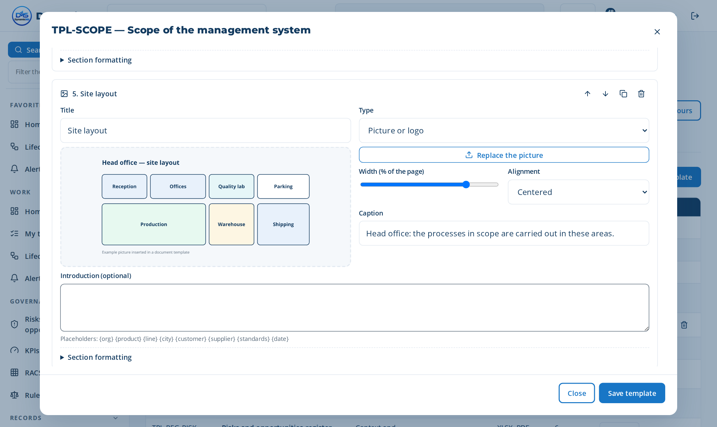
Figure — A picture section in a document template.
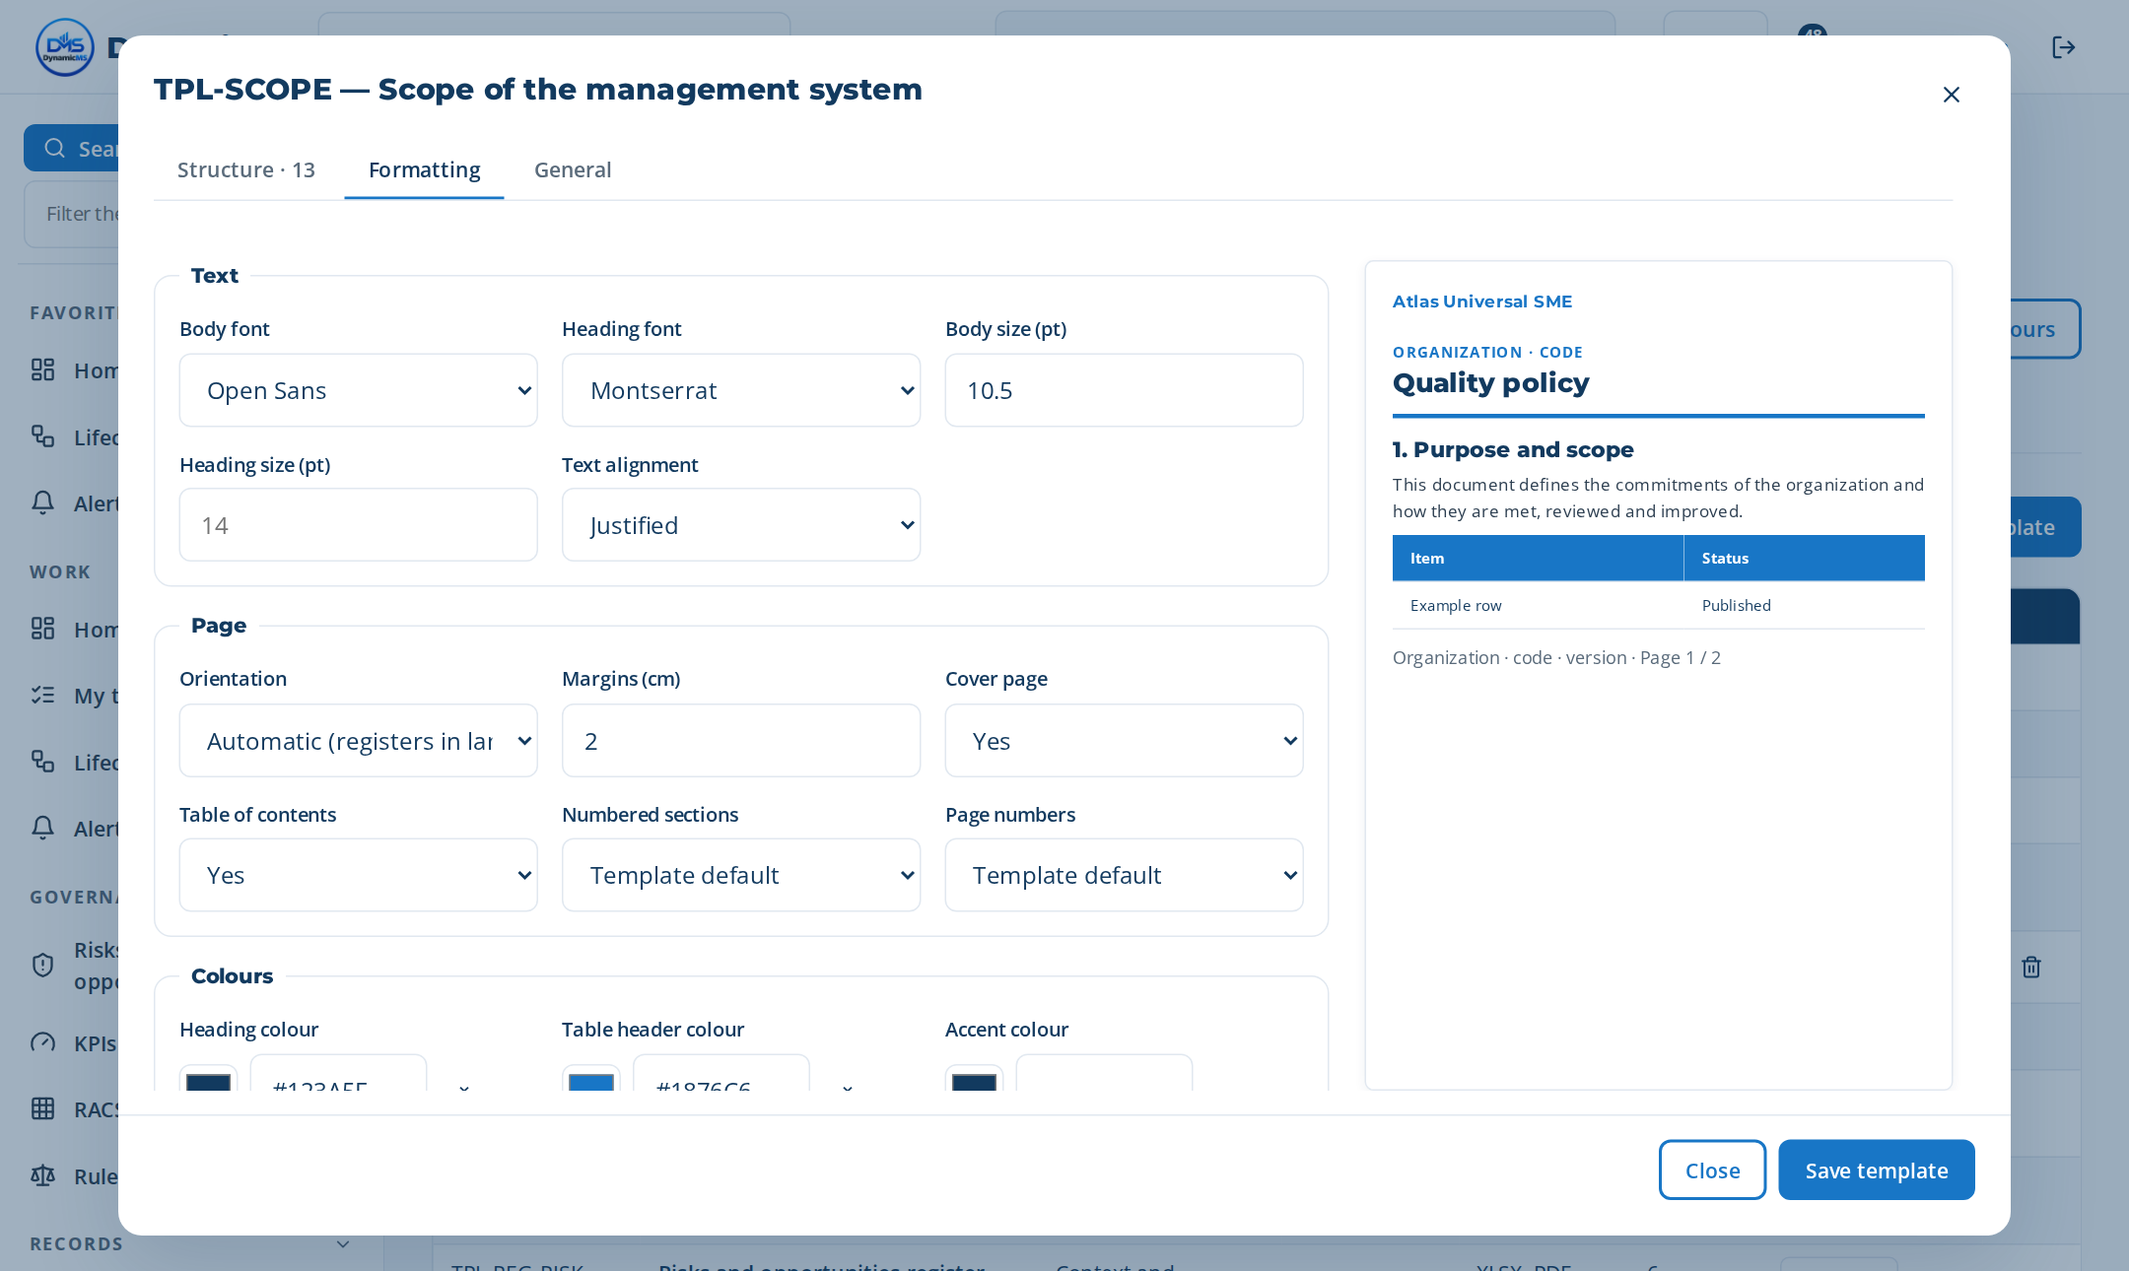
Figure — Formatting of a document template, with its preview.

Documents seeded in the demonstration
Every project of the demonstration has its documents generated from the templates that apply to its management system and standards. The scenario projects of the user guides keep a frozen copy of the content of each current version; the others are rendered from the live data when downloaded.

AT-UNI-QMS — QMS full run 2025–2026 — Atlas Universal SME
Standards: ISO 9001. 48 documents.
Code | Title | Template | Version | Status
AT-UNI-QMS-AUDPRG | Internal audit programme | TPL-AUDPRG | 1.0 | Published
AT-UNI-QMS-AUDREP-01 | Internal audit report — AUD-AT-UNI-QMS-01 | TPL-AUDREP | 1.0 | Published
AT-UNI-QMS-AUDREP-02 | Internal audit report — AUD-AT-UNI-QMS-02 | TPL-AUDREP | 1.0 | Published
AT-UNI-QMS-AUDREP-03 | Internal audit report — AUD-AT-UNI-QMS-03 | TPL-AUDREP | 1.0 | Published
AT-UNI-QMS-AUDREP-04 | Internal audit report — AUD-AT-UNI-QMS-04 | TPL-AUDREP | 1.0 | Published
AT-UNI-QMS-AUDREP-05 | Internal audit report — AUD-AT-UNI-QMS-05 | TPL-AUDREP | 1.0 | Published
AT-UNI-QMS-CAL | Monitoring and measuring equipment register | TPL-CAL | 1.1 | Published
AT-UNI-QMS-CAPA-001 | Corrective action report (8D) — NC-AT-UNI-QMS-001 | TPL-CAPA | 1.0 | Published
AT-UNI-QMS-CAPA-002 | Corrective action report (8D) — NC-AT-UNI-QMS-002 | TPL-CAPA | 1.0 | Published
AT-UNI-QMS-CAPA-006 | Corrective action report (8D) — NC-AT-UNI-QMS-006 | TPL-CAPA | 0.9 | In review
AT-UNI-QMS-CHANGE | Control of changes record | TPL-CHANGE | 1.1 | Published
AT-UNI-QMS-COMM | Communication plan and records | TPL-COMM | 1.0 | Published
AT-UNI-QMS-COMP | Competence matrix and training records | TPL-COMP | 1.0 | Published
AT-UNI-QMS-CTRL | Control plan | TPL-CTRL | 1.0 | Published
AT-UNI-QMS-CTX | Context and interested parties analysis | TPL-CTX | 1.0 | Published
AT-UNI-QMS-DOCLIST | Master list of documented information | TPL-DOCLIST | 1.1 | Published
AT-UNI-QMS-KPI | KPI dashboard and measurement results | TPL-KPI | 1.0 | Published
AT-UNI-QMS-LEGAL | Compliance obligations register | TPL-LEGAL | 1.0 | Published
AT-UNI-QMS-MAN | Management system manual | TPL-MAN | 1.1 | Published
AT-UNI-QMS-MR | Management review minutes | TPL-MR | 1.0 | Published
AT-UNI-QMS-NC | Nonconformity and corrective action register | TPL-NC | 1.1 | Published
AT-UNI-QMS-NCO | Nonconforming outputs register | TPL-NCO | 1.0 | Published
AT-UNI-QMS-OBJ | Objectives and action plan | TPL-OBJ | 1.0 | Published
AT-UNI-QMS-PMAP | Process map and interactions | TPL-PMAP | 1.0 | Published
AT-UNI-QMS-POL-Q | Quality policy | TPL-POL-Q | 1.1 | Published
AT-UNI-QMS-PROC-01 | Procedure — Context To Strategy | TPL-PROC | 1.1 | Published
AT-UNI-QMS-PROC-02 | Procedure — Leadership To Commitment | TPL-PROC | 1.1 | Published
AT-UNI-QMS-PROC-03 | Procedure — Risk To Resilience | TPL-PROC | 1.1 | Published
AT-UNI-QMS-PROC-04 | Procedure — Compliance To Achievement | TPL-PROC | 1.1 | Published
AT-UNI-QMS-PROC-05 | Procedure — People To Capability | TPL-PROC | 1.1 | Published
AT-UNI-QMS-PROC-08 | Procedure — Requirements To Delivery | TPL-PROC | 1.1 | Published
AT-UNI-QMS-PROC-09 | Procedure — Verification To Preparedness | TPL-PROC | 1.1 | Published
AT-UNI-QMS-PROC-10 | Procedure — Monitoring To Evaluation | TPL-PROC | 0.9 | In review
AT-UNI-QMS-PROC-11 | Procedure — Audit To Assurance | TPL-PROC | 0.9 | In review
AT-UNI-QMS-PROC-12 | Procedure — Correction To Innovation | TPL-PROC | 0.1 | Draft
AT-UNI-QMS-PSHEET-GRC005 | Macro process sheet — Regulatory and Compliance Obligations Mapping | TPL-PSHEET | 1.0 | Published
AT-UNI-QMS-PSHEET-UMS002 | Macro process sheet — Process Architecture Mapping | TPL-PSHEET | 1.0 | Published
AT-UNI-QMS-PSHEET-UMS016 | Macro process sheet — Context Analysis and Stakeholder Mapping | TPL-PSHEET | 1.0 | Published
AT-UNI-QMS-PSHEET-UMS022 | Macro process sheet — Quality Policy and Strategic Direction Definition | TPL-PSHEET | 1.0 | Published
AT-UNI-QMS-PSHEET-UMS023 | Macro process sheet — SIPOC and Value Stream Mapping | TPL-PSHEET | 1.0 | Published
AT-UNI-QMS-PSHEET-UMS031 | Macro process sheet — Quality Objectives and Targets Deployment | TPL-PSHEET | 1.0 | Published
AT-UNI-QMS-RACSI | RACSI matrix | TPL-RACSI | 1.0 | Published
AT-UNI-QMS-REG-IP | Interested parties register | TPL-REG-IP | 1.1 | Published
AT-UNI-QMS-RELEASE | Release of products and services record | TPL-RELEASE | 1.0 | Published
AT-UNI-QMS-REQ | Customer requirements review record | TPL-REQ | 1.1 | Published
AT-UNI-QMS-SCOPE | Scope of the management system | TPL-SCOPE | 1.1 | Published
AT-UNI-QMS-SUP | Supplier evaluation register | TPL-SUP | 1.0 | Published
AT-UNI-QMS-WI | Work instruction | TPL-WI | 1.0 | Published

AT-UNI-QHSE — QHSE full run 2025–2026 — Atlas Universal SME
Standards: ISO 9001, ISO 14001, ISO 45001. 53 documents.
Code | Title | Template | Version | Status
AT-UNI-QHSE-ASPECTS | Environmental aspects and impacts register | TPL-ASPECTS | 1.0 | Published
AT-UNI-QHSE-AUDPRG | Internal audit programme | TPL-AUDPRG | 1.0 | Published
AT-UNI-QHSE-AUDREP-01 | Internal audit report — AUD-AT-UNI-QHSE-01 | TPL-AUDREP | 1.0 | Published
AT-UNI-QHSE-AUDREP-02 | Internal audit report — AUD-AT-UNI-QHSE-02 | TPL-AUDREP | 1.0 | Published
AT-UNI-QHSE-AUDREP-03 | Internal audit report — AUD-AT-UNI-QHSE-03 | TPL-AUDREP | 1.0 | Published
AT-UNI-QHSE-AUDREP-04 | Internal audit report — AUD-AT-UNI-QHSE-04 | TPL-AUDREP | 1.0 | Published
AT-UNI-QHSE-AUDREP-05 | Internal audit report — AUD-AT-UNI-QHSE-05 | TPL-AUDREP | 1.0 | Published
AT-UNI-QHSE-AUDREP-06 | Internal audit report — AUD-AT-UNI-QHSE-06 | TPL-AUDREP | 1.0 | Published
AT-UNI-QHSE-CAL | Monitoring and measuring equipment register | TPL-CAL | 1.1 | Published
AT-UNI-QHSE-CAPA-002 | Corrective action report (8D) — NC-AT-UNI-QHSE-002 | TPL-CAPA | 1.0 | Published
AT-UNI-QHSE-CAPA-003 | Corrective action report (8D) — NC-AT-UNI-QHSE-003 | TPL-CAPA | 1.0 | Published
AT-UNI-QHSE-CHANGE | Control of changes record | TPL-CHANGE | 1.1 | Published
AT-UNI-QHSE-COMM | Communication plan and records | TPL-COMM | 1.0 | Published
AT-UNI-QHSE-COMP | Competence matrix and training records | TPL-COMP | 1.0 | Published
AT-UNI-QHSE-CTRL | Control plan | TPL-CTRL | 1.0 | Published
AT-UNI-QHSE-CTX | Context and interested parties analysis | TPL-CTX | 1.0 | Published
AT-UNI-QHSE-DOCLIST | Master list of documented information | TPL-DOCLIST | 1.1 | Published
AT-UNI-QHSE-EPR | Emergency preparedness and response plan | TPL-EPR | 1.0 | Published
AT-UNI-QHSE-HIRA | Hazard identification and risk assessment (HIRA) | TPL-HIRA | 1.1 | Published
AT-UNI-QHSE-INC | Incident investigation report | TPL-INC | 1.0 | Published
AT-UNI-QHSE-KPI | KPI dashboard and measurement results | TPL-KPI | 1.0 | Published
AT-UNI-QHSE-LEGAL | Compliance obligations register | TPL-LEGAL | 1.0 | Published
AT-UNI-QHSE-MAN | Management system manual | TPL-MAN | 1.1 | Published
AT-UNI-QHSE-MR | Management review minutes | TPL-MR | 1.0 | Published
AT-UNI-QHSE-NC | Nonconformity and corrective action register | TPL-NC | 1.1 | Published
AT-UNI-QHSE-NCO | Nonconforming outputs register | TPL-NCO | 1.0 | Published
AT-UNI-QHSE-OBJ | Objectives and action plan | TPL-OBJ | 1.0 | Published
AT-UNI-QHSE-PMAP | Process map and interactions | TPL-PMAP | 1.0 | Published
AT-UNI-QHSE-POL-IMS | Integrated QHSE policy | TPL-POL-IMS | 1.1 | Published
AT-UNI-QHSE-PROC-01 | Procedure — Context To Strategy | TPL-PROC | 1.1 | Published
AT-UNI-QHSE-PROC-02 | Procedure — Leadership To Commitment | TPL-PROC | 1.1 | Published
AT-UNI-QHSE-PROC-03 | Procedure — Risk To Resilience | TPL-PROC | 1.1 | Published
AT-UNI-QHSE-PROC-04 | Procedure — Compliance To Achievement | TPL-PROC | 1.1 | Published
AT-UNI-QHSE-PROC-05 | Procedure — People To Capability | TPL-PROC | 1.1 | Published
AT-UNI-QHSE-PROC-08 | Procedure — Requirements To Delivery | TPL-PROC | 1.1 | Published
AT-UNI-QHSE-PROC-09 | Procedure — Verification To Preparedness | TPL-PROC | 1.1 | Published
AT-UNI-QHSE-PROC-10 | Procedure — Monitoring To Evaluation | TPL-PROC | 0.9 | In review
AT-UNI-QHSE-PROC-11 | Procedure — Audit To Assurance | TPL-PROC | 0.9 | In review
AT-UNI-QHSE-PROC-12 | Procedure — Correction To Innovation | TPL-PROC | 0.1 | Draft
AT-UNI-QHSE-PSHEET-GRC005 | Macro process sheet — Regulatory and Compliance Obligations Mapping | TPL-PSHEET | 1.0 | Published
AT-UNI-QHSE-PSHEET-UMS002 | Macro process sheet — Process Architecture Mapping | TPL-PSHEET | 1.0 | Published
AT-UNI-QHSE-PSHEET-UMS016 | Macro process sheet — Context Analysis and Stakeholder Mapping | TPL-PSHEET | 1.0 | Published
AT-UNI-QHSE-PSHEET-UMS022 | Macro process sheet — Quality Policy and Strategic Direction Definition | TPL-PSHEET | 1.0 | Published
AT-UNI-QHSE-PSHEET-UMS023 | Macro process sheet — SIPOC and Value Stream Mapping | TPL-PSHEET | 1.0 | Published
AT-UNI-QHSE-PSHEET-UMS031 | Macro process sheet — Quality Objectives and Targets Deployment | TPL-PSHEET | 1.0 | Published
AT-UNI-QHSE-RACSI | RACSI matrix | TPL-RACSI | 1.0 | Published
AT-UNI-QHSE-REG-IP | Interested parties register | TPL-REG-IP | 1.1 | Published
AT-UNI-QHSE-REG-RISK | Risks and opportunities register | TPL-REG-RISK | 1.0 | Published
AT-UNI-QHSE-RELEASE | Release of products and services record | TPL-RELEASE | 1.0 | Published
AT-UNI-QHSE-REQ | Customer requirements review record | TPL-REQ | 1.1 | Published
AT-UNI-QHSE-SCOPE | Scope of the management system | TPL-SCOPE | 1.1 | Published
AT-UNI-QHSE-SUP | Supplier evaluation register | TPL-SUP | 1.0 | Published
AT-UNI-QHSE-WI | Work instruction | TPL-WI | 1.0 | Published

NV-AEC-QMS — QMS full run 2025–2026 — Nova Build & Construct
Standards: ISO 9001, ISO 19650, EN 1090, CE Marking (CPR). 48 documents.
Code | Title | Template | Version | Status
NV-AEC-QMS-AUDPRG | Internal audit programme | TPL-AUDPRG | 1.0 | Published
NV-AEC-QMS-AUDREP-01 | Internal audit report — AUD-NV-AEC-QMS-01 | TPL-AUDREP | 1.0 | Published
NV-AEC-QMS-AUDREP-02 | Internal audit report — AUD-NV-AEC-QMS-02 | TPL-AUDREP | 1.0 | Published
NV-AEC-QMS-AUDREP-03 | Internal audit report — AUD-NV-AEC-QMS-03 | TPL-AUDREP | 1.0 | Published
NV-AEC-QMS-AUDREP-04 | Internal audit report — AUD-NV-AEC-QMS-04 | TPL-AUDREP | 1.0 | Published
NV-AEC-QMS-AUDREP-05 | Internal audit report — AUD-NV-AEC-QMS-05 | TPL-AUDREP | 1.0 | Published
NV-AEC-QMS-CAL | Monitoring and measuring equipment register | TPL-CAL | 1.1 | Published
NV-AEC-QMS-CAPA-002 | Corrective action report (8D) — NC-NV-AEC-QMS-002 | TPL-CAPA | 1.0 | Published
NV-AEC-QMS-CAPA-003 | Corrective action report (8D) — NC-NV-AEC-QMS-003 | TPL-CAPA | 1.0 | Published
NV-AEC-QMS-CHANGE | Control of changes record | TPL-CHANGE | 1.1 | Published
NV-AEC-QMS-COMM | Communication plan and records | TPL-COMM | 1.0 | Published
NV-AEC-QMS-COMP | Competence matrix and training records | TPL-COMP | 1.0 | Published
NV-AEC-QMS-CTRL | Control plan | TPL-CTRL | 1.0 | Published
NV-AEC-QMS-CTX | Context and interested parties analysis | TPL-CTX | 1.0 | Published
NV-AEC-QMS-DOCLIST | Master list of documented information | TPL-DOCLIST | 1.1 | Published
NV-AEC-QMS-KPI | KPI dashboard and measurement results | TPL-KPI | 1.0 | Published
NV-AEC-QMS-LEGAL | Compliance obligations register | TPL-LEGAL | 1.0 | Published
NV-AEC-QMS-MAN | Management system manual | TPL-MAN | 1.1 | Published
NV-AEC-QMS-MR | Management review minutes | TPL-MR | 1.0 | Published
NV-AEC-QMS-NC | Nonconformity and corrective action register | TPL-NC | 1.1 | Published
NV-AEC-QMS-NCO | Nonconforming outputs register | TPL-NCO | 1.0 | Published
NV-AEC-QMS-OBJ | Objectives and action plan | TPL-OBJ | 1.0 | Published
NV-AEC-QMS-PMAP | Process map and interactions | TPL-PMAP | 1.0 | Published
NV-AEC-QMS-POL-Q | Quality policy | TPL-POL-Q | 1.1 | Published
NV-AEC-QMS-PROC-01 | Procedure — Context To Strategy | TPL-PROC | 1.1 | Published
NV-AEC-QMS-PROC-02 | Procedure — Leadership To Commitment | TPL-PROC | 1.1 | Published
NV-AEC-QMS-PROC-03 | Procedure — Risk To Resilience | TPL-PROC | 1.1 | Published
NV-AEC-QMS-PROC-04 | Procedure — Compliance To Achievement | TPL-PROC | 1.1 | Published
NV-AEC-QMS-PROC-05 | Procedure — People To Capability | TPL-PROC | 1.1 | Published
NV-AEC-QMS-PROC-06 | Procedure — Infrastructure To Wellbeing | TPL-PROC | 1.1 | Published
NV-AEC-QMS-PROC-08 | Procedure — Requirements To Delivery | TPL-PROC | 1.1 | Published
NV-AEC-QMS-PROC-09 | Procedure — Verification To Preparedness | TPL-PROC | 1.1 | Published
NV-AEC-QMS-PROC-10 | Procedure — Monitoring To Evaluation | TPL-PROC | 0.9 | In review
NV-AEC-QMS-PROC-11 | Procedure — Audit To Assurance | TPL-PROC | 0.1 | Draft
NV-AEC-QMS-PROC-12 | Procedure — Correction To Innovation | TPL-PROC | 0.1 | Draft
NV-AEC-QMS-PSHEET-GRC005 | Macro process sheet — Regulatory and Compliance Obligations Mapping | TPL-PSHEET | 1.0 | Published
NV-AEC-QMS-PSHEET-UMS002 | Macro process sheet — Process Architecture Mapping | TPL-PSHEET | 1.0 | Published
NV-AEC-QMS-PSHEET-UMS016 | Macro process sheet — Context Analysis and Stakeholder Mapping | TPL-PSHEET | 1.0 | Published
NV-AEC-QMS-PSHEET-UMS022 | Macro process sheet — Quality Policy and Strategic Direction Definition | TPL-PSHEET | 1.0 | Published
NV-AEC-QMS-PSHEET-UMS023 | Macro process sheet — SIPOC and Value Stream Mapping | TPL-PSHEET | 1.0 | Published
NV-AEC-QMS-PSHEET-UMS031 | Macro process sheet — Quality Objectives and Targets Deployment | TPL-PSHEET | 1.0 | Published
NV-AEC-QMS-RACSI | RACSI matrix | TPL-RACSI | 1.0 | Published
NV-AEC-QMS-REG-IP | Interested parties register | TPL-REG-IP | 1.1 | Published
NV-AEC-QMS-RELEASE | Release of products and services record | TPL-RELEASE | 1.0 | Published
NV-AEC-QMS-REQ | Customer requirements review record | TPL-REQ | 1.1 | Published
NV-AEC-QMS-SCOPE | Scope of the management system | TPL-SCOPE | 1.1 | Published
NV-AEC-QMS-SUP | Supplier evaluation register | TPL-SUP | 1.0 | Published
NV-AEC-QMS-WI | Work instruction | TPL-WI | 1.0 | Published

HZ-UNI-QMS — QMS full run 2025–2026 — Horizon Universal Holdings
Standards: ISO 9001. 53 documents.
Code | Title | Template | Version | Status
HZ-UNI-QMS-AUDPRG | Internal audit programme | TPL-AUDPRG | 1.0 | Published
HZ-UNI-QMS-AUDREP-01 | Internal audit report — AUD-HZ-UNI-QMS-01 | TPL-AUDREP | 1.0 | Published
HZ-UNI-QMS-AUDREP-02 | Internal audit report — AUD-HZ-UNI-QMS-02 | TPL-AUDREP | 1.0 | Published
HZ-UNI-QMS-AUDREP-03 | Internal audit report — AUD-HZ-UNI-QMS-03 | TPL-AUDREP | 1.0 | Published
HZ-UNI-QMS-AUDREP-04 | Internal audit report — AUD-HZ-UNI-QMS-04 | TPL-AUDREP | 1.0 | Published
HZ-UNI-QMS-AUDREP-05 | Internal audit report — AUD-HZ-UNI-QMS-05 | TPL-AUDREP | 1.0 | Published
HZ-UNI-QMS-CAL | Monitoring and measuring equipment register | TPL-CAL | 1.1 | Published
HZ-UNI-QMS-CAPA-002 | Corrective action report (8D) — NC-HZ-UNI-QMS-002 | TPL-CAPA | 1.0 | Published
HZ-UNI-QMS-CAPA-004 | Corrective action report (8D) — NC-HZ-UNI-QMS-004 | TPL-CAPA | 1.0 | Published
HZ-UNI-QMS-CAPA-008 | Corrective action report (8D) — NC-HZ-UNI-QMS-008 | TPL-CAPA | 1.0 | Published
HZ-UNI-QMS-CAPA-009 | Corrective action report (8D) — NC-HZ-UNI-QMS-009 | TPL-CAPA | 1.0 | Published
HZ-UNI-QMS-CHANGE | Control of changes record | TPL-CHANGE | 1.1 | Published
HZ-UNI-QMS-COMM | Communication plan and records | TPL-COMM | 1.0 | Published
HZ-UNI-QMS-COMP | Competence matrix and training records | TPL-COMP | 1.0 | Published
HZ-UNI-QMS-CTRL | Control plan | TPL-CTRL | 1.0 | Published
HZ-UNI-QMS-CTX | Context and interested parties analysis | TPL-CTX | 1.0 | Published
HZ-UNI-QMS-DOCLIST | Master list of documented information | TPL-DOCLIST | 1.1 | Published
HZ-UNI-QMS-IMP | Improvement plan | TPL-IMP | 1.0 | Published
HZ-UNI-QMS-KPI | KPI dashboard and measurement results | TPL-KPI | 1.0 | Published
HZ-UNI-QMS-LEGAL | Compliance obligations register | TPL-LEGAL | 1.0 | Published
HZ-UNI-QMS-MAN | Management system manual | TPL-MAN | 1.1 | Published
HZ-UNI-QMS-MR | Management review minutes | TPL-MR | 1.0 | Published
HZ-UNI-QMS-NC | Nonconformity and corrective action register | TPL-NC | 1.1 | Published
HZ-UNI-QMS-NCO | Nonconforming outputs register | TPL-NCO | 1.0 | Published
HZ-UNI-QMS-OBJ | Objectives and action plan | TPL-OBJ | 1.0 | Published
HZ-UNI-QMS-PMAP | Process map and interactions | TPL-PMAP | 1.0 | Published
HZ-UNI-QMS-POL-Q | Quality policy | TPL-POL-Q | 1.1 | Published
HZ-UNI-QMS-PROC-01 | Procedure — Context To Strategy | TPL-PROC | 1.1 | Published
HZ-UNI-QMS-PROC-02 | Procedure — Leadership To Commitment | TPL-PROC | 1.1 | Published
HZ-UNI-QMS-PROC-03 | Procedure — Risk To Resilience | TPL-PROC | 1.1 | Published
HZ-UNI-QMS-PROC-04 | Procedure — Compliance To Achievement | TPL-PROC | 1.1 | Published
HZ-UNI-QMS-PROC-05 | Procedure — People To Capability | TPL-PROC | 1.1 | Published
HZ-UNI-QMS-PROC-06 | Procedure — Infrastructure To Wellbeing | TPL-PROC | 1.1 | Published
HZ-UNI-QMS-PROC-07 | Procedure — Knowledge To Control | TPL-PROC | 1.1 | Published
HZ-UNI-QMS-PROC-08 | Procedure — Requirements To Delivery | TPL-PROC | 1.1 | Published
HZ-UNI-QMS-PROC-09 | Procedure — Verification To Preparedness | TPL-PROC | 1.1 | Published
HZ-UNI-QMS-PROC-10 | Procedure — Monitoring To Evaluation | TPL-PROC | 1.1 | Published
HZ-UNI-QMS-PROC-11 | Procedure — Audit To Assurance | TPL-PROC | 1.1 | Published
HZ-UNI-QMS-PROC-12 | Procedure — Correction To Innovation | TPL-PROC | 0.9 | In review
HZ-UNI-QMS-PSHEET-UMS002 | Macro process sheet — Process Architecture Mapping | TPL-PSHEET | 1.0 | Published
HZ-UNI-QMS-PSHEET-UMS016 | Macro process sheet — Context Analysis and Stakeholder Mapping | TPL-PSHEET | 1.0 | Published
HZ-UNI-QMS-PSHEET-UMS022 | Macro process sheet — Quality Policy and Strategic Direction Definition | TPL-PSHEET | 1.0 | Published
HZ-UNI-QMS-PSHEET-UMS023 | Macro process sheet — SIPOC and Value Stream Mapping | TPL-PSHEET | 1.0 | Published
HZ-UNI-QMS-PSHEET-UMS030 | Macro process sheet — Operational Risk and Opportunity Management | TPL-PSHEET | 1.0 | Published
HZ-UNI-QMS-PSHEET-UMS031 | Macro process sheet — Quality Objectives and Targets Deployment | TPL-PSHEET | 1.0 | Published
HZ-UNI-QMS-RACSI | RACSI matrix | TPL-RACSI | 1.0 | Published
HZ-UNI-QMS-REG-IP | Interested parties register | TPL-REG-IP | 1.1 | Published
HZ-UNI-QMS-REG-RISK | Risks and opportunities register | TPL-REG-RISK | 1.0 | Published
HZ-UNI-QMS-RELEASE | Release of products and services record | TPL-RELEASE | 1.0 | Published
HZ-UNI-QMS-REQ | Customer requirements review record | TPL-REQ | 1.1 | Published
HZ-UNI-QMS-SCOPE | Scope of the management system | TPL-SCOPE | 1.1 | Published
HZ-UNI-QMS-SUP | Supplier evaluation register | TPL-SUP | 1.0 | Published
HZ-UNI-QMS-WI | Work instruction | TPL-WI | 1.0 | Published

HZ-UNI-QHSE — QHSE full run 2025–2026 — Horizon Universal Holdings
Standards: ISO 9001, ISO 14001, ISO 45001. 59 documents.
Code | Title | Template | Version | Status
HZ-UNI-QHSE-ASPECTS | Environmental aspects and impacts register | TPL-ASPECTS | 1.0 | Published
HZ-UNI-QHSE-AUDPRG | Internal audit programme | TPL-AUDPRG | 1.0 | Published
HZ-UNI-QHSE-AUDREP-01 | Internal audit report — AUD-HZ-UNI-QHSE-01 | TPL-AUDREP | 1.0 | Published
HZ-UNI-QHSE-AUDREP-02 | Internal audit report — AUD-HZ-UNI-QHSE-02 | TPL-AUDREP | 1.0 | Published
HZ-UNI-QHSE-AUDREP-03 | Internal audit report — AUD-HZ-UNI-QHSE-03 | TPL-AUDREP | 1.0 | Published
HZ-UNI-QHSE-AUDREP-04 | Internal audit report — AUD-HZ-UNI-QHSE-04 | TPL-AUDREP | 1.0 | Published
HZ-UNI-QHSE-AUDREP-05 | Internal audit report — AUD-HZ-UNI-QHSE-05 | TPL-AUDREP | 1.0 | Published
HZ-UNI-QHSE-AUDREP-06 | Internal audit report — AUD-HZ-UNI-QHSE-06 | TPL-AUDREP | 1.0 | Published
HZ-UNI-QHSE-CAL | Monitoring and measuring equipment register | TPL-CAL | 1.1 | Published
HZ-UNI-QHSE-CAPA-002 | Corrective action report (8D) — NC-HZ-UNI-QHSE-002 | TPL-CAPA | 1.0 | Published
HZ-UNI-QHSE-CAPA-005 | Corrective action report (8D) — NC-HZ-UNI-QHSE-005 | TPL-CAPA | 1.0 | Published
HZ-UNI-QHSE-CAPA-007 | Corrective action report (8D) — NC-HZ-UNI-QHSE-007 | TPL-CAPA | 1.0 | Published
HZ-UNI-QHSE-CAPA-008 | Corrective action report (8D) — NC-HZ-UNI-QHSE-008 | TPL-CAPA | 1.0 | Published
HZ-UNI-QHSE-CAPA-010 | Corrective action report (8D) — NC-HZ-UNI-QHSE-010 | TPL-CAPA | 0.9 | In review
HZ-UNI-QHSE-CHANGE | Control of changes record | TPL-CHANGE | 1.1 | Published
HZ-UNI-QHSE-COMM | Communication plan and records | TPL-COMM | 1.0 | Published
HZ-UNI-QHSE-COMP | Competence matrix and training records | TPL-COMP | 1.0 | Published
HZ-UNI-QHSE-CTRL | Control plan | TPL-CTRL | 1.0 | Published
HZ-UNI-QHSE-CTX | Context and interested parties analysis | TPL-CTX | 1.0 | Published
HZ-UNI-QHSE-DOCLIST | Master list of documented information | TPL-DOCLIST | 1.1 | Published
HZ-UNI-QHSE-EPR | Emergency preparedness and response plan | TPL-EPR | 1.0 | Published
HZ-UNI-QHSE-HIRA | Hazard identification and risk assessment (HIRA) | TPL-HIRA | 1.1 | Published
HZ-UNI-QHSE-IMP | Improvement plan | TPL-IMP | 1.0 | Published
HZ-UNI-QHSE-INC | Incident investigation report | TPL-INC | 1.0 | Published
HZ-UNI-QHSE-KPI | KPI dashboard and measurement results | TPL-KPI | 1.0 | Published
HZ-UNI-QHSE-LEGAL | Compliance obligations register | TPL-LEGAL | 1.0 | Published
HZ-UNI-QHSE-MAN | Management system manual | TPL-MAN | 1.1 | Published
HZ-UNI-QHSE-MR | Management review minutes | TPL-MR | 1.0 | Published
HZ-UNI-QHSE-NC | Nonconformity and corrective action register | TPL-NC | 1.1 | Published
HZ-UNI-QHSE-NCO | Nonconforming outputs register | TPL-NCO | 1.0 | Published
HZ-UNI-QHSE-OBJ | Objectives and action plan | TPL-OBJ | 1.0 | Published
HZ-UNI-QHSE-PMAP | Process map and interactions | TPL-PMAP | 1.0 | Published
HZ-UNI-QHSE-POL-IMS | Integrated QHSE policy | TPL-POL-IMS | 1.1 | Published
HZ-UNI-QHSE-PROC-01 | Procedure — Context To Strategy | TPL-PROC | 1.1 | Published
HZ-UNI-QHSE-PROC-02 | Procedure — Leadership To Commitment | TPL-PROC | 1.1 | Published
HZ-UNI-QHSE-PROC-03 | Procedure — Risk To Resilience | TPL-PROC | 1.1 | Published
HZ-UNI-QHSE-PROC-04 | Procedure — Compliance To Achievement | TPL-PROC | 1.1 | Published
HZ-UNI-QHSE-PROC-05 | Procedure — People To Capability | TPL-PROC | 1.1 | Published
HZ-UNI-QHSE-PROC-06 | Procedure — Infrastructure To Wellbeing | TPL-PROC | 1.1 | Published
HZ-UNI-QHSE-PROC-07 | Procedure — Knowledge To Control | TPL-PROC | 1.1 | Published
HZ-UNI-QHSE-PROC-08 | Procedure — Requirements To Delivery | TPL-PROC | 1.1 | Published
HZ-UNI-QHSE-PROC-09 | Procedure — Verification To Preparedness | TPL-PROC | 1.1 | Published
HZ-UNI-QHSE-PROC-10 | Procedure — Monitoring To Evaluation | TPL-PROC | 1.1 | Published
HZ-UNI-QHSE-PROC-11 | Procedure — Audit To Assurance | TPL-PROC | 1.1 | Published
HZ-UNI-QHSE-PROC-12 | Procedure — Correction To Innovation | TPL-PROC | 0.9 | In review
HZ-UNI-QHSE-PSHEET-UMS002 | Macro process sheet — Process Architecture Mapping | TPL-PSHEET | 1.0 | Published
HZ-UNI-QHSE-PSHEET-UMS016 | Macro process sheet — Context Analysis and Stakeholder Mapping | TPL-PSHEET | 1.0 | Published
HZ-UNI-QHSE-PSHEET-UMS022 | Macro process sheet — Quality Policy and Strategic Direction Definition | TPL-PSHEET | 1.0 | Published
HZ-UNI-QHSE-PSHEET-UMS023 | Macro process sheet — SIPOC and Value Stream Mapping | TPL-PSHEET | 1.0 | Published
HZ-UNI-QHSE-PSHEET-UMS030 | Macro process sheet — Operational Risk and Opportunity Management | TPL-PSHEET | 1.0 | Published
HZ-UNI-QHSE-PSHEET-UMS031 | Macro process sheet — Quality Objectives and Targets Deployment | TPL-PSHEET | 1.0 | Published
HZ-UNI-QHSE-RACSI | RACSI matrix | TPL-RACSI | 1.0 | Published
HZ-UNI-QHSE-REG-IP | Interested parties register | TPL-REG-IP | 1.1 | Published
HZ-UNI-QHSE-REG-RISK | Risks and opportunities register | TPL-REG-RISK | 1.0 | Published
HZ-UNI-QHSE-RELEASE | Release of products and services record | TPL-RELEASE | 1.0 | Published
HZ-UNI-QHSE-REQ | Customer requirements review record | TPL-REQ | 1.1 | Published
HZ-UNI-QHSE-SCOPE | Scope of the management system | TPL-SCOPE | 1.1 | Published
HZ-UNI-QHSE-SUP | Supplier evaluation register | TPL-SUP | 1.0 | Published
HZ-UNI-QHSE-WI | Work instruction | TPL-WI | 1.0 | Published

Appendix — Sample pages
Pages of documents generated for Atlas Universal SME (project AT-UNI-QMS), as downloaded in PDF with the default layout.
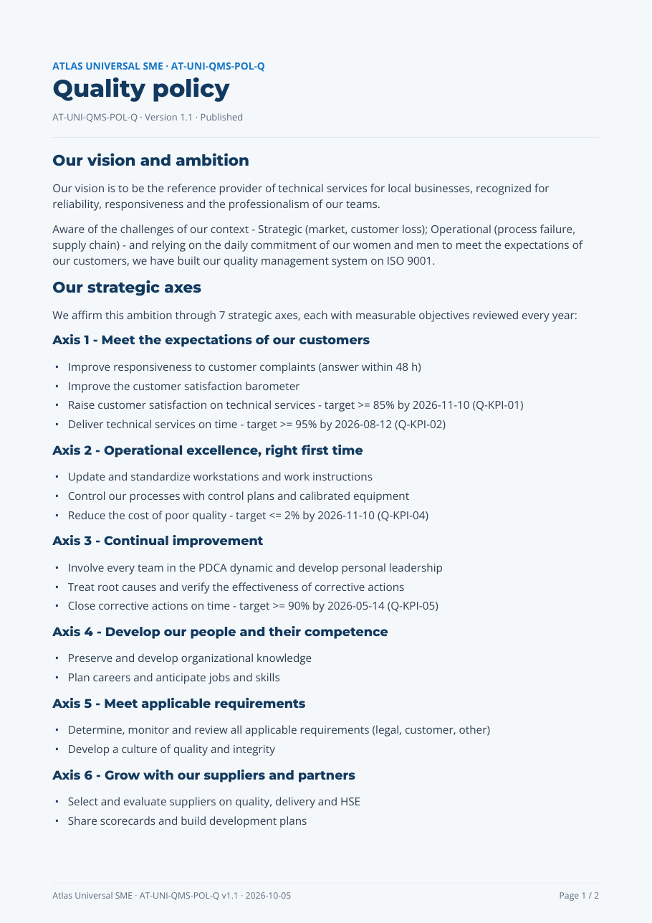
Figure — Quality policy — vision and strategic axes with their objectives.
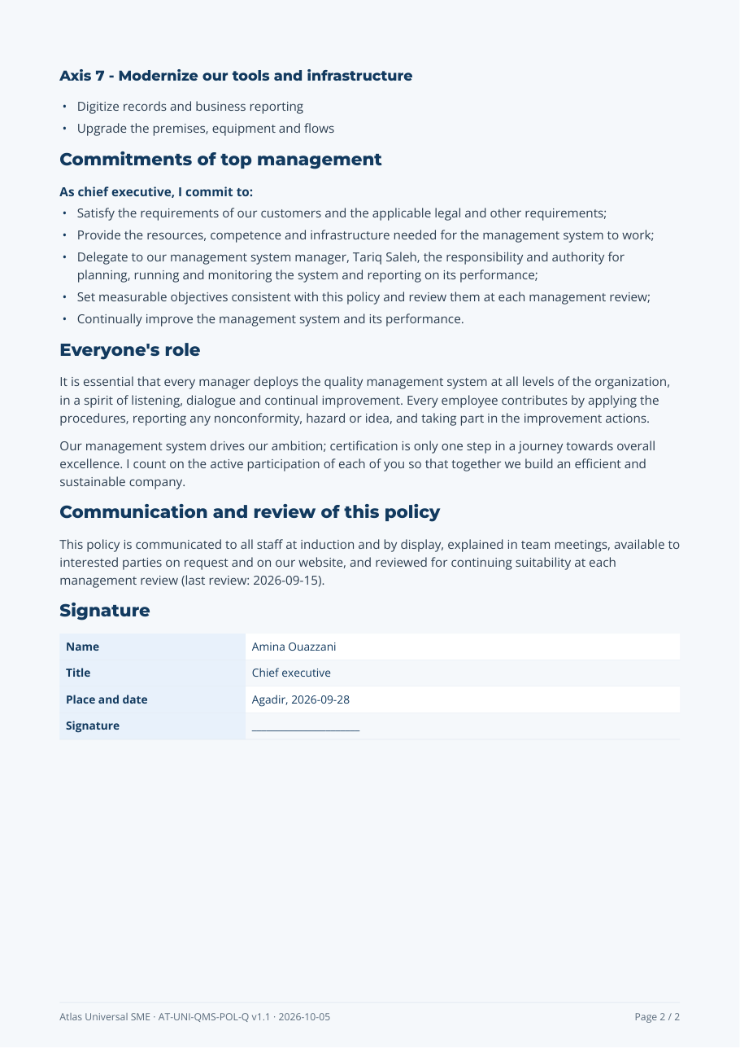
Figure — Quality policy — commitments of the chief executive and signature.
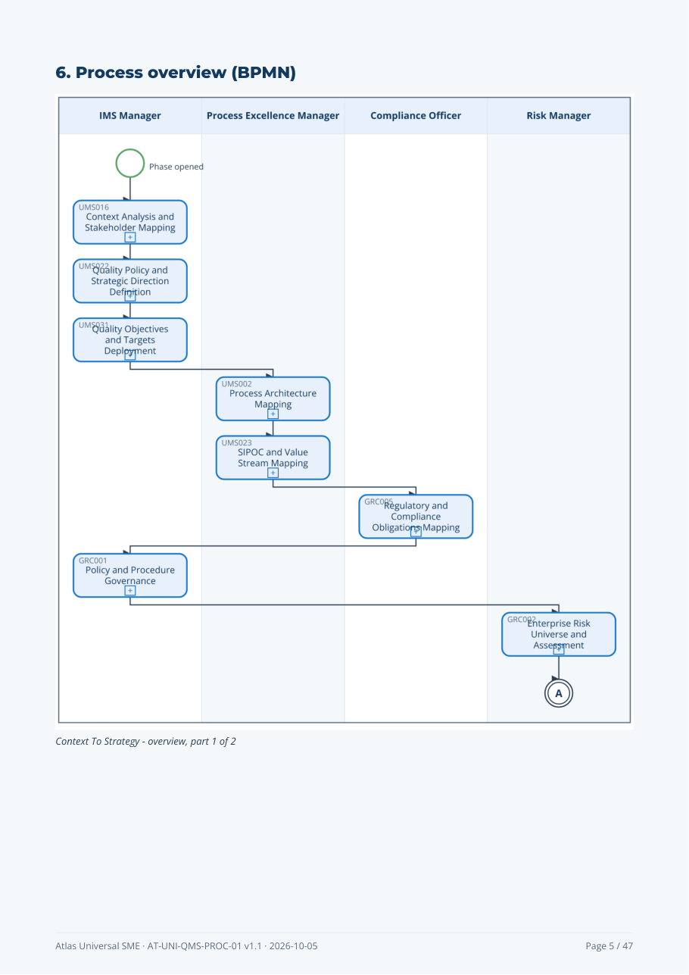
Figure — Procedure — BPMN overview of the phase.
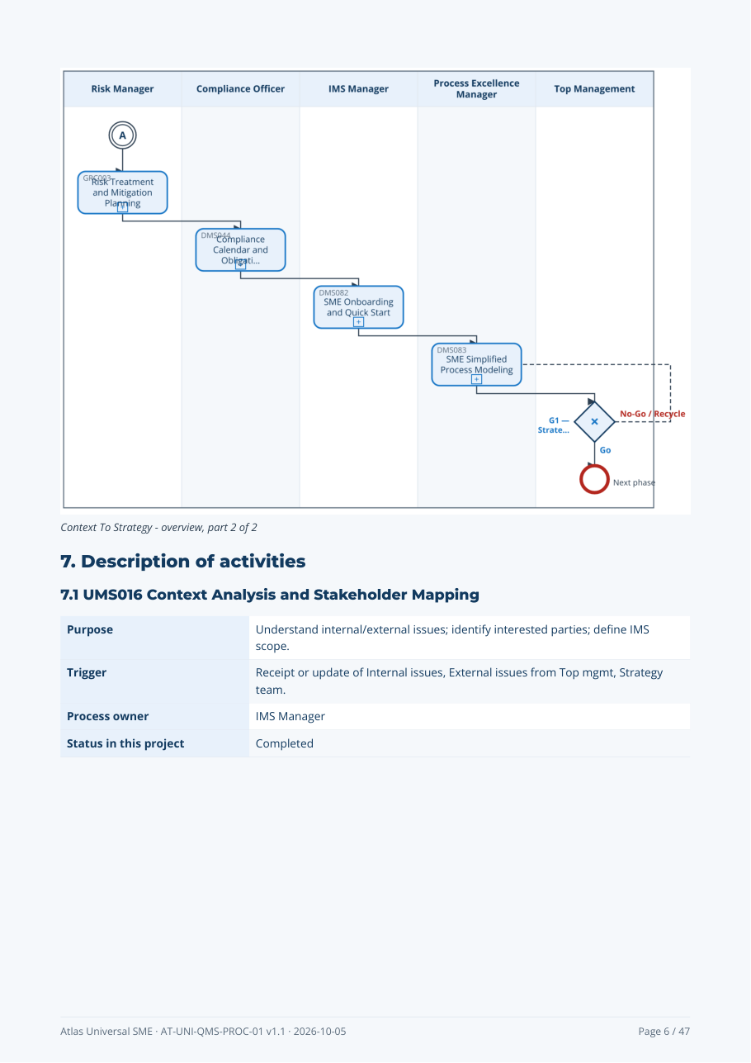
Figure — Procedure — SIPOC of each step and Go / No-Go criteria.
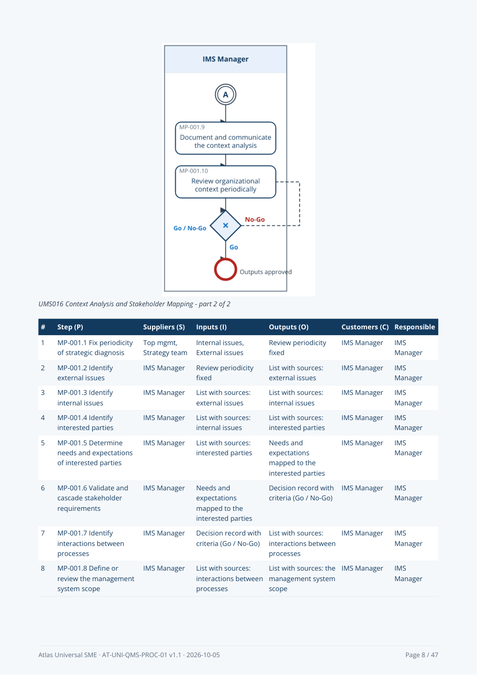
Figure — Procedure — BPMN of a macro process.
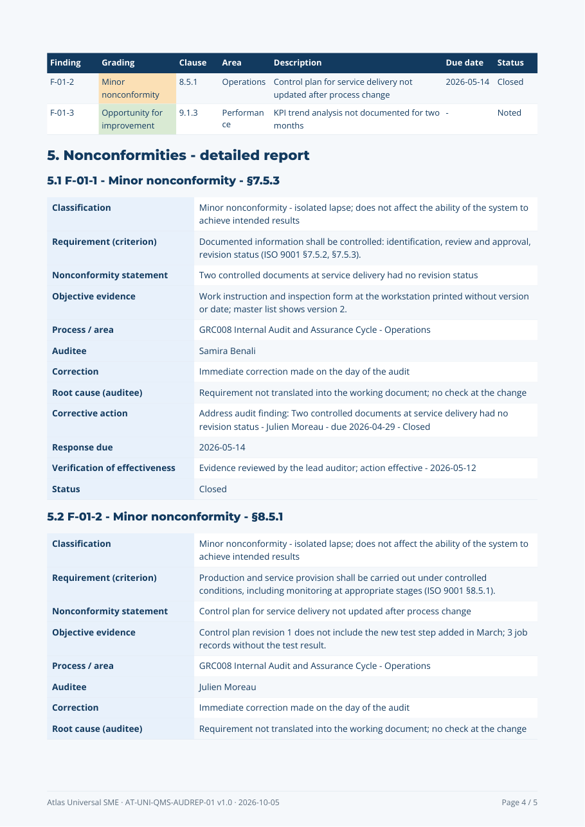
Figure — Internal audit report — detailed report of the nonconformities.
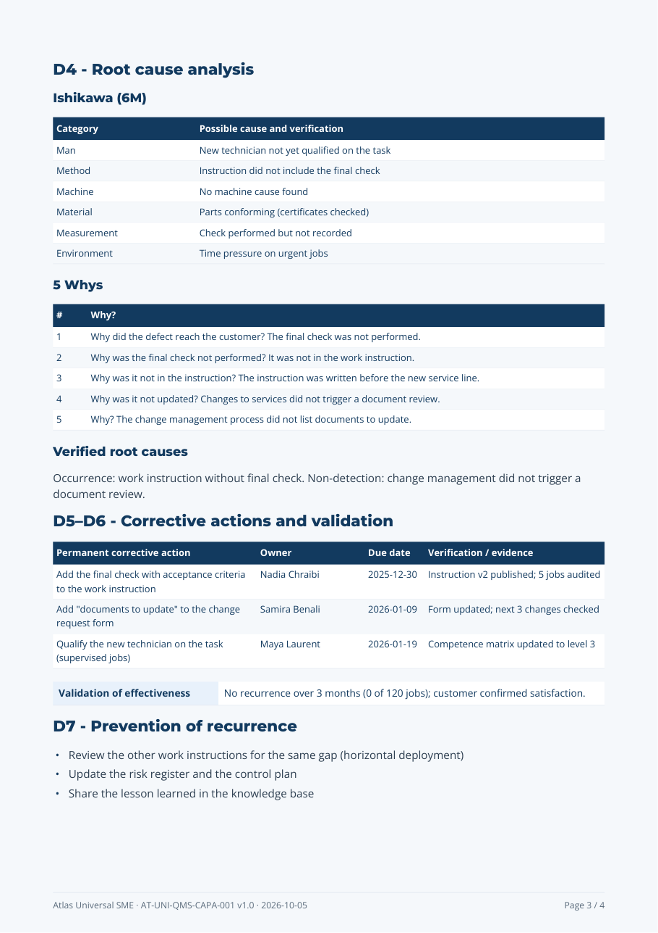
Figure — Corrective action report (8D) — root cause, actions and closure.
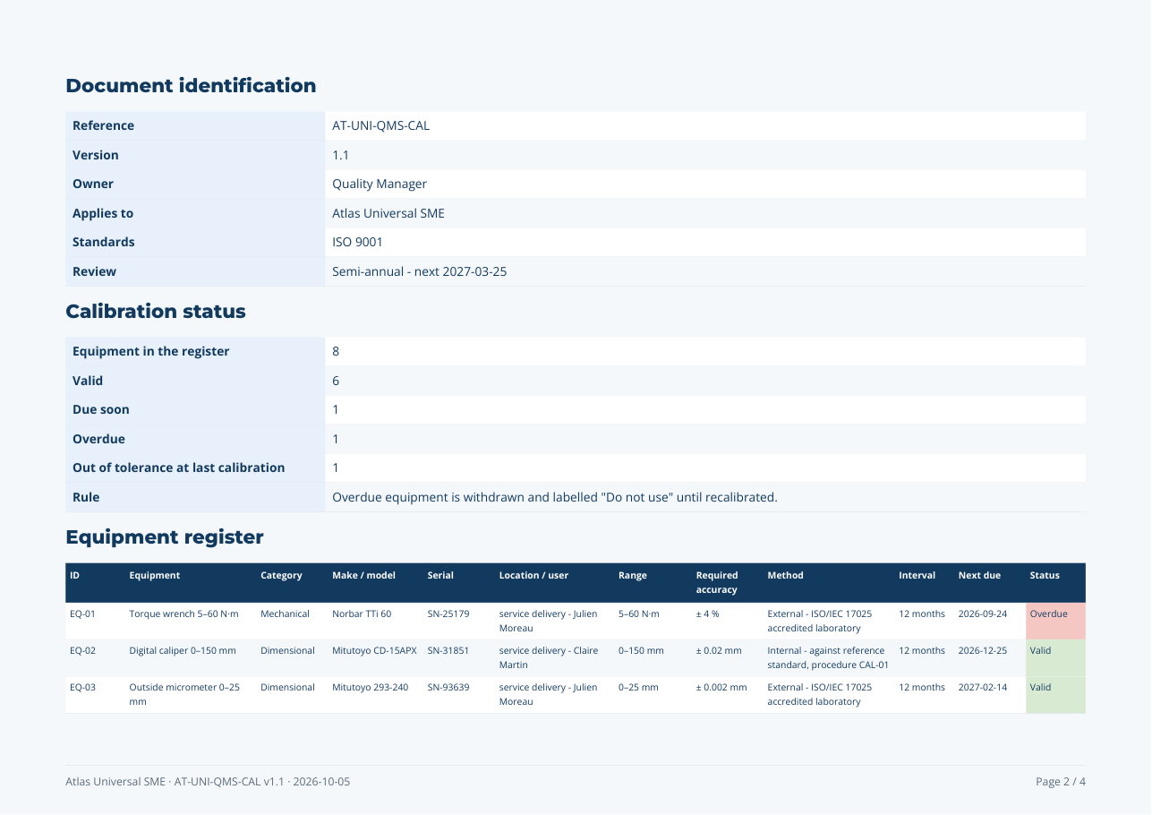
Figure — Monitoring and measuring equipment register.
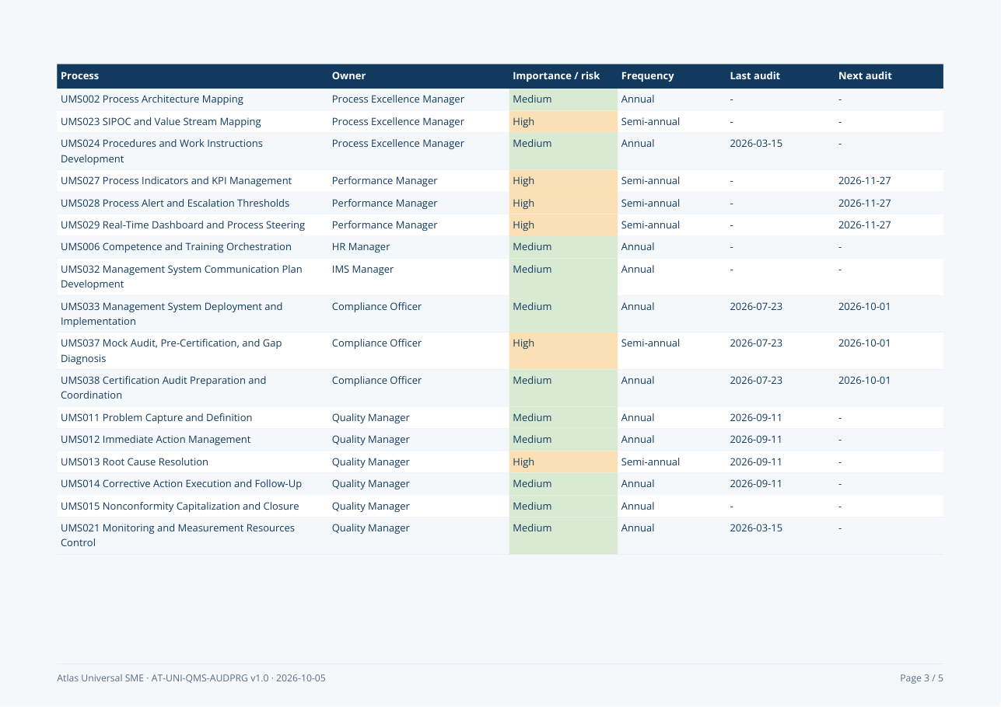
Figure — Internal audit programme — frequency per process.
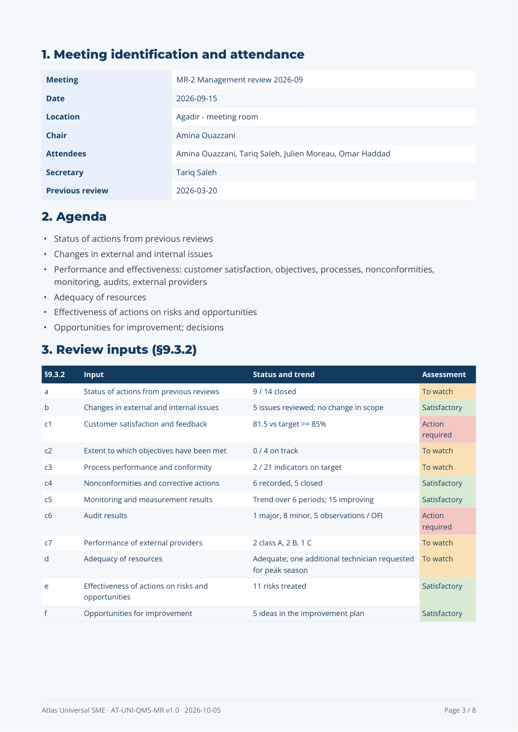
Figure — Management review minutes — inputs of §9.3.2.
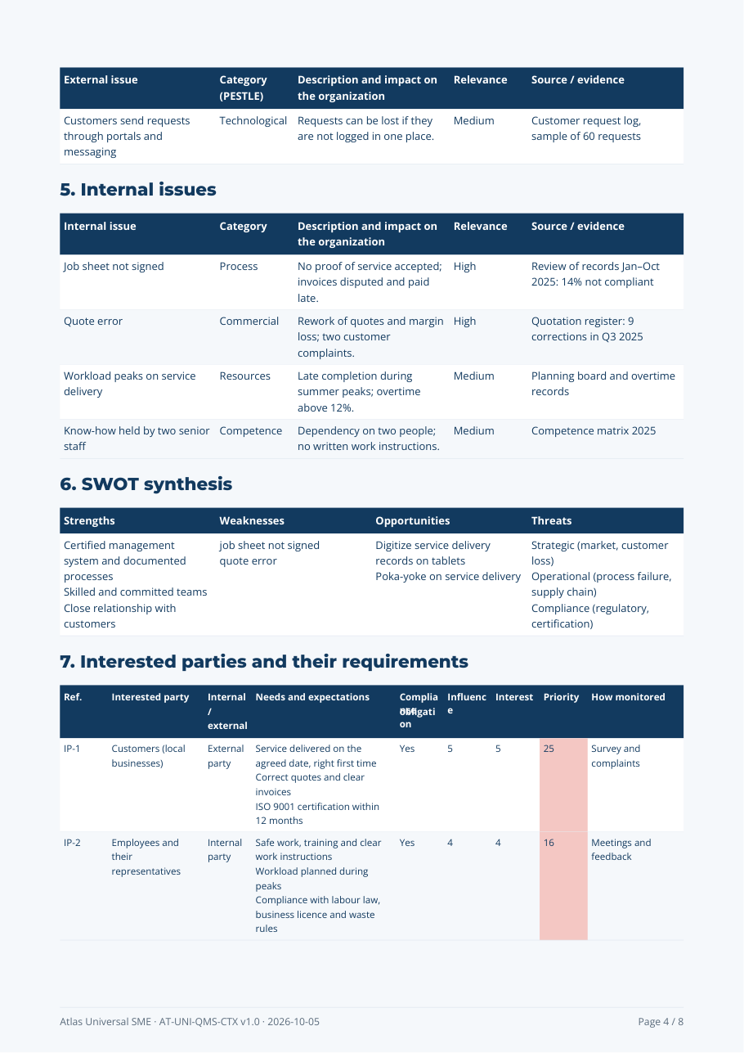
Figure — Context analysis — PESTLE, SWOT and interested parties.
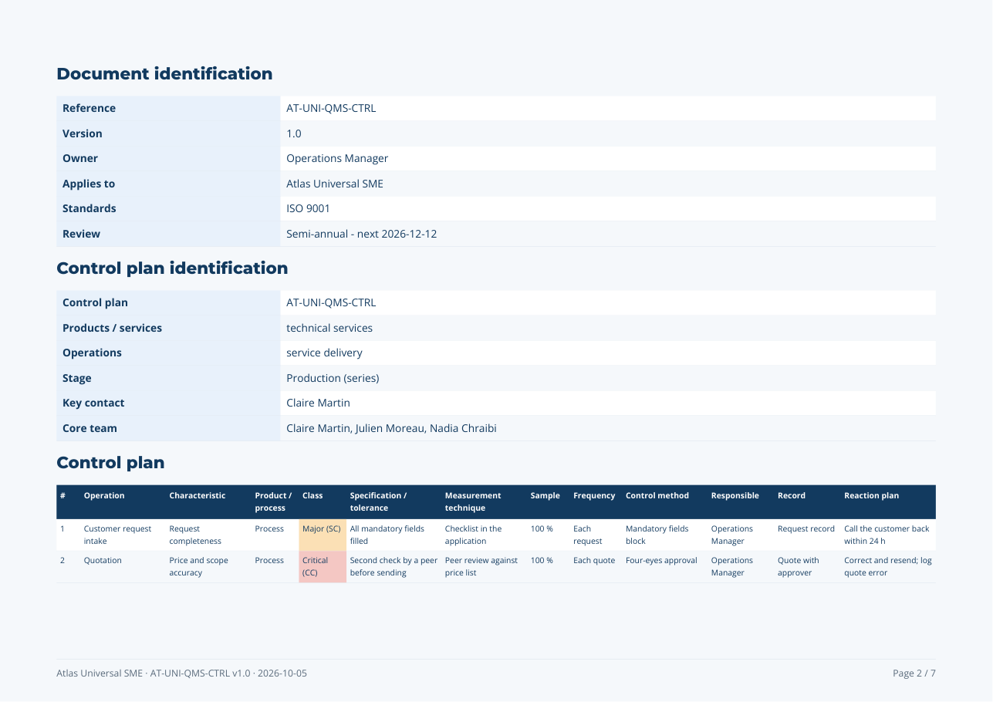
Figure — Control plan.

