**How do we use GitHub ?**

1. Create a new repository in GitHub.com (ex. MyRepo)

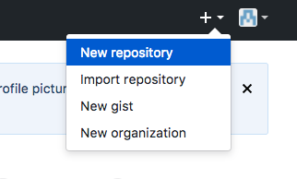

1. Create a repository on the computer (local) with the same name

$ mkdir ~/MyRepo

1. Enter the repository:

$cd ~/MyRepo

1. Define the repository as a Git repository:

$ git init

1. Generate a SSH KEY:

$ ssh-keygen -t rsa

1. In your gitHub space, add the SSH key that you have created:



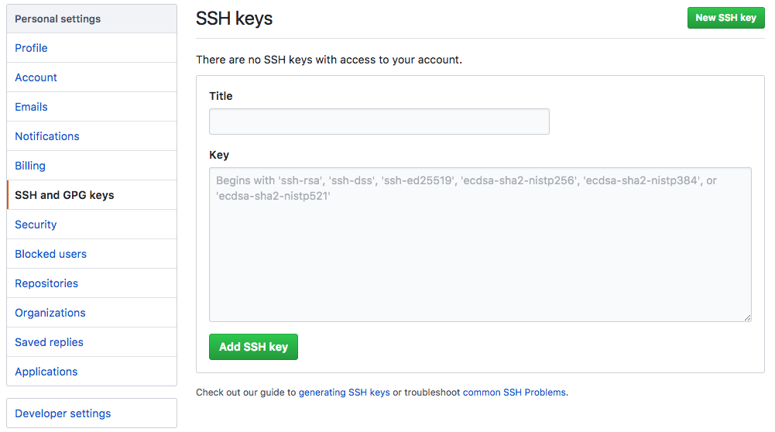

1. Add or create a file in your repository (local)

$ touch FILE

1. Tell to Git that a file was added/created in the repository:

$ git add FILE (or --all, if multiple files)

1. Record a version of the FILE with the commit command:

$ git commit -m “own message”

1. Tell to your computer where is your repository:
   1. Using HTTPS protocol (de not need to generate SSH Key)

$ git remote add origin https://github.com/USERNAME/MyRepo.git

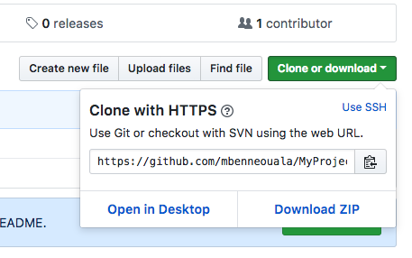

* 1. Using SSH KEY

$ git remote add origin git@github.com:USERNAME/MyRepo.git

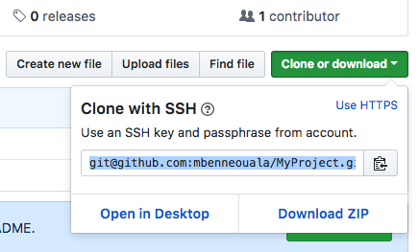

to confirm:

$ git remote -v

1. Push the FILE or modifications to GitHub.com:

$ git push (or git push --set-upstream origin master