# Internship T-Cell.tdB review

## 2019-05-27 Review

## General comments:

Please increase internal unit database to 1/10000

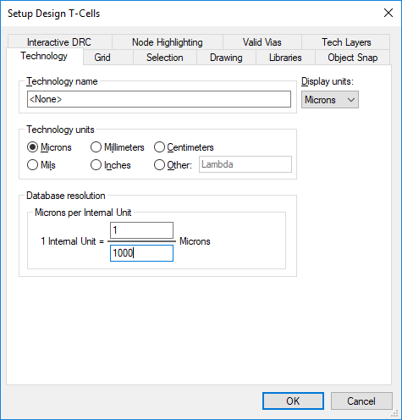

Recommendation for grid setting on WG layers

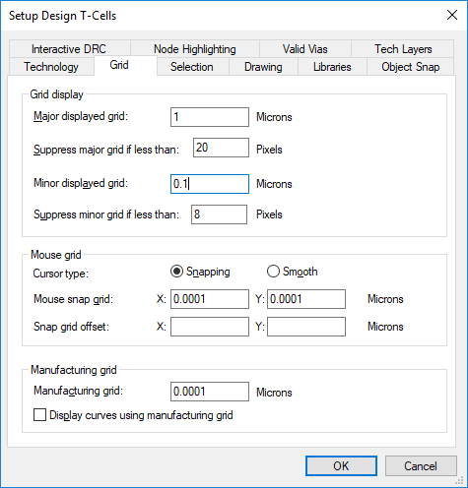

### T-Cells comments

#### Waveguide

* N/A

#### Bend

* Parameters

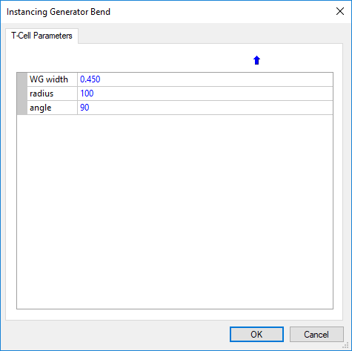

* ~~For the next version:~~
  + ~~Raster the WG layer~~
  + ~~Parameter add~~ 
    - ~~WGGROW width dimension (3µm) – not to include WG width~~
    - ~~WGOVL width dimension (10µm) – not to include WG width~~
    - ~~Overlay width dimension (1.5µm)~~
  + ~~Place origin at center of bottom waveguide~~
* ~~To investigate (with the help of Tanner):~~
  + ~~Can we change the name of the instance? (i.e Bend450_R100_A90_Raster)~~

#### S-Bend

* Parameters

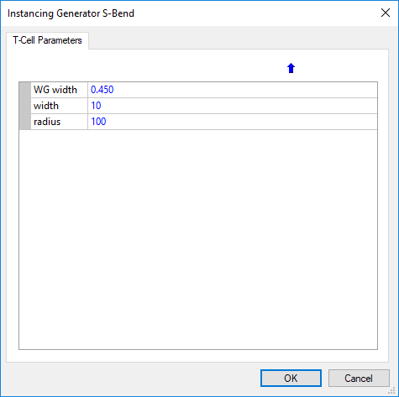

* ~~For the next version:~~
  + ~~Raster the WG layer~~
  + ~~Parameter add~~ 
    - ~~WGGROW width dimension (3µm) – not to include WG width~~
    - ~~WGOVL width dimension (10µm) – not to include WG width~~
    - ~~Overlay width dimension (1.5µm)~~
  + ~~Place origin at center of bottom waveguide~~
* ~~To investigate (with the help of Tanner):~~
  + ~~Can we change the name of the instance? (i.e. SBend450_R100_w10o0_Raster)~~
* Issues:
  + Small gaps in waveguide junction. 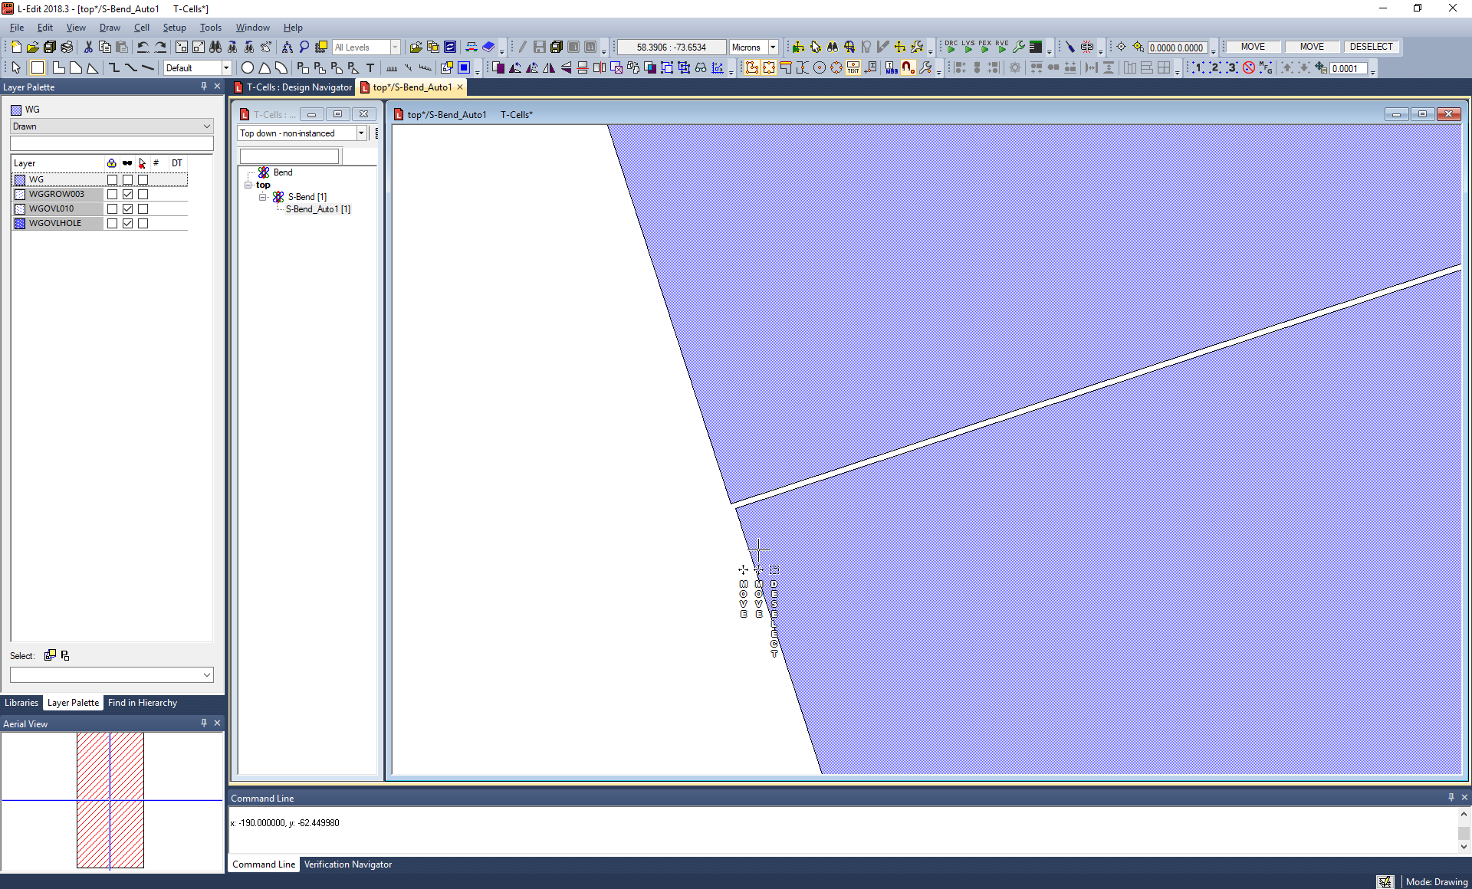
  + ~~Might not be present after raster~~

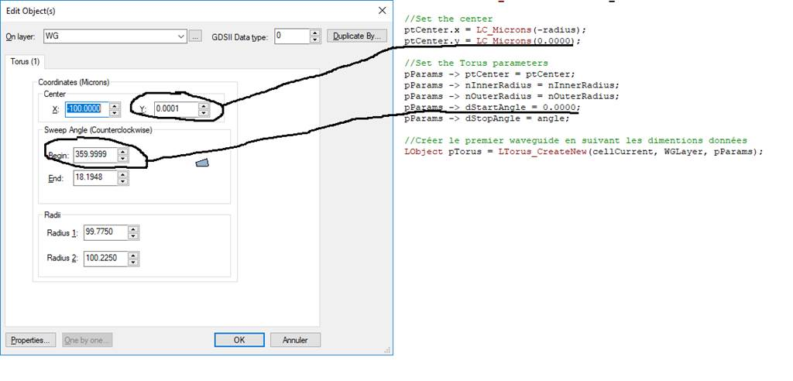

## 2019-06-06 Review

List of streuctures:

* Waveguides
* Bend
* SBend
* Tapers
* MMI

### Waveguide

* Parameters:

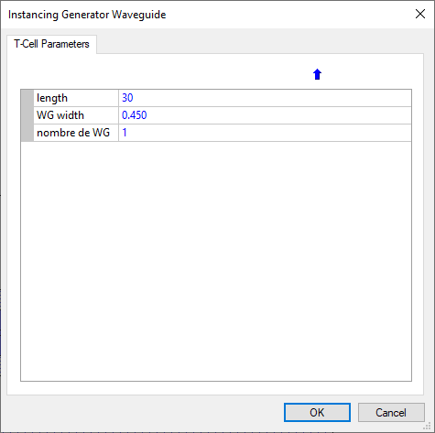

* Would also like to have WGGROW width, WGOVL width and Overlay width width parameters.
* As other structure the name should be WG(width of waveguide)_L(Length of waveguide). In this example WG0o45_L30
* The origin should be placed at center of WG on the left, 0.225 to low in this case.

### Bend

* Parameters

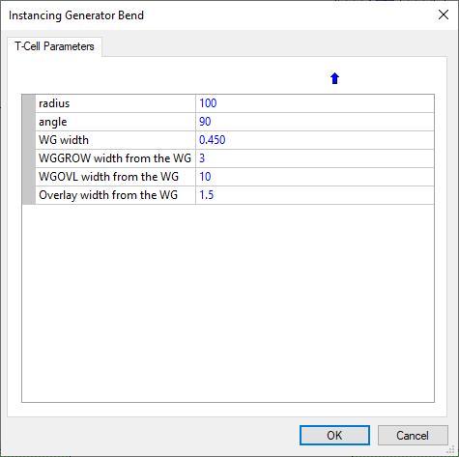

* The naming shall be Bend0o450_R100_A90_Raster (just the nanometer padding

I’m very please with the naming showing up in the cell!!! Nice work!

Also tested many instances with same parameters to look at the naming behaviour conflict. It is very nice to see that this is taking care of automatically, i.e to T-Cell with the same parameter would not be duplicated but a new instance will be created!

## S-Bend

* Parameters

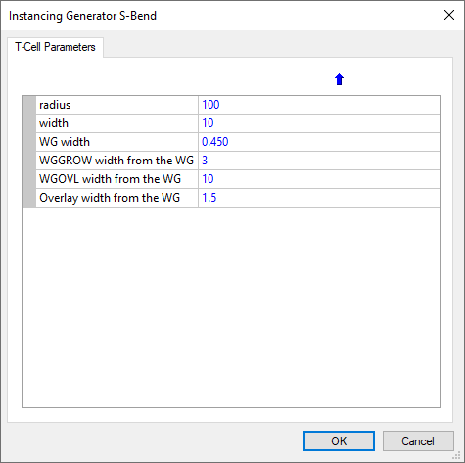

* Still the gap. Might find the condition where we need to add 0.0001 to the angle to the lower bend.

### Taper

* Parameters

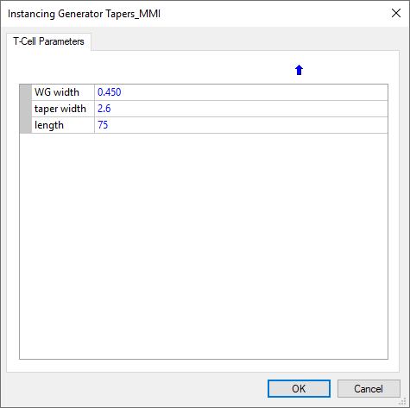

* Name of the T-Cell should not include MMI, just Tapers
* Name of instance should be Taper0o45_L75_W2o6

MMI1x2

* Parameters

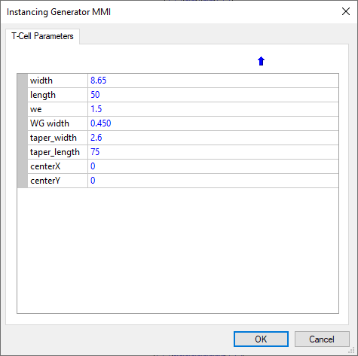

* Name of the instance: 1x2MMI0o450_W8o65_L50_We1o5
* Should try to find a solution to instantiate Taper Cell inside to not duplicate similar structure on design
* Layer modification for this particular instance:
  + WG Layer

This one is fine

* + Grow Layer
    - This one will require to adjust it to get rid of Acute

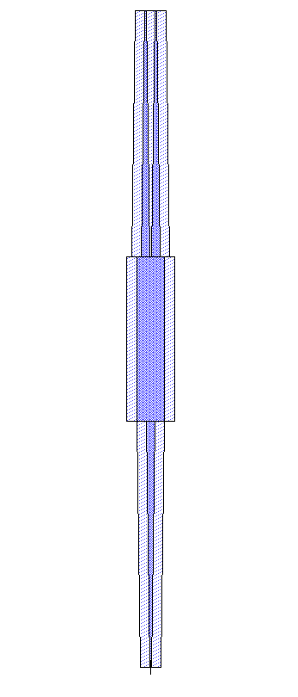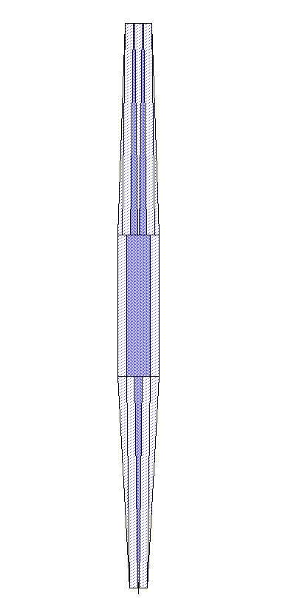

* + Overlay Layer
    - Same thing

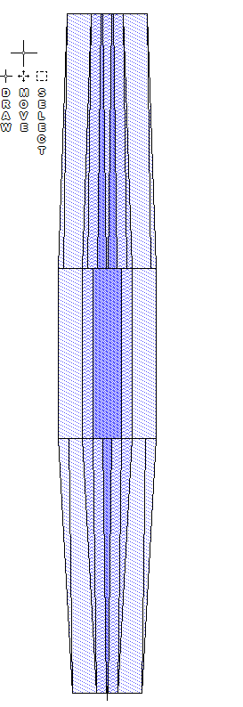

* + Overlay Hole Layer
    - This one is a bit trickier (without showing the WG layer)

