Welcome to "Neon Blast"

An asset made by Kuzkay

After importing the asset into your project make sure your tags & layers are setup propertly (See the image --> )  
  
  
  
  
  
  
  
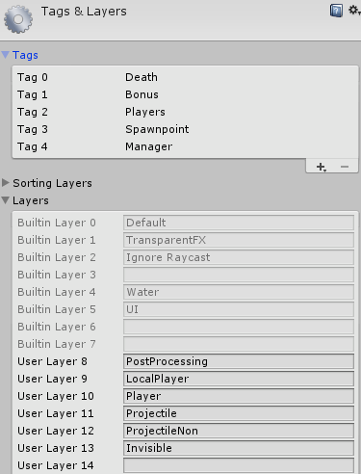  
  
  
  
  
  
How to add a new weapon:  
  
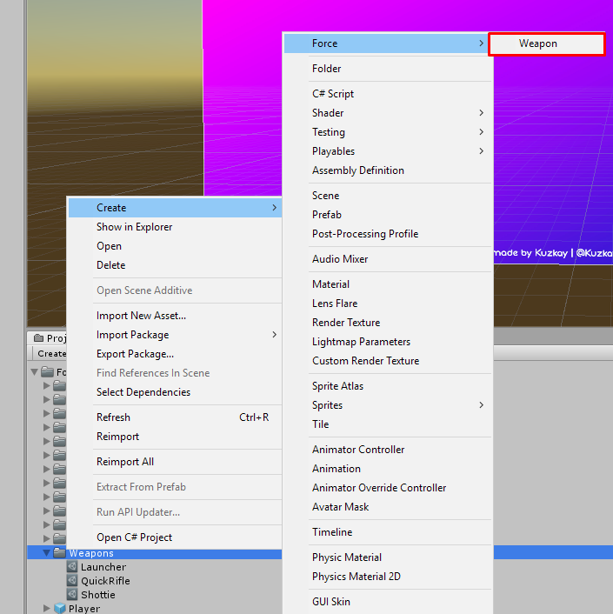

Fist add a new "Weapon" object

Then add it onto players "Shoot" script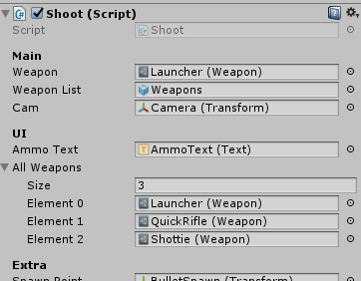

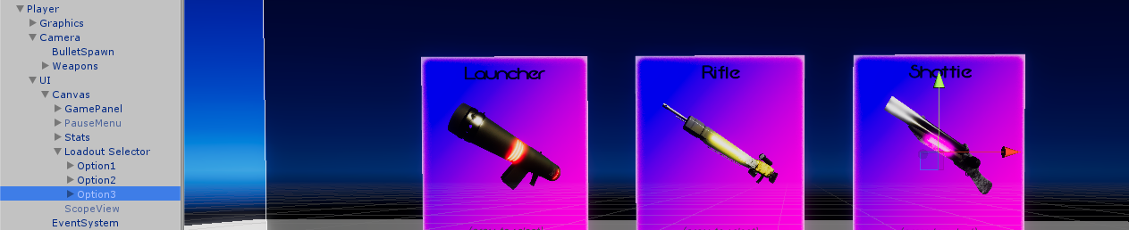

And finally add it to the player model(The order of the models is corresponding to the weapon ID's)

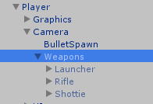

You can also change bonus spawn points, player spawnpoint, game time, points per kill and per death etc. In the "GameManager" object

