- The image file you selected for the site logo.

- Write out the four (4) color labels with the color codes you selected:
  - primary-color __0B4F6C__
  - secondary-color __A5E1F1__
  - accent1-color __FBFBFF__
  - accent2-color __ B80C09__
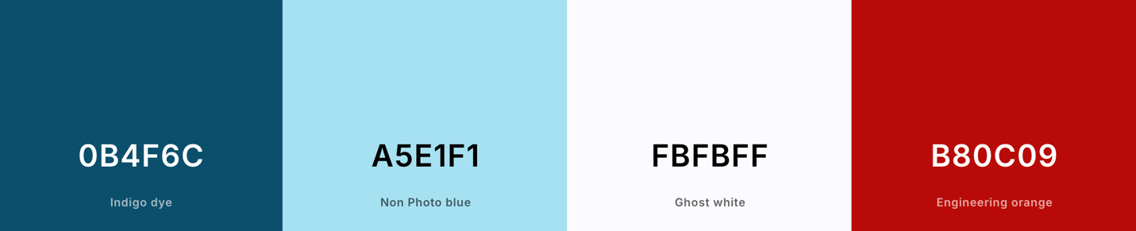
- Write out the two (2) font labels and the names of the fonts you selected:
  - heading-font __Bebas Neue__
  - text-font __Lato__
- Provide the URL link to your color palette that you designed in coolors.co
Here is an example URL link:
https://coolors.co/0b4f6c-a5e1f1-fbfbff-b80c09

