DriveShare
Peer-to-Peer Car Rental Platform
CIS 476 — Term Project Report
University of Michigan — Dearborn
Winter 2026
Submitted: April 13, 2026
Individual Submission

1. Introduction
DriveShare is a web-based peer-to-peer car rental platform that connects car owners with individuals seeking short-term vehicle rentals. Inspired by Turo.com, DriveShare enables owners to list their personal vehicles and allows renters to search, book, and pay for those vehicles directly without going through a traditional dealership or rental agency.
Built using Python (Flask) + SQLite + HTML/CSS/JavaScript, the platform implements six software design patterns as required by the course specification, each mapped to a specific feature of the application.

2. Features & Functionality

2.1 User Registration and Authentication
Users register with name, email, and password. During registration they must set three security questions with answers, used for password recovery. Passwords and security answers are stored as SHA-256 hashes. The Singleton pattern manages the session lifecycle.

2.2 Car Listing and Management
Authenticated owners list vehicles by providing make, model, year, mileage, location, pricing, availability window, description, and an image URL. The Builder pattern constructs the listing object step by step. Owners can edit all fields including updating availability, price, and delisting. The system prevents double-booking by checking date overlaps before confirming any reservation.

2.3 Search and Booking
Renters search for cars by location, date range, and maximum price per day. Leaving location blank and clicking Show All displays every available listing. The search query uses an overlap-safe SQL subquery to exclude already-booked cars for the requested dates.

2.4 Messaging and Communication
DriveShare includes a full in-app messaging system. The Mediator pattern automatically sends confirmation messages to both owner and renter on booking creation. Both parties receive in-app notifications on booking approval, payment, and status changes.

2.5 Payment
Payment is simulated using the Proxy pattern. Clicking Pay Now invokes PaymentProxy which validates, audit-logs, then delegates to RealPaymentService which deducts the renter wallet, credits the owner, marks the booking confirmed, and notifies both parties.

2.6 Rental History (Optional — Implemented)
Both owners and renters view their complete rental history. The page shows all bookings made as a renter and all bookings received as an owner, with dates, amounts, and statuses.

2.7 Reviews (Optional — Implemented)
After a confirmed (paid) rental, renters leave a star rating (1–5) and comment. Average ratings display on each car detail page. Only confirmed renters may review.

3. Design Patterns
Six design patterns are implemented in app.py. Each is described with its purpose, role mapping table, class diagram, and integration explanation.

3.1 Singleton Pattern — UserSession

Description
Ensures only one session manager object exists throughout the application lifecycle. All authentication operations route through the single UserSession instance, preventing multiple conflicting session states.

Role Mapping
Pattern role | Application class | Responsibility
Singleton class | UserSession | Manages Flask session; enforces one instance
Factory method | get_instance() | Returns the single instance; creates on first call
Managed resource | Flask session dict | Stores user_id, email, name server-side

Class Diagram
«singleton»
UserSession
– _instance : UserSession (class-level, starts None)
– session : Flask session dict
+ get_instance() : UserSession [class method]
+ login(user: dict) : void
+ logout() : void
+ is_logged_in() : bool
+ get_current_user() : dict

Execution flow:
UserSession ──────────────→ Flask session (manages)
/recover/verify route ──────────────→ UserSession.get_instance () (calls)
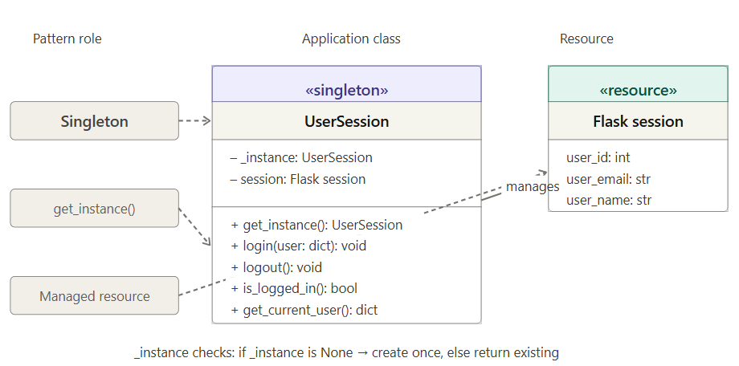

Integration
Every protected route uses the @login_required decorator which calls UserSession.get_instance().is_logged_in(). Because get_instance() always returns the same object, session state is consistent across all requests.

3.2 Observer Pattern — Watchlist Notifications

Description
Allow renters to subscribe to car listings and automatically receive in-app notifications when a price drops or a delisted car becomes available. Decouples the notification logic from the car editing logic.

Role Mapping
Pattern role | Application class | Responsibility
Subject (Observable) | CarListingSubject | Holds observer list; broadcasts state changes
Abstract Observer | RenterObserver | Declares notify() interface
Concrete Observer | WatchlistObserver | Writes notification row to DB when called
Helper / client | notify_watchers() | Loads watchers from DB, fires subject.notify_observers()

Class Diagram
«abstract observer»
RenterObserver
+ notify(car_id, event_type, message) [abstract — raises NotImplementedError]

«concrete observer»
WatchlistObserver
– renter_id : int
+ notify(car_id, event_type, message) : void [writes row to notifications table]

«subject»
CarListingSubject
– car_id : int
– _observers : list[RenterObserver]
+ attach(observer) : void
+ detach(observer) : void
+ notify_observers(event_type, message) : void

Execution flow:
CarListingSubject ──────────────→ RenterObserver (notifies via notify_observers())
WatchlistObserver ──────────────→ RenterObserver (extends (implements))
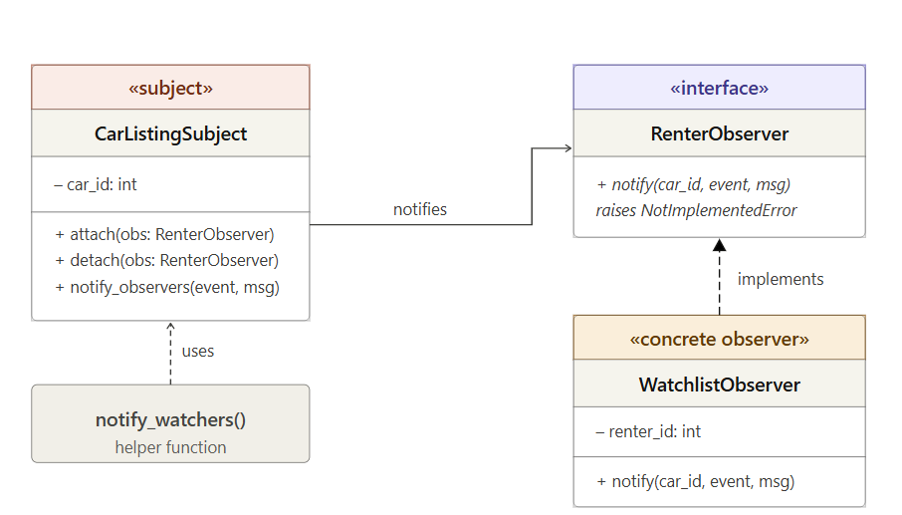

Integration
When edit_car() saves a lower price, it calls notify_watchers(car_id, 'price_drop', msg). This loads all watchlist rows for that car, creates a WatchlistObserver per renter, attaches each to a CarListingSubject, and calls notify_observers() — writing one notification row per watcher.

3.3 Mediator Pattern — DriveShareMediator

Description
Coordinates communication between Search, Booking, and Message components without them referencing each other directly. All cross-component events pass through DriveShareMediator.

Role Mapping
Pattern role | Application class | Responsibility
Abstract Mediator | UIMediator | Declares notify(sender, event, data) interface
Concrete Mediator | DriveShareMediator | Routes events; wires colleague instances
Colleague 1 | SearchComponent | Executes car search queries
Colleague 2 | BookingComponent | Creates reservations; checks overlaps
Colleague 3 | MessageComponent | Sends and persists in-app messages

Class Diagram
«interface»
UIMediator
+ notify(sender, event: str, data) : void [abstract]

«concrete mediator»
DriveShareMediator
– search : SearchComponent
– booking : BookingComponent
– messages : MessageComponent
+ notify(sender, event, data) : void [routes to correct colleague]

Colleagues (each holds self.mediator = mediator):
SearchComponent | BookingComponent | MessageComponent
execute_search(loc,start,end,price,exclude_id) | confirm_booking(data) is_car_available(car,s,e) | send_booking_confirmation(data) persist(data)

Execution flow:
DriveShareMediator ──────────────→ SearchComponent + BookingComponent + MessageComponent (coordinates)
booking_confirmed event ──────────────→ MessageComponent.send_booking_confirmation() (triggers)

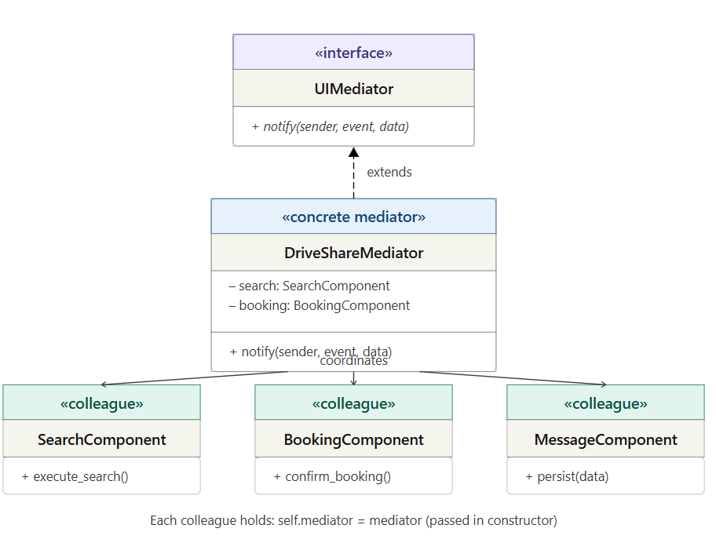

Integration
The book_car route creates DriveShareMediator, calls mediator.booking.confirm_booking(data). BookingComponent notifies the mediator with 'booking_confirmed'. The mediator then calls MessageComponent to send auto-messages to owner and renter, and calls notify_watchers() for Observer alerts.

3.4 Builder Pattern — CarListingBuilder

Description
Constructs car listing objects step-by-step using a fluent interface. Required fields are validated at build() time. Optional fields (description, image, availability) have sensible defaults.

Role Mapping
Pattern role | Application class | Responsibility
Abstract Builder | CarListingBuilder | Declares all build-step interfaces
Concrete Builder | ConcreteCarBuilder | Accumulates attributes; returns product on build()
Product | CarListing (dict) | Completed listing dict ready for DB INSERT
Director | new_car() route handler | Calls builder methods in required sequence

Class Diagram
«abstract builder»
CarListingBuilder
+ set_basic_info(make, model, year) [abstract]
+ set_mileage(mileage) [abstract]
+ set_location(location) [abstract]
+ set_price(price_per_day) [abstract]
+ set_description(desc) [abstract]
+ set_image_url(url) [abstract]
+ set_availability(start, end) [abstract]
+ build() : dict [abstract]

«concrete builder»
ConcreteCarBuilder
– _listing : dict (accumulates attributes with defaults)
+ set_basic_info() : self [fluent — returns self for chaining]
+ set_price() : self
+ set_location() : self
... (all setters return self)
+ build() : dict [validates required fields; raises ValueError if missing]

«product»
CarListing (dict)
make, model, year, mileage, location
price_per_day, description, image_url
avail_start, avail_end, owner_id, is_available

Execution flow:
new_car() route (Director) ──────────────→ ConcreteCarBuilder (calls .set_x().set_y()...build())
ConcreteCarBuilder.build() ──────────────→ CarListing dict (creates product)
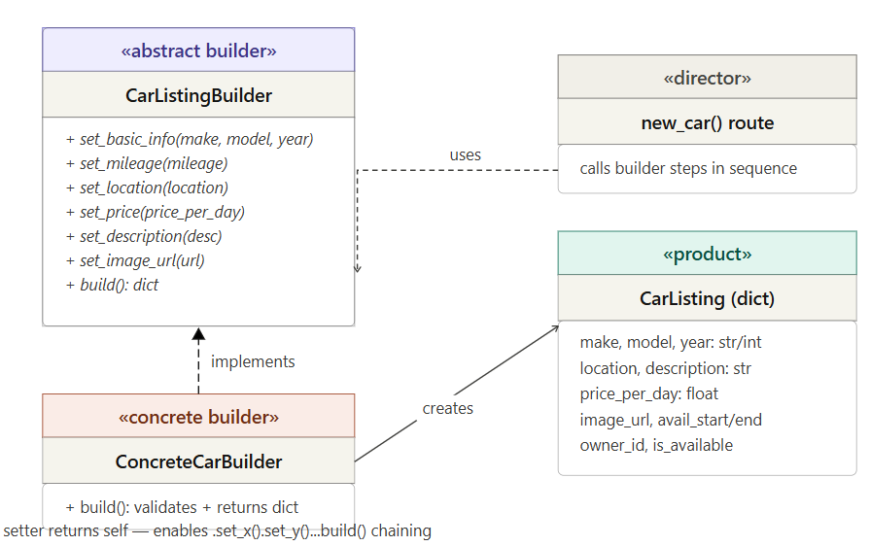

Integration
The new_car route is the Director. It constructs a ConcreteCarBuilder with the owner_id, then chains setter calls using form data, and finally calls .build() which validates all required fields. The resulting dict is passed directly to the SQLite INSERT statement.

3.5 Proxy Pattern — PaymentProxy

Description
Simulates a secure payment gateway. The Proxy intercepts payment requests, validates inputs, logs every attempt to an audit table, then delegates to RealPaymentService. Client code never calls the real service directly.

Role Mapping
Pattern role | Application class | Responsibility
Subject interface | PaymentService | Declares process_payment() interface
Real Subject | RealPaymentService | Deducts balance, credits owner, notifies both parties
Proxy | PaymentProxy | Validates input, audit-logs, delegates, updates log
Client | pay() route handler | Calls PaymentProxy only — never RealPaymentService

Class Diagram
«interface»
PaymentService
+ process_payment(user_id, amount, booking_id) : dict [abstract]

«real subject»
RealPaymentService
+ process_payment(user_id, amount, booking_id) : dict
→ deducts renter balance
→ credits owner balance
→ sets booking status = 'confirmed'
→ inserts notifications for owner + renter
→ inserts message to owner

«proxy»
PaymentProxy
– _real_service : RealPaymentService
+ process_payment(user_id, amount, booking_id) : dict
1. validate: amount > 0, booking exists
2. INSERT payment_log row (status='attempted')
3. delegate to _real_service.process_payment()
4. UPDATE payment_log status = 'success'/'failed'

Execution flow:
PaymentProxy ──────────────→ RealPaymentService (wraps (holds reference))
pay() route ──────────────→ PaymentProxy.process_payment() (calls (never calls Real directly))
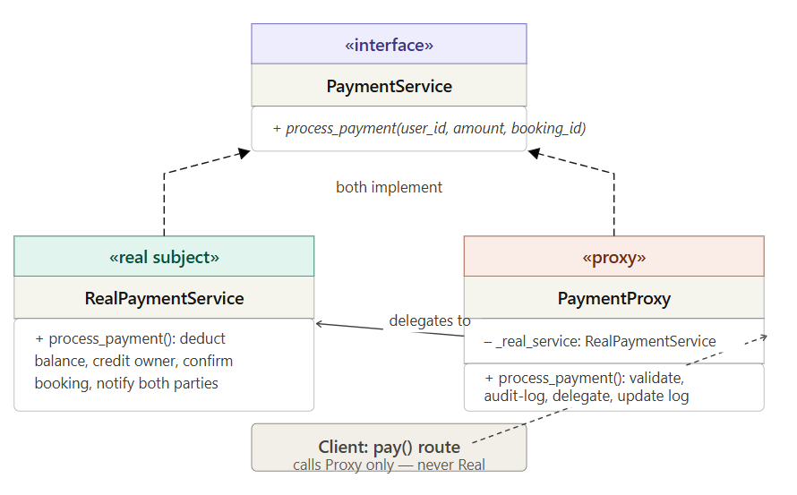

Integration
The pay() route calls PaymentProxy().process_payment(). The proxy validates, logs the attempt, then calls self._real_service.process_payment(). After the real service runs, the proxy updates the audit log with the final status. The payment_log table provides a complete audit trail of every payment attempt.

3.6 Chain of Responsibility — Password Recovery

Description
Implements a three-step identity verification process for password recovery. Each handler checks one security question answer. All three must pass before a password reset is allowed. If any answer is wrong, the chain stops immediately with an error.

Role Mapping
Pattern role | Application class | Responsibility
Abstract Handler | SecurityQuestionHandler | Base class; provides set_next() and default handle()
Concrete Handler 1 | Question1Handler | Validates SHA-256 hash of security answer 1
Concrete Handler 2 | Question2Handler | Validates SHA-256 hash of security answer 2
Concrete Handler 3 | Question3Handler | Validates SHA-256 hash of security answer 3
Assembly function | build_recovery_chain() | Builds chain: Q1.set_next(Q2).set_next(Q3)
Client | /recover/verify route | Calls chain.handle(user, answers) on chain head

Class Diagram
«abstract handler»
SecurityQuestionHandler
– _next : SecurityQuestionHandler (reference to next link)
+ set_next(handler) : handler [links chain; returns handler for chaining]
+ handle(user, answers) : dict [if _next exists, calls _next.handle(); else returns success]

«concrete handler»
Question1Handler / Question2Handler / Question3Handler
+ handle(user, answers) : dict
given = hash_password(answers['answer_N'].strip().lower())
if given != user['security_answer_N']: return {'success': False, 'message': '...'}
return super().handle(user, answers) # pass to next handler

Execution flow:
build_recovery_chain() → Q1 ──(set_next)──→ Q2 ──(set_next)──→ Q3
/recover/verify calls: chain.handle(user, {'answer1':..., 'answer2':..., 'answer3':...})
Q1.handle() → correct? → Q2.handle() → correct? → Q3.handle() → correct? → success
wrong? → {success:False} wrong? → {success:False} wrong? → {success:False}
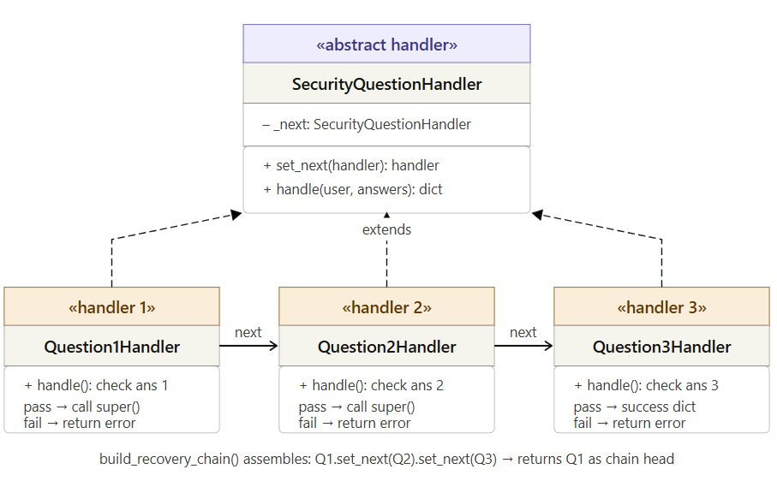

Integration
The /recover/verify route calls build_recovery_chain() which creates Q1, Q2, Q3 and links them. The route then calls chain.handle(dict(user), request.form). Each handler lowercases and hashes the submitted answer, compares to the stored hash, and either returns an error dict (stopping the chain) or calls super().handle() to continue. If all three pass, the base class returns {'success': True} and the session flag can_reset_password is set, enabling the password reset form.

4. Database Schema
DriveShare uses SQLite 3 (built into Python). The database file is created automatically on first run at instance/driveshare.db. All tables use INTEGER PRIMARY KEY AUTOINCREMENT. Foreign key constraints are enforced via PRAGMA foreign_keys = ON.

4.1 users
Column | Type | Description
id | INTEGER PK | Auto-increment primary key
name | TEXT | Full name of user
email | TEXT UNIQUE | Login email — stored lowercase
password | TEXT | SHA-256 hash of password
security_q1/2/3 | TEXT | Security question text (3 questions)
security_answer1/2/3 | TEXT | SHA-256 hash of lowercased answer
balance | REAL | Demo wallet balance (default $500.00)

4.2 cars
Column | Type | Description
id | INTEGER PK | Auto-increment primary key
owner_id | INTEGER FK | References users(id)
make / model / year | TEXT / INT | Vehicle identification
mileage | INTEGER | Current odometer reading
location | TEXT | City and state for pick-up
price_per_day | REAL | Daily rental rate in USD
description | TEXT | Optional owner-written description
image_url | TEXT | URL to car photo
avail_start / avail_end | DATE | Owner-defined availability window
is_available | INTEGER | 1 = listed; 0 = delisted by owner

4.3 bookings
Column | Type | Description
id | INTEGER PK | Auto-increment primary key
car_id | INTEGER FK | References cars(id)
renter_id | INTEGER FK | References users(id)
start_date / end_date | DATE | Reservation period
total_price | REAL | days × price_per_day
status | TEXT | pending / approved / confirmed / cancelled

4.4 Supporting Tables
Table | Purpose
watchlist | Observer subscriptions — (renter, car) pair; stores optional max_price threshold
notifications | In-app alerts written by WatchlistObserver and payment/booking events
messages | User-to-user messages written by MessageComponent (Mediator) and payment flow
reviews | Post-rental ratings (1–5 stars) and comments; only confirmed renters may submit
payment_log | Proxy audit trail — every payment attempt logged with status: attempted/success/failed

5. User Interface
DriveShare uses a dark automotive theme. Colors: near-black backgrounds (#0a0a0a), cream-white text (#f5f0e8), rust-red accents (C94B2A), amber highlights (#E8A020). Typography: Bebas Neue for display headings, Sora for body text.

5.1 Home Page (/)
Home section with quick search bar. Featured cars shown in a responsive grid. Cars owned by the logged-in user are excluded. Navigation bar: Browse Cars, Search, Log In, Messages, Sign Up.
Screenshot:
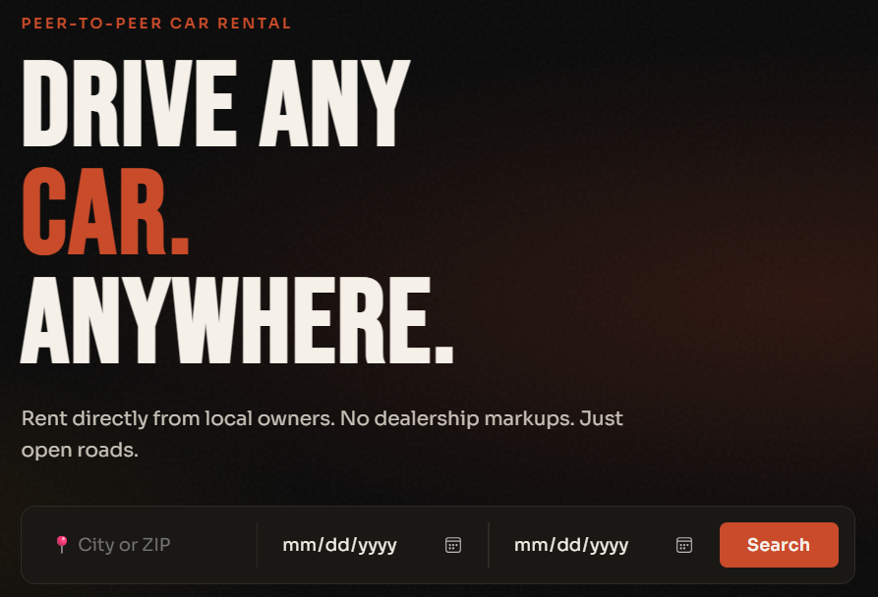
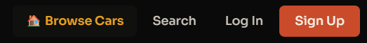

5.2 Search Page (/search)
Location (optional), dates (optional), max price (optional). Show All buttons return all available listings. Results exclude cars booked for the requested dates via overlap-safe SQL.
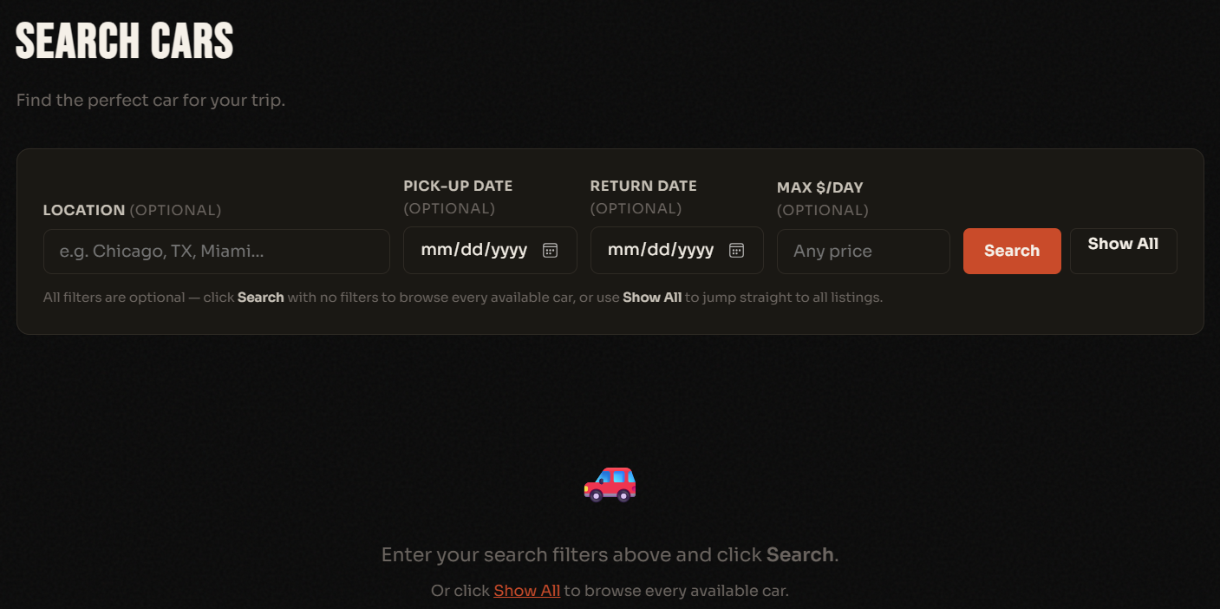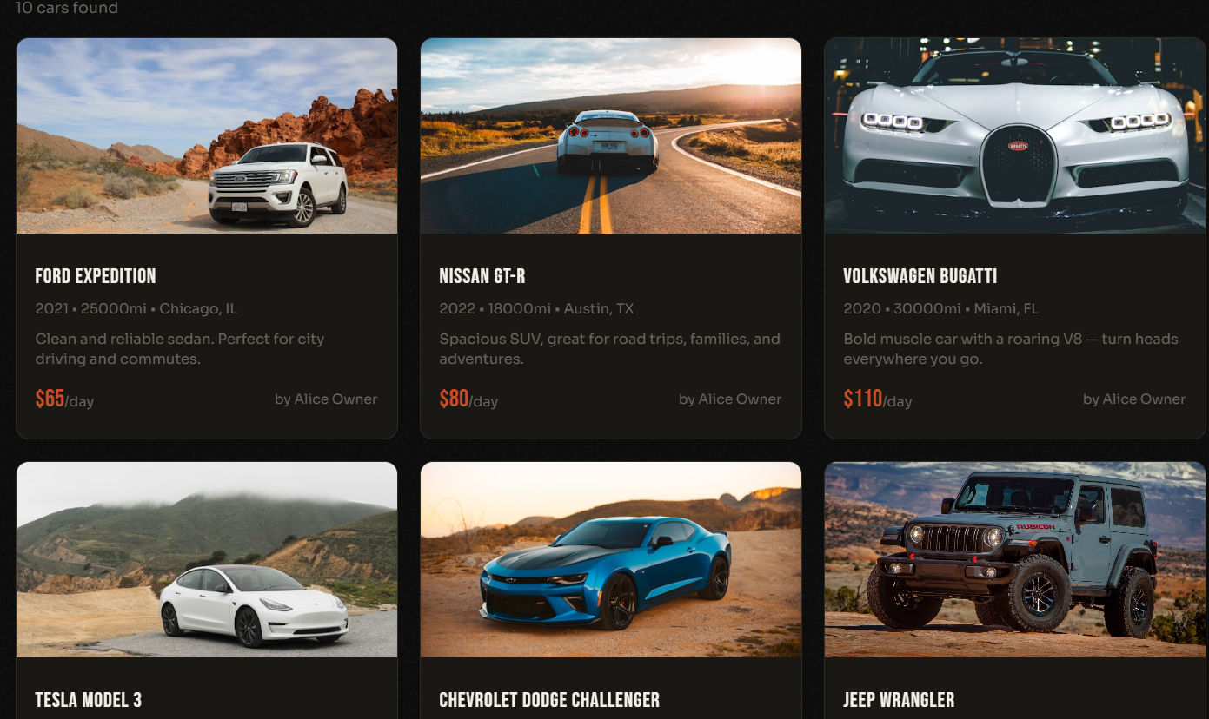

5.3 Car Detail Page (/cars/<id>)
Car photo, make/model/year, location/owner, mileage, availability, description, and reviews. Logged-in non-owners see a booking form, Watch button with price threshold input, a message-owner form and a comments section. Reviews with star ratings displayed below.
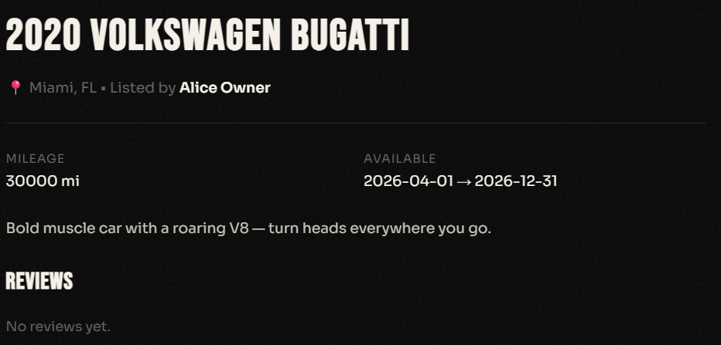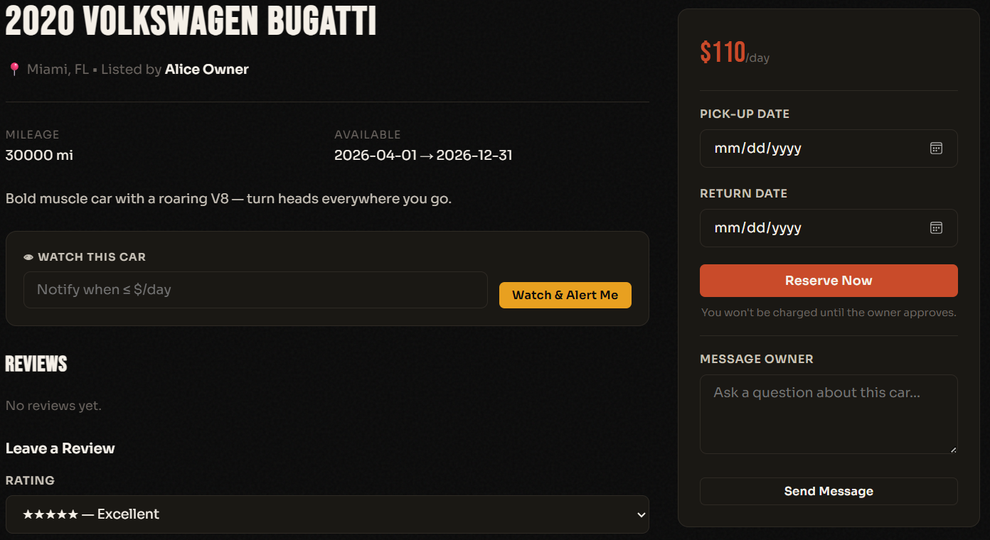

5.4 Dashboard (/dashboard)
Four visually distinct sections: My Cars, My Bookings, Incoming Requests, Notifications, and Messages. Wallet balance loaded fresh from DB each visit.
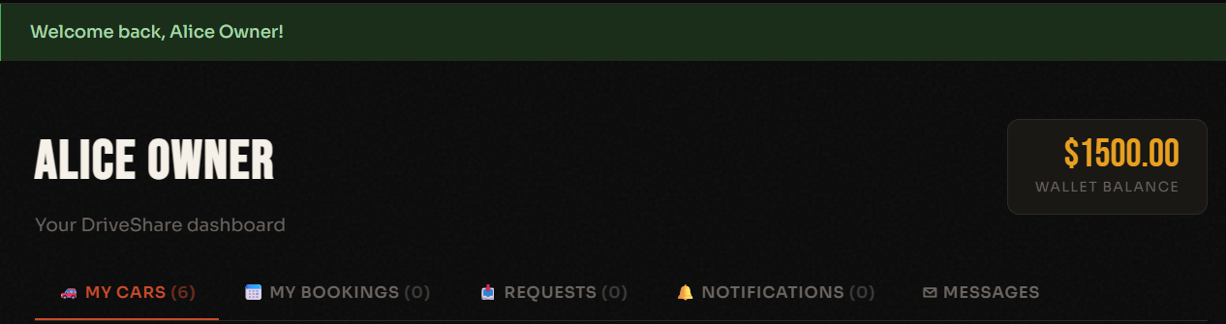

5.5 Registration, Login, Password Recovery
Registration: name, email, password, and three security question/answer pairs. Login: email and password. Recovery: enter email → answer all three questions (Chain of Responsibility) → reset password.
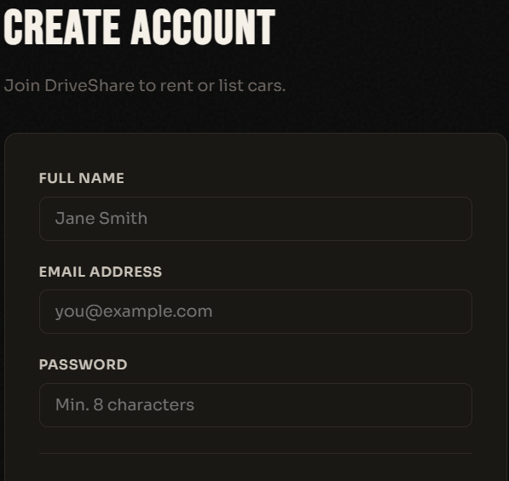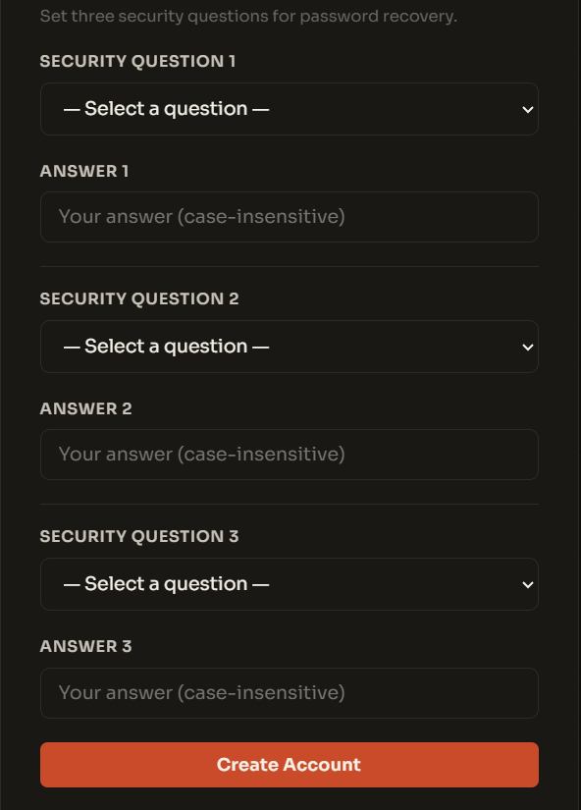
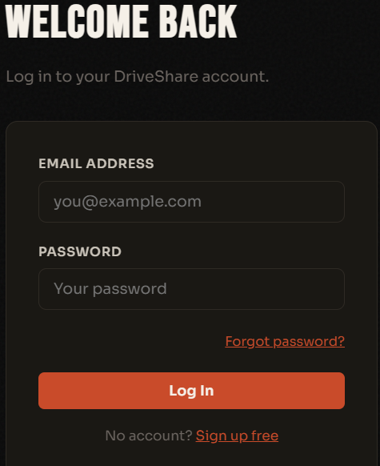
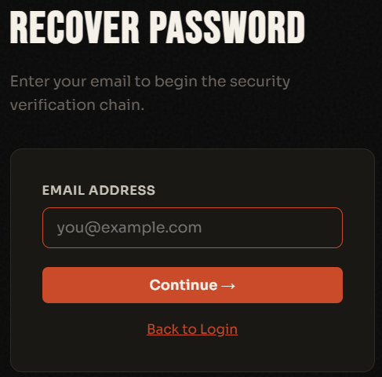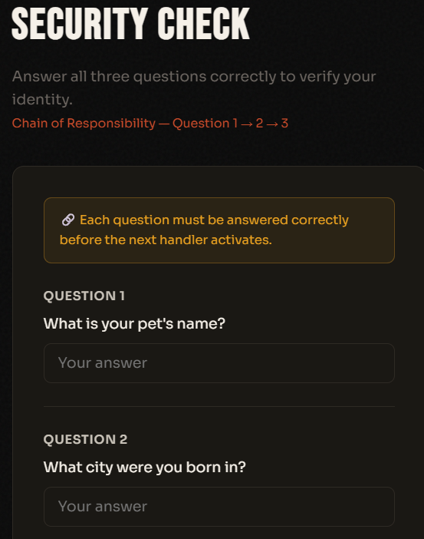

5.6 Messages (messages)
Sent and received messages in conversation view. Compose panel uses a name dropdown. Quick Reply buttons pre-fill the recipient for fast responses.
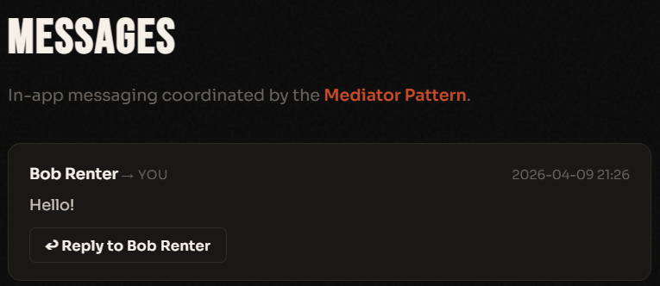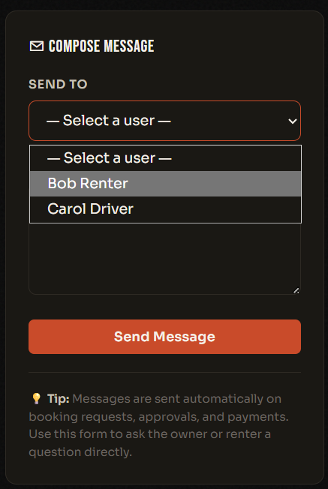

5.7 Rental History (/history)
Two sections: Cars I've Rented (as renter) and Rentals of My Cars (as owner). Each row shows car, dates, status badge, and total amount.
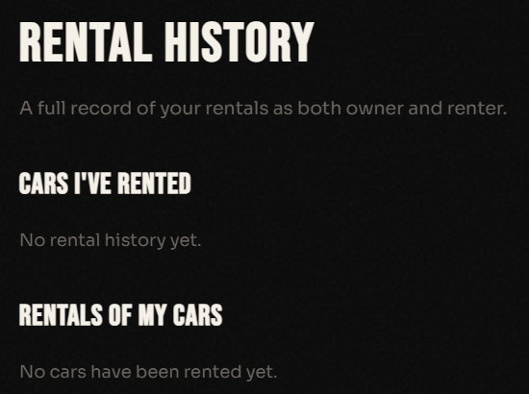
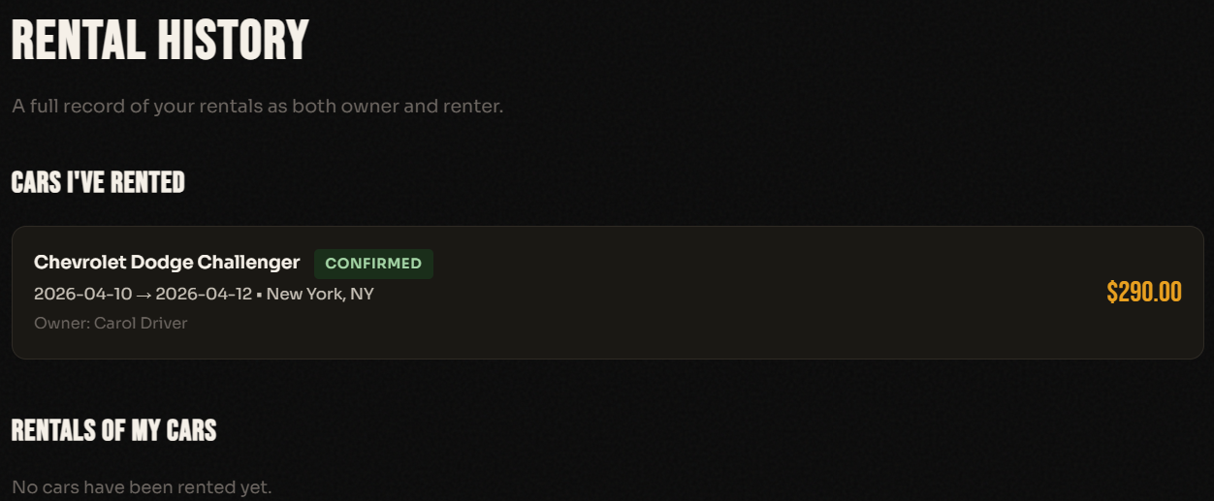

5.8 Listing Car Page Two sections: Basic Info (make, model, year, mileage) and Listing Details (location, price per day, description, image URL, and availability dates). 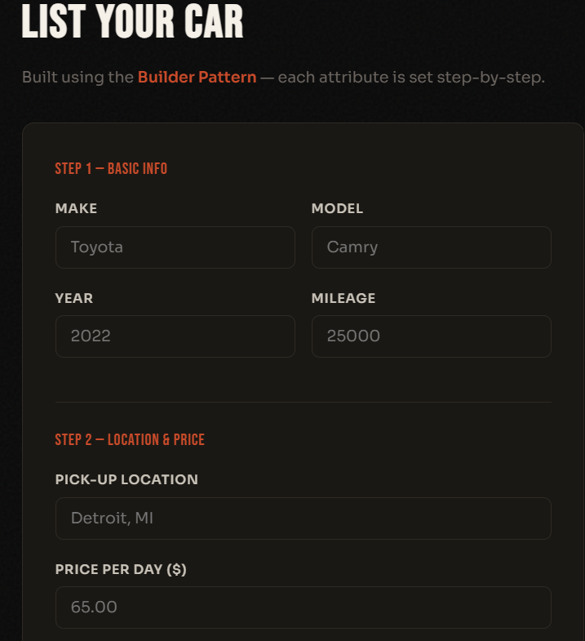

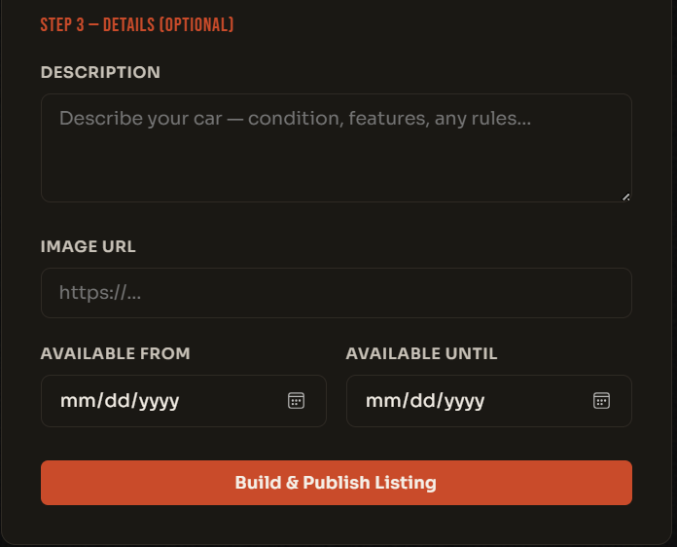

6. Technology Stack
Layer | Technology | Role
Backend | Python 3.11 + Flask 3.x | HTTP routing, session management, DB queries
Database | SQLite 3 (built-in) | Persistent storage — zero configuration
Frontend | HTML5 / CSS3 / Vanilla JS | Jinja2 templates rendered server-side
Typography | Google Fonts (Bebas Neue, Sora) | Display and body typefaces
Security | SHA-256 (hashlib) | Password and security answer hashing
IDE / Tools | VS Code, Git Bash | Development environment

7. References
- Gamma, E., Helm, R., Johnson, R., & Vlissides, J. (1994). Design Patterns: Elements of Reusable Object-Oriented Software. Addison-Wesley.
- Flask Documentation. (2024). Retrieved from https://flask.palletsprojects.com
- Python Software Foundation. (2024). Python 3.11 Documentation. Retrieved from https://docs.python.org
- SQLite Documentation. (2024). Retrieved from https://www.sqlite.org/docs.html
- Turo.com — Reference platform for peer-to-peer car rental UX. Retrieved from https://turo.com
- Unsplash. (2024). Free high-resolution car photography. Retrieved from https://unsplash.com
- Google Fonts. (2024). Bebas Neue and Sora typefaces. Retrieved from https://fonts.google.com

