Weather App
CIS 436 – Mobile Application Development
University of Michigan – Dearborn
Professor: John P. Baugh
Developed by: Michael Berry

1. Application Overview
The Weather App is a mobile Android application developed in Kotlin that allows users to search for real-time weather conditions for any city in the world. The app uses the OpenWeatherMap API to retrieve live weather data and displays it in a clean, easy-to-read interface.
The application demonstrates key mobile development concepts including RESTful API integration, Jetpack ViewModel and LiveData for state management, a multi-fragment UI architecture, and proper orientation change handling.

2. Features
- Search for weather by city name from anywhere in the world
- Displays current temperature, weather description, and weather icon
- Shows detailed weather data including humidity, wind speed, feels like temperature, pressure, visibility, and daily high/low
- Toggle between Fahrenheit and Celsius with a single button tap
- Weather data is retained across device orientation changes using ViewModel
- Error handling for invalid city names or network issues
- Clean, blue-themed UI with weather icons loaded from OpenWeatherMap
- Loading indicator shown while weather data is being fetched

3. Technical Implementation

3.1 Architecture
The app follows a clean two-fragment architecture with a shared ViewModel:
Component | Description
MainActivity | Host activity that loads both fragments into the layout
TopFragment | Contains the search bar, city input field, and the °F/°C toggle button. Handles API calls to OpenWeatherMap using Volley
BottomFragment | Displays all weather information including the weather icon, temperature, description, and detailed stats in a scrollable grid layout
WeatherViewModel | Jetpack ViewModel that holds weather data, loading state, error messages, last searched city, and unit preference across orientation changes using LiveData
WeatherData | Kotlin data class representing a weather response from the API

3.2 Libraries and Technologies
- Kotlin – Primary programming language
- Jetpack ViewModel + LiveData – State management and UI updates
- Volley – HTTP networking library for API calls
- Glide – Image loading library for weather icons
- OpenWeatherMap API – Real-time weather data source
- AGP 9.0.0 / Gradle 9.1.0 – Build tools

3.3 Jetpack Requirements Met
- ViewModel – WeatherViewModel stores all data across rotation
- LiveData – weatherData, isLoading, errorMessage, lastCity, and isFahrenheit are all LiveData objects observed by both fragments
- Fragment – TopFragment and BottomFragment share state through the ViewModel
- activityViewModels() – Both fragments share the same ViewModel instance via the activity scope

4. How to Use the App
1. Launch the app – The app opens showing the search bar at the top and a placeholder message in the bottom section
2. Enter a city name – Type any city name into the search field (e.g., Detroit, London, Tokyo)
3. Tap Search or press Enter – The app fetches weather data from OpenWeatherMap
4. View weather info – The bottom section displays the weather icon, temperature, description, high/low, humidity, wind speed, feels like, pressure, and visibility
5. Toggle units – Tap the °F button in the top right to switch between Fahrenheit and Celsius instantly without re-fetching
6. Search another city – Type a new city name and tap Search to update the display
7. Rotate device – All weather data and unit preference are retained when rotating between portrait and landscape

5. Screenshots
The following screenshots show the app in action across different states and orientations.

5.1 TopFragment – Search Bar

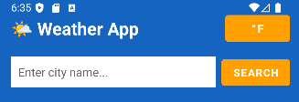

5.2 BottomFragment – Weather Results (Portrait)

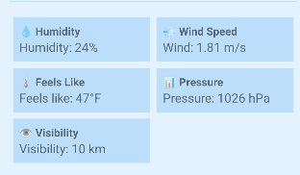

5.3 Weather Results in Fahrenheit

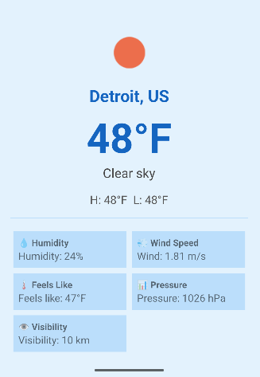

5.4 Landscape Mode

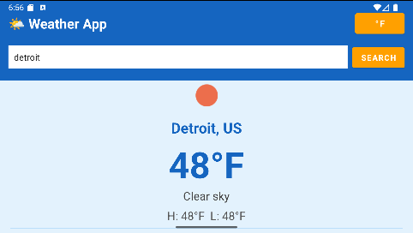

5.5 Error Handling
