GEG 238 Final Project Development Log

Issues:
- arcpy.analysis.Clip failed with every feature layer that I attempted to clip, I replaced it with arcpy.analysis.PairwiseClip and the issue was resolved.
- I was unable to save to the default .gdb, I even deleted all the files and verified overwrite output was enabled in the code but I still could not save it there. I had to create a new .gdb and the issue was resolved.
Changes:
This first version of the tool used file paths for the DEM, pour point, and optional layers inputs and the buffer was predefined. I then replaces that with arcpy parameters:
# INPUTS
input_dem = r"C:\student\Final_project\Data\waimea_dem.tif"
input_pour_point = r"C:\student\Final_project\Data\pour_point.shp"
buffer_distance = "500 Meters"
# Optional layers
optional_layers = r"C:\student\Final_project\Data\roads.shp;C:\student\Final_project\Data\parcels.shp"
output_gdb = r"C:\student\Final_project\Final Project.gdb"

I then used arcpy parameters:
# Inputs as ARCGIS Parameters
input_dem = arcpy.GetParameterAsText(0)
input_pour_point = arcpy.GetParameterAsText(1)
# Buffer distance parameter
buffer_distance = arcpy.GetParameterAsText(2)
# Optional additional layers: roads, parcels, etc.
optional_layers = arcpy.GetParameterAsText(3)
# Output geodatabase
output_gdb = arcpy.GetParameterAsText(4)

ArcGIS Pro Tool parameter settings:
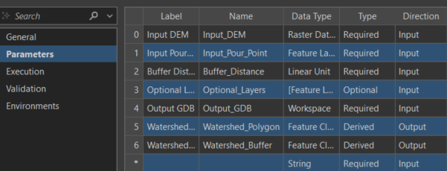
On the first version of the tool I only had two optional parameters to input additional feature layers:
if input_roads != "":
arcpy.analysis.PairwiseClip(
input_roads,
watershed_polygon_output,
roads_clip_output
)
# Step 9: Clip parcels only if there is input
if input_parcels != "":
arcpy.analysis.PairwiseClip(
input_parcels,
watershed_polygon_output,
parcels_clip_output
)

I thought it would make more sense to have a single parameter that accepts multiple feature layers. I accomplished this by creating a for loop to iterate the optional inputs and clip them to the watershed polygon. The split method is used to convert parameter inputs into a list so the loop can clip each layer one at a time.
if optional_layers != "":
layers = optional_layers.split(";")
for layer in layers:
layer_name = arcpy.Describe(layer).baseName
clip_output = output_gdb + "\\" + layer_name + "_Clip"
arcpy.analysis.PairwiseClip(
layer,
watershed_polygon_output,
clip_output
)

