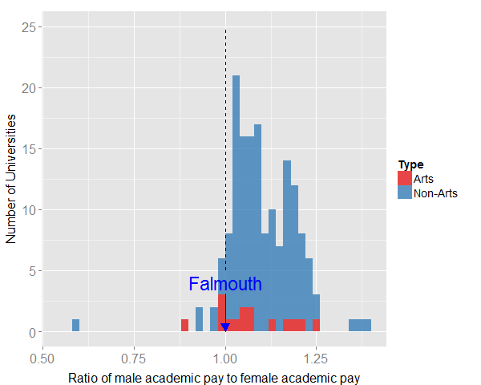

Figure 1: Plot showing the distribution of average male academic pay to average female academic pay across all UK universities. A ratio greater than one imples that the average pay of male academics at an institution is higher than that of female academics. Pay parity imples a ratio of 1, as indicated by the dashed line. The ratio is greater than one in 149 out of 160 surveyed institutions. At Falmouth University the ratio is 1.0 for this worker group, which puts Falmouth in the top 5 UK universities in terms of pay parity for this group.