PostMan screenshots for scenarios as follows:

1. **Create a To-Do**

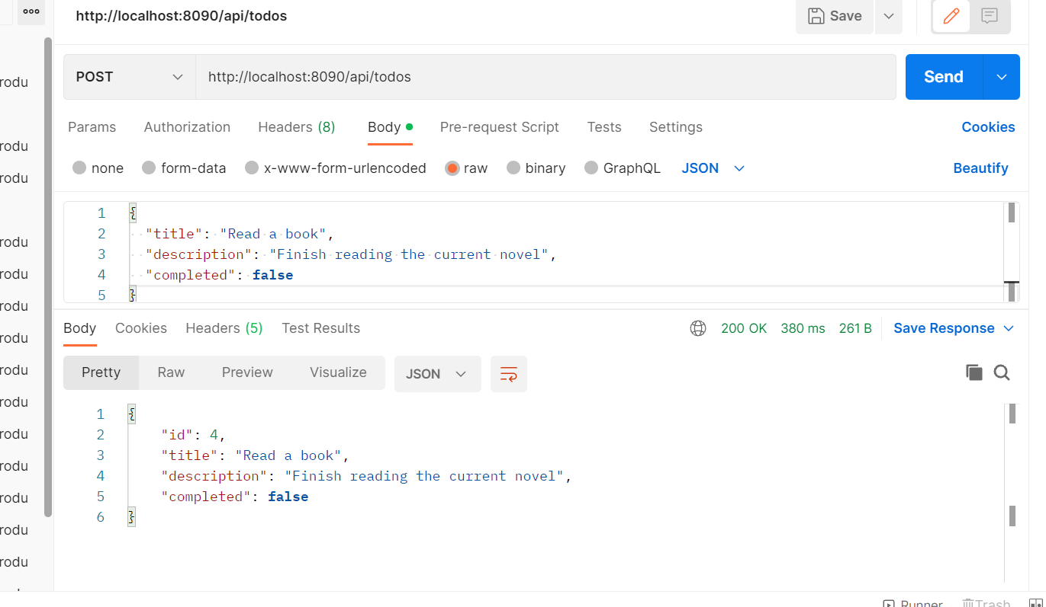

1. **Get All-Todo**

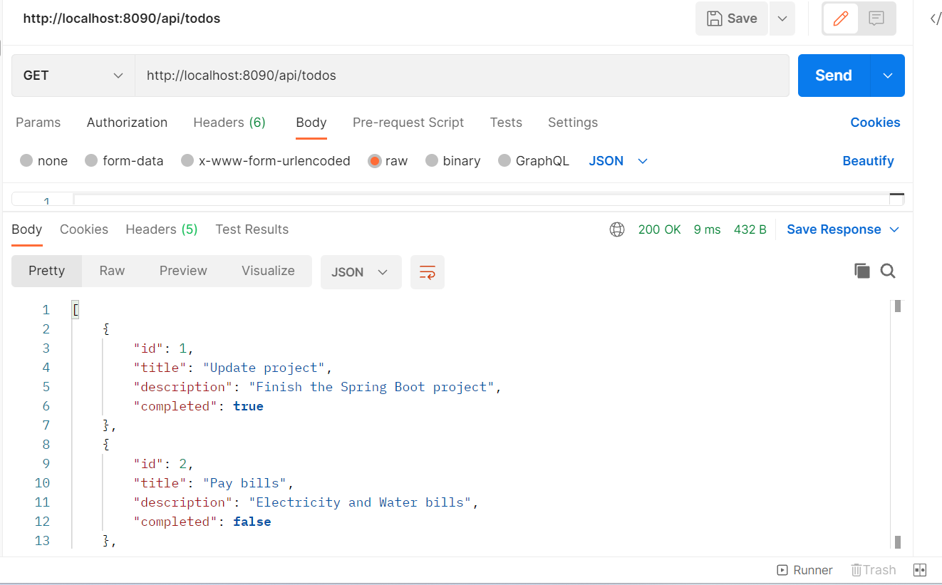

1. **Get a To-do By Id**

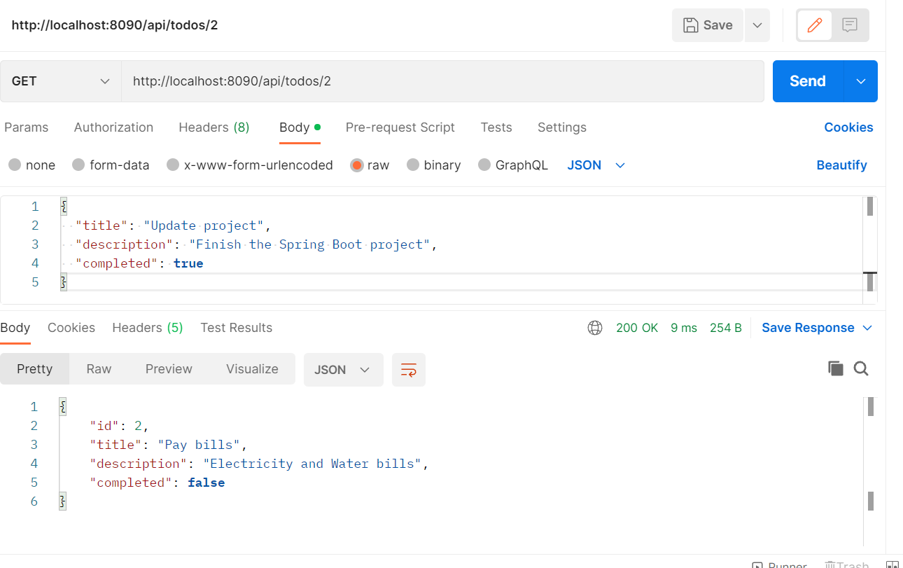

1. **Update a To-Do**

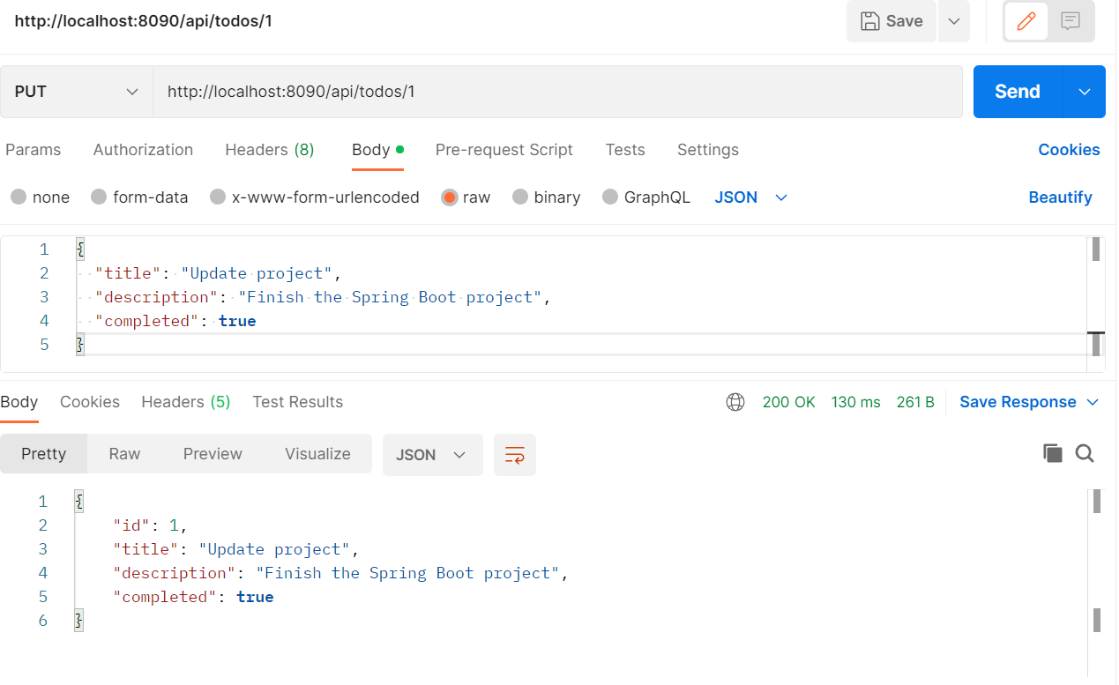

1. **Delete a to-do By Id**

Demonstration:

Currently we have 3 todos

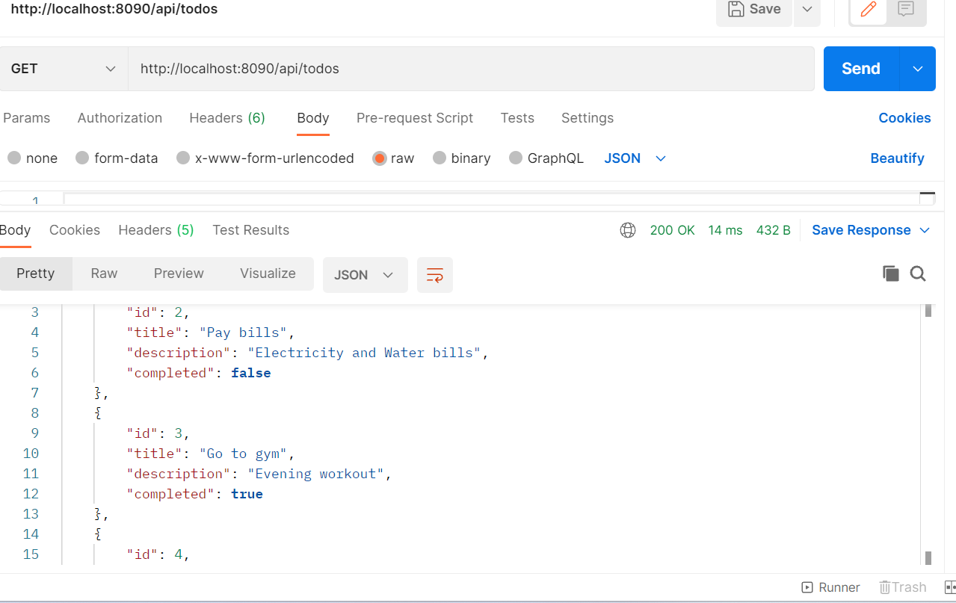

Delete request executed response below:

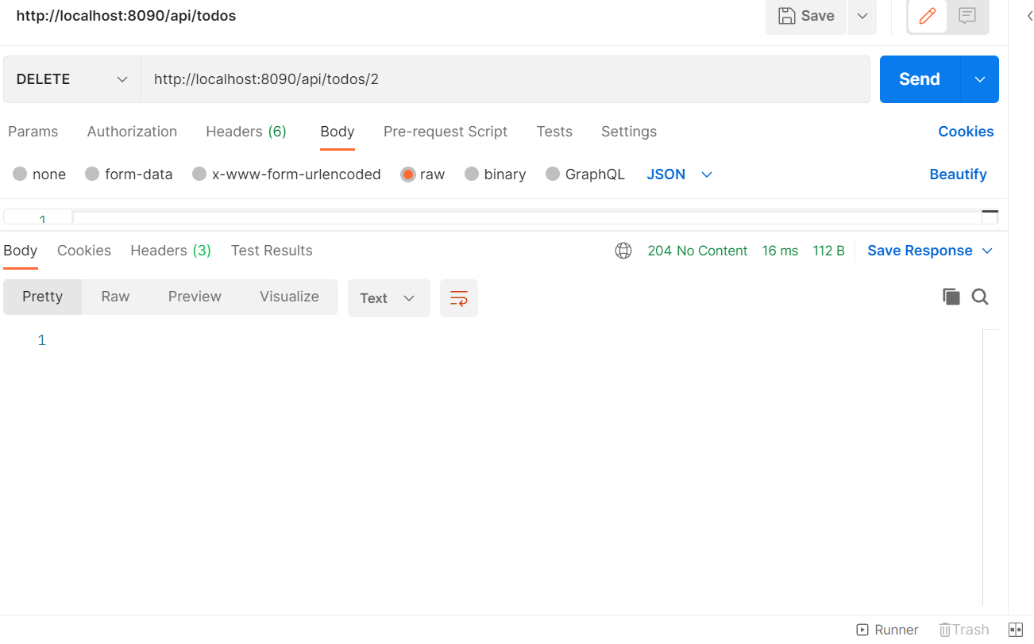

Get all to-dos response now after the above delete

