**RDBMS & Database**

**1) SELECT DISTINCT Job FROM employee**

Ans=> SELECT DISTINCT Job FROM employee

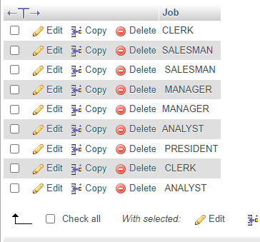

**2) List the details of the emps in asc order of the Dptnos and desc of Jobs?**

Ans => select * from employee order by deptno asc,job desc; 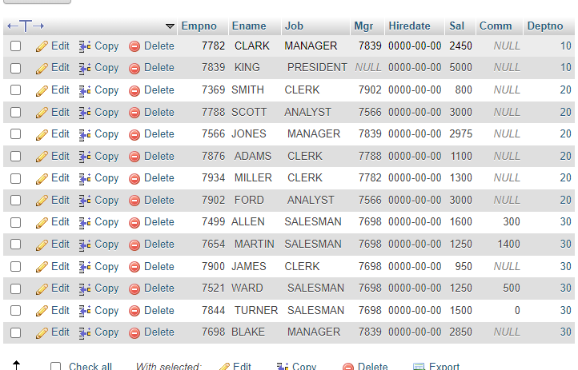

1. **Display all the unique job groups in the descending order?**

Ans=> select distinct job from employee order by job desc;

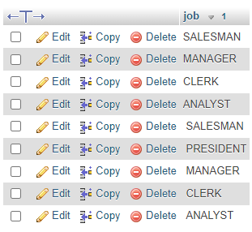

1. **List the emps who joined before 1981**

**Ans=>** SELECT * FROM employee WHERE hiredate < '1981-01-01';

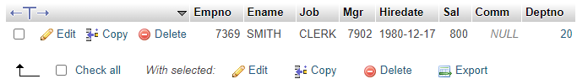

1. **List the Empno, Ename, Sal, Daily sal of all emps in the asc order of Annsal**

**Ans=>** SELECT Empno, Ename, Sal, Sal/365 AS "Daily sal"

FROM employee ORDER BY Sal ASC;

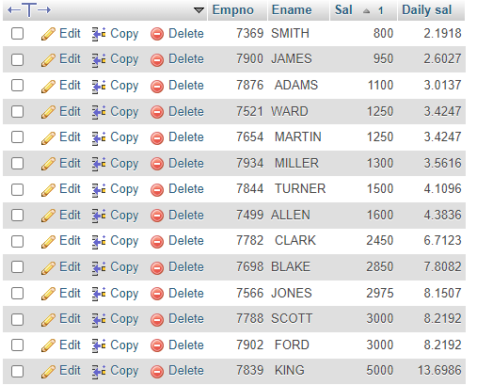

1. **List the Empno, Ename, Sal, Exp of all emps working for Mgr 7369.**

**Ans=>**

1. **Display all the details of the emps who’s Comm. Is more than their Sal?**

**Ans**=> SELECT * FROM employee WHERE Comm > Sal;

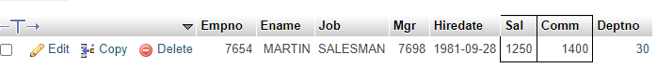

**8)** **List the emps who are either ‘CLERK’ or ‘ANALYST’ in the Desc order**

**Ans=>** SELECT * FROM employee

WHERE job IN ('CLERK', 'ANALYST')

ORDER BY job DESC;

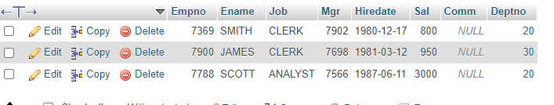

**9) List the emps Who Annual sal ranging from 22000 and 45000.**

**Ans=>** select * from employee where 12*sal between 22000 and 45000;

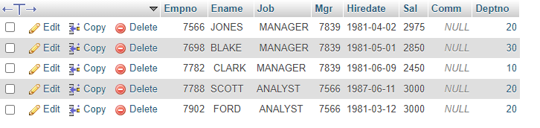

**10) List the Enames those are starting with ‘S’ and with five characters**

**Ans=>** SELECT Ename FROM employee

WHERE Ename LIKE 'S____';

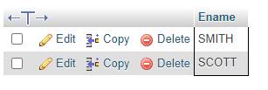

11) **List the emps whose Empno not starting with digit78.**

Ans=> SELECT * FROM employee

WHERE Empno NOT LIKE '78%';

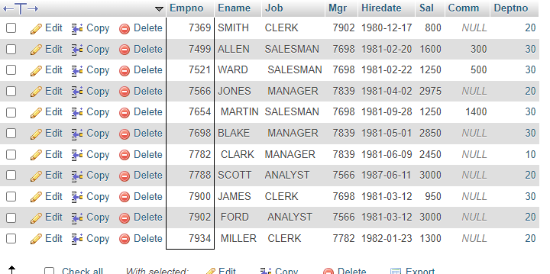

**12) List all the Clerks of Deptno 20.**

**Ans=>** SELECT * FROM employee

WHERE job = 'CLERK' AND Deptno = 20;

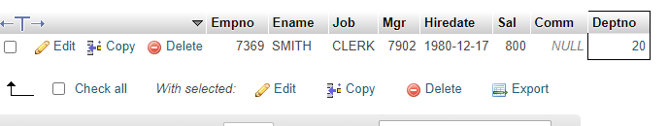

**13) List the Emps who are senior to their own MGRS.**

Ans=> select * from employee w,employee m where w.mgr = m.empno and w.hiredate < m.hiredate ;

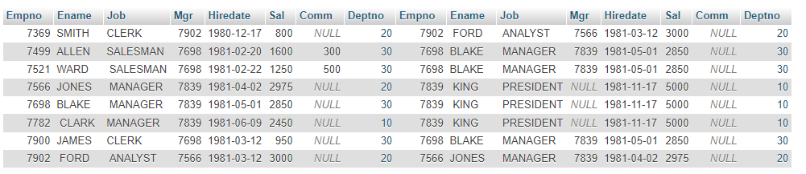

**14) List the Emps of Deptno 20 who’s Jobs are same as Deptno10.**

**Ans=>** SELECT e1.ename AS EmpName, e1.job AS Job, e2.ename AS EmpName, e2.job AS Job

FROM employee e1

JOIN employee e2 ON e1.job = e2.job

WHERE e1.deptno = 20 AND e2.deptno = 10;

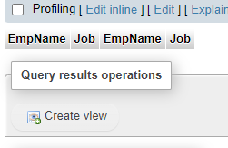

**15)** **List the Emps who’s Sal is same as FORD or SMITH in desc order of Sal**

**Ans=>** Select * from employee where sal in (select sal from employee where ( ename = "SMITH" or ename = "FORD" )) order by sal desc;

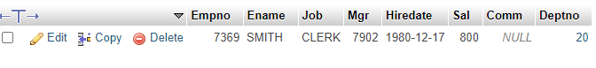

**16)** **List the emps whose jobs same as SMITH or ALLEN.**

**Ans=>** select * from employee where job in (select job from employee where ename = "SMITH" or ename = "ALLEN");

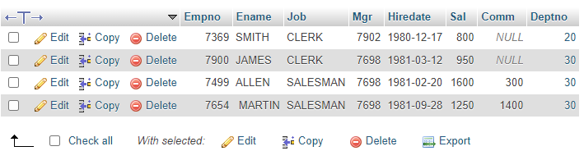

**17)** **Any jobs of deptno 10 those that are not found in deptno 20.**

**Ans=>** select e.job from employee e where e.deptno = 10 and e.job not in (select job from employee where deptno =20);

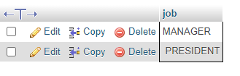

**18)** **Find the highest sal of EMP table.**

**Ans=>** SELECT MAX(sal) FROM employee

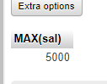

**19)** **Find details of highest paid employee.**

Ans=> select * from employee where sal in (select max(sal) from employee);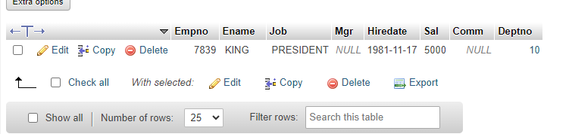

**20) Find the total sal given to the MGR.**

Ans=> select sum(sal) from employee where empno in(select mgr from employee);

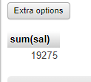

**21) List the emps whose names contains ‘A’.**

**Ans=>** select * from employee where ename like '%A%';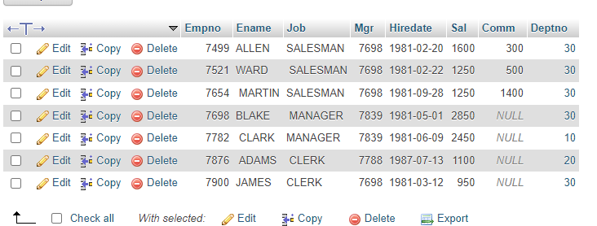

**22)** **Find all the emps who earn the minimum Salary for each job wise in ascending order.**

**Ans=>** select * from employee where sal in (select min(sal) from employee group by job) order by sal asc;

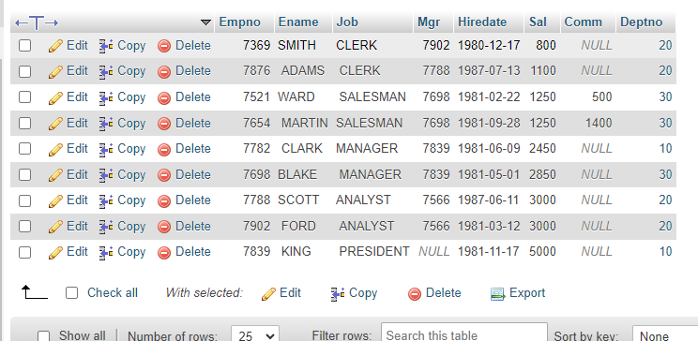

**23) List the emps whose sal greater than Blake’s sal.**

Ans=> select * from employee where sal>(select sal from employee where ename = 'BLAKE');

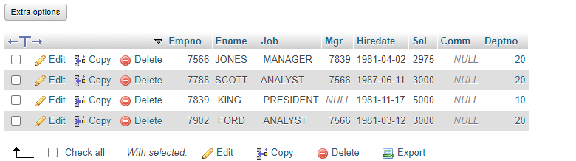

**24) Create view v1 to select ename, job, dname, loc whose deptno are same.**

Ans=> CREATE VIEW v1 AS

SELECT e.ename AS EmployeeName, e.job AS JobTitle, d.dname AS DepartmentName, d.loc AS Location

FROM employee e

JOIN dept d ON e.deptno = d.deptno;

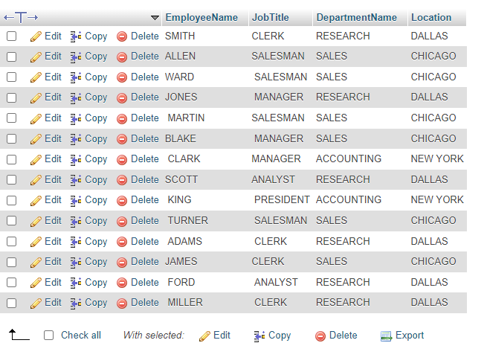

**25) Create a procedure with dno as input parameter to fetch ename and dname.**

Ans=>

**26) Add column Pin with bigint data type in table student**

**Ans=>**ALTER TABLE Student

ADD Pin BIGINT NOT NULL DEFAULT 0;

