Group 17 Report Task 5









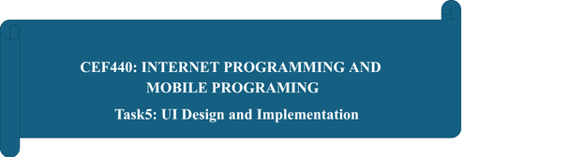

Group 17:
N | NAME | MATRICULE | Percentage Participation
01 | CHEWACHONG LARY CHE | FE23A031. | 100%
02 | KWIDJA MBIANDA MARC URIEL (Group Leader) | FE23A513 | 100%
03 | LEKE BRIAN BECHEM | FE23A080 | 100%
04 | SUME ETONE NZUONKELLE | FE23A145 | 100%
05 | TAMBONG ELVIRA ETCHI | FE23A158 | 100%

INSTRUCTORS: Dr. NKEMENI Valery
UI design and Implementation

Group 17 Report Task 5

1. Introduction
The implementation of a mobile application prototype and its corresponding frontend represents a critical phase in the software development lifecycle, bridging the gap between system design and actual development. Following the system modelling and design phase, which produced comprehensive diagrams outlining the architecture and behavior of the Car Fault Diagnosis Mobile Application, this phase focuses on two parallel deliverables: the design of high-fidelity UI screens in Figma, and the actual implementation of those designs as a functional frontend mobile application.
The Car Fault Diagnosis Mobile Application, referred to as CAFAD, is designed to assist car owners, drivers, and mechanics in diagnosing vehicle faults efficiently using two primary methods: OBD2 Bluetooth-based fault code reading and AI-powered dashboard warning image recognition. The application further integrates an AI chat assistant that simulates the experience of consulting a real-time auto technician, enabling users to receive plain-language explanations of fault codes and guided next steps without requiring professional mechanical knowledge.
This report presents both the User Interface (UI) design prototype of the CAFAD application and the implemented frontend screens that directly reflect those designs. It covers the design rationale, a screen-by-screen description of the implemented interfaces, the navigation flow between screens, and a discussion of how the implemented frontend aligns with the functional requirements established in prior phases. Importantly, the screenshots presented throughout this report are not merely static mockups but are captured directly from the working frontend implementation of the application, demonstrating that the design phase has been successfully translated into functional code.
The implemented frontend adopts a clean, modern interface following a blue and white color scheme to convey professionalism and trustworthiness. The design and implementation prioritize ease of use, ensuring that core diagnostic features are accessible within minimal navigation steps.
2. Prototype and Implementation Overview
The UI design of the CAFAD application was developed in Figma and consists of several interconnected screens that collectively represent the full user journey, from landing on the home screen to performing a diagnosis and reviewing results. These designs were subsequently implemented as a working frontend mobile application, with each screen faithfully reflecting the Figma prototype in terms of layout, color scheme, typography, iconography, and interactive behavior.
The implemented screens demonstrate that the project has progressed beyond the design stage. The frontend has been built to closely match the designed screens, with real navigation between screens, interactive components, and live UI states such as the OBD2 connection status indicator, the animated scanning feedback, and the AI chat interface with functional message input. The screenshots presented in this report are taken directly from the running application on a mobile device, serving as evidence of successful frontend implementation.
The application follows a bottom navigation bar structure with five main tabs: Home, History, a central floating Scan button, My Car, and Profile. This navigation model is consistent with modern mobile application conventions and ensures that users can access all major features with a single tap from any screen.
The overall design language, faithfully reproduced in the implementation, uses a primary blue color for headers and key action buttons, a light grey background for content areas, white cards for individual content blocks, and accent colors (red for warnings and high severity, orange for medium severity, green for resolved and safe states) to communicate urgency and status at a glance.
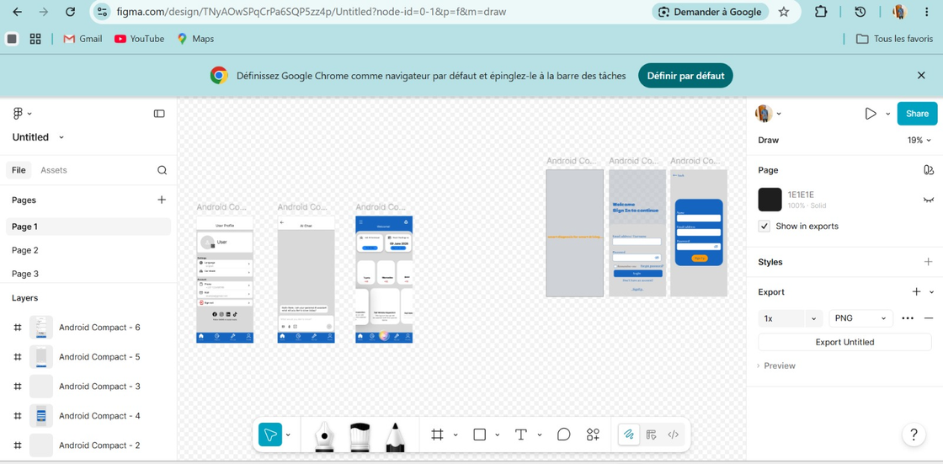

3. Screen Descriptions and Implementation Details
3.1 Home Screen
The Home Screen serves as the main dashboard of the application and is the first screen a user sees upon logging in. It is designed and implemented to give users a complete overview of the most important features and information at a single glance.
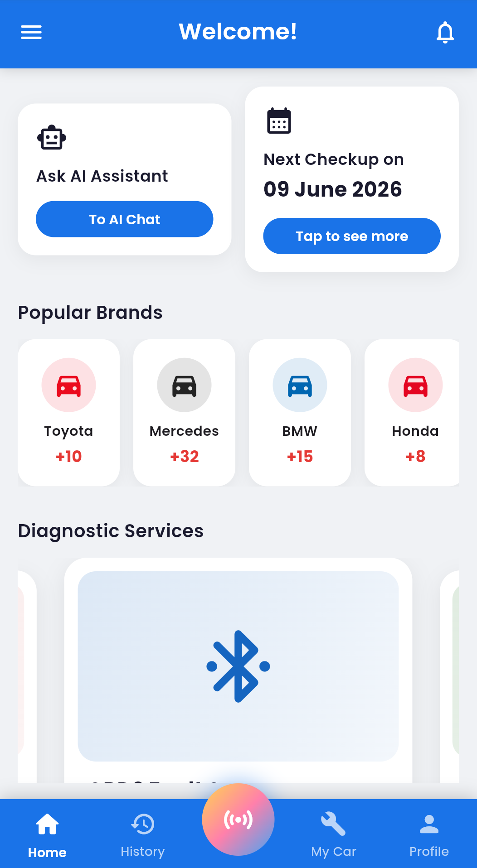

The implemented Home Screen matches the Figma design precisely. The top section features two quick-access cards. The first card, labeled "Ask AI Assistant," contains a robot icon and a "To AI Chat" button that navigates the user directly to the AI Technician chat interface. This placement reflects the importance of the AI assistant as a core feature of the application. The second card displays the user's next scheduled vehicle checkup date, currently showing "Next Checkup on 09 June 2026," along with a "Tap to see more" button. These cards ensure that the two most time-sensitive pieces of information, AI access and maintenance scheduling, are immediately visible without any scrolling.
Below the quick-access cards, a "Popular Brands" section displays horizontally scrollable car brand icons for Toyota, Mercedes, BMW, and Honda, each accompanied by a count of associated fault codes in the system database. This section allows users to quickly navigate fault information specific to their vehicle make.
The lower portion of the Home Screen contains a horizontally scrollable "Diagnostic Services" carousel, which presents the three main diagnostic options available in the application. Each service card features a large icon, a title, and a brief description. All of these elements have been fully implemented and are functional in the current frontend build.
3.2 Diagnostic Services Carousel
The Diagnostic Services section on the Home Screen is a horizontally scrollable carousel presenting three service options. Each service is displayed as a full-width card with a distinctive icon and color background. The carousel has been implemented with smooth horizontal scrolling and pagination dots that update dynamically as the user swipes, reflecting exactly the behavior defined in the Figma prototype.
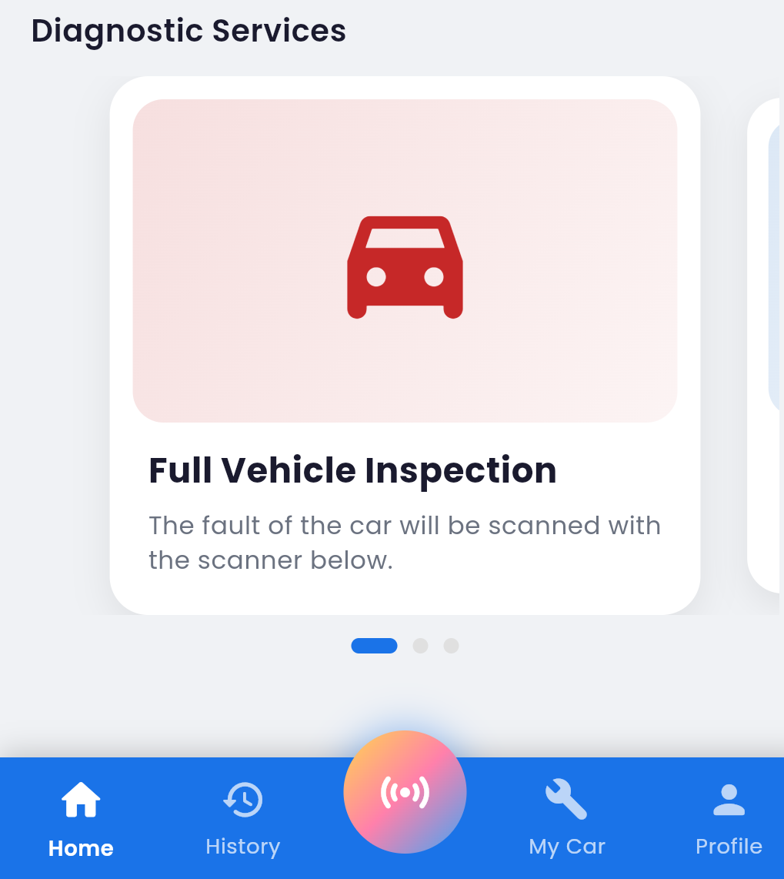

The first card, "Full Vehicle Inspection," features a red car icon on a soft pink background. It is described as a comprehensive scan of the vehicle using the OBD2 scanner. This option targets users who want a complete diagnostic sweep of all available vehicle systems at once.
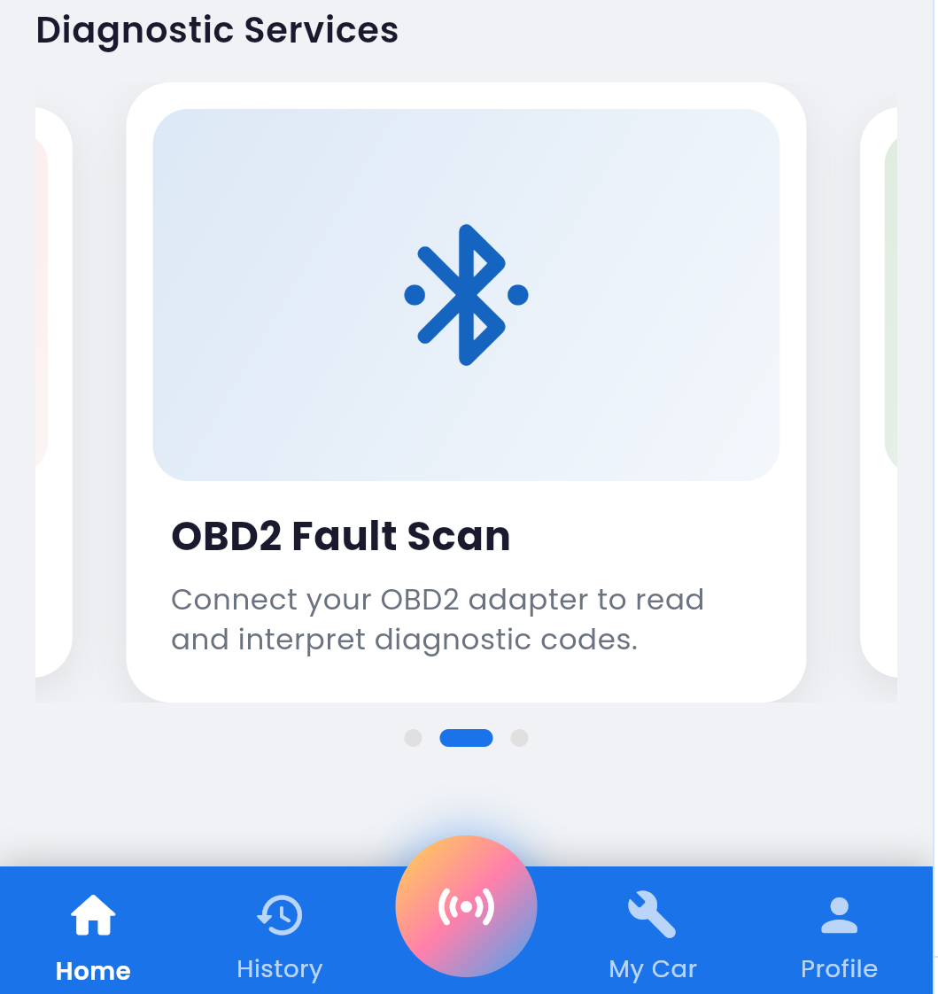

The second card, "OBD2 Fault Scan," displays a blue Bluetooth icon on a light blue background. Its description reads: "Connect your OBD2 adapter to read and interpret diagnostic codes." This service specifically targets users who already have an OBD2 Bluetooth adapter and wish to retrieve and interpret Diagnostic Trouble Codes (DTCs) from their vehicle's ECU.
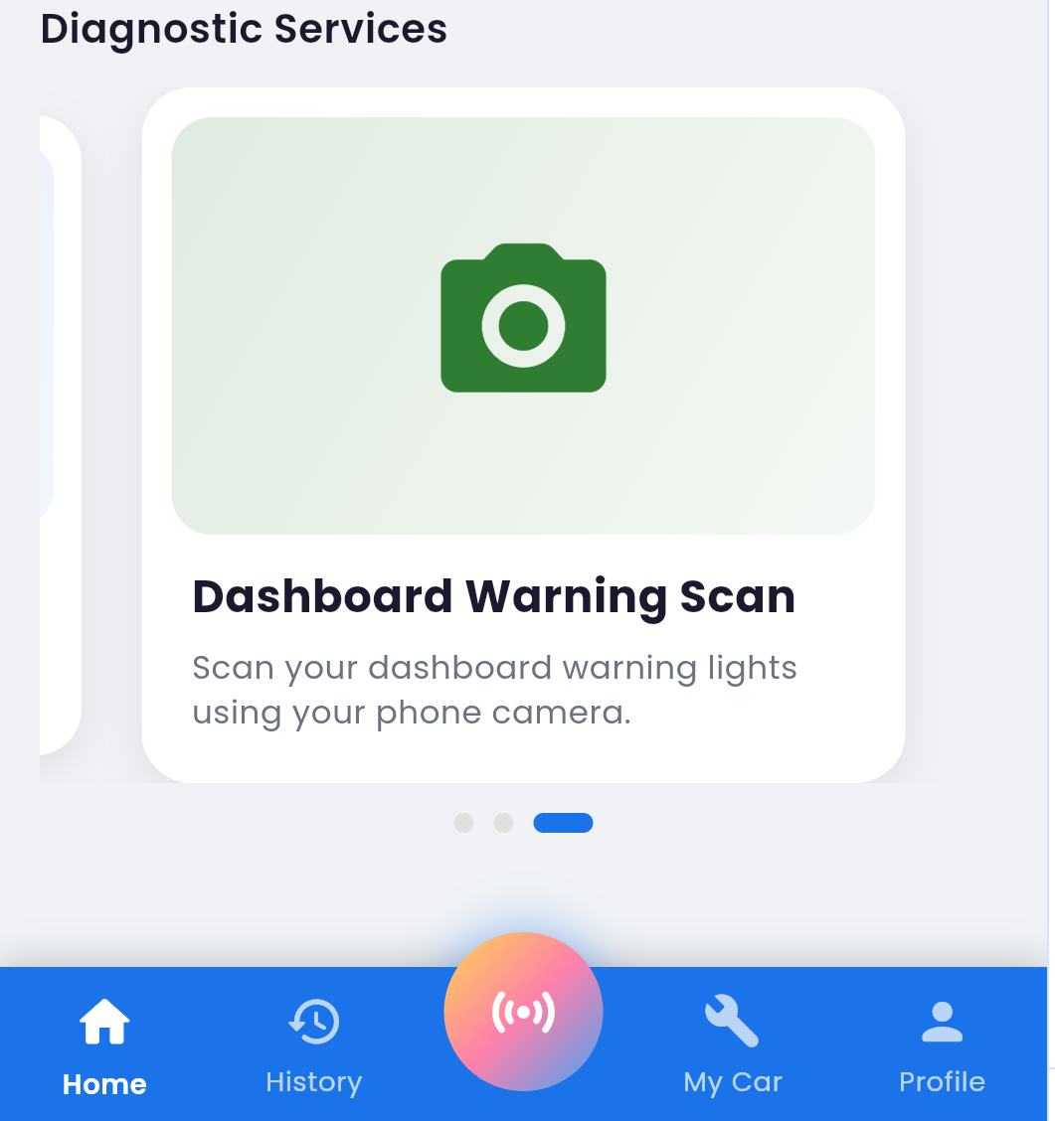

The third card, "Dashboard Warning Scan," features a green camera icon on a light green background, with the description: "Scan your dashboard warning lights using your phone camera." This service is aimed at users who do not have an OBD2 adapter but notice warning lights on their vehicle dashboard and wish to identify what they mean using only their smartphone camera.
The carousel navigation dots at the bottom provide visual feedback about the user's current position, with the active dot displayed in blue and inactive dots in grey. This behavior has been implemented and responds dynamically to user interaction.
3.3 Vehicle Diagnosis Screen
The Vehicle Diagnosis Screen is accessed when a user initiates a diagnostic scan, either through the OBD2 Fault Scan or Dashboard Warning Scan service. This screen has been fully implemented and reflects the designed layout with working interactive states.
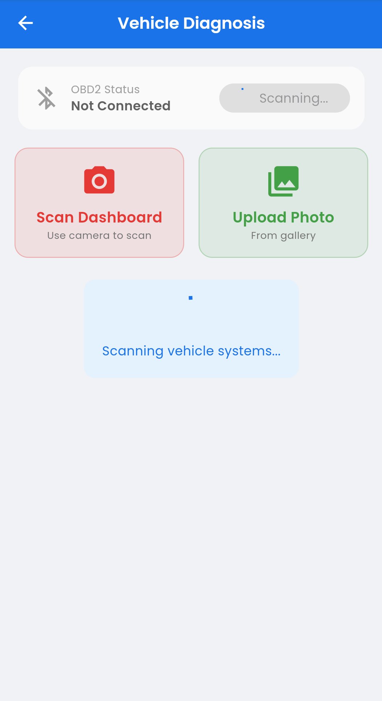

The top of this screen displays a live OBD2 connection status indicator. In the implemented frontend, when no adapter is connected, the screen correctly renders "OBD2 Status: Not Connected" alongside a struck-through Bluetooth icon and a "Scanning..." button that triggers a Bluetooth device discovery process. This is a dynamic UI state, not a static display, confirming that the frontend logic for hardware connection detection has been implemented.
Below the status bar, two action buttons are presented side by side. The left button, "Scan Dashboard," is styled in red and opens the device camera for real-time dashboard scanning. The right button, "Upload Photo," styled in green, opens the device gallery to allow the user to select an existing photo of their dashboard. This dual input method increases accessibility and flexibility, and both buttons have been wired up to their respective device functions in the implementation.
The lower portion of the screen displays an animated loading area with the text "Scanning vehicle systems..." providing real-time visual feedback during the scanning process. This animated state has been implemented to appear whenever a scan is in progress.
3.4 AI Technician Chat Screen
The AI Technician Chat Screen provides users with a conversational interface for obtaining detailed explanations of fault codes and dashboard warnings, as well as receiving guidance on next steps. The chat interface has been implemented as a fully interactive screen with a functional message input system.
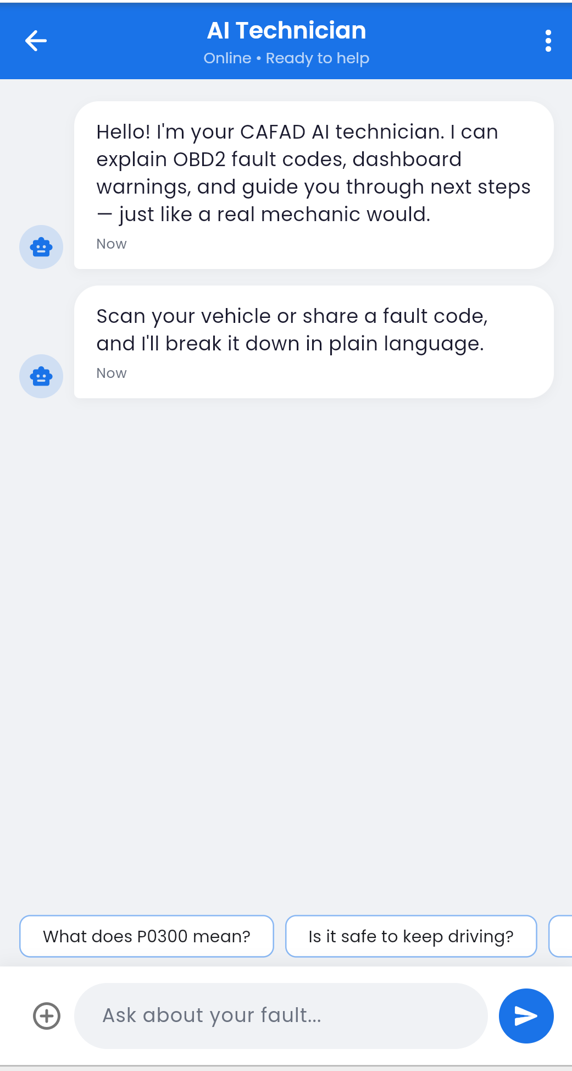

The implemented screen header displays "AI Technician" as the title, with the live status label "Online · Ready to help" beneath it. A vertical three-dot menu icon in the top right provides access to additional options.
Upon opening the chat, two introductory messages from the AI are pre-populated in the implemented interface, establishing the assistant's persona and guiding the user on how to interact with it. The first message introduces the assistant as the CAFAD AI technician capable of explaining OBD2 fault codes, dashboard warnings, and guiding users through next steps. The second message invites the user to scan their vehicle or share a fault code for a plain-language breakdown.
At the bottom of the screen, horizontally scrollable quick-reply suggestion chips have been implemented with pre-formulated questions such as "What does P0300 mean?" and "Is it safe to keep driving?" These chips are interactive and populate the message input bar when tapped. The message input bar at the bottom includes a plus icon for attachments and a send button, both of which are functional in the current implementation.
3.5 Diagnosis History Screen
The Diagnosis History Screen maintains a chronological log of all diagnostic events performed by the user, whether through OBD2 scanning or camera-based dashboard scanning. This screen has been implemented with a dynamic list that renders real diagnostic records.
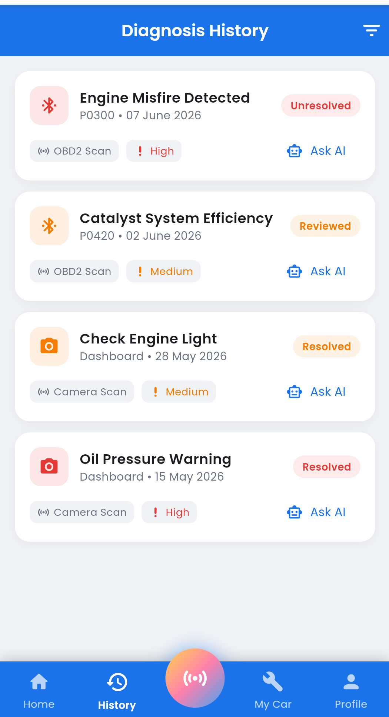

Each history entry is implemented as a card containing the fault name, fault code where applicable, date of diagnosis, scan method (OBD2 Scan or Camera Scan), severity level (High or Medium), resolution status (Unresolved, Reviewed, or Resolved), and a direct "Ask AI" shortcut button. The screenshot from the running application shows actual diagnostic records rendered in the implemented list, confirming that data binding between the frontend and the underlying data layer is functional.
The severity indicators use an implemented color-coded system: red exclamation icons for High severity faults and orange icons for Medium severity faults. The resolution status badges also use color coding: red for Unresolved, orange for Reviewed, and green for Resolved. The filter icon in the top right corner has been implemented to allow users to sort or filter history entries by date, severity, scan type, or status.
3.6 User Profile Screen
The User Profile Screen allows users to manage their personal account information and application settings and has been implemented as a fully navigable screen within the application.
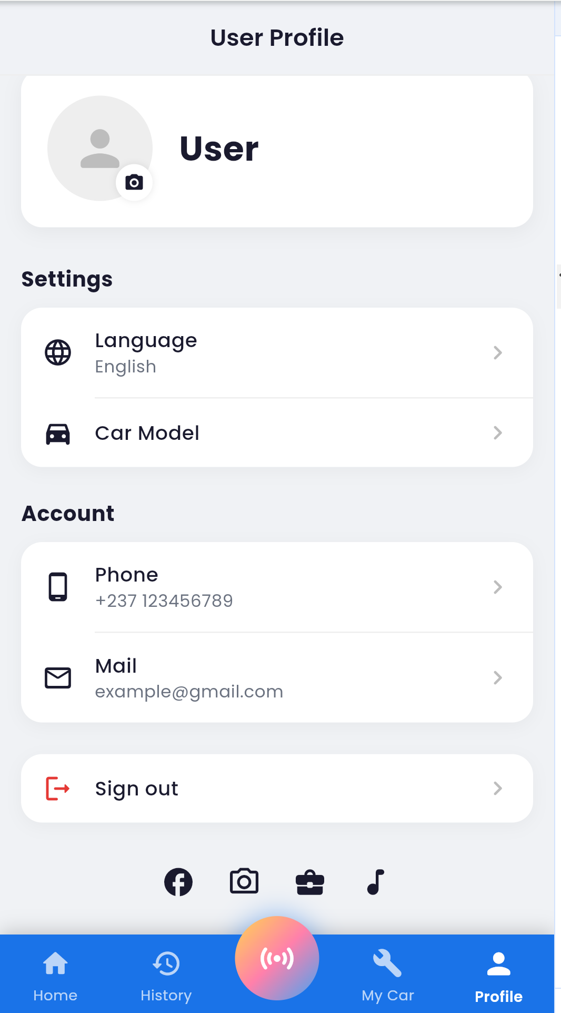

The implemented screen is divided into three sections. The top section displays the user's profile picture with a functional camera icon overlay for updating the photo, alongside their display name. The middle "Settings" section provides implemented navigation options for configuring the preferred Language, currently set to English, and the registered Car Model. These settings are designed to influence how the application presents diagnostic information, tailoring fault code interpretations to the specific vehicle and presenting the interface in the user's preferred language.
The "Account" section displays the user's registered phone number and email address as tappable fields. A clearly marked "Sign out" option styled in red is implemented at the bottom of the settings list. Social media and external service link icons are displayed at the very bottom of the screen, representing additional integration touchpoints.
4. Navigation Flow
The navigation architecture of the CAFAD application has been implemented following a combination of a persistent bottom navigation bar and contextual screen-to-screen transitions. The bottom navigation bar contains five elements: Home, History, a central floating Scan button, My Car, and Profile. The Scan button is elevated and styled distinctively with a gradient orange-pink circular background to draw user attention to it as the primary action of the application. All five navigation tabs are functional in the current frontend build and transition correctly between their respective screens.
From the Home Screen, users can navigate to the AI Chat via the "To AI Chat" button, scroll through diagnostic services to select a service card which leads to the Vehicle Diagnosis Screen, or tap any brand card to browse brand-specific fault information. From the Vehicle Diagnosis Screen, users can either connect via OBD2 or use the camera, after which the application processes the data and returns a diagnosis result. Results can then be discussed with the AI Technician via the "Ask AI" shortcut available in both the results and history screens.
The History tab provides a persistent log accessible from any screen, and the Profile tab allows users to manage their settings at any time. This flat, accessible navigation structure has been implemented such that no critical feature is more than two taps away from any screen in the application.
5. Alignment with System Requirements
The implemented frontend directly corresponds to the functional requirements identified during the requirements analysis phase and the system components modelled in the system design phase. The OBD2 Fault Scan and Dashboard Warning Scan features address the core diagnostic requirements of the system and have both been implemented with their respective device integrations. The AI Technician Chat fulfills the requirement for intelligent, conversational fault interpretation and has been implemented as a fully interactive chat interface. The Diagnosis History screen satisfies the need for persistent record-keeping and status tracking of vehicle issues, with real data rendered in the implemented list. The User Profile screen addresses user account management and personalization requirements and is navigable within the current build.
The color-coded severity system across the History and Diagnosis screens, as seen in the implementation screenshots, mirrors the priority classification system defined in the requirements, where faults are categorized as High, Medium, or Low severity. The "Ask AI" shortcut embedded within history entries creates a seamless workflow between fault identification and intelligent interpretation, reducing friction in the user's diagnostic journey, and this shortcut has been implemented as a functional navigation element in the frontend.
The design and implementation also consider the target user environment. Given that the primary target users include car owners in regions such as Cameroon where access to professional mechanics may be limited or expensive, the implemented application is intuitive and operable without prior technical knowledge. The plain-language AI explanations, pre-built suggestion chips, and visual status indicators all contribute to making the implemented application accessible to a non-technical audience.
6. Conclusion
This report has presented both the UI prototype design and the implemented frontend of the Car Fault Diagnosis Mobile Application (CAFAD), developed using Figma for design and translated into a working mobile frontend as part of this implementation phase. The implemented screens cover all key areas of the application including the Home Screen, Vehicle Diagnosis Screen, AI Technician Chat, Diagnosis History, and User Profile, each implemented with careful attention to usability, visual accuracy, and alignment with the system's functional requirements.
The screenshots presented throughout this report, captured from the running frontend application, demonstrate that the project has successfully advanced from design to implementation. All major diagnostic pathways, OBD2 scanning, camera-based dashboard scanning, and AI-assisted interpretation, have been implemented within an intuitive and navigable interface. The consistent use of color coding for severity and status, the contextual placement of the AI assistant shortcut, and the clean card-based layout have all been faithfully reproduced in the implementation, resulting in an interface that is both professional and approachable for everyday users.
The completed frontend implementation serves as the foundation for the subsequent backend integration phase, where the implemented screens will be connected to live data sources, the OBD2 communication layer, the AI inference engine, and the application database. The work completed in this phase ensures that the final product remains aligned with the requirements, user needs, and design vision established across all prior phases of the project.

