REPUBLIQUE DU CAMEROUN
******************
MINISTÈRE DE L’ENSEIGNEMEN
SUPÉRIEUR
**********
UNIVERSITÉ DE BUEA
********
FACULTÉ D’INGÉNIERIE ET DE
TECHNOLOGIE
******
DEPARTEMENT DU GENIE INFORMATIQUE

REPUBLIC OF CAMEROON
***************
MINISTER OF HIGHER EDUCATION
************
UNIVERSITY OF BUEA
******
FACULTY OF ENGINEERING AND
TECHNOLOGY
*******
DEPARTMENT OF COMPUTER ENGINEERING



CEF440: INTERNET PROGRAMMING AND
MOBILE PROGRAMING
TASK6: DATABASE DESIGN AND IMPLEMENTATION

Group 17:
N | NAME | MATRICULE | Percentage Participation
01 | CHEWACHONG LARY CHE | FE23A031. | 100%
02 | KWIDJA MBIANDA MARC URIEL (Group Leader) | FE23A513 | 100%
03 | LEKE BRIAN BECHEM | FE23A080 | 100%
04 | SUME ETONE NZUONKELLE | FE23A145 | 100%
05 | TAMBONG ELVIRA ETCHI | FE23A158 | 100%

INSTRUCTORS: Dr. NKEMENI Valery
Table of Contents
1.1. Introduction 4
1.2. Data Elements 4
1.2.1. Introduction 4
1.2.2. User Data 4
1.2.3. Vehicle Data 5
1.2.4. Mechanic Data 5
1.2.5. Part-seller Table 5
1.2.4. Diagnosis Data 6
1.2.5. Fault Code Data 6
1.2.6. Diagnosis Result Data 6
1.2.7. AI Chat Data 7
1.3. Conceptual Design 7
1.3.1. Introduction 7
1.3.2. User and Vehicle Relationship 8
1.3.3. Vehicle and Diagnosis Relationship 8
1.3.4. Diagnosis and Fault Code Relationship 8
1.3.5. User and AI Chat Relationship 9
1.3.6. User and Mechanic Relationship 9
1.3.7. User and Part Seller Relationship 9
1.3.8. Conceptual Model Summary 9
1.4. Entity Relationship Diagram (ERD) 9
1.4.1. Introduction 9
1.4.2 Entity Description 10
1.4.3. Relationship Analysis 13
1.4.4. ERD Design Summary 13
1.5. Database Implementation 14
1.5.1. Introduction 14
1.5.2. Database Selection 14
1.5.3. Table Implementation 14
1.5.4. Database Normalization 17
1.6. Connecting the Database to the Backend 18
1.6.1. Introduction 18
1.6.2. Database Connection Configuration 18
1.6.3. Database Operations 19
1.6.4. Data Flow Between Application, Backend, and Database 20
1.7. Conclusion 20

System Modelling and Design

Introduction
This comprehensive report details the database design and implementation for the CAFAD mobile application, a sophisticated automotive diagnostic platform that leverages artificial intelligence to provide multi-modal fault diagnosis capabilities. The system architecture implements a robust PostgreSQL database foundation that supports complex diagnostic workflows, user management, professional mechanic services, and part-sellers services. The implementation adheres to industry best practices for data security, scalability, and performance optimization while maintaining the flexibility required for future feature expansion.

Data Elements

Introduction
Before designing the database, it was necessary to identify the different types of information that the Car Fault Diagnosis Mobile Application (CAFAD) needs to manage. This process helped define the data requirements of the system and ensured that all application functionalities would be supported by the database structure.
The identification of data elements was based on the features implemented during the previous phases of the project, including user management, vehicle management, fault diagnosis, diagnosis history tracking, and AI-assisted support. Each feature requires specific information to be stored, retrieved, and updated whenever users interact with the application.
The analysis resulted in eight main data entities: User, Vehicle, Diagnosis, Fault Code, Diagnosis Result, Mechanics, Part-sellers and AI Chat. These entities represent the core information required for the operation of CAFAD and form the foundation of the database design.

1.2.2. User Data
The User entity stores information related to individuals who use the application. It allows users to create accounts, access personalized services, manage their vehicles, and view their diagnosis history. User information also supports authentication and profile management functionalities within the application.
The main attributes associated with this entity are presented in the table below
Attribute | Description
user_id | Unique identifier assigned to each user
full_name | User's full name
email | Email address used for authentication
password_hash | Encrypted user password
phone | User's contact number
profile_picture | User profile image
created_at | Date and time of account creation
role | Type of user (Carowner,mechanic,part seller,admin)

1.2.3. Vehicle Data
The Vehicle entity stores information about vehicles registered by users. Since a single user may own more than one vehicle, this entity allows the application to maintain vehicle-specific diagnosis records and history.
Each vehicle record contains essential information required for identification and future diagnostic operations.
The vehicle data attributes are being described in the table below
Attribute | Description
vehicle_id | Unique identifier for each vehicle
user_id | Reference to the vehicle owner
brand | Vehicle manufacturer
model | Vehicle model
year | Manufacturing year
vin | Vehicle Identification Number

1.2.4. Mechanic Data
Attribute | Description
mechanic_id | Unique identifier
user_id | Associated user
garage_name | Garage name
specialization | Area of expertise
address | Business location
phone | Contact number

1.2.5. Part-seller Table
Attribute | Description
seller_id | Unique identifier
user_id | Associated user
shop_name | Shop name
address | Shop location
phone | Contact number

1.2.4. Diagnosis Data
The Diagnosis entity stores information generated whenever a diagnostic operation is performed. This information allows users to track previous diagnoses and review detected vehicle issues. Within CAFAD, diagnosis records may originate from OBD2-based scanning or dashboard image analysis.
Attribute | Description
diagnosis_id | Unique diagnosis identifier
vehicle_id | Associated vehicle
diagnosis_type | Type of diagnosis performed
diagnosis_date | Date and time of diagnosis
severity | Severity level of detected issue
status | Current diagnosis status

1.2.5. Fault Code Data
The Fault Code entity contains information about known vehicle fault codes. These records serve as a reference database used to interpret diagnostic results and provide users with meaningful explanations of detected problems. Each fault code includes a description and a recommended action to help users understand possible solutions.
Attribute | Description
fault_id | Unique fault identifier
code | Diagnostic fault code
title | Fault title
description | Detailed explanation of the fault
recommendation | Suggested corrective action

1.2.6. Diagnosis Result Data
The Diagnosis Result entity links diagnosis records to the corresponding fault codes detected during analysis. This entity is important because a single diagnosis may contain multiple fault codes, and the same fault code may appear in different diagnosis sessions. This structure helps maintain a flexible and organized representation of diagnostic outcomes.
Attribute | Description
result_id | Unique result identifier
diagnosis_id | Associated diagnosis
fault_id | Associated fault code

1.2.7. AI Chat Data
The AI Chat entity stores conversations between users and the AI Technician feature integrated into CAFAD. These records help maintain chat history and improve continuity during interactions between users and the AI assistant.
Attribute | Description
chat_id | Unique chat identifier
user_id | Associated user
sender | Sender of the message
message | Message content
timestamp | Date and time the message was sent
The data elements presented in this section provide the foundation for the conceptual database design discussed in the next chapter. By organizing information into well-defined entities, the system can efficiently manage user information, vehicle records, diagnostic results, and AI-assisted interactions while maintaining data consistency and integrity.

1.3. Conceptual Design

1.3.1. Introduction
After identifying the data elements required by the CAFAD system, the next step was to establish how these elements relate to one another. The conceptual design phase focuses on representing the real-world relationships between users, vehicles, diagnoses, fault codes, and AI interactions without considering the technical details of database implementation.
The objective of this phase is to create a clear model of the system's data structure that accurately reflects the application's functionality. By defining the relationships between entities at a conceptual level, it becomes easier to design a database that supports efficient data storage, retrieval, and management.
The conceptual model developed for CAFAD is centered around the user, who interacts with different components of the system through vehicle registration, fault diagnosis, and communication with the AI technician.
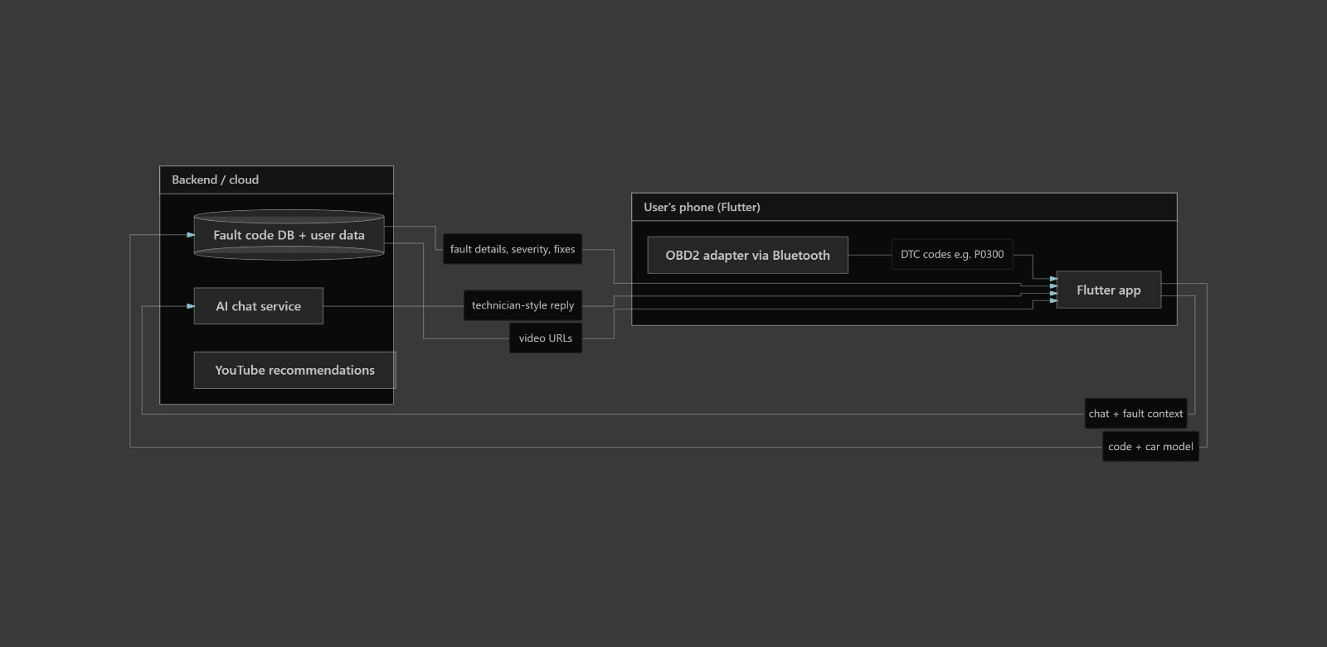

1.3.2. User and Vehicle Relationship
The User entity represents individuals who use the CAFAD application. Since users may own more than one vehicle, a one-to-many relationship exists between the User and Vehicle entities. This means that a single user can register multiple vehicles, while each vehicle belongs to only one user.
This relationship allows users to maintain separate diagnostic histories for different vehicles and provides better organization of vehicle-related information within the application.

1.3.3. Vehicle and Diagnosis Relationship
Each registered vehicle may undergo several diagnostic sessions throughout its lifetime. As a result, a one-to-many relationship exists between the Vehicle and Diagnosis entities. A vehicle can have multiple diagnosis records, while each diagnosis record is associated with only one vehicle.
This relationship enables the application to keep track of previous diagnostic activities and allows users to review the maintenance history of their vehicles over time.

1.3.4. Diagnosis and Fault Code Relationship
One of the most important relationships within the CAFAD system is the relationship between Diagnosis and Fault Code entities. During a diagnostic session, multiple fault codes may be detected. Similarly, the same fault code can appear in different diagnosis sessions performed on different vehicles.
For this reason, a many-to-many relationship exists between Diagnosis and Fault Code entities. To properly manage this relationship, an intermediate entity known as Diagnosis Result is introduced.
The Diagnosis Result entity acts as a linking table that associates diagnosis records with the fault codes identified during analysis. This approach improves database organization and reduces redundancy while maintaining flexibility in storing diagnostic outcomes.

1.3.5. User and AI Chat Relationship
The AI Technician feature enables users to interact with an intelligent assistant for guidance and fault interpretation. Since users can exchange multiple messages with the AI assistant, a one-to-many relationship exists between the User and AI Chat entities.
Each user may have multiple chat records, while every chat message belongs to a specific user. This relationship allows the application to maintain conversation history and provide continuity during future interactions.

1.3.6. User and Mechanic Relationship
A user registered as a mechanic has an associated mechanic profile.

1.3.7. User and Part Seller Relationship
A user registered as a part seller has an associated seller profile.

1.3.8. Conceptual Model Summary
The conceptual design of CAFAD establishes a structured framework for managing the application's data. The relationships identified in this phase ensure that users, vehicles, diagnoses, fault codes, and AI interactions can be organized logically while minimizing data duplication.
The conceptual model serves as the foundation for the Entity Relationship Diagram (ERD), which is presented in the next section of this report. The ERD provides a graphical representation of the entities and relationships discussed in this chapter and forms the basis for the physical database design.

1.4. Entity Relationship Diagram (ERD)

1.4.1. Introduction
The Entity Relationship Diagram (ERD) provides a graphical representation of the database structure developed for the Car Fault Diagnosis Mobile Application (CAFAD). It translates the conceptual relationships identified in the previous chapter into a more detailed model that can be used as the foundation for database implementation.
The ERD illustrates the main entities within the system, their attributes, and the relationships that exist between them. It also identifies primary keys and foreign keys that will later be used to maintain referential integrity within the database.
By using an ERD, it becomes easier to visualize how data flows through the system and how different components interact with one another. This model serves as an important blueprint for the implementation of the PostgreSQL database.
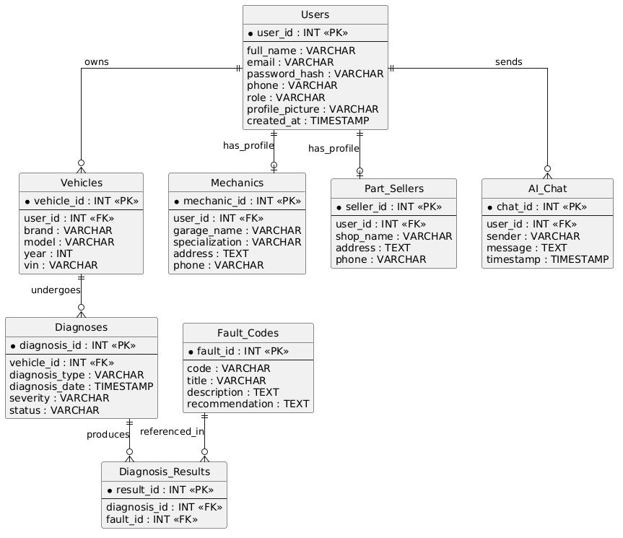

1.4.2 Entity Description
The ERD developed for CAFAD consists of six major entities that support the application's core functionalities.
- User Entity
The User entity stores information related to individuals who use the application. It serves as the central entity from which several relationships originate. Each user is uniquely identified by a user_id and may register one or more vehicles within the system.
Key attributes include:
- user_id
- full_name
- email
- password_hash
- phone
- profile_picture
- created_at

- Vehicle Entity
The Vehicle entity contains information about vehicles registered by users. Since users may own multiple vehicles, each vehicle record is linked to its owner through a foreign key reference.
Key attributes include:
- vehicle_id
- user_id
- brand
- model
- year
- vin

- Diagnosis Entity
The Diagnosis entity stores information generated during diagnostic sessions. Each diagnosis record is associated with a specific vehicle and contains details about the type of diagnosis performed and the results obtained.
Key attributes include:
- diagnosis_id
- vehicle_id
- diagnosis_type
- diagnosis_date
- severity
- status

- Fault Code Entity
The Fault Code entity serves as a repository of known vehicle fault codes and their associated explanations. It allows the system to provide meaningful descriptions and recommendations whenever a fault is detected.
Key attributes include:
- fault_id
- code
- title
- description
- recommendation

- Diagnosis Result Entity
The Diagnosis Result entity acts as an intermediary between Diagnosis and Fault Code entities. It resolves the many-to-many relationship that exists between them by linking diagnostic sessions to the fault codes detected during analysis.
Key attributes include:
- result_id
- diagnosis_id
- fault_id

- AI Chat Entity
The AI Chat entity stores interactions between users and the AI Technician feature. This entity enables the system to maintain conversation history and improve continuity during user interactions.
Key attributes include:
- chat_id
- user_id
- sender
- message
- timestamp

1.4.3. Relationship Analysis
The relationships represented in the ERD ensure that data is organized efficiently while maintaining consistency throughout the system.
- User–Vehicle Relationship: A one-to-many relationship exists between User and Vehicle entities. A single user may register multiple vehicles, while each vehicle belongs to only one user.

- Vehicle–Diagnosis Relationship: A one-to-many relationship exists between Vehicle and Diagnosis entities. One vehicle may have several diagnosis records, while each diagnosis record is associated with only one vehicle.

- Diagnosis–Fault Code Relationship: A many-to-many relationship exists between Diagnosis and Fault Code entities. Multiple fault codes may be identified during a diagnosis session, and the same fault code may appear in multiple diagnosis records.
This relationship is implemented through the Diagnosis Result entity.

- User–AI Chat Relationship: A one-to-many relationship exists between User and AI Chat entities. Each user may have multiple chat messages stored within the system, while every chat message is linked to a specific user.

1.4.4. ERD Design Summary
The Entity Relationship Diagram developed for CAFAD provides a clear and structured representation of the application's data requirements. The design captures all major entities required to support user management, vehicle management, diagnosis tracking, fault interpretation, and AI-assisted interactions.
The relationships defined in the ERD ensure data consistency while minimizing redundancy. Furthermore, the diagram establishes a solid foundation for the physical implementation of the PostgreSQL database discussed in the next chapter.

1.5. Database Implementation

1.5.1. Introduction
Following the development of the Entity Relationship Diagram (ERD), the next stage involved transforming the conceptual design into a relational database structure. Database implementation focuses on creating tables, defining attributes, establishing relationships, and enforcing integrity constraints that ensure consistent data storage and retrieval.
For the CAFAD project, PostgreSQL was selected as the database management system due to its reliability, scalability, and strong support for relational database design. PostgreSQL provides robust data management features and supports the complex relationships required by the application.
The database implementation was based directly on the entities identified during the conceptual design phase and represented in the ERD. Each entity was translated into a relational table with clearly defined primary keys and foreign keys to maintain referential integrity.

1.5.2. Database Selection
The CAFAD system requires a database capable of managing user accounts, vehicle information, diagnosis records, fault code references, and AI-assisted interactions. PostgreSQL was selected because it offers several advantages that make it suitable for this application.
Firstly, PostgreSQL is an open-source relational database management system, making it freely available for development and deployment. Secondly, it provides strong support for structured data and complex relationships through the use of primary and foreign key constraints. Additionally, PostgreSQL is known for its reliability, security features, and scalability, allowing the system to accommodate future enhancements without major structural changes.
Another important advantage is PostgreSQL’s compliance with ACID (Atomicity, Consistency, Isolation, Durability) principles, which helps ensure data integrity and reliability during database transactions.

1.5.3. Table Implementation
Based on the database design, eight tables were created to represent the entities identified within the CAFAD system.

1.5.3.1. Users Table
The Users table stores information about all registered users of the system, including vehicle owners, mechanics, spare part sellers, and administrators. The role attribute is used to distinguish between different categories of users.
Attribute | Description
user_id | Primary key
full_name | User's name
email | User email
password_hash | Encrypted password
phone | Contact number
role | User role
profile_picture | Profile image
created_at | Registration date

1.5.3.2. Vehicles Table
The Vehicles table stores information about vehicles registered by users. Each vehicle record is linked to its owner through a foreign key relationship.
Attribute | Description
vehicle_id | Primary key
user_id | Vehicle owner
brand | Vehicle manufacturer
model | Vehicle model
year | Manufacturing year
vin | Vehicle identification number

1.5.3.3. Mechanics Table
The Mechanics table stores additional information related to users registered as mechanics. This table enables the application to maintain mechanic-specific details while keeping authentication information centralized in the Users table.
Attribute | Description
mechanic_id | Primary key
user_id | Associated user
garage_name | Garage name
specialization | Area of expertise
address | Business address
phone | Contact number

1.5.3.4. Part Sellers Table
The Part Sellers table stores information about spare part vendors who use the application. This allows users to locate and interact with registered sellers when replacement components are needed.
Attribute | Description
seller_id | Primary key
user_id | Associated user
shop_name | Business name
address | Business address
phone | Contact number

1.5.3.5. Diagnoses Table
The Diagnoses table records diagnostic sessions performed on registered vehicles. It stores information regarding the type of diagnosis, date of diagnosis, severity level, and status.
Attribute | Description
diagnosis_id | Primary key
vehicle_id | Diagnosed vehicle
diagnosis_type | Type of diagnosis
diagnosis_date | Date performed
severity | Severity level
status | Diagnosis status

1.5.3.6. Fault Codes Table
The Fault Codes table serves as a repository of known diagnostic fault codes and their explanations. It helps translate technical fault information into understandable descriptions for users.
Attribute | Description
fault_id | Primary key
code | Diagnostic code
title | Fault title
description | Detailed explanation
recommendation | Suggested action

1.5.3.7. Diagnosis Results Table
The Diagnosis Results table acts as a linking table between diagnoses and fault codes. It resolves the many-to-many relationship that exists between these entities.
Attribute | Description
result_id | Primary key
diagnosis_id | Associated diagnosis
fault_id | Associated fault code

1.5.3.8. AI Chat Table
The AI Chat table stores messages exchanged between users and the AI Technician. It enables the system to maintain conversation history and support future AI-assisted interactions.
Attribute | Description
chat_id | Primary key
user_id | Associated user
sender | Message sender
message | Message content
timestamp | Date and time sent

1.5.4. Database Normalization
Database normalization was applied during the design process to reduce data redundancy and improve data consistency. The database structure was organized according to the principles of the Third Normal Form (3NF).
The First Normal Form (1NF) was achieved by ensuring that all attributes contain atomic values and that no repeating groups exist within any table.
The Second Normal Form (2NF) was satisfied by ensuring that all non-key attributes are fully dependent on their respective primary keys.
The Third Normal Form (3NF) was achieved by eliminating transitive dependencies and ensuring that non-key attributes depend only on the primary key of their table.
As a result, the database structure minimizes redundancy, improves maintainability, and supports efficient query execution.

1.6. Connecting the Database to the Backend

1.6.1. Introduction
The database and backend are two essential components that work together to support the functionality of the CAFAD application. While the database is responsible for storing and organizing information, the backend serves as an intermediary layer that processes requests from users and interacts with the database when data needs to be created, retrieved, updated, or deleted.
To ensure smooth communication between the mobile application and the database, a connection mechanism must be established within the backend. This connection allows the application to access user accounts, vehicle information, diagnosis records, fault code references, and AI chat history in real time.
This chapter presents the proposed approach for connecting the PostgreSQL database to the backend and explains how information will flow throughout the system.

1.6.2. Database Connection Configuration
The first step in integrating the backend with PostgreSQL is establishing a secure database connection. The backend server will use a database driver and connection configuration parameters to communicate with the database.
The connection configuration typically includes:
- Database host address
- Database name
- Username
- Password
- Port number
These parameters allow the backend server to authenticate and establish communication with the PostgreSQL database whenever a request is received from the mobile application.
The use of environment variables is recommended to protect sensitive credentials and improve security during deployment.

1.6.3. Database Operations
Once the connection is established, the backend performs various database operations required by the application. These operations are commonly referred to as CRUD operations, which represent Create, Read, Update, and Delete functionalities.
Create Operations
Create operations are used to store new information in the database. Examples within CAFAD include:
- Registering a new user account
- Adding a vehicle
- Creating a diagnosis record
- Saving AI chat messages
Read Operations
Read operations retrieve information from the database. Examples include:
- Viewing registered vehicles
- Retrieving diagnosis history
- Accessing fault code information
- Displaying AI chat conversations
Update Operations
Update operations modify existing records. Examples include:
- Updating user profile information
- Editing vehicle details
- Updating diagnosis status
Delete Operations
Delete operations remove information that is no longer needed. Examples include:
- Removing a vehicle record
- Deleting obsolete diagnosis records
- Removing user-generated content when required
These operations form the foundation of data management within the CAFAD application.

1.6.4. Data Flow Between Application, Backend, and Database
When a user performs an action within the mobile application, the request is first sent to the backend server. The backend processes the request, validates the data, and communicates with the database when necessary.
The database then executes the requested operation and returns the result to the backend. Finally, the backend formats the response and sends it back to the mobile application, where the information is displayed to the user.
This process ensures that all interactions with the database pass through a controlled layer that can enforce validation rules, authentication requirements, and security measures.

1.7. Conclusion
This report presented the database design and implementation process for the Car Fault Diagnosis Mobile Application (CAFAD). The objective of this phase was to establish a structured data management solution capable of supporting the application's core functionalities while preparing the system for future development and integration.
The work began with the identification of the main data elements required by the application. These data elements were organized into entities representing users, vehicles, mechanics, spare part sellers, diagnoses, fault codes, diagnosis results, and AI-assisted interactions. This analysis provided a clear understanding of the information that must be stored and managed within the system.
A conceptual database design was then developed to define the relationships between the identified entities. These relationships were subsequently represented through an Entity Relationship Diagram (ERD), which served as the blueprint for the database structure. The ERD established the foundation for creating a relational database capable of maintaining data integrity and minimizing redundancy.
The database implementation phase focused on translating the conceptual design into relational tables suitable for deployment using PostgreSQL. Appropriate primary keys and foreign keys were incorporated to maintain consistency between related records. Database normalization principles were also applied to improve efficiency and reduce unnecessary duplication of data.
In addition, a proposed backend architecture was presented to illustrate how the Flutter mobile application will communicate with the PostgreSQL database. The backend will serve as an intermediary layer responsible for processing requests, validating data, enforcing security measures, and performing database operations. The report also discussed the proposed integration between the backend and database, including connection configuration, CRUD operations, and data flow within the system.
Overall, the work completed in this phase provides a solid foundation for the continued development of CAFAD. The designed database structure and backend architecture support the application's current requirements while remaining flexible enough to accommodate future enhancements such as OBD2 connectivity, dashboard image analysis, AI-powered diagnostic assistance, mechanic services, and spare-part seller integration. The successful completion of this task marks an important step toward the realization of a complete and functional vehicle fault diagnosis platform.

