REPUBLIQUE DU CAMEROUN
******************
MINISTÈRE DE L’ENSEIGNEMEN
SUPÉRIEUR
**********
UNIVERSITÉ DE BUEA
********
FACULTÉ D’INGÉNIERIE ET DE
TECHNOLOGIE
******
DEPARTEMENT DU GENIE INFORMATIQUE

REPUBLIC OF CAMEROON
***************
MINISTER OF HIGHER EDUCATION
************
UNIVERSITY OF BUEA
******
FACULTY OF ENGINEERING AND
TECHNOLOGY
*******
DEPARTMENT OF COMPUTER ENGINEERING



CEF440: INTERNET PROGRAMMING AND
MOBILE PROGRAMING
TASK2: REQUIREMENT GATHERING

Group 17:
N | NAME | MATRICULE | Percentage Participation
01 | CHEWACHONG LARY CHE | FE23A031. | 2%
02 | KWIDJA MBIANDA MARC URIEL (Group Leader) | FE23A513 | 100%
03 | LEKE BRIAN BECHEM | FE23A080 | 100%
04 | SUME ETONE NZUONKELLE | FE23A145 | 100%
05 | TAMBONG ELVIRA ETCHI | FE23A158 | 100%

INSTRUCTORS: Dr. NKEMENI Valery
Table of Contents
1. Requirement Gathering 3
1.1 Introduction 3
1.2 Stakeholder Identification 3
1.2.1 Overview 3
1.2.2 Identified Stakeholders 3
1.3 Requirement Gathering Techniques 4
1.3.1 Overview 4
1.3.2 Surveys 4
1.3.3 Interviews 4
1.3.4 Brainstorming 6
1.3.5 Observation / Reverse Engineering 6
1.4 Data Gathering 9
1.5 Data Cleaning 9
1.5.1 Overview 9
1.5.2 Cleaning Process and Tools 9
1.6 User Reluctance Assessment 9
1.6.1 Overview 9
1.6.2 Identified Challenges 9
Mitigation Strategies 9
2 Conclusion 10

TASK 2: REQUIREMENT GATHERING FOR A CAR FAULT DIAGNOSIS

1. Requirement Gathering

1.1 Introduction
Requirement gathering is a critical phase in the software development lifecycle where the needs, expectations, and challenges of users and stakeholders are identified and documented. This phase ensures that the system being developed is relevant, user-centered, and capable of solving real-world problems.
Our project focuses on developing a car owner support system. Requirement gathering was essential to understand the difficulties faced by car owners in maintaining their vehicles, diagnosing faults, and accessing reliable services. Various techniques were used to collect both qualitative and quantitative data to ensure a comprehensive understanding of user needs.

1.2 Stakeholder Identification

1.2.1 Overview
Stakeholders are individuals or organizations that have an interest in or are affected by the system. Identifying stakeholders helps ensure that all user needs are considered during system development.

1.2.2 Identified Stakeholders
- Car Owners: These are Individuals who own and use vehicles. They interact with the system for diagnostics and maintenance
- Mechanics and Car technicians: Those who repair vehicles. They Provide repair services and interpret technical issues
- Spare Parts Sellers: These are Vendors of vehicle parts. They supply parts required for maintenance and repairs
- Insurance Companies: Organizations providing vehicle insurance. They handle claims and vehicle-related coverage
- System Administrators: Those who manage, monitor, and maintain the system
Identifying the stakeholders of our system, we classified them as:
- Primary stakeholders: Car owners
- Secondary stakeholders: Mechanics, spare parts sellers, insurance companies
- Tertiary stakeholders: System Administrator

1.3 Requirement Gathering Techniques

1.3.1 Overview
To ensure reliable and complete requirements, multiple data collection techniques were used. This combination allowed the team to gather both quantitative data (through surveys) and qualitative insights (through interviews and observations).

1.3.2 Surveys
Surveys were conducted using Google Forms and distributed to car owners. The purpose was to collect general information about user behaviours, challenges, and expectations
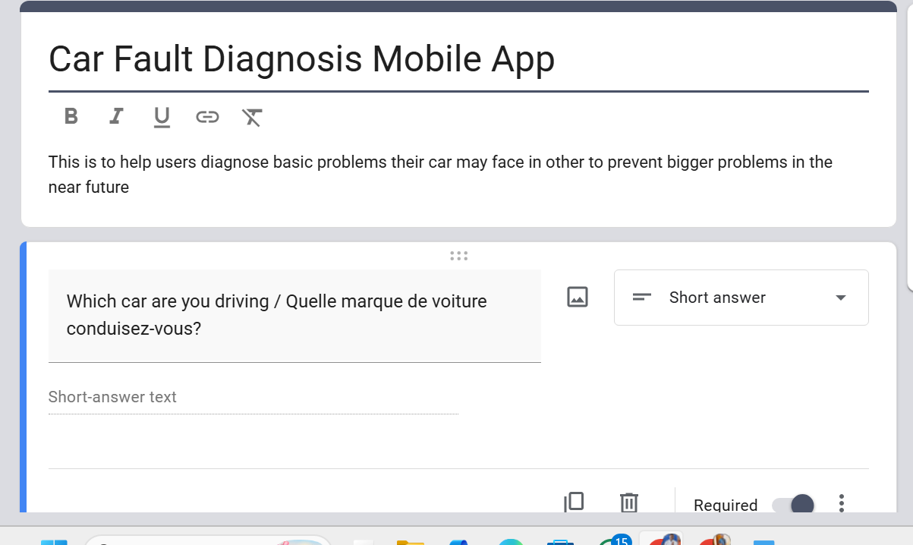
The survey helped identify common issues such as difficulty in diagnosing faults, lack of maintenance tracking, and high repair costs.

1.3.3 Interviews
Interviews were semi-structured. We met teachers of Driving schools to understand how the car works and how fault can be detected easily. We also had some exchange with car owners and we get their feedbacks. In addition, we discuss with some car technicians and mechanics. All these help us to gain deeper insights into user experiences.
Key Insights:
- Many car owners do not understand what is displayed n their dashboard.
- Every thing concerning the dashboard is been explained at the driving school.
- Some experienced car owners actually understand what is on their car dashboard.
- Some car owners rely entirely on mechanics without understanding the problem.
- Some tools that help in car diagnosis actually exist (Example: OBD2).
- Mechanics often face challenges explaining technical issues to customers.
- Some car owners are reluctant to use a digital approach to help them detect car faults.
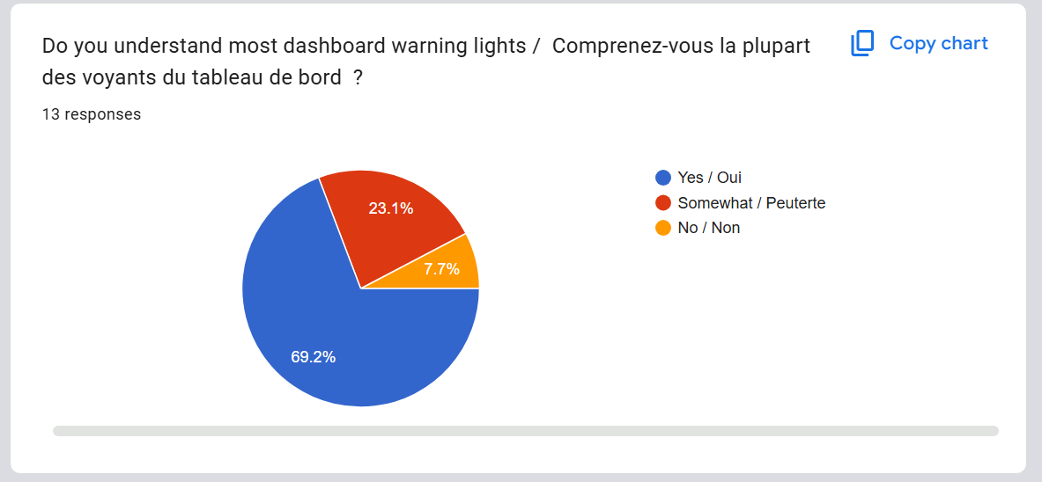

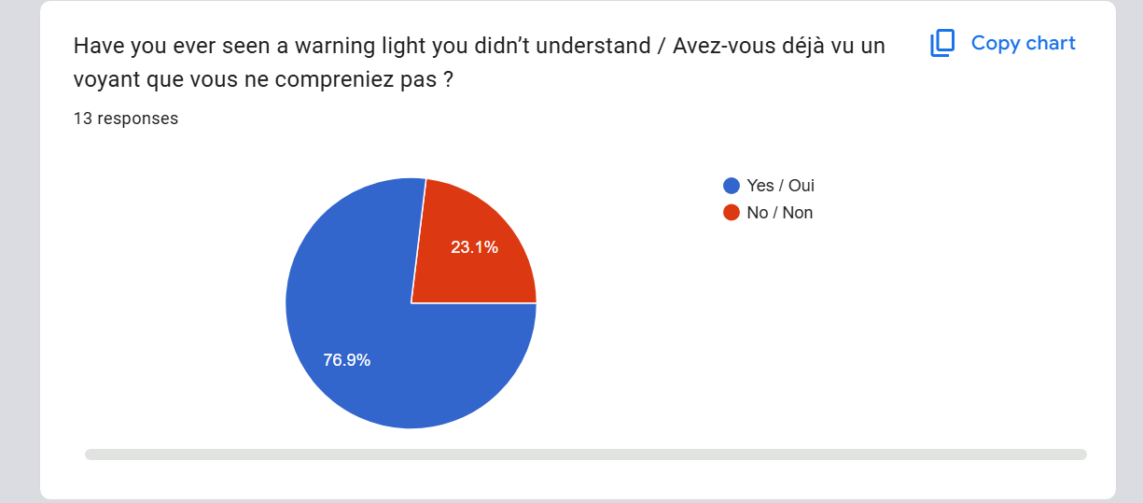

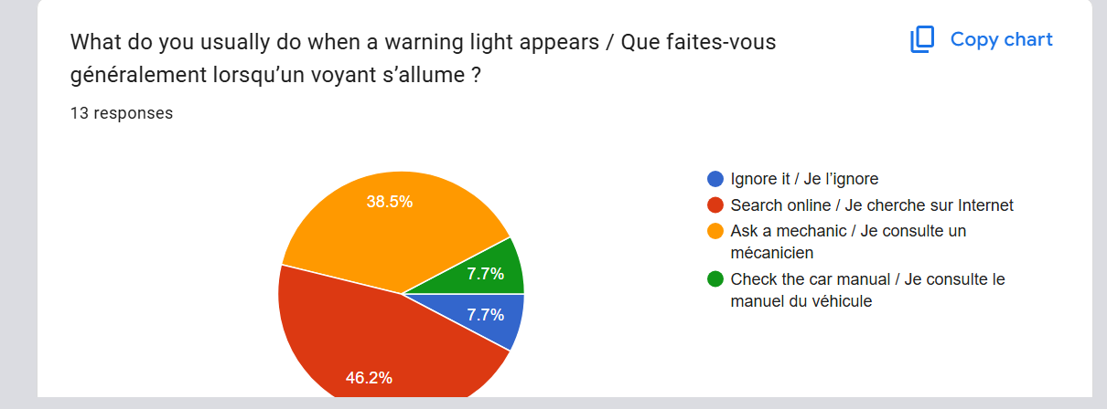

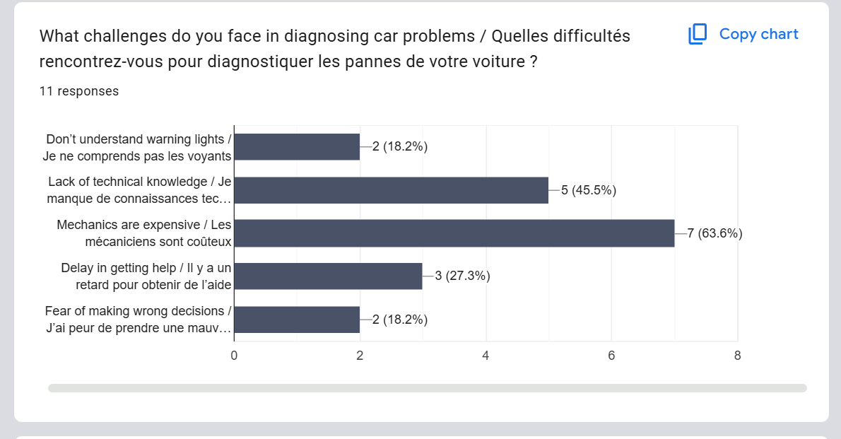

1.3.4 Brainstorming
Brainstorming sessions were conducted within our team to generate ideas and define system features. From the brainstorming, we tried to identify possible solutions to user problems, design system functionalities
Outcomes:
- Vehicle diagnostic feature
- Maintenance reminder system
- Fault code interpretation feature
- Maintenance history tracking

1.3.5 Observation / Reverse Engineering
Reverse engineering was used to analyse existing vehicle maintenance and diagnostic systems. The goal was to understand how current solutions operate, identify their limitations, and determine how they can be improved.

1.3.6 Systems and Practices Analyzed
- Traditional Diagnosis: This is the most common approach used by car owners, where vehicles are taken to mechanics for fault detection and repair. Even though any car owners don’t care about fault detection in their vehicles. They mostly react when a default occurs. When this happens, if they have knowledge and experience, they will try fixing the problem themselves. In the other hand, they rely on mechanics for fault detection and repairs.
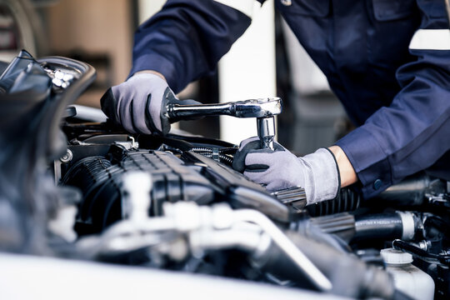
Strengths:
- Relies on practical experience and expertise
- Provides direct human interaction and explanation
- Effective for complex or physical repairs
Limitations:
- Lack of transparency (The mechanic can lie the user)
- High dependency on mechanics
- Risk to get a more complicated situation
- No structured or digital records of past repairs
- Mobile Diagnostic Applications: These applications connect to vehicles (usually via OBD2 devices) to provide real-time diagnostics. Examples include: Torque Pro, Car Scanner ELM OBD2
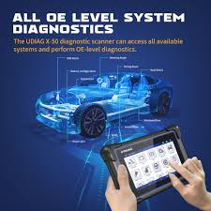
Strengths:
- Provide real-time vehicle data (speed, RPM, temperature, etc.)
- Can read and interpret diagnostic trouble codes
- Offer dashboards and visualizations for monitoring performance
- Generally reliable and widely used
Limitations:
- Some features require technical understanding to interpret fully
- Dependence on external OBD2 hardware
- Limited integration with local services (e.g., mechanics, spare parts)
- Do not provide complete vehicle management (e.g., maintenance history, reminders, cost tracking)
- OBD2-Based Systems: OBD2 (On-Board Diagnostics II) systems are embedded in modern vehicles and provide standardized diagnostic data.
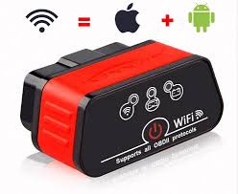
Strengths:
- Highly reliable and accurate fault detection
- Standardized across most modern vehicles
- Provides detailed technical data for diagnostics
Limitations:
- Diagnostic trouble codes may not be easily understood by non-technical users
- Do not provide actionable recommendations or next steps
- Lack user-friendly interpretation and guidance
- Not integrated into a broader vehicle management solution

- Working Principle of Existing diagnostic applications:
Torque Pro: Torque Pro is a mobile application used for vehicle diagnostics and performance monitoring through the OBD2 interface.
Working Principle:
- The application connects to a vehicle’s OBD2 system using an external adapter (usually Bluetooth or Wi-Fi).
- The adapter retrieves real-time data from the vehicle’s Electronic Control Unit (ECU).
- Torque Pro sends queries to the ECU using standard OBD2 protocols.
- The ECU responds with sensor data such as speed, engine RPM, fuel consumption, and temperature.
- The application processes this data and displays it through dashboards, graphs, and gauges.
- It can also read Diagnostic Trouble Codes (DTCs) and provide basic interpretations.
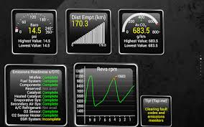
Torque Pro image
Car Scanner ELM OBD2: Car Scanner ELM OBD2 is a mobile diagnostic application designed to monitor vehicle performance and detect faults using OBD2 technology.
Working Principle:
- The app connects to an ELM327-based OBD2 adapter, which serves as a bridge between the smartphone and the vehicle.
- The adapter communicates with the vehicle’s ECU using standardized OBD2 communication protocols.
- The ECU provides real-time data and diagnostic information upon request.
- The application interprets this data and presents it in a user-friendly format (charts, statistics, and reports).
- It can detect and display fault codes and, in some cases, provide descriptions of the issues.
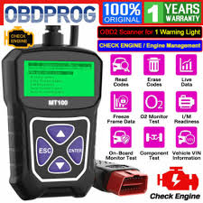
EML OBD2 Image

- Key Gaps Identified: From the analysis of existing systems, the following gaps were identified:
- Limited user-friendly interpretation of technical vehicle data
- Absence of a centralized platform for managing vehicle information
- Lack of automated maintenance reminders
- Weak integration between diagnostics and service providers
- No unified system combining diagnostics, tracking, and decision support
- Proposed Improvements: Based on the identified gaps, our system aims to enhance existing solutions by introducing:
- Fault Interpretation Module: Converts technical diagnostic data into simple, user-friendly explanations
- Maintenance Management System: Stores and tracks vehicle service history
- Smart Reminder System: Notifies users about upcoming maintenance activities
- Cost Estimation Feature: Provides approximate repair and maintenance costs
- Service Integration Module: Connects users with mechanics and spare parts providers
The reverse engineering process demonstrated that existing systems such as traditional mechanic practices, mobile diagnostic applications, and OBD2 technologies are effective and reliable. However, they lack integration, accessibility, and user-centered design. The proposed system builds upon these existing strengths while addressing their limitations, resulting in a more comprehensive, user-friendly, and intelligent vehicle management solution.

1.4 Data Gathering
The following types of data were collected: Vehicle usage and maintenance habits, Common vehicle problems, Repair and maintenance costs, User preferences for digital solutions.
These data were collected though: Surveys, Interviews and Online research

1.5 Data Cleaning

1.5.1 Overview
Data cleaning was necessary to ensure the accuracy, consistency, and reliability of the collected data before analysis.

1.5.2 Cleaning Process and Tools
The following steps were taken:
- Removal of incomplete or irrelevant responses
- Elimination of duplicate entries
- Standardization of similar responses (e.g., grouping similar maintenance issues)
- Correction of inconsistent or unclear answers
For Online data, We used Google form and Excel and for onsite data, we did it manually
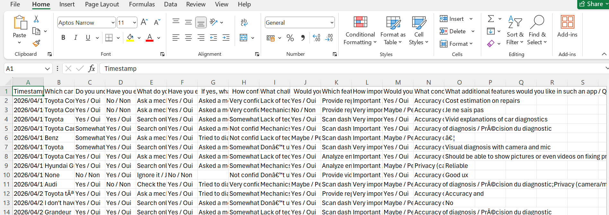

1.6 User Reluctance Assessment

1.6.1 Overview
User reluctance refers to the resistance or hesitation of users to adopt a new system. Understanding this helps in designing a system that users are willing to accept and use.

1.6.2 Identified Challenges
- Lack of trust on new technologies
- Limited technical knowledge among some users
- Preference for traditional methods
- Fear additional cost

Mitigation Strategies
To address these challenges, the following measures were proposed: we can designing a simple and user-friendly interface, Providing clear explanations of vehicle issues, Making the system mobile-friendly and accessible, Educating users on the benefits of the system.

2 Conclusion
The requirement gathering process provided valuable insights into the needs, challenges, and expectations of car owners and other stakeholders. By using a combination of surveys, interviews, brainstorming, and the team was able to collect and analyse relevant data effectively. These findings guided the design of a user-centered system that integrates diagnostic capabilities, maintenance tracking, and decision-support features, ensuring that the final solution is practical, efficient, and aligned with real-world user needs.

