REPUBLIQUE DU CAMEROUN
******************
MINISTÈRE DE L’ENSEIGNEMEN
SUPÉRIEUR
**********
UNIVERSITÉ DE BUEA
********
FACULTÉ D’INGÉNIERIE ET DE
TECHNOLOGIE
******
DEPARTEMENT DU GENIE INFORMATIQUE

REPUBLIC OF CAMEROON
***************
MINISTER OF HIGHER EDUCATION
************
UNIVERSITY OF BUEA
******
FACULTY OF ENGINEERING AND
TECHNOLOGY
*******
DEPARTMENT OF COMPUTER ENGINEERING



CEF440: INTERNET PROGRAMMING AND
MOBILE PROGRAMING
TASK3: REQUIREMENT ANALYSIS

Group 17:
N | NAME | MATRICULE | Percentage Participation
01 | CHEWACHONG LARY CHE | FE23A031. | 100%
02 | KWIDJA MBIANDA MARC URIEL (Group Leader) | FE23A513 | 100%
03 | LEKE BRIAN BECHEM | FE23A080 | 100%
04 | SUME ETONE NZUONKELLE | FE23A145 | 100%
05 | TAMBONG ELVIRA ETCHI | FE23A158 | 100%

INSTRUCTORS: Dr. NKEMENI Valery
Table of Contents
1.1. Introduction 3
1.2. Context Diagram 3
1.2.1. Overview 3
1.2.2. Diagram 4
1.3. Data Flow Diagram (DFD) 6
1.3.1. Overview 6
1.3.2. Diagram 6
1.4. Use Case Diagram 8
1.4.1. Overview 8
1.4.2. Diagram 8
1.5. Sequence Diagram 10
1.5.1. Overview 10
1.5.2. Diagram 10
1.6. Class Diagram 14
1.6.1. Overview 14
1.6.2. Diagram 14
1.7. Activity Diagram 16
1.7.1. Overview 16
1.7.2. Diagram 16
1.8. Deployment Diagram 20
1.8.1. Overview 20
1.8.2. Diagram 20
1.9. Conclusion 21

System Modelling and Design

Introduction
System modelling and design is an essential phase in the software development lifecycle where the requirements gathered during analysis are transformed into structured visual representations of the system. These models provide a clear understanding of how the system will operate, how different components will interact, and how data will flow throughout the application. System design serves as a blueprint for implementation by helping developers, stakeholders, and project supervisors visualize the architecture and behavior of the proposed solution before development begins.
For this project, the modelling and design phase focuses on the Car Fault Diagnosis Mobile Application, an intelligent mobile-based system developed to assist car owners, drivers, and mechanics in diagnosing vehicle faults and managing vehicle maintenance activities. The system integrates OBD2 technology, dashboard warning recognition, artificial intelligence, maintenance tracking, repair cost estimation, and service integration into a unified platform.
The objective of this phase is to represent the functional structure, interactions, and deployment architecture of the system using standard software engineering models and diagrams. These models help identify relationships between system components, define user interactions, illustrate data processing activities, and establish the overall system architecture.
The following diagrams are included in this report:
- Context Diagram
- Dataflow Diagram (DFD)
- Use Case Diagram
- Sequence Diagram
- Class Diagram
- Deployment Diagram
Together, these diagrams provide a comprehensive representation of the proposed system and establish a strong foundation for the implementation phase of the project.

Context Diagram

Overview
A Context Diagram is a high-level representation of a system that illustrates how the system interacts with external entities. It defines the system boundary and shows the flow of information between the system and its surrounding actors without exposing internal processing details. The context diagram helps stakeholders understand the overall scope of the system and identify the primary external users and services involved.
For the Car Fault Diagnosis Mobile Application, the context diagram illustrates how users, external devices, administrators, mechanics, spare parts dealers, artificial intelligence services, and external platforms interact with the system. The system acts as a centralized platform responsible for vehicle diagnostics, maintenance management, intelligent fault interpretation, repair guidance, and service integration.
The major external entities interacting with our system include:
- Car Owners and Drivers
- Mechanics
- Spare Parts Dealers
- System Administrator
- OBD2 Adapter
- AI Service
- YouTube API
The main data exchanged between these entities and the system includes:
- User information
- Vehicle data
- Diagnostic Trouble Codes (DTCs)
- Fault interpretations
- Maintenance records
- Spare part prices
- Notifications
- Video recommendations

Diagram
The context diagram below presents the overall interaction between the Car Fault Diagnosis Mobile Application and its external environment.
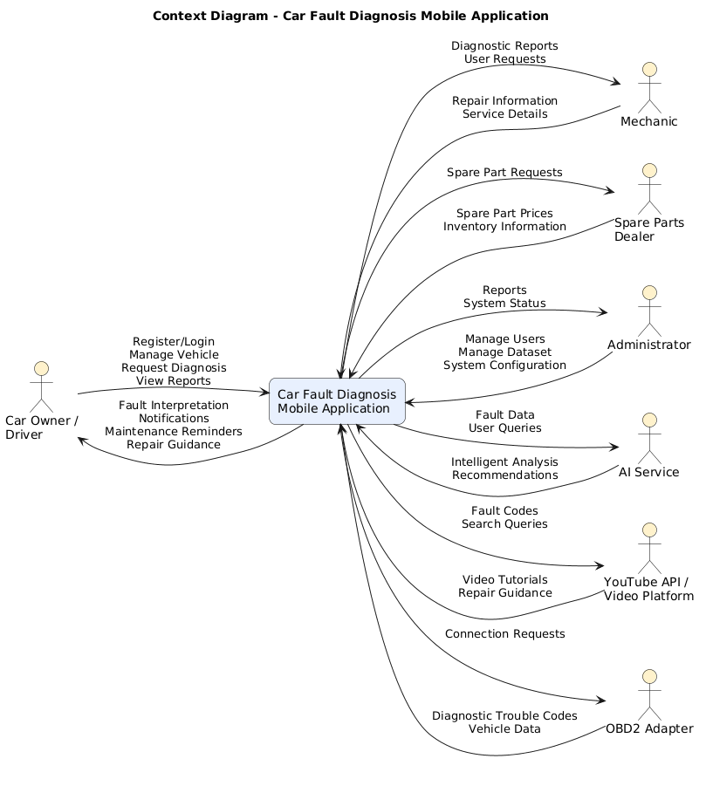
The context diagram illustrates the interaction between the Car Fault Diagnosis Mobile Application and external entities such as car owners, mechanics, spare parts dealers, administrators, AI services, YouTube services, and OBD2 devices. The system receives diagnostic data, user requests, and maintenance information while providing fault interpretations, notifications, repair guidance, and service recommendations.

Data Flow Diagram (DFD)

Overview
A Data Flow Diagram (DFD) is a graphical representation used to illustrate how data moves through a system. It shows the processes performed by the system, the data stores used to keep information, the external entities interacting with the system, and the flow of data between these components. DFDs help developers and stakeholders understand how information is processed and managed within the system.
For the Car Fault Diagnosis Mobile Application, the Data Flow Diagram illustrates how user information, vehicle data, diagnostic results, maintenance records, and service-related information flow through different modules of the system. The diagram also highlights the interactions between users, external services, databases, and processing components.
The data flow of our project is divided into two levels:
- Level 0: Which provide a high-level overview of the major system process and data stores.
- Level 1: Which provide a more detailed breakdown of the internal operations of the system
The major processes represented in the system include:
- User Management
- Vehicle Management
- Diagnostic Processing
- Fault Interpretation
- Maintenance Management
- AI Assistance
- Service Integration
The primary data stores include:
- User Database
- Vehicle Database
- Fault Code Database
- Maintenance Database
- Service Provider Database

Diagram
The diagrams below illustrate the movement and processing of data within the proposed system.
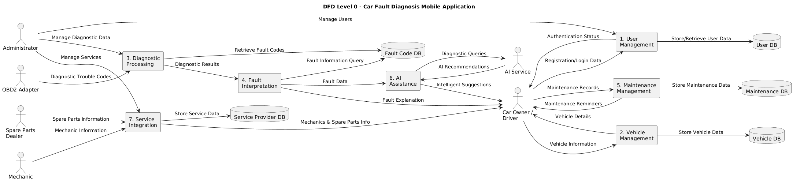
Data Flow Diagram Level 0

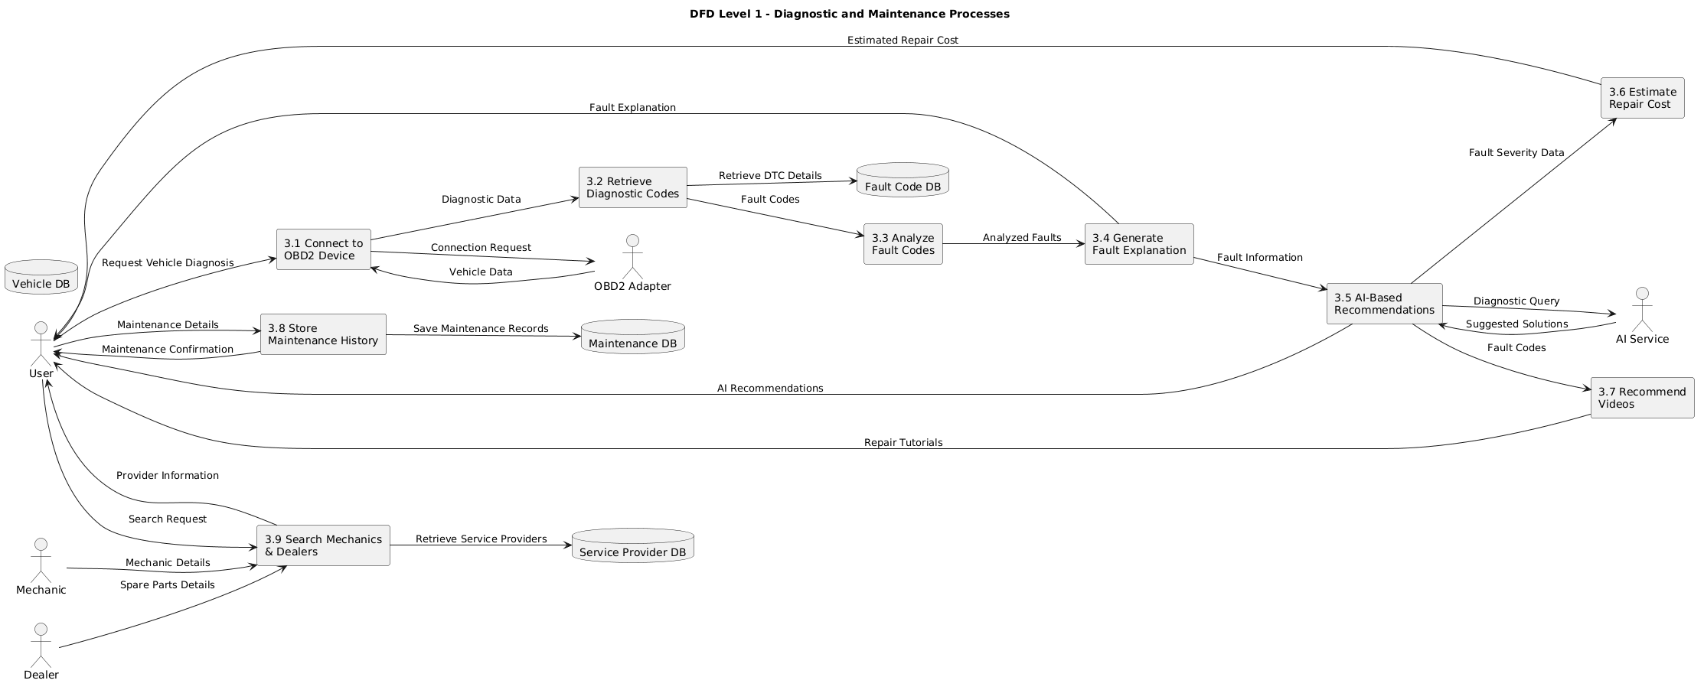

Data Flow Diagram Level 1

Use Case Diagram

Overview
A Use Case Diagram is a behavioral modelling tool used in software engineering to illustrate the interactions between users (actors) and the system. It identifies the major functionalities provided by the system and shows how different users interact with these functionalities. Use case diagrams help in understanding system requirements from the user’s perspective and provide a clear overview of the services the system offers.
For the Car Fault Diagnosis Mobile Application, the use case diagram illustrates how car owners, mechanics, spare parts dealers, and administrators interact with the system. The diagram captures the major operations supported by the application, including vehicle management, fault diagnosis, maintenance tracking, AI assistance, service integration, and administrative management.
The main actors involved in the system are:
- Car Owner / Driver
- Mechanic
- Spare Parts Dealer
- Administrator
The major use cases of the system include:
- User Registration and Login
- Vehicle Management
- OBD2 Connection
- Fault Diagnosis
- Fault Interpretation
- Dashboard Warning Scanning
- AI Chat Assistance
- Repair Cost Estimation
- Maintenance Tracking
- Maintenance Reminders
- Mechanic Search
- Spare Parts Search
- Video Recommendation
- Administrative Management

Diagram
The use case diagram below presents the interaction between the system actors and the functionalities provided by the Car Fault Diagnosis Mobile Application.
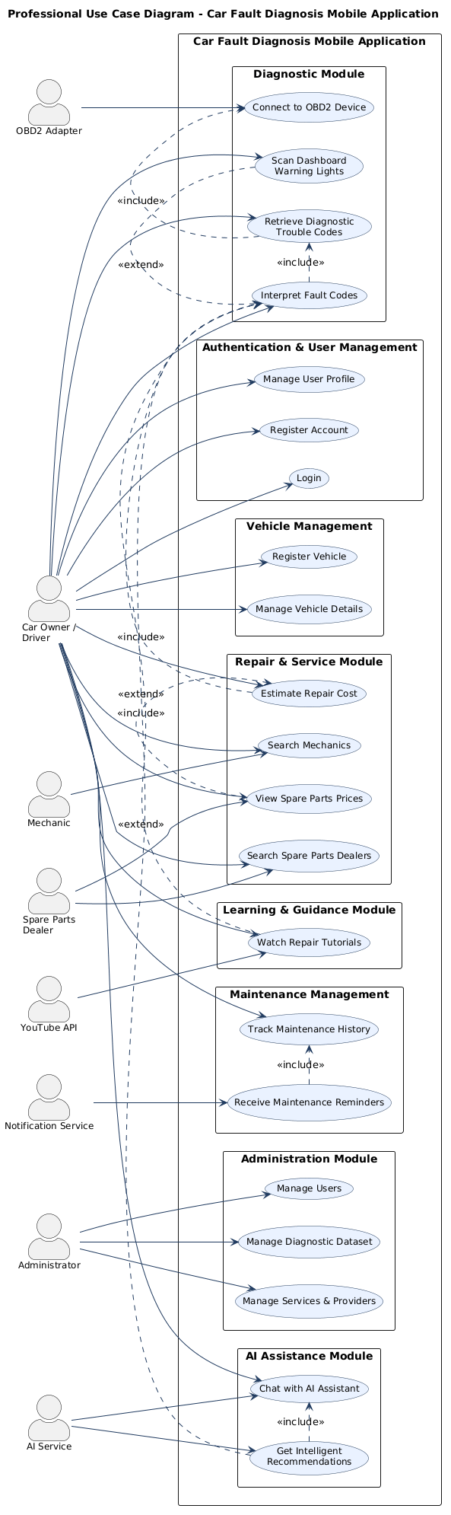

Sequence Diagram

Overview
A Sequence Diagram is a behavioral UML diagram used to represent the order of interactions between system components over time. It illustrates how objects, actors, and system modules communicate with one another to accomplish a specific functionality. Sequence diagrams are important in system design because they help visualize message flow, system behavior, and process execution in a chronological manner.
For the Car Fault Diagnosis Mobile Application, the sequence diagram models the process of diagnosing a vehicle fault using an OBD2 device and intelligent system services. The diagram demonstrates how the user interacts with the mobile application, how the application communicates with external devices and services, and how diagnostic results are processed and returned to the user.
The main components involved in the sequence include:
- Car Owner / Driver
- Mobile Application
- OBD2 Adapter
- Backend Server
- Diagnostic Database
- AI Service
- YouTube API
- Notification Service
The sequence begins when the user requests a vehicle diagnosis through the mobile application. The application establishes a connection with the OBD2 adapter to retrieve Diagnostic Trouble Codes (DTCs). The backend server processes these codes, retrieves fault information from the diagnostic database, and communicates with the AI service to generate intelligent recommendations. The system may also retrieve repair tutorials from YouTube and send maintenance reminders through the notification service before presenting the final results to the user.

Diagram
The sequence diagram below illustrates the detailed interaction flow during the vehicle fault diagnosis process.
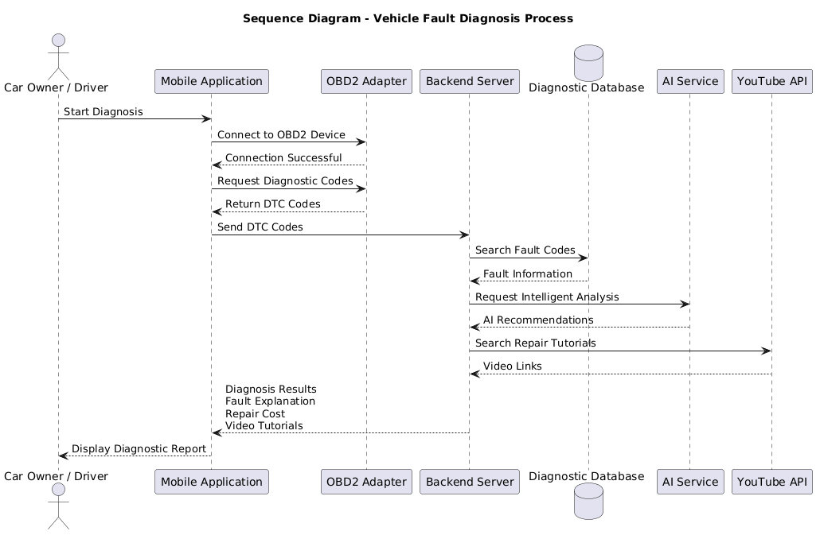
Sequence 1
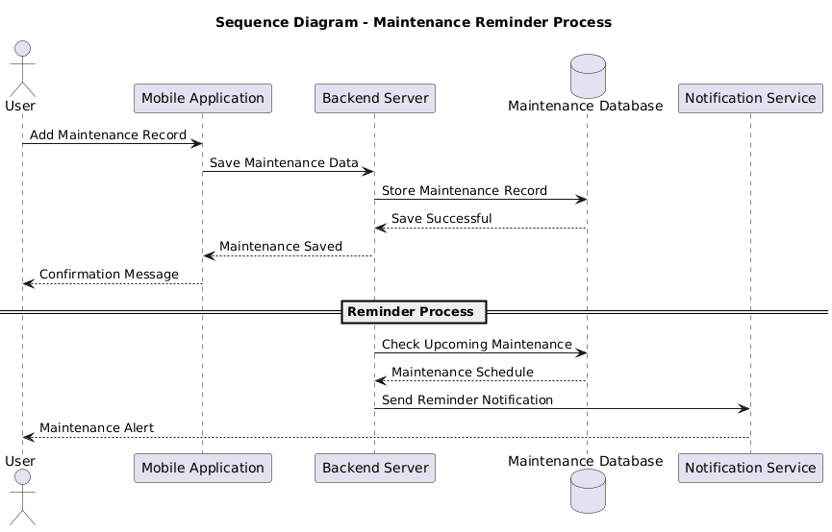
Sequence 2

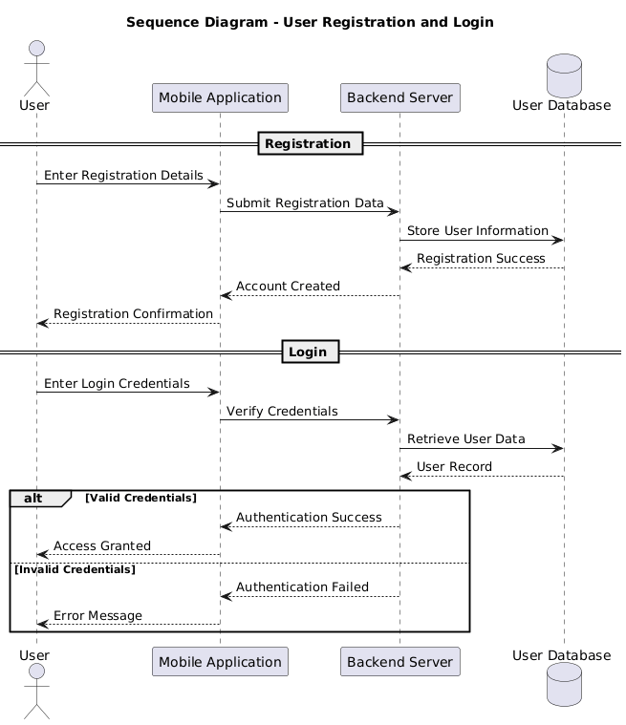
Sequence 3

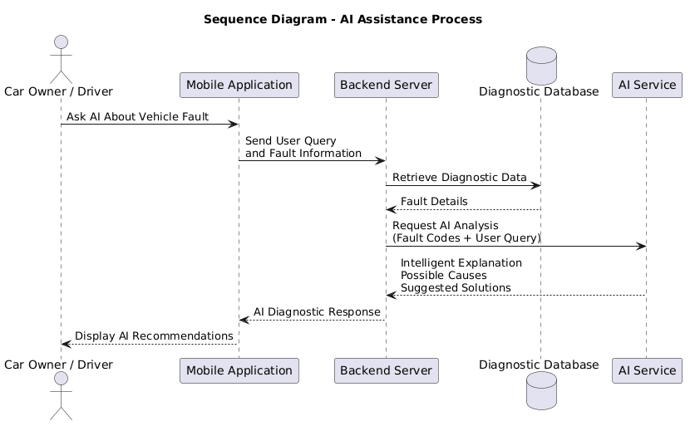
Sequence 4

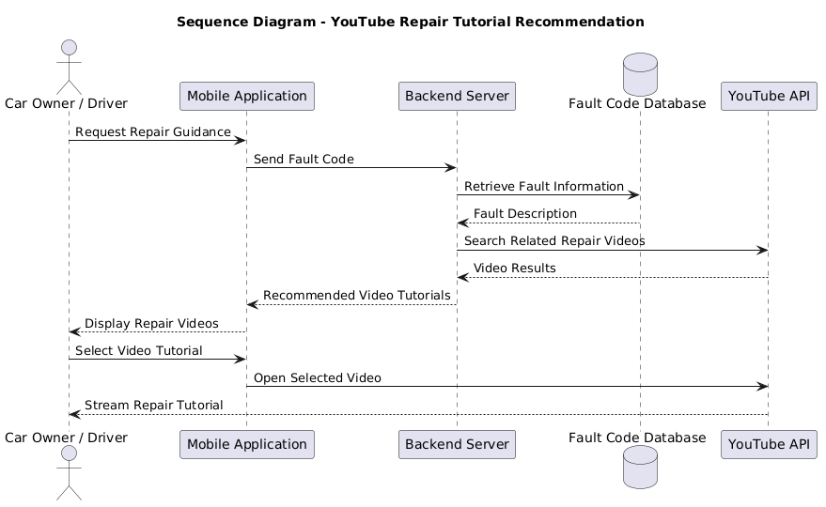
Sequence 5

Class Diagram

Overview
A Class Diagram is a structural UML diagram used to represent the static structure of a system by showing its classes, attributes, methods, and relationships between objects. It serves as a blueprint for software implementation by modeling how data and functionalities are organized within the system.
For the Car Fault Diagnosis Mobile Application, the class diagram represents the major entities involved in vehicle diagnostics, maintenance management, AI assistance, and service integration. It defines the relationships between users, vehicles, diagnostic records, maintenance records, mechanics, spare parts dealers, notifications, and external support modules such as AI services and video recommendations
The diagram helps establish the system architecture by:
- Defining system objects and their responsibilities
- Showing relationships between classes
- Representing inheritance, associations, and dependencies
- Supporting database and backend design
- Providing a foundation for implementation
The main classes represented in the system include:
- User
- Administrator
- Vehicle
- DiagnosticRecord
- FaultCode
- MaintenanceRecord
- Mechanic
- SparePartDealer
- Notification
- AIChatAssistant
- VideoRecommendation

Diagram
The class diagram below illustrates the static structure of the proposed system and the relationships between its major components.
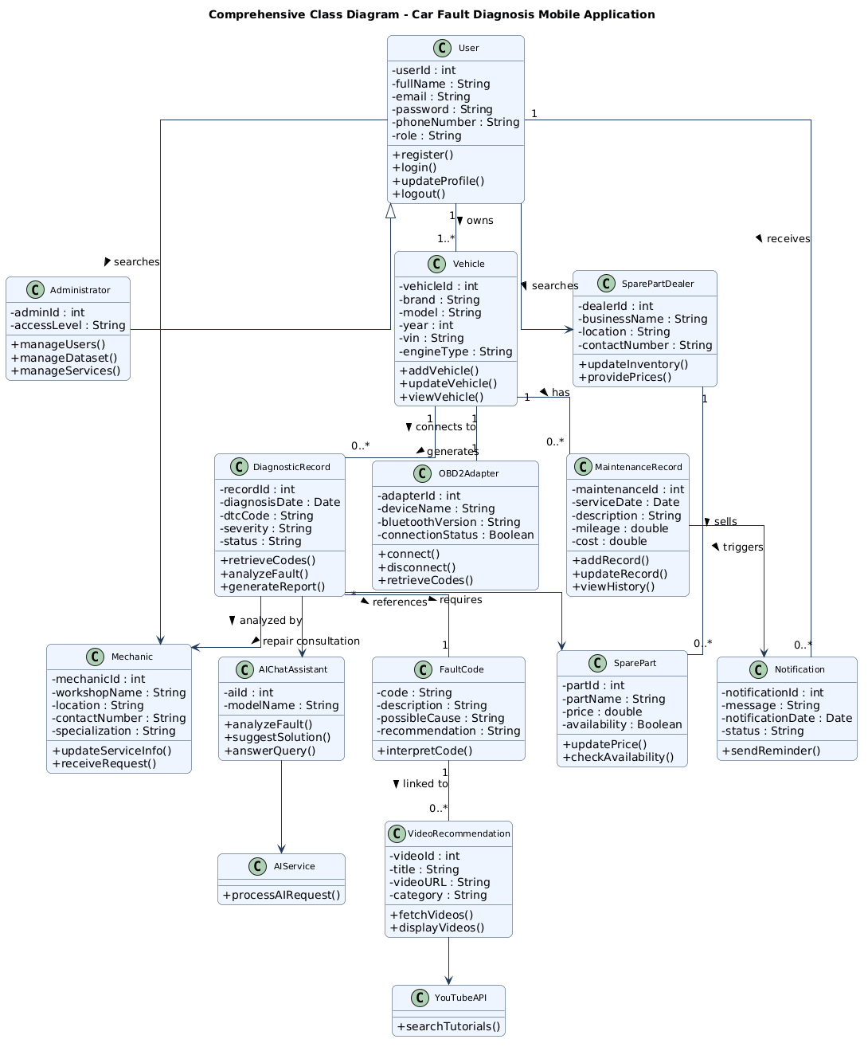
Class Diagram

Activity Diagram

Overview
An Activity Diagram is a behavioral UML diagram used to model the workflow and sequence of activities performed within a system. It illustrates the flow of control from one activity to another, including decisions, parallel operations, and process termination points. Activity diagrams are useful for visualizing business processes, system operations, and user interactions in a dynamic manner.
For the Car Fault Diagnosis Mobile Application, the activity diagram represents the workflow involved in diagnosing vehicle faults and providing intelligent repair assistance. The diagram shows how users interact with the system, how diagnostic data is retrieved from the OBD2 adapter, how fault analysis is performed, and how the system generates recommendations, maintenance reminders, and repair guidance.
The major activities represented in the workflow include:
- User authentication
- Vehicle selection
- OBD2 connection
- Retrieval of diagnostic trouble codes
- Fault analysis and interpretation
- AI recommendation generation
- Repair cost estimation
- Video tutorial recommendation
- Maintenance record update
- Notification generation

Diagram

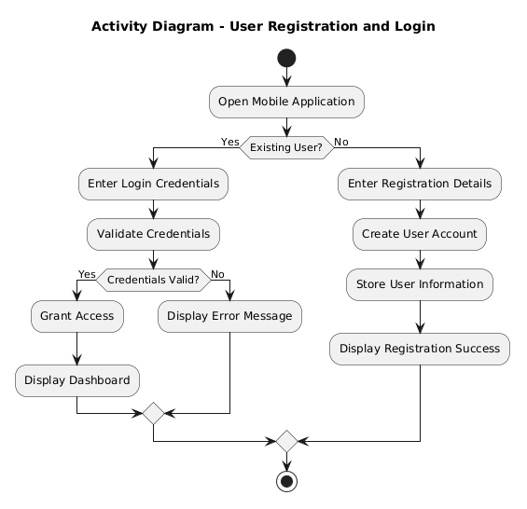
Activity diagram 1
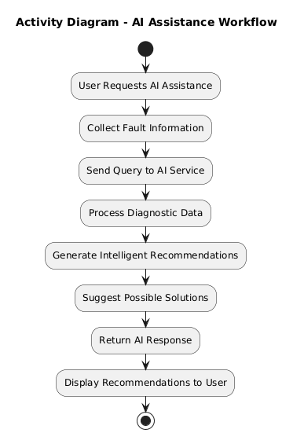
Activity diagram 2

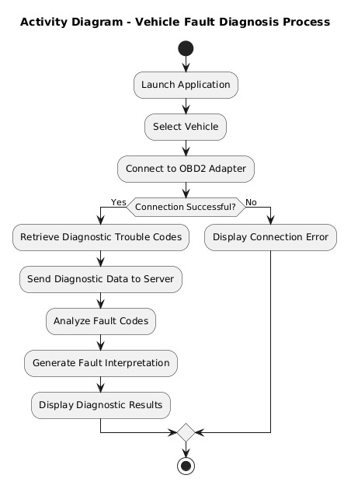
Activity diagram 3

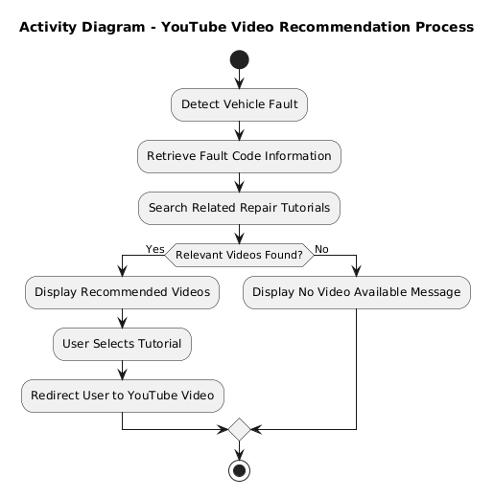
Activity diagram 4
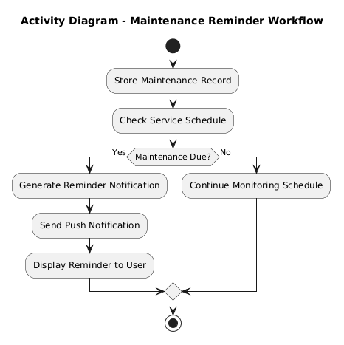

Activity diagram 5

Deployment Diagram

Overview
A Deployment Diagram is a structural UML diagram used to represent the physical architecture of a system. It illustrates how software components are deployed on hardware devices and how these components communicate within the network environment. Deployment diagrams are important for understanding system infrastructure, communication protocols, and the distribution of system resources.
For the Car Fault Diagnosis Mobile Application, the deployment diagram illustrates the interaction between the mobile application, cloud backend services, external APIs, databases, and hardware devices such as the OBD2 adapter. The diagram demonstrates how the different software and hardware components are distributed and connected to support vehicle diagnostics, artificial intelligence processing, maintenance management, notifications, and video guidance services.
The main deployment nodes represented in the system include:
- Mobile Device
- OBD2 Adapter
- Cloud Backend Server
- PostgreSQL Database
- AI Service
- YouTube API
- Firebase Notification Service
The communication between these components occurs through technologies such as:
- Bluetooth communication between the mobile application and the OBD2 adapter
- HTTPS communication between the mobile application and cloud services
- REST APIs for external integrations

Diagram
The deployment diagram below presents the physical architecture and communication structure of the proposed system.
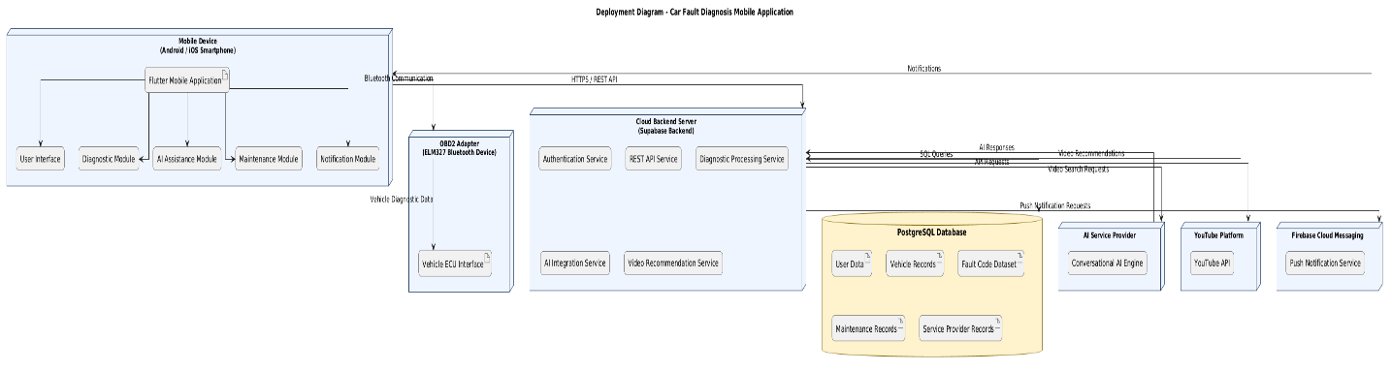

Conclusion
The system modelling and design phase successfully transformed the project requirements into structured visual models that describe the architecture and behavior of the Car Fault Diagnosis Mobile Application. Through the use of Context Diagrams, Data Flow Diagrams, Use Case Diagrams, Sequence Diagrams, Class Diagrams, Deployment Diagrams, and Activity Diagrams, the major components, workflows, and interactions within the system were clearly represented.
The models developed in this report provide a solid foundation for the implementation phase by defining how users, external services, databases, and system modules interact. Features such as OBD2-based fault diagnosis, AI assistance, maintenance tracking, repair cost estimation, and YouTube repair guidance were effectively incorporated into the system design.
Overall, the modelling process has ensured that the proposed system is well-structured, realistic, scalable, and aligned with the project objectives and user requirements.

