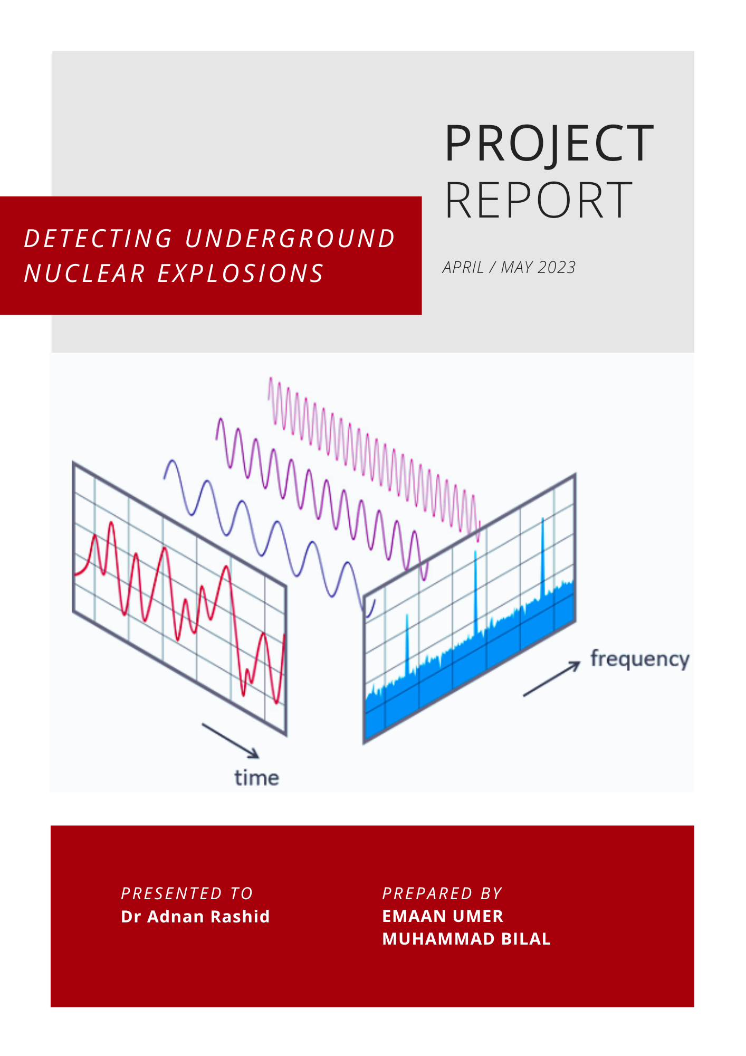

**Table of Contents**

**Background** 2

**1 Historical Overview** 2

**2 Process of Underground Nuclear Testing** 2

**The Problem’s Crucial Importance** 2

1 Global Security 2

2 Environmental and Human Health 2

**Fourier Transform: A mathematical overview** 3

**The Discrete Fourier Transform** 3

Design of DFT algorithm 5

Analysis of the Algorithm 5

The Problem with using a DFT Computation: 6

**The Fast Fourier Transform (FFT)** 6

**From DFT To FFT** 6

**The Cooley-Tukey algorithm.** 7

Design of the Algorithm: 8

Analysis of the Algorithm 8

**Solving the Recurrence Relation** 9

**Detecting signals through wave generation code** 10

**Achievement and Effort** 11

**Problems encountered** 11

**Comments on result of Project** 11

**Future Work** 11

**References** 11

**Introduction**

Nuclear testing has been a significant concern for global security and the environment for decades. This report provides an overview of underground nuclear testing, its historical background, and its implications. The report also examines the importance of detecting underground nuclear explosions and proposes a detection strategy.

# **Background**

## **1 Historical Overview**

Underground nuclear testing refers to the detonation of nuclear devices below the Earth's surface. This type of testing was prevalent during the Cold War era when several countries, including the United States, the Soviet Union, and other nuclear-armed nations, conducted numerous nuclear tests in various geological settings to develop and improve their nuclear weapons capabilities.

## **2 Process of Underground Nuclear Testing**

Underground nuclear testing involves drilling a borehole into the ground and placing a nuclear device, typically contained in a steel or concrete casing, at the bottom of the hole. The device is then detonated, creating a release of energy in the form of an explosion, which results in the vaporization of surrounding rock and formation of a cavity. The energy released in the explosion can cause seismic waves to propagate through the Earth, which can be detected and measured by seismometers located at various distances from the test site.

# **The Problem’s Crucial Importance**

## 1 Global Security

The detection of underground nuclear explosions is a critical issue due to significant implications for global security. Underground nuclear explosions may be associated with clandestine nuclear weapons testing by countries that are not compliant with international agreements such as the Comprehensive Nuclear-Test-Ban Treaty (CTBT), which aims to ban all nuclear explosions. Detecting such explosions can provide crucial information about potential violations of nuclear disarmament treaties and help prevent the proliferation of nuclear weapons.

## 2 Environmental and Human Health

Underground nuclear explosions can have significant environmental and human health impacts. These include the release of radioactive materials into the atmosphere and ground, contamination of soil and water, and potential harm to nearby populations. Detecting and monitoring underground nuclear explosions can provide early warning of such events, enabling timely response and mitigation measures to protect the environment and human health.

Proposed Solution

To detect underground nuclear activity, we will employ the use of the Fourier Transform. The Fourier Transform is a mathematical tool that allows signals to be decomposed into their constituent frequencies. In the case of seismic data, this means that the vibrations of the Earth caused by underground nuclear explosions can be analyzed to determine their frequencies:

1. Seismic data is collected using a network of seismometers located around the world.
2. The Fourier Transform is used to identify the frequency content of the seismic signals.
3. The frequency content of the seismic signals is compared with known characteristics of underground nuclear explosions to create a database of known nuclear explosion signatures.
4. By comparing the frequency content of seismic signals with known nuclear explosion signatures, it is possible to determine whether an underground nuclear explosion has taken place.
5. The Fourier Transform can also be used to improve seismic hazard assessments by accurately identifying seismic signals generated by underground nuclear explosions.
6. The use of the Fourier Transform to detect underground nuclear activity can be a powerful tool in the fight against nuclear proliferation and the protection of the environment and human health.

# **Fourier Transform: A mathematical overview**

The Fourier Transform is a mathematical technique that transforms a function of time, x(t), to a function of frequency, X(ω).

The Fourier Transform of a function can be derived as a special case of the Fourier Series when the period, T→∞.

# **The Discrete Fourier Transform**

In the real world, continuity is impractical as it is impossible to measure a range of values continuously over a dataset. Thus, it is much more practical and realistic to take finite values from a finite dataset. In this case, we modify the original definition of the Fourier Transform, from integrating over a continuous domain to summing over a discrete one.

Doing this results in what is known as the Discrete Fourier Transform (DFT). It is equivalent to the continuous Fourier Transform, but for signals known only at N instants separated by sample times T (i.e. a finite sequence of data).

Let *f(t)* be the continuous signal which is the source of the data. Let *N* samples be denoted *f[0], f[1], f[2], … , f[k], … , f[N-1].*

The Fourier Transform of the original signal, *f(t)*, would be

We could regard each sample *f[k]* as an *impulse* having area *f[k].* Then, since the integrand exists only at the sample points:

In principle, this could be evaluated for any datapoint, but with only N data points to start with, only *N* final outputs will be significant. The DFT also assumes periodicity of the data samples i.e. data is repeated over a constant sampling rate. This is illustrated in the figure below:

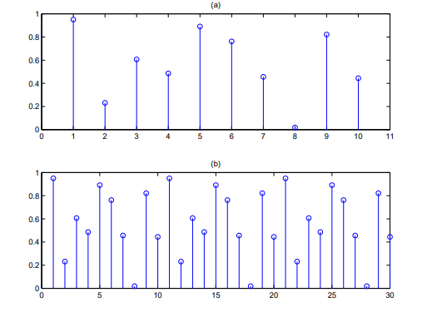

Since the operation treats the data as if it were periodic, we evaluate the DFT equation only for the fundamental frequency:

## 

## Design of DFT algorithm

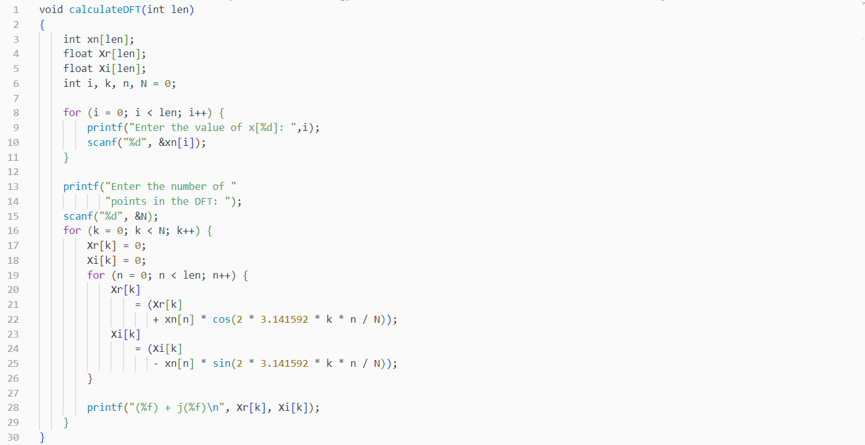

## Analysis of the Algorithm

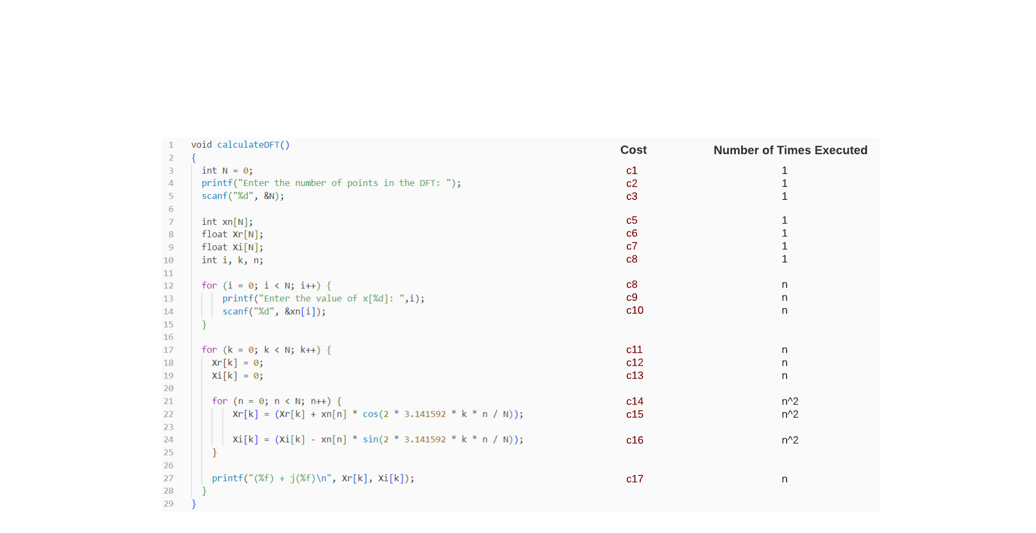

T(n) = O (n^2)

The Problem with using a DFT Computation:  
DFT has limitations and challenges in practical situations:

1. It has high computational complexity for large input sizes (O(N^2)).
2. It requires high memory for intermediate results and coefficients.
3. It assumes periodicity and can cause leakage and aliasing effects, reducing accuracy.
4. It can be time-consuming, making it difficult to use in real-time processing applications with low latency requirements.

# **The Fast Fourier Transform (FFT)**

The FFT is an efficient algorithm for computing the Discrete Fourier Transform (DFT) and its inverse. It does so by exploiting the symmetry and periodic properties of the DFT to reduce the number of computations required to solve a single problem. In contrast to the DFT’s O(N^2) time complexity, the FFT boasts a complexity of O(n log n), which is much faster for larger input sizes. To demonstrate the marginal difference in computation, the table below displays the relevant information:

|  |  |  |  |
| --- | --- | --- | --- |
|  | ***N = 10³*** | ***N = 10⁶*** | ***N = 10⁹*** |
| **N²** | 10⁶ | 10^12 | 10^18 |
| **NlogN** | 10⁴ | 20 * 10^6 | 30 * 10^9 |

For an input size of 100 million, the FFT finishes its computation of what could potentially take years to under just a minute.

The FFT algorithm is typically implemented using a divide-and-conquer approach, where the input signal is recursively divided into smaller subproblems, and the DFT is computed for each subproblem separately. The computed DFTs are then combined to obtain the final DFT of the original input signal. This divide-and-conquer approach allows for efficient computation of the DFT by reusing intermediate results and avoiding redundant computations.

There are several popular FFT algorithms, including the Cooley-Tukey algorithm, the Radix-2 algorithm, and the Radix-4 algorithm, among others. These algorithms differ in their implementation details, but they all share the same basic principle of recursively dividing and conquering the input signal to compute the DFT efficiently.

# **From DFT To FFT**

Before we proceed to analyze the FFT algorithm, it is crucial to gain insight on how this miraculous algorithm actually came into being.

This is the formula for the Discrete Fourier Transform:

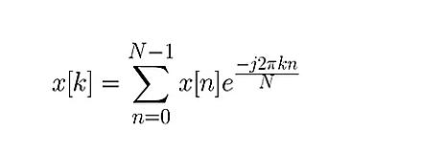

Fourier Transform makes use of two symmetric properties to reduce what are effectively redundant calculations:

1. Complex Conjugate Symmetry 2. Periodicity

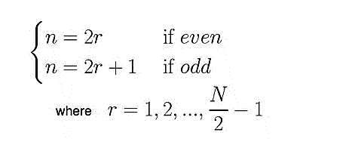Following the properties above, we divide our N signals into even and odd subsequences of size N/2 by assuming the conditions below:

Substituting this into our original discrete function, we can split it into two summations of N/2 each. The advantage of this approach lies in the fact that the even and odd indexed sub-sequences can be computed concurrently.

This equation, through mathematical simplification, simplifies further:

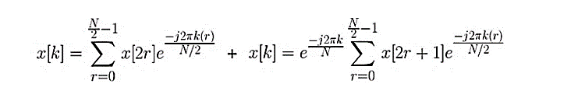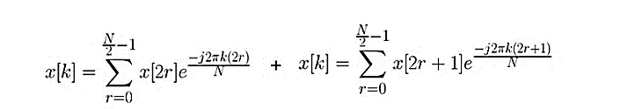

🡪

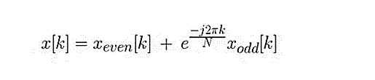

We now end up with our Fast Fourier Transform:

But there's no reason to stop there: as long as our smaller Fourier transforms have an even-valued split, we can reapply this divide-and-conquer approach, halving the computational cost each time, until our arrays are small enough that the strategy is no longer beneficial and there are N 1-point DFTs

With this recursion, we can reduce the complexity to a very feasible operation of O(nlogn). This method of conversion to the frequency domain has its very own algorithm known as the Cooley-Tukey algorithm

# **The Cooley-Tukey algorithm.**

J. W. Cooley and John Tukey published a paper in 1965 describing what is now known as the most common form of the Fast Fourier Transform. This algorithm not only increases the efficiency by orders of magnitude but also scales much better. It’s time complexity of O (N log N) mean that a 256-byte sample takes only about 2000 calculations while a 1024 takes just over 10000. It is particularly suited for signal lengths that are a power of 2, and is also referred to as the Radix-2 algorithm

Here's a high-level explanation of the Cooley-Tukey algorithm for FFT:

1. **Input**: The Cooley-Tukey algorithm takes as input a sequence of n complex numbers representing the discrete signal in the time domain that we want to transform into the frequency domain.
2. **Splitting**: The input signal is split into two smaller sequences by separating the even-indexed samples and odd-indexed samples. This results in two sequences, often referred to as "even" and "odd" halves of the original signal.
3. **Recursion**: The Cooley-Tukey algorithm is applied recursively to the even and odd halves obtained in the previous step. This means that the FFT is applied independently to the even half and the odd half of the input signal.
4. **Combining**: Once the FFT is applied recursively to the even and odd halves, the results are combined to obtain the final FFT of the original input signal. The combining step involves multiplying the odd half by a set of complex numbers known as "twiddle factors" and adding or subtracting them from the even half, depending on the index. The twiddle factors are carefully chosen complex numbers that depend on the signal length and the current index, and they play a key role in efficiently combining the results of the even and odd halves.
5. **Repeat**: Steps 2-4 are repeated recursively until the base case of the FFT is reached, which is when the input signal length is reduced to 1.
6. 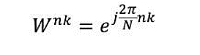**Output**: The final output of the Cooley-Tukey algorithm is the FFT of the original input signal, represented as a sequence of complex numbers in the frequency domain.

Mathematically, a twiddle factor is represented as a complex number of the form:

## Design of the Algorithm:

The pseudocode for this algorithm is shown as follows:

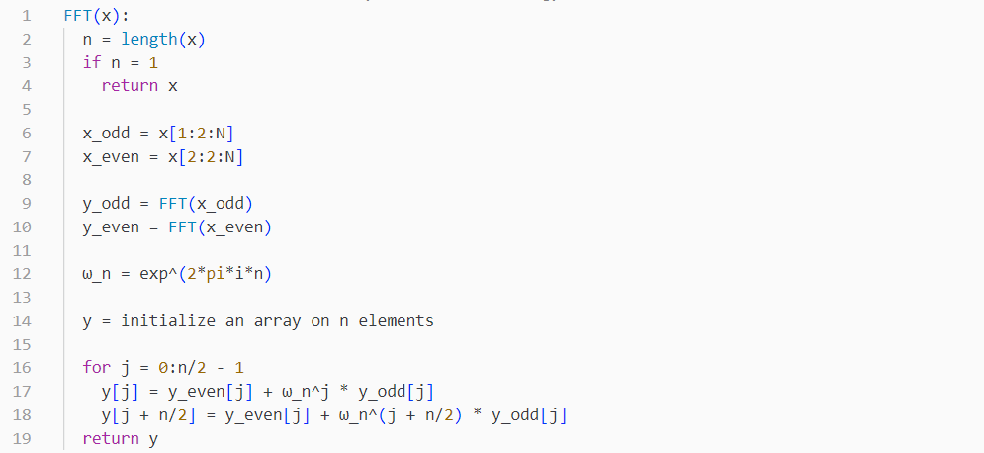

## Analysis of the Algorithm

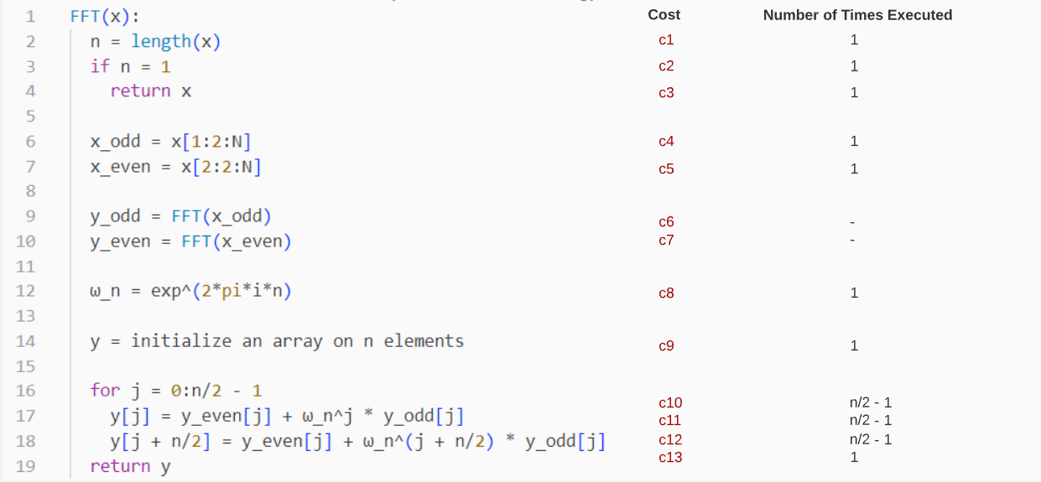



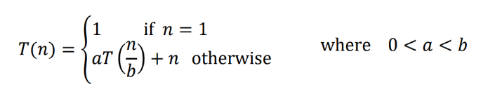To verify the time complexity of this code, we first notice that this algorithm is a recursive algorithm.

Hence, the following format will apply:

To find the non-recursive part:

T(n) = c1*1 + c2*1 + c3*1 + c4*1 + c5*1 + c8*1 +c9*1 + c10*() + c11*() + c12*() + c13*1

= (c1 + c2 + c3 + c4 + c5 + c8 + c9 + c13 – c10 – c11 – c12) + ()\***n =**  O (n)

To find the recursive part:

We make use of the recursion tree concept.

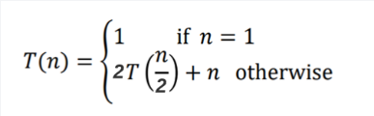If a recursion tree is made of the Fast Fourier Transform, we know that the function is split into two recursive calls (one each for odd and even). *Number of branches of the tree = a = 2*. With each recursive call, we pass half the size of our current sample. *Factor by which input size is reduced = b = 2*

Combining both our results, we get the recurrence relation as:

# **Solving the Recurrence Relation**

We now draw the recursion tree of the given recurrence relation as follows:

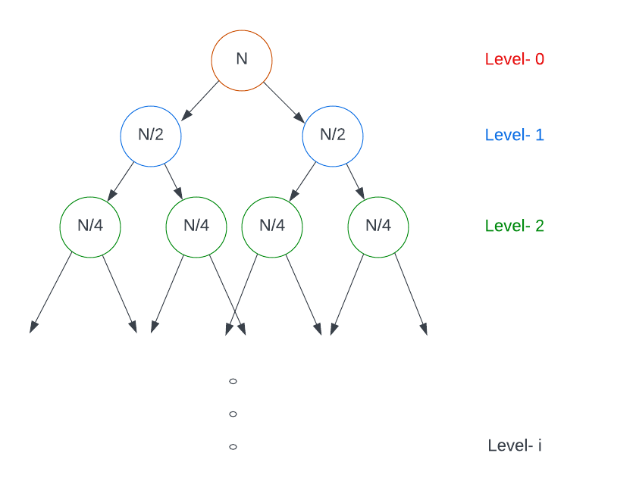

We then determine the cost of each level as:

* Cost of level-0 = n
* Cost of level-1 = n/2 + n/2 = n
* Cost of level-2 = n/4 + n/4 + n/4 + n/4 = n

…and so on.

The total number of levels in the tree are calculated as:

* Size of sub-problem at level-0 = n/2⁰
* Size of sub-problem at level-1 = n/2
* Size of sub-problem at level-2 = n/2² …
* Size of sub-problem at level-i = n/2ⁱ

Because at the last level the size of the sub-problem becomes 1, then n/2ⁱ = 1

We now get i =

This means level-i or level- has nodes

Adding the cost of all levels in the recursion tree and simplifying it, we get our complexity as:

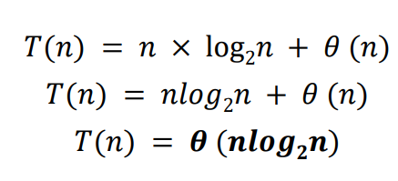

# **Detecting signals through wave generation code**

To detect nuclear activity in seismic signals, we utilized the power of FFT in our Python code. First, we generated two distinct waveforms - one containing pure seismic signals and the other with seismic signals along with nuclear activity. These waveforms were created in the amplitude-time domain.

Next, we applied our FFT code to these waveforms to transform them into the amplitude-frequency domain. This enabled us to analyze the resulting graph and its peaks, which provided us with valuable insights regarding the presence of nuclear activity.

By examining the high-frequency components present in the graph, we were able to accurately identify the presence of nuclear activity. This technique not only allowed us to detect nuclear explosions, but it also helped us better understand the complex behavior of seismic signals in real-world scenarios.

**No nuclear activity present:**

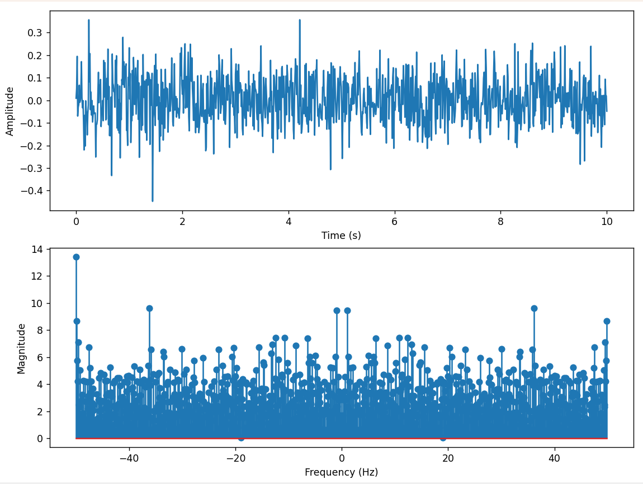 

**Nuclear activity present:**

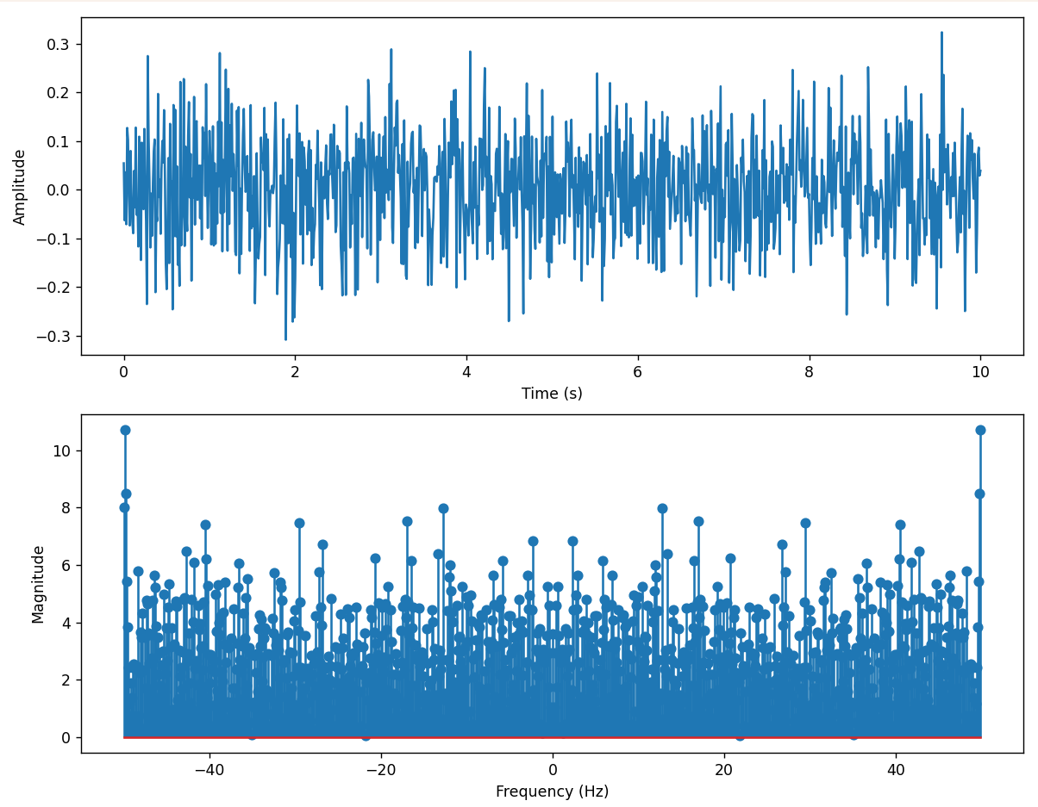 

# **Achievement and Effort**

**The project aimed to develop an algorithm to convert the amplitude-time waveform of a real-life phenomenon, like an earthquake or nuclear explosion, into Fourier Transform. The team used advanced tools and techniques and faced challenges in optimizing the algorithm. They developed an O(NlogN) algorithm capable of producing accurate and reliable results in a timely manner. The project contributes significantly to signal processing and can be used to analyze a range of complex signals.**

# **Problems encountered**

**The project aimed to develop an algorithm to convert the amplitude-time waveform of real-life phenomena like earthquakes and nuclear explosions, and faced several challenges such as data quality, algorithm optimization, signal processing complexity, and graphical visualization. Overcoming these challenges required careful planning and execution, but by leveraging the latest tools and techniques in computational science and signal processing, the team developed a high-quality algorithm that effectively achieved the project objectives and contributed to the field of signal processing.**

# **Comments on result of Project**

**The project successfully achieved its goal of creating an algorithm that could transform the amplitude-time waveform of a real-world phenomenon with a high degree of accuracy and efficiency. However, there were some areas that could be improved upon. The algorithm's application could be broadened to cover a wider range of real-world occurrences, and the issue of data uncertainty was not addressed, which could affect the accuracy of the results.**

# **Future Work**

**Future work could focus on expanding the algorithm's scope to cover a wider range of real-life phenomena such as volcanic eruptions, tsunamis, or weather events. Incorporating uncertainty quantification and optimizing computational efficiency could also improve the accuracy of results and reliability of the algorithm. Further validation using experimental data from real-life phenomena could also be performed to verify the algorithm's effectiveness in practical scenarios and identify areas for improvement.**

# **References**

<https://brianmcfee.net/dstbook-site/content/ch06-dft-properties/Conjugate-Symmetry.html#:~:text=DFT%20conjugate%20symmetry%20says%20that,be%20inferred%20once%20we%20have>

<https://se.copernicus.org/articles/10/59/2019/>

<https://www.ncbi.nlm.nih.gov/pmc/articles/PMC4165831/>

<https://www.youtube.com/watch?v=nmgFG7PUHfo>

<https://byjus.com/maths/fourier-transform/#:~:text=Fourier%20Transform%20is%20a%20mathematical,%2C%20RADAR%2C%20and%20so%20on>.

<https://www.geeksforgeeks.org/discrete-fourier-transform-and-its-inverse-using-c/>

<https://www.robots.ox.ac.uk/~sjrob/Teaching/SP/l7.pdf>