In **CSVParsing** section, please find the java files, GTFS text files and gtfs.sql database file.

1. Clone this repository and put it in a directory.
2. Make sure Java 8 and mysql are installed on your machine.
3. Import the gtfs.sql file (it has all tables that are later populated with the CSvalues from text files) into MySQL.
4. Please add in the Libraries **mysql-connector-java** package.

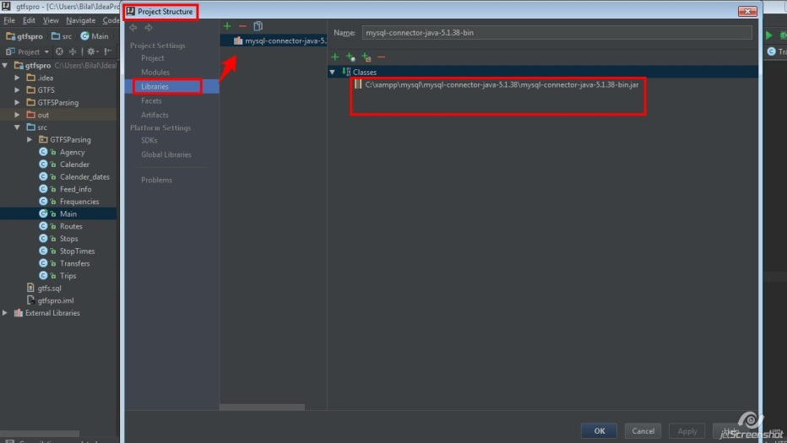

1. Main.java executes the program where CSvalues of the text files are parsed and then sent to be stored in pre-made empty tables in the database.