What's New
Application List Page

- The application list page is selected from the Pages menu.
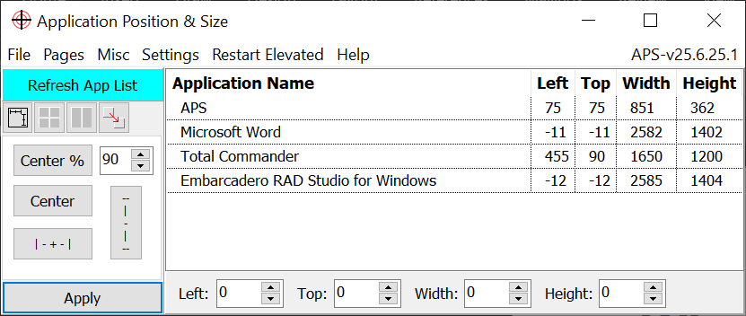

- If the Pages menu is not showing go to Settings and select Pages.
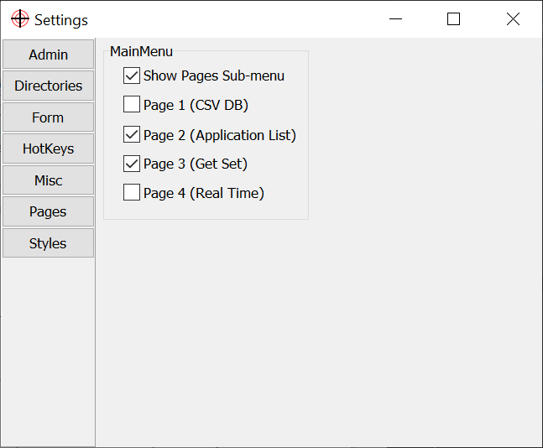

Comments

- APS was written to help position applications when I worked remotely. It really aggravated me when remote desktop put its control bar at the top center and then decided to load office applications top bar with features right under the remote desktop control bar. APS was created so I could quickly reposition and resize apps so everything was accessible.

To Do Next

- Update help file

Contact

- delphi.coder@yahoo.com

