ENGR 3323: Signals and Systems
HW 10_Ch7

Q1) In previous homework you found the exponential Fourier series of x(t). Find the Fourier transform of y(t) and compare X(ω) to the Fourier series coefficients D_{k}.
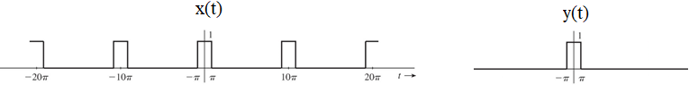

Q2) Find the Fourier transforms of the signals shown below using the Fourier transform integral.

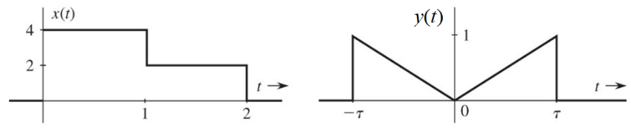

Q3) Find the inverse Fourier transforms of the signals shown below using the inverse Fourier transform integral.

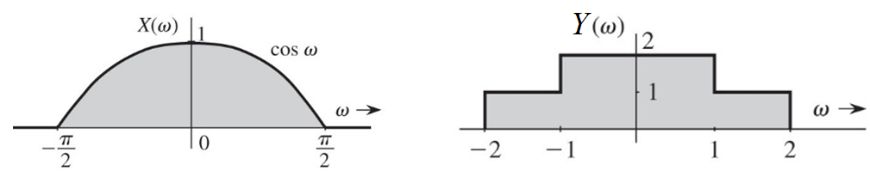

Q4) Sketch the following functions:
a) rect (t/4) b) Δ(3ω/80) c) rect ((t − 8)/6)
d) sinc (πω/7) e) sinc ((ω/7) − 2π) f) sinc (t/5) rect (t/10π)

Q5) Find the inverse Fourier transform of X(ω) for the spectra illustrated in Figure below.
[Hint: X(ω) = |X(ω)| e^{j∠x(ω)}. This problem illustrates how different phase spectra (both with the same amplitude spectrum) represent entirely different signals.]

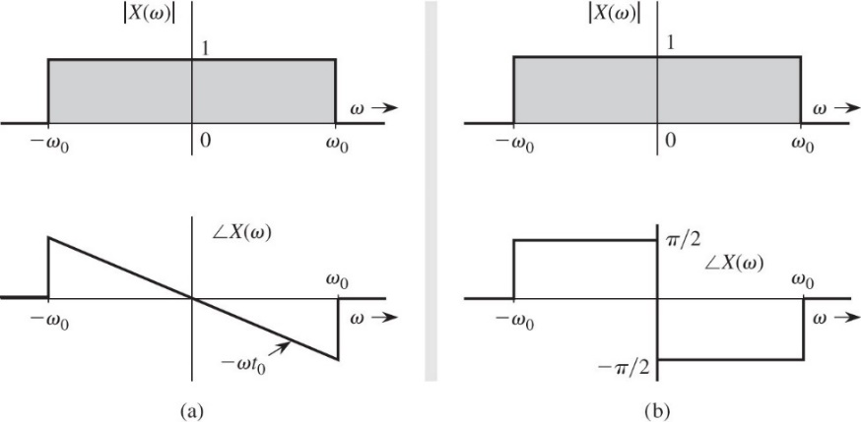
Q6) The Fourier transform of the triangular pulse x(t) in Figure below is expressed as
$$X\left(ω\right)=\frac{1}{ω^{2}}\left(e^{-jω}-jωe^{-jω}-1\right)$$
Use this information, and the time-shifting and time-scaling properties, to find the Fourier transforms of the signals x₁(t) and x₂(t).
