ENGR 3323: Signals and Systems
HW 11_Ch7

Q1) Find the Fourier transforms (FT) of the signals shown below using only the time-shifting property and the FT Table.
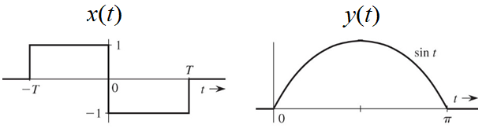
Q2) The signals below are modulated signals with carrier cos(10t). Find the Fourier transforms of these signals by using the Fourier transform properties and the FT table. Sketch the amplitude and phase spectra for the signals.
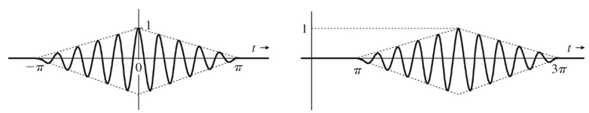
Q3) Use the frequency-shifting property and the FT Table to find the inverse Fourier transform of the spectra shown below
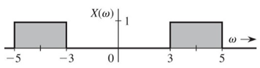

Q4) For a stable LTIC system with transfer function H(s) = 1/(s + 1) find the (zero-state response) if the input x(t) is
a) e^{−2t}u(t) b) e^{−t}u(t) c) e^{t}u(−t) d) u(t)
Q5) Signals x₁(t) = 10⁴rect (10⁴t) and x₂(t) = δ(t) are applied at the inputs of the ideal low-pass filters shown below
H₁(ω) = rect (ω/40,000π) and H₂(ω) = rect(ω/20,000π). The outputs y₁(t) and y₂(t) of these filters are multiplied to obtain the signal y(t) = y₁(t)y₂(t).
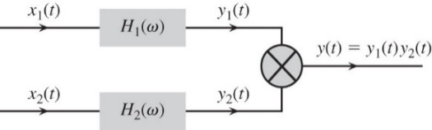
a) Sketch X₁(ω) and X₂(ω). b) Sketch H₁(ω) and H₂(ω).
c) Sketch Y₁(ω) and Y₂(ω). d) Find the bandwidths of y₁(t), y₂(t), and y(t).
Q6) For the signal $x\left(t\right)=\frac{2a}{t^{2}+a^{2}}$ determine the essential bandwidth B (in hertz) of x(t) such that the energy contained in the spectral components of x(t) of frequencies below B Hz is 99% of the signal energy E_{x}.

Q7) Figure below shows a scheme to transmit two signals m₁(t) and m₂(t) simultaneously on the same channel (without causing spectral interference). Such a scheme, which transmits more than one signal, is known as signal multiplexing. In this case, we transmit multiple signals by sharing an available spectral band on the channel, and, hence, this is an example of the frequency-division multiplexing. The signal at point b is the multiplexed signal, which now modulates a carrier of frequency 20,000 rad/s. The modulated signal at point c is now transmitted over the channel.

a) Sketch the spectra at points a, b, and c. b) What must be the minimum bandwidth of the channel?
c) Design a receiver to recover signals m₁(t) and m₂(t) from the modulated signal at point c.

