ENGR 3323: Signals and Systems
HW 12_Ch8

Q1) Figure below shows the Fourier spectra of signals x₁(t) and x₂(t). Determine the Nyquist sampling rates for signals a) x₁(t) b) x₂(t) c) x₁(t) x₂(t) d) x₁²(t)
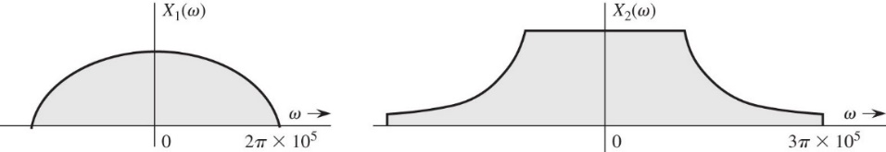
Q2) A signal x (t) = 3 cos 6πt + cos 16πt + 2 cos 20πt is sampled at a rate 25% above the Nyquist rate. Sketch the
spectrum of the sampled signal. How would you reconstruct x (t) from these samples? If the sampling frequency is 25%
below the Nyquist rate, what are the frequencies of the sinusoids present in the output of the filter with cutoff frequency
equal to the folding frequency? Do not write the actual output; give just the frequencies of the sinusoids present in the
output.

Q3) A TV signal (video and audio) has a bandwidth of 4.5 MHz. This signal is sampled, quantized, and binary coded.
a) Determine the sampling rate if the signal is to be sampled at a rate 20% above the Nyquist rate.
b) If the samples are quantized into 1024 levels, what number of bits is required to encode each sample?
c) Determine the binary pulse rate (bits/s) of the binary-coded signal.
d) Determine the quantization error if the signal amplitude range from -10 to 10 Volt.

Q4) Five telemetry signals, each of bandwidth 1 kHz, are quantized and binary coded. These signals are time-division
multiplexed (signal bits interleaved). Choose the number of quantization levels so that the maximum error in sample
amplitudes is no greater than 0.2% of the peak signal amplitude. The signals must be sampled at least 20% above the
Nyquist rate. Determine the data rate (bits per second) of the multiplexed signal.

