ENGR 3323: Signals and Systems
HW 1_Ch1
1) Find the energies of the following signals below.
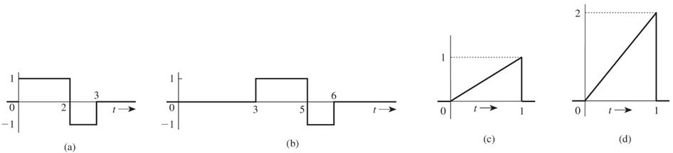
2) Find the power and the rms value of the signal below
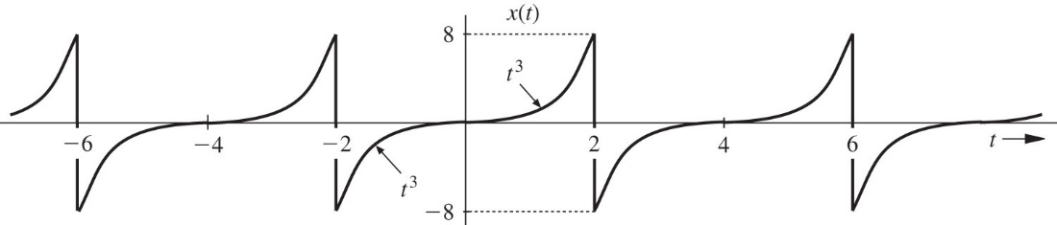
3) for the signal x(t) shown below, sketch the signals a) x(t-4) b) x(-t) c) x(2t-4) 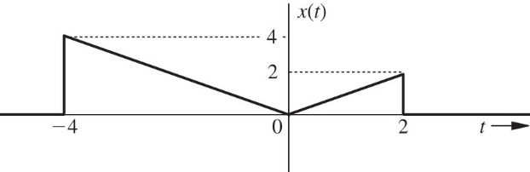
4) sketch the following signals a) u(t-5) – u(t-7) b) (t-4)[u(t-2)-u(t-4)]
5) Simplify the following expressions:
6) Evaluate the following integrals:
7) A sinusoid e^{σt} cos(ωt) can be expressed as a sum of exponentials e^{st} and e^{-st} with complex frequencies s = σ + jω and s = σ - jω. Locate in the complex plane the frequencies of the following sinusoids:

