ENGR 3323: Signals and Systems
HW 2_Ch1
1) For the systems described by the following equations, with the input x(t) and output y(t), determine which of the systems are linear and which are nonlinear.
2) For the systems described by the following equations, with the input x(t) and output y(t), explain with reasons which of the systems are time-invariant parameter systems and which are time-varying-parameter systems.
a) y(t) = x(t − 2) b) y(t) = x(−t) c) y(t) = x(at) d) y(t) = tx(t−2)

3) For the systems described by the following equations, with the input x(t) and output y(t), determine which are causal and which are noncausal.
a) y(t) = x(t − 2) b) y(t) = x(− t) c) y(t) = x(at) a > 1 d) y(t) = x(at) 0 < a < 1

4) For the circuit depicted below, find the differential equations relating outputs y₁(t) and y₂(t) to the input x(t).
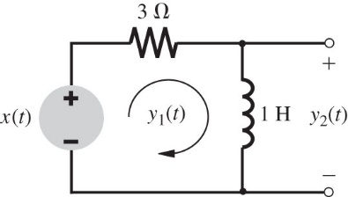

5) A simplified (one-dimensional) model of an automobile suspension system is shown below. In this case, the input is not a force but a displacement x(t) (the road contour). Find the differential equation relating the output y(t) (auto body displacement) to the input x(t) (the road contour).
