ENGR 3323: Signals and Systems
HW 4_Ch2

1) The unit impulse response of an LTIC system is h(t) = e^{-2t} u(t). Find this system’s (zero-state) response y(t) if the input x(t) is
a) 2u(t) b) e^{-t} u(t) c) sin 3t u(t) d) the pulse $2Π\left(\frac{t-1}{2}\right)$ e) δ(t) f) δ(t-2)
2) Figure below shows the input x(t) and the impulse response h(t) for an LTIC system. Let the output be y(t).
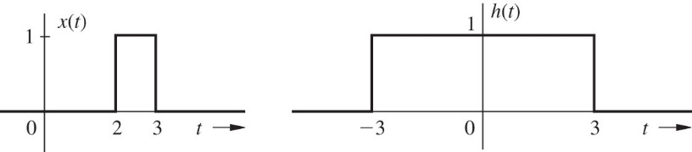
a. By inspection of x(t) and h(t), find y(-1), y(0), y(1), y(2), y(3), y(4), y(5), and y(6). Thus, by merely examining x(t) and h(t), you are required to see what the result of convolution yields at t = −1, 0, 1, 2, 3, 4, 5, and 6.
b. Find the system response to the input x(t).
3) Consider the electric circuit shown below.
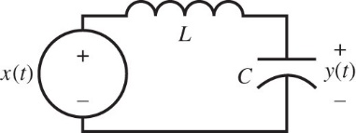
a. Determine the differential equation that relates the input x(t) to output y(t).
b. Find the characteristic equation for this circuit, and express the root(s) of the characteristic equation in terms of L and C.
c. Determine the zero-input response given an initial capacitor voltage of one volt and an initial inductor current of zero amps. That is, find y₀(t) given v_{c}(0) = 1 V and i_{L}(0) = 0 A. [Hint: The coefficient(s) in y₀(t) are independent of L and C.]
d. Plot y₀(t) for t ≥ 0. Does the zero-input response, which is caused solely by initial conditions, ever "die" out?
e. Determine the total response y(t) to the input x(t) = e^{−t}u(t). Assume an initial inductor current of i_{L} (0⁻) = 0 A, an initialcapacitor voltage of v_{c}(0⁻) = 1 V, L = 1 H, and C = 1 F.
4) Explain, with reasons, whether the LTIC systems described by the following equations are (i) stable or unstable in the BIBO sense; (ii) asymptotically stable, unstable, or marginally stable. Assume that the systems are controllable and observable.
a. (D² + 8D + 12)y(t) = (D − 1)x(t)
b. D(D² + 3D + 2)y(t) = (D + 5)x(t)
c. D²(D² + 2)y(t) = x(t)
d. (D + 1)(D² − 6D + 5)y(t) = (3D + 1)x(t)
5) Determine a frequency ω that will cause the input x(t) = cos(ωt) to produce a strong response when applied to the system descriptbed by (D² + 2D + 13/4) y(t) = x(t). Carfully explain your choice.

