ENGR 3323: Signals and Systems
HW 5_Ch4

1) By direct integration find the Laplace transform and the region of the convergence of the following functions:
a) u(t) – u(t-1) b) te^{-t}u(t) c) e^{-2t}u(t - 5) + δ(t-1)
2) Find the inverse (unilateral) Laplace transform of the following functions:
- Suppose a CT signal x(t) = 2[u(t-2) – u(t+1)] has a transform X(s).
- If Y_{a}(s) = e^{-5s}sX(s+1/2), determine and sketch the corresponding signal y_{a}(t).
- If Y_{b}(s) = 2^{-s}sX(s-2), determine and sketch the corresponding signal y_{b}(t).

- Using only the Laplace table and the time-shifting property, determine the Laplace transform of the signals shown below. [Hint: See textbook for discussion of expressing such signals analytically.]
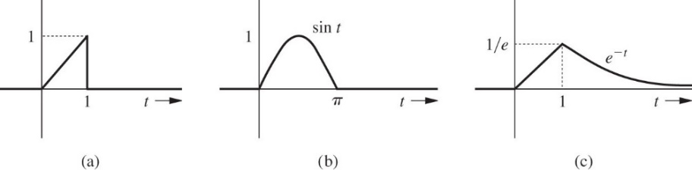
5) It is difficult to compute the Laplace transform X(s) of signal x(t) = (1/t)u(t) by using direct integration. Instead, properties provide a simpler method.
a. Use Laplace transform properties to express the Laplace transform of tx(t) in terms of the unknown quantity X(s).
b. Use the definition to determine the Laplace transform of y(t) = tx(t).
c. Solve for X(s) by using the two pieces from a and b. Simplify your answer.

