ENGR 3323: Signals and Systems
HW 6_Ch4

1) Use the Laplace transform, solve the following differential equations:
a) (D² + 4D + 4)y(t) = (D + 1)x(t) if y(0⁻) =2, $\dot{y}\left(0\right)=1$, and x(t) = e^{-t}u(t)
b) (D² + 6D +25)y(t) = (D+2)x(t) if y(0⁻) =1, $\dot{y}\left(0\right)=1$, and x(t) = 25u(t)

2) Consider a causal LTIC system described by the differential equation
$$\ddot{y}\left(t\right)+ 3\dot{y}\left(t\right)+2y\left(t\right)=2\dot{x}\left(t\right)-x(t)$$
a) Determine the transfer function H(s) for this system
b) Using your result from part (a), determine the impulse response h(t) for this system.
c) Using Laplace transform techniques, determine the ZIR y_{zir}(t) if y(0⁻) =-3, $\dot{y}\left(0^{-}\right)=2$.
d) Using Laplace transform techniques, determine the ZSR y_{zsr}(t) to the input x(t) = u(t).

3) For the circuit shown below, the switch is in open position for a long time before t = 0, when it is closed instantaneously.
a. Write loop equations (in time domain) for t ≥ 0.
b. Solve for y₁(t) and y₂(t) by taking the Laplace transform of loop equations found in part (a).
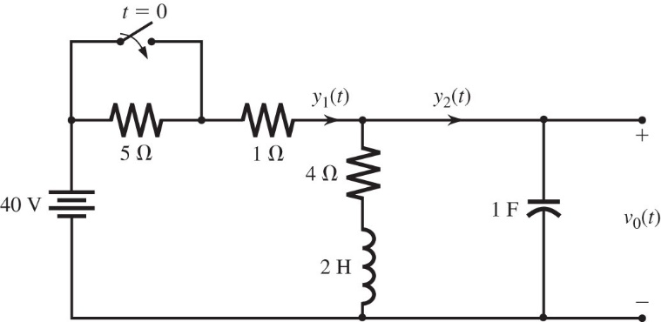
4) For a system with transfer function
$$H\left(s\right)=\frac{2s+3}{s^{2}+2s+5}$$
a. Find the (zero-state) response for input x(t) of (i) 10u(t) and (ii) u(t − 5).
b. For this system write the differential equation relating the output y(t) to the input x(t) assuming that the
systems are controllable and observable.

5) For a system with transfer function
$$H\left(s\right)=\frac{s+3}{{(s+2)}^{2}}$$
Find the magnitude and phase of the frequency response H(jω) and then find the steady-state response to the following inputs:
a) 10 u(t) b) cos(2t+60º)u(t) c) sin(3t-45⁰)u(t) d) e^{j3t}u(t)

