ENGR 3323: Signals and Systems
HW 8_Ch6

Q1) For the periodic signals x(t) and y(t) shown below:
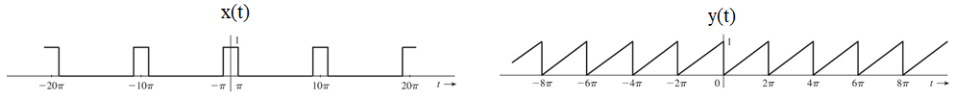
- Find the compact trigonometric Fourier series for x(t) and y(t). If either the sine or cosine terms are absent in the Fourier series of x(t) and y(t), explain why.
- Sketch the amplitude and phase spectra for signal x(t).
- What is the impact on the spectra of x(t) if the period is increased by a factor of two to 20π while the pulse width stays the same 2π?
- What is the impact on the spectra of x(t) if the pulse width is increased by a factor of two to 4π while the period stays the same 10π?
Q2) Over a finite interval, a signal can be represented by more than one trigonometric (or exponential) Fourier series. For instance, if we wish to represent x(t) = t over an interval 0 < t < 1 by a Fourier series with fundamental frequency ω₀ = 2, we can draw a pulse x(t) = t over the interval 0 < t < 1 and repeat the pulse every π seconds so that T₀= π and ω₀ = 2 (Fig. a below). If we want the fundamental frequency ω₀ to be 4, we repeat the pulse every π/2 seconds. If we want the series to contain only cosine terms with ω₀ = 2, we construct a pulse x(t) = |t| over − 1 < t < 1, and repeat it every π seconds (Fig. b below). The resulting signal is an even function with period π. Hence, its Fourier series will have only cosine terms with ω₀ = 2. The resulting Fourier series represents x(t) = t over 0 < t < 1, as desired. We do not care what it represents outside this interval.

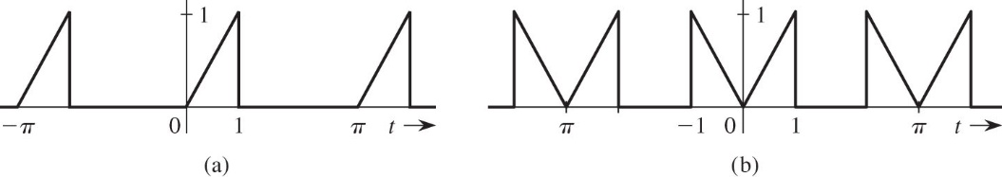

Sketch the periodic signal x(t) such that x(t) = t for 0 < t < 1 and the Fourier series for x(t) satisfies the following
conditions.
a) ω₀ = π/2 and contains all harmonics, but cosine terms only
b) ω₀ = 2 and contains all harmonics, but sine terms only
c) ω₀ = π/2 and contains all harmonics, which are neither exclusively sine nor cosine

Q3) State with reasons whether the following signals are periodic or aperiodic. For periodic signals, find the period and state which of the harmonics are present in the series.
a) 3 sin t + 2 sin 3t
b) 2 + 5 sin 4t + 4 cos 7t
c) 2 sin 3t + 7 cos πt
d) 7 cos πt + 5 sin 2πt
e) 3 cos √2t + 5 cos 2t
f) (3 sin 2t + sin 5t)2

